Supplementary for “Insights into the enhanced flow resistance due to coarsened riverbed sediments via large eddy simulations”

Jiangchao Liu¹, Guojian He², Kai Wang³, Yan Liu^{1*}, & Hongwei Fang^{2,3*}

¹School of Environmental Science and Engineering, Southern University of Science and Technology, Shenzhen 518055, China
²Department of Hydraulic Engineering, Tsinghua University, Beijing 100084, China
³Department of Ocean Science and Engineering, Southern University of Science and Technology, Shenzhen 518055, China

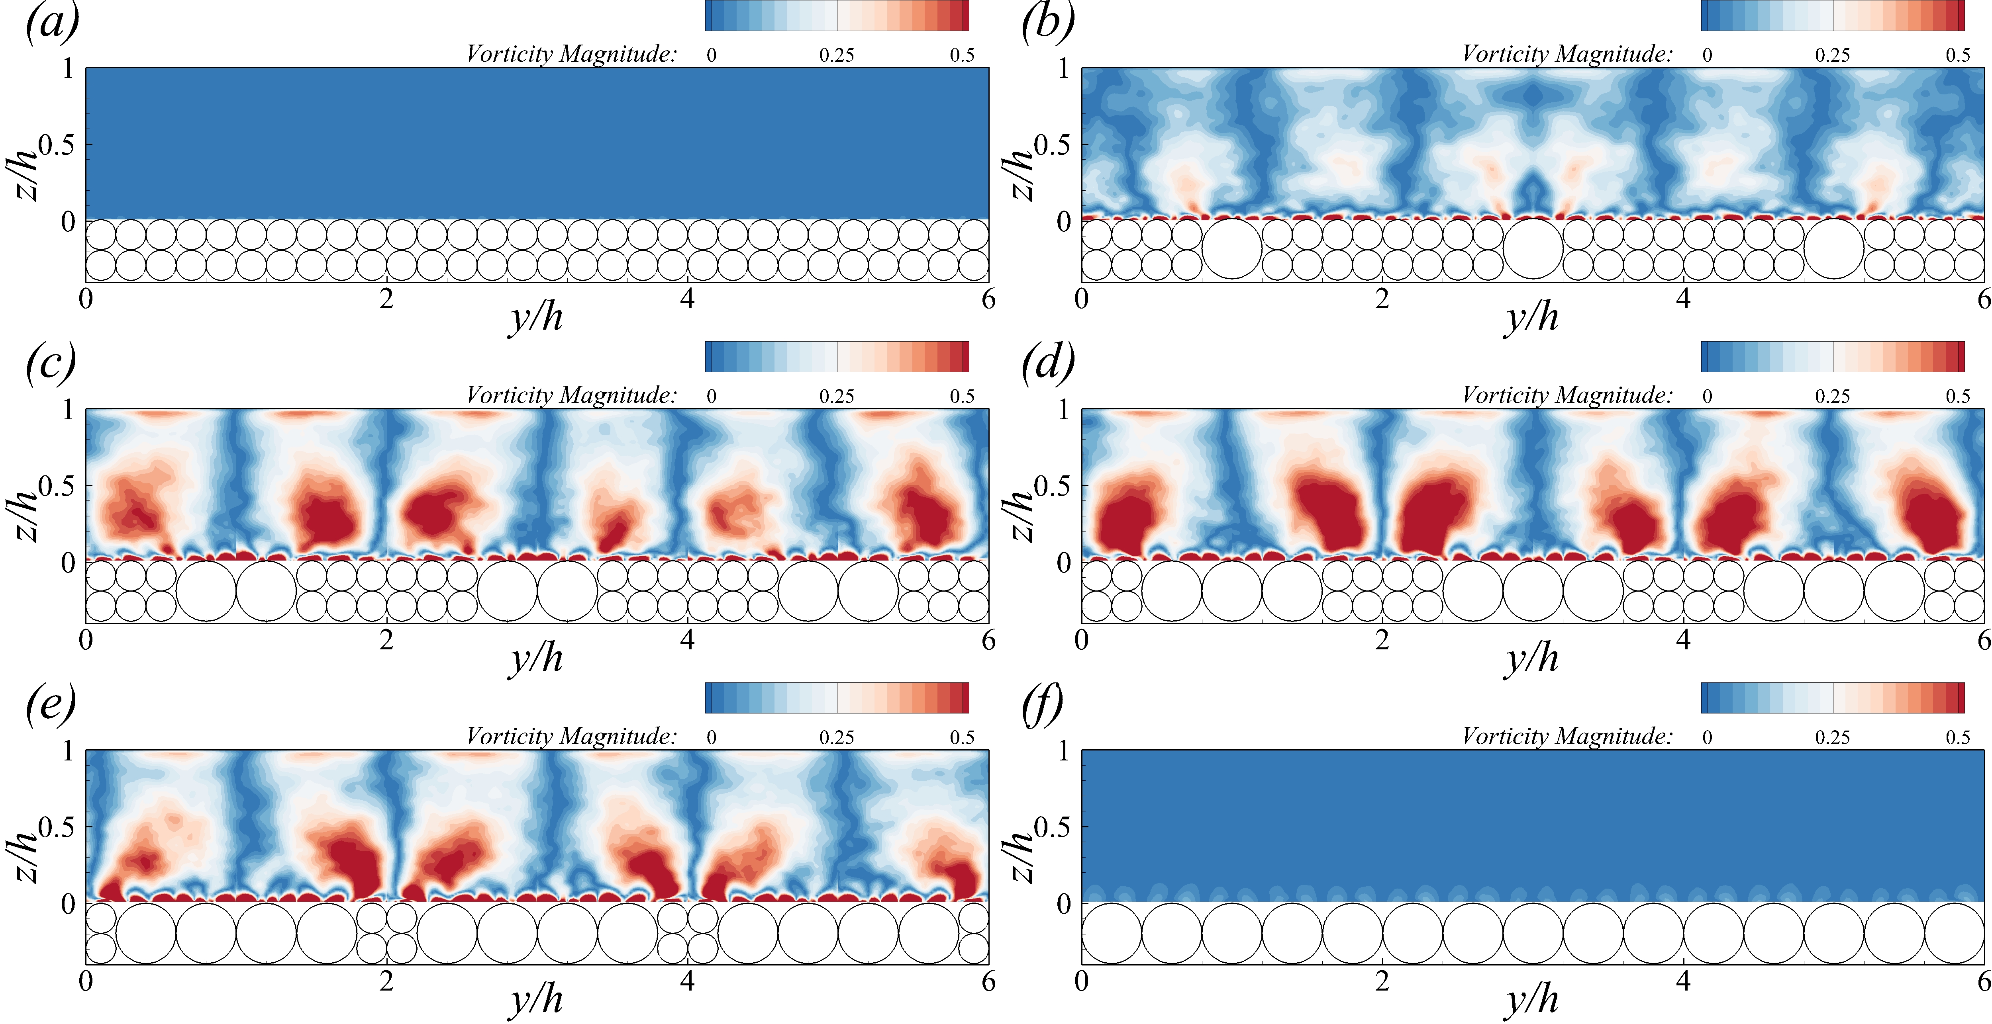
Figure.S1 Contours of the time-averaged vorticity magnitude at the cross-section for Case 1 (a) to Case 6(f).
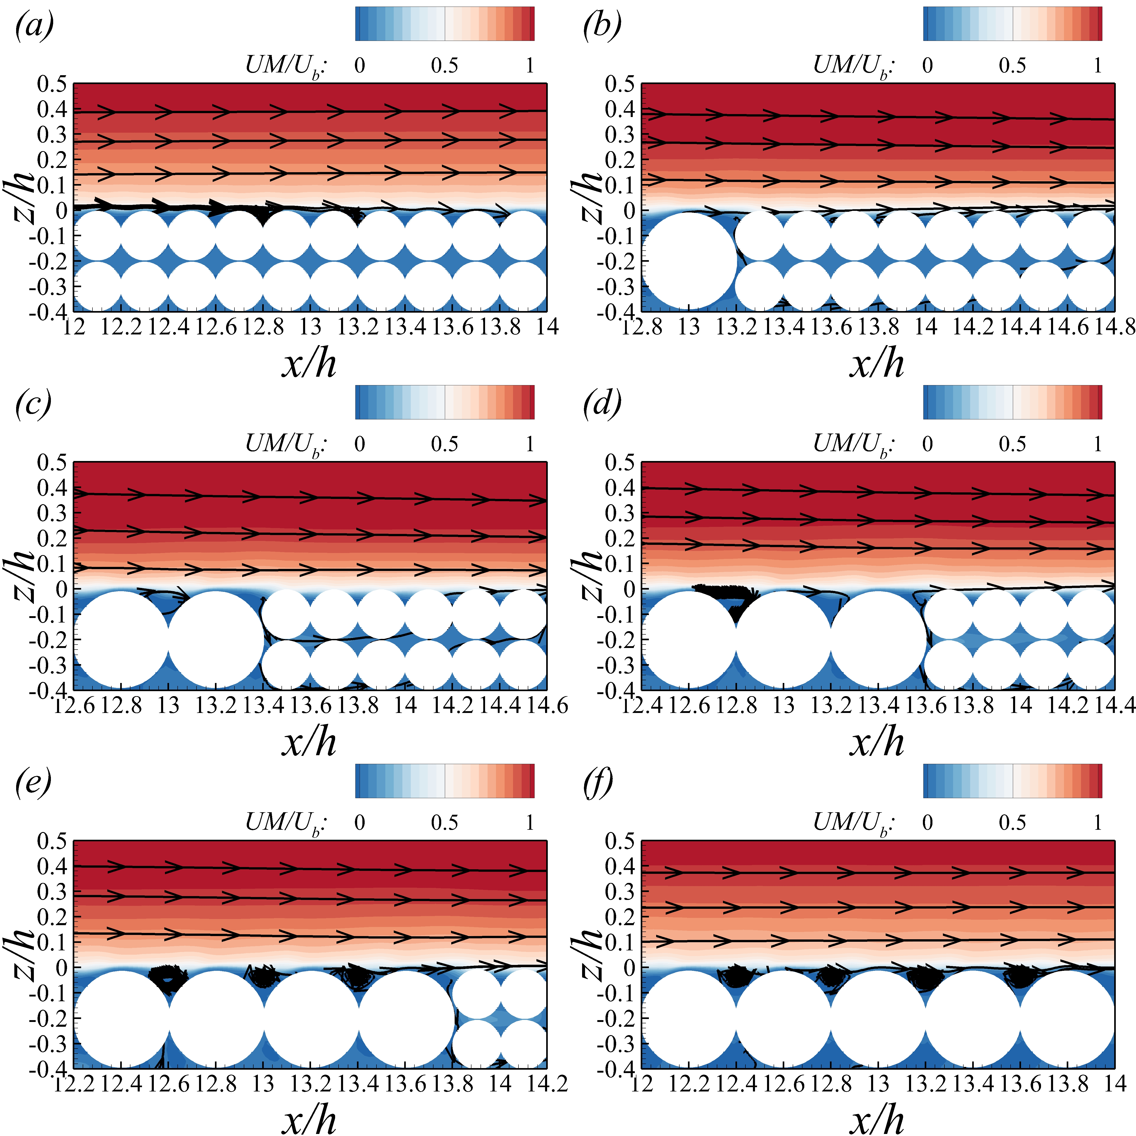
Figure.S2 Contours of the normalized time-averaged streamwise velocity along with in-plane streamlines at the core plane for Case 1(a) to Case 6(f).

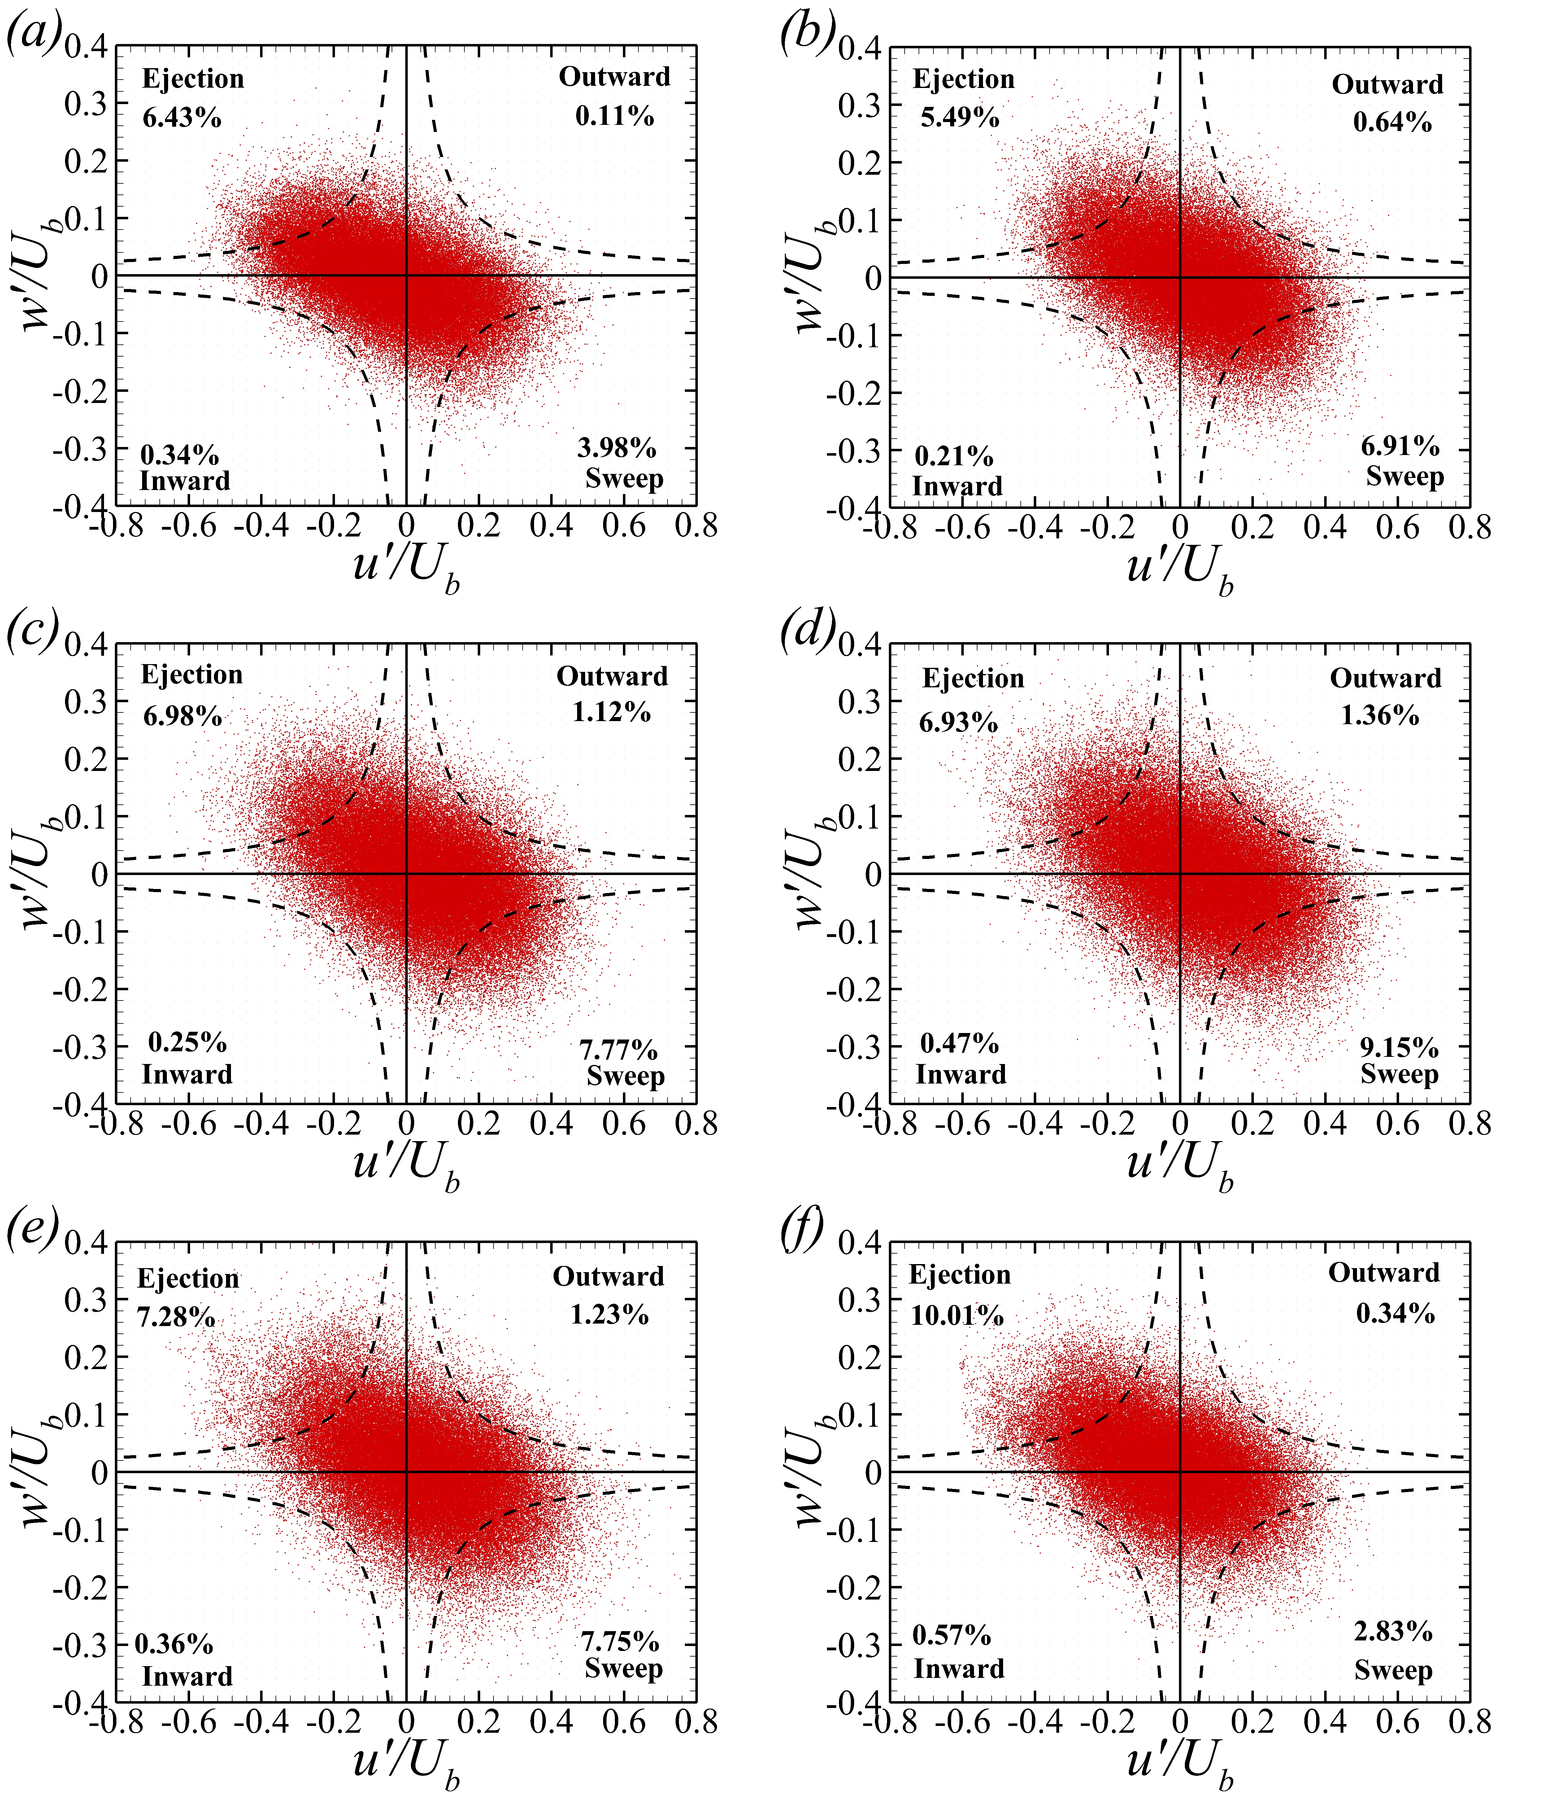
Figure.S3 Quadrant analysis of normalized streamwise and vertical velocity fluctuation located at z/h=0.04 at the core plane for Case 1(a) to Case 6(f).
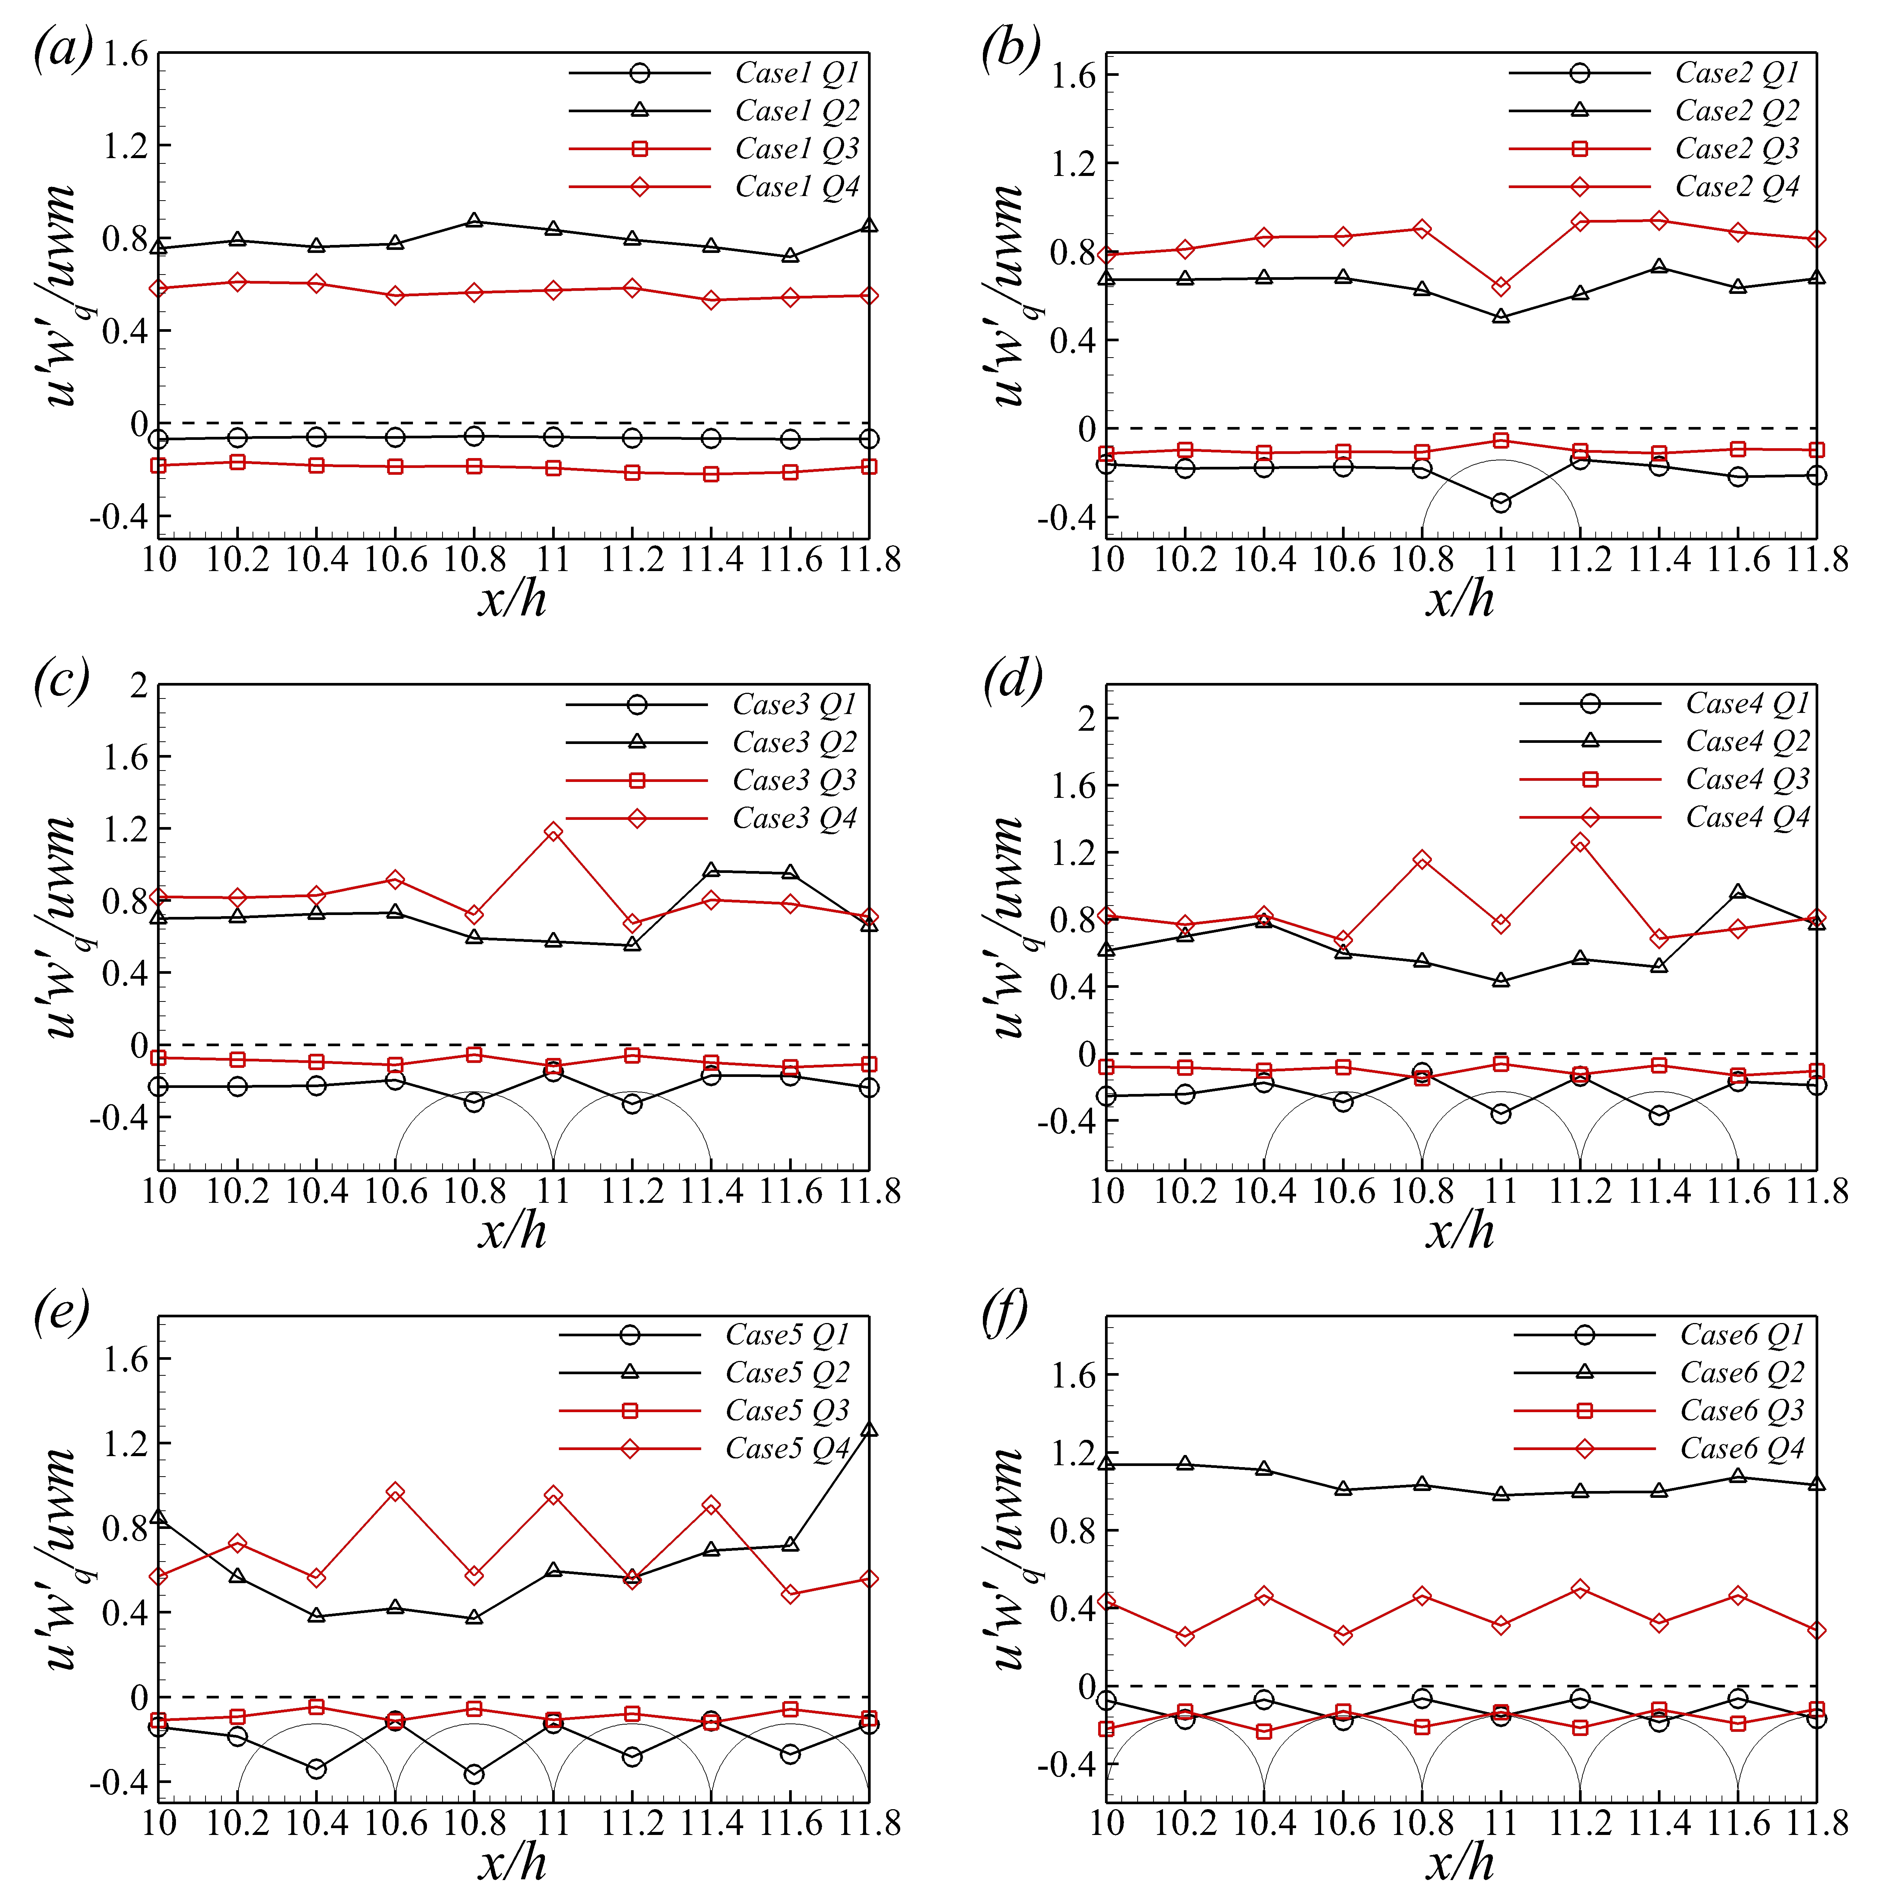
Figure.S4 Contributions from the four quadrants to the Reynolds shear stress along the streamwise direction at the core plane for Case 1 (a) to Case 6 (f). (The solid circles represent the locations of the coarser particles).

