The Penrose tiling[1], Stampfli tiling[2] and Ammann-Beenker tiling[3] that generate quasi-periodically patterned pillar arrayed surfaces are presented in Fig A (a-c), respectively. Micro pillars are arranged at the intersections.

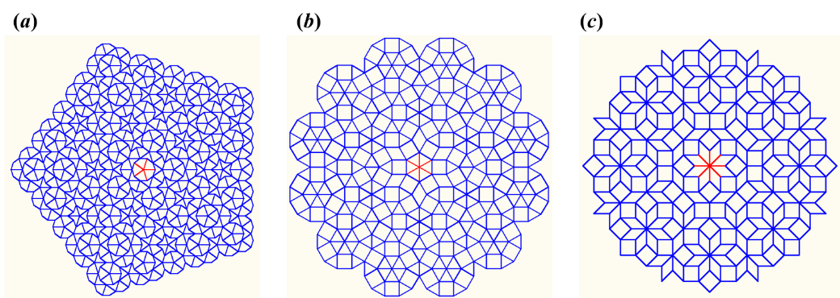

FIG. A. (*a*) The Penrose tiling[1], (*b*) Stampfli tiling[2] and (*c*) Ammann-Beenker tiling[3] that generate quasi-periodically patterned five-fold, six-fold and eight-fold symmetric surfaces, respectively. These patterns have also been presented in Ref. [4].

[1] R. Penrose, Math. Intell. **2**, 32 (1979).

[2] P. Stampfli, Helv. Phys. Acta **59**, 1260 (1986).

[3] F. P. M. Beenker, *Algebraic theory of non-periodic tilings of the plane by two simple building blocks: a square and a rhombus* (Eindhoven University of Technology, Eindhoven, the Netherlands, 1982).

[4] E. H. Chen, Q. Z. Yuan, and Y.-P. Zhao, Soft Matter **14**, 6198 (2018).