Species | Life-trait characteristics |  |  | Picture of bark | Estimation of bark thickness (cm)
Species | Group | Tree-ring structure | Bark type | Picture of bark | Estimation of bark thickness (cm)
Abies alba | Gymnosperm | Non-porous homogeneous | Scaly |  | 0.70 ± 0.06
Picea abies | Gymnosperm | Non-porous homogeneous | Scaly |  | 0.61 ± 0.07
Pinus sylvestris | Gymnosperm | Non-porous heterogeneous | Fissured |  | 0.81 ± 0.08
Larix decidua | Gymnosperm | Non-porous heterogeneous | Fissured |  | 0.72 ± 0.08
Fagus sylvatica | Angiosperm | Diffuse-porous | Smooth |  | 0.26 ± 0.01
Quercus petraea | Angiosperm | Ring-porous | Fissured |  | 0.96 ± 0.09

Supplementary Table S1. Life-trait characteristics of the studied species along with illustration of the bark and estimation of bark thickness (mean ± standard deviation).

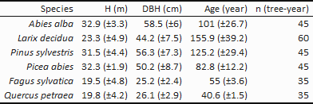
Supplementary Table S2. Mean (± standard deviation) by species of the height (H), diameter at breast height (DBH) and age of the studied trees, as well as their total number (n).

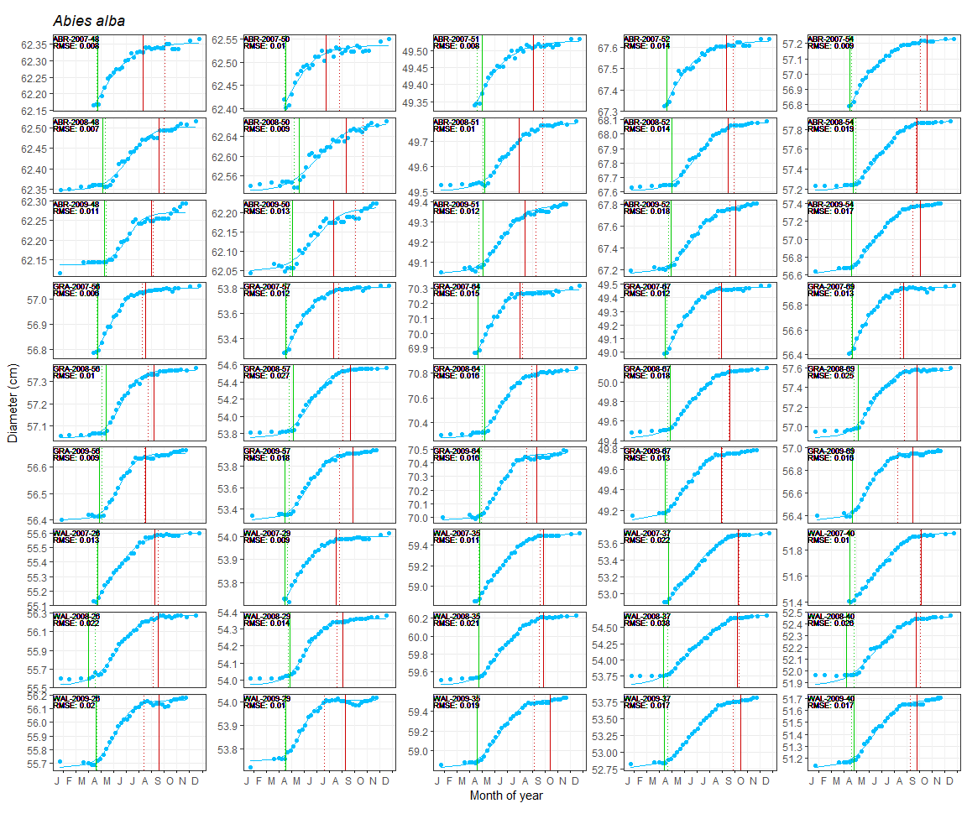
Supplementary Figure S3. Five-parameter logistic growth curve fittings of the weekly band dendrometer measurements for silver fir (Abies alba) trees. Stem diameter variations are presented in y-axis and month of year in x-axis. Sample identity (SITE code – YEAR code – TREE ID code) and goodness-of-fit (RMSE) are written on the left top corner of each plot. Green and red solid vertical lines represent the dates of the beginning and end of wood growth based on microcore approach, while green and red dotted vertical lines represent the beginning and end of stem growth based on dendrometer approach.

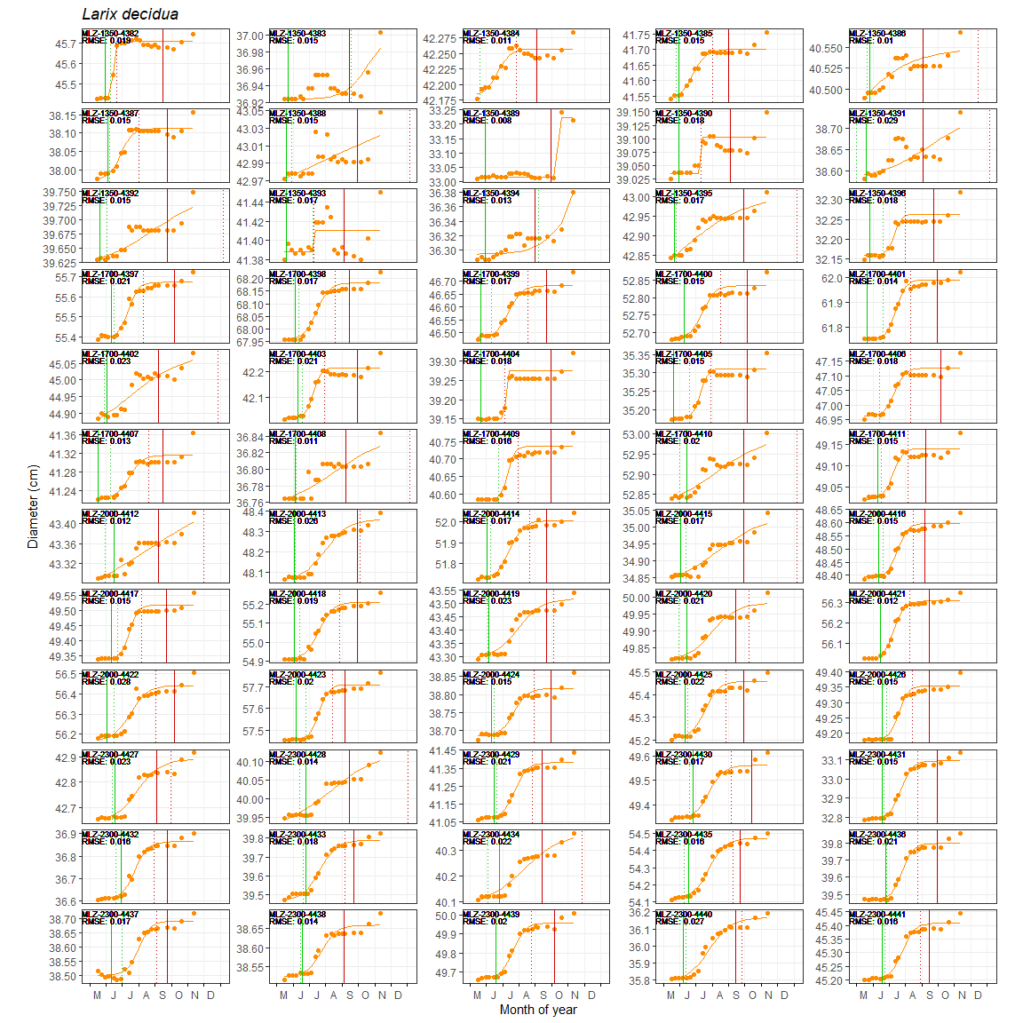
Supplementary Figure S4. Five-parameter logistic growth curve fittings of the weekly band dendrometer measurements of sampled larch (Larix decidua) trees. Stem diameter variations are presented in y-axis and month of year in x-axis. Sample identity (SITE code – ELEVATION code – TREE ID code) and goodness-of-fit (RMSE) is written on the left top corner of each plot. Green and red solid vertical lines represent the dates of the beginning and end of wood growth based on microcore approach, while green and red dotted vertical lines represent the beginning and end of stem growth based on dendrometer approach.
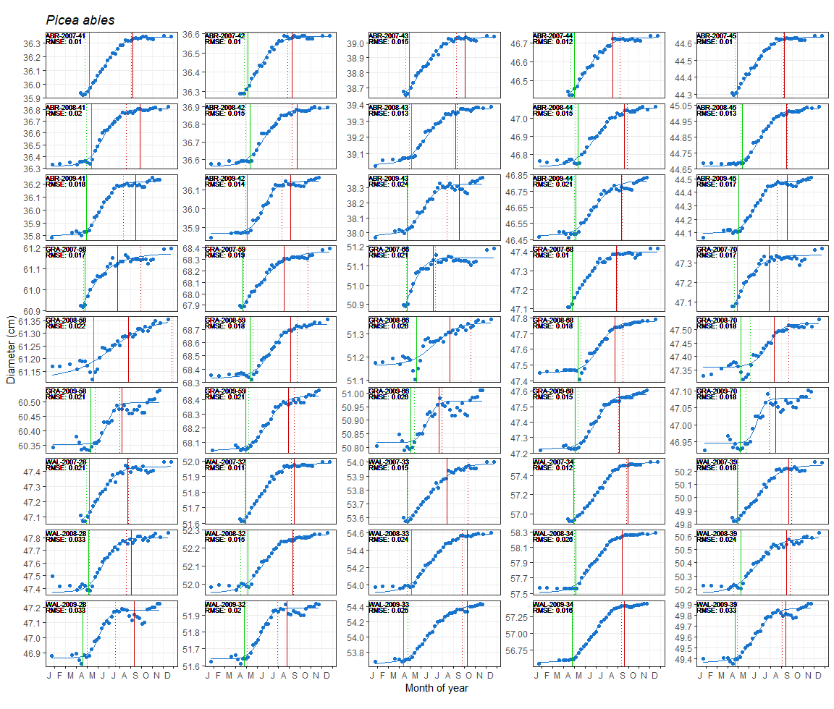
Supplementary Figure S5. Five-parameter logistic growth curve fittings of weekly band dendrometer measurements of sampled Norway spruce (Picea abies) trees. Stem diameter variations are presented in y-axis and month of year in x-axis. Sample identity (SITE code – ELEVATION code – TREE ID code) and goodness-of-fit (RMSE) is written on the left top corner of each plot. Green and red solid vertical lines represent the dates of the beginning and end of wood growth based on microcore approach, while green and red dotted vertical lines represent the beginning and end of stem growth based on dendrometer approach.

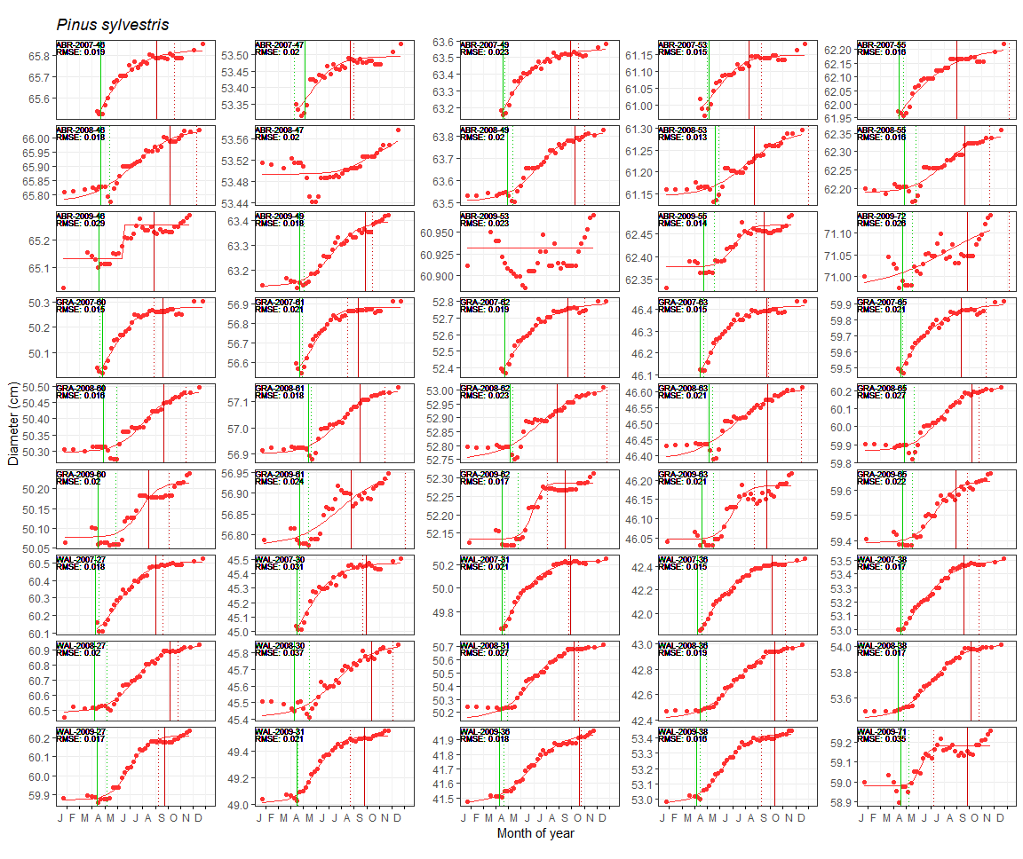
Supplementary Figure S6. Five-parameter logistic growth curve fittings of weekly band dendrometer measurements of sampled Scots pine (Pinus sylvestris) trees. Stem diameter variations are presented in y-axis and month of year in x-axis. Sample identity (SITE code – ELEVATION code – TREE ID code) and goodness-of-fit (RMSE) is written on the left top corner of each plot. Green and red solid vertical lines represent the dates of the beginning and end of wood growth based on microcore approach, while green and red dotted vertical lines represent the beginning and end of stem growth based on dendrometer approach.
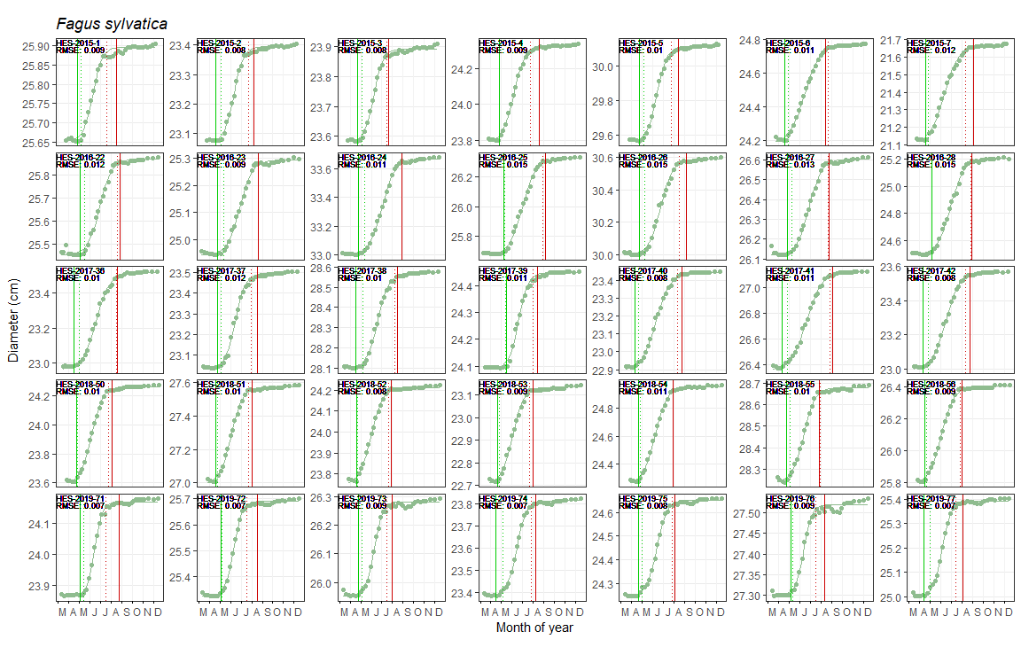
Supplementary Figure S7. Five-parameter logistic growth curve fittings of weekly band dendrometer measurements of sampled European beech (Fagus sylvatica) trees. Stem diameter variations are presented in y-axis and month of year in x-axis. Sample identity (SITE code – ELEVATION code – TREE ID code) and goodness-of-fit (RMSE) is written on the left top corner of each plot. Green and red solid vertical lines represent the dates of the beginning and end of wood growth based on microcore approach, while green and red dotted vertical lines represent the beginning and end of stem growth based on dendrometer approach.
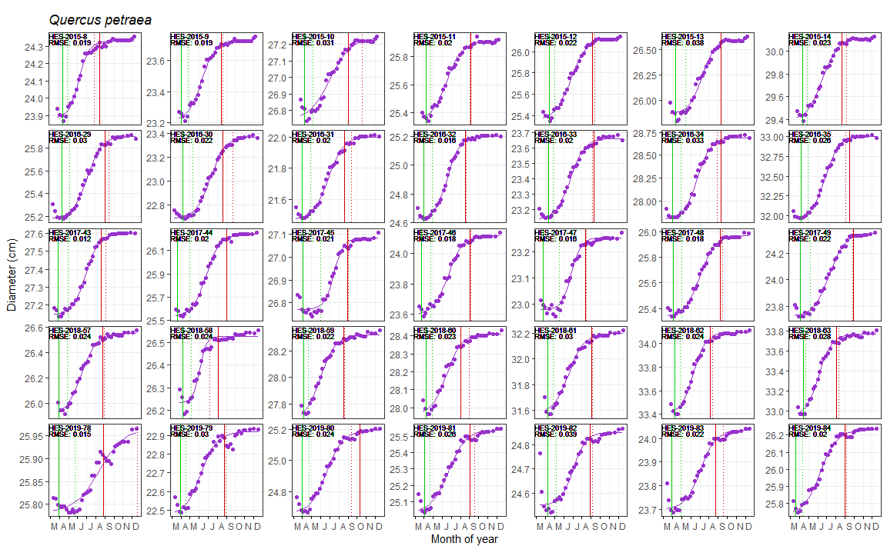
Supplementary Figure S8. Five-parameter logistic growth curve fittings of weekly band dendrometer measurements of sampled sessile oak (Quercus petraea) trees. Stem diameter variations are presented in y-axis and month of year in x-axis. Sample identity (SITE code – ELEVATION code – TREE ID code) and goodness-of-fit (RMSE) is written on the left top corner of each plot. Green and red solid vertical lines represent the dates of the beginning and end of wood growth based on microcore approach, while green and red dotted vertical lines represent the beginning and end of stem growth based on dendrometer approach.

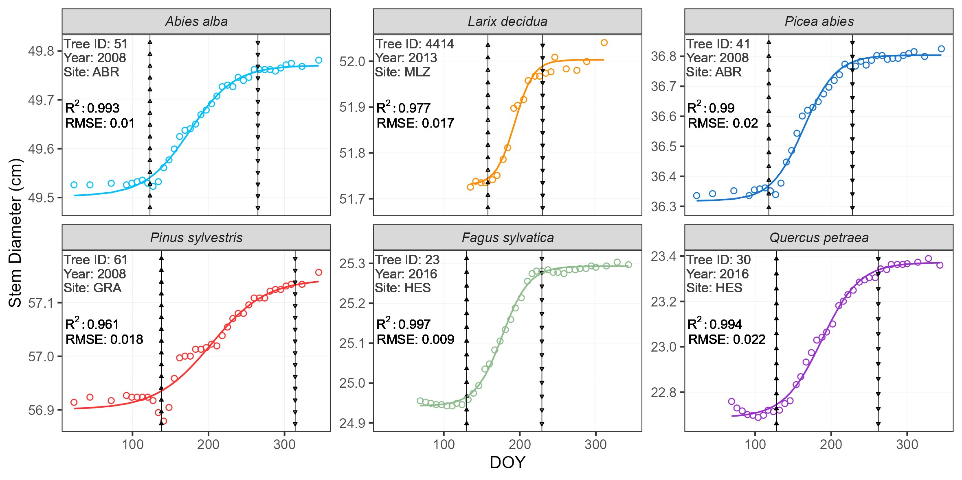
Supplementary Figure S9. Examples of the 5-parameter logistic curve fittings of weekly band-dendrometer measurements of a monitored tree for each studied species. The solid lines correspond to the fitted curves. The hollow points represent dendrometer measurements. The vertical arrowed lines mark the computed 5% (▲) and 95% (▼) growth thresholds.

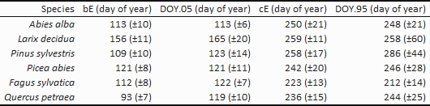
Supplementary Table S10. Mean critical dates (± standard deviation) by species: beginning (bE) and end (cE) of wood growth based on microcore approach, and beginning (DOY.05) and end (DOY.95) of stem radial growth based on manual band dendrometer approach.

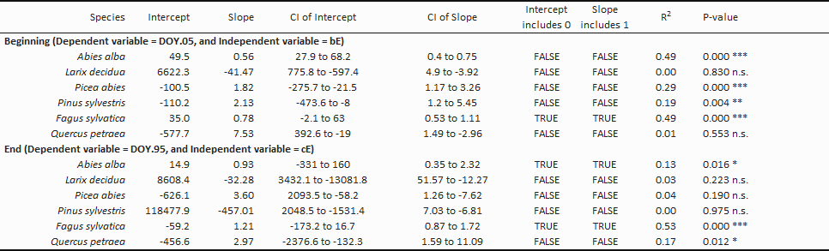
Supplementary Table S11. Coefficients along with their 95% confidence intervals (CI) of the reduce major axis regressions between dendrometer- and microcore-based estimates.

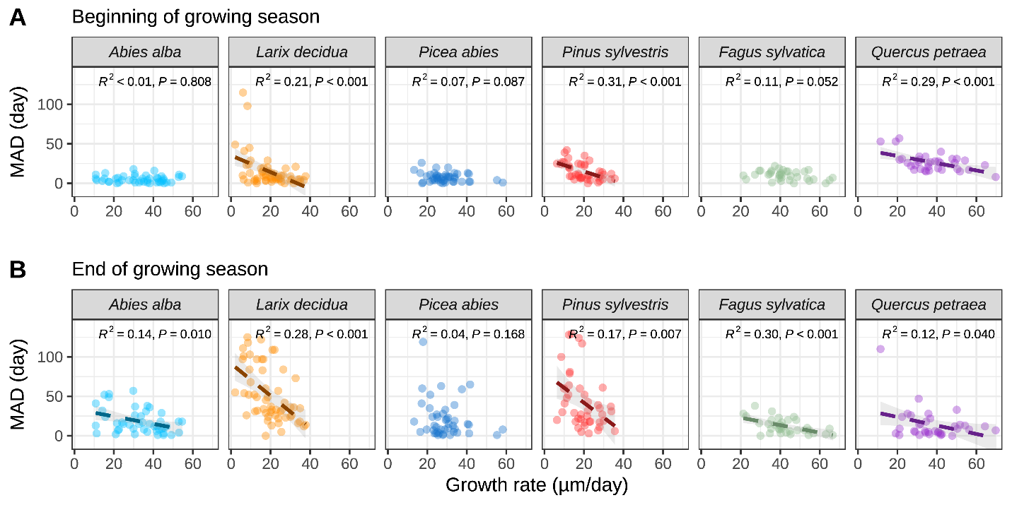
Supplementary Figure S12. Relationships between the growth rate and the mean absolute difference (MAD) between dendrometer- and microcore-based estimates of (A) the beginning and (B) the end of the growing season. The dashed lines and grey ribbons represent the linear regression lines and the confidence intervals.
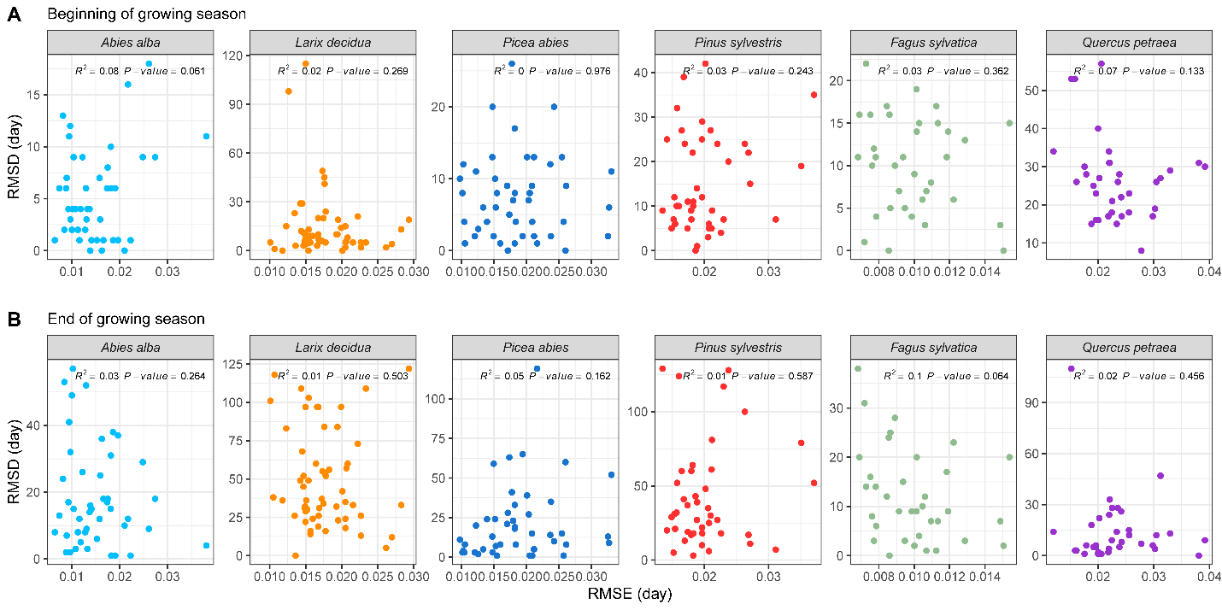
Supplementary Figure S13. Regression analysis between the goodness-of-fit of the 5-parameter logistic model (RMSE) and the accuracy of dendrometer-based estimates (RMSD) for: (A) the beginning of the growing season and (B) the end.
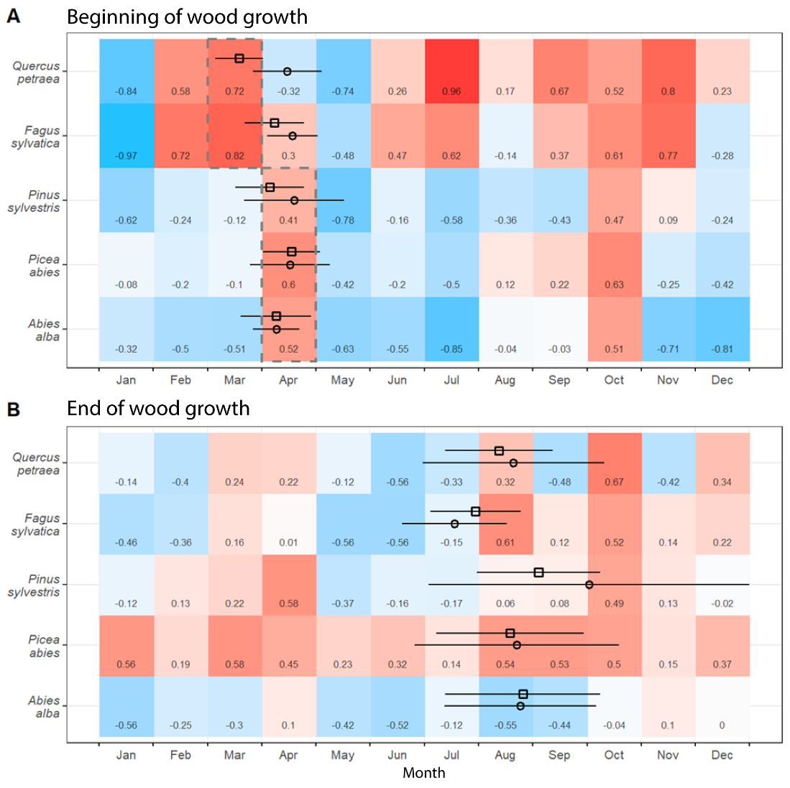
Supplementary Figure S14. Pearson correlation between dendrometer estimates accuracy (RMSD) for: (A) the beginning and (B) the end of growth and the 12 monthly sums of precipitations. Pearson correlation coefficient (R) is given in each cell. The means of critical dates based on microcore approach for each species are represented as hollow black box (□), while the means of critical dates based on dendrometer approach are represented as hollow black circle (○), their standard deviations are represented as horizontal lines. Grey dashed box marked the month selected as “spring precipitation” used in the analysis of the influence of environmental factors on dendrometer accuracy (Figure 5).

