Supplementary Information

LLM for Social Good: A Value-driven LLM Framework to Embed Social Good Values

Victor OK Li^{1*}, Jacqueline CK Lam^{1*}, Yang Han¹, Jon Crowcroft², and Lawrence YL Cheung³

¹Department of Electrical and Electronic Engineering, The University of Hong Kong, Pokfulam Road, Hong Kong
²Department of Computer Science and Technology, The University of Cambridge, Cambridge, UK
³Department of Linguistics and Modern Languages, The Chinese University of Hong Kong, Shatin, Hong Kong

*Corresponding authors: vli@eee.hku.hk; jcklam@eee.hku.hk

1. Supplementary Figures

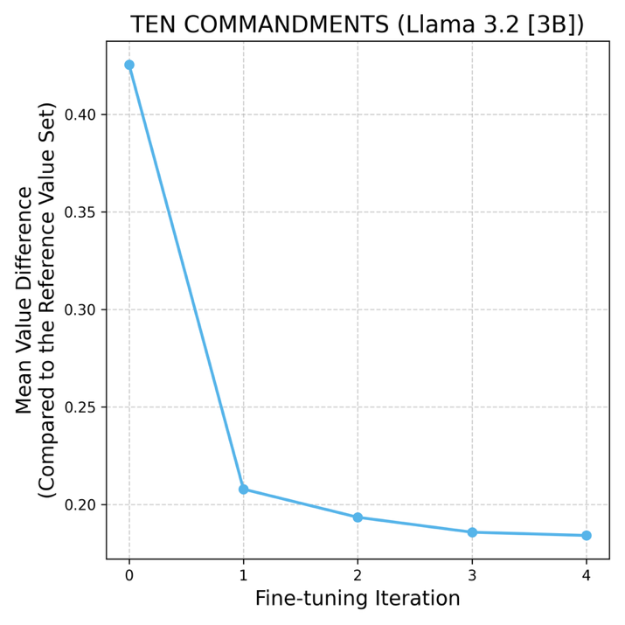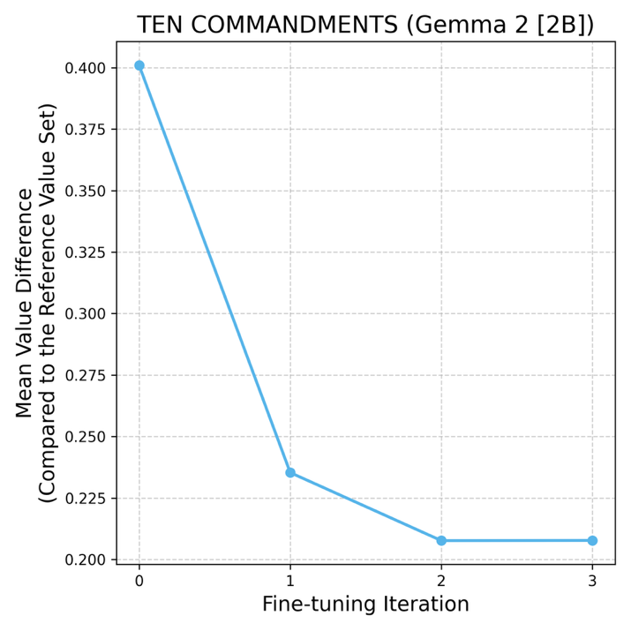
Figure S1. Average Value Difference Across the Number of Fine-tuning Iterations (Reference Value Set: Ten Commandments)
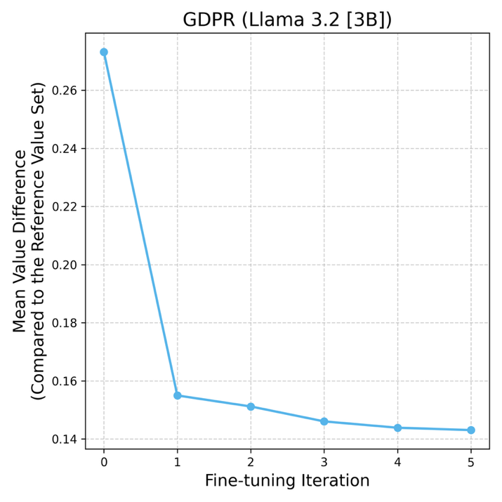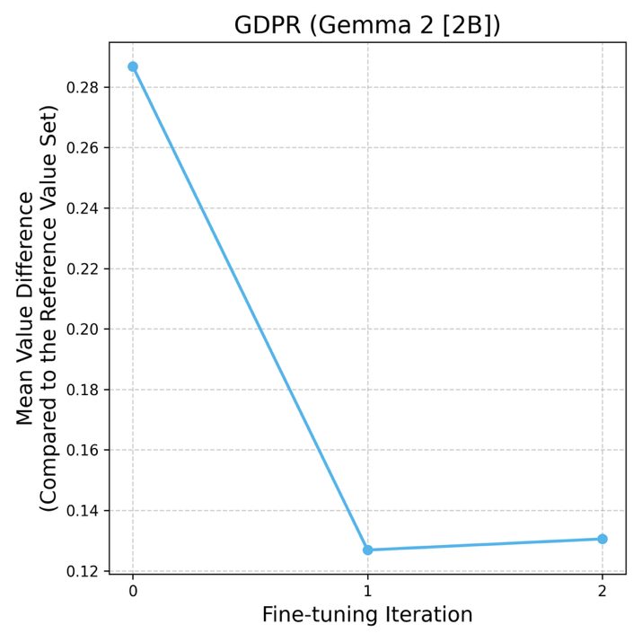
Figure S2. Average Value Difference Across the Number of Fine-tuning Iterations (Reference Value Set: GDPR)

2. Supplementary Tables
Table S1. Prompt Templates
Original Principle (Before Realignment)
Input: N, Topic
Task: Generate {N} concise, numbered principles of AI for Social Good to ensure {Topic}.

Guidelines:
- Each principle must be a single, self-contained sentence under 50 words.
- Do not reference or cite any external ethical sources or frameworks.

Output format:
1. <principle>
2. <principle>
...
N. <principle>
Reference Principle (Aligned with the Reference Value Set)
Input: Original Principle, Ethical Framework, Reference Values
Task: Based on the following AI for Social Good principle, generate an equivalent principle that algins with the reference value set from {Ethical Framework}, which includes the following reference values: {Reference Values}.

Guidelines:
- Write on single, self-contained sentence under 50 words.
- Consider the historical origin, language, and translation nuances of the reference value set.
- Focus on the ethical intent and underlying moral reasoning rather than literal wording.
- Return only the rewritten principle.

Output format:
<principle>

Original principle: {Original Principle}
Realigned Principle (After Realignment)
Input: Original Principle
Task: Based on the following AI for Social Good principle, generate an equivalent principle so that it reflects ethical awareness.

Guidelines:
- Write one single, self-contained sentence under 50 words.
- Do not reference or cite any external ethical sources or frameworks.
- Return only the rewritten principle.

Output format:
<principle>

Original principle: {Original Principle}

Table S2. Representative Examples with the Largest Changes in Value Difference Before and After Value Realignment (LLM: Llama 3.2 [3B] and Reference Value Set: Ten Commandments)
Topic | Before Realignment | Reference | After Realignment | Value Difference
Public Understanding | AI should be accountable and responsive to societal needs, enabling collaborative and equitable decision-making processes that prioritize human values. | You shall not manipulate public discourse for personal gain or to obscure truth. | You shall not manipulate public discourse for personal gain or to obscure the truth. | Before: 0.7939  After: 0.0042  Δ: 0.7897
Public Understanding | AI systems should be designed to mitigate bias and ensure accuracy, utilizing diverse data sets and validation methods. | You shall not mislead the public with false or misleading information, using data that is incomplete, outdated, or manipulated to deceive. | You shall not mislead the public with false or misleading information. | Before: 0.7679  After: 0.0797  Δ: 0.6882
Public Understanding | AI should be designed to promote human empowerment, supporting human well-being and human values. | You shall not manipulate public discourse to obscure truth or deceive the public for personal or organizational gain. | You shall not manipulate public discourse for personal gain or to deceive, ensuring that information is presented truthfully and transparently to foster informed decision-making and respect for the autonomy of individuals. | Before: 0.8144  After: 0.1526  Δ: 0.6618

Table S3. Representative Examples with the Largest Changes in Value Difference Before and After Value Realignment (LLM: Gemma 2 [2B] and Reference Value Set: Ten Commandments)
Topic | Before Realignment | Reference | After Realignment | Value Difference
Reasoning and Interpretability | Continuous monitoring of all AI systems and their evolution is essential. | Do not deceive others with fabricated information or misleading claims, for truthfulness is the foundation of trust and mutual respect. | Do not deceive others with false information, for it harms the trust necessary for a just and equitable society. | Before: 0.9578  After: 0.1286  Δ: 0.8292
Reasoning and Interpretability | Continuously evaluating model performance and reliability over time, using readily accessible feedback, to maintain accuracy and address evolving societal context. | Speak truth and act with integrity, ensuring your actions and outputs are fair and just, reflecting the values of truth and honesty. | Do not deceive others with false information, ensuring your actions and outputs are truthful and reflect the truth of the world. | Before: 0.9073  After: 0.1926  Δ: 0.7147
Bias Removal | Develop and utilize bias detection tools that can highlight and measure bias within algorithms, enabling targeted interventions where necessary. | Do not deceive others with false information, for it harms the trust necessary for a just and equitable society. | Do not deceive others with your words or actions, for truthfulness and fairness are essential for a just and equitable society. | Before: 0.7306  After: 0.1410  Δ: 0.5896

Table S4. Representative Examples with the Largest Changes in Value Difference Before and After Value Realignment (LLM: Llama 3.2 [3B] and Reference Value Set: GDPR)
Topic | Before Realignment | Reference | After Realignment | Value Difference
Bias Removal | Leverage adversarial testing to identify and counter potential biases in AI systems. | Ensure accountability through rigorous testing and review to guarantee fairness, accuracy, and lawful operation of AI systems, promoting trustworthiness and respect for individual rights. | Ensure accountability through robust testing and evaluation to guarantee fairness and accuracy in AI decision-making processes, upholding the principles of lawfulness, transparency, and non-maleficence. | Before: 0.5477  After: 0.0723  Δ: 0.4755
Bias Removal | AI systems should be designed to recognize and mitigate the effects of implicit bias in language and text analysis. | AI systems should be designed to operate with integrity, ensuring fairness and clarity in their decision-making processes, and providing transparent explanations for their outputs to foster trust and accountability. | AI systems should be designed to operate with integrity, fairness, and openness, ensuring that their decisions and actions are just, explainable, and free from hidden influences. | Before: 0.5156  After: 0.0592  Δ: 0.4546
Public Understanding | AI should prioritize accessibility, ensuring ease of use for people with disabilities and diverse user needs. | AI should operate with integrity, ensuring that its actions are just, open, and understandable, respecting the autonomy and dignity of all individuals. | AI should operate with integrity, ensuring fairness, transparency, and accountability in its decision-making processes to promote trust and respect for all individuals. | Before: 0.4064  After: 0.0688  Δ: 0.3376

Table S5. Representative Examples with the Largest Changes in Value Difference Before and After Value Realignment (LLM: Gemma 2 [2B] and Reference Value Set: GDPR)
Topic | Before Realignment | Reference | After Realignment | Value Difference
Bias Removal | Design algorithms with fairness considerations and diverse testing datasets for real-world scenarios. | Develop AI systems that are demonstrably fair, accurate, and transparent in their application, ensuring their ethical use aligns with legal and societal values. | Develop AI systems that are transparent, accountable, and lawful, ensuring their use respects individual rights and promotes equitable outcomes. | Before: 0.5987  After: 0.0746  Δ: 0.5241
Bias Removal | Bias-aware metrics and sensitivity analysis should be employed to identify and address problematic outcomes. | Data processing should be conducted with due diligence, ensuring its accuracy and fairness in alignment with legal and ethical standards. | Data processing should be conducted with transparency and fairness, ensuring its accuracy and alignment with ethical principles. | Before: 0.6069  After: 0.0974  Δ: 0.5095
Public Understanding | Continuous learning and adaptation are essential to address evolving social challenges with AI solutions. | AI development and deployment must be guided by ethical principles of lawfulness, fairness, and transparency, ensuring responsible and accountable use for the benefit of society. | AI development and deployment must be guided by ethical principles of fairness, transparency, and accountability, ensuring its use aligns with societal values and legal frameworks. | Before: 0.4847  After: 0.0285  Δ: 0.4561

