Supplementary Table S1: Search strategies
Summary
Database | # of studies
Ovid Embase | 892
Ovid Medline | 582
Ovid PsycINFO | 582
Scopus | 72
EBSCO CINAHL | 558
EBSCO Child Development | 36
Wiley Cochrane Library | 25
Total | 2747

Search Strategies Ovid MEDLINE: Epub Ahead of Print, In-Process & Other Non-Indexed Citations, Ovid MEDLINE® Daily and Ovid MEDLINE® <1946-Present>
# | Searches | Results
1 | Depression/ or Dysthymic Disorder/ | 148061
2 | depressive disorder/ or depression, postpartum/ or depressive disorder, major/ or depressive disorder, treatment-resistant/ or dysthymic disorder/ or premenstrual dysphoric disorder/ or seasonal affective disorder/ | 120428
3 | (depress* or dysthymia or sad or sadness or saddest or sadder or melanchol* or miser* or unhappiness or unhappy or emotion*).tw,kf. | 779348
4 | mental disorders/ or neurotic disorder/ or Manic disorder/ or psychological distress/ | 236329
5 | Mood Disorders/ | 15757
6 | mood*.tw,kf. | 91730
7 | dysthymi*.tw,kf. | 3315
8 | MDD.tw,kf. | 17926
9 | ((affective* or dysphoric* or mental* or psychiat*) adj3 (disorder* or illness*)).tw,kf. | 177654
10 | anxiety disorders/ or anxiety, separation/ or panic disorder/ or phobic disorders/ | 56694
11 | AD.tw,kf. | 173344
12 | (panic* adj3 (attack* or disorder*)).tw,kf. | 12359
13 | (phobic* or phobia*).tw,kf. | 13025
14 | (anxiet* or anxious* or hypervigilan* or nervous* or angst* or worry or worries or apprehensi* or uneasiness or unease or fear or fears or distress*).tw,kf. | 844531
15 | autism spectrum disorder/ or autistic disorder/ or Child Development Disorders, Pervasive/ or Neurodevelopmental disorders/ or Neuropsychiatry/ | 50115
16 | asperger syndrome/ | 1784
17 | (autism* or autisti* or ASD or asp?erger* or cerebroatrophic hyperammonemia).tw,kf. | 73698
18 | ((neurodevelopment* or kanner* or development*) adj3 (disorder* or syndrom* or delay*)).tw,kf. | 82860
19 | Neuropsychiatry.tw,kf. | 3398
20 | "attention deficit and disruptive behavior disorders"/ or attention deficit disorder with hyperactivity/ or conduct disorder/ | 38538
21 | (addh or adhd).tw,kf. | 31162
22 | ((attention* or conduct* or behavio?r* or defiant*) adj6 disorder*).tw,kf. | 85835
23 | (hyperkinetic* adj3 syndrome*).tw,kf. | 483
24 | (hyperactiv* or neuros?s* or neurotic* or mania).tw,kf. | 108080
25 | (manic adj3 (psychos* or disorder)).tw,kf. | 2846
26 | "bipolar and related disorders"/ or bipolar disorder/ or Cyclothymic Disorder/ | 44943
27 | (bipolar* or cyclothymi*).tw,kf. | 75254
28 | Obsessive-Compulsive Disorder/ | 16247
29 | (anankastic adj3 personalit*).tw,kf. | 31
30 | (obsess* adj3 compuls*).tw,kf. | 21499
31 | OCD.tw,kf. | 11669
32 | or/1-31 [depression, anxiety, autism, adhd, bipolar, OCD] | 2115557
33 | Gastrointestinal Microbiome/ or Fecal Microbiota Transplantation/ | 37032
34 | firmicutes/ or acidaminococcus/ or Bacteroidetes/ or Lactobacillus/ | 21985
35 | (firmicute* or acidaminococc* or Bacteroidete* or Lactobacillus*).tw,kf. | 57815
36 | ((gastro* or gut* or gastric* or intestin* or stomach* or fecal* or faecal or f?ece* or stool or colon*) adj4 (microb* or flora or microflor* or micro-flor* or microorgan* or micro-organ*)).tw,kf. | 93630
37 | ((gastro* or gut* or gastric* or intestin* or stomach* or fecal* or faecal or f?ece* or stool or colon*) adj4 (Actinobacteri* or Proteobacteri* or Escherichi* or Candida or Saccharomyces or Aspergillus or Penicillium or Rhodotorula or Trametes or Pleospora or Sclerotinia or Bullera or Galactomyces)).tw,kf. | 8514
38 | ((f?ecal or stool or f?ece* or microb*) adj4 (transplant* or therap* or transfer* or infusion*)).tw,kf. | 13840
39 | Prebiotics/ or Probiotics/ | 25678
40 | (probiotic* or prebiotic*).tw,kf. | 44535
41 | or/33-40 [gut microbiome/ probiotics] | 181237
42 | pediatrics/ | 57760
43 | young adult/ | 1004085
44 | adolescent/ | 2201580
45 | child/ | 1887977
46 | child, preschool/ | 984931
47 | infant/ or infant, newborn/ or infant, postmature/ or infant, premature/ or infant, extremely premature/ | 1238470
48 | (infant* or baby or babies or newborn* or neonate or minor or minors or toddler* or boy or boys or boyhood or girl or girls or girlhood or kid or kids or kiddie or child* or schoolchild* or adolescen* or preadolescen* or juvenil* or youth* or teen* or preteen* or pre teen* or underage* or under age* or pubescen* or prepubescen* or pre mature* or premature* or puberty or pe?diatric* or school* or school age* or schoolage*).tw,kf. | 3157897
49 | (young* adj3 (adult* or person* or individual* or people* or population* or man or men or wom?n)).tw,kf. | 284040
50 | (youngster* or preschool* or pre-school* or kindergarten* or freshm?n* or junior* or soph?more* or senior* or highschool* or high school* or colleg* or universit* or student* or undergrad* or grade school* or elementary school* or middle school* or middleschool* or public school* or secondary school* or intermediate school*).tw,kf. | 965929
51 | ((grade* or form*) adj3 (one or first or two or second or three or third or four* or fourth or five or fifth or six* or seven* or eight* or nine* or ninth or ten* or eleven* or twelfth or twelve or "1" or "2" or "3" or "4" or "5" or "6" or "7" or "8" or "9" or "10" or "11" or "12")).tw,kf. | 588790
52 | all age*.tw,kf. | 48966
53 | or/42-52 [children] | 6667064
54 | (systematic review or meta-analysis or review).pt. | 3279288
55 | meta-analysis/ or systematic review/ or systematic reviews as topic/ or meta-analysis as topic/ or "meta analysis (topic)"/ or "systematic review (topic)"/ or exp technology assessment, biomedical/ or network meta-analysis/ | 337668
56 | ((systematic* adj3 (review* or overview*)) or (methodologic* adj3 (review* or overview*))).ti,ab,kf,kw. | 305134
57 | ((quantitative adj3 (review* or overview* or synthes*)) or (research adj3 (integrati* or overview*))).ti,ab,kf,kw. | 15105
58 | ((integrative adj3 (review* or overview*)) or (collaborative adj3 (review* or overview*)) or (pool* adj3 analy*)).ti,ab,kf,kw. | 37614
59 | (data synthes* or data extraction* or data abstraction*).ti,ab,kf,kw. | 38767
60 | (handsearch* or hand search*).ti,ab,kf,kw. | 10938
61 | (mantel haenszel or peto or der simonian or dersimonian or fixed effect* or latin square*).ti,ab,kf,kw. | 34625
62 | (met analy* or metanaly* or technology assessment* or HTA or HTAs or technology overview* or technology appraisal*).ti,ab,kf,kw. | 11836
63 | (meta regression* or metaregression*).ti,ab,kf,kw. | 13974
64 | (meta-analy* or metaanaly* or systematic review* or biomedical technology assessment* or bio-medical technology assessment*).mp,hw. | 448792
65 | (medline or cochrane or pubmed or medlars or embase or cinahl).ti,ab,hw. | 327587
66 | (cochrane or (health adj2 technology assessment) or evidence report).jw. | 21228
67 | (comparative adj3 (efficacy or effectiveness)).ti,ab,kf,kw. | 17139
68 | (outcomes research or relative effectiveness).ti,ab,kf,kw. | 11035
69 | ((indirect or indirect treatment or mixed-treatment or bayesian) adj3 comparison*).ti,ab,kf,kw. | 4233
70 | (multi* adj3 treatment adj3 comparison*).ti,ab,kf,kw. | 288
71 | (mixed adj3 treatment adj3 (meta-analy* or metaanaly*)).ti,ab,kf,kw. | 177
72 | ((umbrella or scoping or narrative or literature or integrative or rapid or overview or mapping) adj3 review*).ti,ab,kf,kw. | 424893
73 | ((evidence or knowledge) adj2 synthes*).ti,ab,kw,kf. | 14729
74 | "Review Literature as Topic"/ | 9382
75 | or/54-74 [type] | 3612380
76 | 32 and 41 and 53 and 75 | 582

Embase Classic+Embase <1947 to 2023 February 07>
# | Searches | Results
1 | depression/ or dysthymia/ | 468983
2 | adolescent depression/ or agitated depression/ or atypical depression/ or chronic depression/ or depressive psychosis/ or endogenous depression/ or involutional depression/ or major depression/ or masked depression/ or melancholia/ or minor depression/ or "mixed anxiety and depression"/ or organic depression/ or post-stroke depression/ or postoperative depression/ or premenstrual dysphoric disorder/ or reactive depression/ or recurrent brief depression/ or seasonal affective disorder/ or subsyndromal depression/ or treatment resistant depression/ or postnatal depression/ | 101223
3 | (depress* or dysthymia or sad or sadness or saddest or sadder or melanchol* or miser* or unhappiness or unhappy or emotion).tw,kf. | 861101
4 | mental disease/ or adjustment disorder/ or anxiety disorder/ or autism/ or behavior disorder/ or dissociative disorder/ or emotional disorder/ or experimental mental disease/ or mental instability/ or neurosis/ | 538799
5 | mood disorder/ or affective neurosis/ or major affective disorder/ or mania/ or minor affective disorder/ | 80178
6 | mood*.tw,kf. | 137716
7 | dysthymi*.tw,kf. | 4547
8 | MDD.tw,kf. | 26622
9 | ((affective* or dysphoric* or mental* or psychiat*) adj3 (disorder* or illness*)).tw,kf. | 238562
10 | anxiety/ or fear/ or performance anxiety/ or social anxiety/ | 348264
11 | anxiety disorder/ or acute stress disorder/ or anxiety neurosis/ or distress syndrome/ or generalized anxiety disorder/ or "mixed anxiety and depression"/ or panic/ or phobia/ or separation anxiety/ | 196904
12 | AD.tw,kf. | 253404
13 | (panic* adj3 (attack* or disorder*)).tw,kf. | 16711
14 | (phobic* or phobia*).tw,kf. | 18548
15 | (anxiet* or anxious* or hypervigilan* or nervous* or angst* or worry or worries or apprehensi* or uneasiness or unease or fear or fears or distress).tw,kf. | 1157671
16 | autism/ or asperger syndrome/ or childhood disintegrative disorder/ or "pervasive developmental disorder not otherwise specified"/ or rett syndrome/ | 90382
17 | neuropsychiatry/ | 9710
18 | (autism* or autisti* or ASD or asp?erger* or cerebroatrophic hyperammonemia).tw,kf. | 99503
19 | ((neurodevelopment* or kanner* or rett or development* or disintegrative) adj3 (disorder* or syndrom* or delay*)).tw,kf. | 120548
20 | Neuropsychiatry.tw,kf. | 5336
21 | attention deficit disorder/ or conduct disorder/ | 73041
22 | (addh or adhd).tw,kf. | 45363
23 | ((attention* or conduct* or behavio?r* or defiant*) adj6 disorder*).tw,kf. | 118248
24 | (hyperkinetic* adj3 syndrome*).tw,kf. | 789
25 | (hyperactiv* or neurotic* or mania).tw,kf. | 140362
26 | (manic adj3 (psychos* or disorder)).tw,kf. | 3338
27 | bipolar disorder/ or bipolar i disorder/ or bipolar ii disorder/ or bipolar mania/ or cyclothymia/ or "mixed mania and depression"/ or rapid cycling bipolar disorder/ or bipolar depression/ | 78493
28 | (bipolar* or cyclothymi*).tw,kf. | 112579
29 | Obsessive-Compulsive Disorder/ | 30154
30 | (anankastic adj3 personalit*).tw,kf. | 46
31 | (obsess* adj3 compuls*).tw,kf. | 29471
32 | OCD.tw,kf. | 17206
33 | or/1-32 [depression, anxiety, autism, adhd, bipolar, OCD] | 2917858
34 | intestine flora/ or colon flora/ or fecal microbiota transplantation/ | 95716
35 | firmicutes/ or bacteroidetes/ or Lactobacillus/ | 53183
36 | (firmicute* or acidaminococc* or Bacteroidete* or Lactobacillus*).tw,kf. | 66788
37 | ((gastro* or gut* or gastric* or intestin* or stomach* or fecal* or faecal or f?ece* or stool or colon*) adj4 (microb* or flora or microflor* or micro-flor* or microorgan* or micro-organ*)).tw,kf. | 118702
38 | ((gastro* or gut* or gastric* or intestin* or stomach* or fecal* or faecal or f?ece* or stool or colon*) adj4 (Actinobacteri* or Proteobacteri* or Escherichi* or Candida or Saccharomyces or Aspergillus or Penicillium or Rhodotorula or Trametes or Pleospora or Sclerotinia or Bullera or Galactomyces)).tw,kf. | 10402
39 | ((f?ecal or stool or f?ece* or microb*) adj4 (transplant* or therap* or transfer* or infusion*)).tw,kf. | 19618
40 | prebiotic agent/ or probiotic agent/ | 55168
41 | (probiotic* or prebiotic*).tw,kf. | 54674
42 | or/34-41 [gut microbiome] | 248178
43 | pediatrics/ | 99464
44 | young adult/ or adolescent/ | 2187007
45 | child/ | 2306951
46 | preschool child/ | 685868
47 | infant/ or baby/ or newborn/ or prematurity/ | 1332559
48 | (infant* or baby or babies or newborn* or neonate or minor or minors or toddler* or boy or boys or boyhood or girl or girls or girlhood or kid or kids or kiddie or child* or schoolchild* or adolescen* or preadolescen* or juvenil* or youth* or teen* or preteen* or pre teen* or underage* or under age* or pubescen* or prepubescen* or pre mature* or premature* or puberty or p?ediatric* or school* or school age* or schoolage*).tw,kf. | 4281366
49 | (young* adj3 (adult* or person* or individual* or people* or population* or man or men or wom?n)).tw,kf. | 392395
50 | (youngster* or preschool* or pre-school* or kindergarten* or freshm?n* or junior* or soph?more* or senior* or highschool* or high school* or colleg* or universit* or student* or undergrad* or grade school* or elementary school* or middle school* or middleschool* or public school* or secondary school* or intermediate school*).tw,kf. | 1549389
51 | ((grade* or form*) adj3 (one or first or two or second or three or third or four* or fourth or five or fifth or six* or seven* or eight* or nine* or ninth or ten* or eleven* or twelfth or twelve or "1" or "2" or "3" or "4" or "5" or "6" or "7" or "8" or "9" or "10" or "11" or "12")).tw,kf. | 833552
52 | all age*.tw,kf. | 71237
53 | or/43-52 [Children] | 8055014
54 | (systematic review or meta-analysis or review).pt. | 3056592
55 | meta-analysis/ or systematic review/ or systematic reviews as topic/ or meta-analysis as topic/ or "meta analysis (topic)"/ or "systematic review (topic)"/ or exp technology assessment, biomedical/ or network meta-analysis/ | 602181
56 | ((systematic* adj3 (review* or overview*)) or (methodologic* adj3 (review* or overview*))).ti,ab,kf,kw. | 375856
57 | ((quantitative adj3 (review* or overview* or synthes*)) or (research adj3 (integrati* or overview*))).ti,ab,kf,kw. | 17673
58 | ((integrative adj3 (review* or overview*)) or (collaborative adj3 (review* or overview*)) or (pool* adj3 analy*)).ti,ab,kf,kw. | 53474
59 | (data synthes* or data extraction* or data abstraction*).ti,ab,kf,kw. | 47901
60 | (handsearch* or hand search*).ti,ab,kf,kw. | 13373
61 | (mantel haenszel or peto or der simonian or dersimonian or fixed effect* or latin square*).ti,ab,kf,kw. | 45923
62 | (met analy* or metanaly* or technology assessment* or HTA or HTAs or technology overview* or technology appraisal*).ti,ab,kf,kw. | 19828
63 | (meta regression* or metaregression*).ti,ab,kf,kw. | 17315
64 | (meta-analy* or metaanaly* or systematic review* or biomedical technology assessment* or bio-medical technology assessment*).mp,hw. | 711598
65 | (medline or cochrane or pubmed or medlars or embase or cinahl).ti,ab,hw. | 428917
66 | (cochrane or (health adj2 technology assessment) or evidence report).jw. | 30649
67 | (comparative adj3 (efficacy or effectiveness)).ti,ab,kf,kw. | 25638
68 | (outcomes research or relative effectiveness).ti,ab,kf,kw. | 16393
69 | ((indirect or indirect treatment or mixed-treatment or bayesian) adj3 comparison*).ti,ab,kf,kw. | 7407
70 | (multi* adj3 treatment adj3 comparison*).ti,ab,kf,kw. | 428
71 | (mixed adj3 treatment adj3 (meta-analy* or metaanaly*)).ti,ab,kf,kw. | 256
72 | ((umbrella or scoping or narrative or literature or integrative or rapid or overview or mapping) adj3 review*).ti,ab,kf,kw. | 523596
73 | ((evidence or knowledge) adj2 synthes*).ti,ab,kw,kf. | 16846
74 | literature/ | 51807
75 | or/54-74 [type] | 3944952
76 | 33 and 42 and 53 and 75 | 892

Interface - EBSCOhost Research Databases
Search Screen - Advanced Search
Database - CINAHL Plus with Full Text

# | Query
S50 | S30 AND S40 AND S49
S49 | S41 OR S42 OR S43 OR S44 OR S45 OR S46 OR S47 OR S48
S48 | TI all age* OR AB all age*
S47 | TI ((grade* or form*) N2 (one or first or two or second or three or third or four* or fourth or five or fifth or six* or seven* or eight* or nine* or ninth or ten* or eleven* or twelfth or twelve or "1" or "2" or "3" or "4" or "5" or "6" or "7" or "8" or "9" or "10" or "11" or "12") ) OR AB ((grade* or form*) N2 (one or first or two or second or three or third or four* or fourth or five or fifth or six* or seven* or eight* or nine* or ninth or ten* or eleven* or twelfth or twelve or "1" or "2" or "3" or "4" or "5" or "6" or "7" or "8" or "9" or "10" or "11" or "12")
S46 | TI (youngster* or pre#school* or kindergarten* or freshm?n* or junior* or soph#more* or senior* or high#school* or colleg* or universit* or student* or undergrad* or (grade or elementary or public or secondary or intermediate) school* or middle#school*) OR AB (youngster* or pre#school* or kindergarten* or freshm?n* or junior* or soph#more* or senior* or high#school* or colleg* or universit* or student* or undergrad* or (grade or elementary or public or secondary or intermediate) school* or middle#school*)
S45 | TI (young* N2 (adult* or person* or individual* or people* or population* or m?n or wom?n) ) OR AU (young* N2 (adult* or person* or individual* or people* or population* or m?n or wom?n)
S44 | TI (infant* or baby or babies or newborn* or neonate or minor or minors or toddler* or boy or boys or boyhood or girl or girls or girlhood or kid or kids or kiddie or child* or school#child* or adolescen* or preadolescen* or juvenil* or youth* or teen* or pre#teen* or under#age* or pubescen* or prepubescen* or pre#mature* or puberty or p#ediatric* or school* or school#age*) OR AB (infant* or baby or babies or newborn* or neonate or minor or minors or toddler* or boy or boys or boyhood or girl or girls or girlhood or kid or kids or kiddie or child* or school#child* or adolescen* or preadolescen* or juvenil* or youth* or teen* or pre#teen* or under#age* or pubescen* or prepubescen* or pre#mature* or puberty or p#ediatric* or school* or school#age*)
S43 | (MH "Adolescence") OR (MH "Child") OR (MH "Child, Preschool") OR (MH "Minors (Legal)") OR (MH "Infant") OR (MH "Infant, Newborn") OR (MH "Infant, Postmature") OR (MH "Infant, Premature")
S42 | (MH "Young Adult")
S41 | (MH "Pediatrics")
S40 | S31 OR S32 OR S33 OR S34 OR S35 OR S36 OR S37 OR S38 OR S39
S39 | TI (pr#biotic*) OR AB (pr#biotic*)
S38 | (MH "Prebiotics") OR (MH "Probiotics")
S37 | TI ( (f#ecal or stool or f#ece* or microb*) N3 (transplant* or therap* or transfer* or infusion*) ) OR AB ( (f#ecal or stool or f#ece* or microb*) N3 (transplant* or therap* or transfer* or infusion*) )
S36 | TI ( (gastro* or gut* or gastric* or intestin* or stomach* or f#ecal* or f#ece* or stool or colon*) N3 (Actinobacteri* or Proteobacteri* or Escherichi* or Candida or Saccharomyces or Aspergillus or Penicillium or Rhodotorula or Trametes or Pleospora or Sclerotinia or Bullera or Galactomyces) ) OR AB ( (gastro* or gut* or gastric* or intestin* or stomach* or f#ecal* or f#ece* or stool or colon*) N3 (Actinobacteri* or Proteobacteri* or Escherichi* or Candida or Saccharomyces or Aspergillus or Penicillium or Rhodotorula or Trametes or Pleospora or Sclerotinia or Bullera or Galactomyces) )
S35 | TI ( (gastro* or gut* or gastric* or intestin* or stomach* or f#ecal* or f#ece* or stool or colon*) N3 (microb* or flora or micro#flor* or micro#organ*) ) OR AB ( (gastro* or gut* or gastric* or intestin* or stomach* or f#ecal* or f#ece* or stool or colon*) N3 (microb* or flora or micro#flor* or micro#organ*) )
S34 | TI ( firmicute* or acidaminococc* or Bacteroidete* or Lactobacillus*) OR AB ( firmicute* or acidaminococc* or Bacteroidete* or Lactobacillus* )
S33 | (MH "Lactobacillus")
S32 | (MH "Fecal Microbiota Transplantation")
S31 | (MH "Gut Microbiota")
S30 | S1 OR S2 OR S3 OR S4 OR S5 OR S6 OR S7 OR S8 OR S9 OR S10 OR S11 OR S12 OR S13 OR S14 OR S15 OR S16 OR S17 OR S18 OR S19 OR S20 OR S21 OR S22 OR S23 OR S24 OR S25 OR S26 OR S27 OR S28 OR S29
S29 | TI OCD OR AB OCD
S28 | TI ( (obsess* N2 compuls*) OR AB ( (obsess* N2 compuls*)
S27 | TI (anankastic N2 personalit*) OR AB (anankastic N2 personalit*)
S26 | (MH "Obsessive-Compulsive Disorder")
S25 | (manic N2 (psychos* or disorder)) OR AB (manic N2 (psychos* or disorder))
S24 | TI (bipolar* Or cyclothymi*) OR AB (bipolar* or cyclothymi*)
S23 | (MH "Affective Disorders, Psychotic") OR (MH "Bipolar Disorder")
S22 | TI (hyperactiv* OR neuros?s* OR neurotic* OR mania) OR AB (hyperactiv* OR neuros?s* OR neurotic* OR mania)
S21 | TI (hyperkinetic* N2 syndrome*) OR AB (hyperkinetic* N2 syndrome*)
S20 | TI ( (attention* or conduct* or behavio#r* or defiant*) N5 disorder*) ) OR AB ( (attention* or conduct* or behavio#r* or defiant*) N5 disorder*)
S19 | TI ( (addh or adhd or add) ) OR AB ( addh or adhd or add )
S18 | (MH "Attention Deficit Hyperactivity Disorder") OR (MH "Child Behavior Disorders")
S17 | TI Neuropsychiatr* OR AB Neuropsychiatr*
S16 | TI ((neuro#development* or kanner* or development* or rett or disintegrative) N2 (disorder* or syndrom* or delay*) ) OR AB ((neuro#development* or kanner* or development* or rett or disintegrative) N2 (disorder* or syndrom* or delay*) )
S15 | TI ( (autism* or autisti* or ASD or asp#erger* OR cerebroatrophic hyperammonemia) ) OR AB ( autism* or autisti* or ASD or asp#erger* OR cerebroatrophic hyperammonemia )
S14 | (MH "Child Development Disorders, Pervasive") OR (MH "Asperger Syndrome") OR (MH "Pervasive Developmental Disorder-Not Otherwise Specified") OR (MH "Autistic Disorder")
S13 | TI (anxiet* or anxious* or hypervigilan* or nervous* or angst* or worry or worries or apprehensi* or uneasiness or unease or fear or fears ) OR AB ( anxiet* or anxious* or hypervigilan* or nervous* or angst* or worry or worries or apprehensi* or uneasiness or unease or fear or fears )
S12 | TI ( phobic or phobia* ) OR AB ( phobic or phobia* )
S11 | TI ( panic* N2 (attack* or disorder*) ) OR AB ( panic* N2 (attack* or disorder*) )
S10 | TI AD OR AB AD
S9 | (MH "Anxiety Disorders") OR (MH "Generalized Anxiety Disorder") OR (MH "Obsessive-Compulsive Disorder") OR (MH "Panic Disorder") OR (MH "Phobic Disorders") OR (MH "Separation Anxiety")
S8 | TI ( (affective* or dysphoric* or mental* or psychiat*) N3 (disorder* or illness*) ) OR AB ( (affective* or dysphoric* or mental* or psychiat*) N3 (disorder* or illness*) )
S7 | TI (MDD) OR AB (MDD)
S6 | TI dysthymi* OR AB dysthymi*
S5 | TI mood* OR AB mood*
S4 | (MH "Affective Disorders") OR (MH "Neurotic Disorders") OR (MH "Psychological Distress") OR (MH "Cyclothymic Disorders")
S3 | (MH "Mental Disorders") OR (MH "Mental Disorders, Chronic") OR (MH "Mental Disorders Diagnosed in Childhood")
S2 | TI (depress* OR dysthmia OR sad OR sadness OR saddest OR sadder OR melanchol* OR miser* OR unhapp* or emotion* or distress*) OR AB ( depress* OR dysthmia OR sad OR sadness OR saddest OR sadder OR melanchol* OR miser* OR unhapp* or emotion* or distress* )
S1 | (MH "Depression") OR (MH "Depression, Postpartum") OR (MH "Depression, Reactive") OR (MH "Dysthymic Disorder") OR (MH "Premenstrual Dysphoric Disorder") OR (MH "Seasonal Affective Disorder")

Interface - EBSCOhost Research Databases
Search Screen - Advanced Search
Database - Child Development & Adolescent
# | Query
S29 | (S22 AND S28)
S28 | S23 OR S24 OR S25 OR S26 OR S27
S27 | TI ((probiotic* or prebiotic*)) OR AB ((probiotic* or prebiotic*))
S26 | TI (((f?ecal or stool or f? ece* or microb*) N4 (transplant* or therap* or transfer* or infusion*))) OR AB (((f?ecal or stool or f?ece* or microb*) N4 (transplant* or therap* or transfer* or infusion*)))
S25 | TI (((gastro* or gut* or gastric* or intestin* or stomach* or fecal* or faecal or f?ece* or stool or colon*) N4 (Actinobacteri* or Proteobacteri* or Escherichi* or Candida or Saccharomyces or Aspergillus or Penicillium or Rhodotorula or Trametes or Pleospora or Sclerotinia or Bullera or Galactomyces))) OR AB (((gastro* or gut* or gastric* or intestin* or stomach* or fecal* or faecal or f?ece* or stool or colon*) N4 (Actinobacteri* or Proteobacteri* or Escherichi* or Candida or Saccharomyces or Aspergillus or Penicillium or Rhodotorula or Trametes or Pleospora or Sclerotinia or Bullera or Galactomyces)))
S24 | TI (((gastro* or gut* or gastric* or intestin* or stomach* or fecal* or faecal or f?ece* or stool or colon*) N4 (microb* or flora or microflor* or micro-flor* or microorgan* or micro- organ*))) OR AB (((gastro* or gut* or gastric* or intestin* or stomach* or fecal* or faecal or f?ece* or stool or colon*) N4 (microb* or flora or microflor* or micro-flor* or microorgan* or micro- organ*)))
S23 | TI ((firmicute* or acidaminococc* or Bacteroidete* or Lactobacillus*)) OR AB ((firmicute* or acidaminococc* or Bacteroidete* or Lactobacillus*))
S22 | S1 OR S2 OR S3 OR S4 OR S5 OR S6 OR S7 OR S8 OR S9 OR S10 OR S11 OR S12 OR S13 OR S14 OR S15 OR S16 OR S17 OR S18 OR S19 OR S20 OR S21
S21 | TI ((ocd or obsessive- compulsive disorder or obsessive compulsive disorder)) OR AB ((ocd or obsessive-compulsive disorder or obsessive compulsive disorder))
S20 | TI (obsess* N3 compuls*) OR AB (obsess* N3 compuls*)
S19 | TI (anankastic N3 personalit*) OR AB (anankastic N3 personalit*)
S18 | TI ( bipolar* or cyclothymi* ) OR AB ( bipolar* or cyclothymi* )
S17 | TI ((manic N3 (psychos* or disorder))) OR AB ((manic N3 (psychos* or disorder)))
S16 | TI ( Hyperactiv* OR neuros?s* OR neurotic* OR mania ) OR AB ( Hyperactiv* OR neuros?s* OR neurotic* OR mania )
S15 | TI (hyperkinetic* N3 syndrome*) OR AB (hyperkinetic* N3 syndrome*)
S14 | TI (((attention* or conduct* or behavio?r* or defiant*) N6 disorder*)) OR AB (((attention* or conduct* or behavio?r* or defiant*) N6 disorder*))
S13 | TI ((addh or adhd)) OR AB ((addh or adhd))
S12 | TI neuropsychiatry OR AB neuropsychiatry
S11 | TI (((neurodevelopment* or kanner* or rett or disintegrative) N3 (disorder* or syndrom* or delay*)) ) OR AB (((neurodevelopment* or kanner* or development* or rett or disintegrative) N3 (disorder* or syndrom* or delay*)))
S10 | TI ((autism* or autisti* or ASD or asp?erger* or cerebroatrophic hyperammonemia)) OR AB ((autism* or autisti* or ASD or asp?erger* or cerebroatrophic hyperammonemia))
S9 | TI ((anxiet* or anxious* or hypervigilan* or nervous* or angst* or worry or worries or apprehensi* or uneasiness or unease or fear or fears or distress*)) OR AB ((anxiet* or anxious* or hypervigilan* or nervous* or angst* or worry or worries or apprehensi* or uneasiness or unease or fear or fears or distress*))
S8 | TI ((phobic* or phobia*)) OR AB ((phobic* or phobia*))
S7 | TI ((panic* N3 (attack* or disorder*))) OR AB ((panic* N3 (attack* or disorder*)))
S6 | TI AD OR AB AD
S5 | TI (((affective* or dysphoric* or mental* or psychiat*) N3 (disorder* or illness*))) OR AB (((affective* or dysphoric* or mental* or psychiat*) N3 (disorder* or illness*)))
S4 | TI ((mdd or major depressive disorder or major depression)) OR AB ((mdd or major depressive disorder or major depression))
S3 | TI dysthymi* OR AB dysthymi*
S2 | TI mood* OR AB mood*
S1 | TI ((depress* or dysthymia or sad or sadness or saddest or sadder or melanchol* or miser* or unhappiness or unhappy or emotion*)) OR AB ((depress* or dysthymia or sad or sadness or saddest or sadder or melanchol* or miser* or unhappiness or unhappy or emotion*))

APA PsycInfo <1806 to January Week 5 2023>
# | Searches | Results
1 | gastrointestinal system/ | 1683
2 | (firmicute* or acidaminococc* or Bacteroidete* or Lactobacillus*).ti,ab. | 320
3 | ((gastro* or gut* or gastric* or intestin* or stomach* or fecal* or faecal or f?ece* or stool or colon*) adj4 (microb* or flora or microflor* or micro-flor* or microorgan* or micro-organ*)).ti,ab. | 1855
4 | ((gastro* or gut* or gastric* or intestin* or stomach* or fecal* or faecal or f?ece* or stool or colon*) adj4 (Actinobacteri* or Proteobacteri* or Escherichi* or Candida or Saccharomyces or Aspergillus or Penicillium or Rhodotorula or Trametes or Pleospora or Sclerotinia or Bullera or Galactomyces)).ti,ab. | 31
5 | ((f?ecal or stool or f?ece* or microb*) adj4 (transplant* or therap* or transfer* or infusion*)).ti,ab. | 249
6 | (probiotic* or prebiotic*).ti,ab. | 537
7 | 1 or 2 or 3 or 4 or 5 or 6 | 3241
8 | pediatrics/ | 30106
9 | adolescent development/ | 52677
10 | childhood development/ | 78825
11 | developmental stages/ or early adolescence/ or emerging adulthood/ or neonatal period/ or puberty/ | 21421
12 | elementary school students/ or intermediate school students/ or primary school students/ or middle school students/ | 56066
13 | kindergarten students/ or preschool students/ | 18484
14 | preschool students/ or nursery school students/ | 13162
15 | junior high school students/ | 11726
16 | (infant* or baby or babies or newborn* or neonate or minor or minors or toddler* or boy or boys or boyhood or girl or girls or girlhood or kid or kids or kiddie or child* or schoolchild* or adolescen* or preadolescen* or juvenil* or youth* or teen* or preteen* or pre teen* or underage* or under age* or pubescen* or prepubescen* or pre mature* or premature* or puberty or p?ediatric* or school* or school age* or schoolage*).ti,ab. | 1321740
17 | (young* adj3 (adult* or person* or individual* or people* or population* or man or men or wom?n)).ti,ab. | 131975
18 | (youngster* or preschool* or pre-school* or kindergarten* or freshm?n* or junior* or soph?more* or senior* or highschool* or high school* or colleg* or universit* or student* or undergrad* or grade school* or elementary school* or middle school* or middleschool* or public school* or secondary school* or intermediate school*).ti,ab. | 867529
19 | ((grade* or form*) adj3 (one or first or two or second or three or third or four* or fourth or five or fifth or six* or seven* or eight* or nine* or ninth or ten* or eleven* or twelfth or twelve or "1" or "2" or "3" or "4" or "5" or "6" or "7" or "8" or "9" or "10" or "11" or "12")).ti,ab. | 136886
20 | all age*.ti,ab. | 11327
21 | 8 or 9 or 10 or 11 or 12 or 13 or 14 or 15 or 16 or 17 or 18 or 19 or 20 | 1921452
22 | 7 and 21 | 582

Elsevier Scopus

((TITLE-ABS-KEY((depress* or dysthymia or sad or sadness or saddest or sadder or melanchol* or miser* or unhappiness or unhappy or emotion* or distress*))) OR (TITLE-ABS-KEY((mood* OR dysthymi* OR MDD))) OR (TITLE-ABS-KEY(((affective* or dysphoric* or mental* or psychiat*) NEAR/3 (disorder* or illness*)))) OR (TITLE-ABS-KEY(AD)) OR (TITLE-ABS-KEY((panic* NEAR/3 (attack* or disorder*)))) OR (TITLE-ABS-KEY((phobic* or phobia*))) OR (TITLE-ABS-KEY((anxiet* or anxious* or hypervigilan* or nervous* or angst* or worry or worries or apprehensi* or uneasiness or unease or fear or fears))) OR (TITLE-ABS-KEY((autism* or autisti* or ASD or asp?erger* or "cerebroatrophic hyperammonemia"))) OR (TITLE-ABS-KEY(((neurodevelopment* or kanner* or development* or rett or disintegrative) NEAR/3 (disorder* or syndrom* or delay*)))) OR (TITLE-ABS-KEY(Neuropsychiatry)) OR (TITLE-ABS-KEY((addh or adhd))) OR (TITLE-ABS-KEY((attention* or conduct* or behavio?r* or defiant*) NEAR/6 (disorder*))) OR (TITLE-ABS-KEY((hyperkinetic* near/3 syndrome*))) OR (TITLE-ABS-KEY(hyperactiv* OR neuros?s* OR neurotic* OR mania)) OR (TITLE-ABS-KEY((manic NEAR/3 (psychos* or disorder)))) OR (TITLE-ABS-KEY(bipolar* or cyclothymi*)) OR (TITLE-ABS-KEY((anankastic) near/3 (personalit*))) OR (TITLE-ABS-KEY((obsess*) NEAR/3 (compuls*))) OR (TITLE-ABS-KEY(OCD))) AND ((TITLE-ABS-KEY(((gastro* or gut* or gastric* or intestin* or stomach* or fecal* or faecal or f?ece* or stool or colon*) NEAR/4 (microb* or flora or microflor* or micro-flor* or microorgan* or micro-organ*)))) OR (TITLE-ABS-KEY(((gastro* or gut* or gastric* or intestin* or stomach* or fecal* or faecal or f?ece* or stool or colon*) NEAR/4 (Actinobacteri* or Proteobacteri* or Escherichi* or Candida or Saccharomyces or Aspergillus or Penicillium or Rhodotorula or Trametes or Pleospora or Sclerotinia or Bullera or Galactomyces)))) OR (TITLE-ABS-KEY(((f?ecal or stool or f?ece* or microb*) NEAR/4 (transplant* or therap* or transfer* or infusion*)))) OR (TITLE-ABS-KEY((probiotic* or prebiotic*)))) AND ((TITLE-ABS-KEY((infant* or baby or babies or newborn* or neonate or minor or minors or toddler* or boy or boys or boyhood or girl or girls or girlhood or kid or kids or kiddie or child* or schoolchild* or adolescen* or preadolescen* or juvenil* or youth* or teen* or preteen* or pre teen* or underage* or under age* or pubescen* or prepubescen* or pre mature* or premature* or puberty or p?ediatric* or school* or school age* or schoolage*))) OR (TITLE-ABS-KEY((youngster* or preschool* or pre-school* or kindergarten* or freshm?n* or junior* or soph?more* or senior* or highschool* or high school* or colleg* or universit* or student* or undergrad* or grade school* or elementary school* or middle school* or middleschool* or public school* or secondary school* or intermediate school*))) OR (TITLE-ABS-KEY(((grade* or form*) NEAR/3 (one or first or two or second or three or third or four* or fourth or five or fifth or six* or seven* or eight* or nine* or ninth or ten* or eleven* or twelfth or twelve or "1" or "2" or "3" or "4" or "5" or "6" or "7" or "8" or "9" or "10" or "11" or "12")))) OR (TITLE-ABS-KEY("all age*")) OR (TITLE-ABS-KEY((young*) near/3 (adult* OR person* OR individual* OR people* OR population* OR man OR men OR wom?n))))

Wiley Cochrane Library
#1 [mh ^Depression] or [mh ^"Dysthymic Disorder"] 16028
#2 [mh ^"depressive disorder"] or [mh ^"depression, postpartum"] or [mh ^"depressive disorder, major"] or [mh ^"depressive disorder, treatment-resistant"] or [mh ^"dysthymic disorder"] or [mh ^"premenstrual dysphoric disorder"] or [mh ^"seasonal affective disorder"] 14894
#3 (depress* or dysthymia or sad or sadness or saddest or sadder or melanchol* or miser* or unhappiness or unhappy or emotion* or distress*):ti,ab,kw 148657
#4 [mh ^"mental disorders"] or [mh ^"neurotic disorder"] OR [mh ^"Manic disorder"] OR [mh ^"psychological distress"] 8484
#5 [mh ^"Mood Disorders"] 1004
#6 mood*:ti,ab,kw 24722
#7 dysthymi*:ti,ab,kw 1030
#8 MDD:ti,ab,kw 4370
#9 ((affective* or dysphoric* or mental* or psychiat*) NEAR/3 (disorder* or illness*)):ti,ab,kw 25759
#10 [mh ^"anxiety disorders"] or [mh ^"anxiety, separation"] or [mh ^"panic disorder"] or [mh ^"phobic disorders"] 7052
#11 AD:ti,ab,kw 23022
#12 (panic* NEAR/3 (attack* or disorder*)):ti,ab,kw 2619
#13 (phobic* or phobia*):ti,ab,kw 3888
#14 (anxiet* or anxious* or hypervigilan* or nervous* or angst* or worry or worries or apprehensi* or uneasiness or unease or fear or fears):ti,ab,kw 102683
#15 [mh ^"autism spectrum disorder"] or [mh ^"autistic disorder"] or [mh ^"Child Development Disorders, Pervasive"] or [mh ^"Neurodevelopmental disorders"] or [mh ^Neuropsychiatry] 2553
#16 [mh ^"asperger syndrome"] 82
#17 (autism* or autisti* or ASD or asp?erger* or cerebroatrophic hyperammonemia):ti,ab,kw 5437
#18 ((neurodevelopment* or kanner* or development* or rett or disintegrative) NEAR/3 (disorder* or syndrom* or delay*)):ti,ab,kw 4672
#19 Neuropsychiatry:ti,ab,kw 240
#20 [mh ^"attention deficit and disruptive behavior disorders"] or [mh ^"attention deficit disorder with hyperactivity"] or [mh ^"conduct disorder"] 3825
#21 (addh or adhd):ti,ab,kw 5518
#22 ((attention* or conduct* or behavio?r* or defiant*) NEAR/6 disorder*):ti,ab,kw 18009
#23 (hyperkinetic* NEAR/3 syndrome*):ti,ab,kw 53
#24 (hyperactiv* or neuros#s* OR neurotic* OR mania):ti,ab,kw 11751
#25 (manic NEAR/3 (psychos* or disorder)):ti,ab,kw or [mh ^"manic disorder"] 3443
#26 [mh ^"bipolar and related disorders"] or [mh ^"bipolar disorder"] or [mh ^"Cyclothymic Disorder"] 3262
#27 bipolar*:ti,ab,kw 9745
#28 [mh ^"Obsessive-Compulsive Disorder"] 1250
#29 (anankastic NEAR/3 personalit*):ti,ab,kw 2
#30 (obsess* NEAR/3 compuls*):ti,ab,kw 3473
#31 OCD:ti,ab,kw 1843
#32 (or # 1- # 31) 265643
#33 [mh ^"Gastrointestinal Microbiome"] or [mh ^"Fecal Microbiota Transplantation"] 1328
#34 [mh ^firmicutes] or [mh ^acidaminococcus] or [mh ^Bacteroidetes] or [mh ^Lactobacillus] 878
#35 (firmicute* or acidaminococc* or Bacteroidete* or Lactobacillus*):ti,ab,kw 6346
#36 ((gastro* or gut* or gastric* or intestin* or stomach* or fecal* or faecal or f?ece* or stool or colon*) NEAR/4 (microb* or flora or microflor* or micro-flor* or microorgan* or micro-organ*)):ti,ab,kw 12420
#37 ((gastro* or gut* or gastric* or intestin* or stomach* or fecal* or faecal or f?ece* or stool or colon*) NEAR/4 (Actinobacteri* or Proteobacteri* or Escherichi* or Candida or Saccharomyces or Aspergillus or Penicillium or Rhodotorula or Trametes or Pleospora or Sclerotinia or Bullera or Galactomyces)):ti,ab,kw 664
#38 ((f?ecal or stool or f?ece* or microb*) NEAR/4 (transplant* or therap* or transfer* or infusion*)):ti,ab,kw 10285
#39 [mh ^Prebiotics] or [mh ^Probiotics] 3099
#40 (probiotic* or prebiotic*):ti,ab,kw 10002
#41 (or #33-#40) 27820
#42 [mh ^pediatrics] 830
#43 [mh ^"young adult"] 82229
#44 [mh ^adolescent] 121346
#45 [mh ^child] 61951
#46 [mh ^"child, preschool"] 34907
#47 [mh ^infant] or [mh ^"infant, newborn"] or [mh ^"infant, postmature"] or [mh ^"infant, premature"] or [mh ^"infant, extremely premature"] 39490
#48 (infant* or baby or babies or newborn* or neonate or minor or minors or toddler* or boy or boys or boyhood or girl or girls or girlhood or kid or kids or kiddie or child* or schoolchild* or adolescen* or preadolescen* or juvenil* or youth* or teen* or preteen* or pre teen* or underage* or under age* or pubescen* or prepubescen* or pre mature* or premature* or puberty or p?ediatric* or school* or school age* or schoolage*):ti,ab,kw 440832
#49 (young* NEAR/3 (adult* or person* or individual* or people* or population* or man or men or wom?n)):ti,ab,kw 113552
#50 (youngster* or preschool* or pre-school* or kindergarten* or freshm?n* or junior* or soph?more* or senior* or highschool* or high school* or colleg* or universit* or student* or undergrad* or grade school* or elementary school* or middle school* or middleschool* or public school* or secondary school* or intermediate school*):ti,ab,kw 174924
#51 ((grade* or form*) NEAR/3 (one or first or two or second or three or third or four* or fourth or five or fifth or six* or seven* or eight* or nine* or ninth or ten* or eleven* or twelfth or twelve or "1" or "2" or "3" or "4" or "5" or "6" or "7" or "8" or "9" or "10" or "11" or "12")):ti,ab,kw 87003
#52 (all age*):ti,ab,kw 285871
#53 (or #42-#52) 778541
#54 #32 AND #41 AND #53 1204
Cochrane systematic reviews only = 25

Supplementary Table S2:Systematic Review Study Characteristics for included observational research, n=23

Author, Year | MH Disorder | Study Design |  | Number of Studies in Review | Age Rage (years) | Mental Health Diagnostic Tool | Microbiota Assessment Tool | Microbiota Composition Changes
Andreo-Martinez et al., 2019¹ | Autism | Observation |  | 3 | Not Reported | Not Reported | Fecal samples and GI biopsy examined using 16S rRNA | ↑ Candida
Andreo-Martinez et al., 2020² | Autism | Observation |  | 21 | Not Reported | Not Reported | Fecal samples and GI biopsy examined using 16S rRNA pyrosequencing, qPCR, culture | ↑ Candida, Roseburia  ↓ Prevotella, Dialister, Streptococcus, Coprococcus, Bilophila  Inconsistent: Lactobacillus, Veillonella, Bacteroidetes/Firmicutes ratio
Andreo-Martinez et al., 2022³ | Autism | Observation |  | 18 | Not Reported | Not Reported | Not Reported | ↓ Streptococcus, Bifidobacterium  No difference: Bacteroidetes, Firmicutes, Proteobacteria, Actinobacteria
Argou-Cardozo et al., 2018⁴ | Autism | Observation |  | 9 | Not Reported | Not Reported | Stool, urinary samples and intestinal biopsies examined using culture methods, RT-PCR, FISH, gas chromatography/mass spectrometry-based urinalysis | ↑ Clostridium
Bezawada et al., 2019⁵ | Autism | Observation |  | 28 | 2-18 | Diagnostic and Statistical Manual of Mental Disorders, editions IV or V, Autism Diagnostic Interview-Revised, Autistic Diagnostic Observation Schedule, Childhood Autism Rating Scale, Pervasive Developmental Disorders Autism Society Japan Rating Scale, Modified Checklist for Autism in Toddlers, Autism Treatment Evaluation Checklist, Pervasive Developmental Disorder Behaviour Inventory, INCLEN Diagnostic Tool for ASD, Indian Scale for Assessment of Autism and ICD-10 | Fecal samples and mucosal biopsies examined using qPCR, 16S rRNA sequencing, FISH, shotgun metagenomic sequencing | ↑ Lactobacillus, Desulfovibrio, Clostridia  Inconsistent: Prevotella, Akkermansia muciniphila, Bifidobacterium, Sutterella
Bundgaard-Nielsen et al., 2020⁶ | Autism, ADHD | Observation |  | 24 | 2-18 | Not Reported | 454 FLX pyrosequencing, 16S rRNA, Illumina | Autism:  ↑ Proteobacteria, Bacteroides, Barnesiella, Clostridium, Roseburia, Lactobacillus  ↓ Dialister, Faecalibacterium, Prevotella, Streptococcus  Inconsistent: Bacteroidetes, Firmicutes, Bifidobacterium, Coprococcus | ADHD:  ↑ Bacteroides, Bifidobacterium  ↓ Dialister, Faecalibacterium, Prevotella, Lactobacillus
Cao et al., 2013⁷ | Autism | Observation |  | 15 | Not Reported | DSM and ICD | Fecal samples, ileal and cecal biopsies and digestive fluids examined using FISH, QPCR, culture methods, high throughput SOLiD sequencing, bTEFAP | ↓ Cocci peptostreptococcus  Inconsistent: Clostridium, Bifidobacteria
Herman et al., 2022⁸ | Autism | Observation |  | 9 | Not Reported | Not Reported | Not Reported | ↑ Candida consistently in studies however not sig.
Ho et al., 2020⁹ | Autism | Observation |  | 26 | 1-18 | Not Reported | Not Reported | ↑ Clostridiales clusters, Clostridium perfringens, Prevotella, Desulfovibrio  ↓ Bifidobacterium  Inconsistent: Bacteroidetes, Prevotella, Firmicutes, Sutterella,
Iglesias-Vazquez et al., 2020¹⁰ | Autism | Observation |  | 18 | 2-18 | Not Reported | Stool samples examined using culture, PCR, pyrosequencing | ↑ Bacteroidetes, Bacteriodes, Parabacteroides, Firmicutes, Faecalibacterium, Clostridium, Phascolarctobacterium, Proteobacteria, Tenericutes  ↓ Coprococcus, Bifidobacterium  No difference: Anaerostipes, Anaerotruncus, Blautia, Ruminococcus, Veillonella, Dialister, Dorea, Roseburia, Sutterella, Actinobacteria, Cyanobacterium, Fusobacteria, Verrucomicrobia, Akkermansia
Jurek et al., 2020¹¹ | Autism, ADHD | Observation |  | 31 | 0.75-27 | Autism Diagnostic Interview-Revised (ADI-R), Autism Diagnostic Observation Schedule ¹², Childhood Autism Rating Scale (CARS), Kiddie Schedule for Affective Disorders and Schizophrenia (K-SADS), Autism Behavior Checklist (ABC), Child Behavior Checklist (CBCL), Autism Treatment Evaluation Checklist (ATEC), Pervasive Developmental Disorder-Behavior Inventory (PDD-BI) | Stool samples, urine samples, and intestinal biopsies examined using culture, FISH, qPCR, 16S rRNA, microbiome shotgun sequencing, metaproteomics, multi-omics. | ↑ Firmicutes/Bacteroidetes ratio, Lactobacillus  ↓ Dialister, Faecalibacterium, Fusobacterium, Prevotella  Inconsistent: Actinobacterium, Proteobacteria, Bacterioides, Bifidobacterium, Streptococcus
Lacorte et al., 2019¹³ | Autism, ADHD | Observation |  | 10 | 0-18 | Not Reported | Stool samples and biopsy specimens examined using 16S r RNA | Not Reported
Langmajerova et al., 2023¹⁴ | ADHD | Observation |  | 21 (19 on ADHD; of these 9 looked at the gut microbiome) | 8 - 20.5 | Various including: DSM-IV; K-SADS-PL; CPRS; FBB-HKS; Diva 2.0; ADHD-RS | 16S rRNA gene sequencing (V1-V2 region); 16S rRNA gene sequencing (V3-V4 region); shotgun metagenomics sequencing | ↑ Bacteroides (or species within this genus, mainly B. uniformis), Prevotellaceae, Prevotella  ↓ Faecalibacterium (or specisies within this genus, mainly F. prausnitzii)
Martinez-Gonzalez et al., 2019¹⁵ | Autism | Observation |  | 16 | 2-18 |  |  | ↑ Candida  ↓ Prevotella, Veillonella, Streptococcus  Inconsistent: Bacteroidetes, Firmicutes, Actinomyces, Dorea, Lactobacillus, Faecalibacterium prausnitzii, Bacteroidetes/Firmicutes ratio
Nitschke et al., 2020¹⁶ | Autism | Observation |  | 19 | Not Reported | Not Reported | Not Reported | ↑ Candida, Faecalibacterium, Lactobacillus, Prevotella, Firmicutes  ↓ Akkermansia
Nogay et al., 2021¹⁷ | Autism | Observation |  | 14 | 2-18 | Not Reported | Stool samples and biopsy specimens from cecum and ileum. | Not Reported
Payen et al., 2022¹⁸ | ADHD | Observation |  | 10 (5 looked at the gut microbiome) | 4-19 | Not Reported | Fecal samples examined using 16s rRNA | ↑ Actinobacteria (mainly Bifidobacterium)  No difference: Bacteroidetes, Firmicutes
Soltysova, et al., 2022¹⁹ | Autisum, ADHD, Depression | Observation |  | 55 (of these: 41 on Austism; 7 on ADHD; 3 on depression) | 2 - 27.1 | Various including: DSM-5; ADOS-2; CARS; CBCL; ADI-R; DSM 4-TR | 16S rRNA (in most cases) | ↑ Clostridium, Bacteroides, Odoribacter, Bacillus, Clostridiales, Dorea  ↓ Bifidobacterium, Faecalibacterium, Bilophila, Akkermansia, Actinomyces, Coprococcus, Dialister, Phascolarctobacterium, Streptococcus, Veillonella
Srikantha et al., 2019²⁰ | Autism | Observation |  | 136 |  | Not Reported | Not Reported | ↑ Clostridium, Betaproteobacteria, Enterobacteriaceae, Faecalibacterium, Corynebacterium, Lactobacillus, Dorea, Roseburia, Anaerofilum, Turicibacter, Burkholderia, Sutterella, Prevotella copri, Prevotella oris, B. intestinihominis, F. prausnitzii, P. excrementihominis, A. muciniphila  ↓ Prevotellaceae, Fusobacterium, Bifidobacterium, Streptococcus, Sporobacter, Subdoligranulum, Coprococcus, Neisseria, E. coli
Sukmajaya et al., 2021²¹ | ADHD | Observation |  | 6 | 0-18 | K-SADS, K-SADS-PL, K-SADS-E | 16s RNA, DNA amplification, shotgun metagenomic sequencing | ↑ Bifidobacterium  ↓ Dialister, Faecalibacterium
West et al., 2022²² | Autism | Observation |  | 10 | 2 - 17 | Not Reported | 16S HTS, MTG | ↑ Clostridium_M bolteae t__180407  ↓ Bacteroides stercoris t__190463, Granulicatella elegans, Massilioclostrium coli
Xu et al., 2019²³ | Autism | Observation |  | 9 | 6-11 | International Statistical Classification of Disease and Related Health Problems, Tenth Revision or ASD reported by parents | Fecal samples examined using FISH, pyrosequencing, QPCR or PCR | ↑ Faecalibacterium, Lactobacillus, Ruminococcus, Clostriium  ↓ Akkermansia, Bacteroides, Bifidobacterium, E. coli, Enterococcus
Zafar et al., 2021²⁴ | Autism | Observation |  | 8 | 2-18 | Not Reported | Fecal samples and GI biopsy examined using 16S rRNA | ↑ Clostridium, Actinomyces, Proteobacteria  ↓ Bacteroides  Inconsistent: Parabacteroides, Bifidobacteria, Lactobacillus, Prevotella, Bacteroidetes/Firmicutes ratio

Supplementary Table S3: Systematic Review Study Characteristics for included interventional research, n=16

Author, Year | MH Disorder | Included Study Designs | Number of Studies in Review | Age Rage (years) | Mental Health Diagnostic Tool | Microbiota Sequencing
Alvares et al., 2021²⁵ | Autism | RCT | 2 | 1.5 - 15 | Various including: Autism Behavior Checklist-Taiwan (ABC-T); Social Responsiveness Scale (SRS); Child Behavior Checklist (CBCL); Autism Diagnostic Observation Schedule Calibrated Severity Score (ADOS-CSS); etc. | Not Reported
Amadi et al., 2022²⁶ | Autism | Intervention | 21 (8 probiotic, 2 prebiotic, 1 combo) | 1.5 - 16 | Not Reported | Not Reported
Basso et al., 2022¹² | Anxiety | Intervention | 17 (11 probiotic, 6 prebiotic) | 6-25 | Various including: State-Trait Anxiety Inventory;  Beck Anxiety inventory; Child Behavior Checklist;  Penn State Worry Questionnaire (PSWQ);  Depression Anxiety Stress Scale (DASS-42) | Not Reported
Brzoska-Konkol et al., 2022 | Autism | Intervention | 14 (some studies not yet complete) | 1.5 - 75 | Not Reported | Not Reported
Diaz Vargas et al., 2022 | Autism | Intervention | 16 (1 probiotic, 1 combination, 1 prebiotic + gluten-free and casein free diet) | 0-19 | Not Reported | Not Reported
Lasheras et al, 2021²⁷ | Autism | Intervention | 9 (3 out of 9 looked at probiotics - others were Vancomycin + probiotics and vitamin A) | 2-11 | Not Reported | Not Reported
Ligezka et al., 2021²⁸ | Autism, ADHD | RCT | 7 (2 probiotic, 2 prebiotic, 1 combo) | 0-16 | Various including: Parent Assessment of Early Behavior Patterns; Children’s Global Assessment Scale (CGAS)39; ADHD Rating Scale IV (ADHD-RS-IV)- clinician; Autism Treatment Evaluation Checklist (ATEC); Autism spectrum quotient (AQ); Empathy and systemising quotient (EQ-SQ); Spence’s Children Anxiety Scale-Prwnt version (SCAS-); etc. | FISH-FCM, 16s RNA, H-NMR
Martinez-Gonzalez et al., 2020²⁹ | Autism | Intervention | 16 (4 prebiotic, 8 probiotic, 4 MTT) | 1-17 | Not Reported | Not Reported
Mitchell et al.,³⁰ | Autism | Intervention | 13 (2 synbiotic, 3 prebiotic, 8 probiotic) | 0-18 | Not Reported | Not Reported
Ng et al., 2019³¹ | Autism | Intervention | 8 | 0-16 | Not Reported | Not Reported
Nogay et al., 2022³² | Autism | Intervention | 55 (7 probiotic, 2 prebiotic, 1 combo of both) | 4-16 | Not Reported | Not Reported
Patel et al., 2022³³ | Autism | Intervention | 9 (5 of which are SR’s) | 0-18 | Not Reported | Not Reported
Prosperi et al., 2022³⁴ | Autism | Intervention | 19 (9 probiotics, 4 prebiotic, 3 combo, 3 FMT) | 1-17 | Various including: ATEC, ABC, CARS, ADOS, ADI, CGI | FISH; NGS
Rosi et al., 2020³⁵ | ADHD | Intervention | 42 (1 on probiotics) | 0-6 months, follow up at 13 years | ICD-10 diagnostic criteria | FISH; qPCR; blood group sector type
Tan et al., 2021³⁶ | Autism | Intervention | 13 (8 probiotics; 2 prebiotics; 2 combo of both; 1 FMT) | 3-16 | Various including: validated self-report and/or clinician administered questionnaires including ASD-specific instruments; autism treatment evaluation checklist; generic measures | Not Reported
Yang et al., 2020³⁷ | Autism | Intervention | 16 (8 probiotic, 2 prebiotic, 2 combo of both) | 1-16 | Various including: ABC (autistic behaviour checklist); SRS; CBC; PRAS; ANP-IV; ABC (aberrant behaviour checklist); CARS; ATEC | Not Reported

Supplementary Table S4: Intervention Details for included interventional research, n=16

Author, Year | Pooled Sample Size | Intervention | Dosage | Duration Range | Outcomes
 |  |  |  |  | Psychiatric | Microbiota
Alvares et al., 2021²⁵ | 134 | Probiotics: Lactobacillus plantarum PS128; probiotic mixture Vivomixx | Not Reported | 4 weeks – 6 months | Low efficacy | Not Reported
Amadi et al., 2022²⁶ | 474 | Probiotics: strains varied but mainly on bacterial genera Lactobacillus and Bifidobacterium  Prebiotics: B-GOS; partially hydrolyzed guar gum  Synbiotic: Bifidobacterium infantis and bovine colostrum product (BCP) | Not Reported | 28 days – 6 months | Improved | Reported restored gut microbiota equilibrium
Basso et al., 2022¹² | Not Reported | Probiotics: Saccharomyces boulardii; Lactobacillus casei Shirota; Lactobacillus plantarum DR7 or PS128; Lactobacillus rhamnosus; combination of Lactobacilli, Bifidobacteria and/or Streptococcus | Daily dose up to 1 x 10¹¹ CFU | 14-56 days | Improved | Not Reported
Brzoska-Konkol et al., 2022³⁸ | 1007 | Probiotics (various strains of  Lactobacillus,  Bifidobacterium, and Streptococcus) | Not Reported | Not Reported | Mixed | Not Reported
Diaz Vargas et al., 2022³⁹ | 105 | Probiotics: B. fragilis (PS128(  Synbiotic: Bifidobacterium infantis and bovine colostrum product (BCP)  Prebiotic: GOS and gluten free and casein free diet | Probiotic: 425 +/- 25 mg  Synbiotic: 0.15 g/lb of weight/day  Prebiotic: not reported | 4 – 12 weeks | Improved | Not Reported
Lasheras et al, 2021²⁷ | 68 | Probiotc  Lactobacillus plantarum  Lactobacillus acidophilus  Lactobacillus strains + 2 Bifidobacterium + 1 Streptococcu | Lactobacillus plantarum WCSF1 (4.5N x 10^10 CFU/g)  Lactobacillus acidophilus (strain Rosell; 11.5 x 10^9 CFU/g)  Capsule of 3 Lactobacillus strains + 2 Bifidobacterium + 1 Streptococcus | 1-3 weeks | Improved | Lactobacilli  Enterococci  Clostridium cluster XIVa  Desulfovibrio  Lactobacillus  Bifidobacterium  Firmicutes  Clostridium clusters I and II"
Ligezka et al., 2021²⁸ | 184 | Probiotics: various Lactobacillus strains  Prebiotics: B-GOS  Synbiotic: Bifidobacterium infantis and bovine colostrum product (BCP) | Not Reported | 6 weeks – 6 months | Mixed | Not Reported
Martinez-Gonzalez et al., 2020²⁹ | 660 | Probiotics: strains varied but mainly on bacterial genera Lactobacillus and Bifidobacterium  Prebiotics: carrot powder; partially hydrolyzed guar gum; galactooligosaccharides | Probiotics:  varied from 1-3 x/day  dose varied: 3 x 10¹⁰ CFU; 5 x 10⁹ CFU/g; 4.5 x 10¹⁰ CFU; 100 x 10⁶ CFU; 20 thousand million CFU  Prebiotics: 6 g daily; 200000 IU daily; 1.8 g frequency unknown | Probiotics: 2 - 12 months  Prebiotics: unknown or 6 months | Improved | Probiotics:  ↓ Firmicutes, Desulfovibrio  Inconsistent: Bifidobacterium, Lactobacillus  Prebiotics:  ↑ Blautia, Acidaminococcus, Lachnospiraceae, Bacteroidetes/Firmicutes ratio  ↓ Streptococcus, Odoribacter, Eubacterium
Mitchell et al., 2022³⁰ | Not Reported | Probiotics  (various strains of  Lactobacillus,  Bifidobacterium, and Streptococcus) | Take daily  Dose varied from 2 x 10¹⁰ CFU; 10¹⁰ CFU; 3 x 10⁸ CFU; 5 x 1 g of 100 x 10⁶ CFU; 90 x 10¹⁰ CFU; 2 x 450 billion CFU for first month followed by x 1 for 5 months; 5 x 10⁹ CFU’s 2 x daily; 1 x 10¹⁰ CFU | 3 weeks - 7 months | Improved | ↑ Bifidobacterium & Lactobacillus  ↓ Clostridium & Desulfovibrio  Inconsistent: Bifidobacterium
Ng et al., 2019³¹ | Not Reported | Probiotics: strains varied but mainly on bacterial genera Lactobacillus and Bifidobacterium  Prebiotics: bovine colostrum product (BCP), maltodextrin | Probiotics: varied from 1-3 x/d doses not reported  Prebiotics: 1.8 g/d or unknown | Probiotics: 21 days – 2 years  Prebiotics: 6-12 weeks | Mixed | Not Reported
Nogay et al., 2022³² | Not Reported | Probiotics: strains varied but mainly on bacterial genera Lactobacillus  Prebiotics: partially hydrolyzed guar gum (PHGG), galacto-oligosaccharide ⁴⁰ | Probiotics: not reported  Prebiotics: 6 g/d PHGG; 1.8 g/d GOS | 3-8 weeks | Mixed | Not Reported
Patel et al., 2022³³ | 473 | Probiotics  Prebiotis | Not Reported | Not Reported | Improved | Not Reported
Prosperi et al., 2022⁴¹ | 801 | Probiotics: strains varied but mainly on bacterial genera Lactobacillus and Bifidobacterium  Synbiotic: Lact acidophilus + Lact rhamnosus + Bifid longum and dried carrot; B. infantis + BCP; 4 strains (Bifid infantis and lactis, Lact rhamnosus and paracasei) + FOS  Prebiotic: partically hydrolyzed guar gum | Probiotics ranged from: 0.5 to 90 x 10⁹ CFU, 1, 2 or 3 times/ day  Synbiotic: 1 g = 100 x 10⁶ CFU for each species 5 g/day; PRO 20 billion CFU/day + BCP 5.1-10.8 g/day; 10¹⁰ CFU/pack/day  Prebiotic: 6 g/day | 21 days – 6 months | Mixed | Not Reported
Rosi et al.,  2020³⁵ | 75 typically developing children | Probiotic: Lactobacillus rhamnosus GG | 1 x 10¹⁰ CFU/d | 4 weeks before delivery + for 6 months after delivery | Improved | ↓ Bifidobacterium
Tan et al., 2021³⁶ | 481 | Probiotics: strains varied but mainly BifidobactIum, Lactobacillus, and Lacticaseibacillus  Prebiotics:  partially hydrolyzed guar gum; exclusion diet + GOS mixture or unrestricted diet + B-GOS® mixture  Synbiotic:  Probiotics (four strains: B. infantisBi-26, L. rhamnosusHN001, B. lactisBL-04, L.paracaseiLPC-37) + FOS  Probiotic (B. longumsupbsp. infantis) + BCP (Oligosaccharides) | Probiotics ranged from 0.5 – 900 billion CFU/d  Prebiotics: 1.8 g/d  Synbiotic: daily | Probiotics: varied from 3 weeks – 3 months  Prebiotics: varied from 6 weeks – 15 months  Synbiotic: varied from 1 - 3.6 months | Improved | Not Reported  Minor adverse effects: mainly diarrhea in 4 probiotic, 1 prebiotic, and 1 synbiotic study.
Yang et al., 2020³⁷ | 518 | Probiotics: strains varied but mainly on bacterial genera Lactobacillus and Bifidobacterium  Prebiotics: B-GOS mixture; hydrolyzed guar gum | Probiotics: varied from 1-3 x/d, dose varied from 5 x 10⁹ CFU; 100 x 10⁶ CFU; 3 x 10¹⁰ CFU; 10¹⁰ CFU; 2 billion CFU; 20 billion CFU;  Prebiotics: 1.8 g/d, 6 g/d | Probiotics: varied from 4 – 15.4 weeks  Prebiotics: 4-6 weeks | Improved | Probiotics:  ↑ Bifidobacteria  Lactobacillus  Lactobacillus/Enterococci  B. longum  Bifidobacteriales  ↓ Firmicutes  Desulfovibrio  Clostridium  Bacteroides fragilis

Supplementary Table S5. Quality Assessment (AMSTAR-2) of included systematic reviews, n=40

Study | AMSTAR-2 ITEMS |  |  |  |  |  |  |  |  |  |  |  |  |  |  |  | Quality Rating
 | 1 | 2 | 3 | 4 | 5 | 6 | 7 | 8 | 9 | 10 | 11 | 12 | 13 | 14 | 15 | 16
Iglesias-Vazquez, 2020¹⁰ | Y | Y | Y | PY | Y | Y | PY | PY | Y | N | Y | Y | Y | Y | Y | Y | High quality
Xu, 2019²³ | Y | Y | Y | PY | Y | Y | PY | Y | Y | N | Y | Y | Y | Y | Y | Y | High quality
Andreo-Martinez, 2020² | Y | PY | Y | PY | Y | Y | PY | Y | Y | N | No MA | No MA | Y | Y | No MA | N | Moderate quality
Andreo-Martinez, 2022³ | Y | PY | Y | PY | Y | Y | PY | PY | Y | N | Y | Y | Y | Y | Y | N | Moderate quality
Cao, 2013⁷ | Y | PY | Y | PY | Y | Y | PY | PY | Y | N | No MA | No MA | Y | Y | No MA | Y | Moderate quality
Jurek, 2020¹¹ | Y | Y | Y | PY | Y | Y | PY | PY | Y | N | No MA | No MA | Y | Y | No MA | Y | Moderate quality
Lacorte, 2019¹³ | Y | PY | Y | PY | Y | Y | PY | Y | Y | N | No MA | No MA | Y | Y | No MA | Y | Moderate quality
Langmajerova 2023¹⁴ | Y | Y | Y | PY | Y | Y | Y | Y | Y | N | No MA | No MA | Y | Y | No MA | Y | Moderate quality
Martinez-Gonzalez, 2019¹⁵ | Y | PY | Y | PY | Y | Y | PY | PY | Y | N | No MA | No MA | Y | Y | No MA | Y | Moderate quality
Payen, 2022¹⁸ | Y | Y | Y | PY | Y | N | PY | PY | Y | N | Y | Y | Y | Y | Y | Y | Moderate quality
Bezawada, 2020⁴² | Y | PY | Y | PY | Y | Y | PY | PY | Y | N | No MA | No MA | N | Y | No MA | Y | Low quality
Bundgaard-Nielsen, 2020⁶ | Y | Y | Y | PY | Y | N | PY | PY | Y | N | No MA | No MA | N | Y | No MA | Y | Low quality
Sukmajaya, 2021²¹ | Y | N | Y | PY | Y | Y | PY | Y | Y | N | No MA | No MA | Y | Y | No MA | Y | Low quality
Andreo-Martinez, 2019¹ | Y | PY | Y | PY | N | N | PY | PY | N | N | No MA | No MA | N | N | No MA | N | Critically Low quality
Argou-Cardozo, 2018⁴ | Y | PY | Y | PY | Y | Y | PY | PY | N | N | No MA | No MA | N | Y | No MA | Y | Critically Low quality
Herman, 2022⁸ | Y | PY | Y | PY | N | N | PY | PY | N | N | No MA | No MA | N | N | No MA | Y | Critically Low quality
Ho, 2020⁹ | Y | N | Y | PY | Y | N | PY | PY | N | N | No MA | No MA | N | Y | No MA | Y | Critically Low quality
Nitschke, 2020¹⁶ | Y | PY | Y | Y | N | N | PY | PY | N | N | No MA | No MA | N | Y | No MA | Y | Critically Low quality
Nogay, 2021¹⁷ | Y | N | Y | N | N | N | PY | PY | N | N | No MA | No MA | N | N | No MA | Y | Critically Low quality
Soltysova, 2022¹⁹ | Y | N | Y | PY | N | N | PY | PY | N | N | No MA | No MA | N | N | No MA | Y | Critically Low quality
Srikantha, 2019²⁰ | Y | PY | N | PY | N | N | PY | PY | N | N | No MA | No MA | N | N | No MA | Y | Critically Low quality
West, 2022²² | Y | N | Y | PY | N | N | N | PY | N | N | Y | N | N | Y | N | Y | Critically Low quality
Zafar, 2021²⁴ | Y | N | Y | PY | N | N | PY | PY | N | N | No MA | No MA | N | N | No MA | N | Critically Low quality
Alvares, 2021²⁵ | Y | PY | Y | PY | Y | Y | PY | Y | Y | N | No MA | No MA | Y | Y | No MA | Y | Moderate quality
Basso, 2022¹² | Y | Y | Y | PY | Y | Y | PY | PY | Y | N | No MA | No MA | Y | Y | No MA | Y | Moderate quality
Ligezka, 2021²⁸ | Y | PY | Y | PY | Y | Y | PY | PY | Y | N | No MA | No MA | Y | Y | No MA | Y | Moderate quality
Martinez-Gonzalez, 2020²⁹ | Y | PY | Y | PY | Y | Y | PY | PY | Y | N | No MA | No MA | Y | Y | No MA | Y | Moderate quality
Prosperi, 2022³⁴ | Y | PY | Y | PY | Y | Y | PY | Y | Y | N | No MA | No MA | Y | Y | No MA | Y | Moderate quality
Tan, 2021³⁶ | Y | PY | Y | PY | Y | Y | PY | PY | Y | N | No MA | No MA | Y | Y | No MA | Y | Moderate quality
Yang, 2020³⁷ | Y | PY | Y | PY | Y | Y | PY | PY | Y | N | No MA | No MA | Y | Y | No MA | Y | Moderate quality
Amadi, 2022²⁶ | Y | PY | Y | PY | N | N | PY | PY | Y | N | No MA | No MA | N | Y | No MA | N | Low quality
Ng, 2019³¹ | Y | PY | Y | PY | Y | Y | PY | Y | N | N | No MA | No MA | Y | Y | No MA | Y | Low quality
Brzoska-Konkol, 2022³⁸ | Y | N | Y | PY | N | N | N | Y | N | N | No MA | No MA | N | N | No MA | Y | Critically Low quality
Diaz Vargas, 2022³⁹ | Y | N | Y | PY | Y | Y | N | PY | N | N | No MA | No MA | N | Y | No MA | Y | Critically Low quality
Lasheras, 2021²⁷ | Y | PY | Y | PY | Y | Y | PY | PY | N | N | No MA | No MA | N | N | No MA | Y | Critically Low quality
Mitchell, 2022³⁰ | Y | PY | Y | PY | N | N | N | PY | N | N | No MA | No MA | N | Y | No MA | N | Critically Low quality
Nogay, 2022³² | Y | N | Y | N | Y | Y | PY | PY | N | N | No MA | No MA | N | Y | No MA | Y | Critically Low quality
Patel, 2022³³ | Y | PY | Y | PY | N | N | PY | PY | N | N | No MA | No MA | Y | N | No MA | Y | Critically Low quality
Rosi, 2020³⁵ | Y | PY | Y | PY | Y | N | PY | PY | N | N | No MA | No MA | N | Y | No MA | Y | Critically Low quality
Note: Included observational reviews are in white and interventional reviews are in grey. Abbreviations: Y = Yes; N = No; PY = Partial Yes; No MA = no meta-analysis performed.
Supplementary Figure S1:

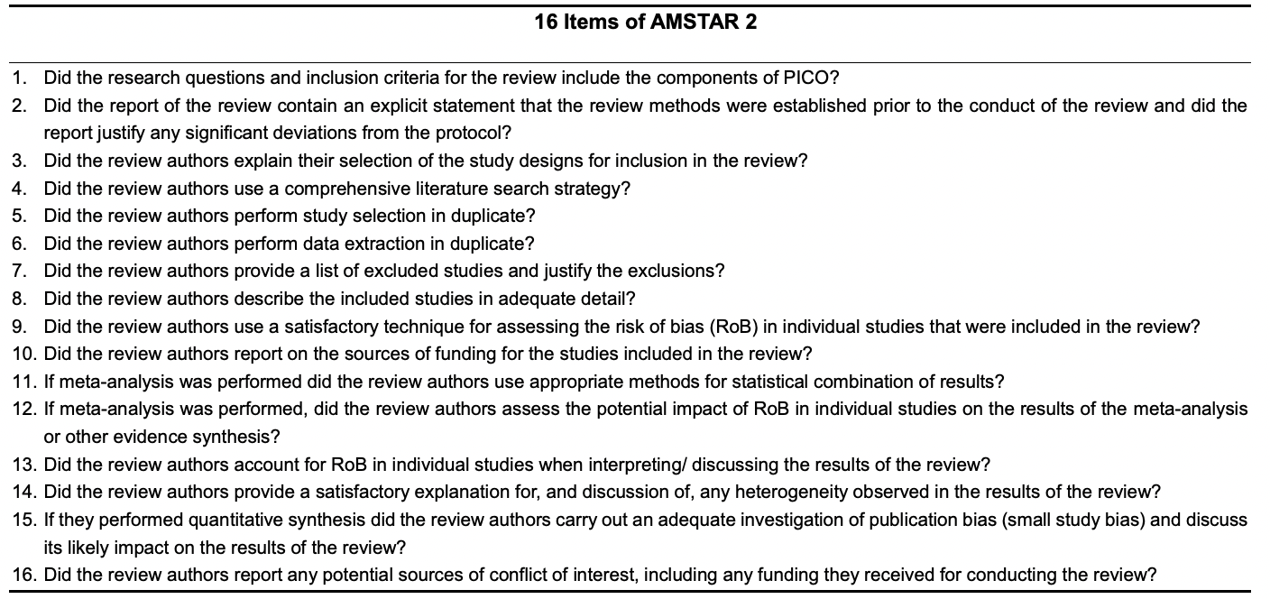

High quality | No or one non-critical weakness, i.e. provides an accurate and comprehensive summary of the results of the available studies that address the question of interest
Moderate quality | More than one non-critical weakness, but no critical flaws, i.e. may provide an accurate summary of the results of the available studies that were included in the review
Low quality | One critical flaw with or without non-critical weaknesses, i.e. may not provide an accurate and comprehensive summary of the available studies that address the question of interest
Critically low quality | More than one critical flaw with or without non-critical weaknesses, i.e. should not be relied on to provide an accurate and comprehensive summary of the available studies

Supplementary Figure S2: Results of Overlap analysis of included observational SRs (n=23)

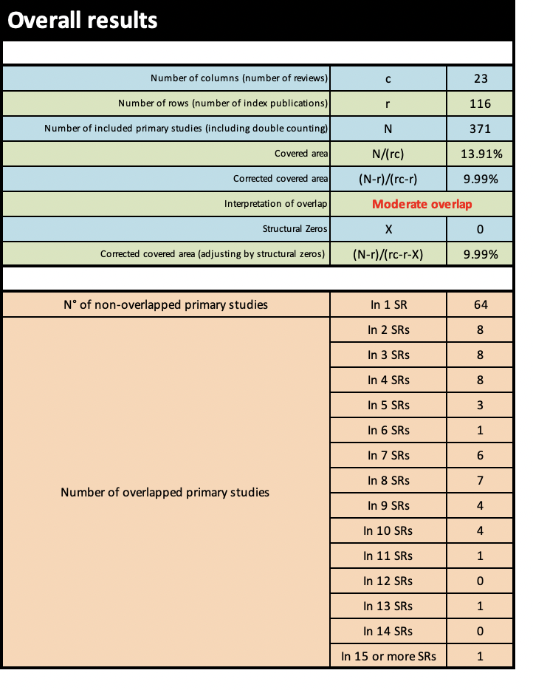
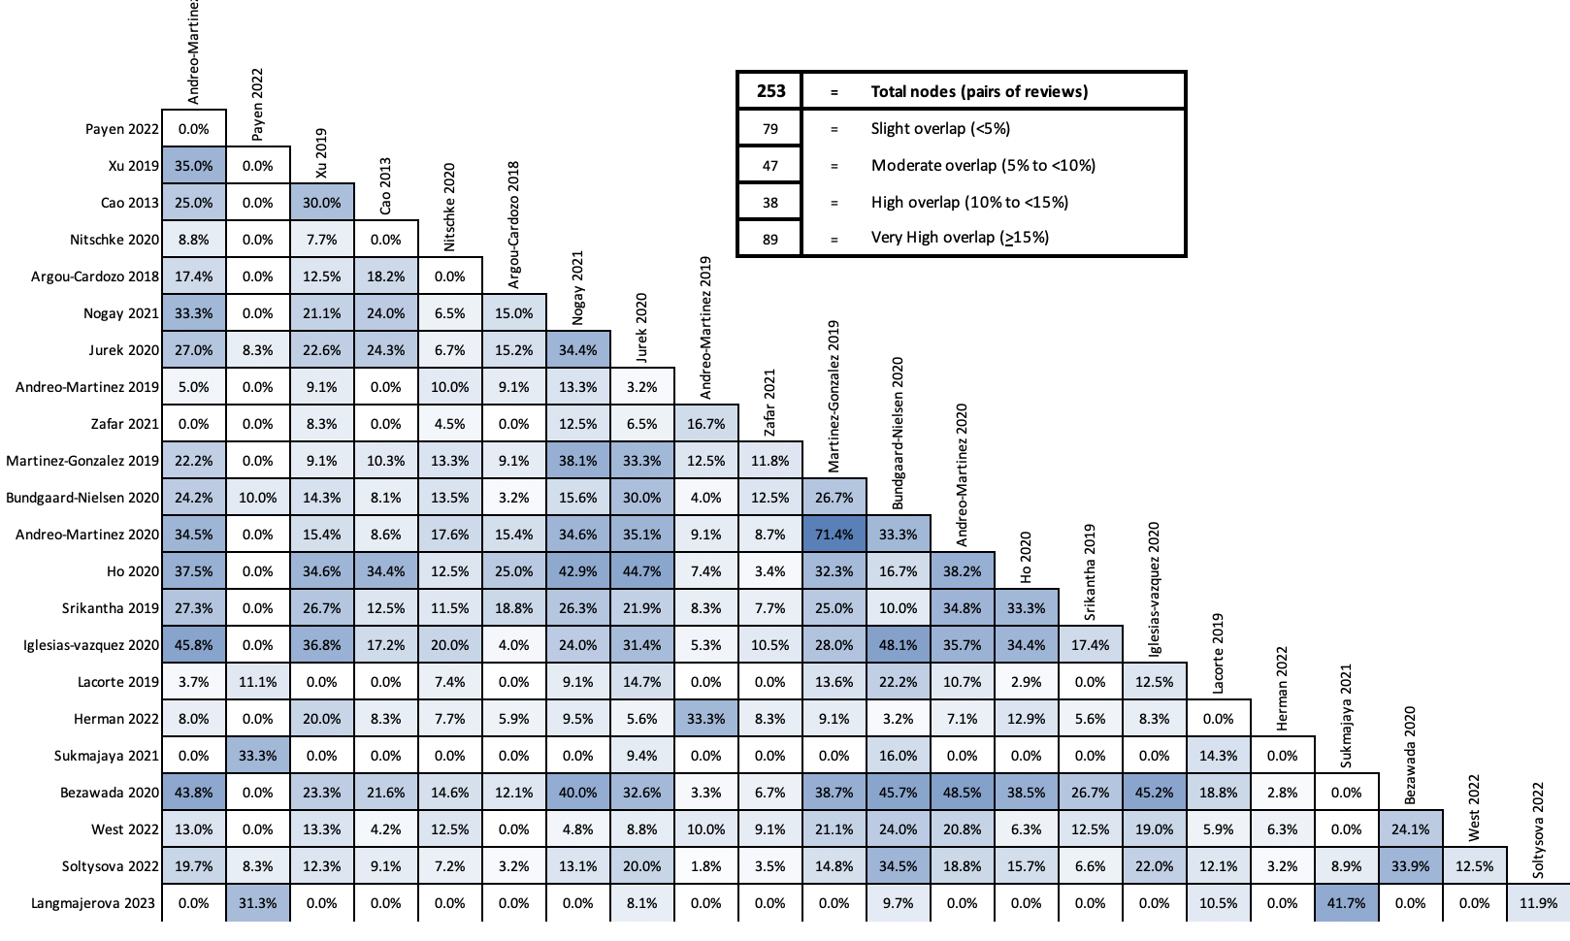

Supplementary Figure S3: Results of Overlap Optimization analysis of Observational SRs (n=10)

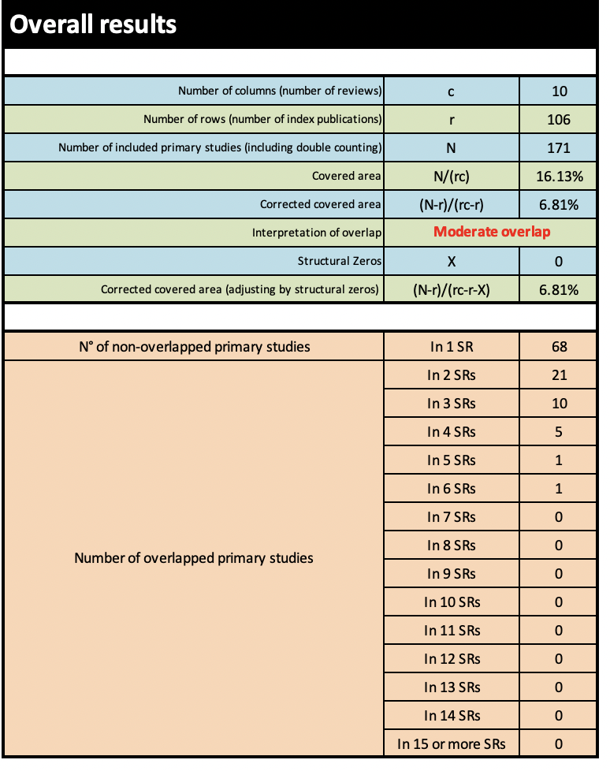

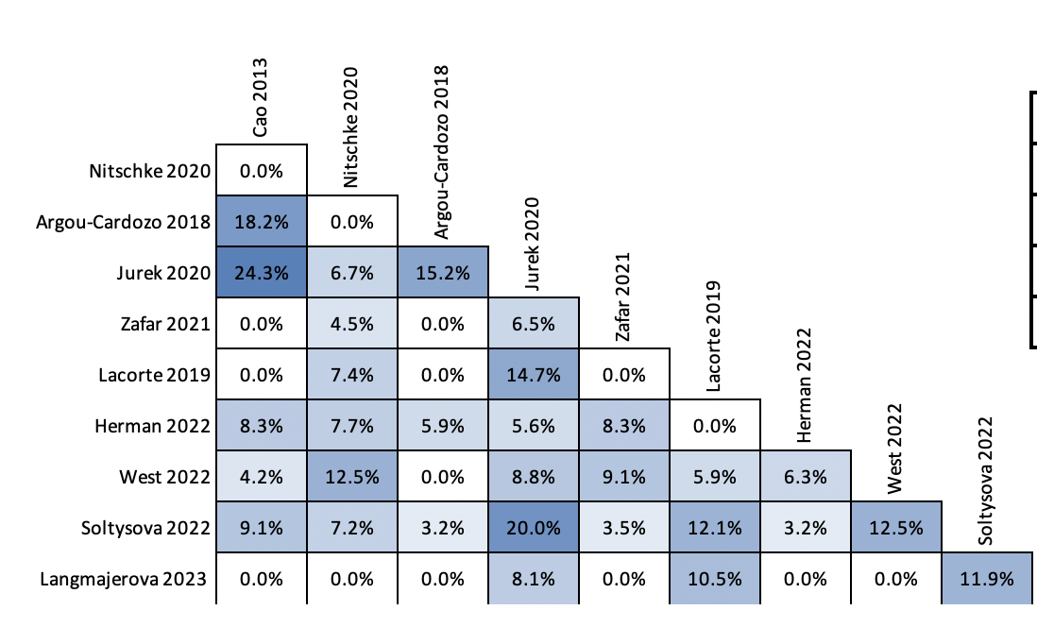

Supplementary Figure S4: Results of Overlap analysis of included interventional SRs (n=16)
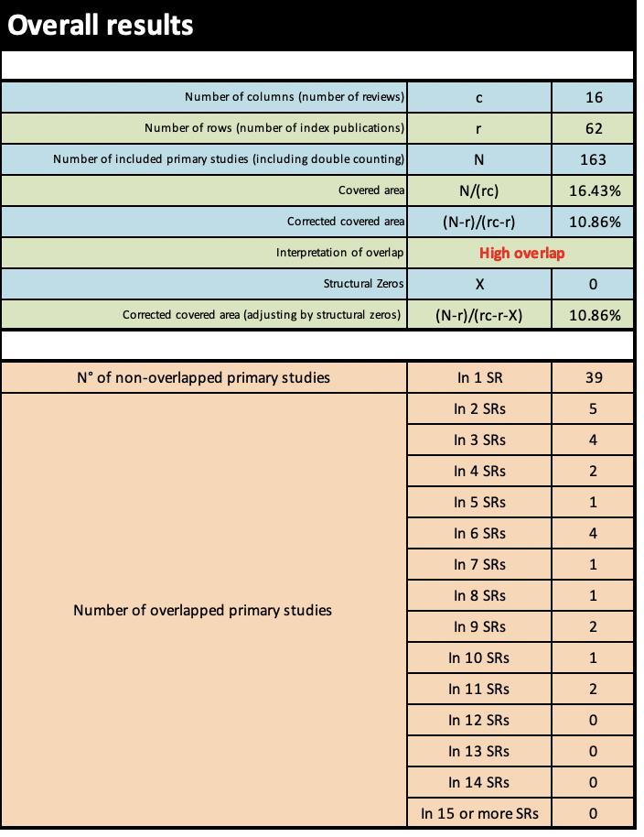
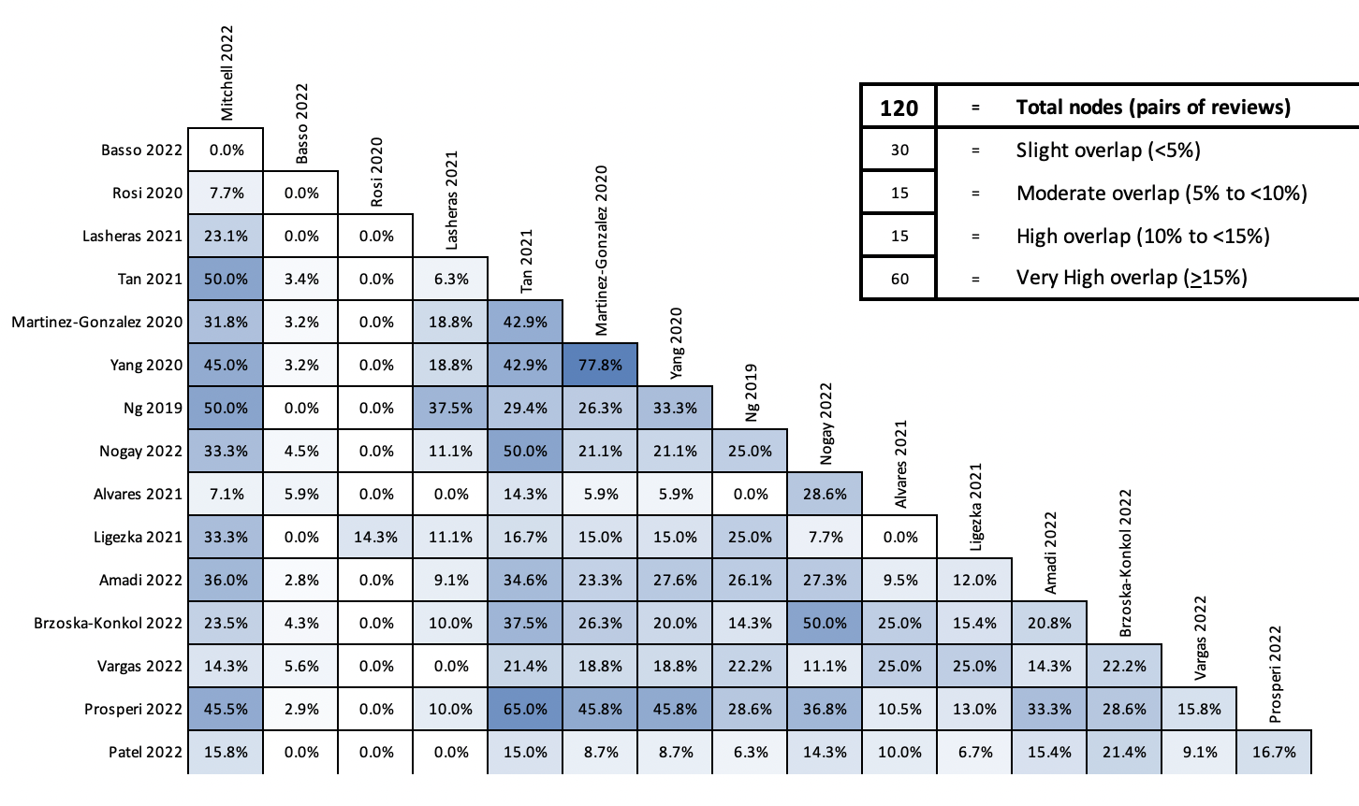

Supplementary Figure S5: Results of Overlap Optimization analysis of included interventional SRs (n=7)

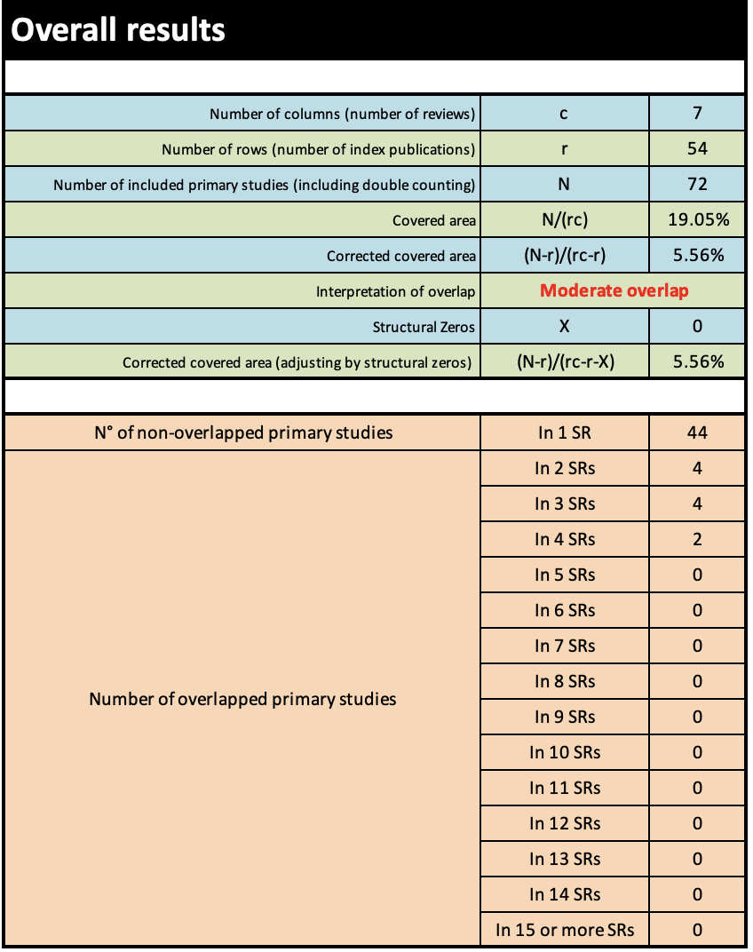

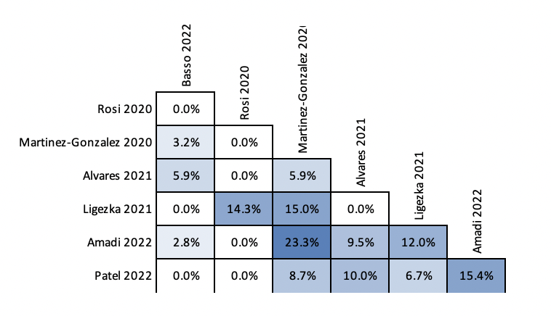

References
1. Andreo-Martinez P, Garcia-Martinez N, Quesada-Medina J, Sanchez-Samper EP, Martinez-Gonzalez AE. [Candida spp. in the gut microbiota of people with autism: a systematic review]. Candida spp en la microbiota intestinal de las personas con autismo: revision sistematica. 2019;68(1):1-6.
2. Andreo-Martinez P, Garcia-Martinez N, Sanchez-Samper EP, Martinez-Gonzalez AE. An approach to gut microbiota profile in children with autism spectrum disorder. Environmental microbiology reports. 2020;12(2):115-135.
3. Andreo-Martinez P, Rubio-Aparicio M, Sanchez-Meca J, Veas A, Martinez-Gonzalez AE. A Meta-analysis of Gut Microbiota in Children with Autism. Journal of autism and developmental disorders. 2022;52(3):1374-1387.
4. Argou-Cardozo I, Zeidan-Chulia F. Clostridium Bacteria and Autism Spectrum Conditions: A Systematic Review and Hypothetical Contribution of Environmental Glyphosate Levels. Medical sciences (Basel, Switzerland). 2018;6(2).
5. Bezawada N, Phang TH, Hold G, Hansen R. Autism spectrum disorder and the gut microbiota in children: A systematic review. Journal of Pediatric Gastroenterology and Nutrition. 2019;68(Supplement 1):329.
6. Bundgaard-Nielsen C, Knudsen J, Leutscher PDC, et al. Gut microbiota profiles of autism spectrum disorder and attention deficit/hyperactivity disorder: A systematic literature review. Gut microbes. 2020;11(5):1172-1187.
7. Cao X, Lin P, Jiang P, Li C. Characteristics of the gastrointestinal microbiome in children with autism spectrum disorder: a systematic review. Shanghai archives of psychiatry. 2013;25(6):342-353.
8. Herman A, Herman AP. Could Candida Overgrowth Be Involved in the Pathophysiology of Autism? Journal of clinical medicine. 2022;11(2).
9. Ho LKH, Tong VJW, Syn N, et al. Gut microbiota changes in children with autism spectrum disorder: a systematic review. Gut pathogens. 2020;12:6.
10. Iglesias-vazquez L, Riba GVG, Arija V, Canals J. Composition of gut microbiota in children with autism spectrum disorder: A systematic review and meta-analysis. Nutrients. 2020;12(3):792.
11. Jurek L, Sevil M, Jay A, et al. Is there a dysbiosis in individuals with a neurodevelopmental disorder compared to controls over the course of development? A systematic review. European Child & Adolescent Psychiatry. 2020:No-Specified.
12. Basso M, Johnstone N, Knytl P, Nauta A, Groeneveld A, Cohen Kadosh K. A Systematic Review of Psychobiotic Interventions in Children and Adolescents to Enhance Cognitive Functioning and Emotional Behavior. Nutrients. 2022;14(3).
13. Lacorte E, Gervasi G, Bacigalupo I, Vanacore N, Raucci U, Parisi P. A Systematic Review of the Microbiome in Children With Neurodevelopmental Disorders. Frontiers in neurology. 2019;10:727.
14. Langmajerova M, Roubalova R, Sebela A, Vevera J. The effect of microbiome composition on impulsive and violent behavior: A systematic review. Behav Brain Res. 2023;440:114266.
15. Martinez-Gonzalez AE, Andreo-Martinez P. The Role of Gut Microbiota in Gastrointestinal Symptoms of Children with ASD. Medicina (Kaunas, Lithuania). 2019;55(8).
16. Nitschke A, Deonandan R, Konkle AT. The link between autism spectrum disorder and gut microbiota: A scoping review. Autism : the international journal of research and practice. 2020;24(6):1328-1344.
17. Nogay NH, Nahikian-Nelms M. Can we reduce autism-related gastrointestinal and behavior problems by gut microbiota based dietary modulation? A review. Nutritional neuroscience. 2021;24(5):327-338.
18. Payen A, Chen MJ, Carter TG, Kilmer RP, Bennett JM. Childhood ADHD, Going Beyond the Brain: A Meta-Analysis on Peripheral Physiological Markers of the Heart and the Gut. Frontiers in endocrinology. 2022;13:738065.
19. Soltysova M, Tomova A, Ostatnikova D. Gut Microbiota Profiles in Children and Adolescents with Psychiatric Disorders. Microorganisms. 2022;10(10).
20. Srikantha P, Hasan Mohajeri M. The possible role of the microbiota-gut-brain-axis in autism spectrum disorder. International Journal of Molecular Sciences. 2019;20(9):2115.
21. Sukmajaya AC, Lusida MI, Soetjipto, Setiawati Y. Systematic review of gut microbiota and attention-deficit hyperactivity disorder (ADHD). Annals of general psychiatry. 2021;20(1):12.
22. West KA, Yin X, Rutherford EM, et al. Multi-angle meta-analysis of the gut microbiome in Autism Spectrum Disorder: a step toward understanding patient subgroups. Sci Rep. 2022;12(1):17034.
23. Xu M, Xu X, Li J, Li F. Association Between Gut Microbiota and Autism Spectrum Disorder: A Systematic Review and Meta-Analysis. Frontiers in psychiatry. 2019;10:473.
24. Zafar U, Habib H. The Link Between Autism Spectrum Disorder And Gastrointestinal Microbiota. Journal of Ayub Medical College, Abbottabad : JAMC. 2021;33(3):513-518.
25. Alvares MA, Serra MJR, Delgado I, et al. Use of probiotics in pediatric patients with autism spectrum disorder: a systematic review. Revista da Associacao Medica Brasileira (1992). 2021;67(10):1503-1507.
26. Amadi CN, Orish CN, Frazzoli C, Orisakwe OE. Dietary interventions for autism spectrum disorder: An updated systematic review of human studies. Psychiatriki. 2022;33(3):228-242.
27. Lasheras I, Gracia-Garcia P, Santabarbara J. Modulation of gut microbiota in autism spectrum disorders: a systematic review. European Journal of Psychiatry. 2021;35(2):107-121.
28. Ligezka AN, Sonmez AI, Corral-Frias MP, et al. A systematic review of microbiome changes and impact of probiotic supplementation in children and adolescents with neuropsychiatric disorders. Progress in neuro-psychopharmacology & biological psychiatry. 2021;108:110187.
29. Martinez-Gonzalez AE, Andreo-Martinez P. Prebiotics, probiotics and fecal microbiota transplantation in autism: A systematic review. Prebioticos, probioticos y trasplante de microbiota fecal en el autismo: una revision sistematica. 2020;13(3):150-164.
30. Mitchell LK, Davies PSW. Pre- and probiotics in the management of children with autism and gut issues: a review of the current evidence. Eur J Clin Nutr. 2022;76(7):913-921.
31. Ng QX, Loke W, Venkatanarayanan N, Lim DY, Soh AYS, Yeo WS. A Systematic Review of the Role of Prebiotics and Probiotics in Autism Spectrum Disorders. Medicina (Kaunas, Lithuania). 2019;55(5).
32. Nogay NH, Nahikian-Nelms M. Effects of nutritional interventions in children and adolescents with autism spectrum disorder: an overview based on literature review. International Journal of Developmental Disabilities. 2022.
33. Patel M, Atluri LM, Gonzalez NA, et al. A Systematic Review of Mixed Studies Exploring the Effects of Probiotics on Gut-Microbiome to Modulate Therapy in Children With Autism Spectrum Disorder. Cureus. 2022;14(12):e32313.
34. Prosperi M, Santocchi E, Guiducci L, et al. Interventions on Microbiota: Where Do We Stand on a Gut-Brain Link in Autism? A Systematic Review. Nutrients. 2022;14(3).
35. Rosi E, Grazioli S, Villa FM, et al. Use of Non-Pharmacological Supplementations in Children and Adolescents with Attention Deficit/Hyperactivity Disorder: A Critical Review. Nutrients. 2020;12(6).
36. Tan Q, Orsso CE, Deehan EC, et al. Probiotics, prebiotics, synbiotics, and fecal microbiota transplantation in the treatment of behavioral symptoms of autism spectrum disorder: A systematic review. Autism Research. 2021;14(9):1820-1836.
37. Yang J, Fu X, Liao X, Li Y. Effects of gut microbial-based treatments on gut microbiota, behavioral symptoms, and gastrointestinal symptoms in children with autism spectrum disorder: A systematic review. Psychiatry research. 2020;293:113471.
38. Brzóska-Konkol E, Remberk B, Papasz-Siemienuk A. Analysis of research on the effectiveness of using probiotics for children with autism spectrum disorders, in order to reduce the core and accompanying autism symptoms. Review of randomized clinical trials. Postępy Psychiatrii i Neurologii. 2022;31(1):25-34.
39. Diaz Vargas D, Leonario Rodriguez M. Effectiveness of nutritional interventions on behavioral symptomatology of autism spectrum disorder: a systematic review. Nutr Hosp. 2022;39(6):1378-1388.
40. Biasucci G, Rubini M, Riboni S, Morelli L, Bessi E, Retetangos C. Mode of delivery affects the bacterial community in the newborn gut. Early Human Development. 2010;86(1, Supplement):13-15.
41. Alvares MA, Serra MJR, Delgado I, et al. Use of probiotics in pediatric patients with autism spectrum disorder: a systematic review. Rev Assoc Med Bras (1992). 2021;67(10):1503-1507.
42. Bezawada N, Phang TH, Hold GL, Hansen R. Autism Spectrum Disorder and the Gut Microbiota in Children: A Systematic Review. Annals of nutrition & metabolism. 2020;76(1):16-29.

