# 11 Supplementary Material

## 11.1 NIOSH calculation sheet

The calculation sheet used to assess the ergonomic risk is shown in Figure 10.

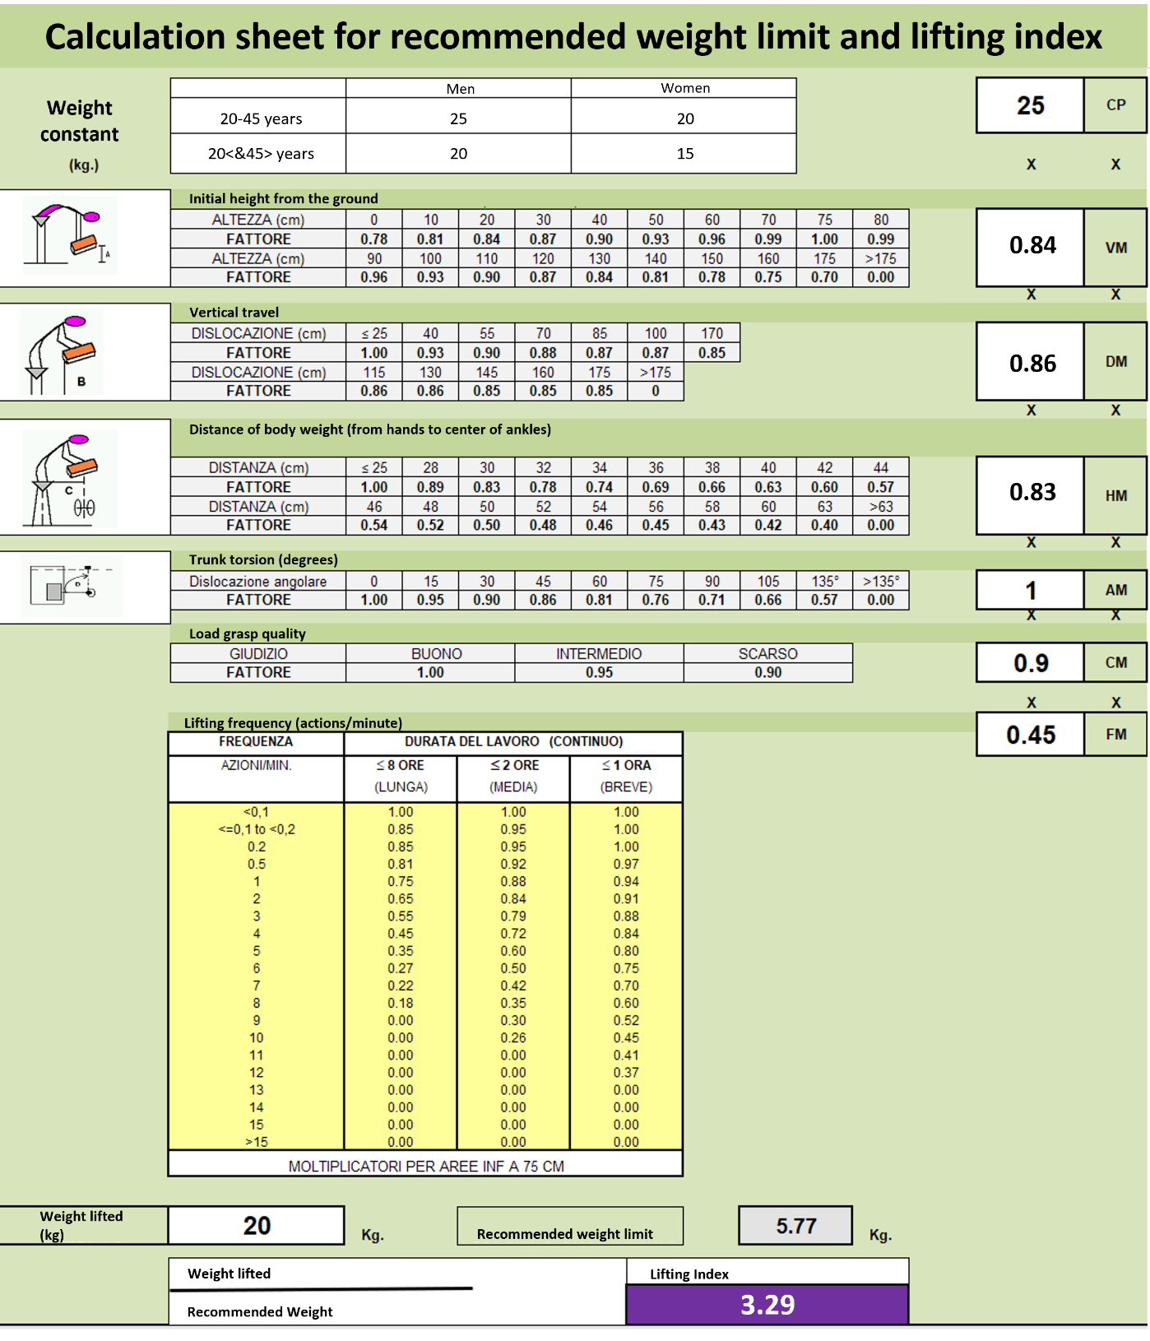

*Figure 10. Calculation sheet for the evaluation of the recommended weight limit and the Lifting Index (Colombini and Occhipinti 2020).*

## 11.2 Questionnaire for the Perceived Effort assessment

The perceived effort assessment relies on the questionnaire in Table 1. The Borg exertion rating scale is based on five verbal anchors (1-low, 2-normal, 3-moderate, 4-high, and 5-very high.

*Table 1. Questionnaire used in phase-3 to record the perceived effort from workers, and the execution time per each working cycle (repetition).*

|  |  |  |  |  |  |  |  |  |  |  |  |  |  |  |  |  |  |  |  |  |  |  |  |  |  |
| --- | --- | --- | --- | --- | --- | --- | --- | --- | --- | --- | --- | --- | --- | --- | --- | --- | --- | --- | --- | --- | --- | --- | --- | --- | --- |
| **Repetition #** |  |  |  |  |  |  |  |  |  |  |  |  |  |  |  |  |  |  |  |  |  |  |  |  |  |
| **Repetition Initial time** |  |  |  |  |  |  |  |  |  |  |  |  |  |  |  |  |  |  |  |  |  |  |  |  |  |
| **Repetition end time** |  |  |  |  |  |  |  |  |  |  |  |  |  |  |  |  |  |  |  |  |  |  |  |  |  |
| **Perceived effort** |  |  |  |  |  |  |  |  |  |  |  |  |  |  |  |  |  |  |  |  |  |  |  |  |  |

## 11.3 Questionnaire used for the Qualitative assessment

The following list defines the constructs of the qualitative assessment:

1. Assistance: physical assistance is delivered by the exoskeleton. Subjective perceptions are those connected with perceived effort reduction, freedom of movement and expectations on the level and timing of physical assistance.
2. Comfort: physical comfort considering perceived pressure, friction, and thermal comfort (e.g. sweating or cold).
3. Stability: how well the exoskeleton conforms to the body. This category is separated from comfort to underline its importance as feedback to the designers.
4. Usability: measurements of user perceptions on how intuitive the exoskeleton is to operate and easy to wear.
5. Acceptance: level of satisfaction and positivity with respect to use of the device. This more general construct measures the sum of the exoskeleton's perceived relevance to the working task and its usefulness.

*Table 2. List of categories of the questionnaire. Each line reports the questions, and the code represented in* *Fig. 8.*

|  |  |  |
| --- | --- | --- |
| ASSISTANCE | **A1** | **I feel less fatigue while using the exoskeleton** |
| A2 | I feel less strain on my back muscles |
| A3 | I feel that the exoskeleton follows my movements |
| A4 | I don’t feel my trunk movements are constrained |
| A5 | I don’t feel my legs movements are constrained |
| A6 | I feel the assistance level fits my needs. |
| COMFORT | C1 | I feel that the exoskeleton's weight is fine |
| C2 | I feel that the exoskeleton's weight distribution suits me well |
| C3 | I feel that the harness is too tight |
| C4 | I don't feel pressure on my chest |
| C5 | I don't feel pressure on my waist |
| C6 | I don't feel pressure on my thighs |
| C7 | I feel that thermal dissipation is adequate |
| C8 | I don't feel more than usual sweating on my back |
| C9 | I don't feel more than usual sweating on my thighs |
| STABILITY | S1 | I feel the exoskeleton securely attaches to my body |
| S2 | I feel the belt is securely attached to my waist |
| S3 | I feel the leg wraps are securely attached to my thighs |
| USABILITY | U1 | The harness is easy and intuitive to don |
| U2 | The harness is easy to regulate and open to doff |
| U3 | I feel confident wearing the exoskeleton on my own |
| U4 | The exoskeleton is easy to turn on and off |
| U5 | The exoskeleton is easy and intuitive to operate |
| ACCEPTANCE | AC1 | The exoskeleton meets my expectations |
| AC2 | I think that the exoskeleton is suited for my tasks |
| AC3 | I don't feel hindered by the exoskeleton during my tasks |
| AC4 | I would use the exoskeleton on a regular basis if it was available on the market |
| AC5 | I feel that the exoskeleton is robust and suited for my work environment |
| AC6 | I think that I would use the exoskeleton the whole working day |
| AC7 | I think that I would use the exoskeleton for all my working tasks |
| AC8 | Please, give a total score to the exoskeleton' s performance |