Combining soft robotics and telerehabilitation for improving motor function after stroke

Proietti T.¹*, Nuckols K.¹*, Grupper J.¹, Schwarz D.¹, Inirio B.¹, Porazinski K.², Wagner D.¹, Cole T.¹, Glover C.¹, Mendelowitz S.¹, Herman M.¹, Breen J.², Lin D.^{3,4}, Walsh C.^{1†}

SUPPLEMENTARY MATERIAL

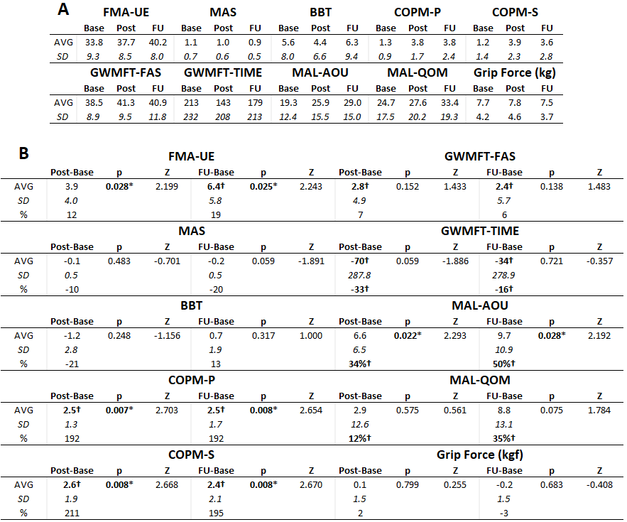

Table 1: Clinical assessments at baseline, post-intervention (after 4 weeks of home therapy), and follow up (2 weeks after post-intervention, 6 weeks from baseline). A) Average and standard deviation, absolute values. B) Average, standard deviation, and percentage, values relative to baseline. * asterisk indicates statistical significance after Wilcoxon signed-rank test (p-value < 0.05). ✝ dagger indicates results over the MCID (FMA = 5.25 [Page2012], MAS = 0.48 [Chen2019], BBT = 5.5 [Chen2009], COPM = 2 [Tuntland2016], GWMFT-FAS = 1 / 17% [Lang2008], GWMFT-TIME = 19s / 16% [Lang2008], MAL = 10% [Hung2022], Grip Force = 5kg [Lang2008]).

