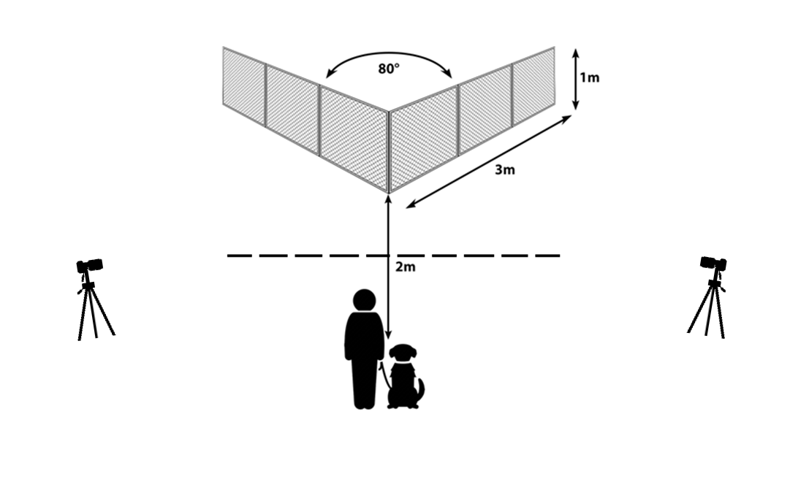
Supplementary Figure S1: The experimental setup of the original tests (Dobos and Pongrácz, 2023, 2024). The owner and the dog are positioned at the starting point. Dogs had to detour the transparent wire-mesh fence to reach the reward, which was placed into the inner corner of the V-shaped fence.

