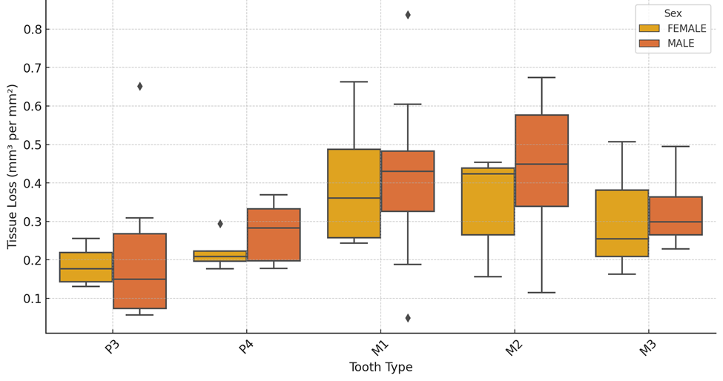
Supplementary Figure S1. Box-and-whisker plots showing tissue loss by tooth type, separated by sex.

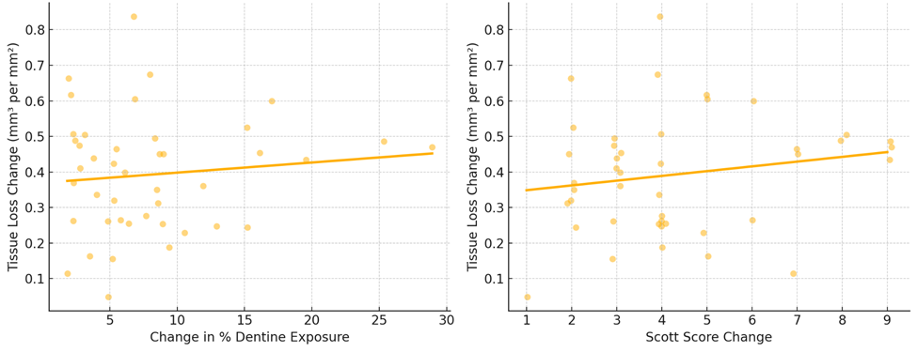
Supplementary Figure S2. Scatter plots illustrating the relationships between change in percent of dentine exposure (PDE) and Krueger-Scott score (KSM change, with tissue loss change (mm³ per mm²). Trend lines indicate weak relationships between PDE and tissue loss, and a slightly better correlation between KSM and tissue loss.

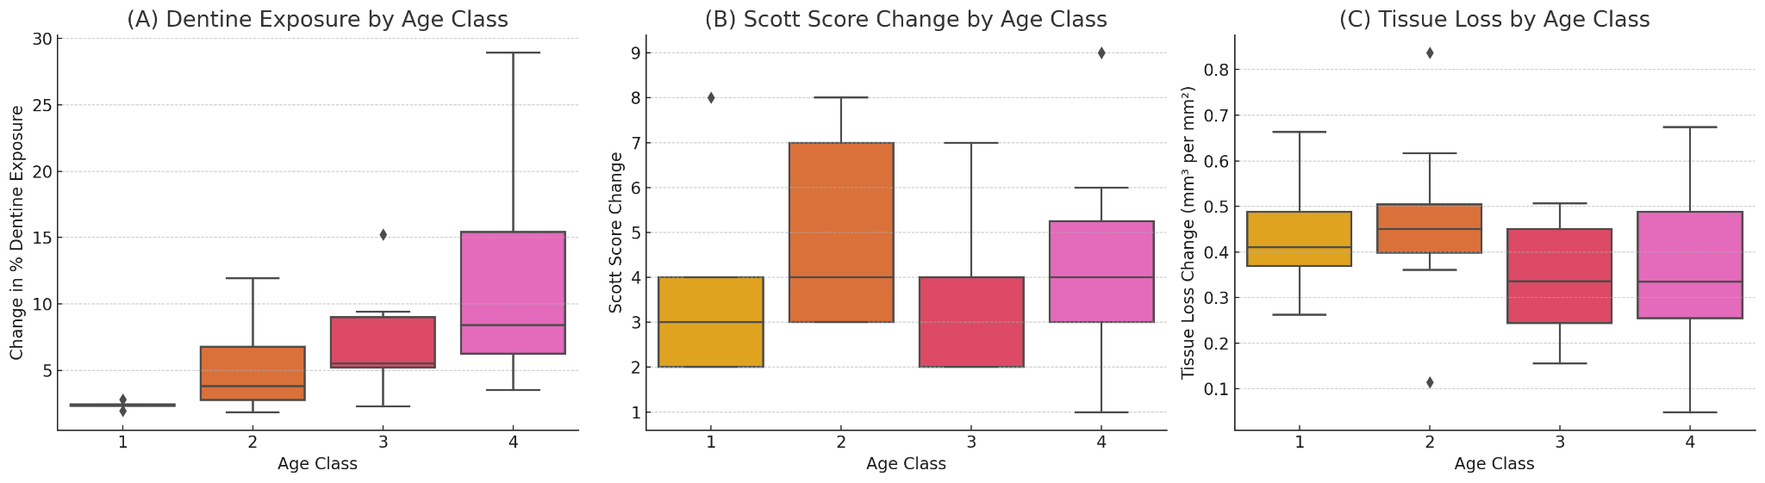
Supplementary Figure S3. Boxplots illustrating the distribution of change in percent of dentine exposure (PDE; A), Krueger-Scott score (KSM) change (B), and Tissue loss change (C) across the four age classes. PDE shows a clear increasing trend with age, while KSM change and tissue loss change remain relatively stable.

