Supplementary materials

Supplementary Tables S1-S4. Fully parameterized model for the various house features included in this study.
Supplementary Tables S5-S8. AICc-weighted model averages for the various house features included in this study.
Supplementary Figures S1-S4. Moran’s I autocorrelograms of the residuals for each category of a vernacular house feature as computed from the fully parameterized model

Supplementary Table S1. Fully parameterized model of ground plan in vernacular houses (significant predictors have been highlighted in boldface type).
Call:
mblogit(formula = HouseShape ~ Neighbor + Polygyny + Mobility + XericHarshness + MountainDwelling + PolComplexity * TemperatureHarshness, data = HouseShape,
random = ~1 | LangFamily, method = "MQL", control = mmclogit.control(maxit = 30))
Equation for rounded vs angular edges:
 | Estimate | SE | z-value | Pr(>|z|)
(Intercept) | 0.13056 | 0.4184 | 0.312 | 0.755
Neighbor | 0.20172 | 0.28511 | 0.708 | 0.479252
PolygynyFrequent | 0.94302 | 0.26401 | 3.572 | 0.000354
PolygynyLimited | 0.55523 | 0.24343 | 2.281 | 0.022556
MobilitySedentary | -1.16322 | 0.22955 | -5.068 | 4.03E-07
PolComplexity | -0.15718 | 0.08327 | -1.888 | 0.059078
TemperatureHarshness | 0.25794 | 0.22137 | 1.165 | 0.243935
XericHarshness | 0.29098 | 0.09612 | 3.027 | 0.002468
MountainDwelling | 0.19945 | 0.08203 | 2.431 | 0.015045
PolComplexity:TemperatureHarshness | -0.2293 | 0.08739 | -2.624 | 0.008692

Supplementary Table S2. Fully parameterized model of floor level in vernacular houses (significant predictors have been highlighted in boldface type)
Call:
mblogit(formula = HouseLevel ~ Neighbor + Polygyny + Mobility +
PolComplexity * TemperatureHarshness + XericHarshness + MountainDwelling,
data = HouseLevel, random = ~1 | LangFamily, method = "MQL",
control = mmclogit.control(maxit = 30))
Equation for Level vs Elevated:
 | Estimate | SE | z-value | Pr(>|z|)
(Intercept) | 1.58769 | 0.96285 | 1.649 | 0.099159
Neighbor | 4.46721 | 0.46494 | 9.608 | < 2.00E-16
PolygynyFrequent | 0.33189 | 0.40883 | 0.812 | 0.416898
PolygynyLimited | -0.3205 | 0.33727 | -0.950 | 0.34197
MobilitySedentary | -2.7327 | 0.88873 | -3.075 | 2.11E-03
PolComplexity | -0.10876 | 0.12228 | -0.889 | 0.373782
TemperatureHarshness | 1.35742 | 0.37355 | 3.634 | 0.000279
XericHarshness | 0.30573 | 0.15359 | 1.990 | 0.046537
MountainDwelling | -0.06674 | 0.1198 | -0.557 | 0.577466
PolComplexity:TemperatureHarshness | -0.24884 | 0.1123 | -2.216 | 0.026707
Equation for Subterranean vs Elevated:
 | Estimate | SE | z-value | Pr(>|z|)
(Intercept) | 2.5028 | 1.1458 | 2.184 | 0.028931
Neighbor | -1.5645 | 0.6534 | -2.395 | 0.016643
PolygynyFrequent | 2.0207 | 0.6751 | 2.993 | 0.002763
PolygynyLimited | 1.2117 | 0.6100 | 1.986 | 0.046981
MobilitySedentary | -1.9648 | 0.9201 | -2.135 | 0.032731
PolComplexity | -1.3296 | 0.3583 | -3.711 | 0.000207
TemperatureHarshness | 1.473 | 0.4651 | 3.167 | 0.001539
XericHarshness | 1.033 | 0.2472 | 4.178 | 2.94E-05
MountainDwelling | 0.5712 | 0.2002 | 2.854 | 0.004321
PolComplexity:TemperatureHarshness | 0.2712 | 0.2112 | 1.284 | 0.199002

Supplementary Table S3. Fully parameterized model of wall materials in vernacular houses (significant predictors have been highlighted in boldface type)
Call:
mblogit(formula = WallMat ~ Neighbor + Polygyny + Mobility +
PolComplexity * TemperatureHarshness + XericHarshness + MountainDwelling,
data = WallMat, random = ~1 | LangFamily, method = "MQL",
control = mmclogit.control(maxit = 30))
Equation for Stone/Brick/Daub/Adobe vs Hanged fabrics/Skins/Mats/Open:
 | Estimate | SE | z-value | Pr(>|z|)
(Intercept) | -3.11696 | 0.51415 | -6.062 | 1.34E-09
Neighbor | 4.89979 | 0.47438 | 10.329 | < 2.00E-16
PolygynyFrequent | 0.05455 | 0.39116 | 0.139 | 0.88909
PolygynyLimited | 0.01964 | 0.36648 | 0.054 | 9.57E-01
MobilitySedentary | 2.50651 | 0.35383 | 7.084 | 1.40E-12
PolComplexity | -0.19729 | 0.12231 | -1.613 | 0.10674
TemperatureHarshness | 0.44436 | 0.26355 | 1.686 | 0.09179
XericHarshness | 0.22722 | 0.13977 | 1.626 | 0.10402
MountainDwelling | 0.32845 | 0.12479 | 2.632 | 0.00849
PolComplexity:TemperatureHarshness | -0.12021 | 0.1074 | -1.119 | 0.26305
Equation for Thatch vs Hanged fabrics/Skins/Mats/Open:
 | Estimate | SE | z-value | Pr(>|z|)
(Intercept) | -0.62342 | 0.44552 | -1.399 | 0.1617
Neighbor | 2.6983 | 0.45444 | 5.938 | 2.89E-09
PolygynyFrequent | 0.18365 | 0.36943 | 0.497 | 0.6191
PolygynyLimited | 0.22021 | 0.35215 | 0.625 | 0.5318
MobilitySedentary | 0.43541 | 0.31353 | 1.389 | 0.1649
PolComplexity | -0.2479 | 0.12487 | -1.985 | 0.0471
TemperatureHarshness | -0.2874 | 0.25794 | -1.114 | 0.2652
XericHarshness | -0.03923 | 0.13191 | -0.297 | 0.7662
MountainDwelling | 0.12878 | 0.12036 | 1.07 | 0.2846
PolComplexity:TemperatureHarshness | -0.07507 | 0.1195 | -0.628 | 0.5299
Equation for Wood/Bamboo/Bark vs Hanged fabrics/Skins/Mats/Open:
 | Estimate | SE | z-value | Pr(>|z|)
(Intercept) | -2.13869 | 0.53443 | -4.002 | 6.29E-05
Neighbor | 3.82351 | 0.468 | 8.17 | 3.09E-16
PolygynyFrequent | 0.08216 | 0.39559 | 0.208 | 0.83547
PolygynyLimited | 0.16692 | 0.37036 | 0.451 | 0.65222
MobilitySedentary | 2.42457 | 0.36691 | 6.608 | 3.89E-11
PolComplexity | -0.38775 | 0.12651 | -3.065 | 0.00218
TemperatureHarshness | -0.08644 | 0.27599 | -0.313 | 0.75412
XericHarshness | -0.26538 | 0.14476 | -1.833 | 0.06676
MountainDwelling | 0.23431 | 0.1261 | 1.858 | 0.06315
PolComplexity:TemperatureHarshness | 0.12081 | 0.10992 | 1.099 | 0.27173

Supplementary Table S4. Fully parameterized model of roof shape in vernacular houses (significant predictors have been highlighted in boldface type)
Call:
mblogit(formula = RoofShape ~ Neighbor + Polygyny + Mobility +
PolComplexity * TemperatureHarshness + XericHarshness + MountainDwelling,
data = RoofShape, random = ~1 | LangFamily, method = "MQL",
control = mmclogit.control(maxit = 100))
Equation for Rounded dome vs Flat:
 | Estimate | SE | z-value | Pr(>|z|)
(Intercept) | 1.88178 | 1.0063 | 1.87 | 0.06148
Neighbor | 3.20459 | 0.67316 | 4.761 | 1.93E-06
PolygynyFrequent | 1.11173 | 0.63682 | 1.746 | 0.08085
PolygynyLimited | 0.83477 | 0.58035 | 1.438 | 0.15032
MobilitySedentary | -3.30191 | 0.69632 | -4.742 | 2.12E-06
PolComplexity | -0.07341 | 0.18837 | -0.39 | 0.69674
TemperatureHarshness | 0.73463 | 0.55364 | 1.327 | 0.18454
XericHarshness | -0.68883 | 0.23293 | -2.957 | 0.0031
MountainDwelling | 0.02883 | 0.20138 | 0.143 | 0.88616
PolComplexity:TemperatureHarshness | -0.54647 | 0.2059 | -2.654 | 0.00795
Equation for Sloped vs Flat:
 | Estimate | SE | z-value | Pr(>|z|)
(Intercept) | 3.8311 | 1.049 | 3.652 | 0.00026
Neighbor | 1.0743 | 0.6267 | 1.714 | 0.086485
PolygynyFrequent | -0.3181 | 0.6137 | -0.518 | 0.604266
PolygynyLimited | -0.2848 | 0.5495 | -0.518 | 0.60419
MobilitySedentary | -2.5967 | 0.7156 | -3.629 | 0.000285
PolComplexity | 0.142 | 0.1827 | 0.777 | 0.436965
TemperatureHarshness | -0.6925 | 0.5508 | -1.257 | 0.208636
XericHarshness | -1.4957 | 0.2392 | -6.254 | 4.00E-10
MountainDwelling | -0.5072 | 0.2027 | -2.502 | 0.012354
PolComplexity:TemperatureHarshness | -0.1966 | 0.1796 | -1.095 | 0.273718

Supplementary Table S5. AICc-weighted model average of ground plan in vernacular houses
Equation for rounded vs angular edges:
 | Estimate | Lower C.I. | Upper C.I. | R.V.I.
(Intercept) | -0.169 | -0.767 | 0.429 | 1.000
Neighbor | 0.022 | -0.123 | 0.167 | 0.270
PolygynyFrequent | 2.235 | 1.737 | 2.733 | 1.000
PolygynyLimited | 1.187 | 0.693 | 1.681 | 1.000
MobilitySedentary | -1.374 | -1.786 | -0.962 | 1.000
PolComplexity | -0.241 | -0.386 | -0.096 | 0.990
TemperatureHarshness | 0.468 | 0.170 | 0.766 | 0.980
XericHarshness | 0.407 | 0.258 | 0.556 | 0.940
MountainDwelling | 0.185 | 0.054 | 0.316 | 1.000
PolComplexity:TemperatureHarshness | -0.265 | -0.422 | -0.108 | 0.000

Supplementary Table S6. AICc-weighted model average of floor level in vernacular houses
Equation for Level vs Elevated:
 | Estimate | Lower C.I. | Upper C.I. | R.V.I.
(Intercept) | 1.263 | -0.469 | 2.996 | 1.000
Neighbor | 5.170 | 4.309 | 6.031 | 1.000
PolygynyFrequent | 1.274 | 0.575 | 1.972 | 1.000
PolygynyLimited | -0.194 | -0.807 | 0.419 | 1.000
MobilitySedentary | -2.852 | -4.523 | -1.180 | 1.000
PolComplexity | -0.225 | -0.441 | -0.010 | 1.000
TemperatureHarshness | 1.579 | 0.925 | 2.233 | 1.000
XericHarshness | 0.188 | -0.075 | 0.450 | 1.000
MountainDwelling | -0.166 | -0.379 | 0.047 | 1.000
PolComplexity:TemperatureHarshness | -0.291 | -0.478 | -0.105 | 1.000
Equation for Subterranean vs Elevated:
 | Estimate | Lower C.I. | Upper C.I. | R.V.I.
(Intercept) | 1.685 | -0.571 | 3.941 | 1.000
Neighbor | -1.258 | -2.610 | 0.093 | 1.000
PolygynyFrequent | 3.580 | 2.177 | 4.983 | 1.000
PolygynyLimited | 1.897 | 0.559 | 3.236 | 1.000
MobilitySedentary | -2.046 | -3.781 | -0.310 | 1.000
PolComplexity | -1.585 | -2.347 | -0.823 | 1.000
TemperatureHarshness | 1.743 | 0.857 | 2.630 | 1.000
XericHarshness | 0.817 | 0.403 | 1.230 | 1.000
MountainDwelling | 0.589 | 0.225 | 0.954 | 1.000
PolComplexity:TemperatureHarshness | 0.229 | -0.221 | 0.678 | 1.000

Supplementary Table S7. AICc-weighted model average of wall materials in vernacular houses
Equation for Stone/Brick/Daub/Adobe vs Hanged fabrics/Skins/Mats/Open:
 | Estimate | Lower C.I. | Upper C.I. | R.V.I.
(Intercept) | -3.972 | -4.930 | -3.014 | 1.000
Neighbor | 5.293 | 4.389 | 6.196 | 1.000
PolygynyFrequent | 0.477 | -0.205 | 1.158 | 1.000
PolygynyLimited | -0.261 | -0.951 | 0.428 | 1.000
MobilitySedentary | 3.023 | 2.358 | 3.688 | 1.000
PolComplexity | -0.103 | -0.315 | 0.110 | 1.000
TemperatureHarshness | 0.236 | -0.038 | 0.509 | 1.000
XericHarshness | 0.398 | 0.167 | 0.629 | 0.990
MountainDwelling | 0.375 | 0.160 | 0.591 | 1.000
PolComplexity:TemperatureHarshness | -0.055 | -0.221 | 0.111 | 1.000
Equation for Thatch vs Hanged fabrics/Skins/Mats/Open:
 | Estimate | Lower C.I. | Upper C.I. | R.V.I.
(Intercept) | -0.121 | -0.937 | 0.696 | 1.000
Neighbor | 2.665 | 1.773 | 3.556 | 1.000
PolygynyFrequent | 0.083 | -0.600 | 0.766 | 1.000
PolygynyLimited | 0.256 | -0.413 | 0.926 | 1.000
MobilitySedentary | 0.290 | -0.284 | 0.863 | 1.000
PolComplexity | -0.578 | -0.831 | -0.324 | 1.000
TemperatureHarshness | -0.095 | -0.373 | 0.183 | 0.990
XericHarshness | 0.026 | -0.196 | 0.247 | 1.000
MountainDwelling | 0.238 | 0.030 | 0.446 | 1.000
PolComplexity:TemperatureHarshness | -0.203 | -0.428 | 0.022 | 1.000
Equation for Wood/Bamboo/Bark vs Hanged fabrics/Skins/Mats/Open:
 | Estimate | Lower C.I. | Upper C.I. | R.V.I.
(Intercept) | -2.041 | -2.945 | -1.138 | 1.000
Neighbor | 3.693 | 2.779 | 4.607 | 0.990
PolygynyFrequent | -0.225 | -0.913 | 0.463 | 1.000
PolygynyLimited | 0.074 | -0.601 | 0.750 | 1.000
MobilitySedentary | 2.379 | 1.739 | 3.020 | 1.000
PolComplexity | -0.484 | -0.720 | -0.248 | 1.000
TemperatureHarshness | -0.004 | -0.260 | 0.251 | 1.000
XericHarshness | -0.293 | -0.532 | -0.054 | 1.000
MountainDwelling | 0.411 | 0.195 | 0.627 | 1.000
PolComplexity:TemperatureHarshness | 0.208 | 0.040 | 0.377 | 1.000
Supplementary Table S8. AICc-weighted model average of roof shape in vernacular houses
Equation for Rounded dome vs Flat:
 | Estimate | Lower C.I. | Upper C.I. | R.V.I.
(Intercept) | 1.628 | -0.128 | 3.385 | 1.000
Neighbor | 3.427 | 2.223 | 4.632 | 1.000
PolygynyFrequent | 1.714 | 0.465 | 2.963 | 1.000
PolygynyLimited | 1.141 | -0.028 | 2.310 | 0.760
MobilitySedentary | -3.760 | -5.073 | -2.447 | 0.710
PolComplexity | -0.017 | -0.103 | 0.068 | 1.000
TemperatureHarshness | 0.071 | -0.611 | 0.753 | 0.760
XericHarshness | -0.759 | -1.166 | -0.352 | 1.000
MountainDwelling | 0.060 | -0.297 | 0.416 | 1.000
PolComplexity:TemperatureHarshness | -0.128 | -0.226 | -0.029 | 0.710
Equation for Sloped vs Flat:
 | Estimate | Lower C.I. | Upper C.I. | R.V.I.
(Intercept) | 4.361 | 2.620 | 6.102 | 1.000
Neighbor | 0.731 | -0.432 | 1.894 | 1.000
PolygynyFrequent | -1.694 | -2.846 | -0.542 | 1.000
PolygynyLimited | -0.729 | -1.778 | 0.319 | 1.000
MobilitySedentary | -2.220 | -3.591 | -0.849 | 1.000
PolComplexity | 0.024 | -0.059 | 0.108 | 1.000
TemperatureHarshness | -0.499 | -1.170 | 0.172 | 1.000
XericHarshness | -1.646 | -2.074 | -1.217 | 1.000
MountainDwelling | -0.559 | -0.929 | -0.189 | 1.000
PolComplexity:TemperatureHarshness | -0.100 | -0.187 | -0.014 | 1.000

Supplementary Table S8. Spatial correlation statistics for model residuals in models that predict different house features

Variable: House level
Response category | moran.i.null | moran.i | p.value
Elevated | -0.00091 | -0.01172 | 0.51092
Level | -0.00091 | -0.01372 | 0.34902
Subterranean | -0.00091 | 0.01086 | 0.46586
Variable: Ground plan
Response category | moran.i.null | moran.i | p.value
Angular edges | -0.00090 | -0.00628 | 0.74741
Round edges | -0.00090 | -0.01401 | 0.43250
Variable: Roof shape
Response category | moran.i.null | moran.i | p.value
Flat | -0.00160 | -0.02679 | 0.23200
Rounded dome | -0.00160 | -0.00164 | 0.99553
Sloped | -0.00160 | -0.00229 | 0.90573
Variable: Wall materials
Response category | moran.i.null | moran.i | p.value
Hanged fabrics, skins, mats, open | -0.00100 | -0.00571 | 0.78217
Stone, brick, daub, adobe | -0.00100 | -0.00864 | 0.65582
Thatch | -0.00100 | -0.02892 | 0.04063
Wood, bamboo, poles, bark | -0.00100 | -0.01390 | 0.44255

Supplementary Figure S1. Moran’s I autocorrelograms of the residuals for each category of ground plan as computed from the fully parameterized model.

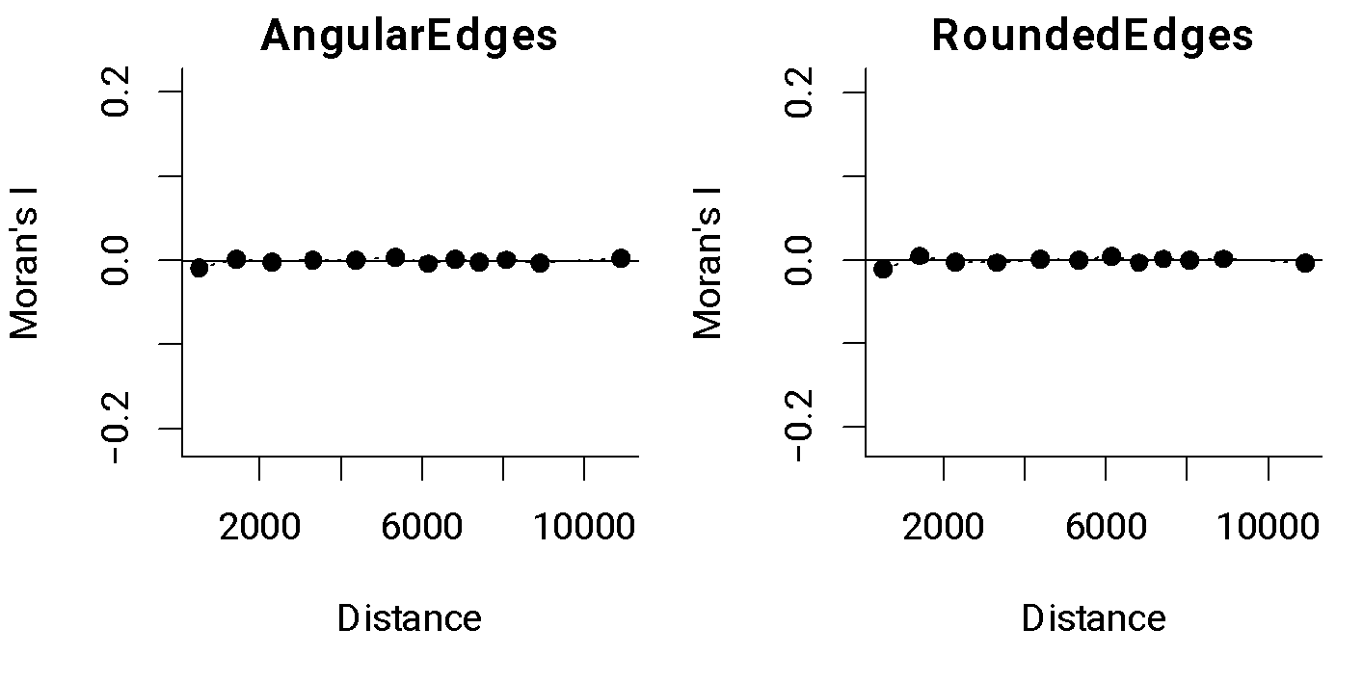

Supplementary Figure S2. Moran’s I autocorrelograms of the residuals for each category of house level as computed from the fully parameterized model.

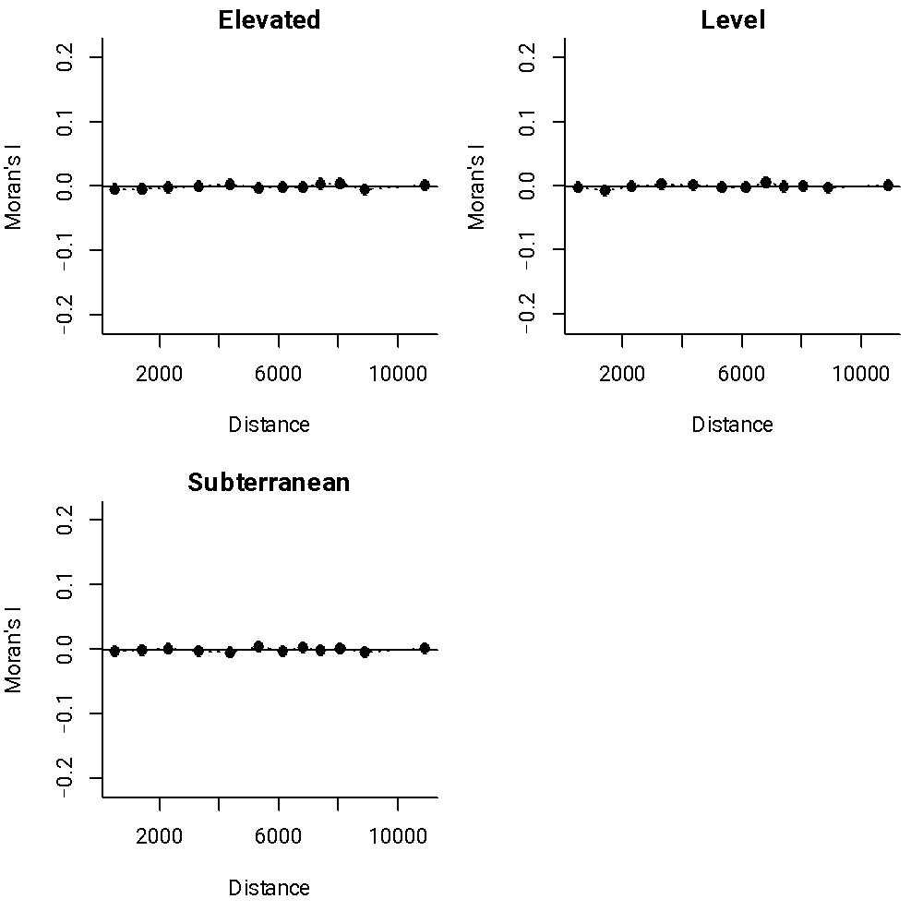

Supplementary Figure S3. Moran’s I autocorrelograms of the residuals for each category of wall material as computed from the fully parameterized model.

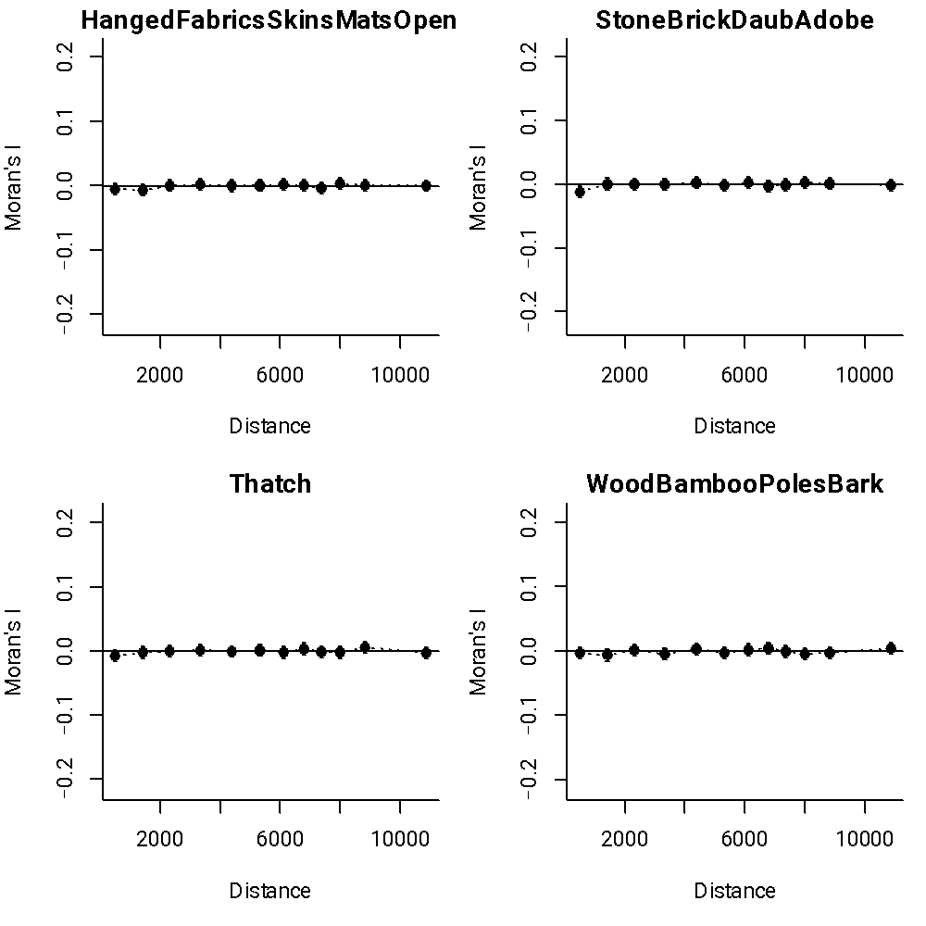
Supplementary Figure S4. Moran’s I autocorrelograms of the residuals for each category of roof shape as computed from the fully parameterized model.

