A Treatment effects
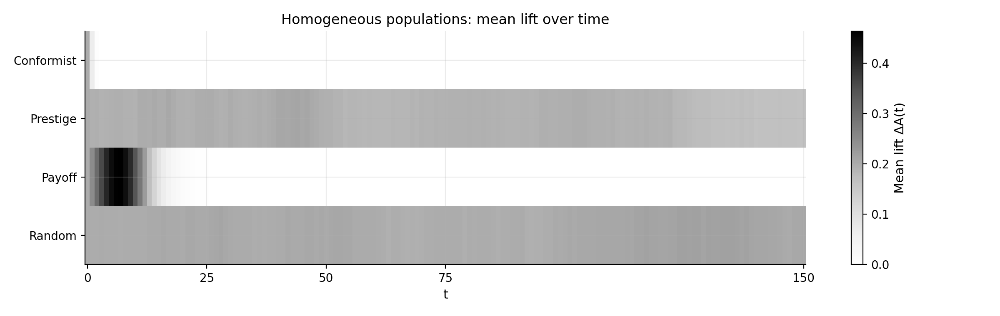
Time-resolved treatment effect ΔA(t) (treatment minus control) for homogeneous populations. The heatmap reports the mean treatment effect over the full horizon t = 0, …, T (T = 150). Conformity shows no average lift at the baseline threshold, payoff-biased copying produces an early pulse that vanishes as both arms saturate, random copying preserves a stable positive lift, and prestige-biased copying yields a moderate but persistent treatment advantage.
Final treatment effects in homogeneous populations ($T=150$). Values are means across $R=100$ paired replications; standard deviations are shown in parentheses for $ΔA(T)$.
Condition | $E[A^{(\text{ctrl})}(T)]$​ | $E[A^{(\text{trt})}(T)]$​ | $E[ΔA(T)]$​
Conformity | 0.007 | 0.007 | 0.000 (0.000)
Prestige | 0.062 | 0.225 | 0.163 (0.263)
Payoff | 1.000 | 1.000 | 0.000 (0.000)
Random | 0.061 | 0.267 | 0.205 (0.224)

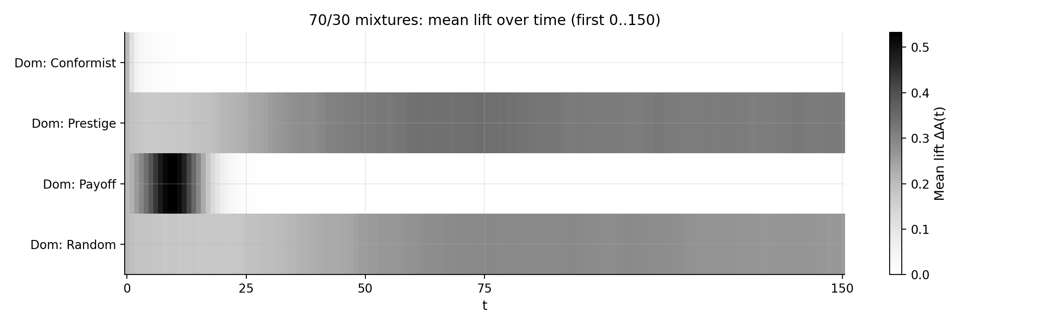
Time-resolved treatment effect ΔA(t) for 70/30 mixed populations over the common short comparison window 0 ≤ t ≤ 150. Over this window, random-dominant ecologies show the largest lift, prestige-dominant ecologies display gradual but modest treatment advantages, payoff-dominant ecologies show early spikes that compress as both arms saturate, and conformity-dominant ecologies remain close to zero. The random-dominant final effect reported in Table 2 uses the extended T = 500 horizon.
Final treatment effects in mixed (70/30) populations. Conformity- and prestige-dominant mixtures are simulated to $T=1500$, the random-dominant mixture to $T=500$, and the payoff-dominant mixture to $T=150$ ($N=400$). Values are means across $R=100$ paired replications; standard deviations are shown in parentheses for $ΔA(T)$.
Dominant strategy | $E[A^{(\text{ctrl})}(T)]$​ | $E[A^{(\text{trt})}(T)]$​ | $E[ΔA(T)]$​
Conformity-dominant | 0.010 | 0.010 | 0.000 (0.000)
Prestige-dominant | 0.896 | 0.931 | 0.034 (0.170)
Payoff-dominant | 0.998 | 0.998 | 0.000 (0.002)
Random-dominant | 0.689 | 0.780 | 0.091 (0.262)

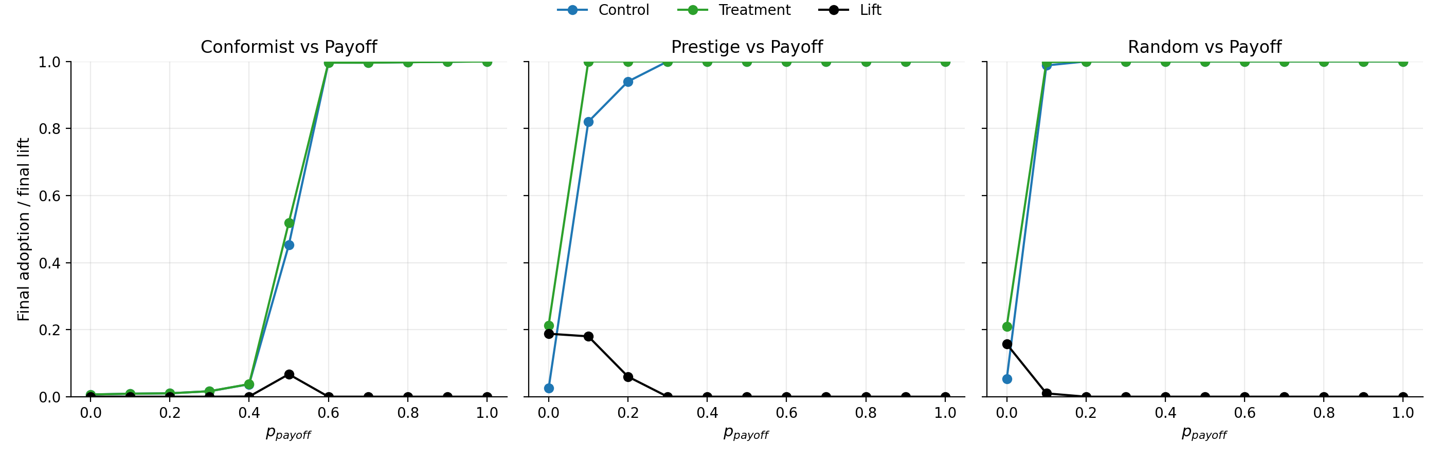
Two-strategy payoff-share sweeps: final adoption in treatment and control as the share of payoff-biased learners increases, shown separately for conformist-, prestige-, and random-based ecologies. The appendix figure decomposes the aggregate payoff-share sweep in Figure 3 into background-specific transition curves.

B Robustness analyses
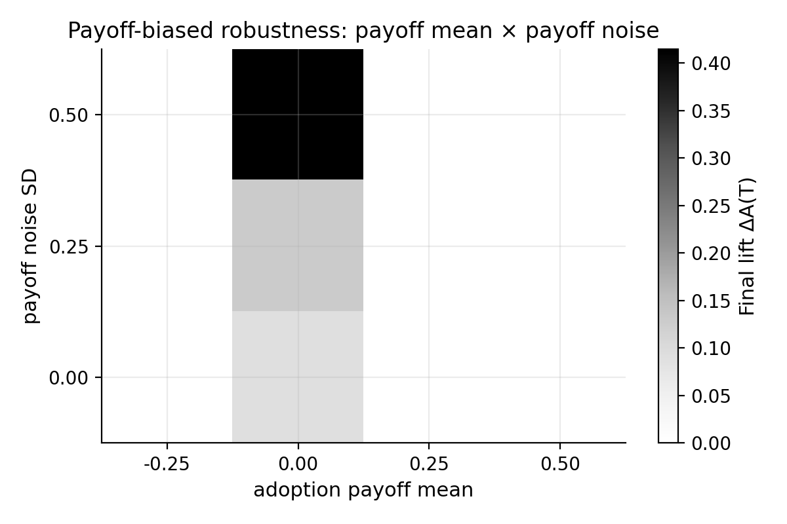
Robustness of homogeneous payoff-biased populations to the mean adoption payoff premium and payoff-noise standard deviation (R = 50, T = 300). Negative payoff premia suppress adoption in both arms; weak or noisy payoff signals can produce sizable final lift; strongly positive payoff premia push both arms to saturation and therefore erase end-of-horizon treatment lift.
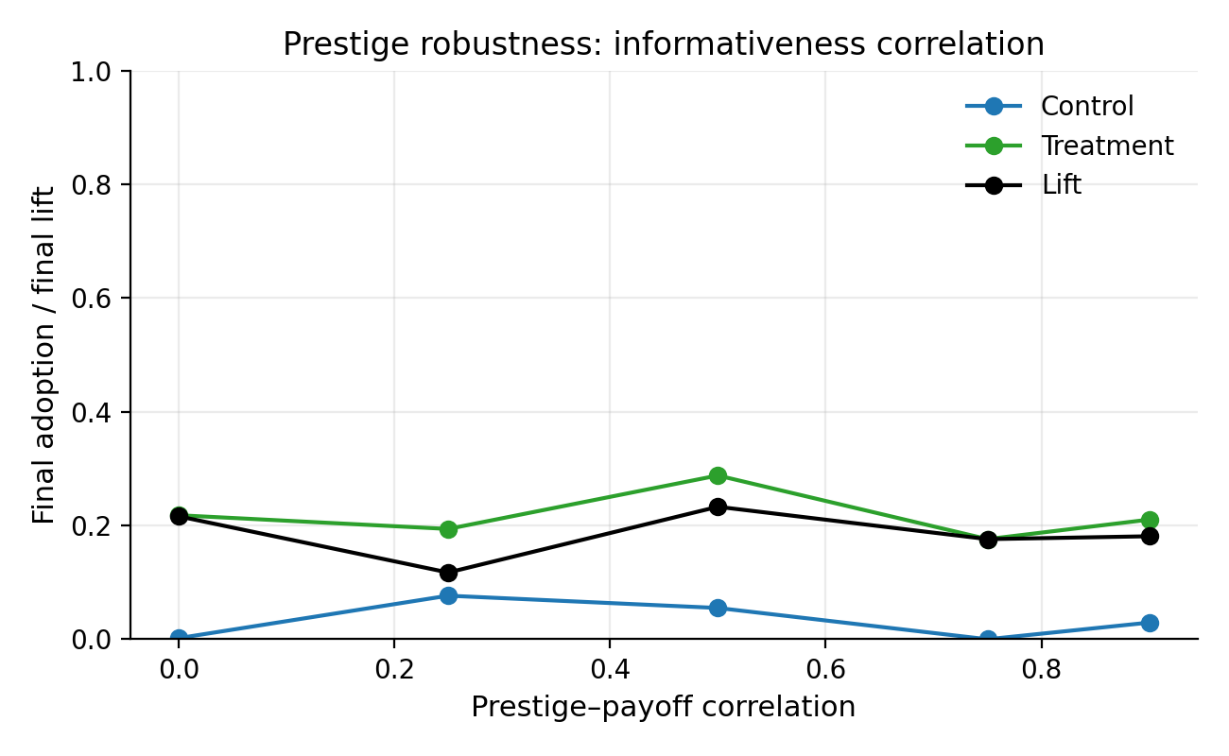
Robustness of homogeneous prestige-biased populations to the correlation between prestige and payoff advantage (R = 50, T = 300). Prestige becomes a directional diffusion channel only when prestige carries information about behavioural value; the resulting final lift is positive across the tested correlations but not strictly monotonic.
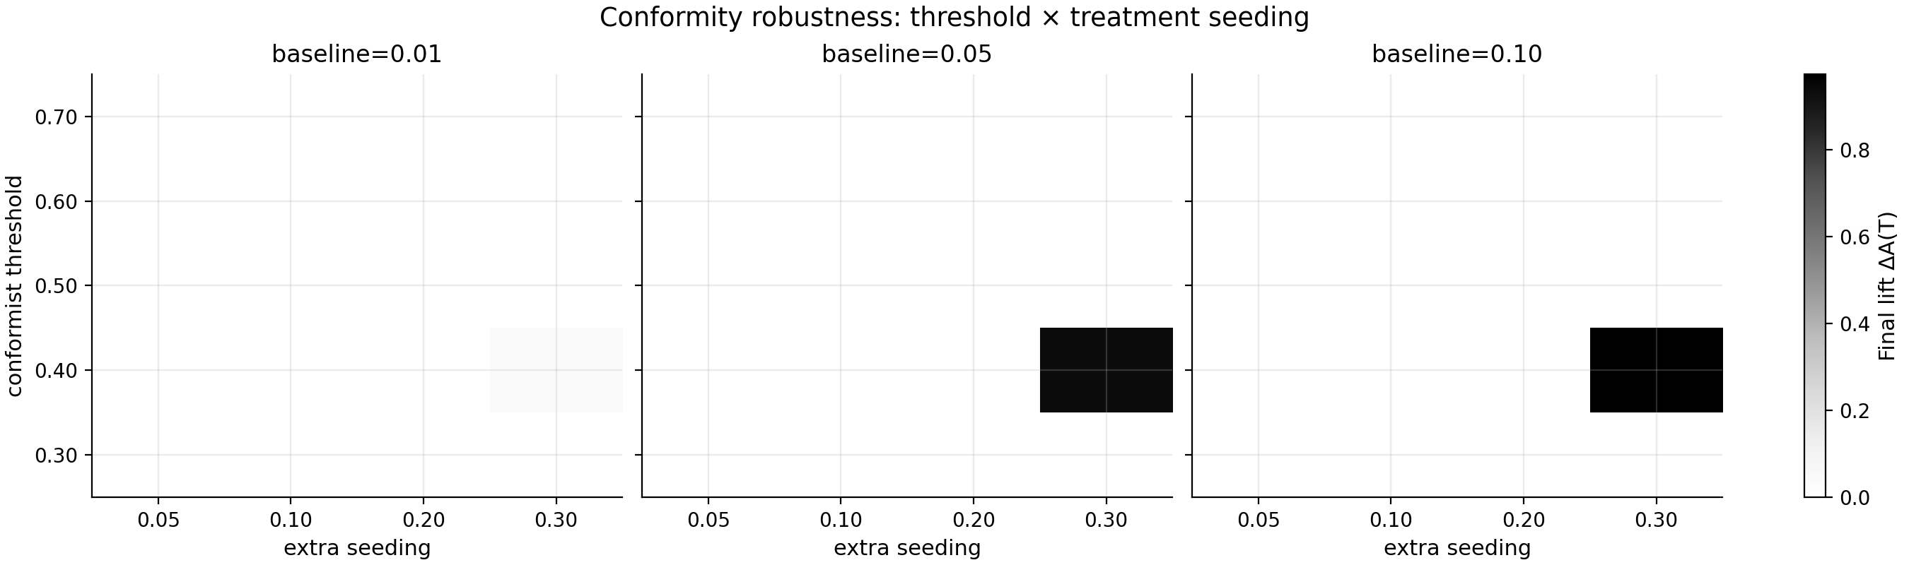
Conformity robustness: final treatment lift as a function of baseline adoption, treatment seeding, and the conformity threshold (R = 50, T = 300). Large treatment effects occur only near threshold boundaries; most parameter combinations produce either joint stalling or joint diffusion.
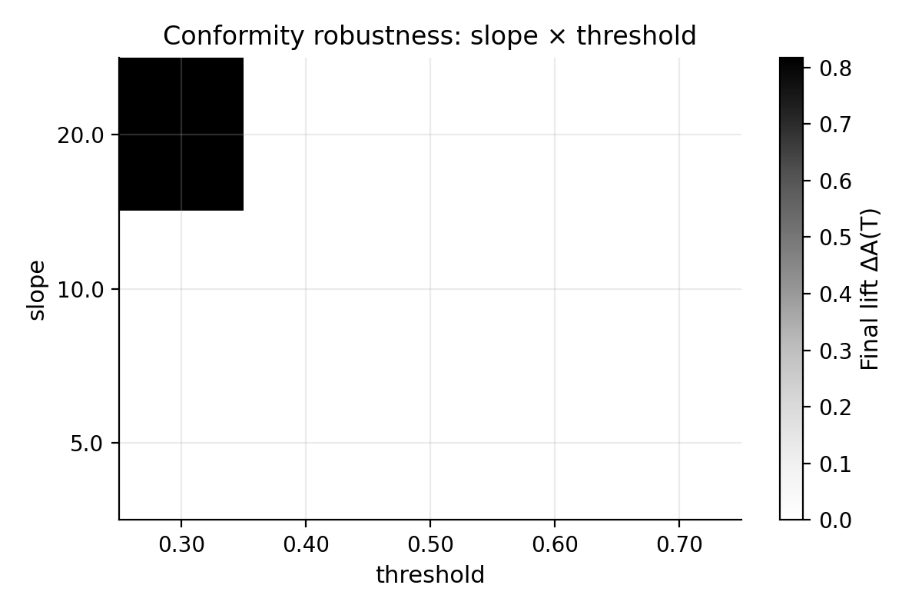
Conformity robustness: final treatment lift as a function of the conformity slope and threshold (R = 50, T = 300). Strong positive lift appears only in a narrow region combining very steep conformity with a comparatively low threshold.

