Appendix A. Supplementary Figures and Tables

Figure 5. Dictator Game: Correlations Between Self-Efficacy and Allocated Amounts Overall and by Gender Groups.
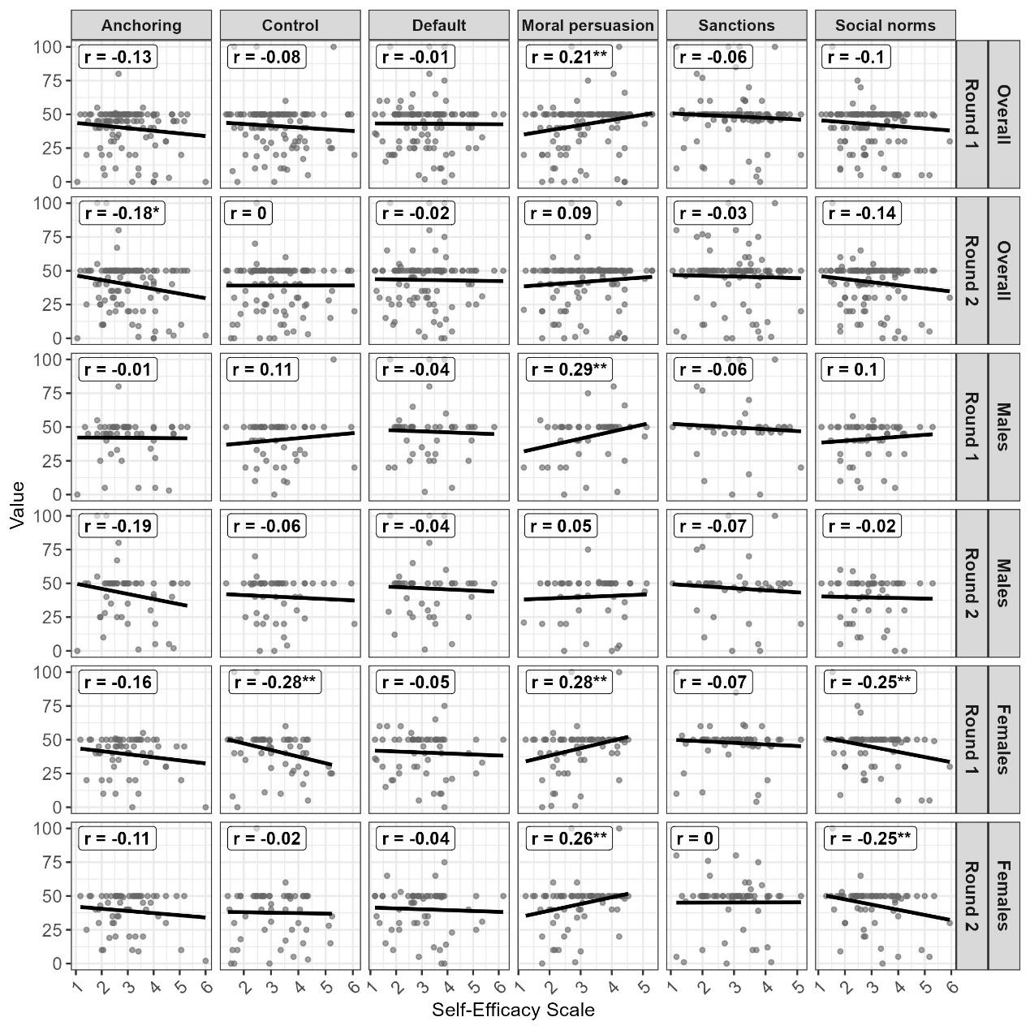
Note: *, **, and *** denote significance levels at 10%, 5%, and 1%, respectively.
Figure 6. Trust Game: Correlations Between Self-Efficacy and Allocated Amounts Overall and by Gender Groups.
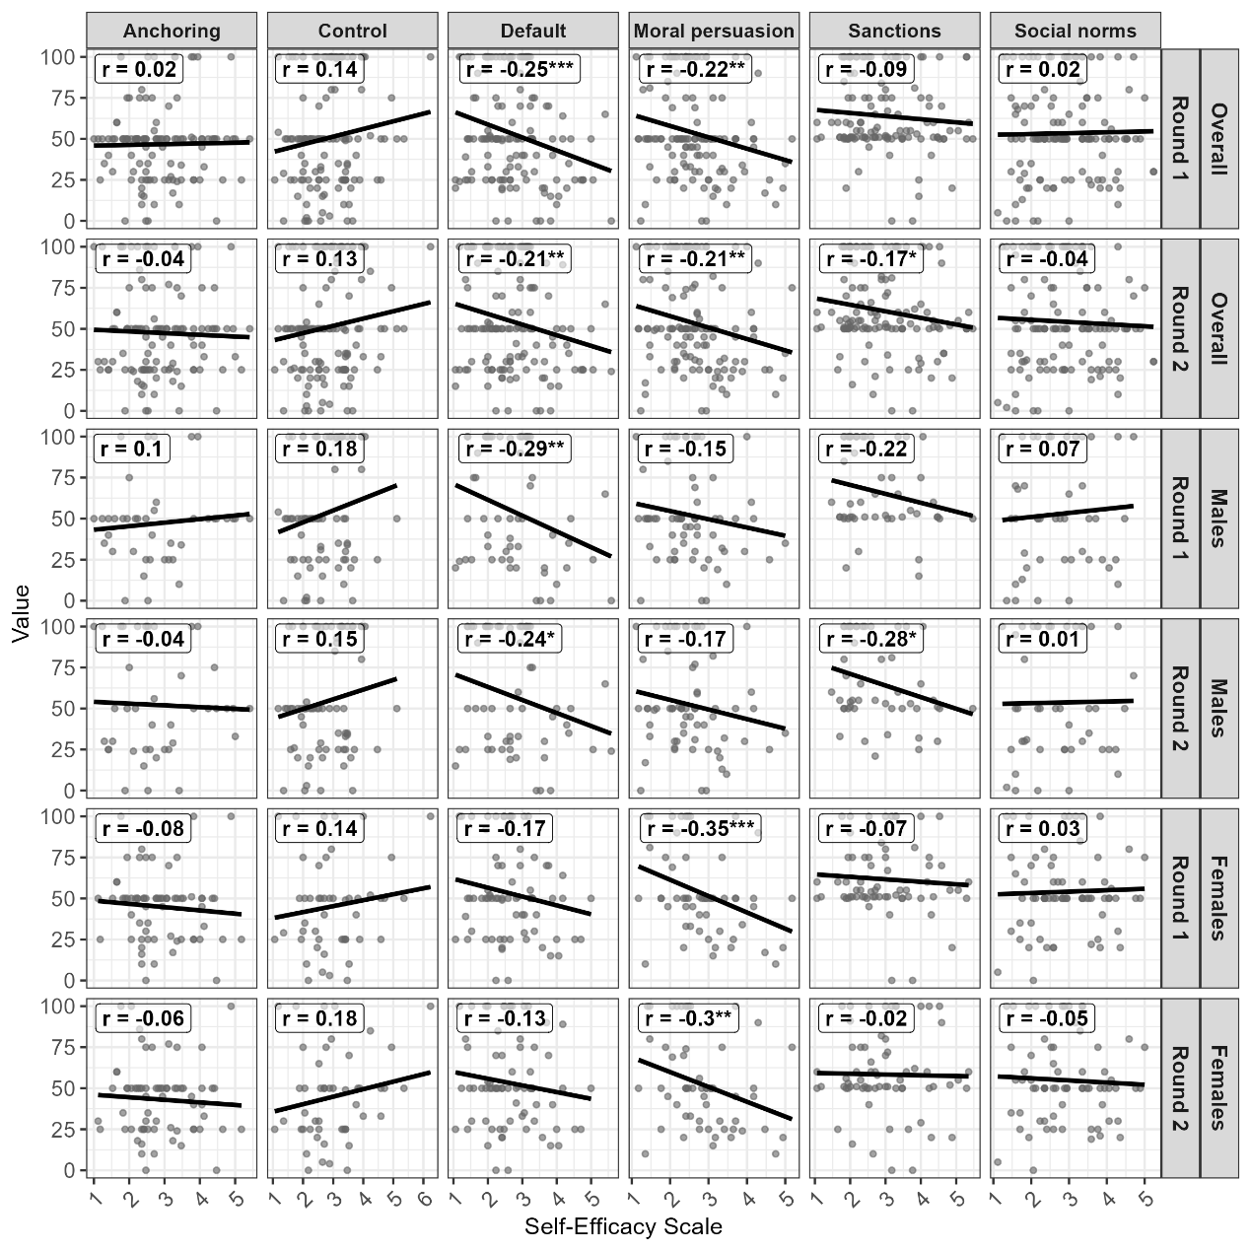
Note: *, **, and *** denote significance levels at 10%, 5%, and 1%, respectively.

Table 8. Dictator Game, Round 1: Regression Results for Model 2 by Treatment and Gender Group
 | Model 1 |  |  | Model 2 |  |  | Model 3 |  |  | Model 4 |  |  | Model 5
 | Total | M. | F. | Total | M. | F. | Total | M. | F. | Total | M. | F. | Total | M. |  | F.
Intercept | 41.4*** | 36.3*** | 45.6*** | 42.3*** | 36.0*** | 46.6*** | 45.2*** | 39.6*** | 49.9*** | 41.9*** | 35.8*** | 46.3*** | 41.4*** | 37.5*** |  | 44.3***
Self-Efficacy | -0.06 | 1.26 | -1.22 | -0.33 | 1.34 | -1.54 | -1.23* | 0.23 | -2.60*** | -0.20 | 1.40 | -1.42 | -0.06 | 0.90 |  | -0.80
Anchoring | 3.51 | 6.05 | 0.39 | -1.16 | 1.95 | -2.77 | -1.34 | 1.66 | -2.89 | -1.13 | 1.97 | -2.76 | -1.10 | 1.84 |  | -2.69
Default | 1.84 | 6.30* | -1.43 | 1.73 | 12.86 | -3.87 | 1.76 | 6.26* | -1.53 | 1.84 | 6.30* | -1.45 | 1.84 | 6.29* |  | -1.40
Moral persuasion | 1.76 | 2.53 | 1.51 | 1.75 | 2.53 | 1.47 | -16.1*** | -13.78 | -22.8*** | 1.75 | 2.52 | 1.48 | 1.76 | 2.56 |  | 1.56
Sanctions | 7.17*** | 9.21** | 5.67* | 7.13*** | 9.21** | 5.62* | 7.00*** | 9.12** | 5.48* | 9.98 | 17.89* | 4.85 | 7.17*** | 9.18** |  | 5.72*
Social norms | 1.56 | 1.16 | 2.59 | 1.51 | 1.19 | 2.58 | 1.34 | 0.83 | 2.55 | 1.54 | 1.21 | 2.58 | 6.15 | -0.64 |  | 11.85
(Anchoring) x (Self-Efficacy) | -1.54 | -1.38 | -1.04
(Default) x  (Self-Efficacy) |  |  |  | 0.03 | -2.05 | 0.80
(Moral persuasion) x ( Self-Efficacy) |  |  |  |  |  |  | 5.66*** | 4.96* | 8.12***
(Sanctions) x (Self-Efficacy) |  |  |  |  |  |  |  |  |  | -0.93 | -2.74 | 0.27
(Social norms) x  (Self-Efficacy) |  |  |  |  |  |  |  |  |  |  |  |  | -1.53 | 0.58 |  | -3.01
N | 663 | 284 | 370 | 663 | 284 | 370 | 663 | 284 | 370 | 663 | 284 | 370 | 663 | 284 |  | 370
R2 | 0.02 | 0.04 | 0.04 | 0.02 | 0.04 | 0.04 | 0.04 | 0.04 | 0.07 | 0.01 | 0.01 | 0.02 | 0.02 | 0.03 |  | 0.04
Adjusted R2 | 0.01 | 0.01 | 0.02 | 0.01 | 0.01 | 0.02 | 0.03 | 0.02 | 0.05 | 0.02 | 0.04 | 0.04 | 0.01 | 0.01 |  | 0.02
Note: *, **, and *** denote significance levels at 10%, 5%, and 1%, respectively.

Table 9. Dictator Game, Round 2: Regression Results for Model 2 by Treatment and Gender Group
 | Model 1 |  |  | Model 2 |  |  | Model 3 |  |  | Model 4 |  |  | Model 5
 | Total | M. | F. | Total | M. | F. | Total | M. | F. | Total | M. | F. | Total | M. |  | F.
Intercept | 39.9*** | 41.9*** | 38.3*** | 41.6*** | 44.2*** | 38.9*** | 43.2*** | 45.3*** | 41.0*** | 41.5*** | 43.8*** | 39.2*** | 40.3*** | 44.5*** |  | 36.4***
Self-Efficacy | -0.30 | -0.57 | -0.22 | -0.86 | -1.28 | -0.40 | -1.33* | -1.60 | -1.40 | -0.80 | -1.16 | -0.52 | -0.44 | -1.36 |  | 0.39
Anchoring | 9.32 | 11.63 | 5.46 | 1.03 | 1.82 | 1.29 | 0.94 | 1.73 | 1.18 | 1.04 | 1.85 | 1.27 | 1.11 | 1.80 |  | 1.37
Default | 4.04* | 6.11 | 2.54 | 2.50 | 4.72 | 3.22 | 3.96 | 6.07 | 2.45 | 4.00 | 6.09 | 2.51 | 4.03* | 6.08 |  | 2.58
Moral persuasion | 3.19 | 0.02 | 6.34** | 3.16 | 0.07 | 6.32** | -7.85 | -8.34 | -12.71 | 3.16 | 0.06 | 6.30** | 3.18 | 0.08 |  | 6.42**
Sanctions | 6.67*** | 6.01 | 7.55** | 6.59*** | 5.95 | 7.53** | 6.52*** | 5.93 | 7.40** | 5.99 | 7.09 | 5.81 | 6.65*** | 5.95 |  | 7.63**
Social norms | 2.65 | -0.70 | 5.76* | 2.54 | -0.93 | 5.76* | 2.45 | -1.03 | 5.73* | 2.55 | -0.89 | 5.76* | 8.28 | -3.72 |  | 18.79**
(Anchoring) x (Self-Efficacy) | -2.73 | -3.24 | -1.39
(Default) x  (Self-Efficacy) |  |  |  | 0.48 | 0.43 | -0.23
(Moral persuasion) x ( Self-Efficacy) |  |  |  |  |  |  | 3.50* | 2.55 | 6.36**
(Sanctions) x (Self-Efficacy) |  |  |  |  |  |  |  |  |  | 0.20 | -0.36 | 0.57
(Social norms) x  (Self-Efficacy) |  |  |  |  |  |  |  |  |  |  |  |  | -1.89 | 0.95 |  | -4.23*
N | 663 | 284 | 370 | 663 | 284 | 370 | 663 | 284 | 370 | 663 | 284 | 370 | 663 | 284 |  | 370
R2 | 0.02 | 0.03 | 0.03 | 0.02 | 0.03 | 0.03 | 0.02 | 0.03 | 0.04 | 0.02 | 0.03 | 0.03 | 0.02 | 0.03 |  | 0.04
Adjusted R2 | 0.01 | 0.01> | 0.01 | 0.01> | 0.01> | 0.01 | 0.01 | 0.01> | 0.03 | 0.01> | 0.01> | 0.01 | 0.01 | 0.01> |  | 0.02
Note: *, **, and *** denote significance levels at 10%, 5%, and 1%, respectively.

Table 10. Trust Game, Round 1: Regression Results for Model 2 by Treatment and Gender Group
 | Model 1 |  |  | Model 2 |  |  | Model 3 |  |  | Model 4 |  |  | Model 5
 | Total | M. | F. | Total | M. | F. | Total | M. | F. | Total | M. | F. | Total | M. |  | F.
Intercept | 56.8*** | 59.6*** | 51.7*** | 52.0*** | 51.7*** | 49.7*** | 53.2*** | 55.6*** | 47.9*** | 55.3*** | 55.4*** | 52.1*** | 57.3*** | 59.1*** |  | 53.6***
Self-Efficacy | -2.34** | -2.48 | -2.13 | -0.65 | 0.42 | -1.48 | -1.07 | -1.02 | -0.88 | -1.79 | -0.94 | -2.26 | -2.51** | -2.30 |  | -2.76*
Anchoring | -11.23 | -18.52 | -1.08 | -3.92 | -5.73 | -0.58 | -3.91 | -5.58 | -0.50 | -3.88 | -5.59 | -0.67 | -3.86 | -5.44 |  | -0.74
Default | 2.69 | 1.34 | 6.85 | 22.2*** | 29.0** | 17.56 | 2.81 | 1.24 | 7.25 | 2.74 | 1.24 | 6.80 | 2.67 | 1.33 |  | 6.65
Moral persuasion | 2.23 | -1.32 | 7.21 | 2.48 | -0.82 | 7.31 | 18.5** | 9.08 | 33.3*** | 2.31 | -1.05 | 7.19 | 2.20 | -1.29 |  | 7.12
Sanctions | 13.8*** | 13.6** | 16.3*** | 13.6*** | 13.3** | 16.3*** | 13.7*** | 13.5** | 16.3*** | 15.9* | 25.0* | 14.1 | 13.8*** | 13.6** |  | 16.3***
Social norms | 3.41 | -0.07 | 8.53* | 3.34 | -0.08 | 8.60* | 3.36 | -0.08 | 8.67* | 3.39 | -0.08 | 8.52* | -6.62 | -13.00 |  | -2.00
(Anchoring) x (Self-Efficacy) | 2.57 | 4.65 | 0.15
(Default) x  (Self-Efficacy) |  |  |  | -7.08** | -10.1** | -3.91
(Moral persuasion) x ( Self-Efficacy) |  |  |  |  |  |  | -5.99* | -4.01 | -9.06**
(Sanctions) x (Self-Efficacy) |  |  |  |  |  |  |  |  |  | -0.73 | -4.49 | 0.75
(Social norms) x  (Self-Efficacy) |  |  |  |  |  |  |  |  |  |  |  |  | 3.50 | 4.77 |  | 3.60
N | 720 | 325 | 385 | 720 | 325 | 385 | 720 | 325 | 385 | 720 | 325 | 385 | 0.04 | 0.04 |  | 0.06
R2 | 0.04 | 0.04 | 0.06 | 0.05 | 0.05 | 0.06 | 0.04 | 0.03 | 0.07 | 0.04 | 0.04 | 0.06 | 0.04 | 0.04 |  | 0.06
Adjusted R2 | 0.03 | 0.01 | 0.04 | 0.04 | 0.03 | 0.04 | 0.03 | 0.01 | 0.05 | 0.03 | 0.01 | 0.04 | 0.03 | 0.01 |  | 0.04
Note: *, **, and *** denote significance levels at 10%, 5%, and 1%, respectively.

Table 11. Trust Game, Round 2: Regression Results for Model 2 by Treatment and Gender Group
 | Model 1 |  |  | Model 2 |  |  | Model 3 |  |  | Model 4 |  |  | Model 5
 | Total | M. | F. | Total | M. | F. | Total | M. | F. | Total | M. | F. | Total | M. |  | F.
Intercept | 58.4*** | 62.4*** | 50.2*** | 55.3*** | 57.7*** | 48.7*** | 55.5*** | 59.8*** | 46.6*** | 56.9*** | 59.2*** | 51.1*** | 58.6*** | 62.8*** |  | 50.4***
Self-Efficacy | -2.73** | -3.13 | -1.76 | -1.66 | -1.42 | -1.28 | -1.72 | -2.19 | -0.58 | -2.20* | -1.97 | -2.05 | -2.80** | -3.28 |  | -1.82
Anchoring | -7.78 | -7.23 | -2.55 | -3.58 | -1.61 | -1.93 | -3.58 | -1.53 | -1.84 | -3.56 | -1.56 | -2.02 | -3.55 | -1.42 |  | -2.00
Default | 3.56 | 3.33 | 7.55 | 16.2* | 21.29 | 15.24 | 3.65 | 3.27 | 7.93* | 3.61 | 3.26 | 7.46 | 3.55 | 3.34 |  | 7.53
Moral persuasion | 1.50 | -2.29 | 6.96 | 1.65 | -2.00 | 7.03 | 16.1* | 7.14 | 31.33** | 1.57 | -2.09 | 6.92 | 1.49 | -2.32 |  | 6.95
Sanctions | 10.7*** | 11.8** | 13.5*** | 10.6*** | 11.7** | 13.5*** | 10.6*** | 11.8** | 13.5*** | 15.1* | 26.0* | 8.73 | 10.7*** | 11.9** |  | 13.5***
Social norms | 3.80 | -0.25 | 9.82** | 3.76 | -0.26 | 9.87** | 3.77 | -0.26 | 9.94** | 3.79 | -0.26 | 9.79** | -1.52 | -10.51 |  | 8.27
(Anchoring) x (Self-Efficacy) | 1.48 | 2.06 | 0.19
(Default) x  (Self-Efficacy) |  |  |  | -4.57 | -6.51 | -2.80
(Moral persuasion) x ( Self-Efficacy) |  |  |  |  |  |  | -5.38* | -3.66 | -8.47**
(Sanctions) x (Self-Efficacy) |  |  |  |  |  |  |  |  |  | -1.51 | -5.11 | 1.57
(Social norms) x  (Self-Efficacy) |  |  |  |  |  |  |  |  |  |  |  |  | 1.86 | 3.78 |  | 0.53
N | 720 | 325 | 385 | 720 | 325 | 385 | 720 | 325 | 385 | 720 | 325 | 385 | 720 | 325 |  | 385
R2 | 0.03 | 0.03 | 0.04 | 0.03 | 0.03 | 0.05 | 0.03 | 0.03 | 0.06 | 0.03 | 0.03 | 0.05 | 0.03 | 0.03 |  | 0.04
Adjusted R2 | 0.02 | 0.01 | 0.03 | 0.02 | 0.01 | 0.03 | 0.02 | 0.01 | 0.04 | 0.02 | 0.01 | 0.03 | 0.02 | 0.01 |  | 0.03
Note: *, **, and *** denote significance levels at 10%, 5%, and 1%, respectively.

Table 12. Dictator Game (Rounds 1 and 2): Regression results for Model 1 estimated without self-efficacy (robustness check).
 | Round 1 |  |  | Round 2
 | Overall | M. | F. | Overall | M. | F.
Intercept | 41.2*** | 40.4*** | 41.9*** | 38.91*** | 40.1*** | 37.6***
Anchoring | -1.09 | 1.60 | -2.60 | 1.20 | 2.15 | 1.33
Default | 1.85 | 6.26* | -1.35 | 4.06* | 6.13 | 2.55
Moral persuasion | 1.76 | 2.62 | 1.67 | 3.20 | -0.01 | 6.37***
Sanctions | 7.17*** | 9.11** | 5.83* | 6.71*** | 6.05 | 7.58**
Social norms | 1.57 | 0.75 | 2.62 | 2.71 | -0.52 | 5.77*
N | 663 | 284 | 370 | 663 | 284 | 370
R2 | 0.01 | 0.01 | 0.04 | 0.04 | 0.01 | 0.01
Adjusted R2 | 0.02 | 0.03 | 0.02 | 0.03 | 0.02 | 0.03

Table 13. Trust Game (Rounds 1 and 2): Regression results for Model 1 estimated without self-efficacy (robustness check).
 | Round 1 |  |  | Round 2
 | Overall | M. | F. | Overall | M. | F.
Intercept | 50.2*** | 52.9*** | 45.29*** | 50.6*** | 53.9*** | 44.9***
Anchoring | -3.94 | -5.69 | -0.39 | -3.63 | -1.77 | -1.77
Default | 2.91 | 1.18 | 7.53* | 3.82 | 3.13 | 8.12*
Moral persuasion | 2.57 | -0.89 | 7.54 | 1.90 | -1.75 | 7.23
Sanctions | 13.56*** | 13.37** | 16.34*** | 10.39*** | 11.59* | 13.48***
Social norms | 3.32 | -0.08 | 8.76* | 3.70 | -0.27 | 10.00**
N | 720 | 325 | 385 | 720 | 325 | 385
R2 | 0.03 | 0.02 | 0.04 | 0.01 | 0.01 | 0.03
Adjusted R2 | 0.03 | 0.03 | 0.04 | 0.02 | 0.02 | 0.04

Appendix B. Experimental Instructions and Intervention Texts
Participants were randomly assigned to one of six experimental conditions: five intervention treatments and one control. Each participant played as allocator (Role A), paired with an anonymous recipient (Role B). The games were fully incentivized with real monetary payoffs, and at the conclusion of the study, five participant pairs were randomly selected to receive payments based on their actual decisions.
Below are the instructions presented in the Dictator Game (DG) and the Trust Game (TG) control conditions, followed by the additional information provided under each treatment.

Dictator Game (Control Condition)
Welcome!
Please read the instructions carefully.
As the allocator, you have 100¢. As the recipient, your counterpart has no money at all.
You will have to decide how much money you wish to give the recipient (if any at all).
You can choose to provide the recipient with any amount between 0–100¢.
You will keep the remaining amount following your decision.
Your decision will end this task.
At the conclusion of the study, we will randomly select five pairs of allocators and recipients and pay them based on the number of cents they have at the end of the task.

Trust Game (Control Condition)
Welcome!
Please read the instructions carefully.
You have been assigned to Role A.
Your counterpart will play Role B.
You will not know the identity of the individual in Role B, and they will not know yours.
You and Player B will receive similar instructions corresponding to your respective roles.
At the beginning of the game, you will receive 100¢ and must decide how many cents you wish to send to the person in Role B, who starts with 0¢.
The amount you send will be tripled.
Player B will then decide how many cents (if any) to send back to you.
Player B’s decision will be made after the study.
The decisions in this study involve real money.
At the conclusion of the study, five pairs of participants will be randomly selected and paid according to their decisions in the round they were assigned to.

Intervention Treatments
Each treatment condition modified the basic game instructions in the following way:

Sanctions Condition
After making your decision, offers of 45¢ or below to the recipient will trigger an audit process.
A subset of these participants will be randomly selected for an audit to ensure fairness in the allocation of funds.
If you are audited and found to have made offers of 45¢ or below, you will incur a fine of 2¢ for every 1¢ below the 45¢ threshold.

Social Norms Condition
Numerous studies (e.g., Engel, 2011; Johnson & Mislin, 2011) indicate that the average transfer by allocators in this game is approximately 45¢.
This information is provided to give you context about the typical behavior of other participants in similar studies.

Anchoring Condition
Dictator game:
Before you start the game, we will briefly illustrate the game. Imagine you decide to give your partner 45¢ in the game. In this case, they get 45¢, and you get 55¢, making it a 55:45 split.
Trust game:
Before you start the game, we will briefly illustrate the game.
Imagine you decide to give your partner 45¢ in the game.
In this case, you transferred 45¢ from the 100¢ you were endowed with at the beginning of the game. You will end with 55¢ plus any amount Player B decides to send back, if any.

Moral Persuasion Condition
Please remember that you were randomly chosen to be the allocator and not the recipient.
Before making your decision, consider the moral and ethical aspects of your choice.
Your decision in this game can significantly impact both yourself and your partner.
By making a fair transfer, you contribute to a sense of fairness, trust, and cooperation in this experiment.

