Supplementary materials
Unpacking transparency in nudging: the impact of different disclosure messages on nudge effectiveness and perceived autonomy

1. Variance inflation factor
Variable | Adjusted Generalised Variance Inflation Factors
 | Nudge effectiveness | Perceived autonomy
Group | 1.003 | 1.003
Political alignment | 1.039 | 1.048
Financial situation | 1.081 | 1.077
Vegetarianism | 1.039 | 1.046
Age | 1.068 | 1.071
Education | 1.048 | 1.047
Food preference: sustainability | 1.138 | 1.145
Food preference: health | 1.124 | 1.129
Food preference: taste | 1.027 | 1.026
Hunger | 1.013 | 1.013
Generalised Variance Inflation Factors are adjusted using GVIF^{1/(2*Df)}, where Df represents degrees of freedom

2. Stepwise logistic regression of nudge effectiveness using restricted sample
 |  | (1b)  Sustainable dish |  | (2b)  Sustainable dish |  | (3b)  Sustainable dish |  | (4b)  Sustainable dish
 | Reference | B (SE) | Z | B (SE) | Z | B (SE) | Z | B (SE) | Z
Control |  | Constant  -0.710 (0.113)*** | -6.289 |  |  | Constant  0.335 (0.359) | 0.933 | Constant  0.017 (0.830) | 0.020
Nudge |  | 0.495 (0.192)** | 2.579 | Constant  -0.215 (0.155) | -1.386 | 0.536 (0.208)** | 2.583 | 0.596 (0.211)** | 2.829
Presence |  | 0.284 (0.219) | 1.296 | -0.211 (0.243) | -0.869 | 0.210 (0.240) | 0.875 | 0.233 (0.242) | 0.962
Purpose |  | 0.577 (0.206)** | 2.796 | 0.082 (0.232) | 0.352 | 0.631 (0.223)** | 2.826 | 0.633 (0.226)** | 2.796
Mechanism |  | 0.681 (0.204)*** | 3.334 | 0.186 (0.230) | 0.808 | 0.541 (0.223)* | 2.427 | 0.552 (0.226)* | 2.436
Combined |  | 0.794 (0.201)*** | 3.939 | 0.298 (0.228) | 1.310 | 0.648 (0.220)** | 2.946 | 0.659 (0.223)** | 2.958
Gender: female | Male |  |  |  |  | 0.414 (0.140)** | 2.954 | 0.396 (0.145)** | 2.732
Political alignment |  |  |  |  |  | -0.148 (0.044)*** | -3.396 | -0.131 (0.045)** | -2.893
Financial situation |  |  |  |  |  | 0.161 (0.074)* | 2.180 | 0.110 (0.078) | 1.405
Vegetarianism |  |  |  |  |  | -0.220 (0.038)*** | -5.823 | -0.207 (0.038)*** | -5.377
Age |  |  |  |  |  |  |  | -0.006 (0.004) | -1.332
Education: high school | Middle school / no degree |  |  |  |  |  |  | 0.597 (0.458) | 1.302
Education: university / College | Middle school / no degree |  |  |  |  |  |  | 0.817 (0.470) | 1.740
Food preference: sustainability |  |  |  |  |  |  |  | 0.062 (0.092) | 0.679
Food preference: health |  |  |  |  |  |  |  | 0.152 (0.111) | 1.366
Food preference: taste |  |  |  |  |  |  |  | -0.195 (0.111) | -1.747
Hunger |  |  |  |  |  |  |  | 0.001 (0.003) | 0.309
N |  | 1059 |  | 704 |  | 964 |  | 963
Pseudo R² (McFadden’s) |  | 0.016 |  | 0.005 |  | 0.068 |  | 0.079
X² |  | 1169.43 |  | 1619.485 |  | 1364.267 |  | 1379.407
p |  | 0.000*** |  | 0.000*** |  | 0.000*** |  | 0.000***
Significance refers to whether this estimate differs from zero.
* p < .05. ** p < .01. *** p < .001 (two-tailed test)

3. Stepwise linear regression of perceived autonomy using restricted sample
 |  |  | (5b)  Autonomy |  | (6b)  Autonomy |  | (7b)  Autonomy |  | (8b)  Autonomy
 |  | Reference | B (SE) | t | B (SE) | t | B (SE) | t | B (SE) | t
 | Control |  | Constant  3.740 (0.024)*** | 154.052 |  |  | Constant  2.952 (0.139)*** | 21.222 | Constant  2.813 (0.165)*** | 16.999
 | Nudge |  | -0.062 (0.043) | -1.449 | Constant  3.678(0.036)*** | 102.722 | -0.093 (0.043)* | -2.138 | -0.098 (0.043)* | -2.253
 | Presence |  | -0.066 (0.048) | -1.364 | -0.004 (0.056) | -0.073 | -0.076 (0.049) | -1.543 | -0.076 (0.049) | -1.550
 | Purpose |  | -0.008 (0.046) | -0.166 | 0.054 (0.054) | 1.013 | -0.031 (0.047) | -0.667 | -0.027 (0.047) | -0.583
 | Mechanism |  | 0.105 (0.046)* | 2.280 | 0.167 (0.053)** | 3.126 | 0.087 (0.047) | 1.876 | 0.081 (0.047) | 1.737
 | Combined |  | 0.014 (0.045) | 0.316 | 0.076 (0.053) | 1.449 | -0.013 (0.046) | -0.289 | -0.021 (0.046) | -0.460
 | Gender: female | Male |  |  |  |  |  |  | 0.007 (0.030) | 0.219
 | Political alignment |  |  |  |  |  | -0.010 (0.009) | -1.134 | -0.011 (0.009) | -1.195
 | Financial situation |  |  |  |  |  | 0.026 (0.015) | 1.699 | 0.035 (0.016)* | 2.176
 | Vegetarianism |  |  |  |  |  | -0.019 (0.008)* | -2.489 | -0.019 (0.008)* | -2.364
Age |  |  |  |  |  |  |  |  | -0.000 (0.001) | -0.197
 | Education: high school | Middle school / no degree |  |  |  |  |  |  | 0.123 (0.082) | 1.499
 | Education: university / College | Middle school / no degree |  |  |  |  |  |  | 0.054 (0.085) | 0.633
 | Food preference: sustainability |  |  |  |  |  | 0.022 (0.019) | 1.203 | 0.025 (0.019) | 1.358
 | Food preference: health |  |  |  |  |  | 0.077 (0.022)*** | 3.469 | 0.079 (0.023)*** | 3.484
 | Food preference:  taste |  |  |  |  |  | 0.112 (0.023)*** | 4.846 | 0.111 (0.023)*** | 4.830
 | Hunger |  |  |  |  |  |  |  | 0.000 (0.001) | 0.490
 | N |  | 1059 |  | 704 |  | 965 |  | 963
 | Adjusted R² |  | 0.007 |  | 0.012 |  | 0.071 |  | 0.074
 | F² |  | 2.588 |  | 3.139 |  | 7.722 |  | 5.800
 | p |  | 0.024* |  | 0.014* |  | 0.000*** |  | 0.000***
Significance refers to whether this estimate differs from zero.
* p < .05. ** p < .01. *** p < .001 (two-tailed test)

4. Stepwise linear regression of perceived autonomy; subscales of perceived autonomy (State Reactance scale, BPNES scale, autonomy-enhancing items) separated for analysis
 | (9)  Autonomy State Reactance |  | (10)  Autonomy State Reactance |  | (11)  Autonomy BPNES |  | (12)  Autonomy BPNES |  | (13)  Autonomy enhancing items |  | (14)  Autonomy enhancing items
 | B (SE) | t | B (SE) | t | B (SE) | t | B (SE) | t | B (SE) | t | B (SE) | t
Control | Constant  4.091 (0.036)*** | 114.691 |  |  | Constant  3.602 (0.032)*** | 112.240 |  |  | Constant  3.218 (0.044)*** | 72.504
Nudge | -0.189 (0.053)*** | -3.592 | Constant  3.902 (0.039)*** | 99.209 | -0.004 (0.047) | -0.076 | Constant  3.599 (0.035)*** | 103.446 | 0.050 (0.065) | 0.762 | Constant  3.268 (0.048)*** | 68.279
Presence | -0.185 (0.053)*** | -3.532 | 0.003 (0.056) | 0.062 | 0.003 (0.047) | 0.067 | 0.007 (0.049) | 0.138 | -0.019 (0.065) | -0.295 | -0.069 (0.068) | -1.024
Purpose | -0.146 (0.052)** | -2.817 | 0.043 (0.055) | 0.785 | 0.078 (0.047) | 1.664 | 0.081 (0.048) | 1.674 | 0.133 (0.064)* | 2.067 | 0.083 (0.067) | 1.249
Mechanism | -0.149 (0.052)** | -2.842 | 0.040 (0.055) | 0.718 | 0.034 (0.047) | 0.719 | 0.038 (0.049) | 0.765 | -0.010 (0.065) | -0.155 | -0.060 (0.068) | -0.889
Combined | -0.214 (0.051)*** | -4.171 | -0.025 (0.054) | -0.467 | 0.089 (0.046) | 1.920 | 0.092 (0.048) | 1.919 | 0.138 (0.064)* | 2.154 | 0.088 (0.066) | 1.326
N | 1916 |  | 1561 |  | 1916 |  | 1561 |  | 1916 |  | 1561
Adjusted R² | 0.009 |  | -0.001 |  | 0.001 |  | 0.001 |  | 0.004 |  | 0.004
F² | 4.489 |  | 0.574 |  | 1.490 |  | 1.528 |  | 2.347 |  | 2.585
p | 0.000*** |  | 0.682 |  | 0.190 |  | 0.192 |  | 0.039* |  | 0.036*
Significance refers to whether this estimate differs from zero.
* p < .05. ** p < .01. *** p < .001 (two-tailed test)

Appendix A. Survey

Vignette and manipulation checks
On the next page you will see a menu of a cafeteria. Imagine that it is lunch break and you have one main course. Which dish do you choose? Please note! You have a chance to win a gift voucher for the dish you choose, so be sure to choose the dish you would like the most. You will receive more information about this at the end of the questionnaire.
I order ... (nudge effectiveness)
o Vol-au-vent with cucumber salad and mashed potatoes
o Stuffed bell pepper with minced meat, tomato sauce, green beans and Spanish rice
o Spring roll with fried rice and sweet and sour sauce
o Vegetable burger with couscous and spinach
o Turkey steak with mustard sauce, rainbow carrots and rösti potatoes
o Indian curry with wok vegetables and rice
o Spaghetti bolognaise
o Penne with mascarpone and pesto rosso
o Chicken burger with ratatouille and polenta

Which of the following dishes were called 'chef's choice'? You only have to choose one dish, even if several dishes would be correct. (Nudge awareness check)
o Vol-au-vent with cucumber salad and mashed potatoes
o Stuffed bell pepper with minced meat, tomato sauce, green beans and Spanish rice
o Spring roll with fried rice and sweet and sour sauce
o Vegetable burger with couscous and spinach
o Turkey steak with mustard sauce, rainbow carrots and rösti potatoes
o Indian curry with wok vegetables and rice
o Spaghetti bolognaise
o Penne with mascarpone and pesto rosso
o Chicken burger with ratatouille and polenta
o I don't know

What information was displayed on the menu? (Disclosure awareness check)
o A sale is in progress
o Behavioural insights are used to make certain dishes more visible
o Some dishes are gluten-free
o Free fruit is available due to subsidization from the Flemish government (
o I don't know

Perceived autonomy
You have just chosen a dish based on a menu. We would like to find out what you think about this menu. Below you will see some questions related to this. These questions may use heavy language, but are of great academic importance. Fill them in as best you can in your opinion. (5-point response scale ranging from “strongly disagree” to “strongly agree”) (Perceived autonomy)
- The design of the menu manipulated me
- The design of the menu is an infringement of my freedom of choice
- The design of the menu has taken away my choice
- The design of the menu has put pressure on me
- My choice is in line with my goals and interests
- I am convinced that my choice fits my taste perfectly
- I feel that my choice is a clear expression of who I am
- I feel like I had the opportunity to influence my choice
To what extent do you agree with the following statements (5-point response scale ranging from “strongly disagree” to “strongly agree”) (Perceived autonomy)
- The design of the menu irritates me
- The design of the menu makes me angry
- I am annoyed by the design of the menu
- The design of the menu helps me to make a choice
- The design of the menu allows me to make a choice according to my personal preference

Covariates
What is your gender?
o Male
o Female
o Not listed:
o I'd rather not say
What is your year of birth?
What is your highest completed degree?
o Middle school / no degree
o High school
o College / university education
o Other:
How would you describe your financial situation?
o I have a lot of trouble making ends meet
o I sometimes struggle to make ends meet
o I earn enough to make ends meet
o I earn enough to live comfortably
o I earn enough to live very comfortably
o I'd rather not say
In the past seven days, how many days did you eat meat or fish? (0-7 scale)
In politics, people sometimes talk about 'left' and 'right'. Where would you place yourself on this scale, where 1 means 'left' and 7 means 'right'? (1-7 scale, with separate “No answer” option)
I think it is important that my meals on a typical day: (5-point response scale ranging from “strongly disagree” to “strongly agree”)
- Are environmentally friendly
- Are healthy
- Are tasty
How hungry are you right now, where 0 is not hungry at all and 100 is extremely hungry? (0-100 scale)

APPENDIX B. Vignette graphics
Control group

Nudge group
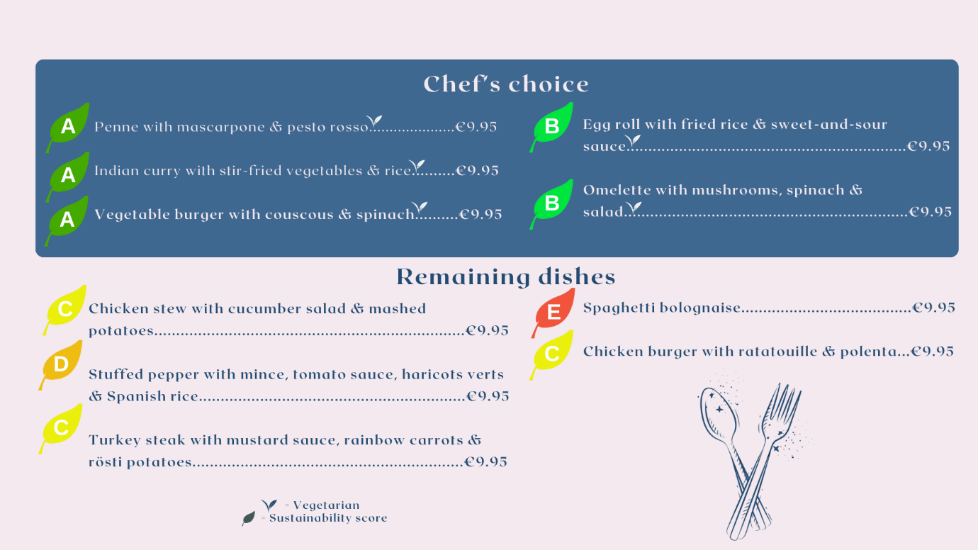

Presence group
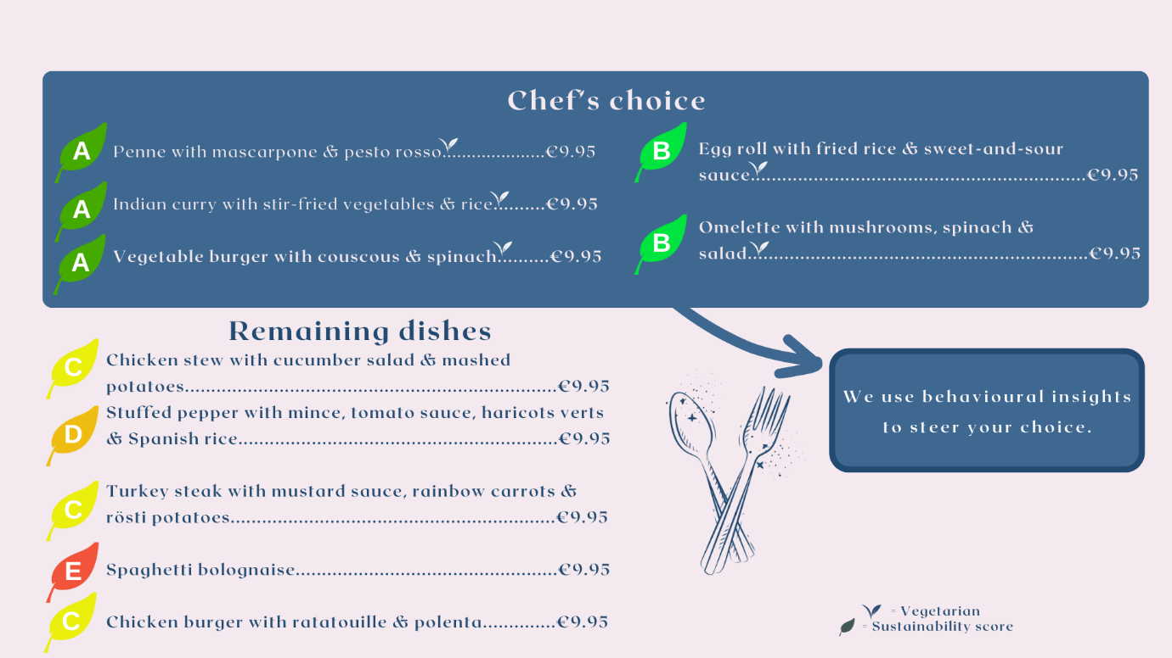
Purpose group
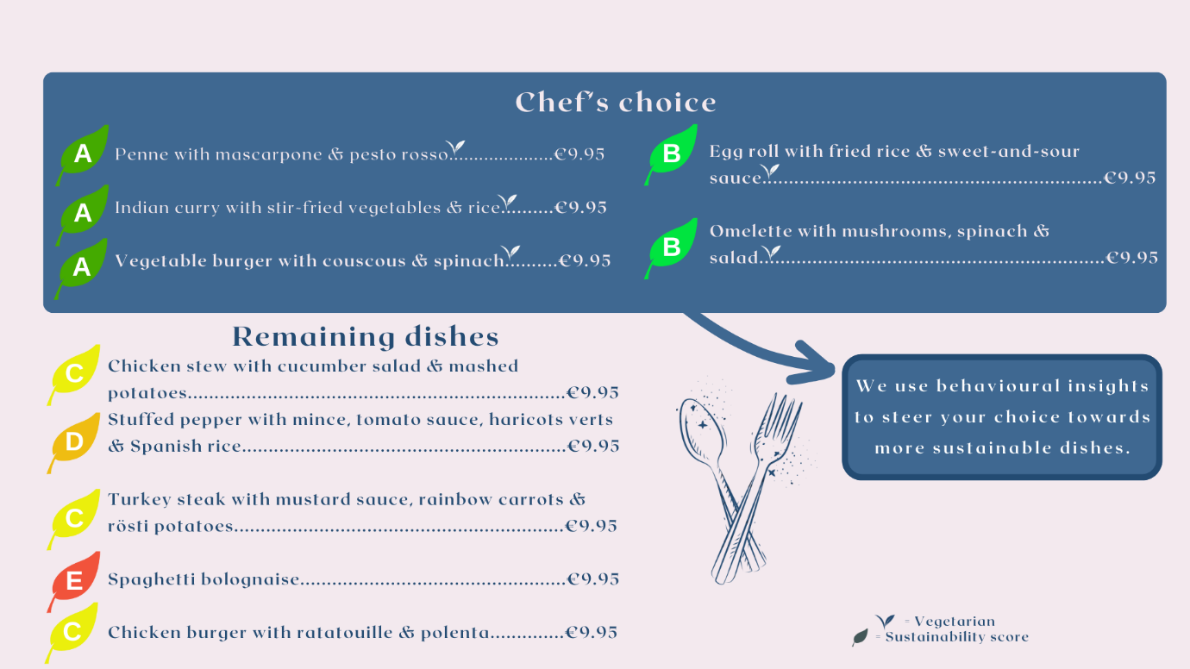

Mechanism group
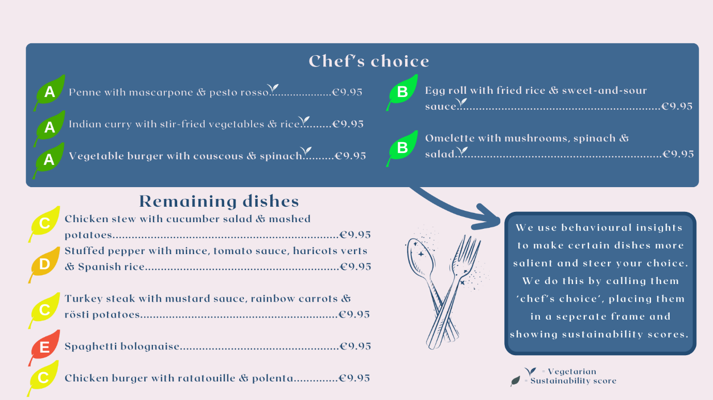
Combined group
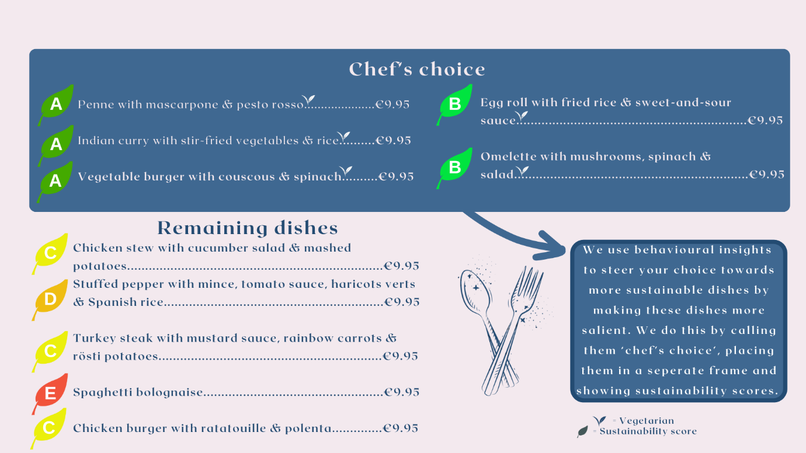

APPENDIX C. Additional analyses
Table 7. Results balance tests
Covariate |  |  | Control | Nudge | Presence | Purpose | Mechanism | Combined | Balance test results
Gender (Women) |  |  | 0.485 | 0.527 | 0.528 | 0.536 | 0.538 | 0.564 | χ²(5) = 4.58, p = .470
Political alignment |  |  | 4.326 (1.669) | 4.288 (1.468) | 4.296 (1.589) | 4.299 (1.623) | 4.43 (1.592) | 4.447 (1.661) | F(5, 1790) = 0.59, p = .706
Financial situation |  |  | 3.128 (0.951) | 3.243 (0.956) | 3.152 (0.994) | 3.175 (0.951) | 3.247 (0.993) | 3.149 (0.978) | F(5, 1852) = 0.84, p = .520
Vegetarianism |  |  | 5.177 (1.969) | 4.957 (1.984) | 5.174 (1.856) | 5.297 (1.827) | 5.325 (1.783) | 4.93 (2.070) | F(5, 1910) = 2.37, p = .037*
Age |  |  | 51.839 (17.903) | 54.55 (16.839) | 53.447 (17.139) | 52.453 (17.659) | 53.128 (18.172) | 52.470 (16.774) | F(5, 1910) = 0.95, p = .444
Edu-cation | Middle school / no degree |  | n = 17 | n = 10 | n = 17 | n = 15 | n = 6 | n = 14 | χ²(10) = 8.60, p = .571
Edu-cation | High school |  | n = 203 | n = 174 | n = 183 | n = 187 | n = 185 | n = 202 | χ²(10) = 8.60, p = .571
Edu-cation | University/ college |  | n = 134 | n = 118 | n = 104 | n = 118 | n = 114 | n = 113 | χ²(10) = 8.60, p = .571
Food preference: sustainability |  |  | 3.11 (0.949) | 3.189 (0.886) | 3.164 (0.863) | 3.091 (0.954) | 3.161 (0.876) | 3.167 (0.922) | F(5, 1910) = 0.56, p = .734
Food preference: health |  |  | 3.932 (0.76) | 3.927 (0.757) | 3.905 (0.69) | 3.944 (0.736) | 3.944 (0.679) | 3.924 (0.77) | F(5, 1910) = 0.12, p = .987
Food preference: taste |  |  | 4.363 (0.705) | 4.447 (0.584) | 4.395 (0.657) | 4.450 (0.558) | 4.43 (0.614) | 4.452 (0.628) | F(5, 1910) = 1.11, p = .352
Hunger |  |  | 34.839 (29.144) | 33.301 (28.062) | 31.878 (28.441) | 33.838 (28.028) | 32.607 (28.346) | 30.745 (27.596) | F(5, 1910) = 0.89, p = .490
Mean and standard deviation per experimental group provided. Count of each instance provided for education.
* p < .05. ** p < .01. *** p < .001

Table 8. Post hoc Tukey HSD Test for vegetarianism
Vegetarianism |  | Mean Difference (I-J) | 95% CI |  | Adjusted p
(I) group | (J) group | Mean Difference (I-J) |  |  | Adjusted p
(I) group | (J) group | Mean Difference (I-J) | Lower Bound | Upper Bound | Adjusted p
Control | Nudge | -0.221 | -0.649 | 0.208 | 0.685
 | Presence | -0.003 | -0.431 | 0.425 | 1.000
 | Purpose | 0.119 | -0.303 | 0.542 | 0.966
 | Mechanism | 0.147 | -0.280 | 0.575 | 0.924
 | Combined | -0.247 | -0.666 | 0.172 | 0.543
Nudge | Presence | 0.217 | -0.228 | 0.662 | 0.731
 | Purpose | 0.340 | -0.099 | 0.779 | 0.235
 | Mechanism | 0.368 | -0.077 | 0.812 | 0.172
 | Combined | -0.027 | -0.463 | 0.410 | 1.000
Presence | Purpose | 0.123 | -0.316 | 0.561 | 0.968
 | Mechanism | 0.150 | -0.294 | 0.594 | 0.929
 | Combined | -0.244 | -0.679 | 0.191 | 0.599
Purpose | Mechanism | 0.028 | -0.411 | 0.466 | 1.000
 | Combined | -0.367 | -0.796 | 0.063 | 0.145
Mechanism | Combined | -0.394 | -0.829 | 0.041 | 0.101
* p < .05. ** p < .01. *** p < .001

Table 9. TOST Equivalence testing for nudge effectiveness
 | Lower bound |  | Upper bound |  | 90% CI
 | Z | p | Z | p | 90% CI
Presence | 3.23 | 0.001*** | -0.61 | 0.271 | [-0.013; 0.118]
Purpose | 2.71 | 0.003** | -1.16 | 0.123 | [-0.034; 0.096]
Mechanism | 2.01 | 0.022* | -1.80 | 0.036* | [-0.062; 0.070]
Combined | 1.18 | 0.119 | -2.69 | 0.004** | [-0.095; 0.035]
Bounds set at +/- 0.076, based on Cohen’s h power analysis (power = 0.08, α = 0.05)
Reference group: Nudge group
* p < .05. ** p < .01. *** p < .001

Table 10. TOST Equivalence testing for perceived autonomy
 | Lower bound |  | Upper bound |  |  | 90% CI
 | t | p | t | p | B (SE) | 90% CI
Presence | 2.876 | 0.002** | -2.786 | 0.003** | 0.002 (0.038) | [-0.061; 0.065]
Purpose | 1.014 | 0.149 | -4.694 | <0.001*** | -0.068 (0.038) | [-0.131; -0.007]
Mechanism | 1.876 | 0.031* | -3.622 | <0.001*** | -0.034 (0.039) | [-0.099; 0.030]
Combined | 1.769 | 0.039* | -3.963 | <0.001*** | -0.041 (0.038) | [-0.103; 0.021]
Bounds set at +/- 0.108 based on Cohen’s d power analysis (power = 0.08, α = 0.05)
Reference group: Nudge group
* p < .05. ** p < .01. *** p < .001

Table 11. Logistic regression analysis of nudge effectiveness including interaction effects
(9)
Sustainable dish
 | B(SE) | Z
Constant | 0.706 (0.594) | 1.188
Nudge | -0.047 (0.872) | -0.054
Presence | -1.434 (0.922) | -1.556
Purpose | -0.042 (0.874) | -0.049
Mechanism | -0.079 (0.946) | -0.084
Combined | 0.358 (0.826) | 0.433
Gender: female | 0.007 (0.252) | 0.026
Political alignment | -0.199 (0.076)** | -2.615
Financial situation | 0.190 (0.134) | 1.415
Vegetarianism | -0.229 (0.066)*** | -3.497
Nudge x gender | 0.571 (0.360) | 1.586
Presence x gender | 0.637 (0.366) | 1.740
Purpose x gender | 0.616 (0.356) | 1.729
Mechanism x gender | 0.928 (0.370)* | 2.504
Combined x gender | 0.204 (0.351) | 0.581
Nudge x political alignment | 0.096 (0.115) | 0.832
Presence x political alignment | 0.105 (0.112) | 0.939
Purpose x political alignment | 0.081 (0.108) | 0.747
Mechanism x political alignment | 0.008 (0.114) | 0.071
Combined x political alignment | 0.027 (0.108) | 0.253
Nudge x financial situation | -0.283 (0.190) | -1.489
Presence x financial situation | 0.040 (0.188) | 0.214
Purpose x financial situation | -0.030 (0.190) | -0.160
Mechanism x financial situation | 0.127 (0.191) | 0.667
Combined x financial situation | -0.058 (0.184) | -0.317
Nudge x vegetarianism | 0.149 (0.092) | 1.619
Presence x vegetarianism | 0.134 (0.095) | 1.414
Purpose x vegetarianism | -0.033 (0.097) | -0.342
Mechanism x vegetarianism | -0.093 (0.104) | -0.900
Combined x vegetarianism | 0.032 (0.091) | 0.355
N | 1737
Pseudo R² (McFadden’s) | 0.066
X² | 396.211
P | 0.000***
Note: coefficients are log-odd estimates and should not be interpreted as predicted probabilities.
Significance using p-values refers to whether the estimated coefficient differs from zero:
* p < .05. ** p < .01. *** p < .001 (two-tailed test)

Table 12. Linear regression analysis of perceived autonomy including interaction effects
(10)
Sustainable dish
 | B(SE) | Z
Constant | 3.192 (0.224)*** | 14.264
Nudge | -0.858 (0.358)* | -2.394
Presence | -0.469 (0.349) | -1.341
Purpose | -0.268 (0.351) | -0.764
Mechanism | -0.710 (0.377) | -1.884
Combined | 0.315 (0.335) | 0.941
Vegetarianism | -0.010 (0.014) | -0.708
Financial situation | 0.019 (0.027) | 0.699
Political alignment | -0.028 (0.016) | -1.759
Food preference: sustainability | -0.033 (0.031) | -1.074
Food preference: health | 0.110 (0.037)** | 2.953
Food preference: taste | 0.077 (0.037)* | 2.067
Nudge x vegetarianism | 0.012 (0.020) | 0.623
Presence x vegetarianism | -0.013 (0.020) | -0.657
Purpose x vegetarianism | -0.017 (0.021) | -0.830
Mechanism x vegetarianism | 0.012 (0.021) | 0.559
Combined x vegetarianism | -0.014 (0.019) | -0.730
Nudge x financial situation | 0.029 (0.040) | 0.726
Presence x financial situation | 0.019 (0.039) | 0.500
Purpose x financial situation | 0.045 (0.039) | 1.143
Mechanism x financial situation | -0.006 (0.039) | -0.144
Combined x financial situation | -0.021 (0.039) | -0.554
Nudge x political alignment | 0.028 (0.025) | 1.125
Presence x political alignment | 0.029 (0.023) | 1.228
Purpose x political alignment | 0.006 (0.023) | 0.264
Mechanism x political alignment | 0.009 (0.024) | 0.383
Combined x political alignment | 0.012 (0.023) | 0.542
Nudge x Food preference: sustainability | 0.123 (0.046)** | 2.661
Presence x Food preference: sustainability | 0.061 (0.047) | 1.313
Purpose x Food preference: sustainability | 0.043 (0.045) | 0.954
Mechanism x Food preference: sustainability | 0.097 (0.047)* | 2.081
Combined x Food preference: sustainability | 0.080 (0.045) | 1.785
Nudge x Food preference: health | -0.098 (0.055) | -1.778
Presence x Food preference: health | -0.036 (0.058) | -0.619
Purpose x Food preference: health | -0.124 (0.055)* | -2.234
Mechanism x Food preference: health | -0.138 (0.058)* | -2.356
Combined x Food preference: health | -0.035 (0.053) | -0.661
Nudge x Food preference: taste | 0.109 (0.062) | 1.776
Presence x Food preference: taste | 0.050 (0.057) | 0.884
Purpose x Food preference: taste | 0.117 (0.061) | 1.913
Mechanism x Food preference: taste | 0.182 (0.058)** | 3.135
Combined x Food preference: taste | -0.087 (0.056) | -1.566
N | 1743
Adjusted R2 | 0.069
F | 4.173
P | 0.000***
Significance using p-values refers to whether the estimated coefficient differs from zero:
* p < .05. ** p < .01. *** p < .001 (two-tailed test)

Original survey graphics are in Dutch
Note: we differ from our preregistration by presenting political alignment as a numerical, instead of a categorical variable. Performing a Chi Squared test with political alignment as a categorical variable does not provide a significant result.

