Appendix A: Link to testable version of survey
In order to try different versions of the experiment, please try this demo version of the Qualtrics survey. Note that the informed consent and study information were removed. This demo version also allows picking a condition, which was not in the actual experiment, and is a feature built in only to allow navigating different versions easier:
https://erasmusuniversity.eu.qualtrics.com/jfe/form/SV_7QkW9OQLwGP9gkS

Appendix B: Subgroup analyses for measures collected in the experiment
In this Appendix we systematically explore the association between the measures collected in our study and snack choice, as well as explore if any of the measures are associated with intervention effectiveness.
We first test for main effects, i.e., whether individual characteristics (e.g., hunger) are associated with the likelihood of choosing healthier snacks. These effects are estimated using logistic regression models, with healthy snack choice as the dependent variable and the individual measure (e.g., hunger) as the independent variable. For each measure, we report the coefficient, standard error, and statistical significance in Table B2. All models are univariate, maximizing statistical power but not accounting for potential confounding by other variables. To explore whether these main effects differ by condition, we conducted analyses on the full sample, as well as separately for the random (excluding control) and choice conditions.
The results of these analyses show that the following measures were significant predictors of healthy snack choice (p < .10): hunger, self-reported healthy diet, fruit consumption, vegetable consumption, attitude toward healthy food, attitude toward unhealthy food, need for autonomy, controlled orientation, impersonal orientation, health motivation, susceptibility to calorie labeling (full and random samples), and susceptibility to financial incentives (choice condition). Interestingly, the significant effect of hunger was only present for respondents in the choice condition, and this could potentially bias our main conclusions. Hence, we re-ran models 1-6 as reported in Table 4 and included hunger as a control variable. As shown in Table B1, our conclusions are unaffected.
Next, we test for interaction effects, assessing whether the effect of an intervention on snack choice is moderated by individual characteristics (e.g., hunger × intervention). As in the main effect models, we use logistic regression with healthy snack choice as the dependent variable. Each model includes two main predictors—intervention (with the control group as the reference category) and the individual measure (e.g., hunger)—as well as their interaction term. We report coefficients, standard errors, and significance levels for all interaction terms in Table B2. These analyses are conducted only in the random condition, as analyses in the choice condition would be confounded by self-selection. For each measure, we estimate four interaction effects: one for each of the three intervention arms and one capturing the effect of receiving any intervention versus control.
The results of these analyses show that the following measures significantly moderated intervention effectiveness (p < .10): age (any intervention, calorie labeling), fruit consumption (financial incentives), demands for commitment (social norms), risk preference (social norms), time preference—impatience (calorie labeling), attitude toward healthy food (financial incentives), and impersonal orientation (social norms).

Table B1. Logistic regressions with the healthier food choice as dependent variable (as in Table 4), and hunger as a control variable
 | 1  All data | 2  Random | 3  Choice | 4  Calorie | 5  Incentive | 6  Norm
Choice | 0.51 (0.23)+ |  |  | 0.26 (0.26) | -0.18 (0.26) | 0.40 (0.46)
Random intervention | 0.38 (0.24)
Calorie labelling |  | 0.31(0.29) | 0.66 (0.28)*
Financial incentive |  | 0.52 (0.30)+ | 0.42 (0.26)
Social norm |  | 0.17 (0.29) | 0.62 (0.46)
Control variables
Hunger | 0.13 (0.04)*** | 0.04 (0.05) | 0.18 (0.06) ** | 0.19 (0.08)* | 0.12 (0.07)+ | 0.16 (0.09)+
Note: +,*,**,*** signify p<0.10,<0.05, <0.01 and <0.001 respectively. Models 1(d)-3(d) use the control condition as baseline. Models 4(d)-6(d) are run on respondents who received one of the three interventions and take randomly assigned interventions as baseline.

Table B2. Logistic regression coefficients (standard error in brackets) for main effects of each of the measured characteristics and healthy food choices, as well as interaction effects between measured characteristics and interventions. Colour coded to facilitate interpretation
 | Main effects |  |  | Interaction effects (predictor x intervention)
 | All data | Random condition (excluding control) | Choice condition | All random interventions | Calorie labelling | Financial incentives | Social norms
Demographics
Age | 0.037 (0.02)+ | 0.087 (0.037)* | 0.022 (0.028) | 0.11 (0.059)+ | 0.152 (0.082)+ | 0.075 (0.07) | 0.125 (0.084)
Sex: Female | 0.039 (0.17) | 0.046 (0.263) | 0.005 (0.25) | 0.169 (0.594) | -0.12 (0.685) | 0.352 (0.736) | 0.377 (0.701)
BMI | -0.006 (0.025) | -0.054 (0.039) | 0.024 (0.038) | -0.114 (0.096) | -0.127 (0.107) | -0.135 (0.116) | -0.07 (0.112)
Self-reported behaviour
Hunger | 0.125 (0.042)** | 0.065 (0.063) | 0.245 (0.065)*** | 0.099 (0.136) | 0.084 (0.161) | -0.008 (0.169) | 0.201 (0.16)
Diet | 0.227 (0.044)*** | 0.225 (0.068)*** | 0.206 (0.066)** | -0.098 (0.14) | 0.044 (0.17) | -0.199 (0.17) | -0.161 (0.173)
Fruit consumption | -0.378 (0.084)*** | -0.644 (0.142)*** | -0.239 (0.121)* | -0.474 (0.28)+ | -0.362 (0.327) | -0.672 (0.354)+ | -0.407 (0.359)
Vegetable consumption | -0.318 (0.111)** | -0.256 (0.164) | -0.298 (0.171)+ | 0.423 (0.384) | 0.178 (0.442) | 0.609 (0.453) | 0.529 (0.47)
Exercise | 0.094 (0.068) | 0.086 (0.106) | 0.175 (0.101)+ | 0.261 (0.232) | 0.537 (0.287)+ | 0.188 (0.279) | 0.09 (0.272)
Economic concepts
Demands commitment | 0.059 (0.073) | 0.062 (0.112) | 0.095 (0.111) | 0.266 (0.245) | 0.245 (0.293) | 0.075 (0.285) | 0.508 (0.309)+
Risk preference | 0.056 (0.074) | 0.066 (0.114) | 0.119 (0.112) | 0.269 (0.237) | 0.001 (0.289) | 0.295 (0.291) | 0.48 (0.288)+
Time preference: impatience | -0.067 (0.071) | -0.037 (0.11) | 0 (0.105) | 0.361 (0.227) | 0.477 (0.275)+ | 0.334 (0.285) | 0.244 (0.272)
Time preference: impulsiveness | 0.064 (0.067) | 0.042 (0.106) | 0.128 (0.1) | 0.091 (0.215) | -0.207 (0.263) | 0.338 (0.281) | 0.246 (0.26)
Psychological concepts
Attitude healthy food | 0.621 (0.075)*** | 0.578 (0.112)*** | 0.722 (0.116)*** | 0.054 (0.266) | -0.23 (0.276) | 0.705 (0.394)+ | 0.128 (0.321)
Attitude unhealthy food | -0.355 (0.065)*** | -0.506 (0.108)*** | -0.17 (0.089)+ | 0.136 (0.253) | 0.159 (0.29) | 0.335 (0.287) | -0.136 (0.335)
Need for autonomy | 0.254 (0.094)** | 0.297 (0.153)+ | 0.21 (0.141) | 0.097 (0.28) | 0.535 (0.381) | -0.438 (0.383) | 0.182 (0.341)
Controlled orientation | -0.176 (0.081)* | -0.098 (0.131) | -0.162 (0.116) | 0.35 (0.275) | 0.23 (0.336) | 0.442 (0.342) | 0.352 (0.323)
Impersonal orientation | -0.215 (0.065)*** | -0.241 (0.106)* | -0.141 (0.093) | 0.193 (0.214) | 0.227 (0.258) | -0.294 (0.306) | 0.429 (0.251)+
Health motivation | 0.393 (0.095)*** | 0.394 (0.15)** | 0.414 (0.141)** | 0.114 (0.291) | 0.194 (0.361) | 0.255 (0.382) | -0.077 (0.348)
Intervention-related concepts
Susceptibility:  calorie labelling | 0.201 (0.058)*** | 0.256 (0.093)** | 0.13 (0.086) | -0.02 (0.183) | 0.175 (0.234) | 0.016 (0.235) | -0.19 (0.216)
Susceptibility: financial incentive | 0.094 (0.071) | 0.04 (0.107) | 0.227 (0.11)* | 0.305 (0.233) | 0.447 (0.277) | 0.208 (0.291) | 0.264 (0.27)
Susceptibility: social norm | 0.103 (0.064) | 0.156 (0.097) | 0.071 (0.1) | 0.16 (0.194) | 0.232 (0.241) | 0.061 (0.248) | 0.15 (0.23)
Note: +,*,**,*** signify p<0.10,<0.05, <0.01 and <0.001 respectively.
Appendix C: Attrition by question and condition
In this Appendix we explore respondent attrition in the field experiment. The experiment was deliberately designed such that most measurements were collected after snack choices, to avoid any spillovers from measuring relevant characteristics on the dependent variable of the study (with hunger as an exception, as respondents may immediately consume their chosen snack). This decision has several potential risks that we studied in this Appendix, that is:
- Respondents received the sole completion incentive early in the study (i.e., after stating their snack choice they received the snack and if applicable the small financial incentive they earned for choosing healthier snacks), and consequently, no incentive was provided for completing any other questions. As such, respondents may be inclined not to fill out questions or quit the survey prematurely.
- Respondents’ allocation to either the random or choice condition may have affected their tendency to complete the study or influenced their tendency to skip some of the questions in the study.
As such, we report in Table C1 the number of respondents completing each question, for the total sample, as well as separately by condition. Furthermore, we tested for differences in attrition between the samples (using Chi-squared tests for independence) and compared the samples on each of the measured characteristics (using independent samples t tests). The results of these analyses suggest that:
- Survey blocks were presented on a single page and respondents had to click a ‘Next’ button to move on to the next page. Drop-out is largest directly after respondents finished a specific block of the survey (structure shown in Table C2, indicated by table borders.). For example, 5% of the sample dropped out after stating their snack choice, and 7.5% of the (remaining) sample dropped out after completing the first page of questions. While some variation in response rates across pages exists (e.g., between diet and attitude toward unhealthy food), these differences are generally small. Overall, later questions tend to have fewer responses, indicating that drop-out increases with survey length.
- After choosing a snack, significantly more respondents in the choice condition drop out from the study (compared to the random condition), i.e., they do not fill out the first question encountered afterwards. We also find that in the choice condition, fewer people fill out information needed to calculate BMI. This is a source of concern, as it suggests that part of the choice condition stimulates subsequent attrition or selective non-response. Note, however, that this represents only 2 out of 20 measures completed after snack choice and we did not correct for multiple hypothesis testing, suggesting these may also be false positives. Importantly, we find no evidence for differences in the means across the random and choice condition for self-rated diet and BMI, even though drop-out on these measures differed between the samples.
- Risk preferences and susceptibility to financial incentives differ significantly between the random and choice condition, with respondents in the choice condition being slightly more risk-taking and assigning a slightly larger importance to the cost of fruit and vegetables. These differences could have different causes that we are unable to disentangle in our design, that is: i) randomisation was not fully successful, ii) selective attrition of respondents, or iii) instructions or content unique to the choice condition causing changes in self-reported measures.
- Although we find no evidence for selective attrition for the main dependent variable (i.e. snack choices), total drop-out was significantly different between the choice and random condition (both including and excluding control). In particular, drop-out was larger in the choice condition.

Table C1. Means (standard deviations) and sample size for each measured characteristic in the study, including % drop-out compared to the previous question.
Variable | Choice | Random (including control) | Total | P value
Hunger | 4.35 (1.80), N = 413 | 4.33 (1.82), N = 451 | 4.34 (1.81), N = 864 | 0.895
% drop from previous | — | — | —
Healthy choice | 0.70 (0.46), N = 399 | 0.65 (0.48), N = 440 | 0.67 (0.47), N = 839 | 0.149
% drop from previous | 3.4% drop | 2.4% drop | 2.9% drop
Diet | 4.95 (1.76), N = 366 | 4.98 (1.79), N = 429 | 4.96 (1.77), N = 795 | 0.79
% drop from previous | 8.3% drop | 2.5% drop | 5.2% drop
Attitude healthy food | 6.76 (1.30), N = 355 | 6.82 (1.29), N = 418 | 6.79 (1.29), N = 773 | 0.554
% drop from previous | 3% drop | 2.6% drop | 2.8% drop
Attitude unhealthy food | 6.52 (1.40), N = 349 | 6.47 (1.50), N = 399 | 6.49 (1.45), N = 748 | 0.638
% drop from previous | 1.7% drop | 4.5% drop | 3.2% drop
Eats fruit daily | 1.74 (0.91), N = 366 | 1.64 (0.85), N = 429 | 1.69 (0.88), N = 795 | 0.116
% drop from previous | -4.9% drop | -7.5% drop | -6.3% drop
Eats vegetables daily | 1.35 (0.64), N = 366 | 1.35 (0.68), N = 429 | 1.35 (0.66), N = 795 | 0.961
% drop from previous | 0% drop | 0% drop | 0% drop
Exercises > 3h/week | 3.40 (1.13), N = 366 | 3.53 (1.08), N = 429 | 3.47 (1.10), N = 795 | 0.097
% drop from previous | 0% drop | 0% drop | 0% drop
Demands commitment | 2.54 (1.07), N = 338 | 2.39 (1.08), N = 397 | 2.46 (1.08), N = 735 | 0.063
% drop from previous | 7.7% drop | 7.5% drop | 7.5% drop
Time preference: impatience | 3.25 (1.12), N = 338 | 3.28 (1.12), N = 395 | 3.26 (1.12), N = 733 | 0.714
% drop from previous | 0% drop | 0.5% drop | 0.3% drop
Time preference: impulsiveness | 3.15 (1.19), N = 329 | 3.12 (1.15), N = 390 | 3.13 (1.17), N = 719 | 0.795
% drop from previous | 2.7% drop | 1.3% drop | 1.9% drop
Risk preference | 3.33 (1.06), N = 332 | 3.17 (1.07), N = 391 | 3.24 (1.07), N = 723 | 0.037
% drop from previous | -0.9% drop | -0.3% drop | -0.6% drop
Susceptibility: calorie labelling | 3.16 (1.38), N = 331 | 3.08 (1.35), N = 391 | 3.11 (1.36), N = 722 | 0.413
% drop from previous | 0.3% drop | 0% drop | 0.1% drop
Susceptibility: financial incentive | 3.87 (1.07), N = 329 | 3.69 (1.13), N = 391 | 3.77 (1.10), N = 720 | 0.035
% drop from previous | 0.6% drop | 0% drop | 0.3% drop
Health motivation | 4.35 (0.83), N = 331 | 4.34 (0.82), N = 392 | 4.35 (0.82), N = 723 | 0.922
% drop from previous | -0.6% drop | -0.3% drop | -0.4% drop
Susceptibility: social norm | 2.67 (1.20), N = 331 | 2.62 (1.28), N = 390 | 2.64 (1.24), N = 721 | 0.629
% drop from previous | 0% drop | 0.5% drop | 0.3% drop
Need for autonomy | 4.07 (0.83), N = 331 | 4.00 (0.82), N = 392 | 4.03 (0.83), N = 723 | 0.257
% drop from previous | 0% drop | -0.5% drop | -0.3% drop
Controlled orientation | 3.21 (1.04), N = 332 | 3.21 (0.94), N = 392 | 3.21 (0.99), N = 724 | 0.915
% drop from previous | -0.3% drop | 0% drop | -0.1% drop
Impersonal orientation | 2.94 (1.29), N = 331 | 2.91 (1.19), N = 390 | 2.92 (1.24), N = 721 | 0.757
% drop from previous | 0.3% drop | 0.5% drop | 0.4% drop
Age | 5.62 (4.77), N = 334 | 5.93 (4.55), N = 391 | 5.79 (4.65), N = 725 | 0.372
% drop from previous | -0.9% drop | -0.3% drop | -0.6% drop
Sex: Non-female | 0.36 (0.48), N = 335 | 0.31 (0.46), N = 391 | 0.33 (0.47), N = 726 | 0.121
% drop from previous | -0.3% drop | 0% drop | -0.1% drop
BMI | 22.33 (3.23), N = 328 | 22.35 (3.01), N = 390 | 22.34 (3.11), N = 718 | 0.937
% drop from previous | 2.1% drop | 0.3% drop | 1.1% drop
Start of survey | N=413 | N=451 | N=864
End of survey | N=328 | N=390 | N=718
Total drop | 20.6% drop | 13.5%drop | 16.9% drop | 0.007
Start of survey (excl. control | N=413 | N=354 | N=767
End of survey (excl. control) | N=328 | N=302 | N=630
Total drop (excl. control) | 20.6% drop | 14.6%drop | 17.8% drop | 0.004
Note: The Qualtrics survey consisted of multiple blocks of questions, each presented on a separate page. In the table above, these blocks are separated by table borders. The P value column reports the results of independent samples t-tests comparing mean scores between the random and choice conditions. Bolded values indicate statistically significant differences between the two conditions, where bolded %drop values indicate Chi-squared tests suggest the observed drop-out is not independent of condition.
Appendix D: Sample size, choice frequencies and minimum detectable effect size per contrast.
In the main text, our main findings are presented in Figure 3, but the exact proportions of healthier or unhealthier snack choices may not be easy to identify. Hence, these are shown in Table D1. We also report minimum detectable effect sizes based on the final sample allocated to or choosing each intervention. These effect sizes were calculated using the pwr package in R, using the function to calculate power for comparing two proportions, with the recommended significance and power levels of 0.05 and 0.8 assuming two-sided test. Using these specifications, our analyses show that our study is powered to detect small to medium effect sizes, as intended. To further facilitate the interpretation of these minimum detectable effect sizes, we also report the smallest increase—relative to the proportion of healthy choices in the no-intervention control group—that our study is powered to detect. That is, Cohen’s h is calculated as follows: 2 × |arcsin(√p₁) − arcsin(√p₂)|, and to facilitate interpretation, we set p1 to 0.594 (i.e., the percentage of healthy choices in the control condition) and calculate the corresponding p2 for Cohen’s h = [0.20, 0.32-0.34, 0.39, and 0.58] (i.e., the minimum detectable effect sizes shown in Table D1). This gives p2 = [0.69, 0.74-0.75, 0.77, 0.84]. In other words, we were powered to observe differences between 9-24% increases in healthy snack choices depending on the comparison. Note that this calculation assumes one-sided tests (i.e., we report the detectable increase in healthy food choice)., while minimum detectable effect sizes were based on two-sided tests, as we did not formulate directional hypotheses. For the sake of completeness, one-sided minimum detectable effect sizes were Cohen’s h = [0.18, 0.28-0.29, 0.34-0.35, 0.51[ with corresponding p2 = [0.68, 0.72-0.73, 0.76, 0.82].

Table D1. Number of healthy and unhealthy choices by condition, with sample size and minimum detectable effect size (MDES) for contrast 1, contrast 2 and contrast 3.
Full sample | Control (n=96) | Random (n=344) | Choice (n=399)
Healthy | 57 (59.4%) | 229 (66.6%) | 278 (69.7%)
Unhealthy | 39 (40.6%) | 115 (33.4%) | 121 (30.3%)
Contrast 2: MDES (vs. control) |  | Cohen’s h = 0.32 | Cohen’s h = 0.32
Contrast 2: MDES (random vs. choice) |  | Cohen’s h = 0.20
Within random | Calorie labelling (n=121) | Incentive (n=112) | Social norm (n=111)
Healthy | 80 (66.1%) | 79 (70.5%) | 70 (63.1%)
Unhealthy | 41 (33.9%) | 33 (29.5%) | 41 (36.9%)
Contrast 1: MDES  (intervention vs. control) | Cohen’s h = 0.38 | Cohen’s h = 0.39 | Cohen’s h = 0.39
Within choice | Calorie labelling (n=164) | Incentive (n=205) | Social norm (n=30)
Healthy | 119 (72.6%) | 137 (66.8%) | 22 (73.3%)
Unhealthy | 45 (27.4%) | 68 (33.2%) | 8 (26.7%)
Contrast 3: MDES  (chosen vs. assigned) | Cohen’s h=0.34 | Cohen’s h = 0.33 | Cohen’s h=0.58

Appendix E: Exploring alternative explanations for effects of chosen interventions.
Our results suggest that chosen interventions outperform randomized interventions. In Table 4 we show that controlling for observed (and significant) predictors of self-selection does not change this conclusion. This partially rules out self-selection as the main mechanism driving these effects (although we cannot rule out self-selection by participants with characteristics we did not observe or control for). In this Appendix, we explore two other possible explanations for the beneficial effects of choosing interventions: i) the act of choosing interventions creates a tendency to choose healthier snacks, and ii) that respondents in the choice condition self-select into interventions with higher conditional average treatment effects.
The act of choosing interventions promotes healthier snack choices.
Respondents in the choice condition may be more likely to choose healthier snacks because they experienced a pressure to act consistently with the previously stated preference for interventions. Ideally, to explore if this mechanism drives healthier snack choices, we would have obtained preferences for interventions some time prior to snack choices in part of the sample, and compared this to respondents who (as in our field experiment) stated their preferred intervention and snack choice in quick succession. The additional time between stating intervention preference and snack choice would likely reduce experienced pressure to act consistently. However, our data does not allow for this comparison. Instead, we relied on respondents in the random condition, who were not asked about their preferences for interventions to inform us about the influence of the act of choosing interventions. Although we do not have data to inform us on their preferred intervention directly, we can rely on the regression models informing self-selection in the choice condition to make an informed ‘guess’ on these respondents’ preferred intervention. The intuition of this analysis is as follows: if the act of choosing interventions fully explains beneficial effects of the choice condition, we should not see a difference between respondents who receive the intervention they would have likely preferred or another intervention altogether.
To explore if this intuition applies, we conducted the following analysis.
- We first estimated a multinomial logistic regression model (see Table E1) using the choice condition only, where the dependent variable was the selected intervention (calorie labelling, financial incentives and social norms). Predictors were selected based on their univariate associations with choice, as shown in Table 4 of the main text, and as such included: age, BMI, demand for commitment, attitude towards the healthier snack,
- This model was then used to predict the most likely intervention choice for each respondent in the random condition (excluding control).
- We then compared the proportion of healthy snack choices across three groups:
- Choice: respondents in the choice condition who received their selected intervention.
- Random (matched): respondents in the random condition who were assigned the intervention our model predicted they would have chosen.
- Random (mismatched): respondents in the random condition who were assigned a different intervention than predicted.
Notably, the model predicted only two random condition respondents to prefer social norm interventions, and as such we are not able to meaningfully compare matched and mismatched respondents in this group. Hence, we focus the remainder of this analysis on calorie labelling and financial incentives.
These comparisons are shown descriptively in Figure E1. We did not perform statistical tests in this exploratory analysis, as our goal was to assess patterns and provide preliminary insights into whether alignment between predicted preference and actual assignment is associated with behavior change. The results suggest that the observed benefits of the choice condition may be partially attributable to being matched with a preferred intervention. Respondents in the Random group who happened to be assigned the intervention our model predicted they would prefer, i.e., random (matched), had higher proportions of healthy choices than those who received a mismatched intervention, i.e., (mis)matched calorie labelling and (mis)matched financial incentives yielded healthy choices in (61.5%) 66.6% and (68.5%) 77.0% of respondents. This finding supports the idea that beneficial effects of choice at least partially occur through alignment with preferred interventions rather than the act of choosing completely driving effectiveness of chosen interventions.
Respondents in the choice condition self-select into more effective interventions.
A second potential explanation for beneficial effects of chosen interventions may be that respondents in the choice condition may be selecting into interventions with higher overall effectiveness, or away from interventions that have little to no effect. The intuition of this explanation is as follows: assume (at least) one of the three interventions has a conditional average treatment effect that is considerably lower than the other interventions, and respondents are able to identify which of the interventions that is. Choice condition respondents have the freedom to self-select such that they do not receive this poorly performing intervention, whereas the random condition respondents are proportionally distributed across the interventions. The large share of respondents receiving the intervention with the lower conditional average treatment may thus bias the overall effectiveness of randomly assigned interventions downwards – and explain why random interventions perform worse than chosen interventions.
To explore if this intuition applies, we conducted the following analysis:
- We reweighted the proportion of healthy snacks chosen in the random condition (per intervention) to reflect the distribution of respondents across the interventions in the choice condition. This allows us to estimate what the overall proportion of healthy snack choices would have been in the random group if participants had been assigned to interventions in the same proportions as those who chose them. Note that we assume in this reweighting that the effectiveness of interventions in the random condition is unaffected by this reweighting. The results of these analyses are shown in Figure E2, where we compared the overall mean proportion of healthy snack choices across four groups:
- Control (randomly assigned no intervention)
- Random (randomly assigned to an intervention, excluding control)
- Random (reweighted) (random assignment adjusted to reflect the Choice group’s intervention distribution, excluding control)
- Self-chosen (participants who chose their preferred intervention)
As expected, given that randomly assigned social norms were the least effective intervention, reweighting the distribution in the random condition to reflect that very few respondents chose norms (and instead preferred more effective intervention), increases the overall proportion of healthy choices in the random reweighted condition by a few percentage points (from 67% to 68%). Intervention in the choice condition remained more effective overall (i.e., 69.7%). The interpretation of this result is not straightforward—it suggests that the higher overall effectiveness observed in the choice condition may stem either from a positive behavioral effect of being able to choose, or from individuals self-selecting into the interventions that are best suited to them, rather than from any change in the intrinsic effectiveness of the interventions themselves.
Table E1. Multinomial regression results for choice condition respondents
Predictor | Calorie vs Incentives | Norms vs Incentives
(Intercept) | -2.89 (1.44)* | -2.513 (2.583)
Age | 0.076 (0.036)* | -0.023 (0.079)
BMI | 0.111 (0.043)** | 0.076 (0.082)
Demand for commitment | 0.067 (0.125) | 0.699 (0.229)**
Diet | -0.049 (0.082) | -0.262 (0.157)+
Attitude towards healthier snacks | -0.169 (0.104) | -0.328 (0.157)*
Need for autonomy | 0.329 (0.175)+ | -0.114 (0.295)
Susceptibility: calorie labelling | 0.34 (0.104)** | 0.375 (0.191)*
Susceptibility: financial incentives | -0.359 (0.128)** | -0.073 (0.227)
Note: +,*,**,*** signify p<0.10,<0.05, <0.01 and <0.001 respectively.

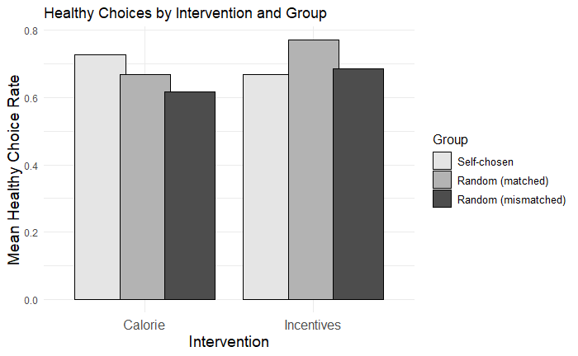
Figure E1. Proportion of healthy choices in respondents receiving self-chosen interventions (choice condition), and random condition respondents randomly receiving interventions ‘matching’ their likely preference or not (mismatched).

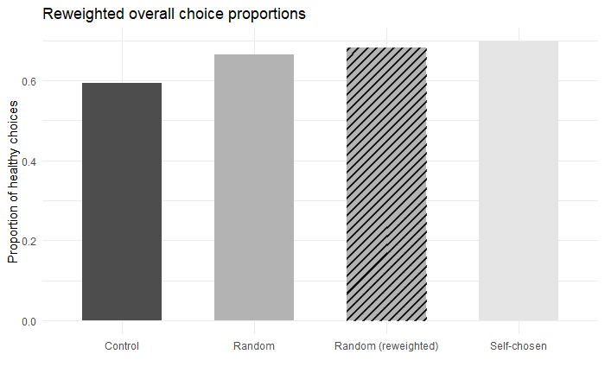
Figure E2. Proportion of healthy choices in control, choice, and random respondents, as well as respondents in the random condition reweighted to mimic the distribution in the choice condition.
Appendix F: Main result with data split by health motivation and year of data collection.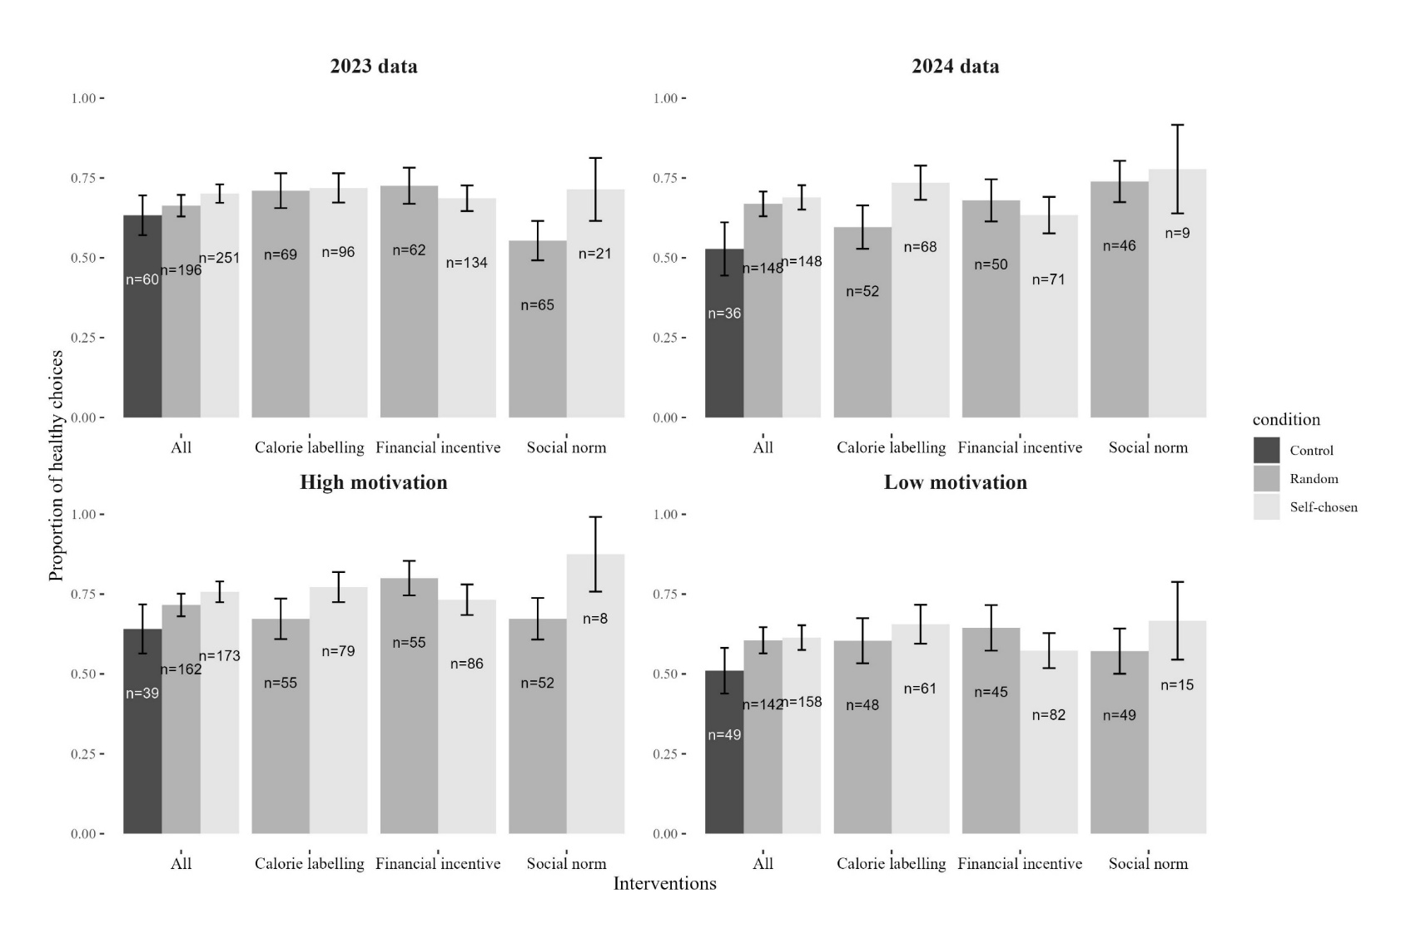
Figure F1. Main study results for sample divided by year of data collection and median split on health motivation (i.e.: ‘The effect of fruit and vegetables on my health is important to me’). Sample was split such that those who agreed strongly with the statement (n=374) were assigned ‘high motivation’ and the remainder of the sample was assigned ‘lower motivation (n=349). It is worth noting that these individuals still had a mean agreement with the statement of 3.6 on a 5 point scale, signalling that the sample on average found the effect of fruit and vegetables on health important.

