**Bridging the intergenerational gap: boosting recycling behavior and policy support through eliciting concerns for future others**

**Supplementary materials**

**Contents:**

Tables S1 to S4

Figures S1 to S2

**Table S1**

*The demographic characteristics of all the participants in Study 1A*

|  |  |  |  |
| --- | --- | --- | --- |
| Variable |  | *N* | Percentage (%) |
| Gender | Female | 207 | 51.75 |
| Male | 193 | 48.25 |
| Age | 18–30 | 204 | 51.0 |
| 31–40 | 154 | 38.50 |
| 41–50 | 31 | 7.75 |
| Over 50 | 11 | 2.75 |
| Education | Secondary school and below | 14 | 3.50 |
| College | 39 | 9.75 |
| University | 320 | 80.0 |
| Graduate school | 27 | 6.75 |
| Average monthly income (yuan) | 5000 and below | 101 | 25.25 |
| 5001–10000 | 151 | 37.75 |
| 10001–15000 | 102 | 25.50 |
| More than 15000 | 46 | 11.50 |

**Table S2**

*The demographic characteristics of all the participants in Study 2A*

|  |  |  |  |
| --- | --- | --- | --- |
| Variable |  | *N* | Percentage (%) |
| Gender | Female | 291 | 62.31 |
| Male | 176 | 37.69 |
| Age | 18–30 | 320 | 68.52 |
| 31–40 | 114 | 24.41 |
| 41–50 | 17 | 3.64 |
| Over 50 | 16 | 3.43 |
| Having child/children | Yes | 192 | 41.11 |
| No | 275 | 58.89 |
| Education | Secondary school and below | 22 | 4.71 |
| College | 71 | 15.20 |
| University | 310 | 66.38 |
| Graduate school | 64 | 13.71 |
| Average monthly income (yuan) | Less than 3000 | 102 | 21.84 |
| 3000–6999 | 126 | 26.98 |
| 7000–10999 | 126 | 26.98 |
| 11000–14999 | 53 | 11.35 |
| 15000 and above | 60 | 12.85 |

**Table S3**

*Ratings of the stimulus material used in Study 2A (N = 50)*

|  |  |  |  |
| --- | --- | --- | --- |
| Variable | *M* | *SD* | One-sample t-test (mean value = 4) |
| Valence | 4.08 | 1.03 | *t* = 0.55, *p* = .584 |
| Arousal | 3.12 | 1.52 | *t* = -4.09, *p* < .001 |
| Affinity | 4.16 | 1.46 | *t* = 0.77, *p* = .443 |
| Gender estimation | 3.70 | 1.75 | *t* = -1.21, *p* = .232 |

We conducted a pilot survey to assess the suitability of materials intended for use in Study 2. There were five images sourced from different newborns, which were then presented to a cohort of fifty participants (*M*age = 29.26, *SD* = 5.76; age range = 20–49, 64% female). For all ratings, people judged how they felt while viewing each picture. The scale of valence ranged from 1 (very negative/unpleasant) to 7 (very positive/pleasant). We also measured whether they felt an emotional arousal and whether they felt an affinity toward the baby from 1 (not at all) to 7 (very much). Finally, people judged what the gender of the baby was from 1 (more likely a boy) to 7(more likely a girl). We selected an image with a moderate level of valence, arousal, and affinity, and its gender estimation remained impartial. The results of the ratings are detailed in Table S3.

**Table S4**

*The demographic characteristics of all the participants in Study 2B*

|  |  |  |  |
| --- | --- | --- | --- |
| Variable |  | *N* | Percentage (%) |
| Gender | Female | 393 | 65.50 |
| Male | 207 | 34.50 |
| Age | 18–30 | 359 | 59.83 |
| 31–40 | 187 | 31.17 |
| 41–50 | 26 | 4.33 |
| Over 50 | 28 | 4.67 |
| Having child/children | Yes | 310 | 51.67 |
| No | 290 | 48.33 |
| Education | Secondary school and below | 23 | 3.83 |
| College | 52 | 8.67 |
| University | 428 | 71.33 |
| Graduate school | 97 | 16.17 |
| Average monthly income (yuan) | Less than 3000 | 128 | 21.33 |
| 3000–6999 | 154 | 25.67 |
| 7000–10999 | 155 | 25.83 |
| 11000–14999 | 78 | 13.00 |
| 15000 and above | 85 | 14.17 |

**Figure S1**

*Facial diagrams illustrating appearances before and after virtual aging*

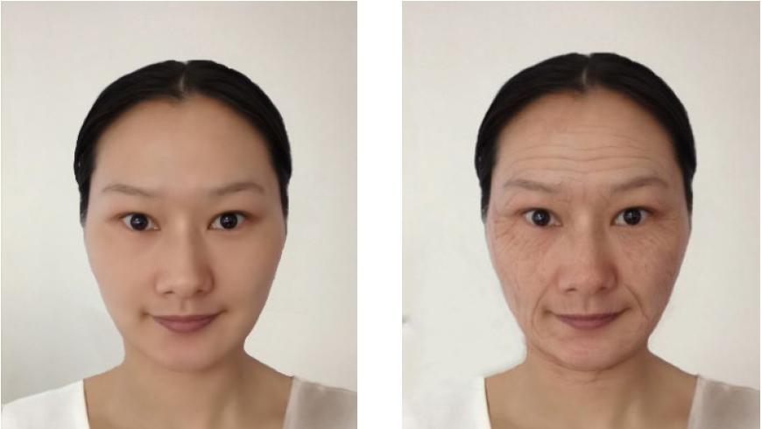

**Figure S2**

*Stimulus provided for the future-other and present-other conditions in Study 2A.*

