**Appendix A: Survey Scripts**

Below, we provide the questions and instructions used in the online survey (the average survey time was approximately six minutes). All participants (1,600 and 1,000 participants in the first and second surveys, respectively) took the exact same questionnaire survey presented in Section A.1.

After the questionnaire survey, the participants were randomly allocated to one of four groups: group with norm information and gender disclosure, group with norm information, group with gender disclosure, and group without additional information. For the participants in the first two groups (i.e., group with norm information and gender disclosure and group with norm information), we showed the instructions in Section A.2. Then, the participant evaluated the agreement score for the ten opinions presented in Section A.3. At that time, we only indicated the gender of the statement poster for each opinion to the participants in the group with norm information and gender disclosure and the group with gender disclosure. The gender of the poster was chosen randomly. To avoid ordering effects, the order of opinions presented to the participants was randomized. An example of a screen displayed during opinion evaluation is shown in Figure A1.

**A.1. Questions in the questionnaire survey (translated from the Japanese original)**

1. Please choose your sex.
   1. Male
   2. Female
2. Please indicate your age.
3. Please choose a prefecture that you live in.
4. How many people are there in the household including yourself?
5. Please tell us about your experience of marriage.
   1. Never married
   2. Married
   3. Bereaved
   4. Divorced
   5. Factual marriage
6. Do you have children?
7. Please indicate the gender of your first child.
8. Choose your nationality.
   1. Japanese
   2. Chinese
   3. Korean
   4. Other
9. Please select your last educational background.
   1. Junior high school degree or less
   2. High school degree
   3. Undergraduate school degree
   4. Junior college, business college degree
   5. Graduate school degree
10. Which political party do you currently support?
    1. No political party to support
    2. Party A
    3. Party B
    4. Party C
    5. Party D
    6. Party E
    7. Other
11. Please select your employment status.
    1. Company director/manager
    2. Company employee
    3. Public servant
    4. Contract worker, temporary worker
    5. Part-time worker
    6. Self-employed / Freelancer
    7. Houseworker
    8. Student
    9. Unemployed (including retired)
    10. Other
12. Please indicate the number of years you have worked.
13. What is the postcode of your residence?
14. Please indicate your annual household income.
    1. Less than 2 million yen
    2. More than 2 million yen, less than 4 million yen
    3. More than 4 million yen, less than 6 million yen
    4. More than 6 million yen, less than 8 million yen
    5. More than 8 million yen, less than 10 million yen
    6. More than 10 million yen, less than 12 million yen
    7. More than 12 million yen, less than 14 million yen
    8. 1400 million yen or more
15. On a scale of one to five, how important do you think it is to address the following issues?
16. Climate change
17. Gender inequality
    1. Not important
    2. Relatively not important
    3. Can’t say either
    4. Relatively important
    5. Important

**A.2. Instructions of norm information presented to randomly selected participants (translated from the Japanese original)**

The following is a summary of the results of a public opinion survey conducted by the Cabinet Office in 2019.

According to the survey, more than 70% of the respondents feel that men are more privileged in society and that gender inequality persists.

Furthermore, more than 90% of respondents require the government to implement policies to promote gender equality.

**A.3. Questions evaluating the agreement score for individual opinion (translated from the Japanese original)**

Ten different opinions expressed anonymously will be displayed on the screen. To what extent do you agree or disagree with each opinion? Please select the option closest to your opinion.

Statement 1. “There are many victims of sexual harassment. To reduce sexual harassment, it should be strictly punished.”

Statement 2. “Japan should formulate a law that requires at least 40% of the board members of listed companies to be women, as has been introduced in Scandinavian countries, to promote women's participation in society.”

Statement 3. “A mother's presence is essential for the education of her children. It is a desirable form of family for a woman to stay at home.”

Statement 4. “It is natural for a married couple to share the same last name, but they should discuss and decide which one to use.”

Statement 5. “Thermal power generation, which emits large amounts of carbon dioxide, should be abolished as soon as possible, and a system for supplying electricity from renewable energy sources should be established.”

Statement 6. “Climate change is becoming more serious every day. Even at the expense of economic growth, efforts to tackle climate change should be pursued rapidly.”

Statement 7. “We should aim for a denitrogenous society, where the same amount of greenhouse gas emissions are absorbed and the net result is zero.”

Statement 8. “To reduce air pollution from automobiles, the government should promote a policy of shifting all domestic vehicles to electric vehicles by 2030.”

Statement 9. “It is necessary to have a defense force in case we are attacked by other countries.”

Statement 10. “The new coronavirus continues to rage around the world. We should wear masks when we go out, especially in crowded places such as trains.”

*[Choices for Opinions 1-10]*

* 1. Strongly agree
  2. Agree
  3. Somewhat agree
  4. Neither agree nor disagree
  5. Somewhat disagree
  6. Disagree
  7. Strongly disagree

*[Debriefing instructions In the first survey, the instructions were not presented to the participants in the control group because they may affect their decisions in the second survey. In contrast, we presented this information to all participants in the second survey.]*

In this survey, you were asked to indicate whether you agree or disagree to ten opinions.

Although we explained "opinions were expressed anonymously,” all the opinions were created by the investigator for the purpose of assessing the level of approval or disapproval of each social problem or issue.

Therefore, all the opinions presented are hypothetical, not realistically expressed.

**A.4: The example of screen displayed during the survey**

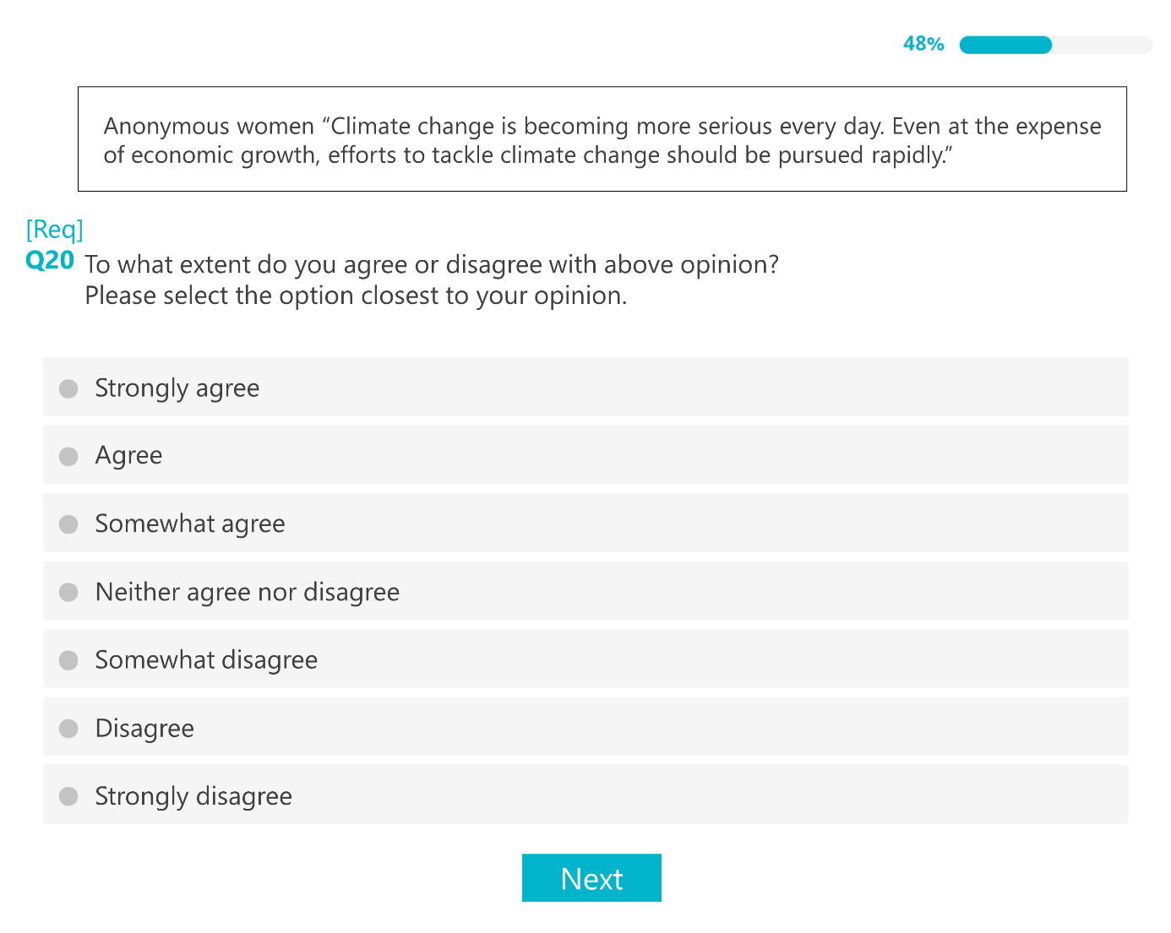

Fig A1. Example of the screen used for evaluation of individual opinions

Note: The language in the figure has been translated into English from Japanese. This figure is an example of a female gender disclosure.

**Appendix B: Detailed description of survey participants**

Appendix B provides a detailed description of survey participants. We recruited 1,600 individuals throughout Japan for the first survey (Fig B1). Table B1 shows the average demographic characteristics of the participants at the group level. The proportion of female participants was 50% for each treatment because of initial screening by gender. By conducting Scheffe’s multiple comparison test, we confirmed that there were no statistical differences in the average of each variable between the four groups.

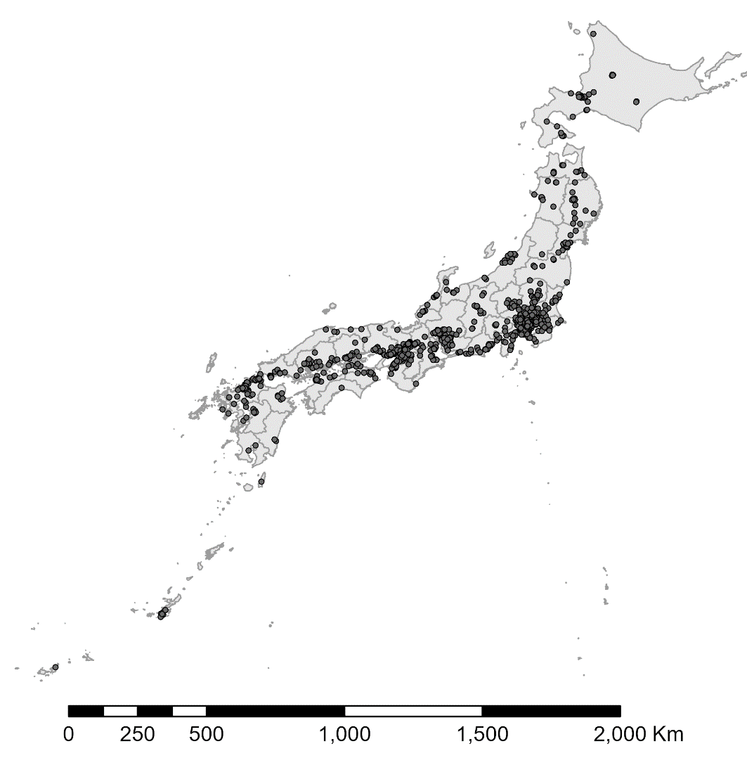

Fig B1. Location of the city where survey participants lived

The average demographic characteristics of our participants were similar to the national average in Japan. For example, the average age and the number of household members in our observations were 44.8 years and 2.7 persons, respectively, which are close to the national averages of 47.7 years and 2.4 persons obtained from the 2020 census data. In addition, approximately 15% of the participants received an annual income of over 10 million yen (equivalent to US$100 thousand). The distribution of annual income shown in Fig B2 confirms that the proportion of each income class was similar to the census data.

In the questionnaire survey, we asked questions about supporting political parties, and 66% of participants responded that they did not support any particular political party. Although 16% of participants supported one political party A, we are not able to disclose the name of the political party due to a contract with the research company. Lastly, we obtained data related to the initial level of interest in gender equality issues. An average of 21% reported that they strongly agree that gender inequality needs to be addressed before the experiment.

Table B1

Average demographic characteristics (the first survey)

|  |  |  |  |  |  |
| --- | --- | --- | --- | --- | --- |
|  | Both treatments | Norm information | Gender disclosure | Control | Total |
|  | (1) | (2) | (3) | (4) | (5) |
| Number of participants | 200 | 200 | 200 | 1000 | 1600 |
| Female proportion (%) | 50 | 50 | 50 | 50 | 50 |
| Age | 44.97 | 44.65 | 44.73 | 44.84 | 44.82 |
|  | (13.55) | (13.64) | (14.12) | (13.81) | (13.78) |
| Number of household members | 2.68 | 2.59 | 2.67 | 2.69 | 2.67 |
| (1.25) | (1.26) | (1.26) | (1.23) | (1.24) |
| University-graduate | 0.47 | 0.52 | 0.51 | 0.49 | 0.50 |
|  | (0.50) | (0.50) | (0.50) | (0.50) | (0.50) |
| Annual income over 10 million yen | 0.15 | 0.11 | 0.17 | 0.15 | 0.15 |
| (0.36) | (0.31) | (0.38) | (0.36) | (0.36) |
| No political party supported | 0.65 | 0.69 | 0.63 | 0.66 | 0.66 |
|  | (0.48) | (0.46) | (0.48) | (0.47) | (0.47) |
| Supporters of political Party A | 0.15 | 0.17 | 0.20 | 0.14 | 0.16 |
|  | (0.36) | (0.37) | (0.4) | (0.35) | (0.36) |
| High interest in gender issues (1=Yes) | 0.21 | 0.18 | 0.19 | 0.23 | 0.21 |
| (0.41) | (0.39) | (0.39) | (0.42) | (0.41) |

Note: Standard deviations are in parentheses. There were no statistical differences between the four groups.

Fig B2. Distribution of annual income among the participants of the first survey

Data source: Ministry of Health, Labour and Welfare of Japan

**Appendix C: Additional tables**

Table C1: Full estimation results for cross-section analysis

|  |  |  |  |  |
| --- | --- | --- | --- | --- |
|  | With gender-sensitive statements | | Without gender-sensitive statements | |
|  | Coefficient | SE | Coefficient | SE |
| Female disclosure | -0.231*** | (0.013) | -0.163*** | (0.007) |
| Female disclosure $×$ normative message | 0.099** | (0.024) | 0.056* | (0.018) |
| Male disclosure | -0.168*** | (0.016) | -0.121*** | (0.009) |
| Male disclosure $×$ normative message | 0.032 | (0.022) | 0.016 | (0.015) |
| Norm information | 0.041*** | (0.007) | 0.049*** | (0.007) |
| Female dummy | 0.090** | (0.019) | 0.026 | (0.030) |
| Age | 0.005 | (0.002) | 0.004 | (0.002) |
| Number of household members | 0.040 | (0.023) | 0.037 | (0.020) |
| University-graduate dummy | 0.020 | (0.034) | -0.055 | (0.029) |
| High income dummy (over 1 million) | -0.146** | (0.045) | -0.120** | (0.034) |
| No political party supported | -0.072 | (0.059) | -0.047 | (0.049) |
| Supporters of political Party A | 0.186* | (0.065) | 0.293** | (0.055) |
| High interest in gender issues (1=Yes) | 0.263** | (0.045) | 0.151* | (0.059) |
| Constant | 1.029*** | (0.133) | 1.118*** | (0.097) |
|  |  |  |  |  |
| Statement dummies | YES | | YES | |
| Prefecture fixed effect | YES | | YES | |
| Observations | 16,000 | | 9,600 | |
| R-squared | 0.201 | | 0.264 | |

Note: The female disclosure variable represents the gender disclosure dummy for women. Female disclosure×normative message is the interaction term between female disclosure and the normative message dummy. The male disclosure variable is a dummy variable indicating the disclosure of the statement poster’s gender as male. The normative message variable denotes whether an individual receives the normative message treatment. Standard errors are clustered at the group level in parentheses; ***, **, and * indicate statistical significance at the 1%, 5%, and 10% levels, respectively.

Table C2: Demographic differences between the control groups in the first and second surveys

|  |  |  |
| --- | --- | --- |
|  | Control group in: | |
|  | First survey | Second survey |
|  | (1) | (2) |
| Number of participants | 1,000 | 187 |
| Average agreement score | 0.89 | 0.81 |
|  | (0.70) | (0.71) |
| Female proportion | 0.50 | 0.49 |
|  | (0.50) | (0.50) |
| Age | 44.84 | 45.90 |
|  | (13.81) | (14.15) |
| Number of household members | 2.69 | 2.63 |
|  | (1.23) | (1.15) |
| University-graduate | 0.50 | 0.49 |
|  | (0.50) | (0.50) |
| Annual income over 10 million yen | 0.15 | 0.15 |
|  | (0.36) | (0.36) |
| No political party supported | 0.66 | 0.60 |
|  | (0.47) | (0.49) |
| Supporters of political Party A | 0.14 | 0.19 |
|  | (0.35) | (0.39) |
| High interest in gender issues (1=Yes) | 0.23 | 0.21 |
|  | (0.42) | (0.41) |

Note: Standard deviations are in parentheses. There were no statistical differences between the two groups.

To examine the sensitivity of the results to the gender-sensitive statements, this study performed robustness checks in which the gender-sensitive statements were excluded from the regression (Table 5). This appendix presents the estimation results excluding each of statements 1 through 10. Panel A and Panel B of Table C1 show the results of the cross-sectional and panel data analyses, respectively. Consistent with the benchmark results, the female disclosure dummy significantly reduced the agreement score and the interaction term was found to be significantly positive in all estimates.

Table C2: Results excluding each statement

|  |  |  |  |  |  |  |  |  |  |  |
| --- | --- | --- | --- | --- | --- | --- | --- | --- | --- | --- |
|  | Statement number excluded from observation | | | | | | | | | |
|  | 1 | 2 | 3 | 4 | 5 | 6 | 7 | 8 | 9 | 10 |
|  | (1) | (2) | (3) | (4) | (5) | (6) | (7) | (8) | (9) | (10) |
| *Panel A: Cross-section (n=14,400)* |  |  |  |  |  |  |  |  |  |  |
| Female gender disclosure | -0.059** | -0.063** | -0.022* | -0.076** | -0.076** | -0.035** | -0.042* | -0.066** | -0.057** | -0.085** |
|  | (0.003) | (0.008) | (0.004) | (0.003) | (0.005) | (0.004) | (0.009) | (0.006) | (0.007) | (0.004) |
| Female gender disclosure | 0.069** | 0.071** | 0.023* | 0.077** | 0.097** | 0.036* | 0.051* | 0.042* | 0.098** | 0.089** |
| $×$ norm information | (0.010) | (0.010) | (0.007) | (0.007) | (0.009) | (0.010) | (0.011) | (0.012) | (0.013) | (0.012) |
|  |  |  |  |  |  |  |  |  |  |  |
| *Panel B: Panel (n=13,932)* |  |  |  |  |  |  |  |  |  |  |
| Female gender disclosure | -0.113* | -0.148** | -0.141** | -0.125* | -0.146** | -0.136* | -0.106* | -0.155** | -0.149** | -0.138* |
|  | (0.054) | (0.055) | (0.055) | (0.054) | (0.055) | (0.055) | (0.054) | (0.055) | (0.055) | (0.055) |
| Female gender disclosure | 0.162* | 0.202* | 0.237** | 0.187* | 0.225** | 0.199* | 0.174* | 0.233** | 0.213** | 0.187* |
| $×$ norm information | (0.078) | (0.078) | (0.078) | (0.078) | (0.079) | (0.078) | (0.077) | (0.079) | (0.079) | (0.079) |

Note: Although this table only provides the results for the two variables, other variables were included in the estimation model. The results for Panel A and B are estimated using Equations 1 and 2, respectively; ** and * indicate statistical significance at the 1% and 5% levels, respectively.