Appendix 1: Working of the smart showers
Hydrao Aloé
The Hydrao Aloé smart shower, used in our study, does not require batteries and is powered by water flow during a shower. The device can record water volume (in whole litres), duration, average temperature, and flow rate per shower. The colour of the LED lights in the shower head changes as set thresholds of water use are reached. During a shower, around two minutes of soaping time is allowed before the next water flow is recorded as a new shower. Due to the device’s simple power source, there are no timestamps of when showers were exactly taken, but only a shower sequence number. The device also has a limited internal memory of 240 showers before the earliest records are overwritten. The device can be connected by Bluetooth to a mobile application to upload the shower data to a cloud database and set the light colours and water use thresholds. Households were only able to access this mobile application after the end of the study. During the study, the mobile application accounts were ‘owned’ by the study team and all data could be downloaded from the cloud database directly by the research team (with consent given by the households). The website of the manufacturer of the device is https://www.hydrao.com/.
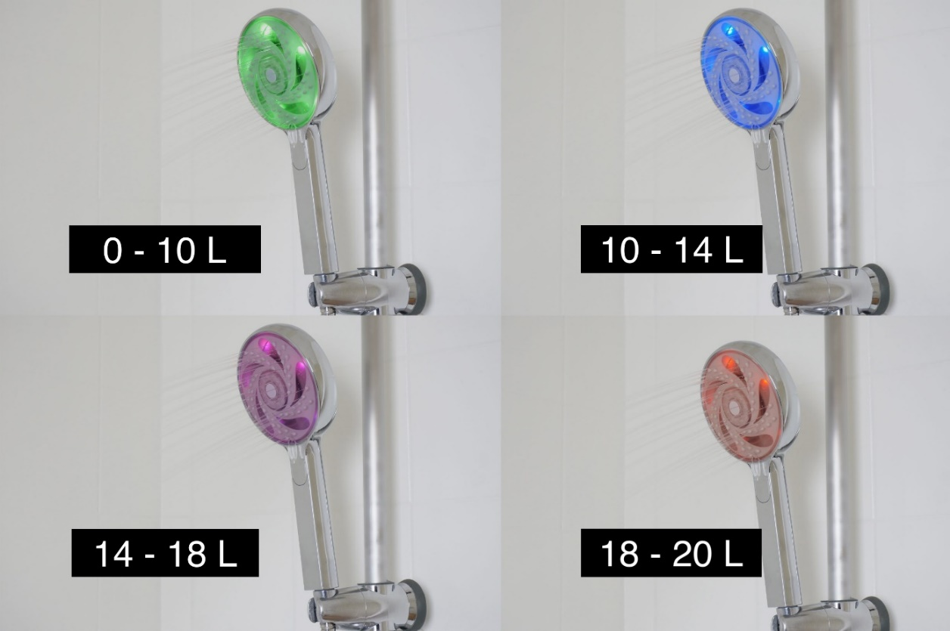
Figure A1. The Hydrao Aloé.

Amphiro B1
The Amphiro B1, which has been used in some other studies, is a water consumption meter that is connected to the shower hose. Similar to the Hydrao Aloé, it is powered by water flow. It can record water volume (in 0.1 litres), duration, average temperature, and flow rate per shower, it does not record a timestamp and has an internal memory for about 240 showers. The device has a monochrome display showing the current water consumption. Additionally, the display also contains a water use indicator (“VERY GOOD”, “OK”, “TOO MUCH”), and a simple animation of a polar bear on an ice shelf that gets smaller as more water is being used, and which disappears when the goal has been surpassed. The device can also be connected by Bluetooth to a mobile application to upload the shower data to a cloud database and set water use thresholds. The Amphiro B1 is no longer in production. The website of the manufacturer is https://www.amphiro.com/.
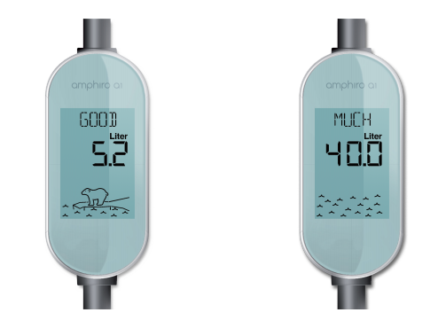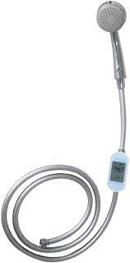
Figure A2. The Amphiro B1.

As part of the Smart Shower Programme and the current study, both the Hydrao Aloé and the Amphiro B1 are installed free-of-charge to residents, but the devices retail for about SGD $150 (about USD $115) in the market (The Straits Times, 2018). The costs of the latest models of the smart shower devices in early 2024, based on the manufacturers’ websites, is about 80-90 Euros. Most households in our study have two bathrooms, so the costs for the devices could come up to about 160-180 Euros (about USD $175-200) per household.

Appendix 2: Baseline summary statistics of treatment and control groups
In any randomized control trial, the randomization protocol is crucial to ensure that the treatment and control group are similar on key characteristics, prior to the treatment intervention. To do this, we use data from the first wave of surveys and additional meter readings before and during the baseline period to allocate the recruited households.
Household baseline water use and household size are key characteristics that may influence our treatment estimates. In early studies, higher baseline use has been found to result in larger savings (Goette et al., 2021) while larger households are likely to have more children or elderly people, which are likely to have different showering behaviours. Moreover, we also consider household's cost-consciousness using their responses to the statements: “Conserving water is important because it saves cost" and “When I choose between products, cost is more important to me than quality" from the first survey. This is because a cost-conscious household might be more susceptible to the smart shower device. Finally, we also look at the number of rooms in a flat and whether the household was located in the Punggol or Choa Chu Kang area.
In Table A2, we show that the randomization has produced a balanced sample between the treatment and control group. Both groups are not significantly different for our key observable baseline characteristics (p-values range from 0.79 to 0.98).
On average, households use about 510 litres per day before intervention, with no significant difference between treatment and control group (p-value = 0.81). A typical household has around 4 people living in 4-room flats. Households tend to agree that saving water is important because it saves costs (mean rating of 1.4) and are neutral in valuing cost more than quality when choosing products (mean rating of 0.12). Both control and treatment group appear to be similar in terms of being cost-conscious. Finally, nearly half of households are located in the Punggol area.

Table A2. Treatment and Control, Balanced on Key Characteristics
Variable | Full | Treatment | Control | F-Statistics (p-value)
No. of Households | 407 | 205 | 202
Mean Household Litres Per Day (Baseline) | 509.61  (13.43) | 506.46  (18) | 512.8  (20.01) | 0.06  (0.81)
Mean Household Size (persons) | 3.90  (0.07) | 3.90  (0.1) | 3.91  (0.1) | 0.00  (0.98)
Mean No. of Rooms | 4.16  (0.03) | 4.17  (0.05) | 4.15  (0.05) | 0.07  (0.79)
Mean Rating – Conserving water is important because it saves cost | 1.42  (0.03) | 1.42  (0.04) | 1.42  (0.05) | 0.00  (0.95)
Mean Rating – When I choose between products, cost is more important to me than quality | 0.12  (0.05) | 0.13  (0.08) | 0.11  (0.08) | 0.01  (0.91)
Proportion Located in Punggol Area (vs Choa Chu Kang Area) | 0.48  (0.02) | 0.48  (0.03) | 0.49  (0.04) | 0.06  (0.81)
Note: Household Litres Per Day (Baseline) is calculated using additional meter readings. This does not coincide exactly with the study’s baseline period since random allocation had to be conducted before the official end of the baseline period or the second visit. Each household had four meter readings over three to four weeks before and during the baseline period. For the cost-consciousness statements, the rating scale is from -2 “Strongly Disagree” to 2 “Strongly Agree”. The F-statistics are taken from regressing the characteristics on treatment households. Unless indicated otherwise, parentheses contain standard errors.

Appendix 3: Ex-post power estimation
For this study, 400 households were targeted for recruitment. In previous studies on smart meters and water conservation, an effect size of 9-10 per cent (water use per shower) (Agarwal et al., 2017) to 19-22 per cent (Tiefenbeck et al., 2018; Agarwal et al., 2017) was observed. Similarly, a treatment effect of 22 per cent was observed for this study. Given an average baseline shower use of 163 LPD, these effect sizes translate to a reduction of about 15-35 litres per day. Using Burlig et al.’s (2020) power estimation approach for experimental panel data, the sample sizes required for different combinations of minimum detectable effect sizes (from 15-30) and power (from 0.70-0.95) were estimated. In all but the most stringent case (mde=15, power=0.95), the achieved sample size used for household-level analysis (n=372) was greater than the estimated required sample sizes. For the achieved sample size, to achieve a power of 0.80, the mde is estimated to be about 12.55.
Table A3. Ex-post power estimation pcpanel package for experimental panel data (Burlig et al., 2020)
Power | Minimum detectable effect (mde) sizes (in levels, not %)
 | 15  (~10%) | 20  (~12%) | 25  (~15%) | 30  (~18%)
0.70 | 206 | 117 | 75 | 53
0.75 | 231 | 131 | 84 | 59
0.80 | 261 | 148 | 95 | 67
0.85 | 298 | 169 | 109 | 76
0.90 | 349 | 197 | 127 | 89
0.95 | 431 | 244 | 157 | 109
Note: Figures show estimated sample sizes required for different combinations of mde and power.

Appendix 4: ANCOVA robustness check
According to McKenzie (2012), a difference-in-difference approach may be underpowered in comparison to an ANCOVA approach that replaces the unit fixed effects by baseline outcome averages. In order to test the robustness of this study’s difference-in-difference test findings, the data was analysed using the robust ANCOVA method (which frees the analysis from the restrictions of homogeneity of regression slopes and other distributional assumptions by picking five points of equal slopes between the covariate and DV for testing). The results are as shown in Table A4: Across all five test points, the intervention (across measurements taken during M2 and M3) was significantly different across the treatment and control groups. Additional analyses with standard errors clustered on households did not change the pattern of results.
Table A4. ANCOVA robustness check
ANCOVA Robustness Check
Test point | Difference in water use  (s.e.) | Lower CI | Upper CI
M1 = 6 | -3.232 ***  (0.471) | -4.456 | -2.008
M1 = 15.408 | -4.867 ***  (0.486) | -6.117 | -3.616
M1 = 21.187 | -5.204 ***  (0.563) | -6.651 | -3.756
M1 = 30.437 | -6.402 ***  (0.841) | -8.584 | -4.256
M1 = 60.649 | -10.188 **  (4.280) | -23.068 | 2.691
Note: | p$<$0.1; ${}^{**}$p$<$0.05; ${}^{***}$p$<$0.01  Standard errors are clustered on devices

Appendix 5: Results without missing data imputation
Table A5.1. Sample distribution across treatment and control without missing data imputation.
Group | No. of households | No. of devices | No. of showers recorded | Mean of water consumption (litres)
Treatment | 187 (2) | 333 (3) | 88,664 (6,104) | 21.58 (-0.16)
Control | 192 (0) | 334 (2) | 90,755 (9,132) | 25.25 (-0.08)
Total | 379 (2) | 667 (5) | 179,419 (15,236) | 23.44 (-0.09)

* NOTE: Figures in parentheses represent the difference (A-B) between the figures with missing data imputation (A) and without missing data imputation (B).

Table A5.1 shows the sample distribution of showers without missing data imputation. While the number of showers dropped by over 15,000, the imputation had minimal effect on the no. of households, no. of devices, as well as the mean water consumption per shower for the analysis. Figure A6 shows the shower water use over the study period with the data imputation – the trends for both the control and treatment groups are similar to Figure 2 in the main text.
Figure A5. Shower water use over the study period without missing data imputation.
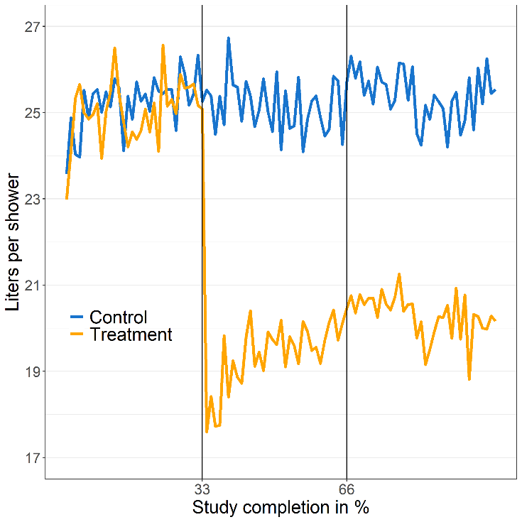

Similarly, Table A5.2 shows the spillover effect analysis without the missing data imputations – results are largely similar to the analysis with the missing data imputed (Table 2 in main text).

Table A5.2. Spillover effect without missing data imputations
Spillover Effect
 | Dependent variable: Water use (litres per day)
 | Overall LPD  (1) | Shower LPD  (2) | Non-shower LPD  (3)
Treatment | -22.195*** | -34.731*** | 12.536*
 | (8.501) | (4.149) | (7.285)
Household fixed effects? | Yes | Yes | Yes
Time fixed effects? | Yes | Yes | Yes
Observations | 1,011 | 1,011 | 1,011
Adjusted R² | 0.956 | 0.906 | 0.950
Note: | ${}^{*}$p$<$0.1; ${}^{**}$p$<$0.05; ${}^{***}$p$<$0.01

Appendix 6: Difference-in-difference estimations for shower frequency
A difference-in-difference estimation was conducted with the shower frequency. Three models were run: model 1 contains data from all devices, model 2 excludes two outlier devices (one in the treatment and one in the control group) that have an extreme increase in the frequency of showers between baseline and intervention periods (by about 5 and 12 showers per day) and model 3 further excludes all devices with incomplete data during the intervention period.
Table A6. Difference-in-difference estimations for shower frequency across three models
Change in shower frequency
 | Dependent variable: Showers Per Day
 | (1) | (2) | (3)
Treatment | -0.104 | -0.116** | -0.113*
 | (0.066) | (0.058) | (0.060)
Excludes outlier devices? | No | Yes | Yes
Excludes devices with partial data during M1? | No | No | Yes
Device fixed effects? | Yes | Yes | Yes
Period fixed effects? | Yes | Yes | Yes
Observations | 2,269 | 2,263 | 2,227
Adjusted R² | 0.920 | 0.935 | 0.939
Note: | ${}^{*}$p$<$0.1; ${}^{**}$p$<$0.05; ${}^{***}$p$<$0.01
 | Standard errors are clustered on devices.

Appendix 7: Spillover effects across subgroups
In order to look at spillover effects at a more granular level, we checked to see if there was heterogeneity in treatment effect among levels of baseline water consumption, as well as household age. The results suggest that the number of older household members seemed to affect the reception to our intervention. While there was weak statistical power, some age heterogeneity, especially in the older age groups, can be observed —the negative spillovers were significantly (p<0.05) stronger for households with people aged 50 and above (see Table A7). The number of household members who generally stay at home did not seem to affect the spillover effect.
Table A7. Spillover effect across subgroups
Spillover Effect
 | Dependent variable: Water use (litres per day)
 | Overall LPD  (1) | Shower LPD  (2) | Non-shower LPD  (3)
Treatment | -23.511*** | -37.048*** | 13.537**
 | (7.856) | (3.982) | (6.656)
Presence of 12 years old & below * Treatment | -0.129 | -7.000 | 6.689
 | (7.527) | (4.442) | (5.774)
Presence of 50 years old & above * Treatment | 21.937* | -0.176 | 22.028*
 | (11.666) | (4.709) | (10.871)
No. of household members who spend most of their time at home * Treatment | 1.990 | 1.192 | 0.793
 | (2.858) | (2.186) | (2.505)
Observations | 1,116 | 1,116 | 1,116
Adjusted R² | 0.959 | 0.925 | 0.948
Note: | p$<$0.1; ${}^{**}$p$<$0.05; ${}^{***}$p$<$0.01

In addition, we looked at the spillover effect across time, in particular comparing the difference in water consumption one month after the intervention as compared to the baseline (M2-M1) as against water consumption after the full treatment (M3-M1). Water consumption patterns were similar across both time periods for both shower water usage as well as non-shower usage (see Figure A6 for the latter), i.e., spillover effects were relatively consistent from M2 to M3.
Figure A7. Change in non-shower litres per day relative to baseline
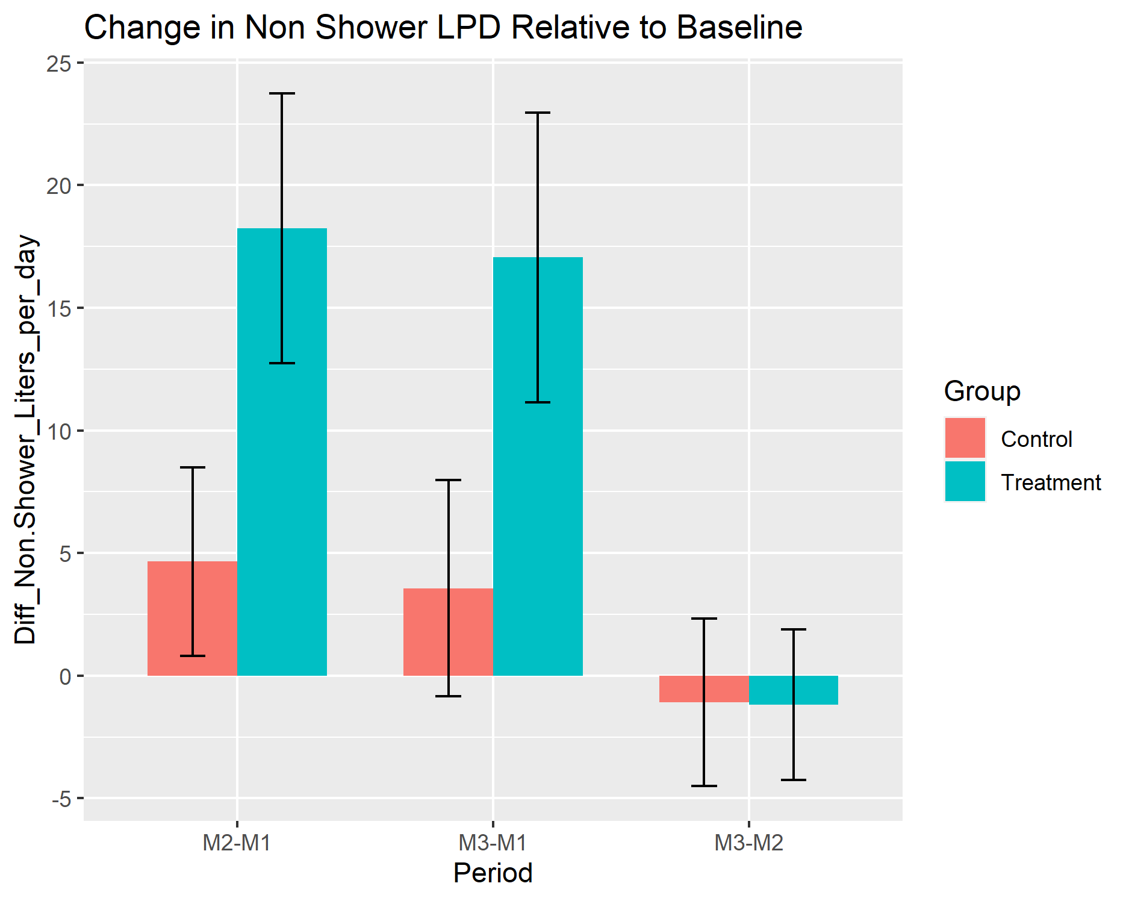

Appendix 8: Water use awareness
In Figures A8.1 & A8.2, we plot the households’ estimated versus actual water use during showers and overlaid a fitted regression line. Points exactly on the 45-degree line refer to households’ estimates that coincide exactly with their actual water use. Alternatively, fitted lines that approach the 45-degree line imply increased awareness. Before the intervention, both treatment and control households’ estimates are uncorrelated with their actual water use. They also tended to underestimate their water use with fitted lines well below the 45-degree line (left graph). After the intervention, treatment households showed increased awareness, with a fitted line approaching the 45-degree line. Interestingly, the control group also appeared to have slightly increased awareness (right graph).

Figure A8.1: Estimated vs. Actual Shower Water Use, Before and After Intervention (Treatment group)
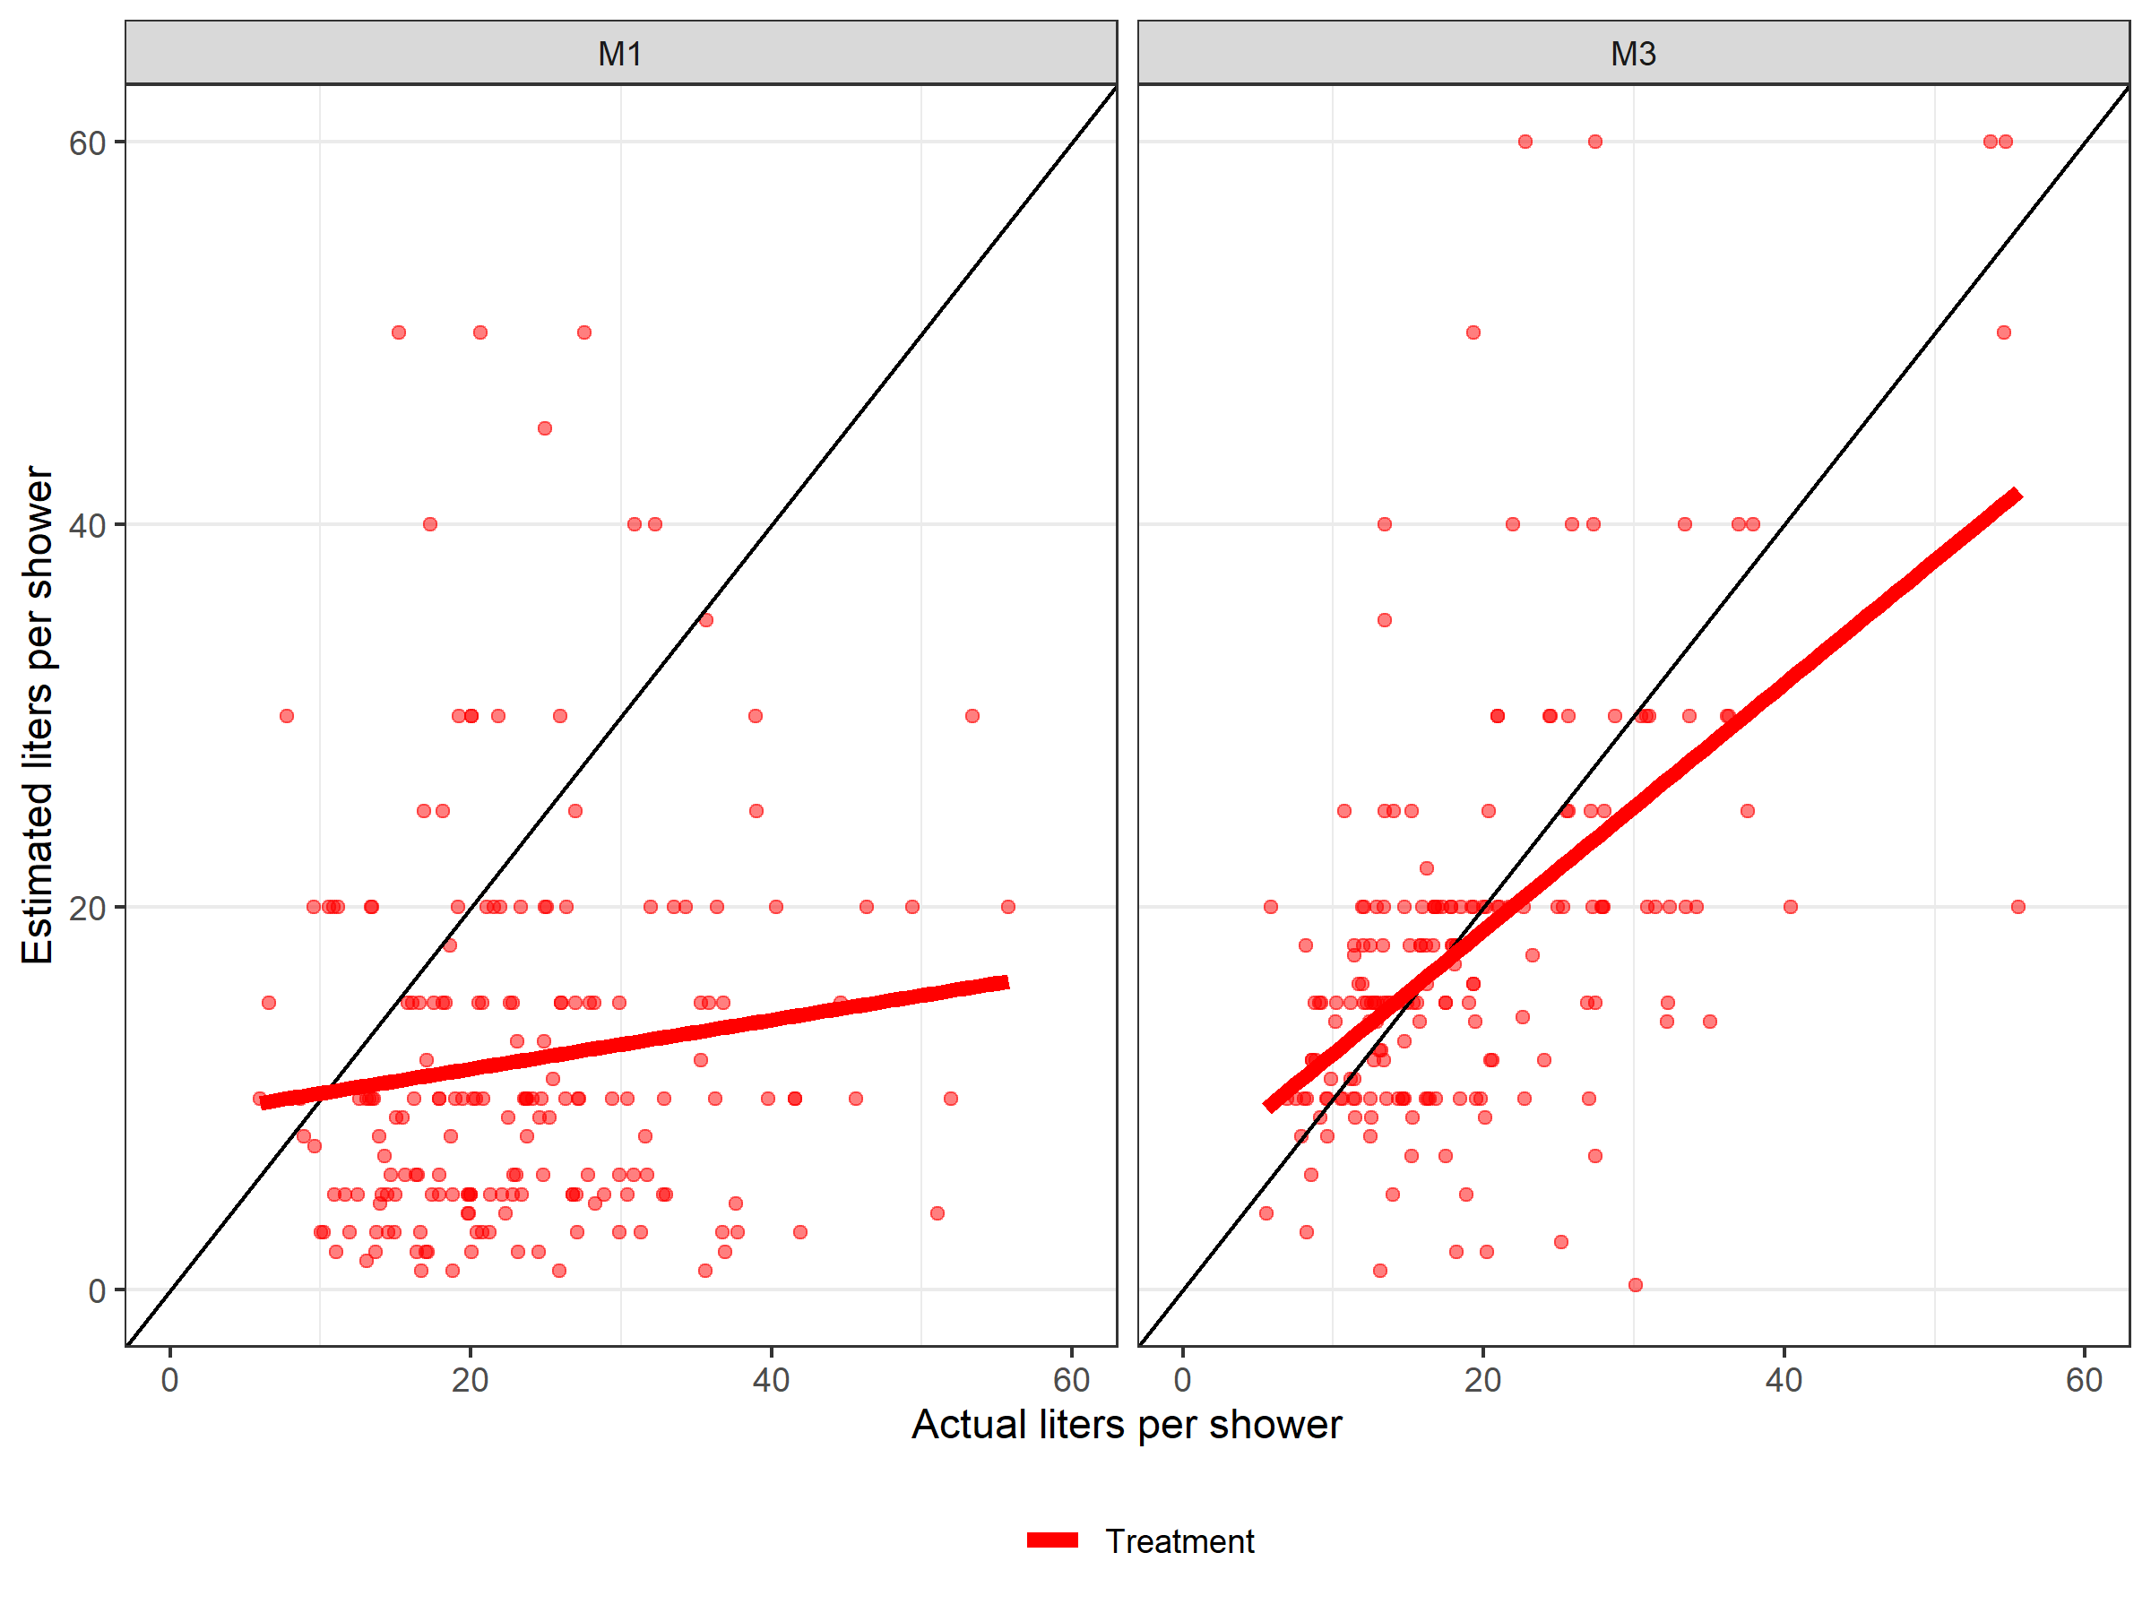

Figure A8.2: Estimated vs. Actual Shower Water Use, Before and After Intervention (Control group)
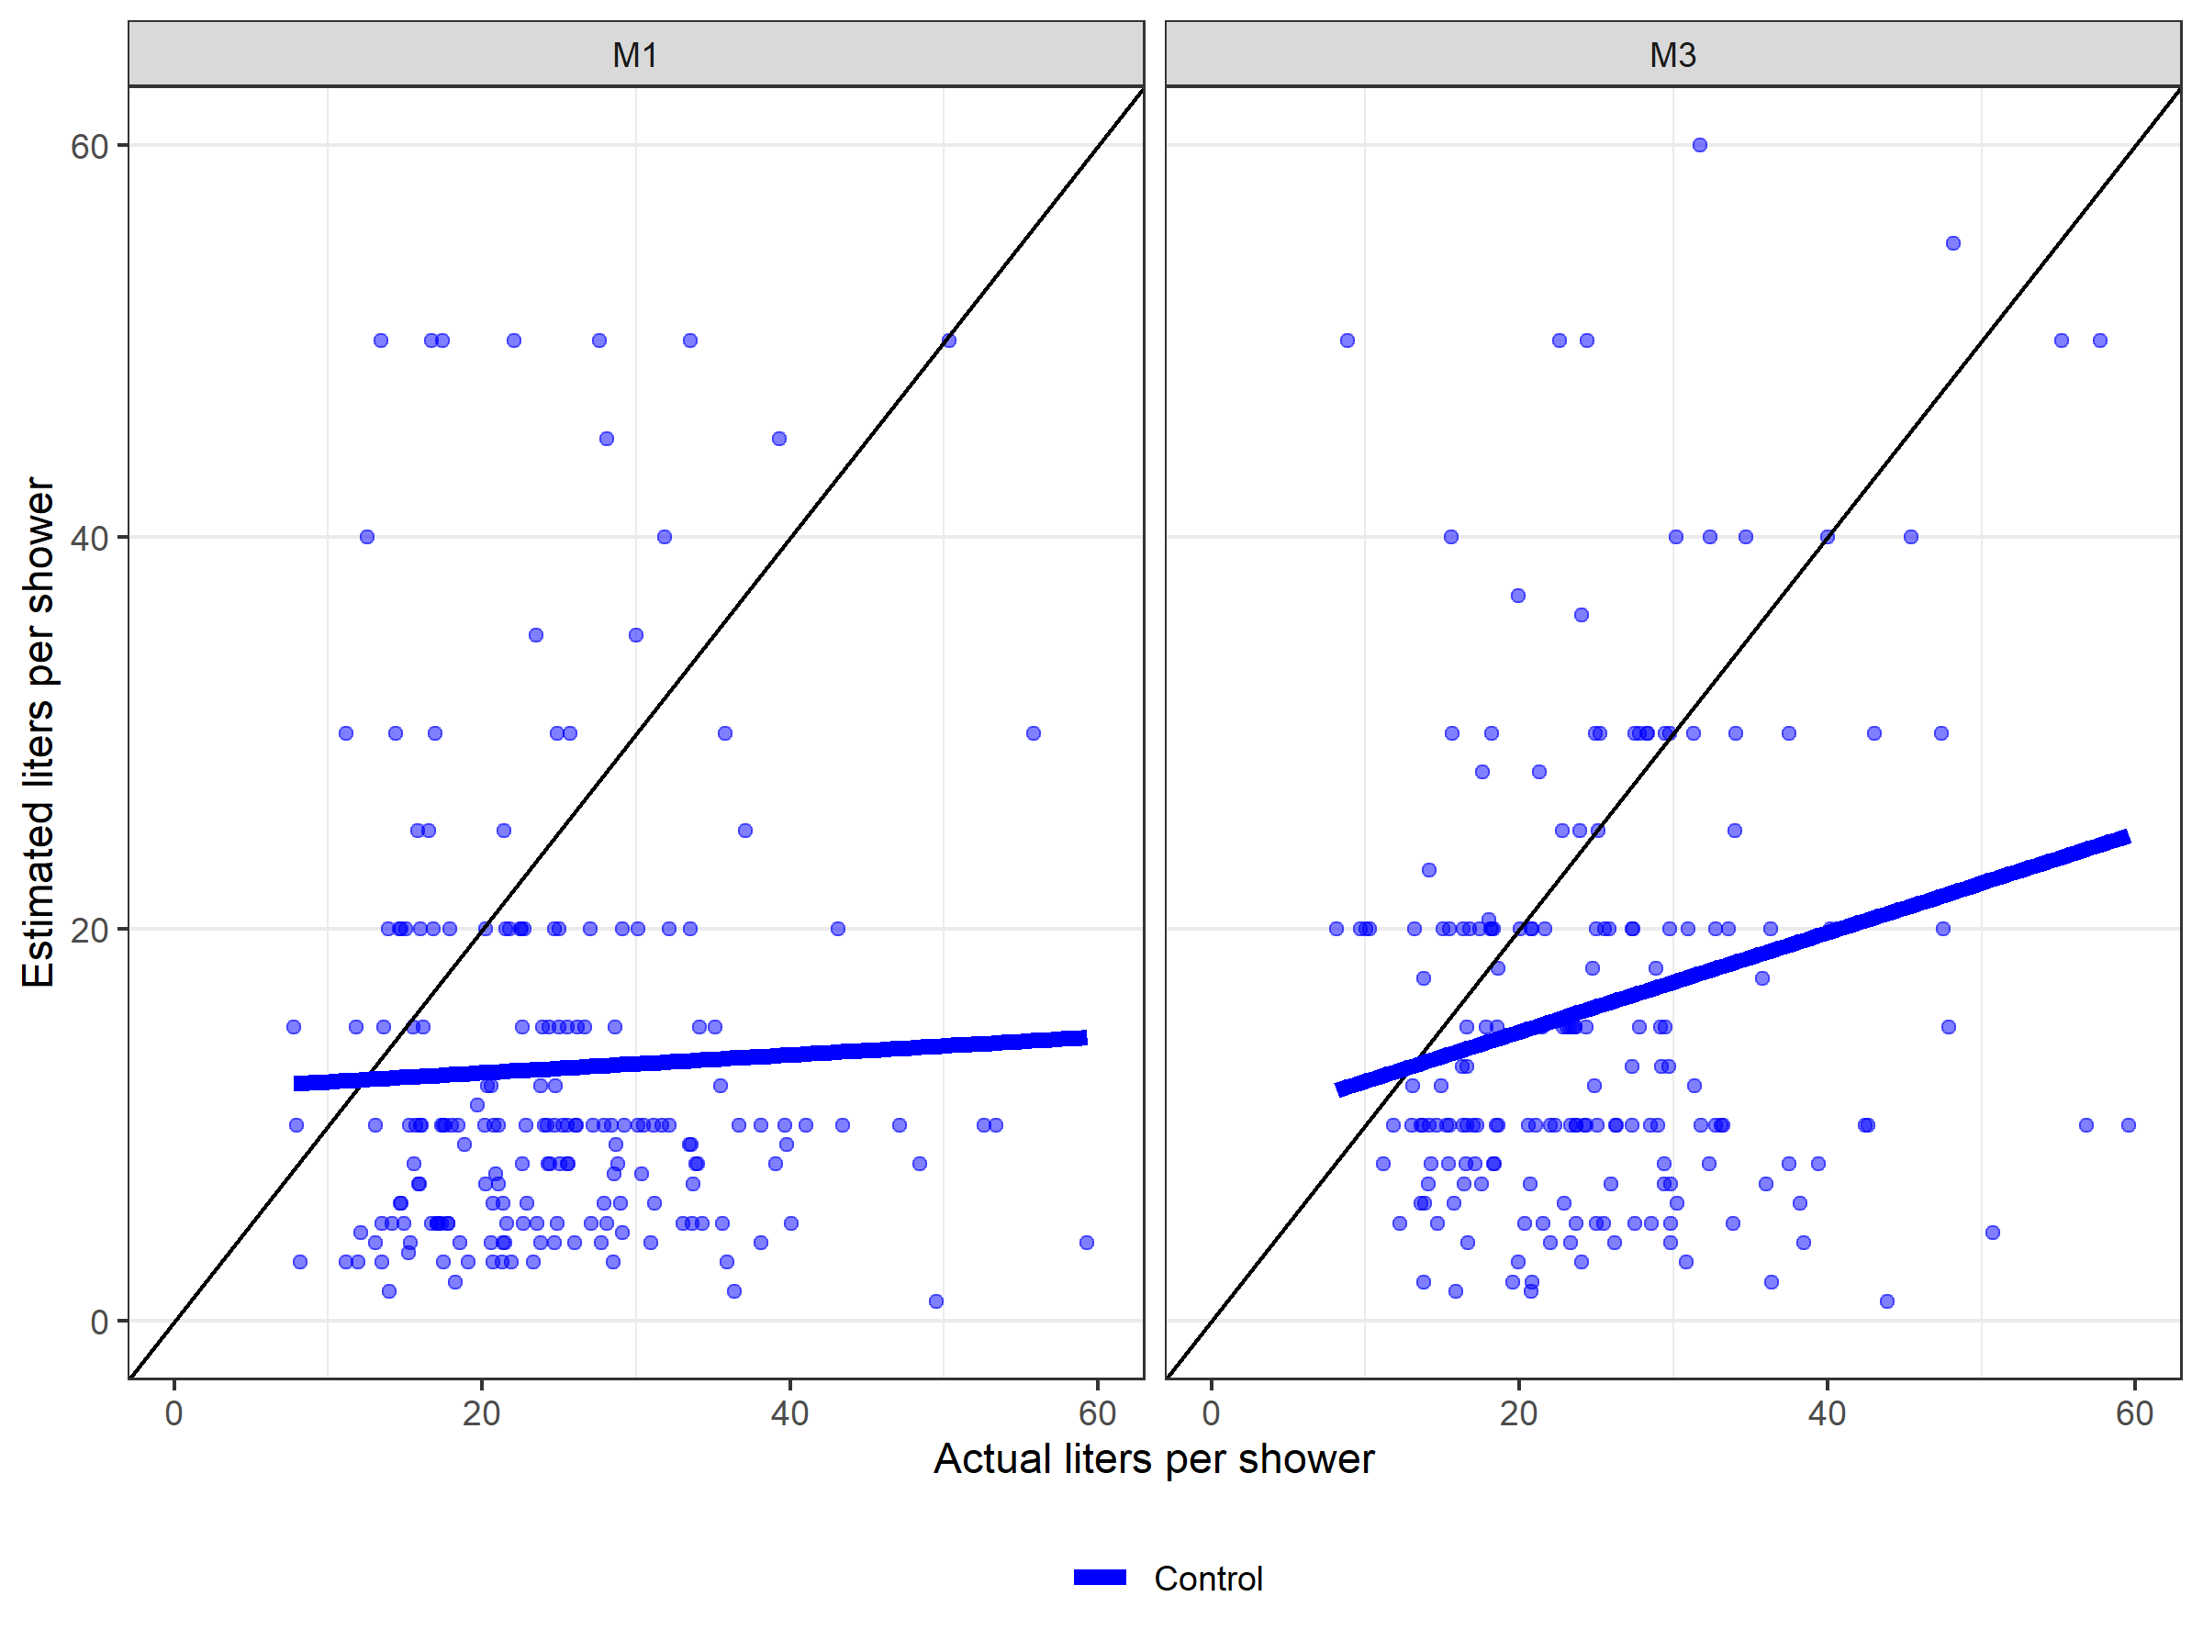
Notes: Household’s estimates of water use during showers were taken from the first (M1) and third (M3) survey responses. Household’s actual water use were taken as the device average during baseline and the second month of the intervention period. Devices must have at least ten showers in either period to be included. Final values take the average of the two devices in a household.

Appendix 9: Overview of water tariffs in Singapore
Singapore’s water comprises three components – Water Tariff, Water Conservation Tax, and Waterborne Fee. The fees for each of the components is also separated into two tiers based on water usage (40m3 or less versus more than 40m3 – 1m3 is equivalent to 1,000 litres). The Water Tariff covers cost incurred during water production, and is charged based on volume of water consumed. The Water Conservation Tax is imposed as a percentage of the water tariff to reflect the marginal cost of water and reinforce the water conservation message. The Waterborne Tax, also charged according to water usage, goes towards meeting the cost of treating used water and maintaining the used water network. Table below shows how the water bill in Singapore is calculated based on these three components.
Figure A9.1: Current pricing structure for Singapore’s water tariffs, and expected pricing based on revised fees in 2024 & 2025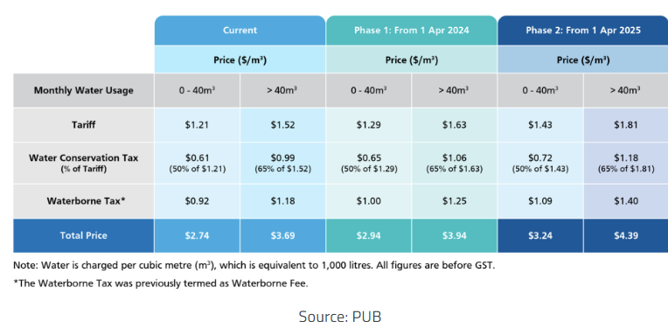

Figure A9.2: Estimated changes in monthly costs (per household) as a result of reduced water usage through the smart shower water device intervention

Appendix 10: Shower statistics
The number of showers per household, as well as number of showers per capita was not significantly different across time period nor treatment groups.
Figure A10.1: Average number of showers per day per capita for control versus treatment groups across the survey period M1 (baseline) to M2 & M3 (post-intervention period)
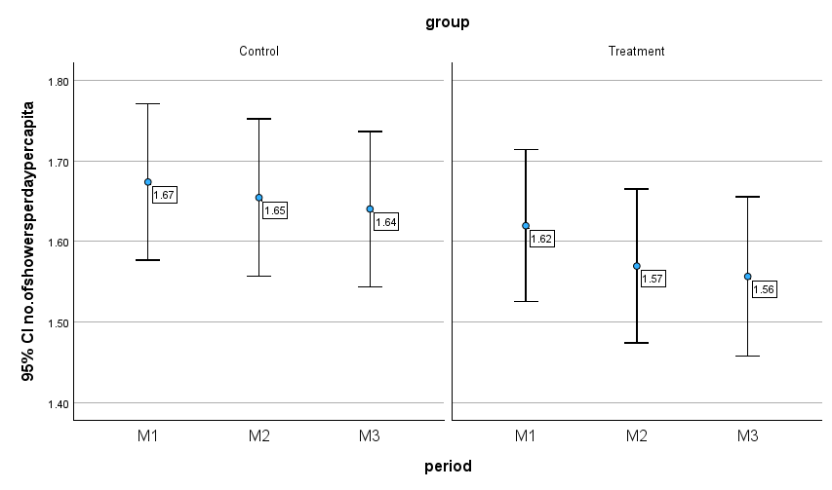
Table A10.1: Average number of showers per day per capita and per household for control versus treatment groups across the survey period M1 (baseline) to M2 & M3 (post-intervention period)
 |  | No. of showers  per day per capita | No. of showers  per day per household
Control | M1 | 1.67 | 6.40
 | M2 | 1.65 | 6.39
 | M3 | 1.64 | 6.34
Treatment | M1 | 1.62 | 6.27
 | M2 | 1.57 | 6.06
 | M3 | 1.56 | 6.07
Total | M1 | 1.65 | 6.34
 | M2 | 1.61 | 6.22
 | M3 | 1.60 | 6.20

Appendix 11: Water pressure in residential high-rise apartments in Singapore
The water pressure at different parts of Singapore varies depending on the elevation of the land and on the time of the day. Generally, the Water Supply (Network) Department maintains a water pressure capable of supplying directly to water fittings not exceeding 25 metres above mean sea level. This means that water supply to water fittings above this level has to be indirect via water storage tanks. The daily water pressure in the distribution system varies with the consumption pattern, being at the highest when the consumption is minimum and lowest when consumption is at the peak (PUB, 2022, p.2).
All the households covered under this study are apartment housing, and all are at the 22nd floor or lower. This implies that almost all households enjoy direct water supply to fittings from water mains. Deviations in terms of water pressure will thus be minimal across households, since they share a common source for their water.

Appendix 12: Personal attitude (on water) statements
Table A12.1 provides an overview of relevant responses across all the surveys. The statements in the table were presented to the household representatives on a 5-point Likert scale (Strongly Disagree, Disagree, Neutral, Agree, and Strongly Agree). Agreement values were then converted to discrete integer values ranging from -2 to 2, hence a value of 0 would be neutral. In all, the most prominent results would be that respondents in the treatment group found the smart shower devices helpful in saving water, but also induced a certain degree of stress.
Table A12.1: Mean responses (from -2 to 2) across 8 personal attitudes (to water) statements across treatment versus control conditions, and across time periods (M1 baseline to M2 & M3 post-intervention periods)
Statements | M1 Control | M1 Treatmt | M2  Treatmt | M3  Control | M3 Treatmt | M3 F-stat (p-value)
B14. I look forward to taking my shower every day. | 1.44 | 1.46 | - | 1.25 | 1.23 | 0.08  (0.78)
B15. I try my best to conserve water. | 1.16 | 1.14 | - | 1.13 | 1.22 | 1.71  (0.19)
B16. I do what is right for the environment, even if it costs more money or takes more time. | 0.95 | 0.91 | - | 0.84 | 0.86 | 0.10  (0.75)
B17. Conserving water is important because it is good for the environment. | 1.45 | 1.42 | - | 1.33 | 1.32 | 0.01  (0.94)
B18. Conserving water is important because it saves cost. | 1.42 | 1.42 | - | 1.28 | 1.28 | 0.01  (0.93)
B19. When I choose between products, cost is more important to me than quality. | 0.11 | 0.13 | - | - 0.01 | 0.16 | 2.27  (0.13)
B20. The smart shower device helps me to save water. | - | - | 0.58 | 0.70 | 0.95 | 9.49  (0.00)
B21. The smart shower device is stressful. | - | - | - 0.65 | - 0.80 | -0.26 | 28.80  (0.00)

Notes: The F-statistics are taken from regressing the statements on treatment households, and the numbers in parentheses are the respective p-values. M1, M2, and M3 refer to Months 1 to 3. In the table, there is no column for M2 Control because we excluded the control group from answering the statements in Month 2.

The first five statements (B14-B18) were not significantly different between treatment and control groups. This indicates that the real-time shower water feedback did not influence the “green” identity of smart shower users. The statement on cost versus quality (B19) was also not significantly different (p>0.10) between the treatment and control groups, even though the control group had a more neutral response in the last survey. The last two statements concerning smart shower devices are significantly different between control and treatment households. This was expected as the control households did not have any prior experience with using the device. Relative to the control group, the treatment households agreed more that the smart shower device helped them conserve water, while they agreed less with the statement that the device was stressful. In short, while the treatment group saw the merits of using smart shower devices, they also experienced some degree of stress using it.
Figure A12.1 illustrates the response differences between the first and the last survey for both treatment and control groups.
- At the end of the intervention (dark colours) both the treatment and control groups appeared to look a little less forward to their showers every day. There are no significant differences between the conditions, hence the reduction in shower pleasure for the treatment group may not be due to the smart shower devices, as otherwise there would have been a difference between the two groups.
- At the end of the intervention, the treatment group was slightly more likely to do their best to conserve water. The difference between the treatment and control group for this statement could indicate an impact of using smart shower devices.
- The change in attitude towards doing what is right for the environment and conserving water became slightly more negative, though the change was not significant for both control and treatment groups.
- The control group was more neutral on the statement that cost is more important than quality in the last survey, but the difference is not significant.
- The treatment group agreed significantly more with the statement that the device helped them save water. However, they also significantly agreed more with the statement that using the device is stressful.

Figure A12.1: Mean responses (from -2 to 2) across 8 personal attitudes (to water) statements across treatment versus control conditions, and across time periods (M1 baseline to M2 & M3 post-intervention periods)

