The Role of Framing and Effort in Green Nudging Acceptance
Supplementary Material

Appendix A

Table A1
Descriptives
 | Study 1 | Study 2
Age (mean) | 26.77 | 27.17
SD | (8.85) | (8.38)
Min/Max | [18-64] | [18-69]
Gender (%)
Male | 63.27 | 41.95
Female | 35.37 | 55.93
Divers | 1.36 | 2.12
German nationality (%) | 39.46 | 90.09
Education (%)
University degree | 49.66 | 40.88
Vocational education | 7.82 | 8.32
Abitur | 28.91 | 43.89
Realschulabschluss | 8.16 | 4.60
Hauptschulabschluss | 4.76 | 0.88
Other | 0.68 | 1.42
Key variables (means, SD):
Acceptance | 4.80 (1.57) | 5.37 (1.92)
Effort | 3.66 (1.85) | 3.21 (1.82)
Problem awareness | 5.26 (1.54) | 5.74 (1.38)
Number of people | 294 | 565

Appendix B
Study 1

Table B1
Predicted Values for Nudging Acceptance (Study 1)
 | Model 1 |  |  | Model 2
Predictors | β | SE | p | β | SE | p
(Intercept) | 4.69 | 0.07 | <.001 | 3.22 | 0.15 | <.001
Effort | -0.02 | 0.02 | .279 | -0.03 | 0.01 | .043
Framing (personal) | 0.22 | 0.10 | .021 | 0.10 | 0.08 | .216
Problem awareness | 0.27 | 0.02 | <.001 | 0.16 | 0.01 | <.001
Framing (personal) x effort | -0.04 | 0.02 | .108 | -0.03 | 0.02 | .170
Intrusive |  |  |  | -0.01 | 0.00 | .002
Effective |  |  |  | 0.44 | 0.01 | <.001
Random effect
σ² | 1.66 |  |  | 1.25
τ₀₀ | 0.58 _{id} |  |  | 0.42 _{id}
ICC | 0.26 |  |  | 0.25
N | 294 _{id} |  |  | 294 _{id}
Observations | 4410 |  |  | 4410
Marginal R²/ Conditional R² | 0.078/ 0.316 |  |  | 0.305/ 0.480
AIC | 15328.186 |  |  | 14069.156

Appendix C

Table C1

List of Presented Nudges and Laws in the Societal (Personal) Framing Conditions

Domain | Societal (Personal) Framing Condition
Default-Nudge
Energy consumption | In rooms of institutes (such as seminar rooms in universities), thermostats are set down to a room temperature of 20 °C by default. If people (you) prefer a warmer room temperature, they (you) must set the temperature higher themselves (yourself).
Meat consumption | In canteens, visitors (you) can choose from various vegetarian dishes. If they (you) would like to have meat as a side dish, they (you) must state this explicitly when ordering. (Campbell-Arvai et al., 2014)
Car usage | When drivers (you) want to insure their (your) car, it is standard practice for car insurance companies to cover up to 10,000 kilometers driven per year. If drivers (you) want to drive more kilometers, they (you) must explicitly state this.
Flying | If customers (you) book a domestic trip through a travel agency (online or on site), the round trip by train is booked for them (you) by default. If customers (you) prefer to fly, they (you) must specify this explicitly.
Plastic usage | When shopping online, customers (you) must explicitly indicate (via mouse click), if they (you) want a new packaging material for their (your) purchase. Otherwise, packaging, that has already been used, will be reused.
Feedback-Nudge
Energy consumption | Customers (You) are told on their (your) electricity bill, how much electricity they (you) used last month compared to their (your) most frugal neighbors. (Allcott, 2011)
Meat consumption | When guests (you) help themselves (yourself) at a buffet, a sign informs them (you) that, according to recent research, a large proportion of study participants are trying to reduce their meat consumption. (Sparkman & Walton, 2017)
Car usage | At the end of each month, drivers (you) receive information by e-mail from their (your) car insurance company about how many kilometers they (you) have driven compared to other drivers.
Flying | A general advertising campaign, carried out by the Federal Environment Agency, shows citizens (you) that many people are giving up air travel and are using alternative means of transport instead.
Plastic usage | When customers (you) want to order a drink at a café, a sign informs them (you) that many customers are switching from disposable to-go cups to sustainable alternatives. (Loschelder et al., 2019)
Social Comparison-Nudge
Energy consumption | Electricity providers introduce a smartphone app that shows citizens (you) the power consumption of all electronic devices in households in real time and on a weekly average. The app also shows which devices have consumed electricity without active use.
Meat consumption | Canteen visitors, who use their canteen card to pay for their meals, receive a monthly email with an overview of how often they have chosen meat-based meals compared to vegetarian meals, as well as the average CO₂ emissions associated with their meal choice.  (When you pay for your meals in a canteen with your canteen card, you receive a monthly overview of how often you have chosen meat-based meals compared to vegetarian meals, as well as the average CO₂ emissions associated with your meal choice.)
Car usage | A pedometer app is enhanced with additional options. In addition to the number of steps, users (you) are also shown how many kilometers and hours they (you) have traveled by car compared to other means of transportation (e.g., cycling or walking). Users (you) also get smart hints like, "This distance would have only taken 6 minutes longer by bike." (Taniguchi et al., 2003) (Jariyasunant et al., 2011)
Flying | When purchasing airline tickets, citizens (you) are automatically told by the Federal Environment Agency how high the CO₂ emissions are, that result from the chosen flight. Passengers (you) also receive information on comparative values for the use of alternative means of transport such as the train.
Plastic usage | Supermarket customers, who have a Payback card, receive statistics on how much plastic packaging they consume each month through their purchases.  (As a Payback card holder, you will receive statistics on how much plastic packaging you use each month through your purchases.)
Law
Energy consumption | It is regulated by law that in public premises (e.g. office buildings, libraries, schools, seminar rooms) the heating is set to 20°C maximum.  (It is regulated by law that you cannot set the heating higher than 20°C in public rooms (e.g. office buildings, libraries, schools, seminar rooms).)
Meat consumption | Canteens in public institutions (schools, universities, public administrations, etc.) must serve their guests (you) only vegetarian dishes at least one day a week.
Car usage | By law, citizens (you) are not allowed to drive in downtown areas.
Flying | The government sets a maximum number of air miles by law, that citizens (you) may fly annually (special regulations for emergencies/special circumstances).
Plastic usage | The sale or distribution of plastic products with a high plastic content, such as plastic bags, to customers (you) in stores is prohibited by law.

Appendix D
Study 1
Table D1
Predicted Values for Nudging Acceptance with Policy Type (Study 1)
 | Model 1 |  |  | Model 2 |  |  | Model 3 |  |  | Model 4
Predictors | β | SE | p | β | SE | p | β | SE | p | β | SE | p
(Intercept) | 4.47 | 0.08 | <.001 | 4.47 | 0.08 | <.001 | 4.67 | 0.09 | <.001 | 4.62 | 0.07 | <.001
Framing (personal) | 0.16 | 0.11 | .129 | 0.16 | 0.10 | .121 | 0.15 | 0.11 | .188 | 0.10 | 0.09 | .242
Policy (f) | 0.64 | 0.05 | <.001 | 0.64 | 0.05 | <.001 | 0.74 | 0.06 | <.001 | 0.70 | 0.05 | <.001
Policy (sc) | 0.09 | 0.05 | .049 | 0.09 | 0.05 | .049 | 0.12 | 0.06 | .034 | 0.39 | 0.05 | <.001
Effort |  |  |  | -0.07 | 0.01 | <.001 | -0.03 | 0.02 | .089 | -0.04 | 0.02 | .012
Framing (personal) × Effort |  |  |  |  |  |  | -0.05 | 0.03 | .050 | -0.03 | 0.02 | .268
Intrusive |  |  |  |  |  |  |  |  |  | -0.21 | 0.01 | <.001
Effective |  |  |  |  |  |  |  |  |  | 0.58 | 0.01 | <.001
Random effect
σ² | 1.68 |  |  | 1.67 |  |  | 2.38 |  |  | 1.70
τ₀₀ | 0.70 _{id} |  |  | 0.68 _{id} |  |  | 0.77 _{id} |  |  | 0.47 _{id}
ICC | 0.29 |  |  | 0.29 |  |  | 0.24 |  |  | 0.22
N | 294 _{id} |  |  | 294 _{id} |  |  | 294 _{id} |  |  | 294 _{id}
Observations | 4410 |  |  | 4410 |  |  | 4410 |  |  | 4410
Marginal R²/ Conditional R² | 0.035/ 0.318 |  |  | 0.041/ 0.319 |  |  | 0.039/ 0.274 |  |  | 0.315 / 0.463
AIC | 15419.520 |  |  | 15396.558 |  |  | 16898.068 |  |  | 15396.199

Table D2
Predicted Values for Nudging Acceptance with Policy Type (Study 2)
 | Model 1 |  |  | Model 2 |  |  | Model 3 |  |  | Model 4
Predictors | β | SE | p | β | SE | p | β | SE | p | β | SE | p
(Intercept) | 5.23 | 0.08 | <.001 | 5.23 | 0.08 | <.001 | 5.23 | 0.08 | <.001 | 5.40 | 0.06 | <.001
Framing (personal) | 0.29 | 0.11 | .008 | 0.29 | 0.11 | .006 | 0.29 | 0.11 | .007 | 0.15 | 0.08 | .054
Framing (generic) | 0.10 | 0.11 | .384 | 0.10 | 0.11 | .342 | 0.10 | 0.11 | .339 | 0.06 | 0.08 | .441
Policy (default) | 0.08 | 0.04 | .040 | 0.08 | 0.04 | .039 | 0.08 | 0.04 | .039 | -0.07 | 0.03 | .021
Policy (info) | 0.52 | 0.04 | <.001 | 0.52 | 0.04 | <.001 | 0.52 | 0.04 | <.001 | 0.18 | 0.03 | <.001
Effort |  |  |  | -0.10 | 0.01 | <.001 | -0.08 | 0.02 | <.001 | -0.06 | 0.01 | <.001
Framing (personal) × Effort |  |  |  |  |  |  | -0.01 | 0.02 | .551 | 0.01 | 0.02 | .681
Framing (generic) x Effort |  |  |  |  |  |  | -0.05 | 0.02 | .037 | -0.02 | 0.02 | .278
Transparent |  |  |  |  |  |  |  |  |  | 0.35 | 0.01 | <.001
Intrusive |  |  |  |  |  |  |  |  |  | -0.38 | 0.01 | <.001
Effective |  |  |  |  |  |  |  |  |  | 0.27 | 0.01 | <.001
Random effect
σ² | 2.10 |  |  | 2.09 |  |  | 2.08 |  |  | 1.21
τ₀₀ | 1.02 _{id} |  |  | 0.81 _{id} |  |  | 0.96 _{id} |  |  | 0.48 _{id}
ICC | 0.33 |  |  | 0.32 |  |  | 0.32 |  |  | 0.28
N | 565 _{id} |  |  | 565 _{id} |  |  | 565 _{id} |  |  | 565 _{id}
Observations | 8475 |  |  | 8475 |  |  | 8475 |  |  | 8475
Marginal R²/ Conditional R² | 0.021/ 0.340 |  |  | 0.032/ 0.338 |  |  | 0.033/ 0.339 |  |  | 0.462/ 0.615
AIC | 31570.470 |  |  | 31470.538 |  |  | 31481.495 |  |  | 26831.241

Study 2
Table D3
Predicted Values for Law Acceptance (Study 2)
 | Model 1 |  |  | Model 2 |  |  | Model 3 |  |  | Model 4
Predictors | β | SE | p | β | SE | p | β | SE | p | β | SE | p
(Intercept) | 4.74 | 0.10 | <.001 | 4.73 | 0.10 | <.001 | 4.73 | 0.10 | <.001 | 5.05 | 0.09 | <.001
Framing (personal) | 0.13 | 0.15 | .389 | 0.13 | 0.14 | .359 | 0.13 | 0.14 | .363 | -0.05 | 0.10 | .631
Framing (generic) | 0.15 | 0.15 | .291 | 0.17 | 0.14 | .226 | 0.17 | 0.14 | .228 | -0.00 | 0.10 | .984
Effort |  |  |  | -0.23 | 0.02 | <.001 | -0.21 | 0.04 | <.001 | -0.13 | 0.03 | <.001
Framing (personal) x effort |  |  |  |  |  |  | -0.06 | 0.05 | .264 | -0.03 | 0.04 | .496
Framing (generic) x effort |  |  |  |  |  |  | -0.01 | 0.05 | .780 | 0.01 | 0.04 | .778
Rationale (present) |  |  |  |  |  |  |  |  |  | 0.14 | 0.09 | .093
Transparent |  |  |  |  |  |  |  |  |  | 0.49 | 0.03 | <.001
Intrusive |  |  |  |  |  |  |  |  |  | -0.48 | 0.02 | <.001
Effective |  |  |  |  |  |  |  |  |  | 0.22 | 0.02 | <.001
Random effect
σ² | 3.40 |  |  | 3.31 |  |  | 3.31 |  |  | 2.01
τ₀₀ | 1.34 _{id} |  |  | 1.17 _{id} |  |  | 1.17 _{id} |  |  | 0.62_{id}
ICC | 0.28 |  |  | 0.26 |  |  | 0.26 |  |  | 0.24
N | 565 _{id} |  |  | 565 _{id} |  |  | 565 _{id} |  |  | 565_{id}
Observations | 2825 |  |  | 2825 |  |  | 2825 |  |  | 2825
Marginal R²/ Conditional R² | 0.001/ 0.283 |  |  | 0.039/ 0.290 |  |  | 0.039/ 0.291 |  |  | 0.448/ 0.578

Appendix E
Study 1

Figure E1

Nudging Acceptance, Perceived Effort, and Problem Awareness per Environmental Domain (Study 1)

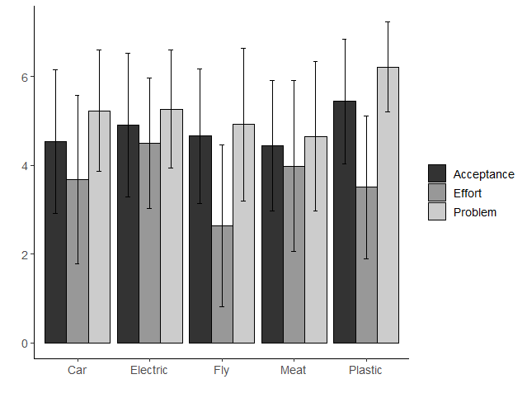
Note. Means of nudging acceptance, perceived effort, and problem awareness are shown for each domain (car use, electricity consumption, traveling by plane, meat consumption, and plastic consumption). Error bars show standard errors.
Table E1
Acceptance

 | n | M | SD | 2. Electric | 3. Flying | 4. Plastic usage | 5. Meat consumption
1. Car | 294 | 4.53 | 1.63 | <.0001 | .178 | <.0001 | .243
2. Electric | 294 | 4.9 | 1.62 | - | .003 | <.0001 | <.0001
3. Flying | 294 | 4.66 | 1.51 | - | - | <.0001 | .012
4. Plastic usage | 294 | 5.44 | 1.41 | - | - | - | <.0001
5. Meat consumption | 294 | 4.45 | 1.47 | - | - | - | -
Problem Awareness

 | n | M | SD | 2. Electric | 3. Flying | 4. Plastic usage | 5. Meat consumption
1. Car | 294 | 5.23 | 1.37 | .622 | <.0001 | <.0001 | <.0001
2. Electric | 294 | 5.26 | 1.32 | - | <.0001 | <.0001 | <.0001
3. Flying | 294 | 4.92 | 1.73 | - | - | <.0001 | .0002
4. Plastic usage | 294 | 6.22 | 1.01 | - | - | - | <.0001
5. Meat consumption | 294 | 4.65 | 1.69 | - | - | - | -
 | Effort
 | n | M | SD | 2. Electric | 3. Flying | 4. Plastic usage | 5. Meat consumption
1. Car | 294 | 3.67 | 1.9 | <.0001 | <.0001 | .042 | .0005
2. Electric | 294 | 4.49 | 1.47 | - | <.0001 | <.0001 | <.0001
3. Flying | 294 | 2.64 | 1.82 | - | - | <.0001 | <.0001
4. Plastic usage | 294 | 3.5 | 1.61 | - | - | - | <.0001
5. Meat consumption | 294 | 3.98 | 1.92 | - | - | - | <.0001

Note. Figure E1 and Table E1 show that support was especially high for nudges promoting behavior change in the domain of plastic consumption, which is also the domain people perceived as most concerning. The domain of meat consumption was least concerning, and nudges that promoted the reduction of meat consumption were also least accepted. Inspecting the extent to which people perceived behavior addressed by the nudge as effortful, we find that eating less meat and using less electricity appeared most effortful for the participants, while traveling less by plane was perceived as least effortful.

Study 2

Figure E2
Nudging Acceptance, Perceived Effort, and Problem Awareness per Environmental Domain (Study 2)

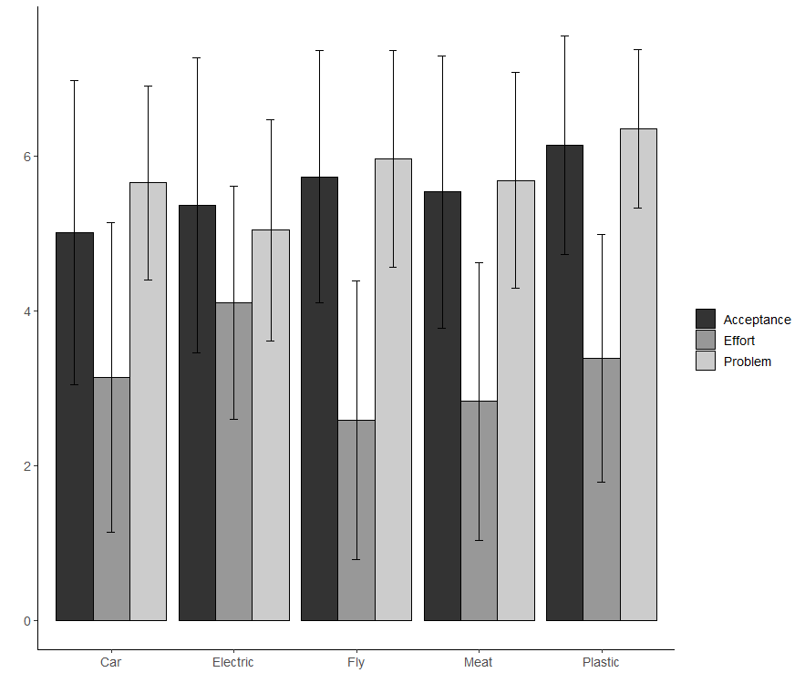
Note. Means of nudging acceptance, perceived effort and problem awareness are shown for each domain (car use, electricity consumption, traveling by plane, meat consumption and plastic consumption). Error bars show standard errors.

Table E2
Acceptance

 | n | M | SD | 2. Electric | 3. Flying | 4. Plastic usage | 5. Meat consumption
1. Car | 565 | 5.51 | 1.6 | <.0001 | <.0001 | <.0001 | <.0001
2. Electric | 565 | 5.52 | 1.4 | - | <.0001 | <.0001 | .004
3. Flying | 565 | 5.5 | 1.64 | - | - | <.0001 | .002
4. Plastic usage | 565 | 6.37 | 1.11 | - | - | - | <.0001
5. Meat consumption | 565 | 5.08 | 1.39 | - | - | - | -
Problem Awareness

 | n | M | SD | 2. Electric | 3. Flying | 4. Plastic usage | 5. Meat consumption
1. Car | 565 | 5.65 | 1.25 | <.0001 | <.0001 | <.0001 | .53
2. Electric | 565 | 5.04 | 1.43 | - | <.0001 | <.0001 | <.0001
3. Flying | 565 | 5.96 | 1.4 | - | - | <.0001 | <.0001
4. Plastic usage | 565 | 6.35 | 1.02 | - | - | - | <.0001
5. Meat consumption | 565 | 5.68 | 1.39 | - | - | - | -
 | Effort
 | n | M | SD | 2. Electric | 3. Flying | 4. Plastic usage | 5. Meat consumption
1. Car | 565 | 3.14 | 2 | <.0001 | <.0001 | <.0001 | <.0001
2. Electric | 565 | 4.1 | 1.51 | - | <.0001 | <.0001 | <.0001
3. Flying | 565 | 2.59 | 1.8 | - | - | <.0001 | <.0001
4. Plastic usage | 565 | 3.38 | 1.6 | - | - | - | <.0001
5. Meat consumption | 565 | 2.83 | 1.79 | - | - | - | <.0001

Note. As in Study 1, across decision-making contexts and nudge types, results of Study 2 (n = 565, n_{obs} = 11,300) show overall high support of green nudges (M = 5.37, SD = 1.92). Similar to Study 1, support was especially high for nudges reducing plastic consumption, which is also the domain people perceived as most concerning (Figure E2, Table E2). Nudges that promote the reduction of meat consumption were least accepted. Using less electricity appeared most effortful for the participants while traveling less by plane was perceived as least effortful. In contrast to Study 1, the domain of electricity consumption was perceived as the least problematic for the environment.

Appendix F

Figure F1
Multilevel Path Analysis (Study 2)
Note. Standardized regression coefficients for the relationship between nudge-framing (generic vs.
societal) and the acceptance of green nudges, mediated by the perceived effectiveness of the nudge. The total effect when excluding all mediating variables (perceived policy effectiveness, intrusiveness, and transparency) is shown in parentheses (see Model 1 in Table 2).
Indirect effect (effectiveness): β = .10; indirect effect (intrusiveness): β = -.01; indirect effect (transparency): β = .003
* = p < .05, ** = p < .01, *** = p < .001

Appendix G
Study 2
Table G1
Predicted Values for Nudging Acceptance (Study 2)
 | Model 1 |  |  | Model 2 |  |  | Model 3 |  |  | Model 4
Predictors | β | SE | p | β | SE | p | β | SE | p | β | SE | p
(Intercept) | 5.43 | 0.07 | <.001 | 5.40 | 0.08 | <.001 | 5.35 | 0.10 | <.001 | 5.37 | 0.07 | <.001
Framing (personal) | 0.27 | 0.10 | .006 | 0.27 | 0.10 | .006 | 0.39 | 0.14 | .005 | 0.30 | 0.11 | .005
Framing (generic) | 0.10 | 0.10 | .303 | 0.10 | 0.10 | .309 | 0.16 | 0.14 | .247 | 0.08 | 0.11 | .449
Effort | -0.07 | 0.01 | <.001 | -0.07 | 0.01 | <.001 | -0.07 | 0.02 | .001 | -0.05 | 0.01 | <.001
Problem awareness | 0.25 | 0.02 | <.001 | 0.25 | 0.02 | <.001 | 0.32 | 0.03 | <.001 | 0.13 | 0.02 | <.001
Rationale (present) |  |  |  | 0.06 | 0.08 | .434 | 0.18 | 0.14 | .189 | 0.13 | 0.11 | .230
Framing (personal) × rationale (present) |  |  |  |  |  |  | -0.24 | 0.20 | .232 | -0.31 | 0.15 | .043
Framing (generic) x rationale (present) |  |  |  |  |  |  | -0.13 | 0.20 | .527 | -0.04 | 0.15 | .773
Framing (personal) x effort |  |  |  |  |  |  | -0.04 | 0.02 | .105 | -0.01 | 0.02 | .726
Framing (generic) x effort |  |  |  |  |  |  | -0.06 | 0.02 | .024 | -0.02 | 0.02 | .232
Rationale (present) x effort |  |  |  |  |  |  | 0.06 | 0.02 | .002 | 0.02 | 0.02 | .229
Rationale (present) x problem awareness |  |  |  |  |  |  | 0.00 | 0.03 | .906 | -0.01 | 0.02 | .651
Framing (personal) × problem awareness |  |  |  |  |  |  | -0.15 | 0.04 | <.001 | -0.09 | 0.03 | .002
Framing (generic) × problem awareness |  |  |  |  |  |  | -0.05 | 0.04 | .215 | -0.02 | 0.03 | .412
Effort × problem awareness |  |  |  |  |  |  | 0.00 | 0.01 | .670 | -0.00 | 0.01 | .591
Transparent |  |  |  |  |  |  |  |  |  | -0.38 | 0.01 | <.001
Intrusive |  |  |  |  |  |  |  |  |  | 0.36 | 0.01 | <.001
Effective |  |  |  |  |  |  |  |  |  | 0.26 | 0.01 | <.001
Random effect
σ² | 2.09 |  |  | 2.09 |  |  | 2.08 |  |  | 1.21
τ₀₀ | 0.81 _{id} |  |  | 0.81 _{id} |  |  | 0.79 _{id} |  |  | 0.46_{id}
ICC | 0.28 |  |  | 0.28 |  |  | 0.28 |  |  | 0.28
N | 565 _{id} |  |  | 565 _{id} |  |  | 565 _{id} |  |  | 565_{id}
Observations | 2825 |  |  | 2825 |  |  | 2825 |  |  | 2825
Marginal R²/ Conditional R² | 0.055/ 0.318 |  |  | 0.055/ 0.318 |  |  | 0.062/ 0.321 |  |  | 0.474/ 0.619
AIC | 31413.170 |  |  | 31417.725 |  |  | 31444.497 |  |  | 26881.280

