SUPPLEMENTARY MATERIALS

Title: Encouraging vaccination against COVID-19 has no compensatory spillover effects

S1. Sociodemographic information of participants

Table S1. Participants’ characteristics
 | Total | Wave 1 | Wave 2
Age group
18-24 | 316 (17.10%) | 232 (19.25%) | 84 (13.06%)
25-34 | 650 (35.17%) | 442 (36.38%) | 208 (32.35%)
35-44 | 651 (35.23%) | 379 (31.45%) | 272 (42.30%)
45-54 | 161 (8.71%) | 95 (7.88%) | 66 (10.26%)
55-64 | 65 (3.52%) | 53 (4.40%) | 12 (1.87%)
65+ | 5 (0.27%) | 4 (0.33%) | 1 (0.16%)
Female | 943 (51.03%) | 632 (52.45%) | 311 (48.37%)
Education level
Primary | 37 (2%) | 30 (2.49%) | 7 (1.09%)
Secondary | 541 (29.27%) | 388 (32.20%) | 153 (23.79%)
Further (A-levels, GNVQ’s) | 555 (30.03%) | 356 (29.54%) | 199 (30.95%)
Higher (degree or more) | 715 (38.69%) | 431 (35.77%) | 284 (44.17%)
Employed | 1,296 (70.13%) | 814 (67.55%) | 482 (74.96%)
Household income
£0-12,999 | 350 (18.94%) | 242 (20.08%) | 108 (16.80%)
£13,000-£16,999 | 155 (8.39%) | 114 (9.46%) | 41 (6.38%)
£17,000-£19,999 | 135 (7.31%) | 99 (8.22%) | 36 (5.60%)
£20,000-£22,999 | 133 (7.20%) | 87 (7.22%) | 46 (7.15%)
£23,000-£26,999 | 130 (7.03%) | 92 (7.63%) | 38 (5.91%)
£27,000-£30,999 | 165 (8.93%) | 104 (8.63%) | 61 (9.49%)
£31,000-£35,999 | 137 (7.41%) | 85 (7.05%) | 52 (8.09%)
£36,000-£43,999 | 174 (9.42%) | 113 (9.38%) | 61 (9.49%)
£44,000-£54,999 | 193 (10.44%) | 105 (8.71%) | 88 (13.69%)
£55,000+ | 276 (14.94%) | 164 (13.61%) | 112 (17.42%)
N | 1,848 | 1,205 | 643
Notes: The first column represents the total sample in both waves. The other two columns represent participants’ characteristics across the two waves of the longitudinal study (Wave 1 and Wave 2).

S2. Vaccination messages in Wave 1

S2.1 Vaccine efficacy condition
Participants in the vaccine efficacy condition were exposed to the following information:
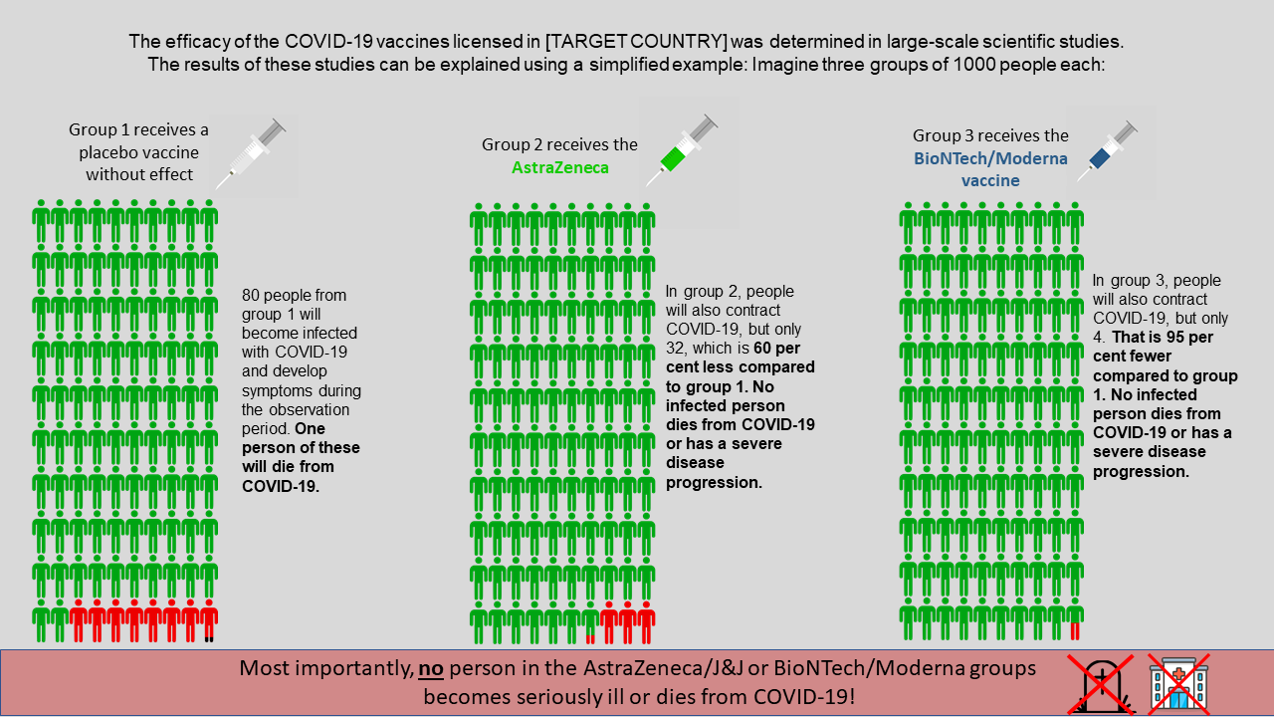

S2.2 Vaccination certificate condition
Participants in the vaccination certificate condition were exposed to the following information:
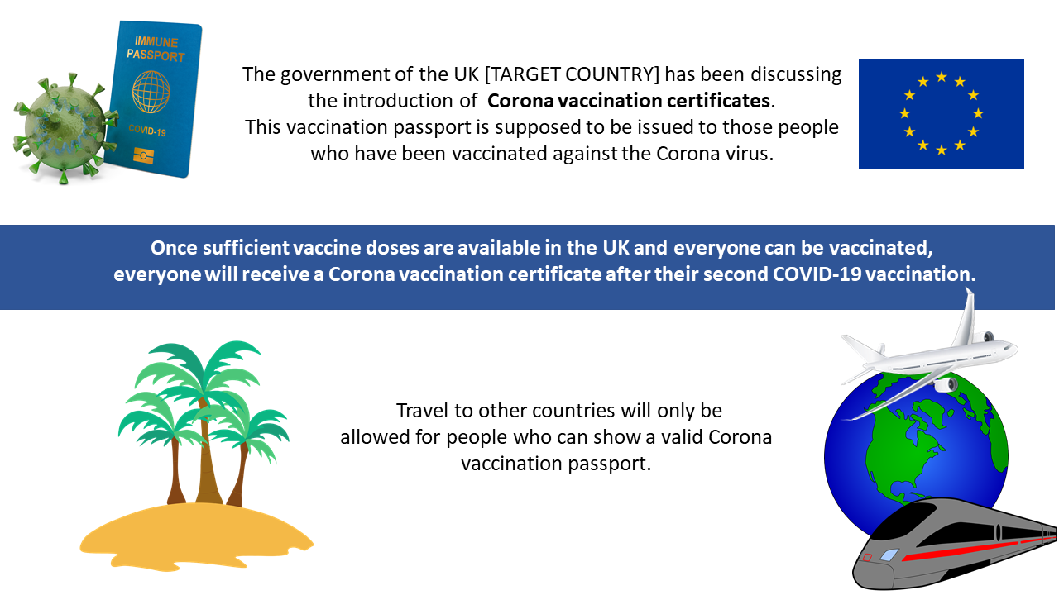

S2.3 Collective benefits condition
Participants in the collective benefits of vaccination condition were exposed to the following information:
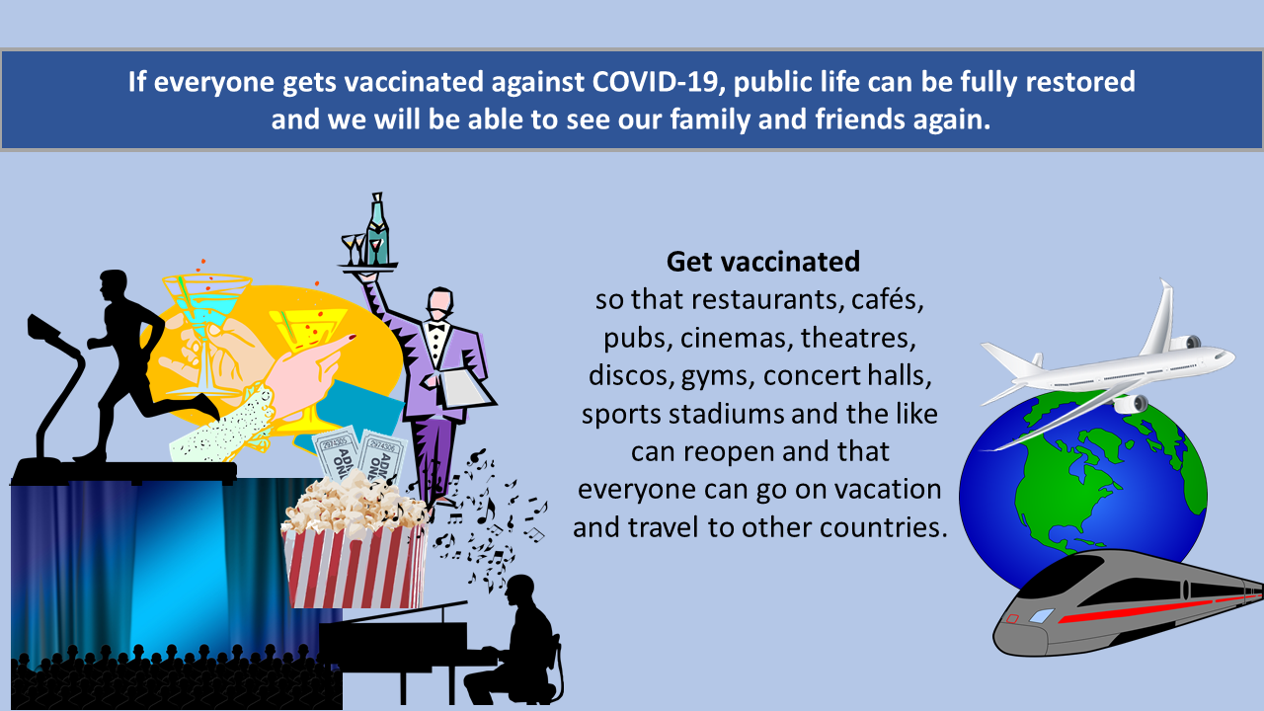

S3. Procedure in Wave 1
Participants who took part in the first wave of the longitudinal study were asked to provide socio-demographic information including age, gender, education employment, household income and vaccination status. Vaccinated participants were excluded from wave 1. Unvaccinated participants who agreed to take part in wave 1 were randomly allocated into four different conditions: 1. control, where no information about vaccination was given 2. Vaccine efficacy condition 3. Vaccination certificate condition and 4. Collective benefits condition. Depending on the condition that participants were allocated into, they were asked attention-check questions. For instance, in the vaccine efficacy condition they were asked “How many people died from COVID-19 in the AstraZeneca group”. They were subsequently asked whether they would get vaccinated against COVID-19 in the next week, if they have the opportunity to do so. Finally, participants were asked a set of questions about the type of vaccine they would choose and the reasons for being unvaccinated.

S4. Dependent variables in Wave 2

S4.1 Protective behaviours
Participants were asked to what extent today and over the next two weeks they intend to engage in the following behaviours
- Stay at home at all times unless I absolutely need to leave the house
- Sanitise hands
- Wear a face mask when in public transport, in stores, at work
- Avoid meeting friends and family unless they live together with me
- Keep two metres distance from others when outside
- Disinfect goods brought into the house
- Follow the rule of six for indoor gatherings
- Check in with Track and Trace app in restaurants and pubs
- Avoid trips outside local district
- Avoid international holiday
- Wear a face mask when outside
- Monitor physical symptoms of COVID-19
- Avoid touching face
- Cough and sneeze into elbow or tissue
- Avoid hoarding groceries and household goods
Protective behaviours were measured on a 5-point scale (1 = Never, 2 = Rarely, 3 = Sometimes, 4 = Often, 5 = Always)

S4.2 Compliance behaviours
Participants were asked to what extent today and over the next two weeks they intend to engage in the following behaviours, in case of exhibiting mild symptoms of illness (e.g., coughing).
- Self-quarantine
- Immediately inform people who had contact with me
- Wear a face mask if I have to leave home
- Refrain from visiting NHS practices
Compliance behaviours were measured on a 5-point scale with verbal anchors “Does not apply at all” (1) and “It completely applies” (5).

S4.3 Prosocial behaviours
Participants were asked whether in the next two weeks they intend to engage in the following behaviours:
- Actively encourage friends and family in the UK to get vaccinated against COVID-19
- Donate money to charities raising funds for COVID-19
- Donate blood to the NHS
- Volunteer to help the NHS
- Volunteer to help the local community, e.g., vulnerable people, people out of jobs
- Campaign to donate COVID-19 vaccines to poorer countries
- Donate 20% of the money paid for survey participation to NHS Charities Together
The first prosocial behaviour (i.e., actively encouraging COVID-19 vaccination) was a 5-point categorical variable, measured on the same scale as in the protective behaviours. The rest of the prosocial behaviours were dichotomous variables, with possible values of 0 for “No” and 1 for “Yes”.

S5. Exploratory analyses and sociodemographic factors
In all the multiple regression models, we controlled for sociodemographic factors such as age, gender, education, employment status and household income. Across the three comparisons, gender was found to be the most consistent significant determinant that was associated with most of the behaviours (i.e., women were more likely to engage in protective and compliance behaviours).

In the comparison by message condition (H1), apart from the sociodemographic factors we controlled for another explanatory variable, namely vaccination willingness. The reason for including this control in the comparison by condition (and not in the other two comparisons) was that this variable was measured only for participants who took part in wave 1, which included only unvaccinated people at that time. Like vaccination status, vaccination willingness was found to be significantly associated with various behaviours of interest. This finding complements the previous finding that vaccinated participants were more likely to engage in most of the protective, compliance, and prosocial behaviours: if not vaccinated, those willing to get vaccinated were also more likely to engage in such behaviours (Fig. 1-3). We further ran three subgroup analyses for H1, H2 and H3, dividing the sample by age, gender, and education respectively. Overall, the subgroup analyses yielded similar results to the main analyses and are therefore reported in (OSF link will be provided). We also used linear regression models as robustness checks and these, overall, yielded similar results to the ones presented above for logistic and ordered probit models regressions.

Fig. 1 | Effect sizes of vaccination willingness on protective behaviours.
Notes: The dots represent regression coefficients. Error bars represent 95% Confidence Intervals. * The effect of participants’ vaccination willingness on the variables “Avoid international holiday” and “Sneeze into elbow or tissue” became non-significant after Bonferroni correction for multiple hypotheses testing.

Fig. 2 | Effect sizes of vaccination willingness on compliance behaviours.
Notes: The dots represent regression coefficients. Error bars are 95% Confidence Intervals. * The effect of vaccination willingness on the variable “Self-quarantine” became non-significant after Bonferroni correction for multiple hypotheses testing.

Fig. 3 | Effect sizes of vaccination willingness on prosocial behaviours.
Notes: The dots represent Odds Ratio. Error bars are 95% Confidence Intervals. The symbol * indicates that the effects remained significant after Bonferroni correction for multiple hypotheses testing. The symbol † represents the “Encourage friends to get vaccinated” variable, which was a 5-level categorical variable regressed on vaccination willingness in an ordered probit model. The dot for this variable therefore represents the regression coefficient and not Odds Ratio. The effect was significant (b=1.06, CI 0.91-1.20, p<0.001).

Effects on participants’ actual donations to the NHS
After completing wave 2, participants were asked whether they wished to donate 20% of their study participation fee to a NHS charity. 80% of the participants (795/983) chose not to donate. None of the predictors or the explanatory variables described above was significantly associated with the choice to donate to the NHS charity, suggesting that, despite the observed effects of vaccination status, there were no significant differences between vaccinated and unvaccinated for this behavioural measure. To further measure participants’ behaviour, we also included a link to redirect them to the NHS Charities Together website. We subsequently tracked whether participants clicked on the link. None of the participants clicked on the link and, since the outcome did not vary, no statistical analysis was performed.

Gender was included as an explanatory variable in all the regression models and found to be the most consistent determinant compared to other socio-demographic factors like age, education, household income and employment. Specifically, in the first comparison (by message condition), females were more likely to engage in nine out of the 15 protective behaviours (60%) and in all the compliance behaviours. This trend was reversed for prosocial behaviours, suggesting that females were less likely to donate money to charities (OR=1.016, CI 0.74-1.38, p<0.001), volunteer to the NHS (OR=1.71, CI 1.30-2.24, p=0.003) and campaign for donating vaccines to other countries (OR=1.66, CI 1.27-2.17, p=0.005). Overall, gender was associated with 16 out of the 26 behaviours (61.50%).

In the comparison by survey participation, gender was found to be associated with exactly the same behaviours as in the comparison by message condition, since the sample included all the participants from the first comparison. In the last comparison by vaccination status, gender was associated with only six out of the 26 behaviours of interest (23%). The mean differences between males and females are presented in the figures below.

Fig.4. Means of intention to engage in protective behaviours by gender.
Notes: This chart includes all the participants across the three comparisons. Protective behaviours were measured on a 1-5 scale with anchors from “Never” to “Always”. Higher values indicate higher engagement in protective behaviours. * “Encouraging others to get vaccinated” was conceptualised as a prosocial behaviour. Due to its measure (i.e., 1-5 scale), it has been included in this graph, and not in the graph about prosocial behaviours, where results are presented in percentages (Fig. 6).

Fig.5. Means of intention to engage in compliance behaviours by gender.
Notes: This chart includes all the participants across the three comparisons. Compliance was measured on a 1-5 scale with anchors from “Never” to “Always”. Higher values indicate higher compliance.

Fig.6. Percentages of intention to engage in prosocial behaviours by gender.
Notes: This chart includes all the participants across the three comparisons. Prosocial behaviours were dichotomous variables with possible answers “Yes” or “No”. Results are presented in percentages. Higher percentage indicates higher engagement in prosocial behaviours.

Another factor that was found to be associated with some behaviours was age. However, there were only a few associations. Amongst them, the most consistent associations across the three comparisons were with the use of the NHS Track and Trace app and the encouragement of other people to get vaccinated. Specifically, younger participants were more likely to use the Track and Trace app and encourage other people to get vaccinated (p < 0.001 in all three comparisons). For the rest of the sociodemographic factors (i.e., education, employment and income) the associations with the behaviours of interest were very limited, without any consistent result. The regression tables can be found in S5 (Main analyses). The effect of vaccination status on protective and compliance behaviours remained significant after controlling for sociodemographic factors.

S5.1 Discussion of the exploratory analyses
In line with previous research, our study detected a gender effect, suggesting that females were more likely to engage in protective and compliance behaviours^{1,2}. The opposite pattern was found in prosocial behaviours, suggesting that females were less likely to donate money and volunteer to the NHS. However, this could not be explained by the idea of cognitive consistency, given that females were less willing to get vaccinated³. Being hesitant to get vaccinated but more willing to engage in protective and compliance behaviours does not necessarily imply cognitive inconsistency; it could be rather interpreted as a purging spillover, given that females were found to be more hesitant to get vaccinated than males^{3,4}. For instance, if females did not contribute to the common good by being vaccine hesitant, then they might have tried to restore their contribution by being more compliant. This gender effect could also be explained by the fact that females appeared to generally be more risk-averse than their male counterparts and, therefore, more likely to engage in behaviours that minimise the risk of COVID-19 infection^{5–7}.

Given that vaccination minimises the risk of infection, females, as risk-averse, would be expected to be more willing to get vaccinated than males. However, since recent evidence suggests the opposite³, one could argue that risk aversion does not explain females’ vaccine hesitancy. On the other hand, despite the fact that vaccine hesitancy could be considered a risk-taking choice, given that unvaccinated people expose themselves to a greater risk, it is yet still a passive one, which in principle requires less effort, generates less regret, and feels safer⁸. If this is the case, then females’ vaccine hesitancy could be explained on the grounds of passive risk-taking.

References
1. Galasso, V. et al. Gender differences in COVID-19 attitudes and behavior: Panel evidence from eight countries. Proc. Natl. Acad. Sci. 117, 27285–27291 (2020).
2. Okten, I. O., Gollwitzer, A. & Oettingen, G. Gender differences in preventing the spread of coronavirus. Behav. Sci. Policy 6, 109–122 (2020).
3. Steinert, J. I. et al. COVID-19 vaccine hesitancy in eight European countries: Prevalence, determinants, and heterogeneity. Sci. Adv. 8, 1–15 (2022).
4. Zintel, S. et al. Gender differences in the intention to get vaccinated against COVID-19: a systematic review and meta-analysis. J. Public Health (Bangkok). 7, 1–25 (2022).
5. Byrnes, J. P., Miller, D. C. & Schafer, W. D. Gender differences in risk taking: A meta-analysis. Psychol. Bull. 125, 367–383 (1999).
6. Pawlowski, B., Atwal, R. & Dunbar, R. I. . Sex Differences in Everyday Risk-Taking Behavior in Humans. Evol. Psychol. 6, 29–42 (2008).
7. Friedl, A., Pondorfer, A. & Schmidt, U. Gender differences in social risk taking. J. Econ. Psychol. 77, 102182 (2020).
8. Keinan, R. & Bereby-Meyer, Y. ‘Leaving it to chance’ - Passive risk taking in everyday life. Judgm. Decis. Mak. 7, 705–715 (2012).

