Appendix A: Experimental Design
A1. Pre-trial training materials and post-training quiz
Welcome to our Food Safety Training!
As part of our study, we will ask you to carry out a food preparation task to a given recipe. As this will involve handling raw ingredients, we require you to complete a short training course before attending our test kitchen. The training will include a short quiz at the end.
Click to begin.
_________________________________________________________________________________
Did you know…
- that you play an important part in keeping people healthy?
- that every time you wash your hands, you reduce the risk of people getting sick?
Click here to see how you can make a real difference to keeping customers happy and healthy.
_________________________________________________________________________________
Harmful bacteria and viruses such as e-coli, salmonella and norovirus can spread very easily from people’s hands to food, work surfaces and equipment. These germs cause illnesses such as sickness, nausea and diarrhoea. It is estimated that every year in the UK around 500,000 people fall ill with foodborne diseases like this¹, and that across Europe around 5,000 people die every year².
Many of these cases could have been avoided with better hand hygiene. Germs can get onto your hands in all sorts of ways. Some are obvious, like sneezing, coughing or using a tissue. Others less so, like touching your hair, face or body, or handling money. It’s safest to assume that, unless you’ve just washed them, your hands are holding germs which could easily get into the food you’re preparing.
As food handing professionals, we play a vital role in helping to prevent the spread of disease by washing our hands properly. But what’s the right way to wash?
Click to find out more
_________________________________________________________________________________
To thoroughly wash your hands, you need warm water, liquid soap, and a disposable towel. Washing your hands properly should take at least 20 seconds between applying soap and rinsing with water (or the duration of singing happy birthday, twice), during which you should cycle through these 6 steps³:
Step 1: Wet your hands under warm running water and apply liquid soap
Step 2: Rub your hands together to make a lather
Step 3: Rub the palm of one hand along the back of the other and along the fingers. Repeat with the other hand
Step 4: Put your palms together with fingers interlocked and rub in between each of the fingers
Step 5: Rub around your thumbs on each hand and then rub the fingertips of each hand against your palms
Step 6: Rinse off the soap with clean water and dry your hands thoroughly on a disposable towel. Turn off the tap with the towel and then throw the towel away
(images from: https://www.food.gov.uk/sites/default/files/media/document/sfbb-introduction-december-2019_1.pdf)
Correct technique is important in hand hygiene, but so is carrying out these steps regularly, throughout the food handling process…
Click to continue

When handling food, it is important to wash your hands during these following critical moments, when there is an increased chance of harmful bacteria and viruses being transmitted by your hands.
When to wash your hands:
Before touching or handling any food, especially ready-to-eat food
After touching raw meat, poultry, fish, eggs or unwashed vegetables
When entering the kitchen e.g. after a break or going to the toilet
After touching or emptying bins
After any cleaning
After touching a cut or changing a dressing
After touching items such as phones, light switches, door handles, cash registers and money
After sneezing or coughing
(images from https://www.food.gov.uk/sites/default/files/media/document/sfbb-introduction-december-2019_1.pdf)
Click to continue

Thanks for reading our training material. Please answer the following questions…

True or False?
- You should wash your hands after taking a break to smoke. True False

(if respondent clicks on True), display ü
(if respondent clicks on False), display X
(once respondent clicks, reveal the following information)
Always wash your hands after every break you take, including after a break to smoke.

Click to continue

True or False?
- It is more important to clean your fingertips than the backs of your hands, as they make the most contact with food you handle True False

(if respondent clicks on True), display X
(if respondent clicks on False), display ü
(once respondent clicks, reveal the following information)

Cleaning your fingertips only is a food safety risk. When washing your hands, it is important to clean them all over, including the backs of your hands, and between your fingers, as these can all be areas where harmful bacteria and viruses can otherwise remain, and transfer to food you’re handling.

Click to continue

True or False?
- E.coli, Salmonella and Norovirus are all potential diseases that can spread through improper hand hygiene . True False

(if respondent clicks on True), display ü
(if respondent clicks on False), display X
(once respondent clicks, reveal the following information)

Food poisoning can lead to illnesses, resulting in symptoms such as nausea, vomiting, diarrhoea and in extreme cases, even death. Proper hand hygiene can limit the spread of these illnesses, as harmful bacteria and viruses can spread very easily from hands to food.

Click to continue

True or False?
- Handling money may allow harmful bacteria to spread to your hands. True False

(if respondent clicks on True), display ü
(if respondent clicks on False), display X
(once respondent clicks, reveal the following information)

Money can transmit harmful bacteria’. In fact, did you know that, in the UK, faecal bacteria can be present on up to 14% of banknotes, and 10% of credit cards?⁴. It is therefore important to thoroughly wash your hands after handling any money
Click to continue

True or False?
- It’s fine to not specifically wash your fingertips, as they will be cleaned when handwashing anyway. True False

(if respondent clicks on True), display X
(if respondent clicks on False), display ü
(once respondent clicks, reveal the following information)

Fingertips are the part of the hand likely making most regular contact with food, and it can be an overlooked area in handwashing. It is important to thoroughly wash every area of the hand with liquid soap, to help prevent the spread of food-borne illnesses

Click to continue

- Put these handwashing steps in the correct order
(Randomly display order of the following steps)
Wet your hands under warm running water and apply liquid soap
Rub your hands together to make a lather
Rub the palm of one hand along the back of the other and along the fingers. Repeat with the other hand
Put your palms together with fingers interlocked and rub in between each of the fingers
Rub around your thumbs on each hand and then rub the fingertips of each hand against your palms
Rinse off the soap with clean water and dry your hands thoroughly on a disposable towel. Turn off the tap with the towel and then throw the towel away

(If the respondent scores between 1 and 5 display X, and reveal the following message):
Oops, you got something wrong, the right order is (present the order above, as Step 1- Step 6)

(If the respondent scores 6 display ü, and reveal the following message):
Congratulations, you got all the steps in the right order

Click to continue

Enter the correct answer
- If you are washing correctly, you should rub your hands with soap for at least this long before rinsing with water:

(answer entry box) seconds

(if respondent types anything but “20”), display X
(if respondent types in “20”), display ü
(once respondent clicks, reveal the following information)

You should be washing your hands for a duration of 20 seconds if you are thoroughly cycling through the 6 recommended steps. To help keep a count, this is approximately the duration of singing Happy Birthday twice.

Click to continue

Multiple choice
- Which of the following are points when you should wash your hands while working with food?

a) After emptying bins
b) After cleaning your workstation
c) After using your phone
d) After peeling fruit that has already been washed
e) After turning on a light switch
f) After holding a kitchen knife
g) After going to the toilet

(if respondent clicks on d or f, or fails to click on all 5 correct answers), display X
(if respondent clicks on a, b, c, e and g), display ü
(once respondent clicks, reveal the following information)

You must always wash your hands properly before handling or preparing food, including after handling raw food and before handling ready-to-eat food. If you touch any surfaces that might not be clean, you need to wash your hands again before handling food.

Click to continue
________________________________________________________________________________
Now you know the correct handwashing procedure to keep people safe and healthy. Thanks for completing the training!
_______________________________________________________________________________

A2. Food preparation task instructions
Instructions

Welcome to the burger task!

Today, you will play the part of a worker in a hamburger restaurant. You will register an order from a customer using your tablet, and then you will prepare a classic burger, following the recipe cards at your workstation.

Your job is to complete the order as quickly as possible while following all the steps of the recipe, exactly. For safety reasons, you won't actually cook the burgers, just prepare the patties and assemble the garnish.

The tablet will time you as you prepare the burger and will tell you how long you took at the end. You will run through this task twice, from start to finish. See if you can go faster on your second run! You have 25 minutes in total.

You should have all the ingredients and equipment you need at your workstation, but if you need help, please ask an experimenter.

Please wait for an experimenter to check you are ready before you do anything!

The first thing you will need to do is input the order for one classic burger, using your tablet.
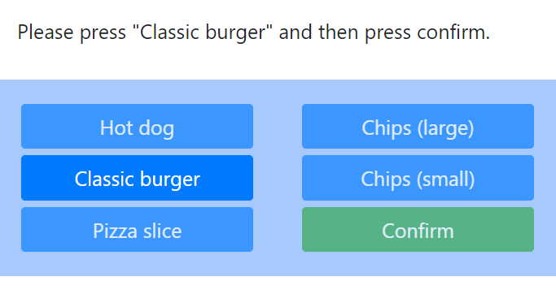 Fig. A2.1. Food preparation task tablet screen: putting in burger order.

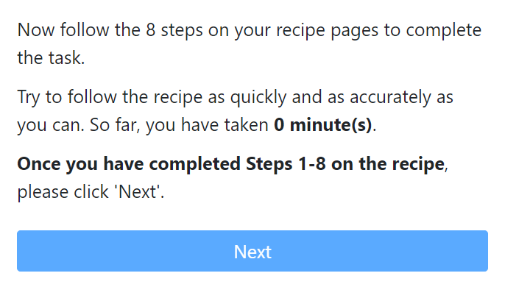
Fig. A2.2. Food preparation task tablet screen: instructions and time in task.

Classic burger recipe

This recipe makes one classic burger.

Step 1
Begin by preparing the patty. Add one portion minced beef to a mixing bowl.

Step 2
Add 1 tbsp breadcrumbs, ½ tsp dried herb mix, and ½ tsp onion powder to the mixing bowl containing the beef mince. Then add 1 tbsp olive oil and mix thoroughly by hand.

Step 3
Roll the meat mix into a ball and flatten it to form a patty. Put the patty on a plate and season with a pinch of salt and pepper (salt and pepper are pre-mixed in a bowl at your workstation). Then, set the plate aside on your hob area, for cooking.

At this point, if you were preparing a burger for real, you would cook it. For the purposes of this study we will skip that step and move on to the garnish.

Step 4
Now prepare the garnish. Tear off a leaf of lettuce from the head. Wash your leaf and one tomato.

Step 5
Now prepare the salsa. Grate the tomato into a clean bowl and add 1 pinch salt and pepper, 1 pinch dried coriander, and 1 pinch garlic powder. Then mix the salsa using a spoon.

Step 6
Now prepare the bun for your burger. Garnish the bottom half of each bun with 1 tbsp salsa place the lettuce leaf on top.

Step 7
Before you do anything else, please tidy your workstation.
Put any leftover salsa into the bin nearest you. Then place all the bowls and utensils you have used in the designated area for dirty crockery.
Lastly, please wipe down your workstation’s countertop with a paper towel.

Step 8
Now use the tablet to register the order as complete and follow the instructions on the screen.

The steps at which we expected handwashing were as follows:
- After putting the order into the tablet, and before touching any food
- After mixing the beef patty by hand, and before touching the vegetables
- After touching the unwashed vegetables, and before touching the spices
- After putting leftover food into the bin, and before restarting
- After putting the second order into the tablet, and before touching any food
- After mixing the second beef patty by hand, and before touching the vegetables
- After touching the unwashed vegetables on the second run, and before touching the spices
- After putting leftover food into the bin

A3. Post-trial survey
Introduction

ASK ALL
TEXT

This survey will last about 10 minutes. Your responses will be kept anonymous and analysed together with other participants' responses.

Purpose

ASK ALL
SINGLECODE

First, what do you think the purpose of this study is? Please give as much detail as you can.
- [OPEN TEXT INPUT]
- I don’t know

WorkIntro1

ASK ALL
TEXT

Now, a few questions about your work as a food handler. If you have more than one job, please answer for the one you consider to be your main job.

FBOType

ASK ALL
SINGLECODE

Which of the following best describes the place you work for in your main job?
- Restaurant, cafe and takeaway
- Catering business run from home, B&B, mobile catering and temporary business
- Marquee, food stall, food pop up or food van
- Nursery, school or care home
- Distance selling, mail order or online food delivery including dark kitchen

JobType

ASK ALL
SINGLECODE

Which of the following best describes your role?
- Chef or cook
- Kitchen porter
- Something else

Facility1
ASK ALL
MULTICODE

Which of the following does your place of work offer/use?
Please select all that apply.

- Food hygiene training for new staff
- Food hygiene refresher training for existing staff
- Diaries recording food hygiene checks and incidents
- Safer food, better business information pack
- Information included in this pack displayed in premises, e.g., handwashing guidance
- Probes to check the temperature of food you are cooking, reheating or storing
- A change of apron to be used after working with raw food
- Disposable cloths for cleaning surfaces
- Clean catering workwear (e.g., jackets, hats) for use at each shift
- Liquid soap for handwashing
- Sealed and labelled containers for foods containing allergens
- Damaged utensils that are routinely used for food preparation and cooking
- None of these
[Scripter notes: Randomise options but always keep 'None of these' at the bottom]

Facility2
ASK ALL
MULTICODE

Which of the following does your place of work have?
Please select all that apply.
- A separate sink dedicated solely to washing vegetables and salads
- A separate sink dedicated solely to handwashing
- A separate bin just for food waste
- A separate place to prepare raw and cooked foods
- Brightly coloured waterproof dressings or plasters to cover cuts
- Separate chopping boards for raw and cooked foods
- Separate utensils for raw and cooked foods
- Separate utensils/equipment/area for allergens
- A sign encouraging people to wash their hands before working with food
- Fridge and Freezer temperature checks, i.e., are the temperatures monitored in the fridge and freezer?
- None of these
[Scripter notes: Randomise options but always keep 'None of these' at the bottom]

HWNorm
ASK ALL
SINGLECODE

How frequently do your co-workers wash their hands after handling or touching meat at work?
- Always
- Often
- Sometimes
- Rarely
- Never
- My co-workers never need to handle meat
- Don’t know

WorkIntro2
ASK ALL
TEXT

Next, we would like to ask you a few questions about the food preparation task you have just completed. You may need to think back about your experience and please answer the follow questions to the best of your knowledge.

Taskease1
ASK ALL
SINGLECODE

How easy or difficult did you find completing today’s kitchen task?
- Very easy
- Somewhat easy
- Neither easy nor difficult
- Somewhat difficult
- Very difficult

Taskease2
ASK ONLY IF ANY OPTION SELECTED EXCEPT FOR ‘Very easy’ IN ‘Taskease1’
SINGLECODE

What did you find most difficult about today’s kitchen task?
- Following the recipe precisely
- Completing the task quickly
- Working in an unfamiliar kitchen
- Something else

HWDuration
ASK ALL
SINGLECODE/OPEN

How long did you try to spend washing your hands each time you did so in today's kitchen task?
- [OPEN NUMERIC INPUT] seconds each time
- I didn’t think about it / I don’t know
- I didn’t wash my hands

HWTimer1
ASK ONLY IF VALID NUMERIC INPUT PROVIDED IN ‘HWDurantion’
MULTICODE/OPEN

Which of the following, if any, did you use to keep track of how long you spent washing your hands?
Please select all that apply.
- The countdown timer attached to the sink
- A clock or watch (including phone clocks)
- Counting the seconds up from zero
- Counting the seconds down from zero
- Reciting a song (out loud or in your head)
- Something else (please specify): [OPEN TEXT INPUT]
- I did not keep track *Exclusive
[Scripter notes: Only show option 1 if participant belongs to group 1 (timer treatment group). Randomise response presentation order for option 1-5]

HWTimer2
ASK ONLY IF ANY OPTIONS IN ‘HWTimer1’ SELECTED EXCEPT FOR ‘I did not keep track’
SINGLECODE

Which of the following was the main thing you used to keep track of how long you spent washing your hands?

- The countdown timer attached to the sink
- A clock or watch (including phone clocks)
- Counting the seconds up from zero
- Counting the seconds down from zero
- Reciting a song (out loud or in your head)
- Something else
- Don’t know
[Scripter notes: Please only show codes if the corresponding response option at HWTimer1 was selected; please also present codes in the same order as in HWTimer1 (if they appear)]

HWTimer3
ASK ONLY IF GROUP = 1 AND OPTION 1 NOT SELECTED IN ‘HWTimer1’
MULTICODE

You said you didn’t use the timer device at the sink to keep track of how long you spent washing your hands. Why?
Please select all that apply.
- I didn’t notice it
- I wasn’t sure how to use it
- It didn’t work
- Something else (please specify) *Open
- None of these reasons
- Don’t know

HWTimer4
ASK ONLY IF ANY OPTIONS IN ‘HWTimer3’ = 1 – 4 SELECTED
SINGLECODE

Which was the main reason you didn’t use the timer device at the sink to keep track of how long you spent washing your hands?
- I didn’t notice it
- I wasn’t sure how to use it
- It didn’t work
- I did something else to keep track of how long I spent washing my hands
- None of these reasons
- Don’t know
[Scripter notes: Please only show codes if the corresponding response option at HWTimer3 was selected; please also present codes in the same order as in HWTimer3 (if they appear)]

PRECOMMIT1
ASK ONLY IF GROUP = 2
MULTICODE

When you completed your remote training before today’s session, you were asked to commit to doing several things and electronically sign your name.
Which two of the following did you to commit to doing?
- Washing my hands after touching raw meat
- Washing my hands before touching or handling any food
- Washing my hands after disposing of or composting food waste
- Washing my hands after cleaning
- Washing my hands after using a mobile phone
- Washing my hands after touching light switched or door handles
- Can’t remember *Exclusive
[Scripter notes: Do not allow the participant to proceed if more than two codes are selected. If they try, please display the error message “You have selected too many answers. Please select only TWO options from the list.”; please randomise presentation order of response codes 1-6]

PRECOMMIT2
ASK ONLY IF GROUP = 2
MULTICODE

When you completed your remote training before today’s session, you were asked to commit to doing several things and electronically sign your name.
And which three of the following did you to commit to doing whenever you wash your hands?
- Using soap and wetting my hands under warm running water
- Washing the backs of my hands by rubbing against the other hand’s palm
- Interlocking my fingers and rubbing between each finger thoroughly
- Rubbing around the thumbs on each hand when washing my hands
- Washing my fingertips by rubbing against my other hand’s palm
- Drying my hands thoroughly afterwards
- Turning the tap off using a paper towel
- Can’t remember [EXCLUSIVE] *Exclusive
[Scripter notes: Do not allow the participant to proceed if more than two codes are selected. If they try, please display the error message “You have selected too many answers. Please select only THREE options from the list.”; please randomise presentation order of response codes 1-7]

WorkIntro3
ASK ALL
TEXT

We would like to gather some information about you to help us understand our work better.

Age
ASK ALL
SINGLECODE

How old are you?
- [OPEN NUMERIC INPUT]
- I prefer not to say

AgeGroup
ASK IF ‘Prefer not to say’ SELECTED IN ‘Age’
SINGLECODE

If you are happy to, could you please tell us which of the following group your age is in?
- 16-25
- 26-35
- 36-49
- 50-65
- 66+
- I prefer not to say

Gender
ASK ALL
SINGLECODE

What is your gender?
- Male
- Female
- I identify in a different way
- I prefer not to say

Finish
ASK ALL
TEXT
Thank you for completing the survey. Your data will be stored anonymously and securely with us. Should you wish to withdraw from this study, please close the tab now. You will not be able to withdraw after you submit your response.

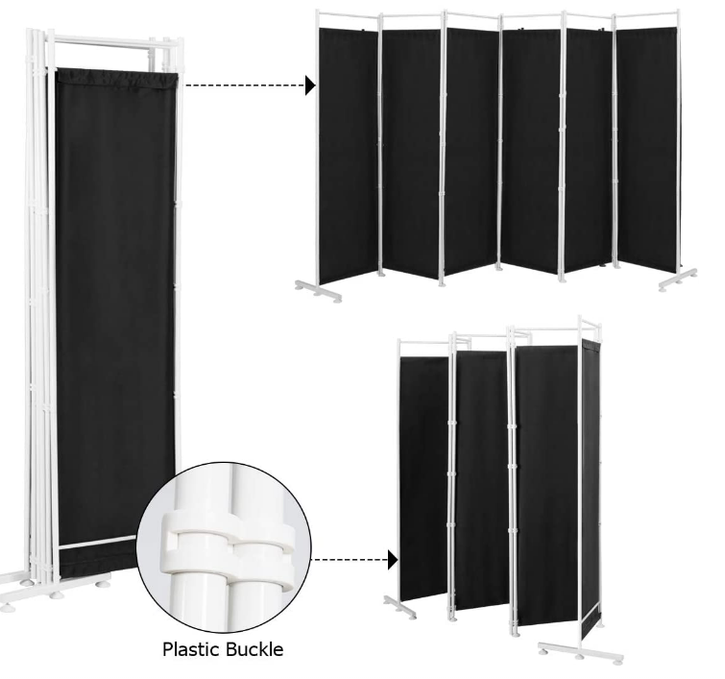
A4. Materials

Fig. A4.1. Opaque dividers. Participants’ views of one another and other workstations were obscured using 180cm tall folding dividers. These dividers consisted of a metal frame that could be arranged flexibly, with black canvas panels to block line of sight.
A5. Code frame
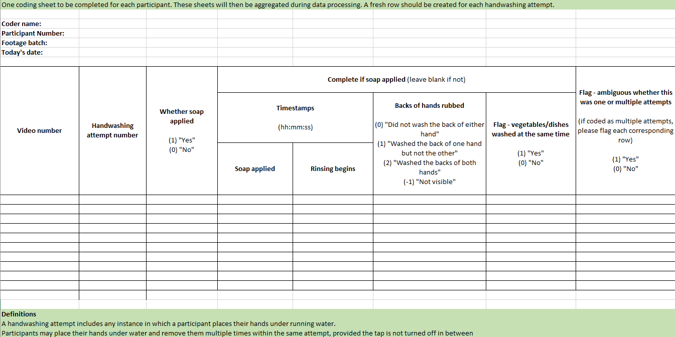
Fig A5.1. Code frame.

