SUPPLEMENTARY MATERIAL: ONLINE PUBLICATION ONLY

_________________________________
Categories of In-Game Disclosures
_________________________________

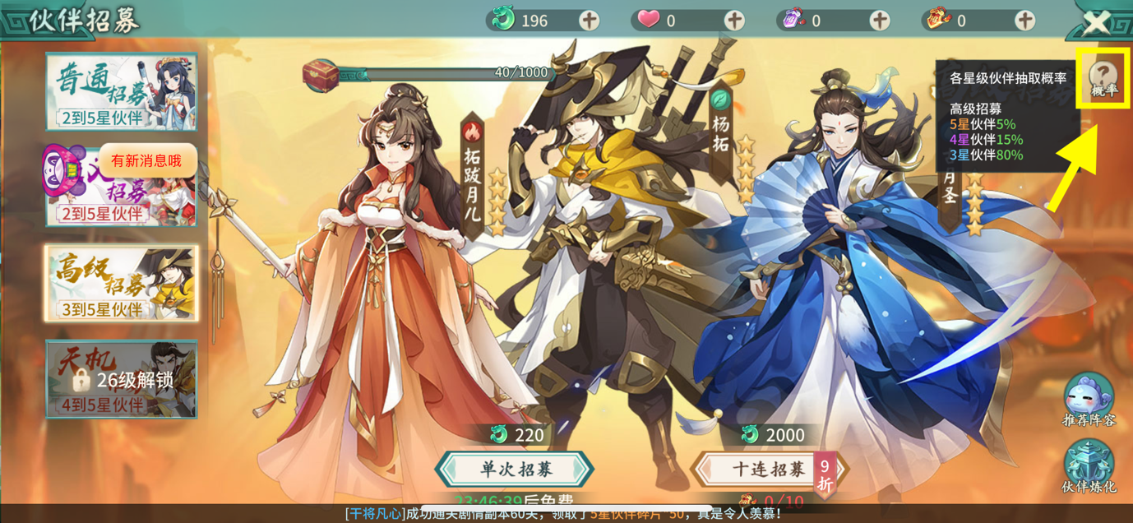

Fig.S1: Game 68’s (轩辕剑：剑之源) probability disclosure can be accessed immediately after tapping a small button explicitly referencing ‘probabilities’ (i.e., the ‘(?)’ symbol that has ‘概率 [probabilities]’ written on it; annotated; 11.5% of in-game disclosures). ©2005–2016 CMGE

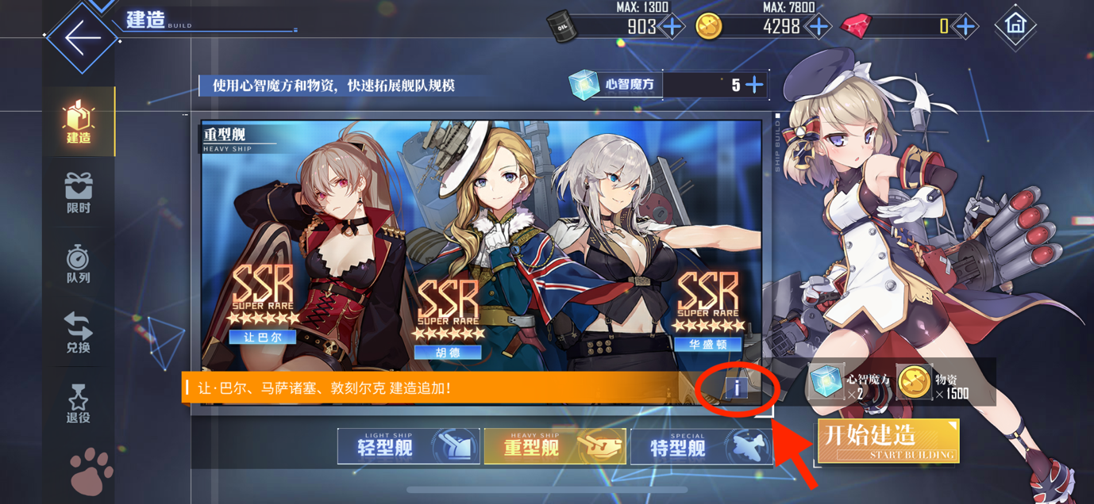

Fig.S2: Game 61’s (碧蓝航线 [Azur Lane]) probability disclosure can be accessed immediately after tapping a small generic symbol (i.e., the ‘[i]’ symbol; annotated; 55.8% of in-game disclosures). © 2009–2020 bilibili; 上海蛮啾网络科技有限公司[Shanghai Manjuu Technology Co.,Ltd]; 厦门勇仕网络技术股份有限公司

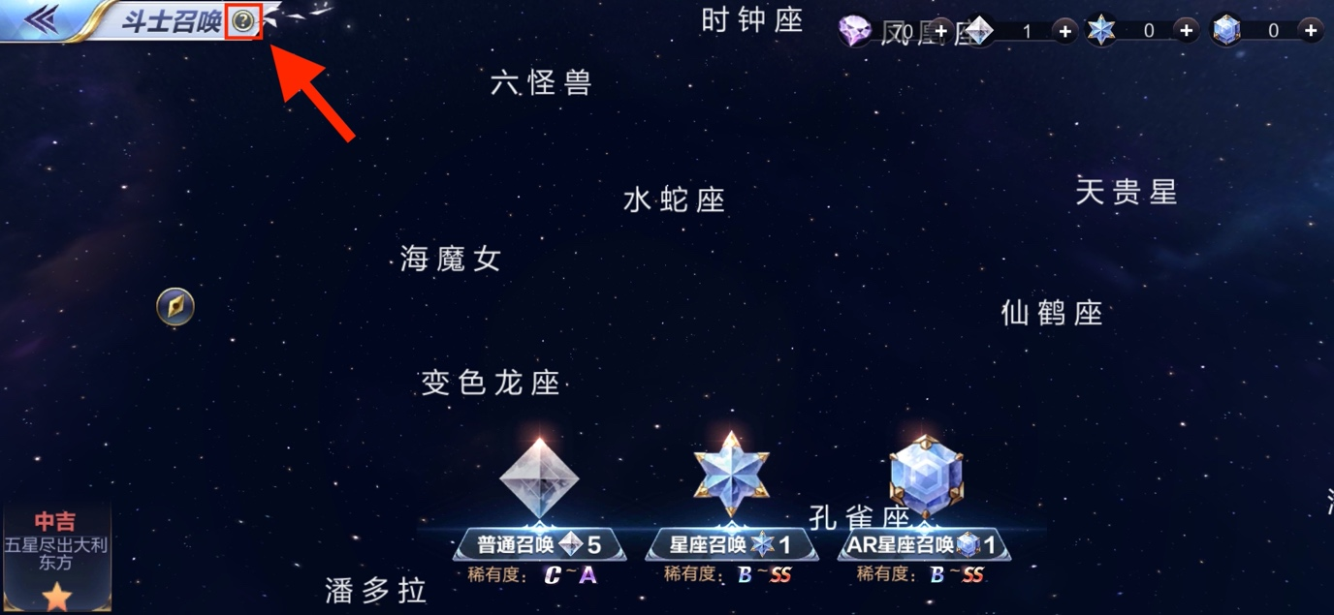

Fig.S3: Game 43’s 圣斗士星矢 [Saint Seiya: Knights of the Zodiac] probability disclosure can be accessed immediately after tapping a small generic symbol (i.e., the ‘(?)’ symbol; annotated; 55.8% of in-game disclosures). © 1998–2020 Tencent; Masami Kurumada

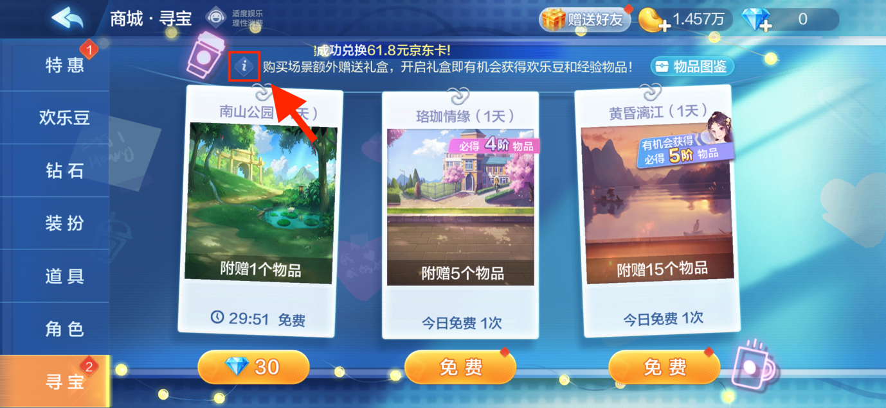

Fig.S4: Game 29’s (欢乐斗地主 [Happy Poker]) probability disclosure can be accessed immediately after tapping a small generic symbol (i.e., the ‘<i>’ symbol; annotated; 55.8% of in-game disclosures). © 2020 Tencent

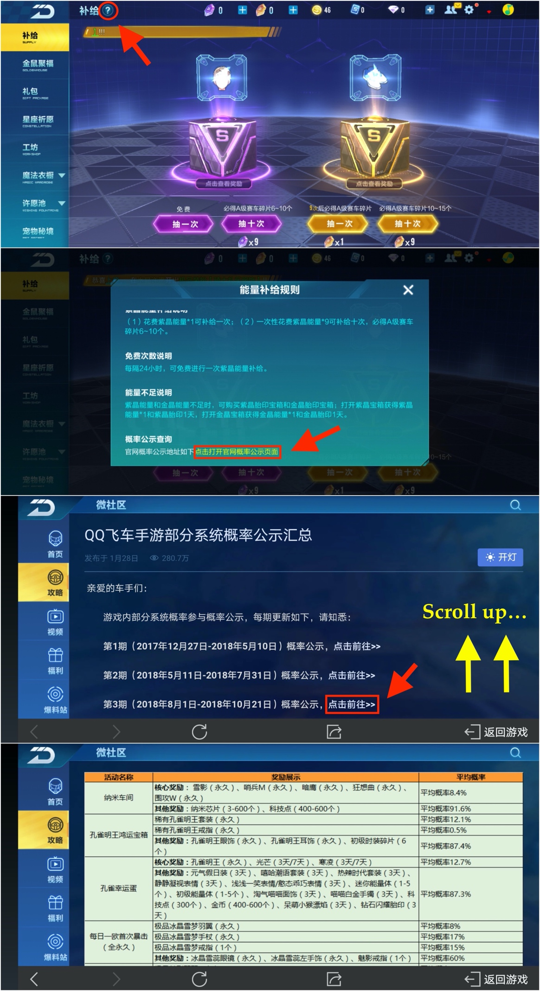
Fig.S5: Game 17’s (QQ飞车) probability disclosure can be accessed after tapping a small generic symbol and following additional steps (15.4% of in-game disclosures). The process in detail is as follows: tapping the ‘(?)’ (annotated) at the top of the first screenshot; then tapping the hyperlink at the bottom of the second screenshot (annotated); then tapping on the hyperlinks on the third screenshot (annotated). Notably, the notices were listed in chronological order and not in reverse chronological order, meaning that to access the most recently updated probability disclosure, the player must scroll down to the bottom of the page shown on the third screenshot. The bottommost screenshot shows the probability disclosure being shown after following the above steps. © 2010–2020 Tencent

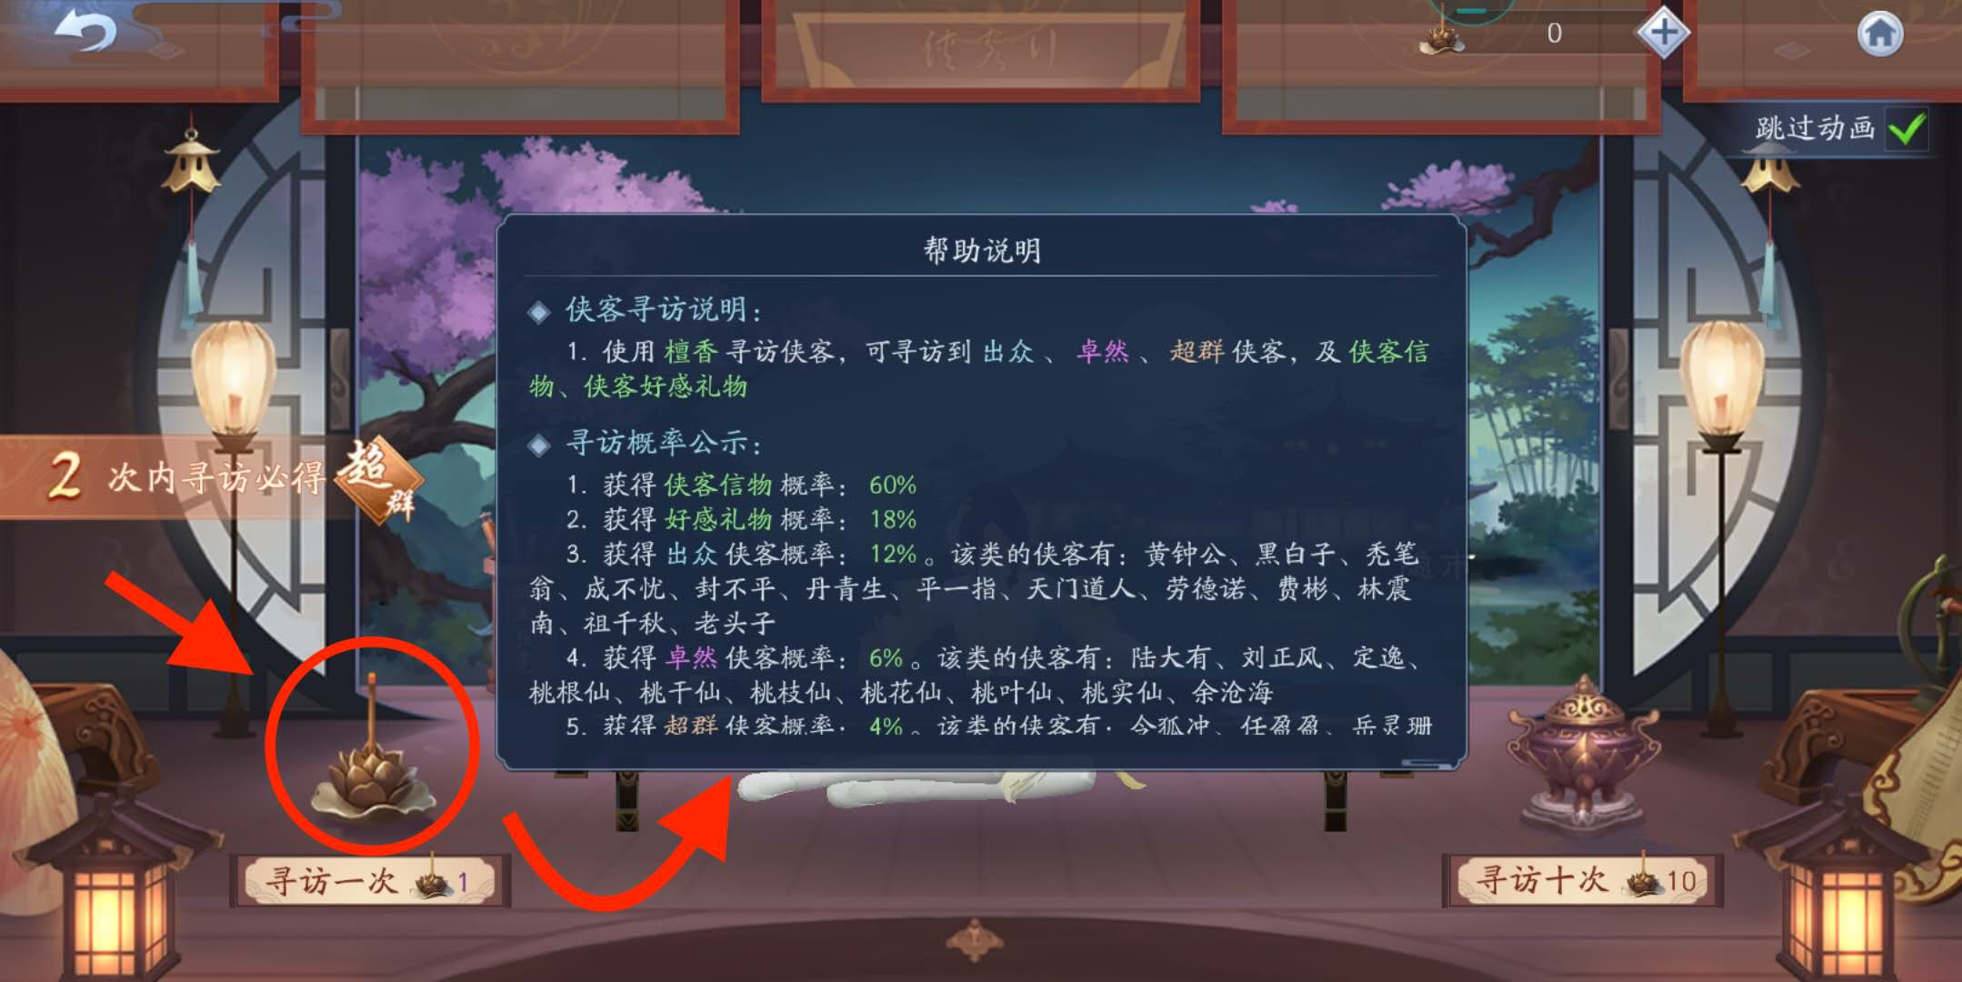

Fig.S6: Game 14’s (新笑傲江湖) probability disclosure can be accessed by tapping a graphic element that was not seemingly interactable (i.e., the incense burner; annotated; 5.8% of in-game disclosures). © 2020 完美世界 [Perfect World]

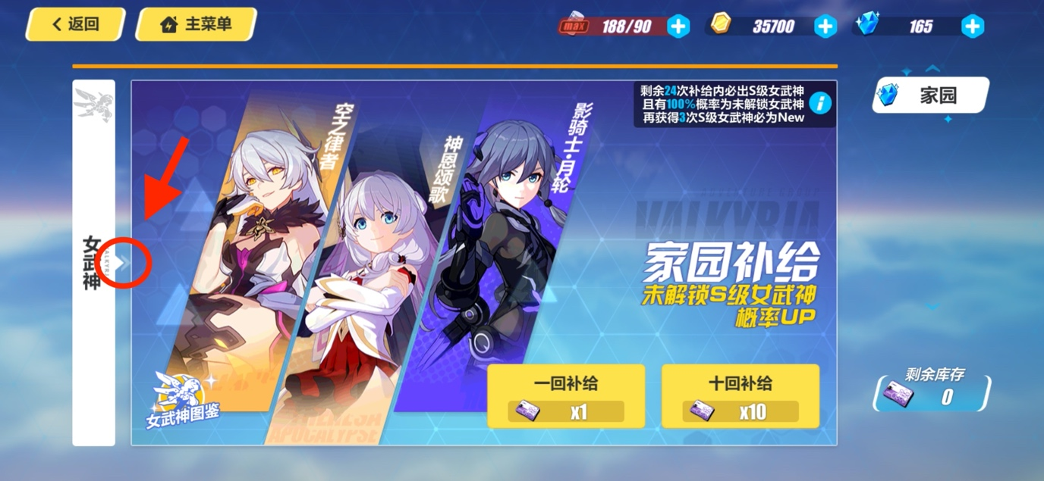

Fig.S7: Game 23’s (崩坏3 [Honkai Impact 3rd]) probability disclosure can be accessed by tapping a graphic element that was not seemingly interactable (i.e., the arrows on the left side of the loot box purchase page; annotated; 5.8% of in-game disclosures). Notably, tapping the blue ‘(i)’ symbol near the top right did not bring up the probability disclosure and instead disclosed the pity-timer mechanic, unlike other games in the majority category where tapping a similar small generic symbol would have allowed the player to access the loot box disclosure. © 2012–2020 miHoYo

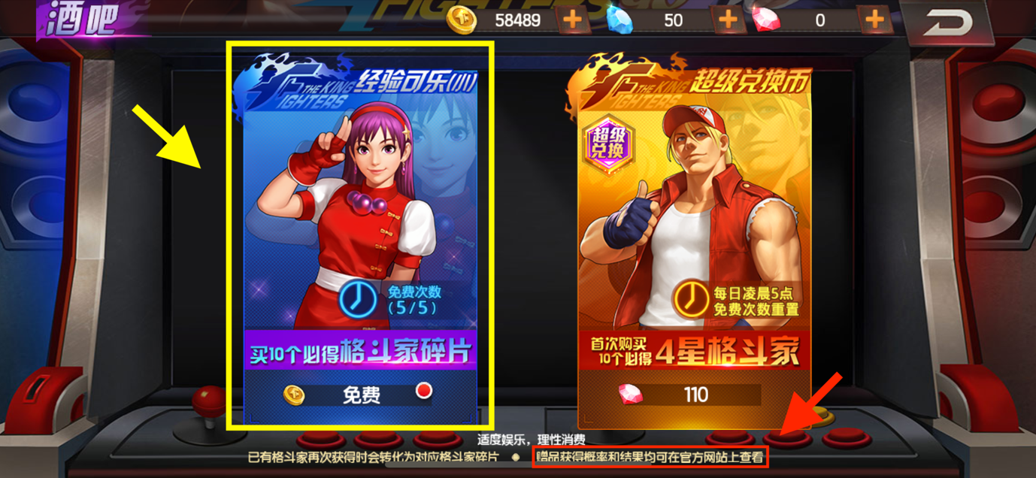

Fig.S8: Game 105’s (拳皇98终极之战OL-SNK官方正版授权) probability disclosure can be accessed by tapping a graphic element that was not seemingly interactable (i.e., the big banner; annotated in yellow; 5.8% of in-game disclosures) and then following additional steps. Notably, the loot box purchase page stated that the probability disclosure is available on the game’s official website (annotated in red). However, no such disclosure was found by the Authors. © 1998–2020 Tencent; SNK Corporation

_________________________________
Categories of Website Disclosures
_________________________________

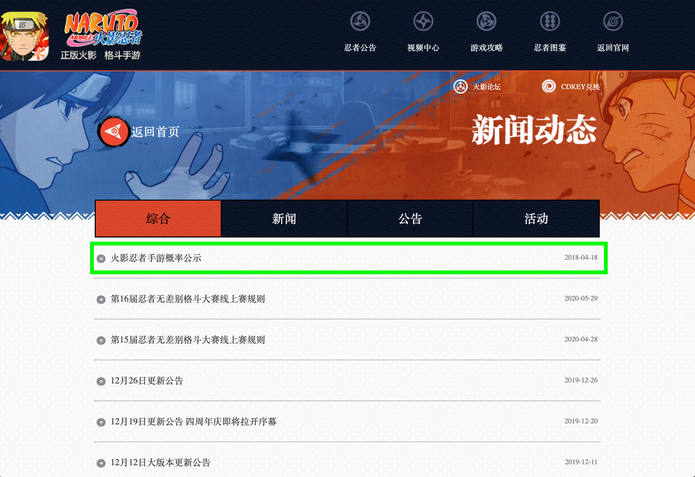

Fig.S9: Game 11’s (火影忍者 [Naruto Mobile]) probability disclosure (annotated) was published categorically under the ‘公告 [notice]’ tab and which was then pinned to the top of all other posts (3.0% of website disclosures), as demonstrated by comparing the 18 April 2018 date of publication of the probability disclosure with the dates of publication of other posts, which were listed chronologically. ©2002 MASASHI KISHIMOTO / 2007 SHIPPUDEN; © BANDAI NAMCO Entertainment Inc.; © 2019 TENCENT

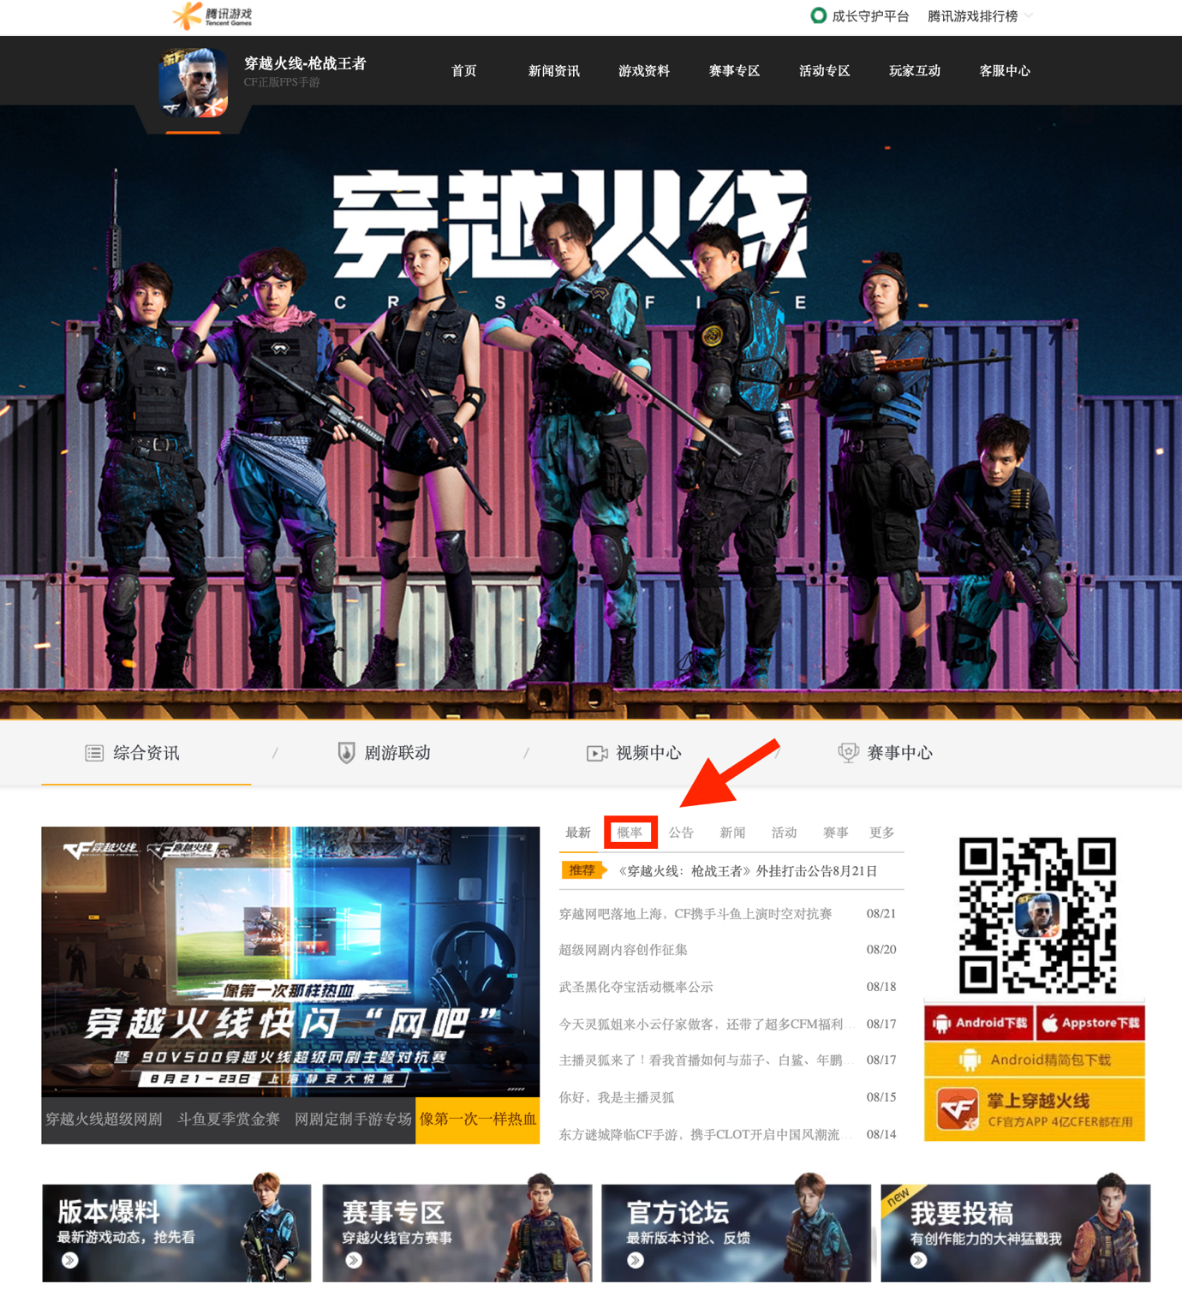

Fig.S10: Game 35’s (穿越火线:枪战王者) various probability disclosures for different loot boxes were separately published categorically under the ‘概率 [probabilities]’ tab (annotated), which was separated out from other categorical post tabs and displayed on the homepage (1.5% of website disclosures). © 1998 - 2020 Tencent; Smilegate Entertainment

______________________________________
Inaccurate and Non-Compliant Disclosures
______________________________________

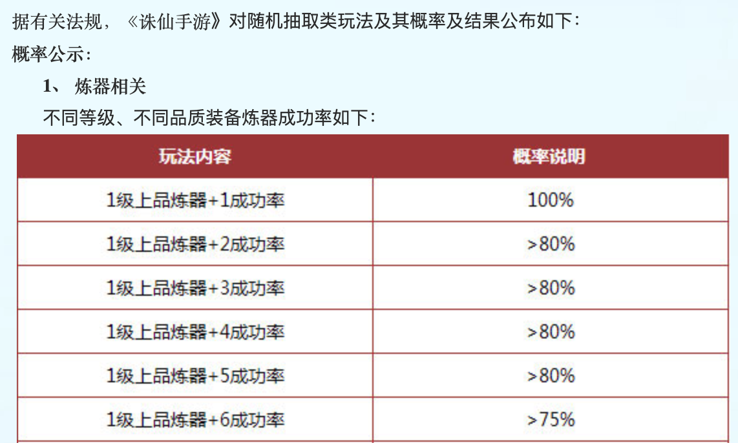

Fig.S11: Game 34’s (诛仙手游) probability disclosure disclosed indefinite probabilities of, for example, ‘> 80%.’ It is not known whether this was merely the innocuous result of rounding down a probability with multiple digits after the decimal point to assist in the player’s ease of comprehension, or if something else more sinister is afoot, as no further requisite explanation was provided. This disclosure was therefore defective, incomplete and non-compliant with the PRC law. © 2017 完美世界 [Perfect World]

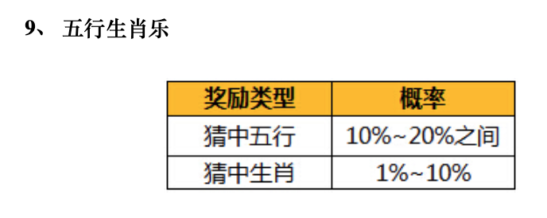

Fig.S12: Game 25’s (问道) probability disclosure presented certain probabilities as a range: ‘between 10%~20%’ and ‘1%~10%.’ It is not known how the probability range will be used to calculate results for each individual purchase, as no further requisite explanation was provided. Both were therefore defective, inaccurate and non-compliant with the PRC law. © 2004-2020吉比特网络 [G-BITS]; 雷霆游戏 [Leiting Games]

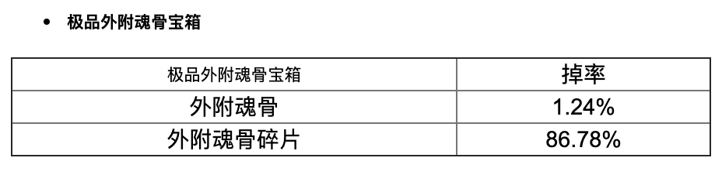

Fig. S13: Game 41’s (新斗罗大陆) probability disclosure disclosed probabilities summing to less than 100% for multiple loot boxes: 1.24%+86.78%=87.92%. It is not known what rewards, if any, would be provided the other 12.08% of the time, as no further requisite explanation was provided. This disclosure was therefore defective, incomplete and non-compliant with the PRC law. © 2004-2017 上海玄霆娱乐信息科技有限公司

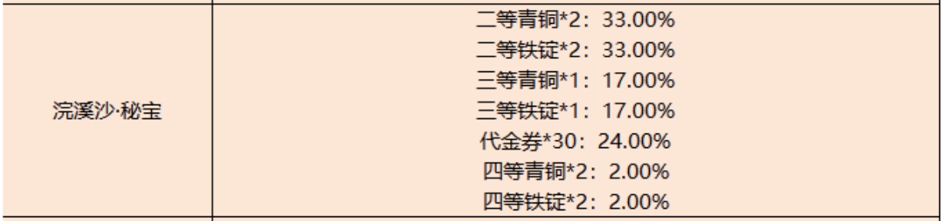

Fig.S14: Game 101’s (御龙在天) probability disclosure disclosed probabilities summing to more than 100% for multiple loot boxes: 33+33+17+17+24+2+2=128%! It is not known whether this loot box potentially contained more than one reward and the probabilities of obtaining individual rewards were separately calculated, which may have caused the various probabilities to sum to more than 100%, as no further requisite explanation was provided. This disclosure was therefore defective, incomplete and non-compliant with the PRC law. This game also contained up to 433 different types of loot boxes, according to its website disclosure, as counted by the First Author. © 1998 - 2020 Tencent

_______________________
COPYRIGHT NOTICE
_______________________
The Authors acknowledge that the copyright of all screenshots of video games and websites used in this paper are retained by their respective copyright holders. The Authors use these copyrighted materials for the purposes of research, criticism or review under the fair dealing provisions of copyright law in accordance with Sections 29(1) and 30(1) of the UK Copyright, Designs and Patents Act 1988.

