## Supplementary Materials – Do Nudges Crowd Out Prosocial Behavior?

### Additional Figures



**Figure S1.** Average donation to charity in each condition, with 95 % confidence intervals.



**Figure S2.** Average donation to charity and perception of nudges. Panel A distinguishes between subjects who perceived the nudges as attempts to manipulate behavior and those who did not, while Panel B distinguishes between subjects who considered themselves successfully manipulated by the nudge and those who did not share this view. Error bars are 95 % confidence intervals.



**Figure S3.** Distribution of donations measured in USD.

### Experimental instructions

This part of the document provides the experimental instructions as they were presented for the subjects. The first section describes how the nudges were used. The second shows how the additional information about the nudges were presented. The last section contains all instructions and questions for the subjects in the control group, also indicating where the nudged conditions (with and without additional information) deviated from the control.

1. Nudges

**Default nudge:**

(Added “yes” as a pre-selected choice when making the choice whether to donate or not. Also changed the default value of the slider from 0 to 50, when making the choice of how much to donate, for subjects choosing to donate.)

**Social norm nudge:**

(Additional information provided at the stage of choosing whether to donate or not.)

“Previous studies have shown that about 80% of participants choose to donate money in similar situations.”

**Moral nudge:**

(Question added prior to making the decision whether to donate or not.)

You now have the chance to donate any amount of the additional $0.5 to UNICEF.

Before you make a decision, please respond to the following question:

*What do you think is the****most morally right to do****, in this situation?*

|  |  |
| --- | --- |
| Donate | Not donate |
|  |  |

2. Additional information about the nudges

The additional information read, for the three groups respectively:

**Default nudge + extra information:**

“*Before proceeding, please note that when asked to donate, the default choice (pre-selected) is set to donate.*

*Changing which choice is the default choice is a method that can be used to affect behavior. This method is frequently used by companies and organizations to promote certain behavior. It has been proven to have a large impact on choices and behavior for example when giving consent for organ donations, choosing insurance policies, eating healthy and in many other situations.*”

**Social norm nudge + extra information:**

”*Before proceeding, please note that when asked to donate, you will be informed of the choices made by other people.*

*Providing information about choices made by other people is a method that can be used to affect behavior. This method is frequently used by companies and organizations to promote certain behavior. It has been proven to have a large impact on choices and behavior for example when trying to reduce household energy consumption, making people choose good insurance policies, eating healthy and in many other situations.*”

**Moral nudge + extra information:**

*“Before proceeding, please note that before you are asked to donate, you will be asked what you think is the most morally right choice.*

*Asking what is morally right to do is a method that can be used to affect behavior. This method can be used by companies and organizations to promote certain behavior, and has been proven to have a large impact on choices and behavior.”*

3. Complete set of instructions and questions  
(horizontal lines indicate a new page, square brackets show where conditions deviate from the control group.)

Hello and welcome!

Thank you for taking part in this survey. We want to know your thoughts about a UNICEF advertisement. UNICEF is a United Nations agency responsible for providing humanitarian and developmental aid to children around the world. You will be shown the advertisement and then asked a few questions. There are no right or wrong answers, we are only interested in your opinion. All answers will be treated confidentially.

We expect that this survey will take less than 5 minutes to complete and you will be paid $0.5, with a chance of an additional $0.5.

_________________________________________________________________________________

Your answers in this study will be anonymous. That is, your answers cannot be directly linked to you as a person. Your participation is voluntary and you can always choose to cancel.

Do you consent to participate in this study? (If you do not, simply leave this page)

I voluntarily participate

Please enter your Prolific ID here:



_________________________________________________________________________________

This is an advertisement used by UNICEF. Please look at it and then answer the questions below.

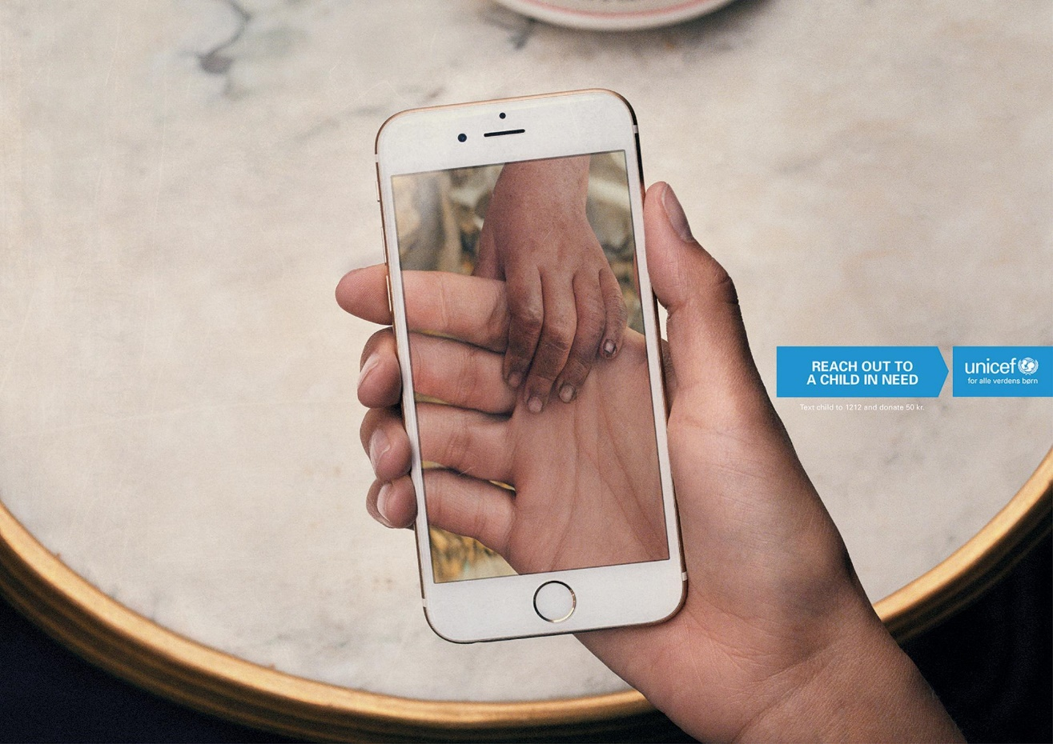

Please answer the following questions:

|  | Yes | Maybe | No |
| --- | --- | --- | --- |
| *Did you know about UNICEF from before?* |  |  |  |
| *Do you know what they do?* |  |  |  |
| *Is it easy to understand the message of the advertisement?* |  |  |  |
| *Is the graphical design suitable for the purpose of the advertisement?* |  |  |  |
| *Is the picture sutiable for the message of the advertisement?* |  |  |  |
| *Does the layout of the text reflect the same emotions as the picture?* |  |  |  |
| *To verify your attention, please answer "Maybe" on this question.* |  |  |  |
| *Are you emotionally moved by the advertisement?* |  |  |  |
| *Do you think that the advertisement is well made?* |  |  |  |

*Please indicate your gender.*

|  |  |  |
| --- | --- | --- |
| Male | Female | Other |

*Please indicate your age.*



_________________________________________________________________________________

Thank you for your answers!

You will be paid $0.5 for the answers you just provided. You will also receive an additional $0.5, which you may choose to  donate to UNICEF. If you prefer, you can also keep the additional $0.5 for yourself.

[Additional information in the conditions involving additional information about nudges, see second section of this document.]

_________________________________________________________________________________

[Additional question in the moral nudge conditions, see first section of this document.]

_________________________________________________________________________________

*You now have the chance to donate any amount of the additional $0.5. to UNICEF.*  
[Additional information for the social norm nudge, see first section of this document.]   
 *Do you want to donate some of the money?*

| *Yes* | *No* | |  | |
| --- | --- | --- | --- | --- |
|  |  |  | |

[In the default nudge, ”Yes” was pre-selected.]

_________________________________________________________________________________

(For donating participants)

How much do you want to give to UNICEF?

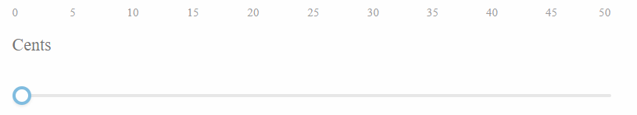

[In the default nudge condition, 50 Cents was pre-selected]

_________________________________________________________________________________

(For donating subjects)

How much do you agree with the following statements?

|  |  |  |  |  |  |  |
| --- | --- | --- | --- | --- | --- | --- |
|  | Strongly disagree | Disagree | Agree | | Strongly agree | |
| I am happy with my choice to donate money to UNICEF. |  |  |  |  | |
| When giving money to UNICEF I experienced a sense of joy and satisfaction for helping others. |  |  |  |  | |

(For non-donating subjects)

How much do you agree with the following statement?

|  |  |  |  |  |
| --- | --- | --- | --- | --- |
|  | Stronlgy disagree | Disagree | Agree | Stronlgy agree |
| I am happy with my choice to not donate money to UNICEF. |  |  |  |  |

_________________________________________________________________________________

(In the default nudge conditions)

When deciding whether to give to UNICEF or not, YES was pre-selected.

When you made the choice to donate or not, did you feel like the this pre-selected choice was an attempt to manipulate your answer?

| *Yes* | *No* | |  | |
| --- | --- | --- | --- | --- |
|  |  |  | |

Do you think that the pre-selected choice succeeded in manipulating your answer?

| *Yes* | *No* | |
| --- | --- | --- |
|  |  |

(In the social norm nudge conditions)

When you made the choice to donate or not, you received information about how much other participants contribute.

Did you feel like the information about how much other people donate was an attempt to manipulate your answer?

| *Yes* | *No* | |  | |
| --- | --- | --- | --- | --- |
|  |  |  | |

*Do you think that the information about how much other people donate succeeded in manipulating your answer?*

| *Yes* | *No* | |  | |
| --- | --- | --- | --- | --- |
|  |  |  | |

(In the moral nudge conditions)

When you made the choice to donate or not, did you feel like the question about what was morally right was an attempt to manipulate your answer?

| *Yes* | *No* | |
| --- | --- | --- |
|  |  |

Do you think that the the question about what was morally right succeeded in manipulating your answer?

| *Yes* | *No* | |
| --- | --- | --- |
|  |  |

_________________________________________________________________________________

Thank you for taking part in this survey!

By clicking continue you will be directed back to Prolific.