Supplementary Materials 5: Survey Invitation

Dear Masterclass Participants,

Thank you for taking part in the ‘Living on the Edge’ bioarchaeology project’s masterclass series this year. It has been wonderful to get to know many of you.

If you have attended at least one masterclass, we now invite you to participate in a ten-minute long Qualtrics survey. To take part, please click on the link below or scan the QR code provided. The survey is available until 11:59pm 14 January 2022 and once you have begun, you have two weeks to complete your entry.

Click to access the survey: https://anu.au1.qualtrics.com/jfe/form/SV_9ztpf1L1HZVvgLY

Or Scan the QR Code:
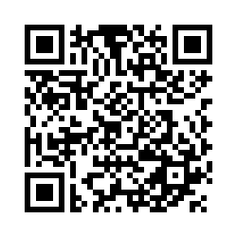

Wishing you all a safe and happy holiday season,
Stacey, Anna-Claire, Rasmi, Naruphol, Justyna, Charlotte, and Siân
The Living on the Edge Bioarchaeology Project Team
https://www.livingontheedgebioarch.com/

