Appendix A: Prompts
Every sequence of three stake sizes started with a prompt (Prompt 1) that introduced the scenario. This was followed by two prompts (Prompt 2 and 3) that simply changed the stake value (x). There were four different payoff stake sequences: (1) 100, 200, 400; (2) 400, 200, 100; (3) 200, 400, 100; and (4) 100, 400, 200.To test for whether framing matters (framing effects), we slightly modified the prompts without changing the meaning. An exact comparison is given following the prompts below.
Frame 1
Prompt 1
Imagine you are a Japanese college student participating in a study of human decision-making. You are matched with another participant who you do not know and will not meet. You are given an endowment of x Japanese yen and can do two things: send the entire endowment to the other player or keep the endowment. If you send your endowment to the other player, the endowment will be doubled while being transferred and the other player will receive 2x yen. If you keep your endowment, you will have your endowment. The other player is also given an endowment of x yen and can do the same things: send the entire endowment to you or keep it. If the other player sends it you receive 2x yen, and if the other keeps it, you don’t receive anything. In short, if you and the other player keep your respective endowments, you each get x yen; if you and the other player both send your initial endowments you each get 2x yen; if you send your endowment and the other payer keeps his/her endowment you get nothing and the other player gets 3x yen; if the other player sends his/her endowment and you keep yours, you get 3x yen and the other player gets nothing. You and the other player make your decisions simultaneously. What option do you choose? Do not explain your answer. If you choose to send your endowment you must only respond with ‘A’ and if you choose to keep your endowment you must only respond with ‘B’.
Prompts 2 and 3
Now you will complete the same task but are matched with a different study participant who you do not know and will not meet. You are given an endowment of x Japanese yen and can do two things: send the entire endowment to the other player or keep the endowment. If you send your endowment to the other player, the endowment will be doubled while being transferred and the other player will receive 2x yen. If you keep your endowment, you will have your endowment. The other player is also given an endowment of x yen and can do the same things: send the entire endowment to you or keep it. If the other player sends it you receive 2x yen, and if the other keeps it, you don’t receive anything. In short, if you and the other player keep your respective endowments, you each get x yen; if you and the other player both send your initial endowments you each get 2x yen; if you send your endowment and the other payer keeps his/her endowment you get nothing and the other player gets 3x yen; if the other player sends his/her endowment and you keep yours, you get 3x yen and the other player gets nothing. You and the other player make your decisions simultaneously. What option do you choose? Do not explain your answer. If you choose to send your endowment you must only respond with ‘A’ and if you choose to keep your endowment you must only respond with ‘B’.

Frame 2
Prompt 1
Imagine you are a Japanese college student participating in a study of human decision-making. You are matched with another participant who you do not know and will not meet. You are endowed with x Japanese yen and the other player is also endowed with x yen. In this game both you and the other player can choose between Strategy A and Strategy B. You and the other player will choose your strategies simultaneously. Choosing Strategy A sends an amount double the endowment to the other player. If one chooses strategy B they keep their endowment. If you choose Strategy A and the other player also chooses Strategy A both you and the other player receive 2x yen. If you choose strategy B and the other player chooses Strategy A you receive 3x yen and the other player receives nothing. If you choose Strategy A and the other player chooses Strategy B you receive nothing and the other player receives 3x yen. If you and the other player both choose strategy B you both receive x yen. What option do you choose? Do not explain your answer. If you choose to send your endowment you must only respond with ‘A’ and if you choose to keep your endowment you must only respond with ‘B’.
Prompts 2 and 3
Now you will complete the same task but are matched with a different study participant who you do not know and will not meet. You are endowed with x Japanese yen and the other player is also endowed with x yen. In this game both you and the other player can choose between Strategy A and Strategy B. You and the other player will choose your strategies simultaneously. Choosing Strategy A sends an amount double the endowment to the other player. If one chooses strategy B they keep their endowment. If you choose Strategy A and the other player also chooses Strategy A both you and the other player receive 2x yen. If you choose strategy B and the other player chooses Strategy A you receive 3x yen and the other player receives nothing. If you choose Strategy A and the other player chooses Strategy B you receive nothing and the other player receives 3x yen. If you and the other player both choose strategy B you both receive x yen. What option do you choose? Do not explain your answer. If you choose to send your endowment you must only respond with ‘A’ and if you choose to keep your endowment you must only respond with ‘B’.
An Exact Comparison of Frame 1 and Frame 2 for Prompt 1
The two framings of prompt 1 describe the same decision-making scenario, but they differ in structure, wording, and some details. Here are the exact differences:
Frame 2:
"Imagine you are a Japanese college student participating in a study of human decision-making." (Identical to Frame 1)
"You are matched with another participant who you do not know and will not meet." (Identical to Frame 1)
"You are endowed with x Japanese yen and the other player is also endowed with x yen." (Combines information from sentences 3 and 6 of Frame 1)
"In this game both you and the other player can choose between Strategy A and Strategy B." (Introduces "Strategy A" and "Strategy B" early)
"You and the other player will choose your strategies simultaneously." (Mentions simultaneity earlier than Frame 1)
"Choosing Strategy A sends an amount double the endowment to the other player." (Rephrases sentence 4 from Frame 1)
"If one chooses strategy B they keep their endowment." (Rephrases sentence 5 from Frame 1)
"If you choose Strategy A and the other player also chooses Strategy A both you and the other player receive 2x yen." (Similar to part of sentence 8 in Frame 1 but phrased differently)
"If you choose strategy B and the other player chooses Strategy A you receive 3x yen and the other player receives nothing." (Rephrased part of sentence 8 from Frame 1)
"If you choose Strategy A and the other player chooses Strategy B you receive nothing and the other player receives 3x yen." (Rephrased part of sentence 8 from Frame 1)
"If you and the other player both choose strategy B you both receive x yen." (Similar to part of sentence 8 in Frame 1 but phrased differently)
"What option do you choose?" (Identical to Frame 1)
"Do not explain your answer." (Identical to Frame 1)
"If you choose to send your endowment you must only respond with ‘A’ and if you choose to keep your endowment you must only respond with ‘B’." (Identical to Frame 1)

Summary of Specific Differences:
Sentence 3 in Frame 1: "You are given an endowment of x Japanese yen and can do two things: send the entire endowment to the other player or keep the endowment."
vs. Sentence 3 in Frame 2: "You are endowed with x Japanese yen and the other player is also endowed with x yen."
Sentence 4 in Frame 1: "If you send your endowment to the other player, the endowment will be doubled while being transferred and the other player will receive 2x yen."
vs. Sentence 6 in Frame 2: "Choosing Strategy A sends an amount double the endowment to the other player."
Sentence 5 in Frame 1: "If you keep your endowment, you will have your endowment."
vs. Sentence 7 in Frame 2: "If one chooses strategy B they keep their endowment."
Sentence 6 in Frame 1: "The other player is also given an endowment of x yen and can do the same things: send the entire endowment to you or keep it."
vs. Sentence 3 in Frame 2: Combined with the earlier part of Frame 1.
Sentence 7 in Frame 1: "If the other player sends it you receive 2x yen, and if the other keeps it, you don’t receive anything."
vs. Sentence 8 in Frame 2: "If you choose Strategy A and the other player also chooses Strategy A both you and the other player receive 2x yen."
vs. Sentence 9 in Frame 2: "If you choose strategy B and the other player chooses Strategy A you receive 3x yen and the other player receives nothing."
vs. Sentence 10 in Frame 2: "If you choose Strategy A and the other player chooses Strategy B you receive nothing and the other player receives 3x yen."
vs. Sentence 11 in Frame 2: "If you and the other player both choose strategy B you both receive x yen."
Sentence 8 in Frame 1: "In short, if you and the other player keep your respective endowments, you each get x yen; if you and the other player both send your initial endowments you each get 2x yen; if you send your endowment and the other player keeps his/her endowment you get nothing and the other player gets 3x yen; if the other player sends his/her endowment and you keep yours, you get 3x yen and the other player gets nothing."
Summarized in multiple sentences in Frame 2 (Sentences 8-11).
Sentence 9 in Frame 1: "You and the other player make your decisions simultaneously."
vs. Sentence 5 in Frame 2: "You and the other player will choose your strategies simultaneously."
These differences highlight the variation in structure, wording, and the order of information presented between the two Frames.

Appendix B: Additional Tables and Figures

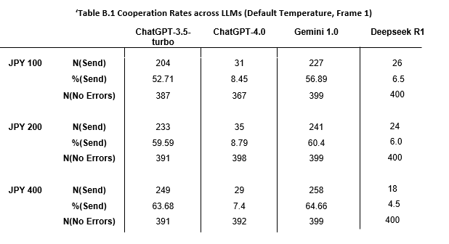
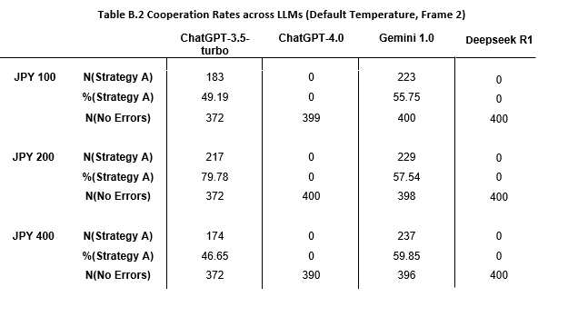
Figure B.1 Overall Distribution of Responses across LLMs (Temperature 1, Frame 1)
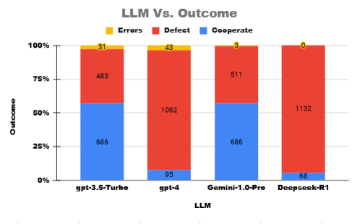

Figure B.2 Overall Cooperation Rates, LLM Temperature Setting = 0

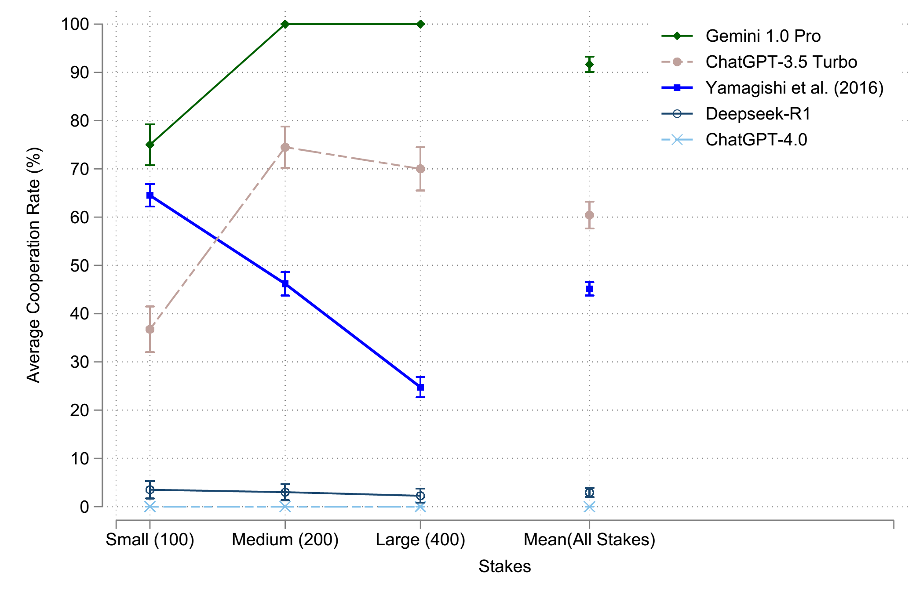
Note. The vertical lines depict 95% confidence intervals around means.

Figure B.3 Order Effects, All Stake Size Sequences
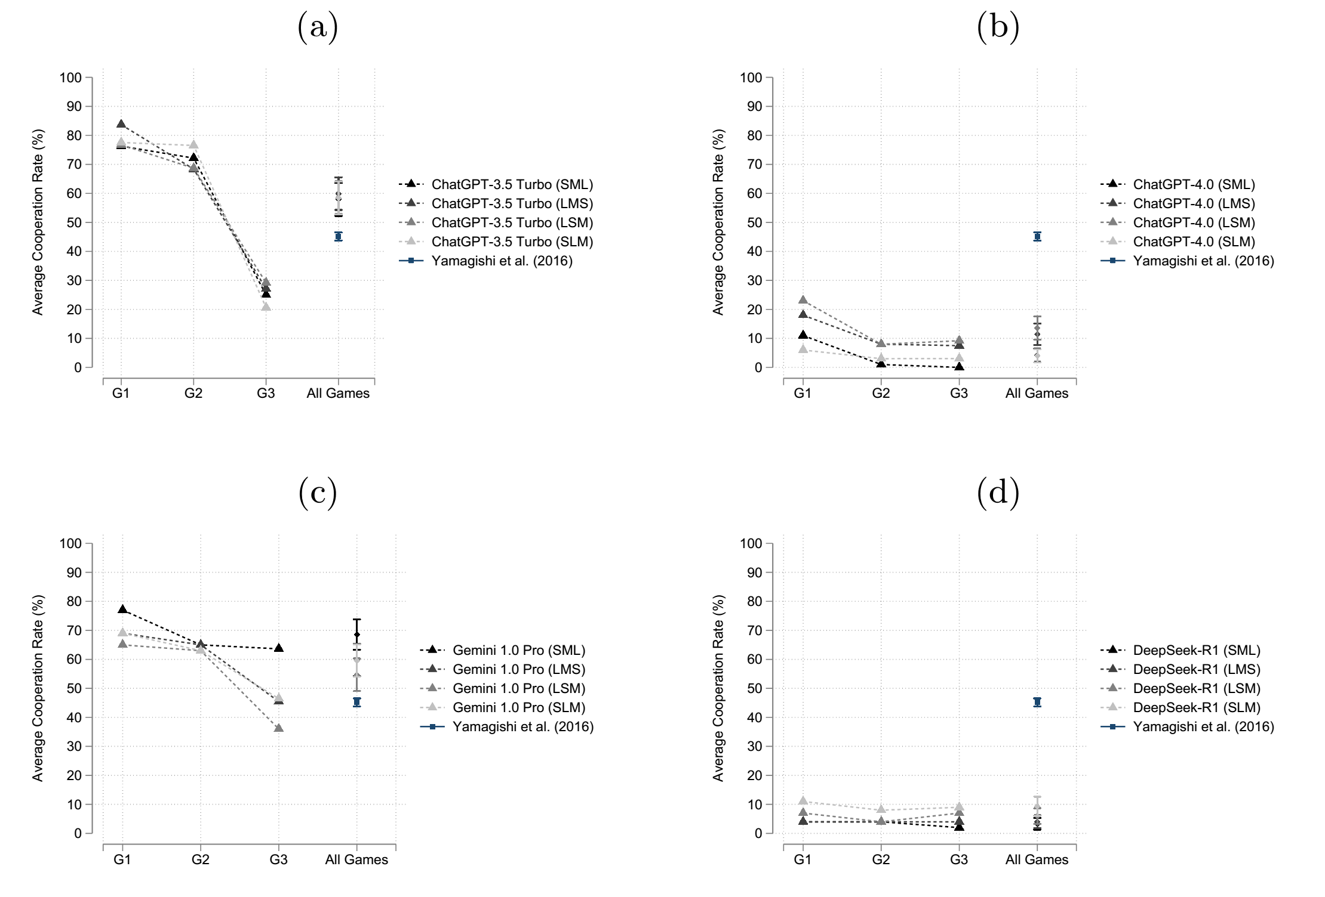
Note. The letters S, M and L refer to the small (JPY 100), medium (JPY 200) and large (JPY 400) stakes. G1, G2, and G3 depict the order in which stakes were presented to the LLMs in the query. For instance, in the SML queries, we presented the LLM JPY 100 in Game 1 (denoted as G1), JPY 200 in Game 2 (denoted as G2) and JPY 400 in Game 3 (denoted as G3). For the LMS sequence we presented the LLM JPY 400 in Game 1 (denoted as G1), JPY 200 in Game 2 (denoted as G2) and JPY 100 in Game 3 (denoted as G3). The vertical lines depict 95% confidence intervals around means.

Figure B.4 DeepSeek-R1 Sequence Effects

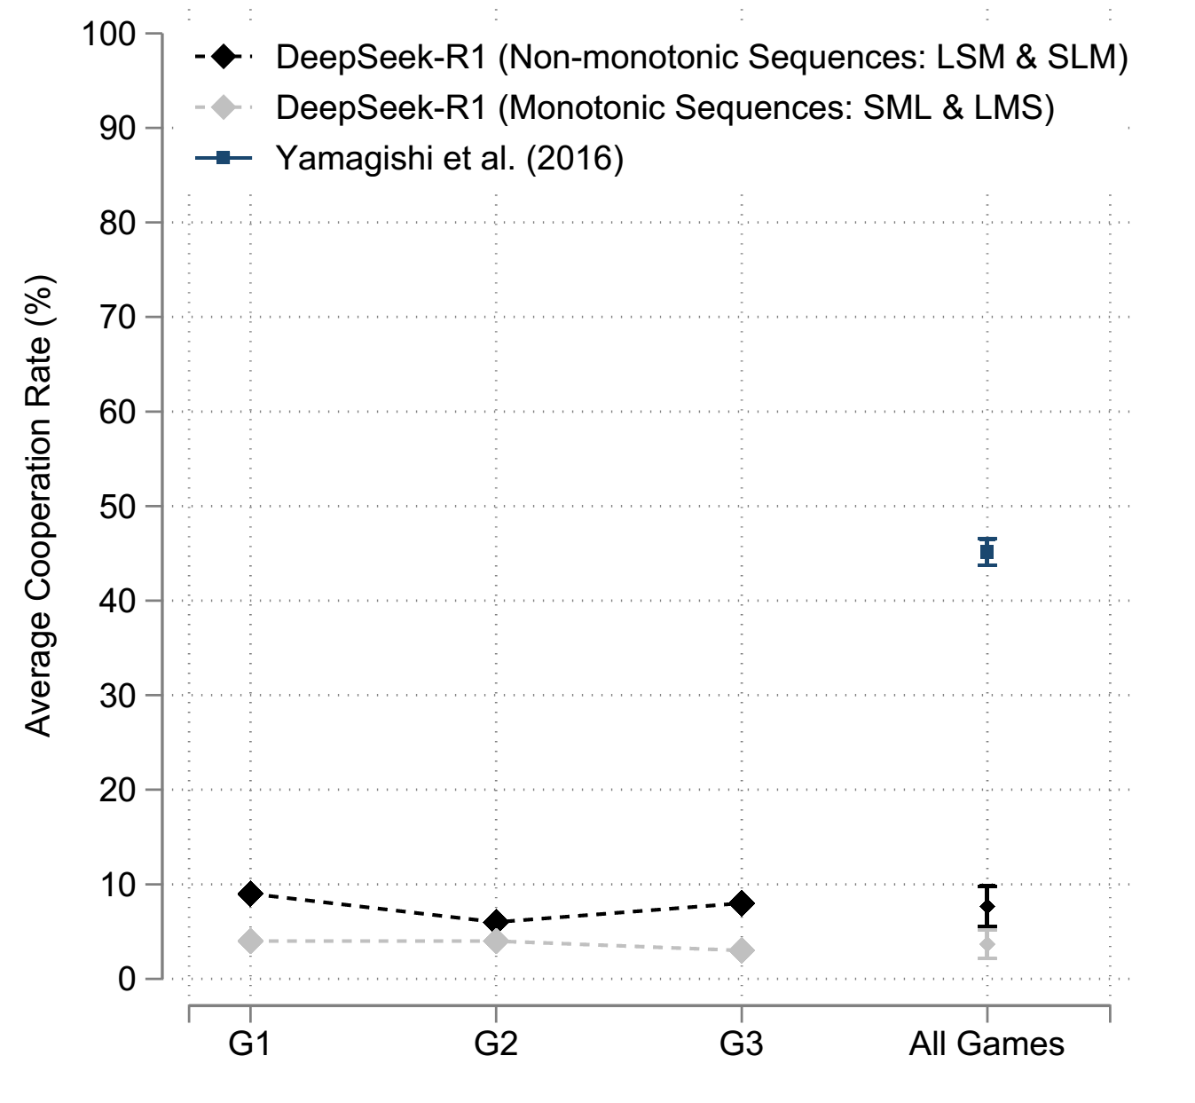
Note. The letters S, M and L refer to the small (JPY 100), medium (JPY 200) and large (JPY 400) stakes. G1, G2, and G3 depict the order in which stakes were presented to the LLMs in the PD game order. The light color diamonds refer to monotonically changing stakes (either SML or LMS) and the dark color diamonds to non-monotonically changing stakes(either LSM or SLM). A two sample test of proportions between the average cooperation rates in monotonic sequences (SML and LMS; 4%) and in non-monotonic sequences (LSM, SLM; 7.6%) is z=2.9962, p=0.0027.

