For Online Publication

Web Appendix:

APPENDIX A: ADDITIONAL RESULTS

  - A survey of SM vs. DE papers

Whether SM has led to serious bias in the SM vs. DE literature depends on: (1) the type of decision involved, (2) the importance of off-equilibrium considerations, and (3) the use of procedures to correct for it. Since these factors are inherently empirical, we collected data on all ultimatum game studies from the meta- study performed in 2011 (Brandts and Charness 2011), as well as from studies that we located on Econlit using the keyword searches “ultimatum game,” “minimum acceptable offer” or “acceptance threshold.” We found 31 papers and 63 experiments.10 Data were obtained either from the authors or calculated from the graph. We found 16 SM ultimatum games and 45 DE ultimatum games, which yield the number of observations in Table A.1. Out of 16 SM games, 12 are performed with the threshold method. Only 6 SM experiments reported the acceptance/rejection rate.
Next, we present evidence that behavior of the respondent diverges depending on whether SM or DE is used. The average offer is not significantly influenced by the method of elicitation (p > 0.1) and is roughly 40% of endowment (Table A.1 Column 1). Each observation represents one experiment and we report linear probability models as recommended by Angrist and Pischke (2008). Offer levels are higher in the more recent time period (p < 0.05) and lower in developing countries (p < 0.01). Controlling for these factors does not affect the relationship between offer and method of elicitation (Column 2). The lack of an effect is robust to weighting for the study’s citation count (Column 3) or the study’s number of observations (Column 4). A Wilcoxon-Mann-Whitney test cannot reject the null of equality of offers (p = 0.59).

DE increases acceptance rate of the responder by roughly 20 percentage points (p < 0.001) (Table A.2 Column 1). This increase is robust to controls for offered amount, whether the experiment is repeated, and whether the study is in a developing country (Column 2). Repeating the experiment reduces acceptance rate by 12 percentage points (p < 0.001) (Column 2). Like SM, repeating the experiment may involve decisions at one information set affecting the utility (but not the payoffs) of decisions at another information set.

10Papers reporting DE experiments are: Bornstein and Yaniv (1998); Cameron (1999); Croson (1996); Fershtman and Gneezy (2001); Forsythe et al. (1994); Gneezy and Guth (2003); Güth et al. (1982); Henrich (2000); Henrich and McElreath (2001); Hoffman and Smith (1994); Hoffman et al. (1996); Ruffle (1998);
Slembeck (1999); Slonim and Roth (1998); Suleiman (1996); Weg and Smith (1993); Roth et al. (1991); Anderson et al. (2000); Oxoby and McLeish (2004). Papers reporting SM experiments are: Andreoni et al. (2003); Blount (1995); Carter and Irons (1991); Harrison and McCabe (1996); Munier and Zaharia (2002); Solnick and Schweitzer (1999); Solnick (2001); Oxoby and McLeish (2004); Ong et al. (2012); Brañas-Garza et al. (2006); Poulsen and Tan (2007); Schmitt et al. (2008); Güth et al. (1997). Some papers reported multiple experiments.

APPENDIX TABLE A.1
Offer levels in ultimatum game meta-analysis

 | (1) | (2) | (3) | (4)
(Intercept) | 0.412*** | -7.079* | 0.402*** | 0.415***
 | (0.00814) | (3.209) | (0.00813) | (0.00751)
Strategy method | 0.0136 | -0.0187 | 0.0133 | 0.00245
 | (0.0159) | (0.0173) | (0.0352) | (0.0140)
Year of experiment |  | 0.00376*
 |  | (0.00161)
Repeated experiment |  | 0.00728
 |  | (0.0142)
Developing country |  | -0.0586**
 |  | (0.0174)
Mean of Y | 0.416 | 0.416 | 0.403 | 0.415
N | 61 | 61 | 61 | 60
Standard errors in parentheses
+ p<0.1, * p<0.05, ** p<0.01, *** p<0.001
Notes: Column 1 has no controls, Column 2 controls for year of experiment, whether the experiment was conducted repeatedly, and whether the study was conducted in a developing country. Column 3 weights by citation counts for the paper. Column 4 weights by the number of observations in the study.

When the interaction between offer and SM is included, offers increase acceptance in SM (p < 0.1) (Column 3): an additional 1 percentage point in offer is associated with an additional 2.5 percentage points in acceptance rate when SM is used than when DE is used. When we drop developing countries (all of which used DE), DE still increases acceptance rates (p < 0.1) (Column 4). Furthermore, a significant effect of offers emerges: an additional 1 percentage point in offer is associated with an additional 0.9 percentage points in acceptance rate when DE is used (p < 0.1); SM yields an insignificant greater 1.9 percentage points in acceptance rate per 1 percentage point in offer (p > 0.1).
Removing interaction terms, but weighting by citation counts, renders the main effect of DE vs. SM insignificant (Column 5). Weighting by the number of observations yields an effect of 10 percentage points (p < 0.01) (Column 6). In sum, we observe that the behavior of the respondent, especially the acceptance rate, diverges depending on whether SM or DE is used.
Additionally, among the 16 SM experiments, 6 report the acceptance/rejection rate along with average threshold, 9 report average threshold only (rendering the acceptance data unusable for Table A.2), and 1 reports nothing for the responder (also rendering the data unusable). The 6 SM studies reporting acceptance rates have a somewhat lower average threshold than the 9 studies reporting thresholds only. This suggests that if these 9 studies also reported acceptance rates, the 9 studies would have had lower acceptance rates

APPENDIX TABLE A.2
Acceptance rate in ultimatum game meta-analysis

 | (1) | (2) | (3) | (4) | (5) | (6)
(Intercept) | 0.877*** | 0.768*** | 0.823*** | 0.549** | 0.788*** | 0.696***
 | (0.0183) | (0.134) | (0.133) | (0.197) | (0.0915) | (0.111)
Strategy method | -0.198*** | -0.208*** | -1.205* | -0.933+ | -0.0943 | -0.103**
 | (0.0528) | (0.0507) | (0.535) | (0.518) | (0.122) | (0.0357)
Offer level |  | 0.399 | 0.264 | 0.900+ | 0.291 | 0.554*
 |  | (0.306) | (0.306) | (0.451) | (0.225) | (0.267)
Repeated experiment |  | -0.120*** | -0.114** | -0.113** | -0.138*** | -0.125***
 |  | (0.0337) | (0.0330) | (0.0352) | (0.0300) | (0.0272)
Developing country |  | -0.0241 | -0.0278
 |  | (0.0381) | (0.0372)
Strategy Method X Offer |  |  | 2.507+ | 1.874
 |  |  | (1.338) | (1.288)
Mean of Y | 0.853 | 0.853 | 0.853 | 0.841 | 0.860 | 0.867
N | 50 | 50 | 50 | 33 | 50 | 49
Standard errors in parentheses
+ p<0.1, * p<0.05, ** p<0.01, *** p<0.001
Notes: Column 1 has no controls, Column 2 controls for: year of experiment; whether the experiment was conducted repeatedly; and whether the study was conducted in a developing country. Column 3 adds the interaction between SM and offer level. Column 4 does the same but drops developing countries. Column 5 weights by citation counts for the paper. Column 6 weights by the number of observations in the study.

than the 6 studies reporting both. In this case, the effect of DE increasing acceptance rates would be larger and more significant. We next show a CDF of the rejection rate study by study, where the SM first-order stochastically dominates the results from the DE studies. Still, since these studies may have idiosyncratic differences in design and did not necessarily randomize whether subjects experienced SM or DE, we next turn to our own experiments.

Appendix Figure A.1: Rejection Rates

1

.8

.6
Cumulative Density

.4

.2

0
0 .2 .4 .6 .8
Rejection Rate

Hot Cold

  - Trust game – DE vs. SM for respondent

In this study, we examine another canonical game, the trust game, also on MTurk. We had 94 subjects split evenly between the role of proposer and respondent and between SM and DE (2x2 design). In the trust game, the proposer receives $0.50 and chooses how much to transfer to the responder in increments of $0.10 (Figure B.4). Any money transferred by proposer is tripled. Responder then chooses how much to return to the proposer. In DE, she is informed about the amount transferred and decides how much should be given back. In SM, she is asked to indicate how much she would return for every possible amount transferred (Figure B.5). Proposer’s transfer can be considered a measure of trust, while responder’s return-transfer can be considered a measure of trustworthiness. Instructions are in Appendix B.

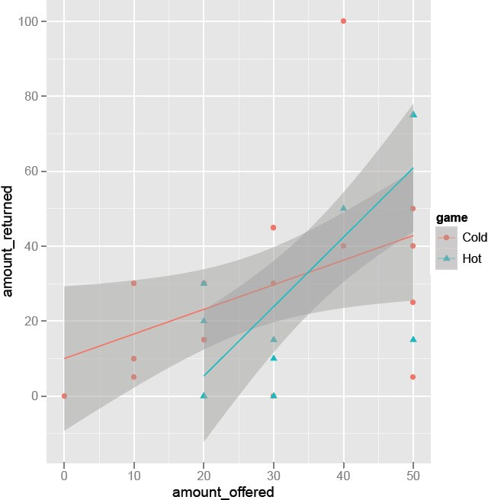
Appendix Figure A.2:
Each point represents an amount offered and amount returned in the trust game. Red dots indicate SM scenarios and blue dots indicate DE scenarios.

    - Results

In Figure A.2, we plot the relationship between amount offered by the proposer and the amount returned by the responder. We can see that the relationship is more intense in the DE (hot) setting.
A linear probability model indicates that respondents return $0.66 for each $1.00 that is offered in the SM setting, but they return $1.85 for each $1.00 offered in the DE setting (p < 0.05).

  - Additional Analyses of Ultimatum game – DE vs. SM and low vs. high salience

One concern with the aforementioned analyses is that strategy/threshold provides far more data at offer levels that are off-equilibrium or rare. Discarding data for offers other than 40% or 50% (these offers occur over 80% of the time) still yields divergence between SM and DE (Figure A.3). Focusing only on 40% offers with one observation per subject-pair renders 100% acceptance in DE but significantly lower acceptance in

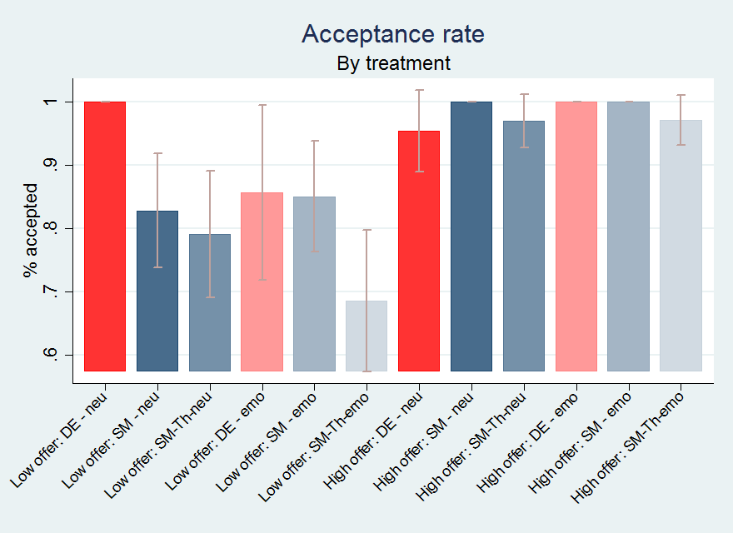
Appendix Figure A.3: Ultimatum Game in laboratory: Acceptance at different offer levels for DE, SM, and SM-Th. Low offer level is 40% and high offer level is 50% of the endowment.

SM.11

  - Complete Analyses of 3-Players Prisoners Dilemma

The identities of the other players were never revealed. Each player was endowed 100 points (which were later converted into cents, 5 points = 1 cent). In the first stage, the players had to decide whether to contribute 20 points to a common investment project. The payoff was the sum of retained points, either 80 or 100–plus the payoff from the project–which was defined as 0.6 * total amount of contributions. Thus, if everyone contributed, the payoff from the project would be 36 (0.6 * 3 * 20). But if only one player contributed, the project payoff would be 12, and the contributor is left with 92 points (80 + 0.6 * 20), while the two non-contributing players end the first stage with 112 points each (100 + 0.6 * 20).
In the second stage, each player can deduct up to 21 points from each of the other players. However, any deduction is also applied to the deducting player. For example, when a player deducts 10 points from another player, her own payoff is also deducted by 10 points. Deductions can be contingent on the behavior
11High salience of off-equilibrium considerations further reduce the willingness for responders to accept low offers in the threshold setting.

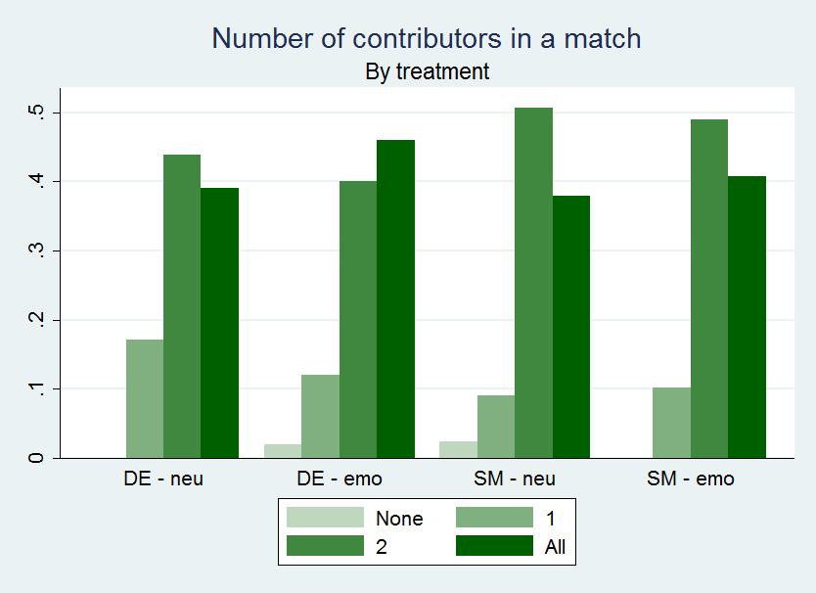
Appendix Figure A.4: Three-Player Prisoners’ Dilemma: Number of contributors per match for different treatments.

of the other players in the first stage. In the DE setting, players are informed about the behavior of other players in the first stage before choosing the deductions.
In the SM setting, players are not informed about the first stage results, but are asked to decide hypo- thetically what to deduct in each possible outcome of the first stage (when the two other players contribute, when the two other players defect, and when one defects and one contributes). Thus, in total, in the SM setting, each player reports four possible deductions. After the decision is made, the action of other players (but not their identity) is revealed and the final payoffs are calculated.

    - Contributions

Figure A.4 presents the number of contributors across different treatments. Across all four treatments, between 80-90% of groups had two or more contributors.

Table A.3 reports regression analyses, which yield statistically insignificant differences in the probability of contribution (Column 1) and the number of contributors (Columns 2 and 3).

APPENDIX TABLE A.3
Contributions in Three-Player Prisoners’ Dilemma

 | Contribution rate | No. of contributors | No. contr (ordered probit)
(Intercept) | 0.740*** | 2.220***
 | (0.0397) | (0.0648)
Strategy method | 0.00715 | 0.0215 | 0.0301
 | (0.0522) | (0.0853) | (0.132)
Emotions | 0.0268 | 0.0805 | 0.135
 | (0.0527) | (0.0896) | (0.141)
Strategy x Emotions | -0.00511 | -0.0153 | -0.0360
 | (0.0717) | (0.118) | (0.186)
Mean of Y | 0.756 | 2.268 | 2.268
N | 586 | 586 | 586
Robust standard errors in parentheses
+ p<0.1, * p<0.05, ** p<0.01, *** p<0.001
Notes: Contribution rate and number of contributors per match explained by treatment dummies. Column (3) contains estimates of an ordered probit model.

    - Deductions

Figure A.5 shows deductions. Deductions are larger for defectors than for contributors. Defectors are punished more when one of the other players contributes.

The action of the deductor in the first stage also matters. Defectors deduct less than contributors (Figure A.6).

Figure A.7 reports the average treatment effects. SM subjects deduct more, but this figure is slightly misleading because SM asks players to specify all potential deductions, whereas in DE, players specify only deductions in realized nodes. Since scenarios with two or more defectors are rare in DE, we observe larger average deductions in SM when we do not condition on the type of receiver.

Figure A.5 examines deductions by type of receiver. The third column in each set of four in this figure is of interest—it shows the deduction applied to defectors when there is 1 defector, as roughly 40% of the time, there is only 1 defector and the punisher is a contributor. SM subjects deduct more. Thus, less acceptance of non-cooperative behavior is observed in SM in both the ultimatum game and the three-player prisoners’ dilemma. We next examine the interaction with salience. Figures A.7 and A.8 report the aggregate effects of salience: differences between SM and DE emerge depending on salience.

Appendix Figure A.5: Three-Player Prisoners’ Dilemma: Average deduction to different re- ceivers for different treatments.
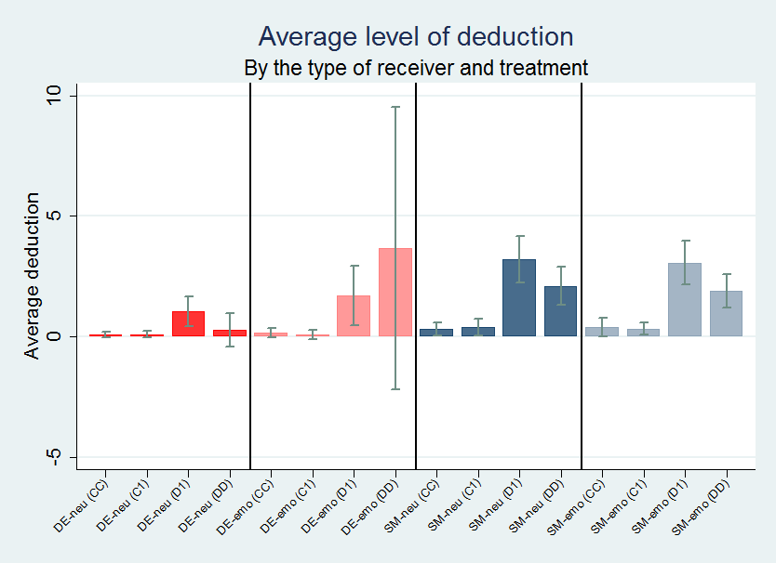
Notes: DD represents a deduction to both defectors, CC represents a deduction to both contributors. In a situation when one player contributes and the other defects, D1 represents a deduction to a defector and C1 to a contributor.

Appendix Figure A.6: Three-Player Prisoners’ Dilemma: Average deductions for different treatments depending on whether deducting player was a contributor or defector.
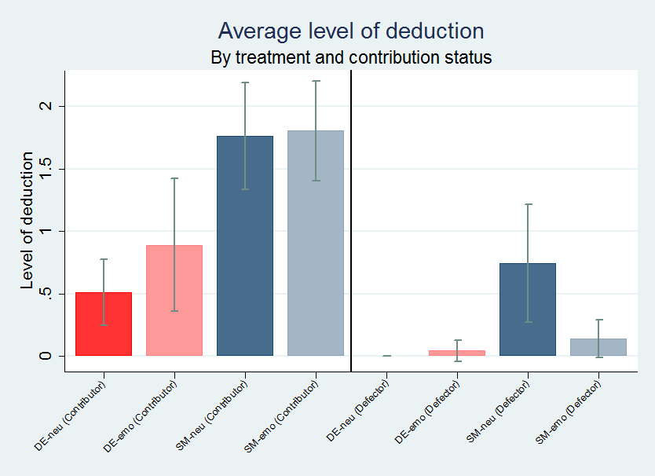
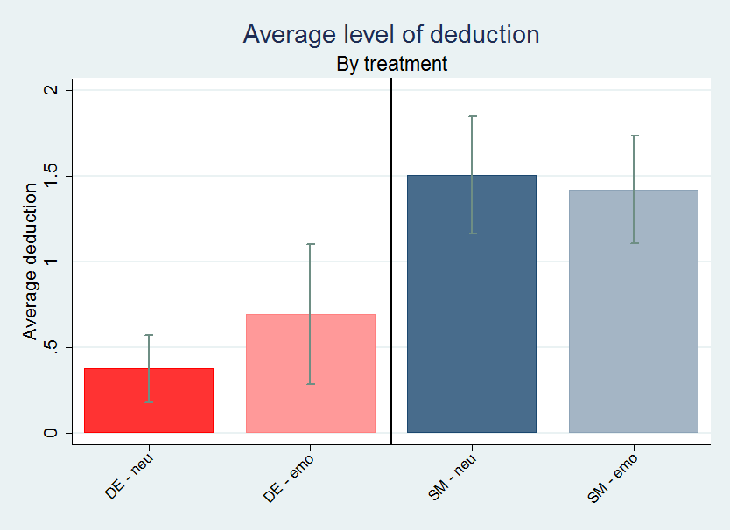

Appendix Figure A.7: Three-Player Prisoners’ Dilemma: Average deductions for different treatments

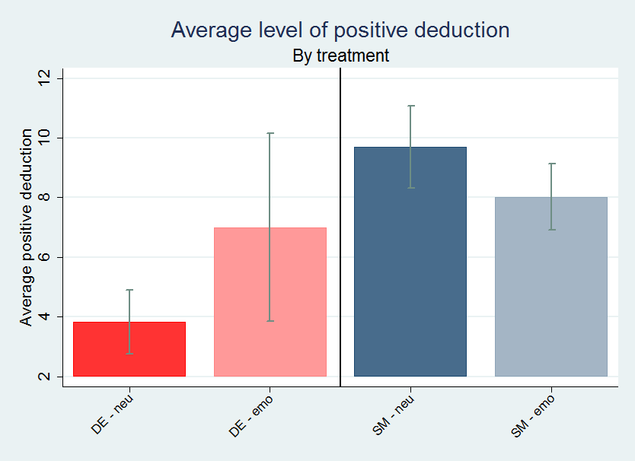
Appendix Figure A.8: Three-Player Prisoners’ Dilemma: Average positive deductions for different treatments (observations with zero deduction being excluded)

Table A.4 shows that subjects in SM made 1.1 points larger deductions (p < 0.001) and were 5.7 percent- age points more likely to deduct (p < 0.1) in the group salience setting (Columns 1 and 2). Restricting to non-zero deductions, salience significantly affects the difference between DE and SM by 4.9 points (p < 0.05) (Table A.4 Column 3). In terms of magnitudes, salience is roughly equivalent to the entire difference between SM and DE. SM subjects in the group salience setting made 5.9 points larger deductions (p < 0.001). To put this in perspective, like in Study 4, if we interpret salience as the treatment effect of interest, we see evidence that salience has no significant treatment effect but is weakly positive under DE and weakly negative under SM. The difference in treatment effects is statistically significant at the 5% level.

Similar results emerge when we control for the first stage outcome or restrict the sample to specific first stage outcomes, that is, restrict the sample to one observation per subject-first stage outcome. Table
A.5 restricts to contributors making the decision to deduct when the first stage resulted in exactly one defector and exactly two contributors (including the subject). Defectors received 3.1 points larger deductions (p < 0.001) and were 34 percentage points more likely to have a deduction (p < 0.001) (Columns 1 and 2). SM subjects made 1.3 points larger deductions (p < 0.05) in the group salience setting (Column 1), equivalent to roughly 40% of the effect of being a sole defector. Restricting to non-zero deductions, salience

APPENDIX TABLE A.4
Deductions in Three-Player Prisoners’ Dilemma.

 | Deduction level | Deduction probability | Non-zero deduction level
(Intercept) | 0.376 | 0.0983*** | 3.824*
 | (0.294) | (0.0271) | (1.521)
Strategy method | 1.129*** | 0.0569+ | 5.875***
 | (0.330) | (0.0304) | (1.642)
Emotions | 0.317 | 0.000744 | 3.176
 | (0.400) | (0.0369) | (2.069)
Strategy x Emotions | -0.403 | 0.0210 | -4.856*
 | (0.456) | (0.0421) | (2.245)
Mean of Y | 1.253 | 0.150 | 8.352
N | 1627 | 1627 | 244
Standard errors in parentheses
+ p<0.1, * p<0.05, ** p<0.01, *** p<0.001
Notes: Columns (1) and (2) use the entire sample; Column (3) examines positive deductions only.

significantly affects the difference between DE and SM by 4.7 points (p < 0.1) (Column 3). In terms of magnitudes, salience is roughly 70% of the entire difference between SM and DE. SM subjects in the group salience setting made 6.4 points larger deductions (p < 0.01). If we interpret salience as the treatment effect of interest, we again see evidence that salience has no significant treatment effect but is weakly positive under DE and weakly negative under SM. The difference in treatment effects is statistically significant at the 10% level.
Other models also yield significant differences between SM and DE. Table A.6 controls for the status of the deductor (contributor or defector) and for the first stage outcome (two defectors, one defector, or none). As noted from the figures, contributors deduct more (p < 0.001), by 1.2 points, and defectors get more deductions, 1.6 points more when defecting as a pair (p < 0.001) and 2.4 points more when defecting singly (p < 0.001). SM subjects deduct 0.9 points more in the group salience setting (p < 0.01), roughly equivalent to being a contributor (Column 1). Restricting to non-zero deductions, significant differences between DE and SM emerge depending on salience (p < 0.05) (Column 3). In terms of magnitudes, salience is roughly equivalent to the entire difference between SM and DE. SM subjects in the group salience setting made 6.1 points larger deductions than DE subjects (p < 0.001). This means that salience has no significant treatment effect but is weakly positive under DE and weakly negative under SM. The difference in treatment effects is statistically significant at the 5% level.
Table A.7 fully interacts all possible first stage outcomes and saturates them as controls. Analogous to the other results, contributors deduct 2.5 points more (p < 0.001) (Column 1) and are 18 percentage points

APPENDIX TABLE A.5
Deduction level regression for a subsample: only observations for people who contributed with deductions made towards the only other contributor or the only defector.

 | Deduction level | Deduction probability | Non-zero deduction level
(Intercept) | -0.772 | 0.0235 | 2.085
 | (0.546) | (0.0469) | (2.258)
Strategy method | 1.345* | 0.00717 | 6.383**
 | (0.587) | (0.0504) | (1.919)
Emotions | 0.371 | -0.0194 | 2.406
 | (0.712) | (0.0612) | (2.399)
Strategy x Emotions | -0.371 | 0.0789 | -4.691+
 | (0.819) | (0.0703) | (2.697)
Receiver is defector | 3.128*** | 0.342*** | 2.317
 | (0.351) | (0.0301) | (1.742)
Mean of Y | 1.858 | 0.219 | 8.489
N | 626 | 626 | 137
Standard errors in parentheses
+ p<0.1, * p<0.05, ** p<0.01, *** p<0.001

APPENDIX TABLE A.6
Full sample, controlling for effect of contribution status and for the receiver of the deduction, but no interactions of these controls with emotions or SM dummy.

 | Deduction level | Deduction probability | Non-zero deduction level
(Intercept) | -1.225*** | -0.0825** | 0.855
 | (0.347) | (0.0312) | (2.398)
Strategy method | 0.880** | 0.0290 | 6.089***
 | (0.319) | (0.0287) | (1.681)
Emotions | 0.347 | 0.00415 | 3.290
 | (0.383) | (0.0345) | (2.073)
Strategy x Emotions | -0.458 | 0.0148 | -5.186*
 | (0.436) | (0.0393) | (2.261)
To the only contributor | -0.0249 | 0.000368 | -0.193
 | (0.250) | (0.0225) | (2.020)
To the only defector | 2.387*** | 0.268*** | 1.776
 | (0.250) | (0.0225) | (1.541)
To two defectors | 1.555*** | 0.175*** | 1.357
 | (0.273) | (0.0246) | (1.644)
Contributor | 1.165*** | 0.131*** | 1.658
 | (0.213) | (0.0192) | (1.544)
Mean of Y | 1.253 | 0.150 | 8.352
N | 1627 | 1627 | 244
Standard errors in parentheses
+ p<0.1, * p<0.05, ** p<0.01, *** p<0.001

APPENDIX TABLE A.7
Regression with all the possible outcomes of first stage dummied (contribution status and the number of all contributors in the group).

 | Deduction level | Deduction probability
(Intercept) | -1.460 | -0.1000
Strategy method | (0.913)  1.161*** (0.322) | (0.0829) 0.0626*  (0.0292)
Emotions | 0.344 | 0.00375
 | (0.387) | (0.0352)
Strategy x Emotions | -0.472 | 0.0146
Receiver is defector Contributor | (0.442)  2.034*** (0.214)  2.487***  (0.609) | (0.0401)  0.221*** (0.0194) 0.176** (0.0553)
No of contr = 1 | 0.214 | 0.0165
 | (0.923) | (0.0838)
No of contr = 2 | 0.562 | 0.0537
 | (0.893) | (0.0810)
Contributor X No of contr = 2 | -1.649* | -0.0551
 | (0.675) | (0.0613)
No of contr = 3 | -0.817 | -0.0113
 | (1.065) | (0.0967)
Mean of Y | 1.253 | 0.150
N | 1627 | 1627
Standard errors in parentheses
+ p<0.1, * p<0.05, ** p<0.01, *** p<0.001

more likely to deduct (p < 0.01) (Column 2). Defectors get deducted 2 points more (p < 0.001) (Column 1) and are 22 percentage points more likely to be deducted (p < 0.001) (Column 2). Contributors deduct less by 1.6 points when everyone contributed (p < 0.05) (Column 1). Notably, SM subjects deduct 1.2 points more in the group salience setting (p < 0.001) (Column 1) and are 6 percentage points more likely to deduct (p < 0.05), equivalent to a large fraction of the deduction to defectors.
Focusing on the treatment impact of salience, the sign of the treatment flips, and flips significantly, between the two elicitation methods.

APPENDIX B: EXPERIMENTAL INSTRUCTIONS

This section presents the online and lab instructions for the experiments.

  - Amazon Mechanical Turk

A sample paragraph from the login task is transcribing (not translating) a Tagalog translation of Adam Smith’s The Wealth of Nations: Kaya sa isip o diwa na tayo ay sa mga ito, excites ilang mga antas ng parehong damdamin, sa proporsyon ng kasiglahan o dulness ng kuru-kuro. Ang labis na kung saan sila magbuntis sa kahirapan ng mga wretches nakakaapekto sa partikular na bahagi sa kanilang mga sarili ng higit pa sa anumang iba pang; dahil sa takot na arises mula sa kathang isip nila kung ano ang kani-kanilang mga sarili ay magtiis, kung sila ay talagang ang wretches kanino sila ay naghahanap sa, at kung sa partikular na bahagi sa kanilang mga sarili ay talagang apektado sa parehong miserable paraan. Ang tunay na puwersa ng mga kuru-kuro na ito ay sapat na, sa kanilang mga masasaktin frame, upang gumawa ng na galis o hindi mapalagay damdam complained ng.

    - Instructions for Ultimatum game – DE vs. SM for respondent

Appendix Figure B.1: Player 1
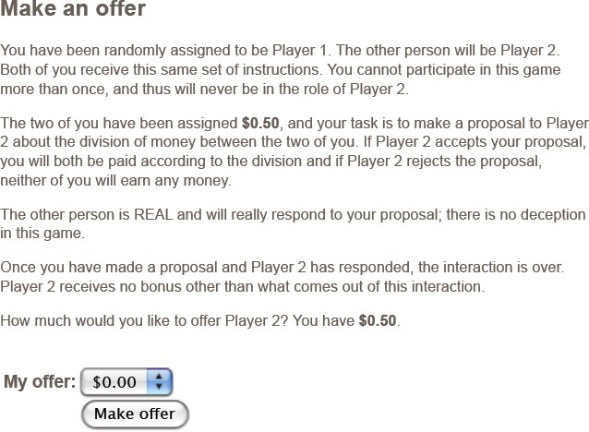

Appendix Figure B.2: Player 2 under DE

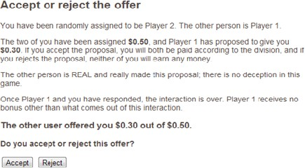

Appendix Figure B.3: Player 2 under the SM

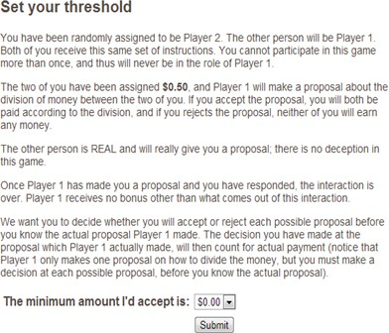

    - Instructions for Trust game – DE vs. SM for respondent

Appendix Figure B.4: Player 1
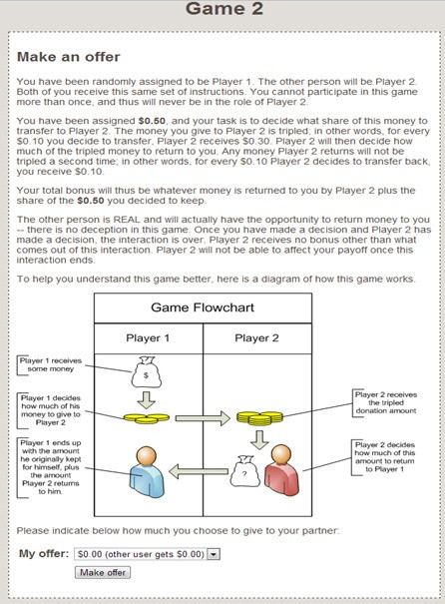

Appendix Figure B.5: Player 2
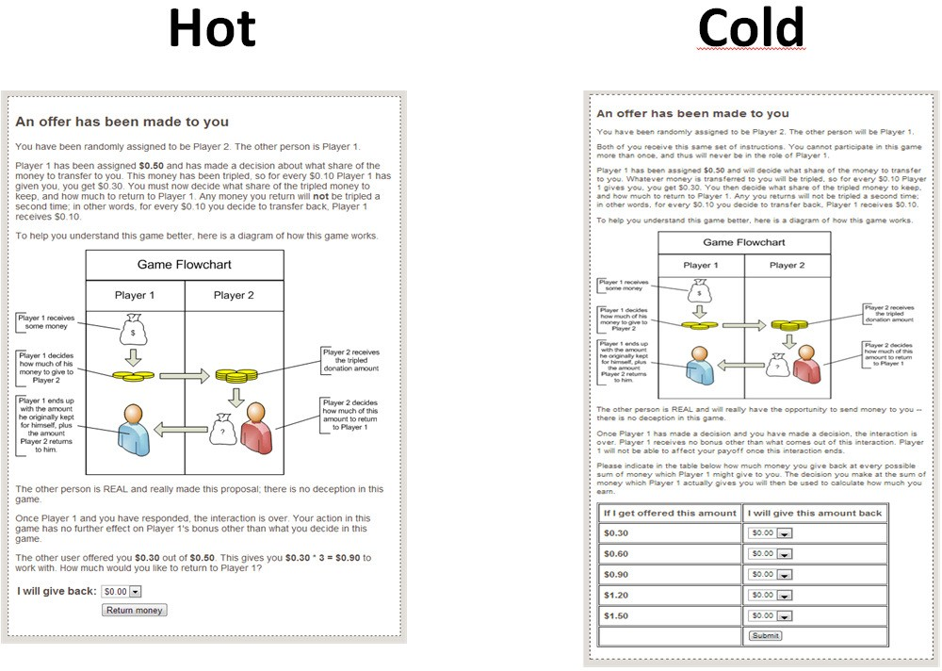

  - Lab Instructions

We present the original German and the English translations by Google; subjects only saw the German version.

    - Instructions for Ultimatum game – DE vs. SM and low vs. high salience Emotional Setting 112
All

Anleitung
Zu Beginn dieses Experiments sind die Teilnehmer zufällig in 2-er Gruppen aufgeteilt worden. Sie haben also ein Gegenüber, aber Sie wissen nicht wer es ist und werden es auch nie von uns mittgeteilt bekommen. Auch Ihrem Gegenüber werden wir Ihre Identität nie mitteilen.
Innerhalb Ihrer 2-er Gruppe gibt es 2 verschiedene Rollen: Vorschlagender und Antwortender. Per Zufall werden wir Ihre Rolle auf der nächsten Seite zuteilen. Zunächst die Regeln:
In diesem Experiment haben Sie beide zusammen 100 Cent erhalten. In diesem Experimen geht es um die Aufteilung dieser 100 Cent. Dabei macht der Vorschlagende dem Antwortenden eine „Take-it-or-Leave-it- offer“, bzw. der Vorschlagende macht einen Vorschlag und der Antwortende kann diesen nur entweder genau

12Emotional Setting 1 is coded as 0 and Emotional Setting 2 is coded as 1 in the data analysis.

so annehmen oder ablehnen. Wenn er ablehnt, bekommen beide Teilnehmer 0 Cent.

AUFGABE DES VORSCHLAGENDEN:
Der Vorschlagende schlägt eine Verteilung der 100 Cent vor. Der Vorschlagende hat dabei 11 Möglichkeiten:
1.) 100 Cent für sich, 0 Cent für den Antwortenden. 2.) 90 Cent für sich, 10 Cent für den Antwortenden.
3.) 80 Cent für sich, 20 Cent für den Antwortenden. 4.) 70 Cent für sich, 30 Cent für den Antwortenden.
5.) 60 Cent für sich, 40 Cent für den Antwortenden. 6.) 50 Cent für sich, 50 Cent für den Antwortenden.
7.) 40 Cent für sich, 60 Cent für den Antwortenden. 8.) 30 Cent für sich, 70 Cent für den Antwortenden.
9.) 20 Cent für sich, 80 Cent für den Antwortenden. 10.) 10 Cent für sich, 90 Cent für den Antwortenden.
11.) 0 Cent für sich, 100 Cent für den Antwortenden. Während der Vorschlagende seine Entscheidung trifft, wartet der Antwortende.

Direct Elicitation

AUFGABE DES ANTWORTENDEN:
Hat der Vorschlagende seine Entscheidung getroffen, zeigt der Computer dem Antwortenden den Vorschlag an. Der Antwortende kann den Vorschlag entweder annehmen oder ablehnen.

ERGEBNISBILDSCHIRM:
Am Schluss sehen beide Teilnehmer einen Ergebnisbildschirm. Hier wird beiden der Vorschlag angezeigt, und ob dieser angenommen oder abgelehnt wurde.

Strategy Method

AUFGABE DES ANTWORTENDEN:
Während der Vorschlagende seine Entscheidung trifft, entscheidet der Antwortende schon gleichzeitig welche Vorschläge er annehmen und welche er ablehnen würde. Das heisst für jeden der elf möglichen Vorschläge instruiert der Antwortende den Computer diesen entweder anzunehmen oder abzulehnen.

ERGEBNISBILDSCHIRM:
Erst wenn beide Teilnehmer ihre Entscheidungen unwiderruflich getroffen haben wird der Computer den Vorschlag gemäss den Instruktionen des Antwortenden annehmen oder ablehnen. Beide sehen dann einen Ergebnisbildschirm. Hier wird der Vorschlag angezeigt, und ob dieser angenommen oder abgelehnt wurde.

Threshold Method

AUFGABE DES ANTWORTENDEN:
Während der Vorschlagende seine Entscheidung trifft, entscheidet der Antwortende schon gleichzeitig wieviel er mindestens geboten bekommen muss um anzunehmen. Das heisst er instruiert den Computer

welchen Betrag er mindestens geboten bekommen muss. Alle Vorschläge die ihm weniger bieten wird der Computer dann ablehnen, alle Vorschläge die ihm mehr bieten wird der Computer dann annehmen.

ERGEBNISBILDSCHIRM:
Erst wenn beide Teilnehmer ihre Entscheidungen unwiderruflich getroffen haben wird der Computer den Vorschlag gemäss den Instruktionen des Antwortenden annehmen oder ablehnen. Beide Teilnehmer sehen dann einen Ergebnisbildschirm. Hier wird beiden der Vorschlag angezeigt, und ob dieser angenommen oder abgelehnt wurde.

All

Ferner werden die resultierenden Auszahlungen angezeigt:
Wenn der Antwortende den Vorschlag annimmt: Beide bekommen das Geld genau gemäss dem gemachten Vorschlag.
Wenn der Antwortende den Vorschlag ablehnt: Beide Teilnehmer in der 2-er Gruppe bekommen 0 Cent.

Emotional Setting 2 All
Anleitung
Zu Beginn dieses Experiments sind die Teilnehmer zufällig in 2-er Gruppen aufgeteilt worden. Sie haben also ein Gegenüber, aber Sie wissen nicht wer es ist und werden es auch nie von uns mittgeteilt bekommen. Auch Ihrem Gegenüber werden wir Ihre Identität nie mitteilen.
Innerhalb Ihrer 2-er Gruppe gibt es 2 verschiedene Rollen: Diktator 13 und Untertan. Per Zufall werden
wir Ihre Rolle auf der nächsten Seite zuteilen. Zunächst die Regeln:
In diesem Experiment haben Sie beide zusammen 100 Cent erhalten. In diesem Experiment geht es um die Aufteilung dieser 100 Cent. Dabei macht der Diktator dem Untertan eine Take-it-or-Leave-it-offer“, bzw. der Vorschlagende macht einen Vorschlag und der Untertan kann diesen nur entweder genau so annehmen oder ablehnen. Wenn er ablehnt bekommen beide Teilnehmer 0 Cent.
AUFGABE DES Diktator :
Der Diktator schlägt eine Verteilung der 100 Cent vor. Der Diktator hat dabei 11 Möglichkeiten:
1.) 100 Cent für sich, 0 Cent für den Untertan. 2.) 90 Cent für sich, 10 Cent für den Untertan.
3.) 80 Cent für sich, 20 Cent für den Untertan. 4.) 70 Cent für sich, 30 Cent für den Untertan.
5.) 60 Cent für sich, 40 Cent für den Untertan. 6.) 50 Cent für sich, 50 Cent für den Untertan.

13Emphasis is added for the reader to see the difference with emotional setting 1. The subjects did not see italicized instructions.

7.) 40 Cent für sich, 60 Cent für den Untertan. 8.) 30 Cent für sich, 70 Cent für den Untertan.
9.) 20 Cent für sich, 80 Cent für den Untertan. 10.) 10 Cent für sich, 90 Cent für den Untertan.
11.) 0 Cent für sich, 100 Cent für den Untertan.

Direct Elicitation

Während der Diktator seine Entscheidung trifft, wartet der Untertan. AUFGABE DES ANTWORTENDEN:
Hat der Diktator seine Entscheidung getroffen, zeigt der Computer dem Untertan den Vorschlag an. Der
Untertan kann den Vorschlag entweder annehmen oder ablehnen.

ERGEBNISBILDSCHIRM:
Ob der Diktator sich für Annahme oder Ablehnung entschieden hat, dass sehen beide Teilnehmer am Ergebnisbildschirm. Hier wird beiden der Vorschlag angezeigt, und ob dieser angenommen oder abgelehnt wurde.

Strategy Method

AUFGABE DES ANTWORTENDEN:
Während der Diktator seine Entscheidung trifft, entscheidet der Untertan schon gleichzeitig welche Vorschläge er annehmen und welche er ablehnen würde. Das heisst für jeden der elf möglichen Vorschläge instruiert der Untertan den Computer diesen entweder anzunehmen oder abzulehnen.

ERGEBNISBILDSCHIRM:
Erst wenn beide Teilnehmer ihre Entscheidungen unwiderruflich getroffen haben wird der Computer den Vorschlag gemäss den Instruktionen des Untertan annehmen oder ablehnen. Beide Teilnehmer sehen dann einen Ergebnisbildschirm. Hier wird beiden der Vorschlag angezeigt, und ob dieser angenommen oder abgelehnt wurde.

Threshold Method

AUFGABE DES ANTWORTENDEN:
Während der Diktator seine Entscheidung trifft, entscheidet der Untertan schon gleichzeitig wieviel er mindestens geboten bekommen muss um anzunehmen. Das heisst er instruiert den Computer welchen Betrag er mindestens geboten bekommen muss. Alle Vorschläge die ihm weniger bieten wird der Computer dann ablehnen, und alle Vorschläge die ihm mehr bieten wird der Computer dann annehmen.

ERGEBNISBILDSCHIRM:

Erst wenn beide Teilnehmer ihre Entscheidungen unwiderruflich getroffen haben wird der Computer den Vorschlag gemäss den Instruktionen des Untertan annehmen oder ablehnen. Beide Teilnehmer sehen dann einen Ergebnisbildschirm. Hier wird beiden der Vorschlag angezeigt, und ob dieser angenommen oder abgelehnt wurde.

All

Ferner werden die resultierenden Auszahlungen angezeigt:
Wenn der Untertan den Vorschlag annimmt: Beide bekommen das Geld genau gemäss dem gemachten Vorschlag.
Wenn der Untertan den Vorschlag ablehnt: Beide Teilnehmer in der 2-er Gruppe bekommen 0 Cent.

    - Ultimatum game instructions (Google Translation to English) Emotional Setting 1
All

Manual
At the beginning of this experiment, the participants were randomly divided into groups of two. You have a counterpart, but you do not know who it is and never will get it shared by us. We will never reveal your identity to yoyr counterpart.
Within your 2-person group there are 2 different roles: proposer and responder. By chance, we assign your role on the next page. First the rules:
In this experiment, you both received 100 cents together. The distribution of these 100 cents is the topic of this experiment. The proposer makes a "take-it-or-leave-it-offer" to the respondent, that si, the proposer makes a suggestion and the respondent can only either accept or reject it. If she declines, both participants get 0 cent.

TASK OF THE PROPOSAL:
The proposer suggests a distribution of 100 cents. The proposer has 11 options:
1) 100 cents for themselves, 0 cents for the respondent. 2.) 90 cents for themselves, 10 cents for the respondent.
3.) 80 cents for themselves, 20 cents for the respondent. 4.) 70 cents for themselves, 30 cents for the respondent.
5.) 60 cents for themselves, 40 cents for the respondent. 6.) 50 cents for themselves, 50 cents for the respondent.

7.) 40 cents for themselves, 60 cents for the respondent. 8.) 30 cents for themselves, 70 cents for the respondent.
9.) 20 cents for themselves, 80 cents for the respondent. 10.) 10 cents for themselves, 90 cents for the respondent.
11.) 0 cents for themselves, 100 cents for the respondent. While the proposer makes his decision, the respondent waits.

Direct Elicitation

TASK OF THE ANSWER:
When the proposer has made his selection, the computer displays the suggestion to the respondent. The respondent can either accept or reject the proposal.

RESULTS SCREEN:
At the end, both participants see a result screen. They are bith shown the suggestion and whether it was accepted or rejected.

Strategy Method

TASK OF THE ANSWER:
While the proposer makes his decision, the respondent symultaneoulsy decides which suggestions he would accept and which he would reject. That is, for each of the eleven possible suggestions, the respondent instructs the computer to either accept or reject it.

RESULTS SCREEN:
Only when both participants have irrevocably made their decisions will the computer accept or reject the proposal according to the respondent’s instructions. Both will see a result screen displaying to both of them the proposal and whether it has been accepted or rejected.

Threshold Method

TASK OF THE ANSWER:
While the proposer makes his decision, the respondent symultaneously decides at least how much she has to get bid to accept. That is, she instructs the computer which amount she has to get at least bid. The computer then rejects any suggestions that will give it less and accept athose that will give it more.

RESULTS SCREEN:
Only when both participants have irrevocably made their decisions will the computer accept or reject the proposal according to the respondent’s instructions. Both participants will see a result screen, displaying to

both of them the suggestion and whether it was accepted or rejected.

All

In addition, the resulting payouts are displayed:
If the respondent accepts the proposal: Both get the money exactly according to the proposal made. If the respondent rejects the proposal: Both participants in the 2-group get 0 cent.
Emotional Setting 2 All
Manual
At the beginning of this experiment, the participants were randomly divided into groups of two. So you have a counterpart, but you do not know who it is and never will get it shared by us. We will never disclose your identity to your counterpart.
Within your 2-person group there are 2 different roles: Dictator and Subject. By chance, we will assign your role on the next page. First the rules:
In this experiment, you both received 100 cents together. The distribution of these 100 cents is the topic of this experiment. In doing so, the dictator makes the subject a “take-it-or-leave-it-offer,” that is, the proposer makes a suggestion and the subject can only either accept or reject it. If the subject declines, both participants get 0 cent.

TASK OF THE DICTATOR:
The dictator proposes a distribution of 100 cents. The dictator has 11 options:
1) 100 cents for themselves, 0 cents for the subject. 2.) 90 cents for themselves, 10 cents for the subject.
3.) 80 cents for themselves, 20 cents for the subject. 4.) 70 cents for themselves, 30 cents for the subject.
5.) 60 cents for themselves, 40 cents for the subject. 6.) 50 cents for himself, 50 cents for the subject.
7.) 40 cents for himself, 60 cents for the subject. 8.) 30 cents for themselves, 70 cents for the subject.
9.) 20 cents for themselves, 80 cents for the subject. 10.) 10 cents for himself, 90 cents for the subject.
11.) 0 cent for themselves, 100 cents for the subject.

Direct Elicitation

While the dictator makes his decision, the subject waits. TASK OF THE ANSWER:
Once the dictator has made his selection, the computer displays the proposal to the subject. The subject can either accept or reject the proposal.

RESULTS SCREEN:
If the dictator has opted for acceptance or rejection, both participants will see a result screen, dsiplaying the suggestion and whether it was accepted or rejected.

Strategy Method

TASK OF THE ANSWER:
While the dictator makes his decision, the subject symultaneously decides which proposals she will accept and which she will refuse. That is, for each of the eleven possible suggestions, the subject instructs the computer to either accept or reject it.

RESULTS SCREEN:
Only when both participants have irrevocably taken their two decisions will the computer accept or reject the proposal according to the subject’s instructions. Both participants will see a result screen, displaying to both of them the suggestion and whether it was accepted or rejected.

Threshold Method

TASK OF THE ANSWER:
While the dictator makes his decision, the subject symultaneously decides at least how much she has to get bid to accept. That is, the subject instructs the computer which amount she has to get at least bid. The computer then reject any suggestions that will give it less, and accepts any suggestions that will give it more.

RESULTS SCREEN:
Only when both participants have irrevocably made their decisions will the computer accept or reject the proposal according to the subject’s instructions. Both participants will see a result screen, dsiplaying to both of them the suggestion and whether it was accepted or rejected.

All

In addition, the resulting payouts are displayed:
If the subject accepts the proposal: Both get the money exactly according to the proposal made. If the subject rejects the proposal: Both participants in the 2-group get 0 cent.

    - Instructions for Three-Player Prisoners’ Dilemma - DE vs. SM and Low vs. High Salience

This section presents screenshots of the experimental instructions. The first set of figures with the purple background (emotional setting 114) are in the original German. The second set of figures show English

14Emotional Setting 1 is coded as 0 and Emotional Setting 2 is coded as 1 in the data analysis.

translations by Google Chrome; subjects only saw the German version. The second set of figures use a red background (emotional setting 2). The other change between emotional setting 1 and 2 is the use of the word “group” or “team” when describing the game.

Appendix Figure B.6: Instructions for contribution stage of game
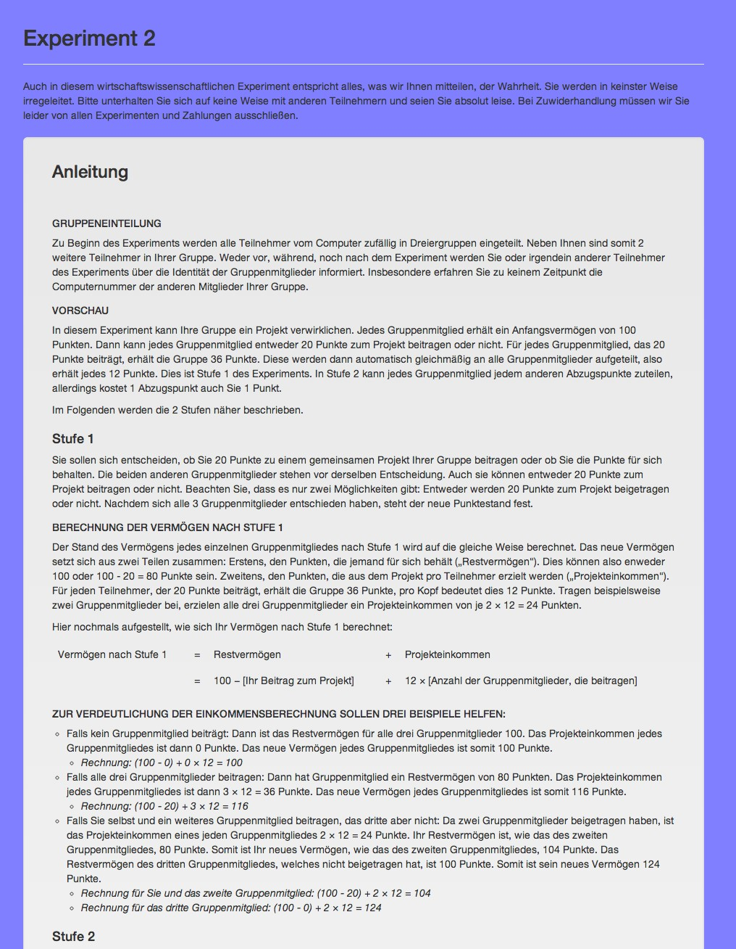

Appendix Figure B.7: Instructions for deduction stage of game
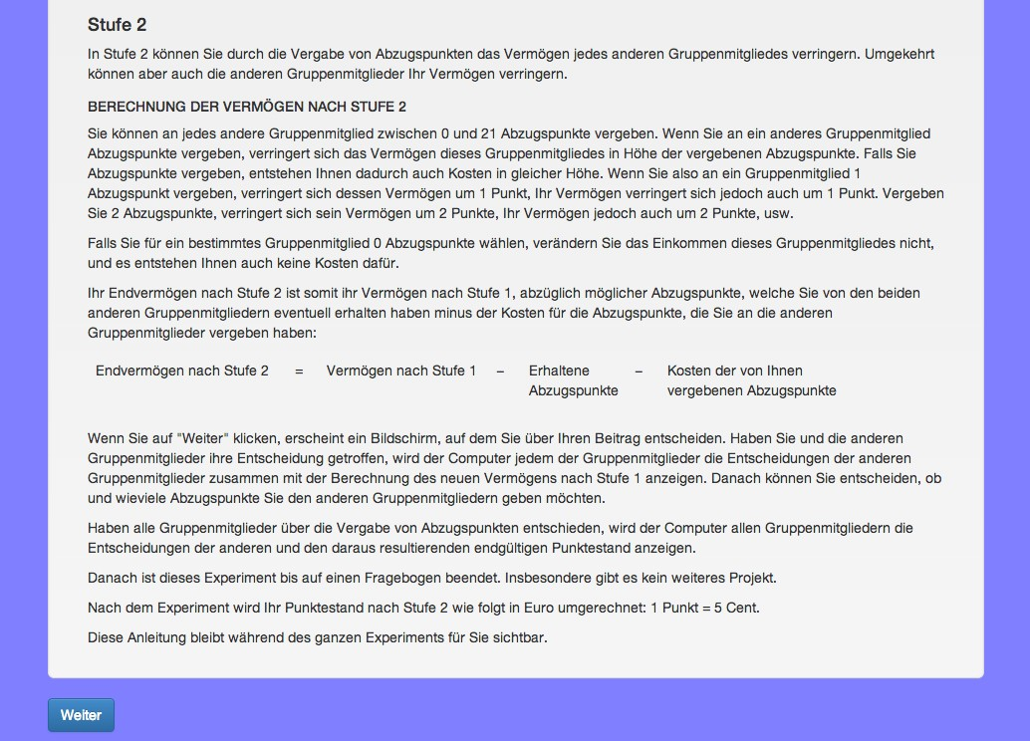

Appendix Figure B.8: Control question
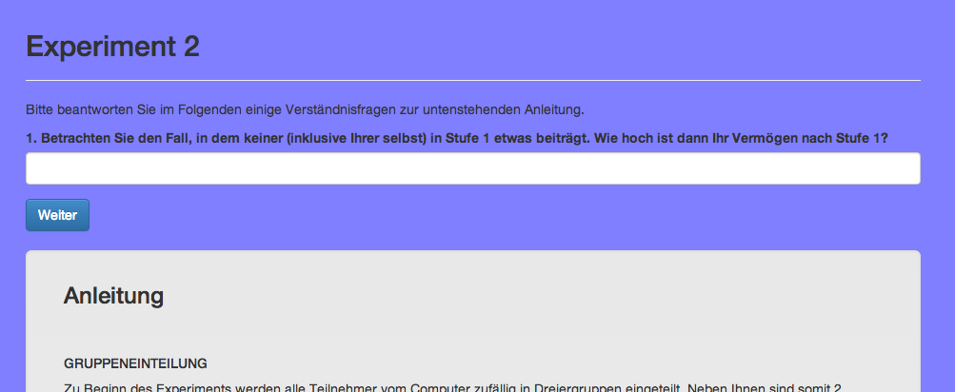

Appendix Figure B.9: Control question feedback
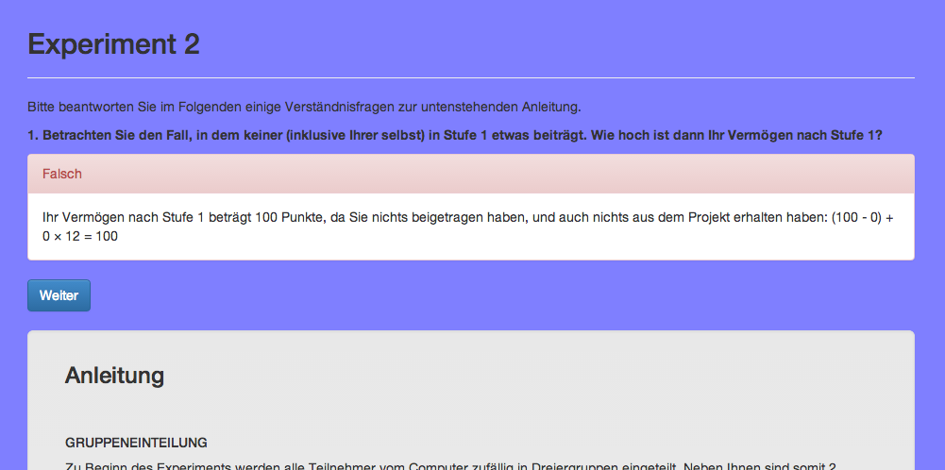

Appendix Figure B.10: Second control question
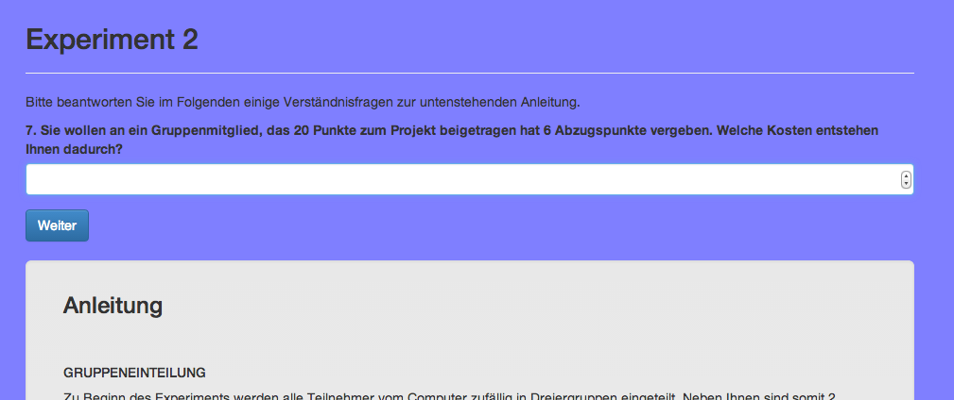

Appendix Figure B.11: Contribution decision
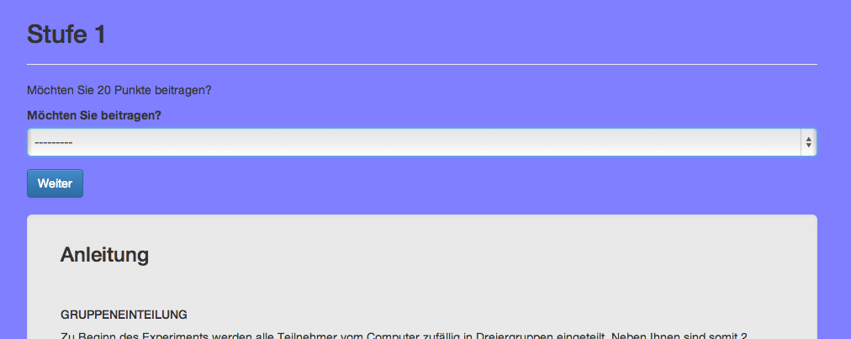

Appendix Figure B.12: Deduction decision 1
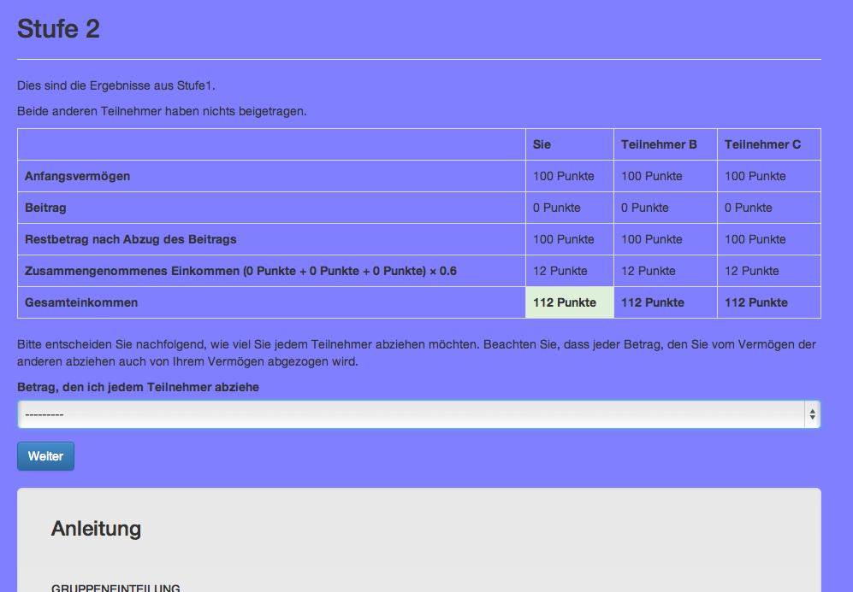

Appendix Figure B.13: Deduction decision 2
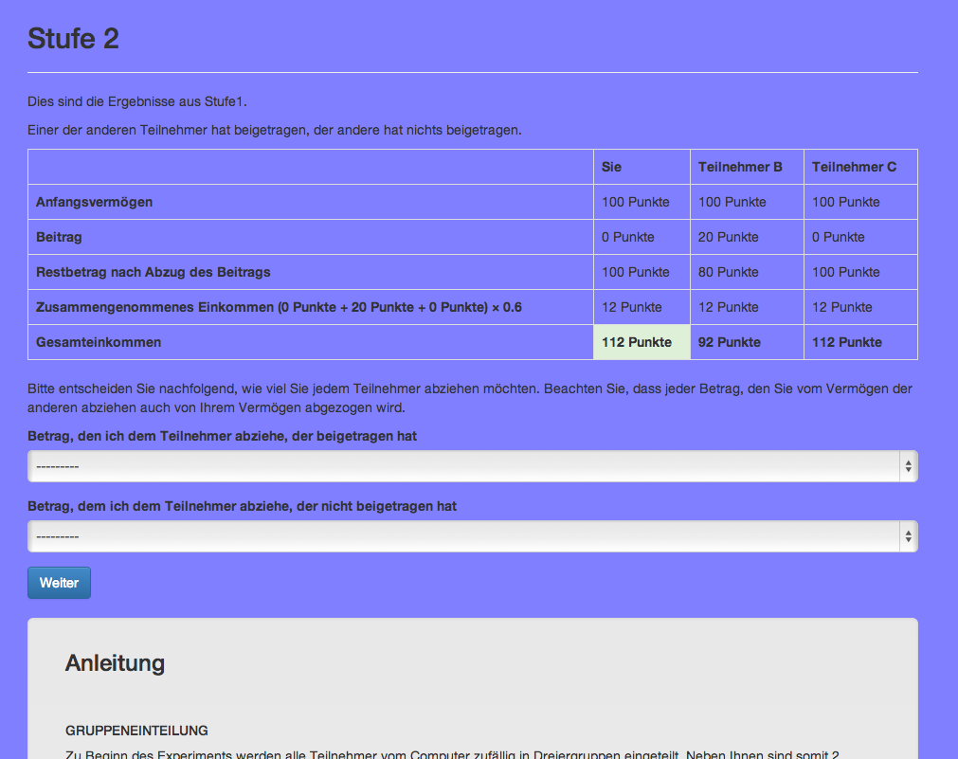

Appendix Figure B.14: Deduction decision 3
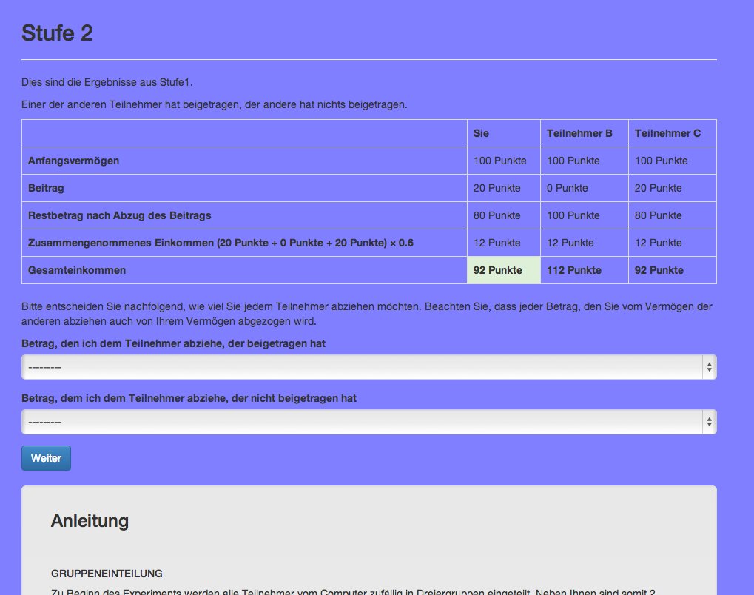

Appendix Figure B.15: English Translation
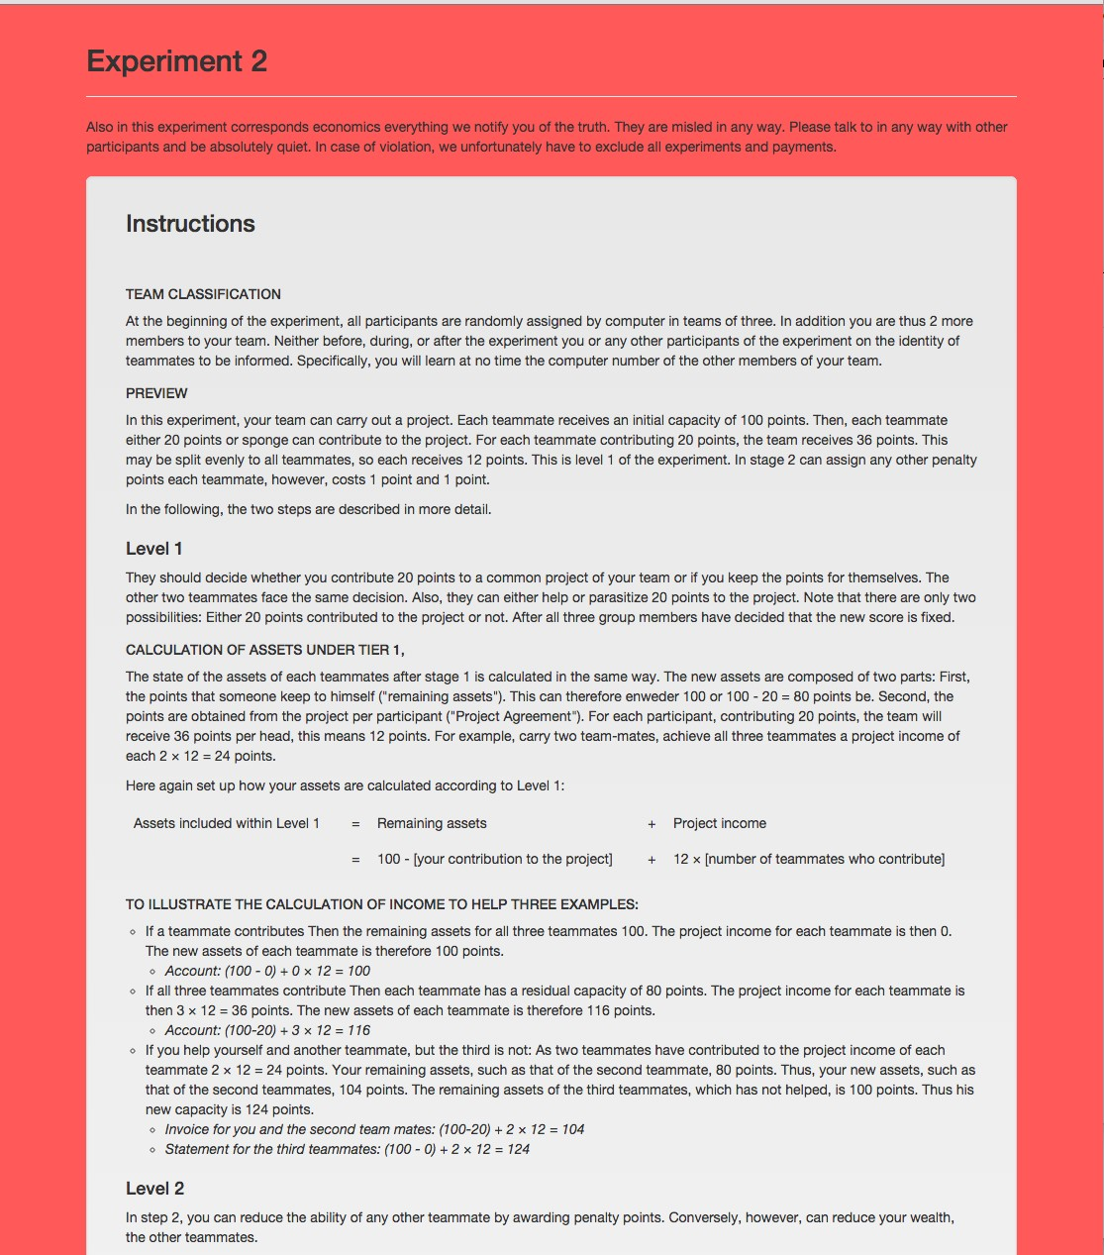

Appendix Figure B.16: English Translation
