Online Appendix for:

Who Punishes? A note on responses to cooperation and defection across cultures

Talbot M. Andrews
Assistant Professor
University of Connecticut
talbot.andrews@uconn.edu

- Table A1: Regression results for target contributions and received punishment
- Table A2: Regression results for punishment by city
- Figure A1: Probability those who contribute more are punished less by city
- Supplemental analysis: Differences in who is punished by culture
  - Figure A2: Mean punishment of targets at each possible target contribution in each city
  - Figure A3: Mean punishment of targets at each possible target contribution in each city by culture
  - Figure A4: Predicted probability a target was punished based on their contribution by culture
  - Figure A5: Predicted amount a target was punished based on their contribution by culture
- Table A3: Regression results for effect of punisher and target contributions by culture
- Table A4: Regression results for punisher contributions and punishment
- Figure A6: Amount those who contribute more punish by city
- Figure A7: Predicted probability a target was punished based on punisher contributions by culture
- Figure A8: Predicted amount a target was punished based on punisher contributions by culture
- Table A5: Rate of punishment by target and punisher contribution
- Table A6: Amount of punishment by target and punisher contribution
- Table A7: Rate of punishment by target and punisher contribution by culture
- Table A8: Amount of punishment by target and punisher contribution by culture
- Figure A9: Predicted amount of punishment by target and punisher contribution by culture
- Table A9: Regression results for probability and amount punished by target and punisher contribution
- Figure A10: Mean contribution by city
- Supplemental References

Table A1: Regression results for target contributions and received punishment
Both models regress punishment on punisher contributions, indicators for each level of target contributions, and an interaction between the two. The omitted base category is the target contributing nothing. Model 1 is a linear probability model, and Model 2 is a linear regression. Both models use observations at the subject and period level. The dependent variable for model 1 is a dummy variable where 0 indicates no punishment and 1 indicates punishment. The dependent variable for model 2 is the amount of punishment inflicted. All models cluster the standard errors at the level of the group and the individual and have fixed effects at the city level. Standard errors are in parentheses, * p < 0.05, ** p < 0.01, *** p < 0.001. Full results are illustrated in Figure 1 in the main text.

 | (1)  Pr(Punish) |  | (2)  Punishment Amount
Punisher Contribution | 0.0168*** | (0.003) | 0.101*** | (0.0132)
Target Contribution=1 | -0.112** | (0.038) | -0.412** | (0.150)
Target Contribution=2 | -0.127** | (0.044) | -0.493** | (0.174)
Target Contribution=3 | -0.174*** | (0.045) | -0.499* | (0.230)
Target Contribution=4 | -0.169** | (0.054) | -0.788*** | (0.166)
Target Contribution=5 | -0.196*** | (0.036) | -0.650*** | (0.150)
Target Contribution=6 | -0.210*** | (0.052) | -0.743*** | (0.188)
Target Contribution=7 | -0.173*** | (0.051) | -0.672** | (0.204)
Target Contribution=8 | -0.258*** | (0.050) | -0.869*** | (0.187)
Target Contribution=9 | -0.253*** | (0.070) | -0.874*** | (0.226)
Target Contribution=10 | -0.282*** | (0.039) | -0.768*** | (0.154)
Target Contribution=11 | -0.281*** | (0.080) | -0.895*** | (0.232)
Target Contribution=12 | -0.270*** | (0.052) | -0.857*** | (0.187)
Target Contribution=13 | -0.264*** | (0.065) | -0.863*** | (0.208)
Target Contribution=14 | -0.225** | (0.086) | -0.666* | (0.282)
Target Contribution=15 | -0.268*** | (0.040) | -0.538** | (0.178)
Target Contribution=16 | -0.383*** | (0.082) | -0.700* | -(0.340)
Target Contribution=17 | -0.187* | (0.074) | -0.497* | (0.239)
Target Contribution=18 | -0.166** | (0.063) | -0.404 | (0.223)
Target Contribution=19 | -0.0722 | (0.082) | -0.280 | (0.304)
Target Contribution=20 | -0.106** | (0.038) | -0.225 | (0.158)
Target Contribution=1 X Punisher Contribution | 0.006 | (0.004) | -0.001 | (0.023)
Target Contribution=2 X Punisher Contribution | 0.003 | (0.004) | -0.015 | (0.020)
Target Contribution=3 X Punisher Contribution | 0.003 | (0.005) | -0.038 | (0.025)
Target Contribution=4 X Punisher Contribution | 0.007 | (0.005) | -0.008 | (0.023)
Target Contribution=5 X Punisher Contribution | 0.004 | (0.003) | -0.030* | (0.015)
Target Contribution=6 X Punisher Contribution | 0.002 | (0.005) | -0.052** | (0.020)
Target Contribution=7 X Punisher Contribution | -0.001 | (0.004) | -0.049* | (0.019)
Target Contribution=8 X Punisher Contribution | 0.007 | (0.005) | -0.030 | (0.019)
Target Contribution=9 X Punisher Contribution | -0.001 | (0.007) | -0.050* | (0.023)
Target Contribution=10 X Punisher Contribution | -0.001 | (0.003) | -0.056*** | (0.014)
Target Contribution=11 X Punisher Contribution | -0.003 | (0.007) | -0.058** | (0.0212
Target Contribution=12 X Punisher Contribution | -0.005 | (0.004) | -0.057*** | (0.017)
Target Contribution=13 X Punisher Contribution | -0.006 | (0.005) | -0.065*** | (0.019)
Target Contribution=14 X Punisher Contribution | -0.009 | (0.006) | -0.084*** | (0.022)
Target Contribution=15 X Punisher Contribution | -0.007* | (0.003) | -0.091*** | (0.015)
Target Contribution=16 X Punisher Contribution | 0.002 | (0.005) | -0.077*** | (0.023)
Target Contribution=17 X Punisher Contribution | -0.012* | (0.005) | -0.091*** | (0.018)
Target Contribution=18 X Punisher Contribution | -0.016*** | (0.004) | -0.107*** | (0.016)
Target Contribution=19 X Punisher Contribution | -0.022*** | (0.005) | -0.111*** | (0.019)
Target Contribution=20 X Punisher Contribution | -0.028*** | (0.003) | -0.126*** | (0.014)
Constant | 0.336*** | (0.034) | 0.811*** | (0.157)
Observations | 33600 | 33600 | 33600 | 33600

Table A2: Regression results for punishment by city
Both models regress punishment on punisher contributions, target contributions, each city, and an interaction between the three. The omitted category for city is Boston. Model 1 is a linear probability model, and Model 2 is a linear regression. Both models use observations at the subject and period level. The dependent variable for model 1 is a dummy variable where 0 indicates no punishment and 1 indicates punishment. The dependent variable for model 2 is the amount of punishment inflicted. All models cluster the standard errors at the level of the group and the individual and have fixed effects at the city level. Standard errors are in parentheses, * p < 0.05, ** p < 0.01, *** p < 0.001. Model 1 results are illustrated in Figure 2 and Figure A1. Model 2 results are illustrated in Figure 1 and Figure A6.

 | (1)  Pr(Punish) |  | (2)  Punishment Amount
Punisher Contribution | 0.037** | (0.011) | 0.175*** | (0.051)
Target Contribution | -0.001 | (0.009) | 0.027 | (0.022)
Punisher x Target Contribution | -0.002** | (0.001) | -0.009*** | (0.003)
Melbourne | -0.042 | (0.198) | -0.227 | (0.559)
Nottingham | 0.038 | (0.175) | 0.173 | (0.471)
St. Gallen | 0.127 | (0.169) | 0.577 | (0.458)
Chengdu | 0.282 | (0.167) | 0.769 | (0.456)
Zurich | 0.258 | (0.198) | 0.344 | (0.511)
Bonn | -0.134 | (0.264) | 0.020 | (0.703)
Copenhagen | 0.194 | (0.194) | 0.094 | (0.506)
Dnipropetrovs'k | 0.242 | (0.185) | 1.013* | (0.498)
Seoul | 0.273 | (0.199) | 0.942 | (0.524)
Istanbul | 0.160 | (0.163) | 0.850 | (0.435)
Minsk | 0.074 | (0.168) | 0.757 | (0.474)
Samara | 0.322 | (0.168) | 1.714** | (0.585)
Riyadh | 0.268 | (0.169) | 1.158** | (0.433)
Athens | 0.428* | (0.178) | 2.451** | (0.800)
Muscat | 0.231 | (0.175) | 1.148* | (0.474)
Melbourne x Punisher Contribution | 0.026 | (0.015) | 0.052 | (0.065)
Nottingham x Punisher Contribution | 0.007 | (0.014) | -0.002 | (0.069)
St. Gallen x Punisher Contribution | -0.005 | (0.013) | -0.045 | (0.056)
Chengdu x Punisher Contribution | -0.010 | (0.012) | -0.068 | (0.057)
Zurich x Punisher Contribution | -0.003 | (0.014) | -0.022 | (0.058)
Bonn x Punisher Contribution | 0.014 | (0.019) | -0.008 | (0.064)
Copenhagen x Punisher Contribution | -0.003 | (0.014) | 0.012 | (0.062)
Dnipropetrovs'k x Punisher Contribution | -0.019 | (0.014) | -0.087 | (0.064)
Seoul x Punisher Contribution | -0.010 | (0.015) | -0.068 | (0.060)
Istanbul x Punisher Contribution | -0.001 | (0.013) | -0.021 | (0.060)
Minsk x Punisher Contribution | -0.011 | (0.013) | -0.068 | (0.058)
Samara x Punisher Contribution | -0.018 | (0.012) | -0.128* | (0.060)
Riyadh x Punisher Contribution | -0.032* | (0.013) | -0.130* | (0.056)
Athens x Punisher Contribution | -0.032* | (0.016) | -0.242** | (0.093)
Muscat x Punisher Contribution | -0.021 | (0.0134 | -0.107 | (0.061)
Melbourne x Target Contribution | -0.013 | (0.015) | -0.038 | (0.041)
Nottingham x Target Contribution | 0.001 | (0.011) | -0.007 | (0.026)
St. Gallen x Target Contribution | -0.002 | (0.010) | -0.026 | (0.026)
Chengdu x Target Contribution | -0.017 | (0.010) | -0.046 | (0.026)
Zurich x Target Contribution | -0.008 | (0.012) | -0.017 | (0.030)
Bonn x Target Contribution | 0.007 | (0.016) | -0.011 | (0.043)
Copenhagen x Target Contribution | -0.002 | (0.012) | 0.017 | (0.031)
Dnipropetrovs'k x Target Contribution | -0.002 | (0.013) | -0.042 | (0.031)
Seoul x Target Contribution | -0.012 | (0.014) | -0.051 | (0.038)
Istanbul x Target Contribution | -0.010 | (0.011) | -0.055 | (0.036)
Minsk x Target Contribution | 0.015 | (0.012) | 0.014 | (0.032)
Samara x Target Contribution | -0.005 | (0.010) | -0.063 | (0.035)
Riyadh x Target Contribution | -0.005 | (0.010) | -0.041 | (0.026)
Athens x Target Contribution | -0.027* | (0.013) | -0.168* | (0.069)
Muscat x Target Contribution | 0.013 | (0.013) | 0.002 | (0.033)
Melbourne x Punisher x Target | -0.001 | (0.001) | 0.001 | (0.003)
Nottingham x Punisher x Target | -0.001 | (0.001) | -0.001 | (0.003)
St. Gallen x Punisher x Target | 0.001 | (0.001) | 0.002 | (0.003)
Chengdu x Punisher x Target | 0.001 | (0.001) | 0.004 | (0.003)
Zurich x Punisher x Target | 0.001 | (0.001) | 0.001 | (0.003)
Bonn x Punisher x Target | -0.001 | (0.001) | 0.001 | (0.003)
Copenhagen x Punisher x Target | -0.001 | (0.001) | -0.002 | (0.003)
Dnipropetrovs'k x Punisher x Target | 0.001 | (0.001) | 0.004 | (0.003)
Seoul x Punisher x Target | 0.001 | (0.001) | 0.003 | (0.003)
Istanbul x Punisher x Target | 0.001 | (0.001) | 0.002 | (0.003)
Minsk x Punisher x Target | -0.001 | (0.001) | 0.001 | (0.003)
Samara x Punisher x Target | 0.001 | (0.001) | 0.005 | (0.003)
Riyadh x Punisher x Target | 0.002* | (0.001) | 0.010** | (0.004)
Athens x Punisher x Target | 0.002 | (0.001) | 0.015* | (0.007)
Muscat x Punisher x Target | 0.001 | (0.001) | 0.006 | (0.005)
Constant | 0.037 | (0.157) | -0.517 | (0.405)
Observations | 33600 | 33600 | 33600 | 33600

Figure A1: Probability those who contribute more are punished less by city
The predicted change in probability of being punished for each additional token a target contributes to the public good. Vertical bars are 95% confidence intervals clustered at the individual and group level. Full results are available in Table A2.

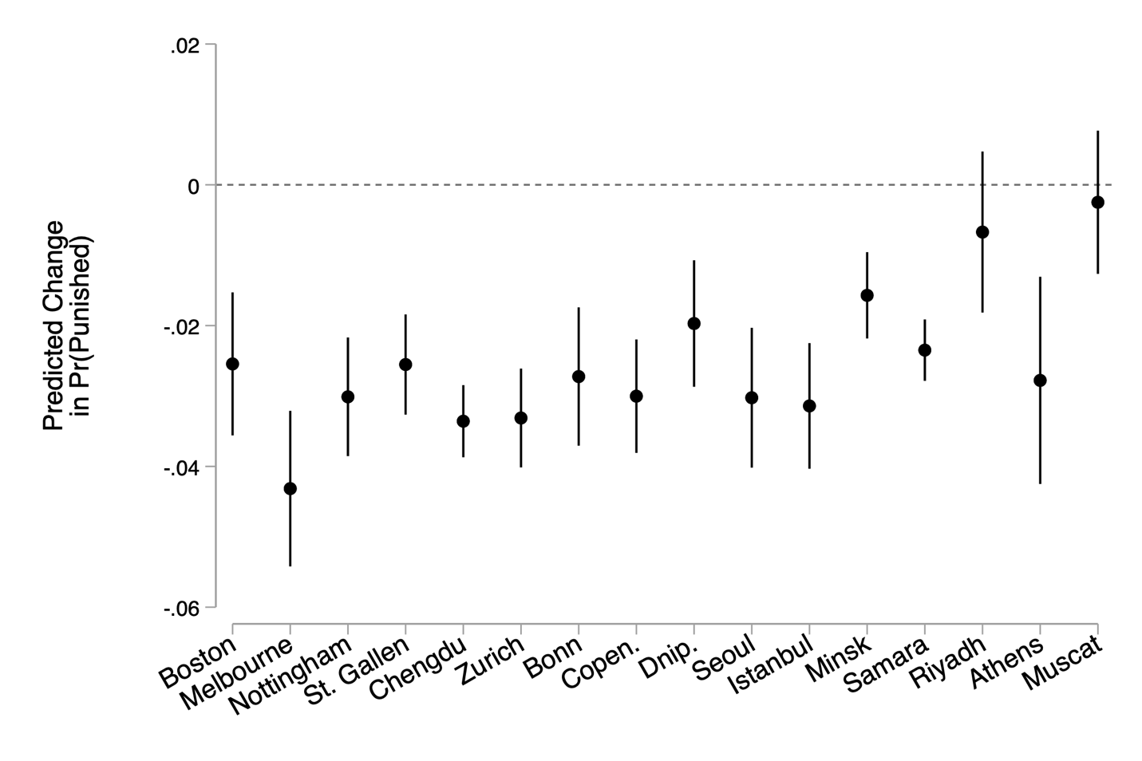

Supplemental analysis: Differences in who is punished by culture

Figure A2: Mean punishment of targets at each possible target contribution in each city.
In Figure A2, I plot the mean punishment of a target at each possible contribution of the target in each city. The analyses presented in the main text and above in the online appendix find that in most instances, the more someone cooperates the less they are punished. However, these analyses were conducted at the level of the city. Here, I turn to differences at the cultural level. (Gächter et al. 2010; Inglehart and Baker 2000).
Figure A3 plots the mean punishment of targets at each possible target contribution in each city, but unlike in Figure A2 the results are broken down by cultural group as delineated by (Gächter et al. 2010). These descriptive statistics reveal patterns of cultural differences in punishment behavior. While in most cases those who contribute more are punished less, in Arabic speaking and southern European cities there may be some differences in the relationship between target contributions and punishment. There is certainly more punishment being inflicted on high contributors in Arabic speaking and southern European cities.

Figure A3: Mean punishment of targets at each possible target contribution in each city by culture.

In order to determine if these patterns are the result of significant differences in the relationship between target contributions and punishment, I group targets into four based on their contribution to the public good. These include: defector (contributed nothing), low contributor (contributed 1-9 tokens), high contributor (contributed 10-19 tokens) and full contributor (contributed 20 tokens). I then regress the probability and amount respondents were punished based on their contribution category, the contributions of the punisher, the culture of the city, and an interaction between the three. The results are presented in Figure A4 and A5, as well as Table A3. In no case do increased contributions lead to increased punishment frequency or severity – in most cases, the more players contribute, the less they are punished.

Figure A4: Predicted probabilities a target was punished based on their contribution to the public good in the period. Error bars are 95% confidence intervals and full results are presented in Table A3, model 1.
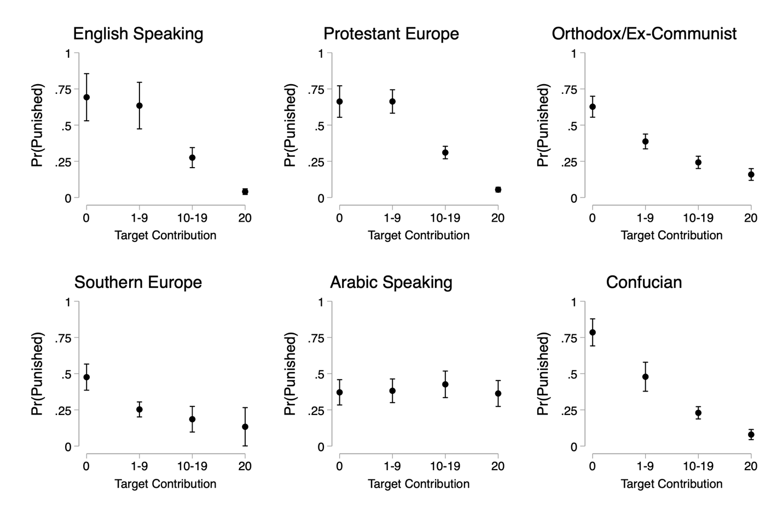

Figure A5: The predicted amount a target was punished based on their contribution to the public good in the period. Error bars are 95% confidence intervals and full results are presented in Table A3, model 2.
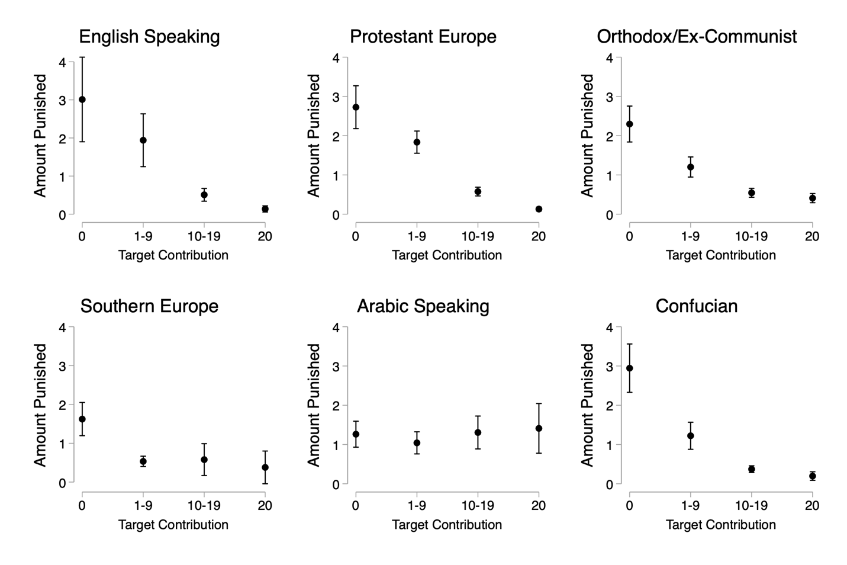

Table A3: Regression results for effect of punisher and target contributions by culture
Both models regress punishment on target contributions, punisher contributions, culture, and an interaction between the three. Contributions are categorized into defectors (contribute nothing), low contributors (contribute 1-9), high contributors (contribute 10-19), and full contributors (contribute 20). The omitted base categories are defectors and those in English-speaking cultures. Both models use observations at the subject and period level. The dependent variable for model 1 is a dummy variable where 0 indicates no punishment and 1 indicates punishment. The dependent variable for model 2 is the amount of punishment inflicted. All models cluster the standard errors at the level of the group and the individual. Standard errors in parentheses, * p < 0.05, ** p < 0.01, *** p < 0.001.

 | (1)  Pr(Punish) |  | (2)  Punishment Amount
Target: Low contributor | 0.250 | (0.197) | 0.0937 | (0.0701)
Target: High contributor | 0.102 | (0.0547) | 0.0612* | (0.0292)
Target: Full contributor | 0.0676 | (0.0380) | 0.0541 | (0.0314)
Punisher: Low contributor | 1.094*** | (0.260) | 0.656*** | (0.142)
Punisher: High contributor | 3.510*** | (0.700) | 0.857*** | (0.0554)
Punisher: Full contributor | 3.135*** | (0.697) | 0.635*** | (0.106)
T: Low contributor x P: Low contributor | -1.075** | (0.327) | -0.555*** | (0.157)
T: Low contributor x P: High contributor | -1.970*** | (0.583) | -0.209* | (0.105)
T: Low contributor x P: Full contributor | -0.938 | (0.778) | -0.0906 | (0.149)
T: High contributor x P: Low contributor | -0.889** | (0.319) | -0.524** | (0.187)
T: High contributor x P: High contributor | -3.388*** | (0.700) | -0.772*** | (0.0693)
T: High contributor x P: Full contributor | -2.390*** | (0.669) | -0.270** | (0.101)
T: Full contributor x P: Low contributor | -0.842** | (0.320) | -0.625*** | (0.154)
T: Full contributor x P: High contributor | -3.146*** | (0.737) | -0.802*** | (0.0824)
T: Full contributor x P: Full contributor | -3.114*** | (0.699) | -0.664*** | (0.111)
Protestant Europe | 0.371 | (0.203) | 0.161** | (0.0618)
Orthodox/Ex-Communist | 1.537** | (0.468) | 0.400*** | (0.0834)
Southern Europe | 1.521*** | (0.460) | 0.396*** | (0.0721)
Arabic Speaking | 0.702*** | (0.185) | 0.226*** | (0.0589)
Confucian | 0.526* | (0.217) | 0.263*** | (0.0745)
T: Low contributor x Protestant Europe | -0.235 | (0.277) | 0.0177 | (0.0980)
T: Low contributor x Orthodox/Ex-Communist | -0.508 | (0.472) | -0.166 | (0.101)
T: Low contributor x Southern Europe | -0.739* | (0.288) | -0.226* | (0.0888)
T: Low contributor x Arabic Speaking | -0.237 | (0.281) | -0.0597 | (0.0931)
T: Low contributor x Confucian | -0.506 | (0.289) | -0.157 | (0.111)
T: High contributor x Protestant Europe | -0.256 | (0.241) | -0.0921 | (0.0933)
T: High contributor x Orthodox/Ex-Communist | -0.805 | (0.536) | -0.223* | (0.0975)
T: High contributor x Southern Europe | -0.329 | (0.810) | -0.222 | (0.119)
T: High contributor x Arabic Speaking | 0.308 | (0.340) | 0.0611 | (0.103)
T: High contributor x Confucian | -0.403 | (0.233) | -0.174 | (0.0928)
T: Full contributor x Protestant Europe | -0.148 | (0.260) | -0.109 | (0.0846)
T: Full contributor x Orthodox/Ex-Communist | -0.905 | (0.530) | -0.254* | (0.105)
T: Full contributor x Southern Europe | -1.588*** | (0.461) | -0.451*** | (0.0786)
T: Full contributor x Arabic Speaking | 0.544 | (0.361) | 0.0925 | (0.0940)
T: Full contributor x Confucian | -0.272 | (0.266) | -0.192* | (0.0880)
P: Low contributor x Protestant Europe | -0.306 | (0.421) | -0.249 | (0.189)
P: Low contributor x Orthodox/Ex-Communist | -1.085 | (0.571) | -0.502** | (0.170)
P: Low contributor x Southern Europe | -1.318* | (0.543) | -0.592*** | (0.162)
P: Low contributor x Arabic Speaking | -0.831* | (0.355) | -0.467** | (0.166)
P: Low contributor x Confucian | 0.300 | (0.412) | -0.129 | (0.163)
P: High contributor x Protestant Europe | -1.809* | (0.804) | -0.337*** | (0.100)
P: High contributor x Orthodox/Ex-Communist | -2.534** | (0.910) | -0.477*** | (0.110)
P: High contributor x Southern Europe | -3.119*** | (0.934) | -0.754*** | (0.136)
P: High contributor x Arabic Speaking | -2.145* | (0.904) | -0.555*** | (0.143)
P: High contributor x Confucian | -2.237** | (0.839) | -0.470** | (0.150)
P: Full contributor x Protestant Europe | -0.230 | (0.810) | -0.101 | (0.133)
P: Full contributor x Orthodox/Ex-Communist | -1.673 | (0.943) | -0.399** | (0.147)
P: Full contributor x Southern Europe | -0.502 | (1.513) | -0.262 | (0.197)
P: Full contributor x Arabic Speaking | -2.033* | (0.873) | -0.567*** | (0.133)
P: Full contributor x Confucian | 0.374 | (0.884) | -0.0590 | (0.137)
T: Low contributor x P: Low contributor x Protestant Europe | 0.361 | (0.464) | 0.158 | (0.211)
T: Low contributor x P: Low contributor x Orthodox/Ex-Communist | 0.364 | (0.576) | 0.313 | (0.178)
T: Low contributor x P: Low contributor x Southern Europe | 0.674 | (0.415) | 0.444** | (0.171)
T: Low contributor x P: Low contributor x Arabic Speaking | 0.827* | (0.420) | 0.453* | (0.180)
T: Low contributor x P: Low contributor x Confucian | -0.218 | (0.451) | 0.0654 | (0.184)
T: Low contributor x P: High contributor x Protestant Europe | 1.371 | (0.703) | 0.0888 | (0.142)
T: Low contributor x P: High contributor x Orthodox/Ex-Communist | 0.910 | (0.807) | -0.0288 | (0.139)
T: Low contributor x P: High contributor x Southern Europe | 1.639* | (0.738) | 0.367* | (0.155)
T: Low contributor x P: High contributor x Arabic Speaking | 1.471 | (0.762) | 0.155 | (0.154)
T: Low contributor x P: High contributor x Confucian | 1.724* | (0.787) | 0.205 | (0.184)
T: Low contributor x P: Full contributor x Protestant Europe | -0.0552 | (0.882) | 0.000533 | (0.179)
T: Low contributor x P: Full contributor x Orthodox/Ex-Communist | 0.196 | (1.021) | 0.0182 | (0.178)
T: Low contributor x P: Full contributor x Southern Europe | -1.144 | (1.281) | -0.213 | (0.223)
T: Low contributor x P: Full contributor x Arabic Speaking | 0.751 | (0.981) | 0.242 | (0.185)
T: Low contributor x P: Full contributor x Confucian | -1.033 | (1.010) | -0.132 | (0.200)
T: High contributor x P: Low contributor x Protestant Europe | 0.177 | (0.483) | 0.228 | (0.242)
T: High contributor x P: Low contributor x Orthodox/Ex-Communist | 0.568 | (0.659) | 0.396 | (0.217)
T: High contributor x P: Low contributor x Southern Europe | 0.438 | (0.910) | 0.474* | (0.241)
T: High contributor x P: Low contributor x Arabic Speaking | 0.791 | (0.546) | 0.416 | (0.228)
T: High contributor x P: Low contributor x Confucian | -0.170 | (0.491) | 0.121 | (0.222)
T: High contributor x P: High contributor x Protestant Europe | 1.706* | (0.815) | 0.269* | (0.129)
T: High contributor x P: High contributor x Orthodox/Ex-Communist | 1.963* | (0.946) | 0.341** | (0.126)
T: High contributor x P: High contributor x Southern Europe | 1.831 | (1.205) | 0.544** | (0.176)
T: High contributor x P: High contributor x Arabic Speaking | 2.066* | (0.984) | 0.589** | (0.181)
T: High contributor x P: High contributor x Confucian | 2.156* | (0.850) | 0.406* | (0.173)
T: High contributor x P: Full contributor x Protestant Europe | 0.220 | (0.793) | 0.0956 | (0.145)
T: High contributor x P: Full contributor x Orthodox/Ex-Communist | 0.791 | (0.954) | 0.0948 | (0.151)
T: High contributor x P: Full contributor x Southern Europe | -0.100 | (1.730) | 0.155 | (0.226)
T: High contributor x P: Full contributor x Arabic Speaking | 2.457** | (0.928) | 0.322* | (0.159)
T: High contributor x P: Full contributor x Confucian | -0.734 | (0.849) | -0.0831 | (0.146)
T: Full contributor x P: Low contributor x Protestant Europe | 0.218 | (0.454) | 0.343 | (0.205)
T: Full contributor x P: Low contributor x Orthodox/Ex-Communist | 0.897 | (0.665) | 0.627** | (0.192)
T: Full contributor x P: Low contributor x Southern Europe | 1.733* | (0.725) | 0.728*** | (0.200)
T: Full contributor x P: Low contributor x Arabic Speaking | 0.455 | (0.528) | 0.444* | (0.194)
T: Full contributor x P: Low contributor x Confucian | 0.276 | (0.623) | 0.293 | (0.199)
T: Full contributor x P: High contributor x Protestant Europe | 1.333 | (0.855) | 0.279* | (0.130)
T: Full contributor x P: High contributor x Orthodox/Ex-Communist | 1.841 | (0.973) | 0.366** | (0.139)
T: Full contributor x P: High contributor x Southern Europe | 3.220** | (0.998) | 0.881*** | (0.155)
T: Full contributor x P: High contributor x Arabic Speaking | 1.467 | (1.015) | 0.471* | (0.185)
T: Full contributor x P: High contributor x Confucian | 1.734 | (0.906) | 0.392* | (0.179)
T: Full contributor x P: Full contributor x Protestant Europe | -0.00531 | (0.829) | 0.0486 | (0.146)
T: Full contributor x P: Full contributor x Orthodox/Ex-Communist | 1.068 | (0.982) | 0.265 | (0.161)
T: Full contributor x P: Full contributor x Southern Europe | 0.644 | (1.528) | 0.319 | (0.201)
T: Full contributor x P: Full contributor x Arabic Speaking | 3.230* | (1.610) | 0.553** | (0.197)
T: Full contributor x P: Full contributor x Confucian | -0.670 | (0.917) | -0.0111 | (0.148)
Constant | 8.61e-12 | (.0001) | 7.09e-12 | (0.0001)
Observations | 27084 |  | 27084

Table A4: Regression results for punisher contributions and punishment
Both models regress punishment on target contributions, indicators for each level of punisher contributions, and an interaction between the two. The omitted base category is the punisher contributing nothing. Both models use observations at the subject and period level. The dependent variable for model 1 is a dummy variable where 0 indicates no punishment and 1 indicates punishment. The dependent variable for model 2 is the amount of punishment inflicted. All models cluster the standard errors at the level of the group and the individual and have fixed effects at the city level. Standard errors in parentheses, * p < 0.05, ** p < 0.01, *** p < 0.001. Full results are illustrated in Figure 2 in the main text.

 | (1)  Pr(Punish) |  | (2)  Punishment Amount
Punisher Contribution=1 | 0.0093 | (0.056) | -0.371 | (0.270)
Punisher Contribution=2 | 0.041 | (0.052) | -0.235 | (0.256)
Punisher Contribution=3 | -0.010 | (0.051) | -0.399 | (0.255)
Punisher Contribution=4 | 0.010 | (0.070) | -0.302 | (0.322)
Punisher Contribution=5 | 0.024 | (0.045) | -0.280 | (0.252)
Punisher Contribution=6 | 0.082 | (0.059) | -0.332 | (0.253)
Punisher Contribution=7 | 0.126* | (0.061) | 0.002 | (0.276)
Punisher Contribution=8 | 0.129* | (0.056) | -0.146 | (0.276)
Punisher Contribution=9 | 0.164* | (0.075) | -0.157 | (0.366)
Punisher Contribution=10 | 0.189*** | (0.044) | 0.266 | (0.249)
Punisher Contribution=11 | 0.201* | (0.091) | 0.483 | (0.440)
Punisher Contribution=12 | 0.305*** | (0.063) | 0.435 | (0.279)
Punisher Contribution=13 | 0.347*** | (0.085) | 0.619 | (0.343)
Punisher Contribution=14 | 0.440*** | (0.095) | 0.976* | (0.403)
Punisher Contribution=15 | 0.361*** | (0.050) | 1.116*** | (0.301)
Punisher Contribution=16 | 0.372*** | (0.104) | 0.752 | (0.400)
Punisher Contribution=17 | 0.505*** | (0.078) | 1.002** | (0.363)
Punisher Contribution=18 | 0.441*** | (0.083) | 0.733* | (0.334)
Punisher Contribution=19 | 0.261 | (0.152) | 0.487 | (0.588)
Punisher Contribution=20 | 0.471*** | (0.046) | 1.960*** | (0.270)
Target Contribution | -0.007** | (0.002) | -0.025 | (0.013)
Punisher Contribution=1 x Target Contribution | 0.002 | (0.004) | 0.018 | (0.019)
Punisher Contribution=2 x Target Contribution | 0.003 | (0.004) | 0.013 | (0.017)
Punisher Contribution=3 x Target Contribution | 0.006 | (0.005) | 0.023 | (0.021)
Punisher Contribution=4 x Target Contribution | 0.007 | (0.006) | 0.011 | (0.025)
Punisher Contribution=5 x Target Contribution | -0.001 | (0.004) | 0.013 | (0.017)
Punisher Contribution=6 x Target Contribution | -0.006 | (0.006) | 0.012 | (0.020)
Punisher Contribution=7 x Target Contribution | -0.002 | (0.005) | -0.010 | (0.018)
Punisher Contribution=8 x Target Contribution | -0.008 | (0.005) | 0.001 | (0.021)
Punisher Contribution=9 x Target Contribution | -0.012 | (0.007) | 0.002 | (0.030)
Punisher Contribution=10 x Target Contribution | -0.014*** | (0.003) | -0.030 | (0.016)
Punisher Contribution=11 x Target Contribution | -0.014 | (0.008) | -0.044 | (0.030)
Punisher Contribution=12 x Target Contribution | -0.021*** | (0.005) | -0.044* | (0.020)
Punisher Contribution=13 x Target Contribution | -0.025*** | (0.006) | -0.053* | (0.022)
Punisher Contribution=14 x Target Contribution | -0.029*** | (0.006) | -0.080** | (0.025)
Punisher Contribution=15 x Target Contribution | -0.023*** | (0.003) | -0.079*** | (0.019)
Punisher Contribution=16 x Target Contribution | -0.021** | (0.006) | -0.054* | (0.024)
Punisher Contribution=17 x Target Contribution | -0.031*** | (0.005) | -0.069** | (0.021)
Punisher Contribution=18 x Target Contribution | -0.023*** | (0.005) | -0.048* | (0.019)
Punisher Contribution=19 x Target Contribution | -0.015 | (0.008) | -0.033 | (0.032)
Punisher Contribution=20 x Target Contribution | -0.028*** | (0.003) | -0.111*** | (0.016)
Constant | 0.235*** | (0.037) | 0.826*** | (0.230)
Observations | 33600 | 33600 | 33600 | 33600

Figure A6: Amount those who contribute more punish more by city
The predicted change in punishment amount for each additional token a punisher contributes to the public good. For all panels, vertical bars are 95% confidence intervals clustered at the individual and group level. Full results are available in Table A2.
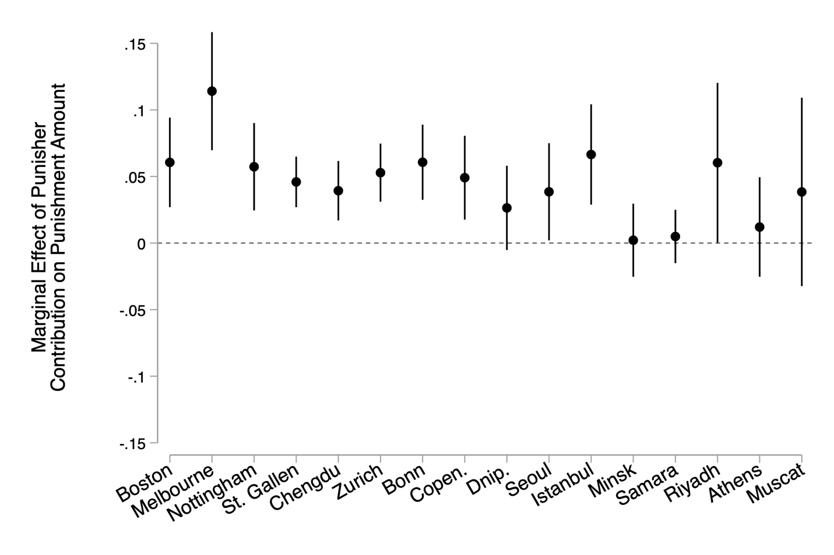

Figure A7: The predicted probability a target was punished based on the punisher’s contribution to the public good in the period. Error bars are 95% confidence intervals and full results are presented in Table A3, model 1.

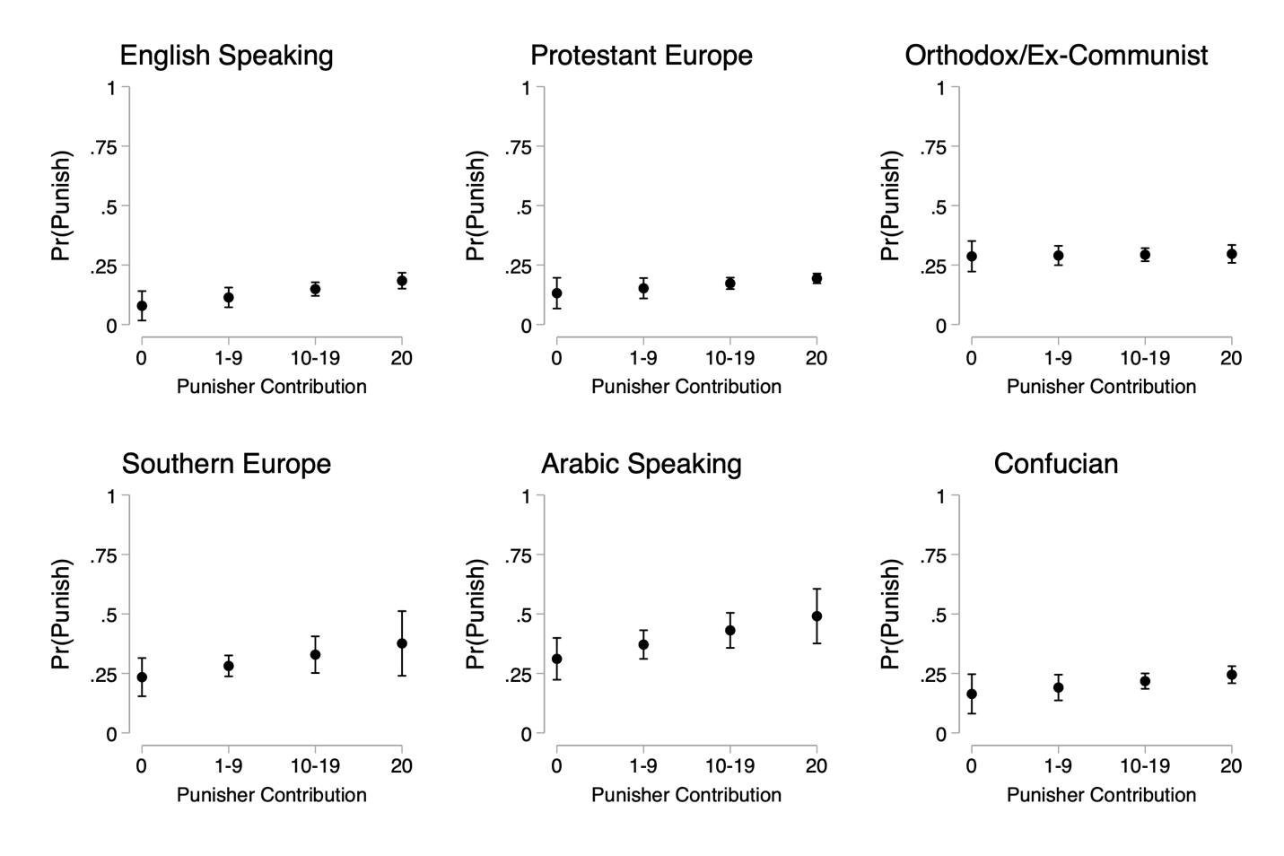

Figure A8: The predicted amount a target was punished based on the punisher’s contribution to the public good in the period. Error bars are 95% confidence intervals and full results are presented in Table A3, model 2.
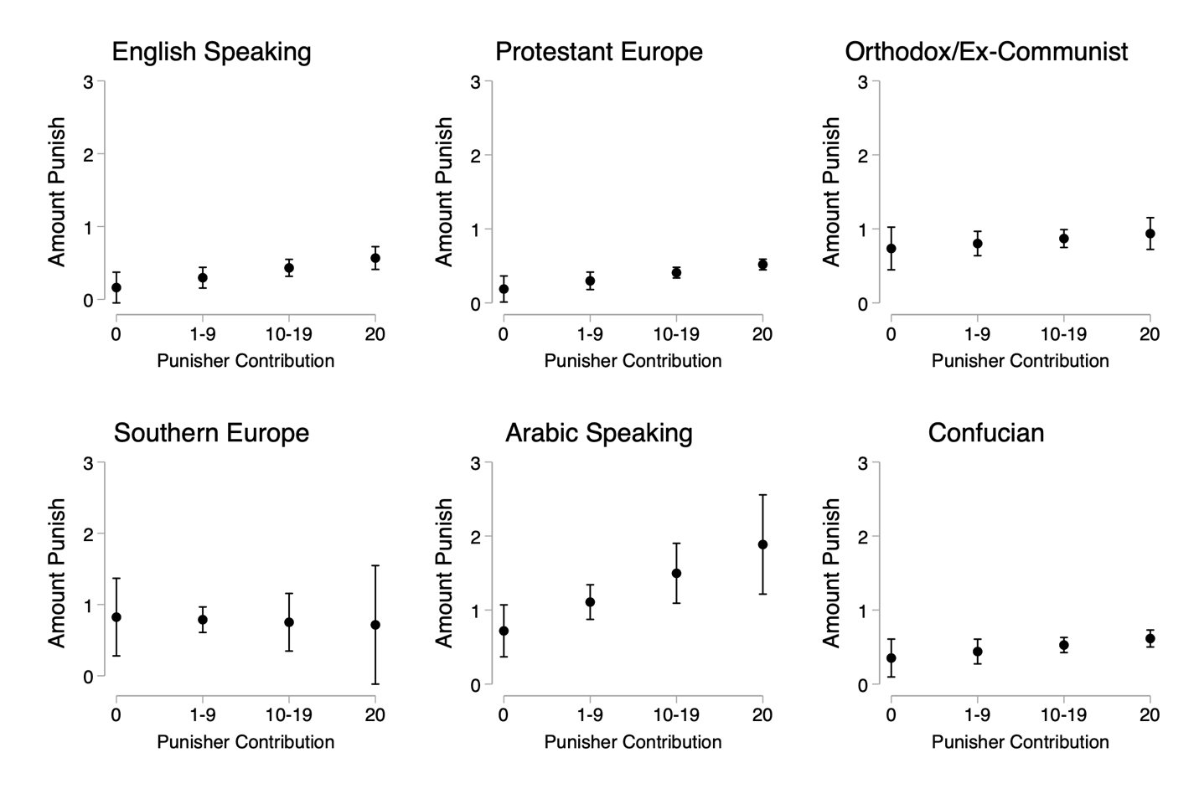

Table A5: Each cell reports the proportion who punish at each level of target and punisher contributions. In brackets are the number of observations in the cell, where observations are at the level of the subject and period.

 |  | Target Contribution
 |  | 0 | 1-9 | 10-19 | 20
Punisher Contribution | 0 | 0.32  [832] | 0.27  [885] | 0.21  [390] | 0.15  [445]
Punisher Contribution | 1-9 | 0.52  [885] | 0.24  [3056] | 0.29  [949] | 0.30  [576]
Punisher Contribution | 10-19 | 0.68  [390] | 0.55  [949] | 0.17  [3,434] | 0.13  [1618]
Punisher Contribution | 20 | 0.64  [445] | 0.56  [567] | 0.40  [1,618] | 0.03  [10,036]

Table A6: Each cell reports average punishment expenditure at each level of target and punisher contributions. In brackets are the number of observations in the cell, where observations are at the level of the subject and period.
 |  | Target Contribution
 |  | 0 | 1-9 | 10-19 | 20
Punisher Contribution | 0 | 1.14  [832] | 0.88  [885] | 0.67  [390] | 0.47  [445]
Punisher Contribution | 1-9 | 1.34  [885] | 0.48  [3056] | 0.63  [949] | 0.76  [576]
Punisher Contribution | 10-19 | 2.33  [390] | 1.37  [949] | 0.31  [3,434] | 0.31  [1618]
Punisher Contribution | 20 | 3.14  [445] | 2.02  [567] | 0.88  [1,618] | 0.10  [10,036]

Table A7: Each cell reports the proportion who punish at each level of target and punisher contributions. In brackets are the number of observations in the cell, where observations are at the level of the subject and period. Results are broken out by each culture, as delineated by Herrmann et al. (2008).

English Speaking |  | Target Contribution
 |  | 0 | 1-9 | 10-19 | 20
Punisher Contribution | 0 | 0.00  [26] | 0.09  [32] | 0.06  [49] | 0.05  [74]
Punisher Contribution | 1-9 | 0.66  [32] | 0.19  [190] | 0.19  [62] | 0.09  [47]
Punisher Contribution | 10-19 | 0.86  [49] | 0.74  [62] | 0.15  [410] | 0.11  [183]
Punisher Contribution | 20 | 0.64  [74] | 0.64  [47] | 0.43  [183] | 0.02  [2,290]
Protestant Europe |  | Target Contribution
 |  | 0 | 1-9 | 10-19 | 20
Punisher Contribution | 0 | 0.16  [62] | 0.27  [44] | 0.13  [69] | 0.11  [141]
Punisher Contribution | 1-9 | 0.57  [44] | 0.28  [298] | 0.24  [174] | 0.23  [134]
Punisher Contribution | 10-19 | 0.68  [69] | 0.67  [174] | 0.15  [1,102] | 0.10  [531]
Punisher Contribution | 20 | 0.70  [141] | 0.72  [134] | 0.49  [531] | 0.02  [4,634]
Orthodox/Ex-Communist |  | Target Contribution
 |  | 0 | 1-9 | 10-19 | 20
Punisher Contribution | 0 | 0.40  [160] | 0.33  [229] | 0.24  [109] | 0.20  [110]
Punisher Contribution | 1-9 | 0.55  [229] | 0.24  [770] | 0.27  [362] | 0.36  [236]
Punisher Contribution | 10-19 | 0.78  [109] | 0.47  [362] | 0.19  [498] | 0.14  [474]
Punisher Contribution | 20 | 0.64  [110] | 0.49  [236] | 0.30  [474] | 0.04  [1,240]
Southern Europe |  | Target Contribution
 |  | 0 | 1-9 | 10-19 | 20
Punisher Contribution | 0 | 0.40  [338] | 0.26  [280] | 0.24  [34] | 0.00  [13]
Punisher Contribution | 1-9 | 0.46  [280] | 0.22  [1,112] | 0.25  [76] | 0.17  [12]
Punisher Contribution | 10-19 | 0.50  [34] | 0.53  [76] | 0.11  [172] | 0.18  [71]
Punisher Contribution | 20 | 0.77  [13] | 0.33  [12] | 0.49  [71] | 0.03  [184]
Arabic Speaking |  | Target Contribution
 |  | 0 | 1-9 | 10-19 | 20
Punisher Contribution | 0 | 0 .23  [208] | 0.26  [200] | 0.35  [89] | 0.37  [51]
Punisher Contribution | 1-9 | 0.42  [200] | 0.35  [340] | 0.43  [191] | 0.38  [100]
Punisher Contribution | 10-19 | 0.53  [89] | 0.51  [191] | 0.47  [154] | 0.34  [64]
Punisher Contribution | 20 | 0.29  [51] | 0.48  [100] | 0.47  [64] | 0.33  [94]
Confucian |  | Target Contribution
 |  | 0 | 1-9 | 10-19 | 20
Punisher Contribution | 0 | 0.26  [38] | 0.20  [100] | 0.15  [40] | 0.13  [56]
Punisher Contribution | 1-9 | 0.79  [100] | 0.24  [346] | 0.27  [84] | 0.32  [47]
Punisher Contribution | 10-19 | 0.65  [40] | 0.58  [84] | 0.17  [998] | 0.10  [295]
Punisher Contribution | 20 | 0.84  [56] | 0.55  [47] | 0.37  [295] | 0.03  [1,594]

Table A8: Each cell reports the average punishment at each level of target and punisher contributions. In brackets are the number of observations in the cell, where observations are at the level of the subject and period. Results are broken out by each culture, as delineated by Herrmann et al. (2008).

English Speaking |  | Target Contribution
 |  | 0 | 1-9 | 10-19 | 20
Punisher Contribution | 0 | 0.00  [26] | 0.25  [32] | 0.10  [49] | 0.07  [74]
Punisher Contribution | 1-9 | 1.09  [32] | 0.27  [190] | 0.31  [62] | 0.32  [47]
Punisher Contribution | 10-19 | 3.51  [49] | 1.79  [62] | 0.22  [410] | 0.43  [183]
Punisher Contribution | 20 | 3.14  [74] | 2.45  [47] | 0.85  [183] | 0.09  [2,290]
Protestant Europe |  | Target Contribution
 |  | 0 | 1-9 | 10-19 | 20
Punisher Contribution | 0 | 0.37  [62] | 0.39  [44] | 0.22  [69] | 0.29  [141]
Punisher Contribution | 1-9 | 1.16  [44] | 0.46  [298] | 0.29  [174] | 0.46  [134]
Punisher Contribution | 10-19 | 2.07  [69] | 1.49  [174] | 0.24  [1,102] | 0.18  [531]
Punisher Contribution | 20 | 3.28  [141] | 2.30  [134] | 0.95  [531] | 0.08  [4,634]
Orthodox/Ex-Communist |  | Target Contribution
 |  | 0 | 1-9 | 10-19 | 20
Punisher Contribution | 0 | 1.54  [160] | 1.28  [229] | 0.83  [109] | 0.70  [110]
Punisher Contribution | 1-9 | 1.55  [229] | 0.58  [770] | 0.52  [362] | 0.76  [236]
Punisher Contribution | 10-19 | 2.51  [109] | 1.20  [362] | 0.39  [498] | 0.37  [474]
Punisher Contribution | 20 | 3.00  [110] | 2.00  [236] | 0.70  [474] | 0.12  [1,240]
Southern Europe |  | Target Contribution
 |  | 0 | 1-9 | 10-19 | 20
Punisher Contribution | 0 | 1.15  [338] | 1.03  [280] | 1.29  [34] | 0.00  [13]
Punisher Contribution | 1-9 | 1.30  [280] | 0.41  [1,112] | 0.62  [76] | 0.67  [12]
Punisher Contribution | 10-19 | 1.91  [34] | 1.09  [76] | 0.28  [172] | 0.46  [71]
Punisher Contribution | 20 | 4.15  [13] | 1.58  [12] | 1.44  [71] | 0.16  [184]
Arabic Speaking |  | Target Contribution
 |  | 0 | 1-9 | 10-19 | 20
Punisher Contribution | 0 | 0.70  [208] | 0.72  [200] | 1.11  [89] | 1.31  [51]
Punisher Contribution | 1-9 | 0.97  [200] | 0.73  [340] | 1.28  [191] | 1.19  [100]
Punisher Contribution | 10-19 | 2.07  [89] | 1.58  [191] | 1.15  [154] | 1.00  [64]
Punisher Contribution | 20 | 1.80  [51] | 1.63  [100] | 2.28  [64] | 2.53  [94]
Confucian |  | Target Contribution
 |  | 0 | 1-9 | 10-19 | 20
Punisher Contribution | 0 | 0.53  [38] | 0.27  [100] | 0.23  [40] | 0.32  [56]
Punisher Contribution | 1-9 | 1.92  [100] | 0.37  [346] | 0.56  [84] | 1.15  [47]
Punisher Contribution | 10-19 | 1.80  [40] | 1.23  [84] | 0.27  [998] | 0.18  [295]
Punisher Contribution | 20 | 4.04  [56] | 1.81  [47] | 0.61  [295] | 0.05  [1,594]

Figure A9: The predicted amount a target was punished based on the punisher and target’s contribution to the public good in the period. Error bars are 95% confidence intervals and full results are presented in Table A3, model 2.
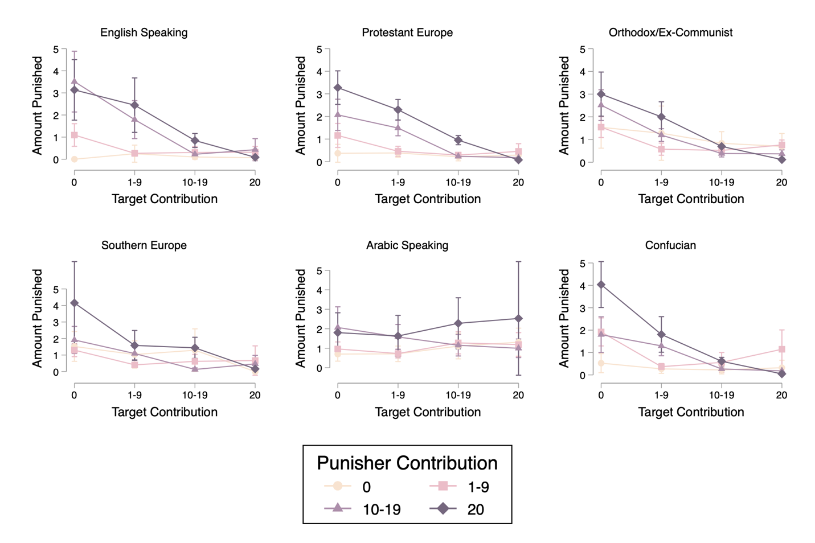

Table A9: Regression results for probability and amount punished by target and punisher contribution
Both models regress punishment on target contributions, punisher contributions, and an interaction between the two. Contributions are categorized into defectors (contribute nothing), low contributors (contribute 1-9), high contributors (contribute 10-19), and full contributors (contribute 20). The omitted base categories are defectors. Both models use observations at the subject and period level. The dependent variable for model 1 is a dummy variable where 0 indicates no punishment and 1 indicates punishment. The dependent variable for model 2 is the amount of punishment inflicted. All models cluster the standard errors at the level of the group and the individual and have fixed effects at the city level. Standard errors in parentheses, * p < 0.05, ** p < 0.01, *** p < 0.001. The results are illustrated in Figure 3.

 | (1)  Pr(Punish) |  | (2)  Punishment Amount
Punisher: Low contributor | 0.213*** | (0.047) | 0.245 | (0.229)
Punisher: High contributor | 0.361*** | (0.057) | 1.261*** | (0.287)
Punisher: Full contributor | 0.334*** | (0.051) | 2.122*** | (0.298)
Target: Low contributor | -0.044 | (0.035) | -0.219 | (0.156)
Target: High contributor | -0.103* | (0.046) | -0.398 | (0.232)
Target: Full contributor | -0.160*** | (0.045) | -0.548* | (0.219)
P: Low contributor x T: Low contributor | -0.232*** | (0.044) | -0.622*** | (0.179)
P: Low contributor x T: High contributor | -0.140* | (0.059) | -0.310 | (0.263)
P: Low contributor x T: Full contributor | -0.067 | (0.057) | -0.010 | (0.256)
P: High contributor x T: Low contributor | -0.088 | (0.052) | -0.767** | (0.248)
P: High contributor x T: High contributor | -0.399*** | (0.062) | -1.577*** | (0.307)
P: High contributor x T: Full contributor | -0.385*** | (0.063) | -1.417*** | (0.302)
P: Full contributor x T: Low contributor | -0.051 | (0.053) | -0.957** | (0.299)
P: Full contributor x T: High contributor | -0.139* | (0.057) | -1.859*** | (0.313)
P: Full contributor x T: Full contributor | -0.450*** | (0.055) | -2.434*** | (0.310)
Constant | 0.279*** | (0.041) | 0.927*** | (0.213)
Observations | 27084 | 27084 | 27084 | 27084

Figure A10: Mean contributions by city
Error bars are standard errors of the mean. Results are at the level of the subject and period.

Supplemental References

Gächter, S., Herrmann, B., & Thöni, C. (2010). Culture and cooperation. Philosophical Transactions of the Royal Society B: Biological Sciences, 365(1553), 2651–2661. https://doi.org/10.1098/rstb.2010.0135

Inglehart, R., & Baker, W. E. (2000). Modernization, cultural change, and the persistence of traditional values. American Sociological Review, 65(1), 19–51. https://doi.org/10.2307/2657288

