Appendix
A.1. Experimental instructions (translated from French)
General information: Welcome. This experiment will last about an hour and a quarter. We ask you to not communicate with the other participants for the duration of this experiment. We also ask you not to write on the Instructions. For your participation, you will receive a payoff of 2.50 Euros, whatever the decisions you make during the experiment. You can in addition increase your earnings. The experiment is divided into a number of sections, for which you will receive separate instructions. Your earnings will be calculated at the end of the experiment. You will receive by check all of your earnings during the different sections, in addition to the 2.50 Euros.
Treatment-speciﬁc information (varying payoffs and the existence of information): Please read these instructions carefully. You can earn a certain amount of money depending on your decisions. You will be randomly assigned to a group of ﬁve participants for a series of twenty periods. The group will remain unchanged over these twenty periods. In each period, you will see on the screen six boxes marked a, b, c, d, e, and f with numbers hidden behind them (1, 2, 3, 4, 5, and 6). These numbers are placed in a random order that will change each time. In each period, you will have to click on a box. Once you have clicked on it, you will see a number appear in bold. For example, in the screen below, you clicked on box "c" and the hidden number is 4.
You can click on the other boxes but only the ﬁrst box on which you clicked matters. You will be asked to report the number you saw at the ﬁrst click, as described in the screen below

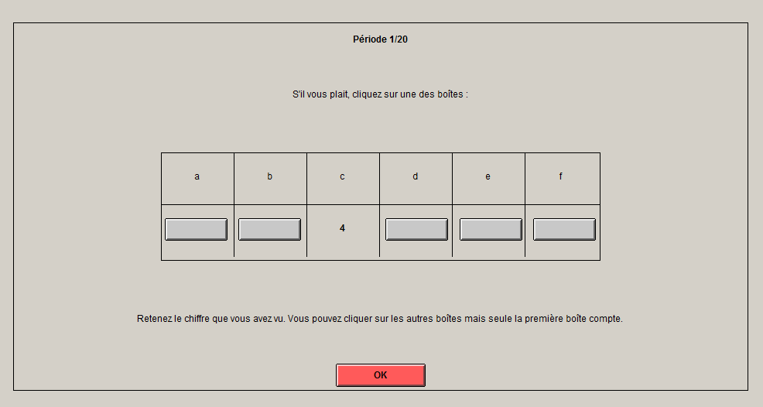

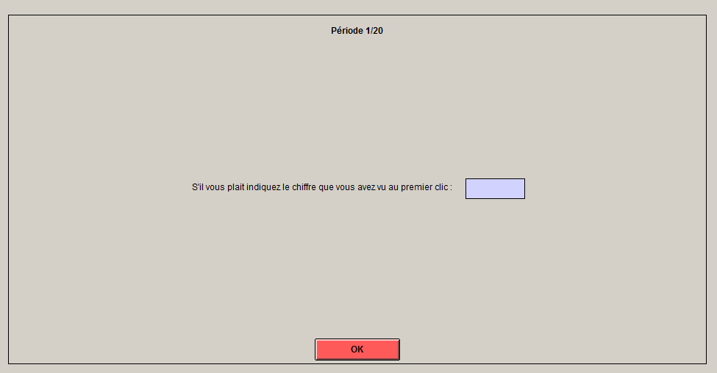

The number reported has to be between 1 and 6. Your earnings will be determined by the number you entered according to the following table (Example: High):

Reported number | 1 | 2 | 3 | 4 | 5 | 6
Payoff | 1 Euro | 2 Euros | 3 Euros | 4 Euros | 5 Euros | 6 Euros

For example, if you wrote "1", you will receive 1 Euro. If you wrote "2", you will receive 2 Euros; if you wrote "3", you will receive 3 Euros, and so on. The higher the reported number, the higher your payoff.
In each period, six new boxes will appear on the screen. You will have to click on one of them and, again, ﬁll in the input boxes. This part of the experiment will end after twenty periods.

At the end of the experiment one period will be drawn randomly to determine your payoff, and you will be paid according to the number you entered in this period.
In each period, we will also ask you to guess the percentage of those in your group who have correctly reported their ﬁrst click (excluding yourself). For example, in the screen below, you are asked to choose between 0%, 25%, 50%, 75% or 100%.

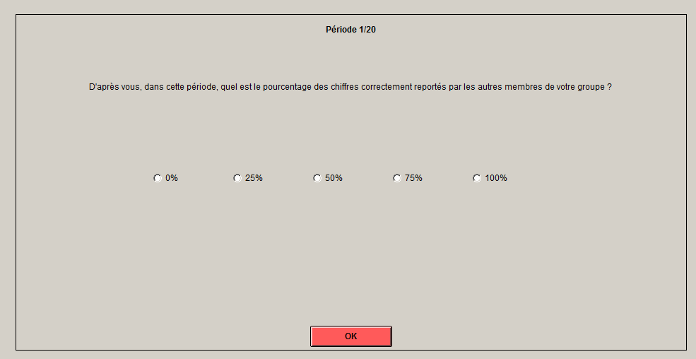

[Next a screen will appear and inform you about the correct answer] (text in brackets only in the information treatment). One of the percentages you have entered will be randomly selected at the end of the experiment, and you will receive 50 Euro cents if you guessed correctly.
Important: your decisions are anonymous and private. The computer program does not allow us to link your identity to your answers. Errors will not be punished and the experiment will continue even in the case of mistakes. You will be paid according to what you report. If you have any questions, please raise your hand and we will come to see you!
Memory game: You will now participate in a memory game. Be careful: numbers will appear on the screen. You will have to memorize them and report the whole sequence. The list of numbers to remember will become longer and longer. It is forbidden to write them down or use a calculator. The participant in this session with the highest score in this memory game will receive two additional Euros. A random draw will be carried out in the case of a tie.

A.2 Theoretical model

A.2.1 Equilibria and interaction effects
Let $I$ be a binary variable indicating whether the agents are informed ($I=1$) or not ($I=0$) about the true fraction of cheaters. In line with the recent literature on dishonesty, the decision to cheat is assumed to be the result of a tradeoff between pecuniary benefits $B$ and non-monetary costs $C$. The monetary benefits associated with cheating are assumed to rise with factor $x$ such that $B=B\left(x\right)$. The non-monetary cost function $C$consists of four elements described below. Agent $i$ will cheat in period $t$ if her material benefits $B$ of cheating outweigh the psychological costs $C$ of cheating such that:
$B\left(x\right)>C\left(k_{i},G\left(x\right),R\left(x\right)×π\left(I\right),\hat{β_{t}^{j}}\left(I\right)\right),j=L,H,$ (A1)
where $k_{i}$ is a fixed Kantian cost. It is assumed that individuals are heterogeneous and make “unconditional” commitments to behave honestly (Harsanyi, 1980; Kajackaite and Gneezy, 2017; Abeler et al., 2019). This unconditional commitment, however, is weak in the sense that cheating costs are also sensitive to external factors and social influences (e.g., Figuieres et al., 2013; Le Maux et al., 2019; Abeler et al., 2019; Masclet and Dickinson, 2019).
The “guilt component” $G\left(x\right)$ is a variable lying cost that rises with stakes. It relies on the idea that people want to maintain a positive self-image, which makes lying costly even in the absence of observability (Kandel and Lazear, 1992). This also relates to the theory of self-concept maintenance suggesting that individuals strive to maintain a positive and consistent self-concept by using categorization or rationalization. However, while categorization and rationalization may work quite well when one lies for small amounts it may be less effective when stakes are higher (see Mazar et al. 2008). Costs $G\left(x\right)$ are thus expected to rise with payoffs $x$ since higher stakes are likely to reduce rationalization and categorization.
The “shame effect”, denoted $R\left(x\right)×π\left(I\right)$, relies on the idea that being observed as a cheater may induce a cost in terms of shame and potential loss in reputation (e.g. Garbarino et al., 2019). Shame is expected to rise with payoffs $x$ since higher stakes are likely to intensify external pressure (Vrij, 2008) and/or may cause larger costs for experimenters in ‘observed’ cheating games (Gneezy, 2005; Fischbacher and Föllmi-Heusi, 2013). Shame increases with the subjective probability of being observed denoted $π\left(I\right)$. With information ($I=1$, the agents know that their behavior will be displayed (yet anonymously) to others. Hence, we could expect $π$ to be larger with information.
The “social conformity” effect, denoted $\hat{β_{t}^{j}}\left(I\right)$ reflects that people comply with social norms and conform to others’ behavior. The cost of cheating is assumed to decrease with the fraction $\hat{β_{t}^{j}}$ of other agents who are thought to be dishonest in period $t$ (Rauhut, 2013). This conformity effect is dynamic in the sense that an exogenous variation in $x$ that encourages (reduces) cheating at $t$ also reduces (increases) the conditional commitment to honesty at $t+1$, which will make cheating even more (less) attractive in t + 2, and so on
Assuming a quasi-linear cheating cost function, $C$ is rewritten as follows:
$C=k_{i}+G\left(x\right)+R\left(x\right)×π\left(I\right)−α\hat{β_{t}^{j}}\left(I\right),$ (A2)
where $α$ measures the extent to which cheating costs are responsive to beliefs ${\hat{β}}_{t}^{j}$. The belief ${\hat{β}}_{t}^{j}$ of a $j$-type agent in period $t$ is expressed as:
${\hat{β}}_{t}^{j}\left(I\right)=I{×β}_{t−1}+\left(1−I\right)×β^{j},j=L,H$. (A3)
Beliefs are assumed to vary with the information condition. With information ($I=1$, the conformity effect is driven by others’ behavior, such that the agents behave according to the true fraction $β_{t−1}$ of cheaters observed in period $t−1$. Without information ($I=0$), we hypothesize that the agents have heterogeneous (and exogenous) beliefs about what the others are doing in period $t$. We assume that the agents are of two types: either pessimistic, i.e., they expect a high fraction $β^{H}$ of agents to be dishonest, or optimistic, i.e., they expect a low fraction $β^{L}$ of cheaters. If parameter $α$ in equation (A2) is non-negative and if the agents are not informed about the true fraction ($I=0$ in equation 3), then agents’ behaviors are driven by their exogenous beliefs $β^{L}$ and$β^{H}$ only and, therefore, are stable through time. If $α$ is non-negative in equation (A2), and if the agents are informed about the true fraction ($I=1$ in equation A3), then the share of liars will not only vary with stakes $x$ but will further move due to changes in beliefs. The effectof information $I$ on those long-run effects is conditioned by beliefs $β^{L}$ and$β^{H}$. Without information, the agents may still accurately anticipate the true fraction on average. In that case, providing information may have an opposite effect on over- and under-estimators, and yet on average, the informed agents are adjusting their choices towards the same mean as the without-information condition.
Long-run equilibria are derived as follows. Combining equation A2 with equation A1, we obtain:
$B\left(x\right)>k_{i}+G\left(x\right)+R\left(x\right)×π\left(I\right)−α\hat{β_{t}^{j}}\left(I\right),j=L,H.$ (A4)
In order to compute the share of cheaters, let $k_{i}^{j}=B−R×π+α\hat{β_{t}^{j}}$ represent the fixed cost at which agents are indifferent between cheating and being honest. Any $j$-type agent with Kantian morality under $k_{t}^{j}$will lie about his/her true state. For simplicity, we assume for each type that the Kantian morality is uniformly distributed over the unit interval. Integrating over all agents yields the fraction of agents who are dishonest in period t:
$β_{t}=p×k_{t}^{L}+\left(1−p\right)×k_{t}^{H}$ (A5)
where $p$ and $\left(1−p\right)$ stand for the population shares of low and high types, respectively.
Let us set $I=0$. By replacing $k_{t}^{L}$ $withB−φ^{j}$, with$φ^{j}=G\left(x\right)+R\left(x\right)×π\left(0\right)−α\hat{β_{t}^{j}}\left(0\right)$, we get:
$β_{t}=p×\left[B\left(x\right)−φ^{L}\right]+\left(1−p\right)×\left[B\left(x\right)−φ^{H}\right]$, (A6)
which is equal to $β_{t}=B\left(x\right)−{pφ}^{L}−\left(1−p\right)φ^{H}$. Using equation 3 and replacing $φ^{j}$ with its value we get: $β_{t}=B\left(x\right)−G\left(x\right)−π\left(0\right)R\left(x\right)+α\left[pβ_{}^{L}+\left(1−p\right)β_{}^{H}\right]$, which is invariant through time. Thus, the long run equilibrium is necessarily stable. We obtain:
$β_{without}=B\left(x\right)−G\left(x\right)−π\left(0\right)R\left(x\right)+α\overline{β}$. (A7)
where $\overline{β}=pβ_{t}^{L}+\left(1−p\right)β_{t}^{H}$ is the average expectation of others’ behavior when no information is received.
With information ($I=1$), the share of cheater in the short run is obtained by replacing $\overline{β}$ with $β_{t−1}^{}$ and $π\left(0\right)$ with $π\left(1\right)$ in equation A7:
$β_{t}=B\left(x\right)−G\left(x\right)−π\left(1\right)R\left(x\right)+αβ_{t−1}^{}$. (A8)
The long run stationary equilibrium, $β$ hereafter, is given by:
$β=B\left(x\right)−G\left(x\right)−π\left(1\right)R\left(x\right)+αβ$. (A9)
Solving for $β$ yields:
$β_{with}=\frac{B\left(x\right)−G\left(x\right)−π\left(1\right)R\left(x\right)}{1−α}$ . (A10)
By definition, an interior point is stable if the absolute value of the derivative of $β_{t}$ with respect to $β_{t−1}$ is strictly less than 1 in equation A8, i.e., if $α<1$, which we will assume all along the paper.
Now let $∆=β_{with}−β_{without}$stand for the average treatment effect of information. We have:
$∆=β_{with}−β_{without}=\frac{B\left(x\right)−G\left(x\right)−π\left(1\right)R\left(x\right)}{1−α}−β_{without}$. (A11)
From A7, we get
$B\left(x\right)=β_{without}+G\left(x\right)+π\left(0\right)R\left(x\right)−α\overline{β}$. (A12)
By substituting (A12) in (A11), we obtain $∆=\frac{β_{without}+π\left(0\right)R\left(x\right)−α\overline{β}−π\left(1\right)R\left(x\right)}{1−α}−\frac{{\left(1−α\right)β}_{without}}{1−α}$ . By simplifying, we have:
$∆=\frac{π\left(0\right)−π\left(1\right)}{1−α}R\left(x\right)+\frac{α}{1−α}\left(β_{without}−\overline{β}\right)$. (A13)
The derivative of $∆$ with respect to $x$ amounts to:
$\frac{d∆}{dx}=\frac{π\left(0\right)−π\left(1\right)}{1−α}\frac{dR}{dx}+\frac{α}{1−α}\frac{dβ_{without}}{dx}$ (A14)
Equation (A14) consists of two elements, each describing a particular interaction effect. First, $∆$ will change with $x$ if the information condition affects the feeling to be observed, so that $π\left(1\right)$> $π\left(0\right)$, inducing the agents to be more responsive to shaming effects when the information is provided. Second, with information, there are multiplier effects if α is non-negative. Any change in payoffs that affects $β_{without}$ is exacerbated if the agents are informed about the true extent of norm violations.
Of course, it is possible that there is no interaction effect. In equation A13, when $π\left(0\right)=π\left(1\right)$, we obtain $β_{with}=β_{without}$ if $\overline{β}=β_{without}$. In that case, without information, the agents act as if they had perfect knowledge of the equilibrium share of liars. Since $β^{L}<\overline{β}<β^{H}$, we expect differences in the fraction of liars by type. However, those differences counteract each other on average, inducing no fundamental difference in equilibria.

A.2.2. Graphic illustration
Figure A.1 shows the possible sets of equilibria for different values of the model parameters. Equations A7 (without information) and A10 (with information) are depicted with black and grey lines, respectively. On these curves, $β_{t}$ is a function of $β_{t−1}$ and all other variables are held constant. The model parameters were chosen for graphical convenience with the only purpose of illustrating the main features of the model. The intersection points on the 45-degree line indicate the two interior stationary points, i.e., $β_{with}$ (in grey) and $β_{without}$ (in black).
When there is no social conformity effect ($α=0$) and no effect of information on the subjective probability ($π\left(0\right)=π\left(1\right)$), then information does not matter as described in panel (a): we obtain $β_{with}=β_{without}$. As shown in panel (b), an increase in $α$ affects both equilibria but modifies only the slope for the information condition (without information, the agents account for their exogenous beliefs. With information, they adjust their belief according to the true fraction). Note that in panel (b), parameter $\overline{β}$ has been arbitrarily chosen so that the agents underestimate the level of fraud on average: $\overline{β}<β_{without}$. As a result, providing information about the true fraction increases cheating ($β_{with}>β_{without}$ as suggested in equation A13. Now, if the subjective probability $π$ is impacted by the information condition (panel c), we observe a shift downwards of $β_{with}$ due to the shame effect. Last, an increase in stakes $x$ that affects lying (here negatively) has a larger effect on $β_{with}$ than on $β_{without}$ due to the interaction effects (i.e. both conformity and shame effects).

Figure A.1: Model predictions (“with info” in grey, “without” in black)

A.3 Additional results: Tables

Table A.1: Description and statistics of the control variables

Treatment

Variable | Description | Total | Low  No Info | Low  Info | High  No Info | High  Info | Very High  No info | Very High  Info
Age | Age of subject | 21.50 | 22.67 | 22.57 | 22.96 | 20.18 | 19.97 | 21.34
Female | Is female (Y/N) | 0.51 | 0.53 | 0.56 | 0.52 | 0.48 | 0.60 | 0.38
Economics | Is an Economics student (Y/N) | 0.43 | 0.16 | 0.30 | 0.52 | 0.71 | 0.34 | 0.41
Risk aversion | Number of safe choices in Holt/Laury | 6.22 | 5.96 | 6.12 | 6.14 | 6.18 | 6.42 | 6.42
 | 2002 risk-aversion game: higher=more risk-
 | averse
Cheating attitude | Average assessment of justiﬁability of 11 | 3.23 | 3.07 | 3.31 | 3.38 | 3.32 | 3.15 | 3.07
 | practices on a 1-10 scale (taken from the
 | World Values Survey): higher=less moral
Religious | Importance of God in life: 1=No importance, | 3.52 | 3.74 | 3.66 | 3.41 | 3.60 | 3.37 | 3.38
 | 10=High importance
Political orientation | 1 leaning to Left, 10 leaning to Right | 4.61 | 4.59 | 4.26 | 4.36 | 5.08 | 4.75 | 4.48
Finance | Financial knowledge: 1=None, 2=Some, | 2.33 | 2.29 | 2.36 | 2.20 | 2.45 | 2.29 | 2.34
 | 3=High
Memory game | Points achieved in memory game: | 6.23 | 5.99 | 6.20 | 6.11 | 6.36 | 6.28 | 6.38
 | higher=better memory

Table A.2: The determinants of the intensity of cheating (RE Tobit models)
 | RE Tobit | RE Tobit | RE Tobit
 | (1) | (2) | (3)
Payoff low | Ref. | Ref. | Ref.
Payof: High | .333 | .005 | -.010
 | (.493) | (.457) | (.420)
Payoff : Very High | -.1631** | -1.813*** | -1.665***
 | (.518) | (.453) | (.419)
Info | .991** | .844** | .572*
 | (.406) | (.356) | (.334)
First box 1 |  | 5.142*** | 5.125***
 |  | (.081) | (.078)
First box 2 |  | 4.128*** | 4.167***
 |  | (.081) | (.078)
First box 3 |  | 3.027*** | 2.997***
 |  | (.081) | (.078)
First box 4 |  | 1.594*** | 1.559***
 |  | (.083) | (.080)
First box 5 |  | Ref. | Ref.
First box 6 |  | -8.515 | -8.627
 |  | (115.66) | (307.15)
Period | .079*** | .066*** | .040***
 | (.007) | (.004) | (.004)
Age |  | -.052 | -.041
 |  | (.035) | (.034)
Female (binary) |  | -.900** | -.815**
 |  | (.365) | (.337)
Economics (binary) |  | .055 | .016
 |  | (.409) | (.378)
Risk aversion (1=Hight to 10 Low) |  | .109 | .102
 |  | (.105) | (.097)
Morality (1:High to 10 Low) |  | .514*** | .467***
 |  | (.144) | (.133)
Religion (1=No to 10 High) |  | -.258*** | -.228***
 |  | (.058) | (.054)
Political orientation (1=Left to 10=Right) |  | -.127 | -.128
 |  | (.086) | (.079)
Financial knowledge (1=None to 3=High) |  | .270 | .256
 |  | (.310) | (.286)
Memory Game (2=Low to 9=High) |  |  | .281**
 |  |  | (.120)
Believes 0 dishonest |  |  | Ref.
Believes ¼ dishonest |  |  | .538***
 |  |  | (.085)
Believes 2/4 dishonest |  |  | .646***
 |  |  | (.093)
Believes ¾ dishonest |  |  | .679***
 |  |  | (.107)
Believes 4/4 dishonest |  |  | .818***
 |  |  | (.161)
Lag 0 dishonest*info |  |  | Ref.
Lag ¼ dishonest*info |  |  | .241***
 |  |  | (.089)
Lag 2/4 dishonest*info |  |  | .164*
 |  |  | (.096)
Lag ¾ dishonest*info |  |  | .258**
 |  |  | (.125)
Lag 4/4 dishonest*info |  |  | .602**
 |  |  | (.244)
Constant | -4.165*** | -5.279*** | -7.056***
 | (0.459) | (1.574) | (1.652)
Log likelihood | -11148.05 | -8036.50 | -7627.82
N | 11200 | 11200 | 10640

Note: Standard errors are in parentheses. ***, **, *, indicate significance at the 0.01, 0.05,
0.10, respectively for the 2-tailed test.

Table A.2 report results from regressions using RE Tobits models to account for left-censoring which is endemic in our data. It shows that the level of payoffs affects cheating significantly. Precisely the size of lie is significantly lower when the payoff is Very High as shown by the negative and significant coefficient associated with the Very High dummy variable in estimates. The size of the lie is also influenced by the information condition: lying increases with information as shown by the positive and significant coefficient associated with the dummy variable information in estimates (1) and (2). After controlling for belief (“belief x dishonest” variables) and the number of dishonest people observed in the group in the information treatments in the previous period (“Lag x dishonest*info variables”), the information variable is no more significant. The interaction variables (“Lag x dishonest*info variables”) are significant, indicating that the intensity of cheating increases with the number of observed liars in the group in the previous period compared to the reference case where no liar is observed. The size of the lie is also positively and significantly influenced by the individuals’ beliefs about others’ behavior. The period variable captures a positive and significant coefficient, indicating that cheating increases other time. Most of demographics are insignificant except gender, religion and self-reported cheat attitude.

Table A.3: Cheating types by payoff and information

Notes: Based on behavior across the 20 rounds. A never cheater did not cheat in any of the periods in which the ﬁrst number 6= 6, an always cheater cheated in all periods in which the ﬁrst number 6= 6, and a partial cheater cheated in some but not all of the periods in which the ﬁrst number 6= 6.
N |  | Never cheater | Partial cheater | Always cheater
Panel A. By payoffs
Low | 160 | 35.6% | 51.9% | 12.5%
High | 215 | 30.7% | 57.7% | 11.6%
Very High | 185 | 48.1% | 46.5% | 5.4%
Panel B. By information
Without | 260 | 45.8% | 44.2% | 10%
With | 300 | 31% | 59.3% | 9.7%

Table A.3 shows the distribution of these three types in each treatment. The percentage of “Always cheaters” is relatively low, at around 10-12%, in all treatments. We can see from panel (A) of Table A3 that the fraction of “Never cheaters” is signiﬁcantly higher in Very High (∆ Very High-Low=12.5 ppts, p=0.019), and that of “Partial cheaters” (∆ Very High-Low=7.1 ppts, p=0.019) and “Always cheaters” (∆ Very High-Low=5.4 ppts, p=0.319) is lower. The lower dishonesty in Very High thus partly comes from a shift from “Partial” or “Always cheaters” to “Never cheaters”, and partly from “Partial cheaters” reducing their dishonesty. This again provides support to hypothesis H1a. Panel (B) of Table A.3 shows that the percentage of Always cheaters is stable across the two information conditions, while the percentage of “Never cheaters” falls by 15 percentage points, and that of “Partial cheaters” rises by the same amount (p=0.000). Information thus signiﬁcantly increases the fraction of conditional cheaters.

Table A.4: Main regressions focusing on early periods
 | (1) | (2) | (3) | (4)
 | b/se | b/se | b/se | b/se
Only first five periods
With information | 0.023 | 0.012 | 0.021 | 0.040
 | (0.029) | (0.030) | (0.043) | (0.039)
Payoff: High | 0.005 | -0.012 | -0.016 | -0.005
 | (0.041) | (0.043) | (0.064) | (0.053)
Payoff: Very high | -0.071* | -0.089** | -0.129** | -0.104**
 | (0.037) | (0.037) | (0.055) | (0.050)
Add. Controls | No | Yes | Yes | Yes
N | 2800 | 2800 | 2313 | 1839
Only first ten periods
Information | 0.053* | 0.043 | 0.060 | 0.062
 | (0.031) | (0.031) | (0.046) | (0.043)
Payoff: High | 0.017 | 0.006 | 0.004 | 0.003
 | (0.046) | (0.046) | (0.074) | (0.067)
Payoff: Very high | -0.092** | -0.112*** | -0.178*** | -0.175***
 | (0.041) | (0.040) | (0.062) | (0.059)
Add. Constrols | No | Yes | Yes | Yes
N | 5600 | 5600 | 4668 | 4194
Notes: These are marginal effects from random-effect probit models. Additional controls as in Table 3. Standard errors clustered at the group level appear in parentheses. Signiﬁcance levels: *p ≤ 0.1, **p ≤ 0.05,***p ≤ 0.01.

Figure A1: The percentage of dishonest individuals over time by information
(a) Low
(b) High
(c) Very High

Note: The Low, High and Very High treatments cover 3,200, 4,300 and 3,700 observations respectively.

Figure A2: The percentage of liars by payoff and ﬁrst number seen
(a) Treatments without Information
b) Treatments with Information

Note: Low covers 3,200 observations, High 4,300 observations, and Very High 3,700 observations. Box 6 does not appear as dishonesty is not possible when uncovering a six.

Figure A3: Beliefs and the true percentage of others who are honest
(a) Treatments Without Information (b) Treatments with Information
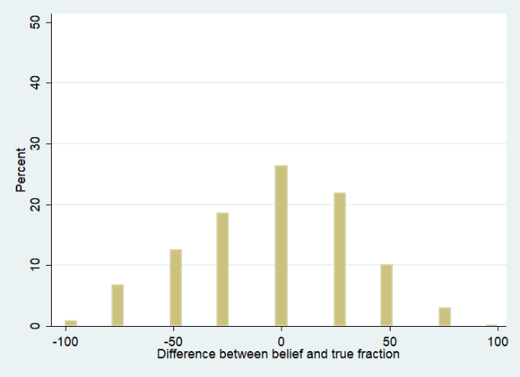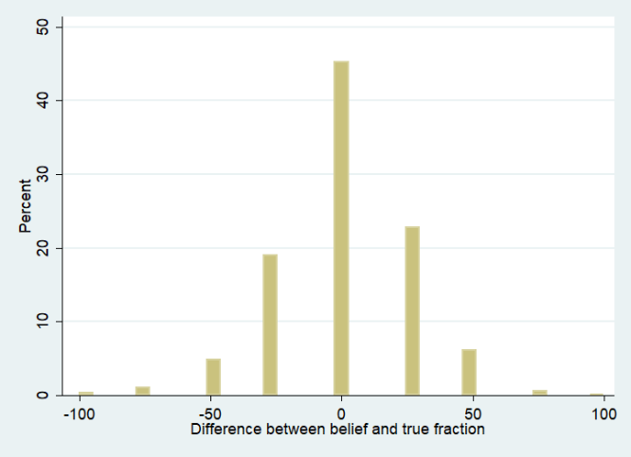

Notes: The Without Information treatment covers 5,200 observations and the With Information treatment 6,000 observations. Negative (positive) values imply that the true percentage honest is larger (smaller) than the percentage believed honest, i.e., the individual overestimates (underestimates) dishonesty.

Figure A3a shows that beliefs deviate widely from the true percentage without information. On average, individuals signiﬁcantly overestimate the true percentage of liars (average belief=68.1%; true fraction=72.1%; ∆=4.0 ppts, p=0.000). In Figure A3b, signiﬁcant average differences are still found (average belief=69.1%; true fraction=68.1%; ∆=-1.0 ppt, p=0.003), but these differences narrow substantially at the individual level. Overall, these results support hypothesis H3b: while individuals form heterogeneous beliefs, those beliefs are barely affected at the average level (69.1% versus 68.1%), which may explain the little effect of information in our experiment.

A4. Examples of messages from the post-questionnaire experiment concerning the following question: Please explain what was your strategy during the experiment

Type of message | Original Message (in French) | Message translated from French
Always report the highest figure to maximize earnings: 107 participants (19.1%) | Gagner au maximum, j'ai du mentir pour cela | To win the most, I had to lie for it
 | Mentir pour augmenter mes chances de gain | Lying to increase my chances of winning.
 | Mentir pour avoir le plus de gains possible | Lying to have the maximum possible gains.
 | J'ai fait en sorte d'avoir toujours le maximum d'argent possible. Je ne me souciais pas de respecter correctement les consignes. | I made sure to always have the maximum amount of money. I didn't care about following the instructions correctly.
 | mentir pour avoir les plus gros gain possible | Lying to have the biggest possible gains.
 | Gagner, gagner, gagner | Winning, winning, winning
 | essayer de gagner le maximum en trichant éventuellement en fonction des gains possibles | Trying to win the maximum by cheating, depending on the possible gains.
 | Toujours jouer ce qui rapportera le plus, quitte à reporter un chiffre erroné. | Always play what will bring the most, even if it means reporting an incorrect number.
 | la rationalité. c'est à dire tous le monde choisi numéro 6 pour gagner plus argent. même si le chiffre qu'ils voient n'est pas 6 | Rationality, meaning everyone chooses number 6 to earn more money, even if the number they see is not 6.
 | Mettre 6 pour espérer gagner le plus grand gain | Putting 6 to hope for the biggest gain.
 | Gagner de l'argent | Making money.
Always honest (stated explicitly): 92 participants (16,43%) | être honnete | Be honest.
Always honest (stated explicitly): 92 participants (16,43%) | Toujours avoir été honnête. | Always be honest
Always honest (stated explicitly): 92 participants (16,43%) | etre honnete | Be honest.
Always honest (stated explicitly): 92 participants (16,43%) | Ne pas tricher, et être honnête | Do not cheat and be honest.
Always honest (stated explicitly): 92 participants (16,43%) | l'honnêteté | Honesty.
Always honest (stated explicitly): 92 participants (16,43%) | Ne pas mentir | Do not lie.
 | être honnête | Be honest.
 | De toujours reporter correctement le chiffre caché derrière la boîte. | Always report the number behind the box correctly.
 | Etre le plus honnête et penser que les autres le seraient aussi. | Be as honest as possible and think that others would be too.
 | Honneteté | Honesty.
 | Honnêteté du début à la fin | Honesty from start to finish.
 | Répondre de manière honnête et reporter toujours les valeurs qui apparaissaient derrière les boîtes, ce qui n'était peut-être justement pas \"stratégique\"! | Answer honestly and always report the values that appeared behind the boxes, which might not have been "strategic"!
 | Remplir correctement les cases, étant donné qu'il était spécifié que les gains se font en fonction du premier chiffre cliqué, et non celui rapporté à la fin.\r\n | Fill in the correct boxes, given that it was specified that gains are based on the first clicked number, not the one reported at the end.
 | de bien reporter le chiffre, quitte à gagner moins | Report the number correctly, even if it means earning less.
 | J'ai toujoursé été honnête. | I have always been honest.
 | Honnête | Honesty.
 | Ma stratégie a été d'être honnête. | My strategy was to be honest.
 | Ne pas tricher. Estimer en général que la plupart des gens seront honnêtes (75 pourcents). | Do not cheat. Generally estimate that most people will be honest (75 percent).
 | J'ai toujours essayer de respecter les regles et ne pas tricher sur les numeros indiqués meme sachant que le cas contraire n'etait pas penalisé | I always tried to respect the rules and not cheat on the indicated numbers, even knowing that the opposite was not penalized.
 | ETRE HONNETE | BE HONEST.
 | De toujours être honnête mais de ne pas penser que les autres participants le serait. | Always be honest but not think that the other participants would be.
 | J'ai simplement été honnêt, même si il est plus appétissant de mentir (sur la partie une) | I simply was honest, even though it is more tempting to lie (on the first part).
 | Respecter les règles | Respect the rules.
 | Ne pas mentir | Do not lie.
 | Toujours reporté le vrai résultat | Always report the true result.
 | La stratégie que j'ai appliqué est d'être honnête à 100% dans mes réponses car je déteste le mensonge et les opportunistes. | The strategy I applied was to be 100% honest in my answers because I hate lies and opportunists.
 | Répondre honnêtement. Même s'il n'était pas précisé que que le chiffre indiqué devait correspondre au chiffre découvert, j'ai préféré les faire correspondre. | Answer honestly. Even if it was not specified that the indicated number had to correspond to the discovered number, I preferred to make them match.
 | Dire la vérité, rien que la vérité, juste la vérité au début (raisonnement de juriste... pas le plus efficace) | Tell the truth, nothing but the truth, just the truth at the beginning (jurist's reasoning... not the most effective).
 | L'honneteté, j'ai reporté les chiffres que je voyais sans vraiment avoir de stratégie. | Honesty; I recorded the numbers I saw without really having a strategy.
No clear strategy (intuition, chance…): 92 participants (16.42%) | on peu dire que j'ai laisser mon intuition et mon instinct me guider. | It can be said that I let my intuition and instinct guide me. To let my natural impulses take over. To follow my instinct.
 | De laisser mes impulsions naturelles se faire | To let my natural impulses take place
 | suivre mon instinct | To follow my instinct.
 | Essayer de mettre toutes les chances de mon coté | Try to put all the chances on my side
 | on peu dire que j'ai laisser mon intuition et mon instinct me guider. | I can be said to let my intuition and instinct guide me.
 | jeu aléatoire \r\nprobabilité | random game \r\nprobability
 | Se basant sur la probabilité des apparition des chiffres | Based on the probability of numbers appearing
No clear strategy (Follow the rules,rely on chance…): 87 participants (15.53%) | Honêteté et hasard | Honesty and chance.
 | Suivre les regles données | Follow the given rules.
 | Je n'ai pas vraiment eu de stratégie, j'ai essayé de bien consigner mes chiffres et de m'en remettre au hasard. | I didn't really have a strategy; I tried to record my numbers well and rely on chance.
 | Suivre les règles du jeu et miser sur la chance. | Follow the rules of the game and bet on luck.
 | Répondre honnetement aux questions, réfléchir, mais surtout que une grande partie du jeu est aléatoire alors utiliser l'instinct. | Answer honestly to questions, reflect, but especially since a large part of the game is random, use instinct.
Partial lie to ensure a reasonable/minimum gain: 52 participants (9.15%) | Honnete lorsque les gains étaient interessants, mlahonette lorsqu'ils n'étaient pas en ma faveur | Honest when the gains were interesting, dishonest when they were not in my favor.
 | J'ai décidé de suivre les consignes de jeu lorsque le gain n'est pas, à mon sens, trop faible dans la première partie. De ce fait, un gain trop faible me poussait la plupart du temps à dévier des consignes. | I decided to follow the game instructions when the gain was not, in my opinion, too low in the first part. Therefore, a gain that was too low most of the time prompted me to deviate from the instructions.
 | Etre honnête quand j'avais des bons scores, mentir quand c'était vraiment petit | Being honest when I had good scores, lying when it was really small.
 | Inscrire les gains les plus élevés quand le chiffre découvert était faible. | Entering the highest gains when the discovered number was low.
 | Mentir quand la mise etait trop basse | Lying when the bet was too low.
 | quand les gains etaient trop faibles je mettais 5 ou 6, cependant quand j'avais 4 5 ou 6 je mettais le gain juste. | When the gains were too low, I put 5 or 6; however, when I had 4, 5, or 6, I entered the correct gain.
 | Essayer de reporter le chiffre le plus élevé possible, si < 3 alors j'ai menti | Trying to report the highest possible number; if < 3, then I lied.
 | Dire la verité sauf sur les trop petits gains | Telling the truth except for very small gains.
 | Quand des petits chiffres tombaient (entre 1 et 3) je mettais plus 5 ou 6 , cependant quand les chiffres etaient entre 4 et 5 je mettais les vraies. | When small numbers fell (between 1 and 3), I put 5 or 6 more. However, when the numbers were between 4 and 5, I entered the true values.
 | être honnête dans l'ensemble en disant le véritable chiffre sauf parfois quand le gain était vraiment faible. | Being honest overall by stating the true number except sometimes when the gain was really low.
 | J'essayais de jouer le plus honnétement possible mais sans donner toujours la vraie réponse lorsque mon chiffre était bas de façon a perdre les autres. | I tried to play as honestly as possible but not always giving the true answer when my number was low to mislead others.
 | Toujours être sûre d'avoir un gain supérieur à 3 | Always making sure to have a gain greater than 3.
 | Déclarer les chiffres rééels à partir de 4. | Declaring the actual numbers from 4 and above.
 | Etre honnête lorsque les chiffres étaient supérieurs à 3 et mentir lorsqu'ils étaient inférieurs | Being honest when the numbers were higher than 3 and lying when they were lower.
 | ASSURER UN MINIMUM DE REVENUS | ENSURING A MINIMUM INCOME
 | Réporter le bon chiffre si il était assez élevé sinon mettre 6 | Report the correct number if it was high enough; otherwise, enter 6.
 | Pour l'expérience 1, dire la vérité entre 4 et 6 sinon mettre 5 ou 6 | For Experiment 1, tell the truth between 4 and 6; otherwise, enter 5 or 6.
 | Ma stratégie de jeu pour la première étape était de reporter le chiffre indiqué a l'exception du chiffre 1 ou 2. | My game strategy for the first stage was to report the indicated number, except for the number 1 or 2.
 | Dans la première épreuve, je répondais de façon honnête de façon systématique dès lors que les gains étaient supérieurs à 3. Dans le cas inverse, j'avais tendance à mentir en augmentant le chiffre donné, et le faux chiffre en question était plus élevé en règle générale si le chiffre obtenu était bas. | In the first trial, I systematically answered honestly when the gains were above 3. In the opposite case, I tended to lie by increasing the given number, and the false number in question was generally higher if the obtained number was low.
 | Essayer d'etre un maximum honnete, tout en ayant un seuil auquelle ne pas descendre et donc mentir | Try to be as honest as possible while having a threshold not to descend and therefore lie.
 | Partie 1 si strictement en dessous de 4 mettre un autre chiffre sinon mettre le chiffre obtenu | Part 1: If strictly below 4, enter another number; otherwise, enter the obtained number.
 | Ma stratégie était de dire la vérité quand le chiffre était assez haut et de mentir quand ce dernier était trop faible. | My strategy was to tell the truth when the number was high enough and to lie when it was too low.
 | J'ai reporté le plus souvent le bon chiffre sauf parfois quand celui-ci était trop faible | I mostly reported the correct number, except sometimes when it was too low.
 | Pour la première expérience, j'ai hésité à mettre tout le temps, 6 afin de toucher le maximum. Mais je ne trouvais pas pas cela très correct. Du coup en fonction du chiffre tiré je mettais entre 4 et6 (afin de minimiser malgrés tout mon gain, sans trop \"tricher\"). | For the first experience, I hesitated to always enter 6 to maximize my earnings. But I didn't find that very fair. So, depending on the drawn number, I entered between 4 and 6 (to minimize my gain despite everything, without "cheating" too much).
 | De ne pas dire de chiffres en dessous de 4 | Do not enter numbers below 4.
 | Dans la premiere partie j'ai profité du fait qu'on pouvait mettre un chiffre élevé au lieu d'un chiffre bas pour gagner plus d'argent. Pour les chiffre 4, 5, 6 j'ai indiqué tout le temps le chiffre correct mais pour les chiffres bas. | In the first part, I took advantage of the fact that I could enter a high number instead of a low number to earn more money. For numbers 4, 5, 6, I always entered the correct number, but for low numbers.
Lying when others lie: 29 participants (5.2%) | etre le plus honnête possible proportionnellement par rapport aux choix des autres. | Be as honest as possible proportionally to the choices of others.
Lying when others lie: 29 participants (5.2%) | j'ai essayer d'etre assez honnete, sauf en sachant que d'autres l'etait moins, j'ai evolué | I tried to be honest enough, except knowing that others were less so, I evolved.
Lying when others lie: 29 participants (5.2%) | J'ai d'abord voulut répondre honnêtement aux gains inscrits puis voyant les pourcentages dès le début être trop faible (75% d'entrée qui se sont effilochés), j'ai considéré que mon intérêt personnel : le plus fort gain primait donc et ait suivit la tendance en tentant du coup, d'avoir le plus fort gain possible. Je me suis abaissé à mentir sur les gains, autant être en haut. | I initially wanted to answer honestly to the recorded gains. Still, seeing the percentages being too low from the beginning (75% who unraveled), I considered that my personal interest, the highest gain, took precedence, and I followed the trend, trying to have the highest possible gain. I lowered myself to lie about the gains, might as well be on top.
Lying when others lie: 29 participants (5.2%) | Si le nombre était inférieur ou égal à 4, je mettais 6 et donc je n'étais pas honnête, lorsque j'ai vu que les memnbres de mon groupe n'étaient pas honnêtes non plus je n'ai plus hésiter pour na pas risquer de trop perdre d'argent. | If the number was less than or equal to 4, I entered 6, so I was not honest. When I saw that the members of my group were not honest either, I no longer hesitated not to risk losing too much money.
Lying when others lie: 29 participants (5.2%) | Au début j'ai suivi les règles du jeu mais je me suis rendue compte que les autres participants devaient tous mettre le numéro 6 pour aggner plu, alors j'ai commencé à le faire aussi à la moitié de le premiere partie. | At the beginning, I followed the rules of the game, but I realized that the other participants had to all enter the number 6 to win more, so I started doing the same in the middle of the first part.
Lying when others lie: 29 participants (5.2%) | l'honnêté sauf en cas d'une quasi certitude de tricherie de la part des autres joueurs | Honesty, except in case of almost certain cheating by other players.
Lying when others lie: 29 participants (5.2%) | Au début hesitante sur le fait de \"tricher\" puis en pensant aux comportements des autres participants j'ai commencé à le faire | At first hesitant about "cheating," then thinking about the behavior of other participants, I started doing it.
Lying when others lie: 29 participants (5.2%) | J'ai été honnête la plupart du temps\r\nSur la 1ère partie de l'expérience, j'ai fini par décider de mentir lorsque je reportais le chiffre après qu'un membre du groupe ait menti plusieurs fois. | I was honest most of the time. In the first part of the experiment, I eventually decided to lie when reporting the number after a group member had lied several times.
Lying when others lie: 29 participants (5.2%) | J'ai essayé d'etre le plus honete possible mais voyant le comportement de jeu de mes partenaire je me suis ravisée | I tried to be as honest as possible, but seeing the gameplay behavior of my partners, I changed my mind.
Lying when others lie: 29 participants (5.2%) | Au début, j'ai tout fait selon les règles en n'imaginant même pas que l'on puisse tricher, ça ne m'est même pas passé par la tête. Puis, en voyant les résultats statistiques, j'ai compris que les gens étaient plus stratégiques que moi, alors je me suis mise à prendre parti de chaque situation sans être honnête. | At first, I did everything according to the rules, not even imagining that one could cheat; it didn't even cross my mind. Then, seeing the statistical results, I understood that people were more strategic than me, so I started taking sides in each situation without being honest.
Lying when others lie: 29 participants (5.2%) | J'ai essayé d'être le plus honnête possible, sauf dans les cas où je pensais que la grande majorité ne le serais pas | I tried to be as honest as possible, except in cases where I thought the vast majority wouldn't be.
Lying when others lie: 29 participants (5.2%) | être honnête sur les premières périodes puis modifier le numéro au fur et à mesure que le groupe le faisait. | Be honest in the early periods, then modify the number as the group does.
Always the highest figure (no reason explicitly mentioned): 25 participants (4.4%) | « Toujours mettre 6 « | "Always put 6"
 | « mentir » | "lie"
 | « Mentir directement sur le numéro de la boite | "Lie directly about the box number"
 | « Pour le premier jeu, ca a été de mettre 6 à chaque cession, qu'importe le chiffre derrière la boite » | "For the first game, it was about putting 6 in each round, regardless of the number behind the box"
 | « de mettre toujours 6 » | "to always put 6"
 | « J'ai mis 6 partout » | "I put 6 everywhere"
 | « ne pas inscrire le chiffre caché mais le chiffre le plus fort (6) » | "Do not enter the hidden number but the strongest number (6)"
 | « Répondre tout le temps 6“ | "Answer 6 all the time"
 | « Rentrez le chiffre 6 plutôt que celui indiqué » | "Enter the number 6 rather than the one indicated"
Always the highest figure because there are no penalties, no consequences: 25 participants (4.4%) | Toujours mentir. Puisqu'il n'y a pas de contrôle, ni d'influene sur le groupe ou par le groupe la meilleure stratégie était de toujours mentir pour maximiser les chances que le tour tiré au sort soit un \"6\". | Always lie. Since there is no control, no influence on the group or by the group, the best strategy was to always lie to maximize the chances that the randomly drawn turn would be a "6".
 | Mettre 6 à chaque fois puisque peut importe que l'on mente ou non, seul le chiffre retranscrit était compté. L'honnêteté n'était pas valorisé au contraire, une personne honnête pouvait être pénalisé car si elle avait tiré le chiffre 1 et inscrit le chiffre 1 elle gagnait 1E alors que un menteur qui inscrivait le chiffre 6 au lieu de 1E gagnait 6E | Put 6 every time because whether you lie or not, only the transcribed number was counted. Honesty was not valued; on the contrary, an honest person could be penalized because if they drew the number 1 and wrote down 1, they won 1€, while a liar who wrote 6 instead of 1€ won 6€.
 | il n'était pas interdit de mettre 6 à chaque fois donc j'ai mis 6 pour gagner le maximum | It was not forbidden to put 6 every time, so I put 6 to win the maximum.
 | Comme, dans le cadre de cette expèrience, il n'y a aucun intérêt à être honnête, et surtout aucune sanction à jouer pour son propre interêt, j'ai joué à chaque fois pour maximiser mes gains personnels. | As, in the context of this experiment, there is no interest in being honest, and especially no sanction for playing for one's own interest, I played each time to maximize my personal gains.
 | Ma stratégie de jeu a été de considérer que les \"erreurs de report\" n'étant pas comptés et que seul le dernier chiffre tiré par le logiciel serait mon gain, de mentir sur le chiffre qui apparaissait à l'écran et d'inscrire 6. | My game strategy was to consider that the "reporting errors" were not counted and that only the last number drawn by the software would be my gain, to lie about the number that appeared on the screen, and to write 6.
 | Parce que le jeu était entièrement anonyme, j'ai décidé de faire fi dans la plupart des cas de ma propre conscience pour optimiser mes gains. \r\nIl n'y aurait eu ne serait-ce qu'un doute sur l'anomymat ou une possibilité qu'on sache mon identité et j'aurais eu un tout autre comportement de jeu. Par conséquent, dans une situation réelle, où il y a toujours un doute sur le fait qu'un comportement puisse être révélé je n'aurais, je pense pas du tout eu la même stratégie de jeu.\r\nPar ailleurs, utilisation que je compte faire de l'argent gagné (inviter un amie au resto ou inviter un ami à une activité) m'a permis de me déculpabiliser de mon comportement.\r\nParce que je suis habituellement quelqu'un qui ne ment pas. | Because the game was entirely anonymous, I decided to ignore my own conscience in most cases to optimize my gains. If there had been even a doubt about anonymity or a possibility that my identity would be known, I would have had a completely different playing strategy. Therefore, in a real situation, where there is always a doubt that behavior could be revealed, I think I would not have had the same playing strategy at all. Furthermore, the use I plan to make of the money earned (invite a friend to a restaurant or invite a friend to an activity) allowed me to absolve myself of my behavior. Because I am usually someone who does not lie.
 | Mettre le 6 tout le temps puisque les fautes ne sont pas sanctionnées et que c'était le chiffre rapportant le plus | Always put 6 since mistakes are not penalized, and it was the number that brought the most.
 | J'ai compris en lisant les instructions qu'il était possible de tricher, en indiquant toujours le chiffre 6 dans la première partie, ce qui permettait de recevoir un gain conséquent sans conséquence. J'ai donc décidé de toujours indiquer le chiffre 6 peu importe le chiffre qui se trouvait réellement sous la boîte. | I understood by reading the instructions that it was possible to cheat by always indicating the number 6 in the first part, which allowed receiving a substantial gain without consequences. So I decided to always indicate the number 6 no matter the number that was actually under the box.
 | Mentir n'étant pas sanctioné, il etait intéréssant de vouloir maximiser son profit, quelle que soit les 2 premieres expériences. Ceci ce faisait, en inscrivant le chiffre 6 au maximum car c'est celui qui rapportait le plus. | Since lying was not sanctioned, it was interesting to want to maximize one's profit, regardless of the first two experiences. This was done by entering the number 6 as much as possible because it was the one that brought the most.
 | Ma stratégie de jeu s'appuyait sur le fait d'écrire le chiffre 6 (parfois 5 lorsque je n'avais pas besoin de mentir). En effet, il semble que mentir soit autorisé ou en tout cas toléré. Plus le chiffre est grand et plus le gain est grand. Je ne voyais donc pas l'intérêt d'écrire un chiffre différent de 6. | My game strategy relied on writing the number 6 (sometimes 5 when I didn't need to lie). Indeed, it seems that lying is allowed or at least tolerated. The larger the number, the greater the gain. So, I didn't see the point of writing a number other than 6.
Partial liar /honest (no reason explicitly stated): 17 participants (3.05%) | J'ai été honnête la plupart du temps, c'est tout.. | I was honest most of the time, that's all.
 | Etre honnête dans 99% des cas. | Be honest in 99% of cases.
 | Essayer d'etre le plus honnete possible mais en priviligeant quand meme mon gain potentielle | Try to be as honest as possible but still prioritize my potential gain.
 | honneté sauf quelques petits derapages | Honesty, with a few small slip-ups.
 | Miser honnêtement dans 90% des cas. | Bet honestly in 90% of cases.
 | Etre honnete dans la limite du raisonnable et de mes interets | Be honest within reason and for my interests.
 | Etre honnete le plus possible tout en essayant de faire le maximum de profit | Be honest as much as possible while trying to make the maximum profit.
 | répondre honêtement la plupart du temps | Answer honestly most of the time.
 | Avoir le plus de gain possible, mais ce dans la limite du raisonnable | Have the maximum gain possible, but within reason.
 | Essayer d'être honnête le plus possible, mais en gardant à l'esprit la somme maximale à gagner. | Try to be honest as much as possible but keeping in mind the maximum sum to win.
 | être honnête quand ça m'arrangeait et essayer de gagner le plus tout en étant honnête\r\n | Be honest when it suited me and try to maximize the gain while being honest.
 | Etablir un équilibre en honneté et le maximum de gain possible en laissant de manière raisonable, peu de place a la chance. | Establish a balance between honesty and the maximum possible gain, leaving reasonably little room for chance.
 | J'ai essayé d'être honnête le plus possible même si il m'est arrivé de mentir, si je devais justifier je ne serais comment : un peu pour augmenter mes chances mais aussi pour voir un peu le fonctionnement et les possibilités de stratégie. | I tried to be honest as much as possible, even if I sometimes lied. If I had to justify, I wouldn't know how: a bit to increase my chances but also to understand the functioning and strategy possibilities.
 | j'ai voulu être plutot honnete tout en étant raisonable lorsque j'ai modifié les informations | I wanted to be rather honest while being reasonable when I modified the information.
Lying more over time: 14 participants (2.33%) | être honnete au debut puis sur la fin prendre un maximum de risque et mentir pour gagner le plus gros gain | Be honest at the beginning, then towards the end, take maximum risks and lie to win the biggest gain.
Lying more over time: 14 participants (2.33%) | Au début, reporter les chiffres que j'ai réellement vu\r\nVers la fin, j'ai augmenté d'un cran la valeur des chiffres que j'ai vu pour espérer un gain plus grand même en ne reportant pas le chiffre que j'ai vu derrière la boîte | At first, report the numbers I actually saw. Towards the end, I increased the value of the numbers I saw by one to hope for a larger gain, even if I did not report the number I saw behind the box.
Lying more over time: 14 participants (2.33%) | J'ai commencé en disant la vérité mais très vite j'ai assez vite mis le gain le plus élevé pour toutes les autres solutions. | I started by being honest, but quickly put the highest gain for all other solutions.
Lying more over time: 14 participants (2.33%) | Au départ je répondais aux questions comme demandé, puis j'ai repondu en fonction de moin intérêt. | At first, I answered the questions as requested, then I responded according to my interest.
Lying more over time: 14 participants (2.33%) | Au début je n'ai pas triché, puis à la fin si. | At first, I did not cheat, but in the end, I did.
 | J'ai essayé de deviner si les autres allaient mentir, en partant du principe que plus on avançait dans l'expérimentation, moins on aurait une mauvaise conscience à propos du mensonge car on s'y habituait (donc je mettais des pourcentages de moins en moins élevés)\r\nIl fallait aussi prendre en compte que l'on est tous étudiant et donc que la majorité d'entre nous a besoin d'argent | I tried to guess whether others would lie, assuming that as we progressed in the experiment, we would have less guilt about lying because we would become accustomed to it (so I assigned progressively lower percentages). It was also important to consider that we are all students, and therefore, the majority of us need money.
Always the highest figure because there are no consequences for others (the group, other in general, the experimenter..): 12 participants (2.15%) | Gagner le maximum d'argent, tant que cela ne nuisait pas aux autres participants. | Earn the maximum amount of money as long as it doesn't harm other participants.
 | Toujours mettre 6 même si on a tiré un nombre différent pour maximiser nos revenus propres. Ici \"mentir\" n'a pas d'impact sur les autres = pas de remords. | Always input 6 even if a different number was drawn to maximize our own income. Here, "lying" has no impact on others = no remorse.
 | Noter 6 aussi souvent que possible car je connaissais les conséquences de cette action et savais que cela ne porterait préjudice à personne. | Note 6 as often as possible because I knew the consequences of this action and knew that it would not harm anyone.
 | J'ai pensé à récupérer un maximum d'argent, en mettant un maximum les chances d emon coté. Le fait de mentir sans que ça n'impacte sur autrui n'est pas une chose grave. | I thought about maximizing my earnings by maximizing the odds on my side. Lying without impacting others is not a serious matter.
 | J'ai triché car il n'y avait pas d'enjeu, j'aurais été honnête si mes réponses avaient pu causer un quelquonque dommage à quelqu'un. Je n'ai pas triché pour le jeu de mémoire en revanche car je ne voulais pas être exclue. | I cheated because there was no stake; I would have been honest if my answers could have caused any harm to someone. I did not cheat for the memory game, however, because I did not want to be excluded.
 | J'ai décidé dans un premier temps d'être honnête, puis n'ayant finalement pas l'impression de voler quelqu'un, j'ai décidé de ne plus l'être de manière à gagner plus d'argent. Si cet argent avait été celui d'un autre participant, je ne l'aurais évidemment pas fait. | I initially decided to be honest, but then, not feeling like I was taking something away from someone, I decided not to be honest to earn more money. If this money had belonged to another participant, I would not have done it, of course.
Learning over time: 7 participants (1.25%) | L'honnêteté dans un premier temps, le temps de découvrir l'expérience. Ensuite, j'ai envisagé la possibilité de tricher lorsque cela était plus avantageux. | Honesty initially, as time to discover the experience. Then, I considered the possibility of cheating when it was more advantageous.
 | franchement j'étais un peu perdu au depart | Honestly, I was a bit lost at the beginning.
Feeling observed: 1 participant (0.2%) | J'ai été honnête et considéré que tous les autres de mon groupe également, nous sachant \"surveillés\" même si les feuilles indiquaient le contraire | I was honest and considered everyone else in my group as well, knowing we were "monitored" even if the sheets indicated otherwise

The theory of self-maintenance relies on the idea that people prefer to see themselves in a positive light and avoid cognitive dissonance caused by actions that are inconsistent with their self-concept. For instance, it is well known that most individuals typically have strong beliefs in their own morality and that they want to maintain this aspect of self-concept (see Mazar et al.2008 for a discussion).

