Online Appendices
B. Instructions to Participants
Instructions
General Instructions: You will now be taking part in an economics experiment. If you read the following instructions carefully, you can earn a considerable amount of money. It is therefore very important that you read these instructions with care.
It is prohibited to communicate with the other participants during the experiment. If you violate this rule, we will have to exclude you from the experiment and from all payments.
Details: This experiment consists of a series of 3 periods. In period 1, you will be grouped with 3 other participants. In period 2, you will be grouped with 7 others and in period 3 with 1 other. The decisions you and the other people in your group make will determine the amounts earned by each of you.
How to Earn Money: During the experiment, your earnings will be in the form of points. At the end of the experiment, your points will be converted into dollars and you will be paid your entire earnings in cash.
At the beginning of each period, each participant will receive 20 points. During each period, you will be given the option to keep any number of your points for yourself, or invest any number of your points to a group project. At the same time, the other(s) in your group will also be deciding how many of their points to keep or invest.
No one will be able to see the decisions of other members in the group until all decisions have been submitted, and all decisions will be made anonymously so nobody will be able to connect anyone with their particular decisions.
In each period: you will receive $0.10 for each point you keep, $0.07 for each point you invest, and $0.07 for each point invested by anyone else in your group.
Thus, at the end of a period, your earnings for the period will equal:
($0.10 * Points you kept) + ($0.07 * Total Points Invested by the Group, including you)
Therefore, your investments raise the earnings of others, while their investments raise your earnings as well. For each point invested by any other member of the group, you earn $0.07. For each point you invest, every member of your group, including you, earns $0.07 as well.
Quiz
Please answer the following questions to check your understanding of the experiment. These questions will not impact your final earnings
.
Question 1: Suppose there are two people in the group. Player 1 invests 0 and player 2 invests 20.
a) How much does Player 1 earn?
b) How much does Player 2 earn?
Question 2: Suppose there are four people in the group. Player 1 invests 0, player 2 invests 20, and players 3 and 4 each invest 10.
a) How much does Player 1 earn?
b) How much does Player 2 earn?
c) How much does Player 3 earn?

Question 3: Suppose there are eight people in the group. Player 1 invests 0, player 2 invests 20, and players 3 -8 each invest 10.
a) How much does Player 1 earn?
b) How much does Player 2 earn?
c) How much does Player 3 earn?
The Investment Table: Now suppose that you know the investments of the other people in your group before you choose yours. This means that you can base your investment on those of the other members of the group. What would you invest?
In each period you will see the following two screens:
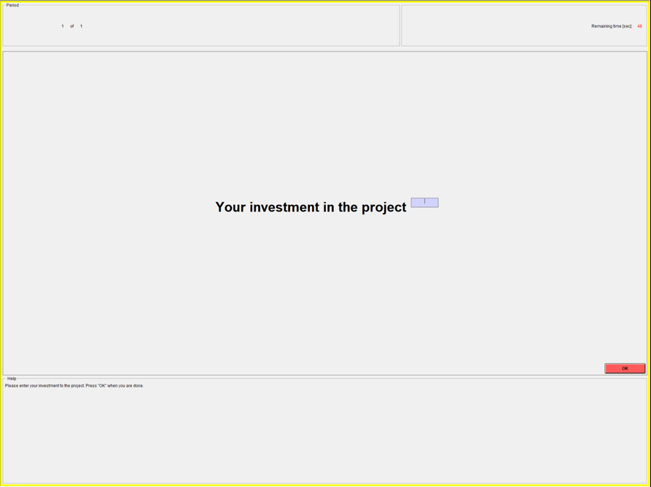
Figure 1: Unconditional Investment

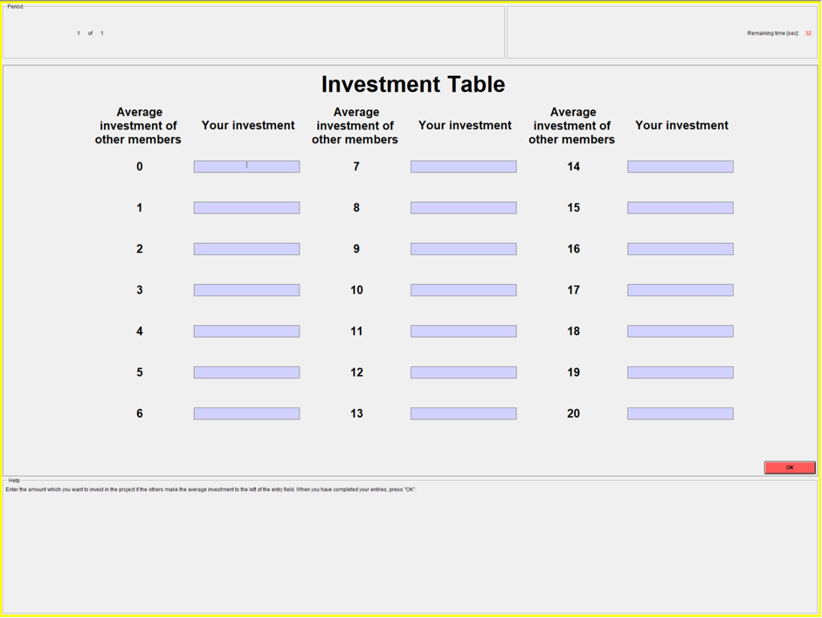
Figure 2: Investment table

On the first screen, please enter your investment. On the second screen, there is a table where you can enter an investment in response to each average investment of your other group members. For example, in the first space, enter the amount you would invest if the average investment of the others in your group was 0. In the second space, enter your investment if the average of the others’ investments was 1, etc. . . In each period, the decisions on the second screen count for one randomly chosen group member and the decisions on the first screen count for the rest of the group members.
For example: Suppose that there are four players in a group. On the first screen, player 1 invests 0, player 2 invests 9, player 3 invests 20, and player 4 invests 11. Player 4 is randomly chosen to have the decisions on her second screen count. The average of the other three players’ (players 1 – 3) investments is (0 + 9 + 20)/3 = 9.67. Rounding to the nearest integer, the average is 10. Now suppose that on screen 2, in the space corresponding to 10, player 4 has chosen to invest 15. Then the total amount invested is 0 + 9 + 20 + 15 = 44. In that case, each player earns 44*$0.07 from the project. They receive this payment in addition to $0.10 for each point that they did not invest.
In each period, a die will be rolled to determine whose decisions on the second screen count. Only one period will count toward your earnings today. At the end of the experiment, a die will also be rolled to determine which period counts. In addition to your payment from the period that counts, you will receive a show-up fee of $10. There will be a practice period now to help you become more comfortable with the task.

C. Instructions to Coders
Instruction: Graph Classification
You will be given a set of graphs, each of which represents a function of X and Y. X is plotted along the horizontal axis and Y is on the vertical axis.
Your task is to classify these graphs into four categories A, B, C, or D, according to the category that best describes the graph.
A. When X increases, Y also increases. Y has an upward slope.
B. Y is always 0. Y is flat at 0.
C. Y takes on higher values as X increases until some value of X, and then Y takes on lower values as X continues to increase. Y has a hump-shape.
D. If the graph does not fit into any of the above three types, classify it as Type D. Please note that even if a graph does not fit exactly into one of the criteria for Types A, B, or C, you can choose the type that best describes the overall pattern of the function. If the function is not well described by either A, B, or C, it should be classified as Type D.
Notes:
• Make sure to observe the graph carefully before making a classification.
• Record the category for each graph on the sheet provided to you.
• Make sure to double-check each classification before submitting the results.
• If you have any questions or concerns, please do not hesitate to ask for clarification.

