SUPPLEMENTARY MATERIAL TO THE PAPER

Experimental evidence shows that
ulterior motive attribution drives counter-punishment

Manuel Muñoz-Herrera Nikos Nikiforakis

Abstract: This document contains additional regressions & figures (Appendix A), additional descriptive statistics (Appendix B), an analysis of individual punishment and counter-punishment strategies (Appendix C), the instructions for the online surveys (Appendix D), and the instructions for the laboratory experiment (Appendix E).

Appendix A. Additional regressions & figures

A.1 Counter-punishment and personality traits
In the first three columns in Table A1, we report estimates from regression models similar to those in Table 1 in the paper, with the difference that these models control also for personality traits (Big-5 markers). The dependent variable is the average amount of counter-punishment (see column I), the probability of counter-punishment (see column II), and the effective level of counter-punishment chosen by those who choose a positive level of counter-punishment (see column III). In the last three columns, we report models on the average amount of punishment (see model IV), controlling for the amount taken (see model V), as well as for personality traits (see model VI).

Table A1. Regressions on counter-punishment and punishment controlling for personality traits

 | Counter-Punishment |  |  |  | Punishment
 | Amount |  | Choice | Severity | Amount
 |  | I | II | III | IV | V | VI
Punishment |  | 0.774*** | 0.007*** | 0.662***
 |  | (0.115) | (0.001) | (0.162)
Third-party (3P) |  | 13.369 | 0.183 | -2.332 | 5.424 | 33.278 | 19.043
 |  | (10.426) | (0.134) | (21.447 | (12.477) | (19.594) | (21.951)
Punishment X 3P |  | -0.484*** | -0.005*** | -0.067
 |  | (0.144) | (0.001) | (0.225)
Amount taken |  | 1.103 | 0.026 | -0.883 | 0.920 | 3.850* | 3.036*
 |  | (1.440) | (0.019 | (1.484 | (1.294 | (1.565 | (1.448
Amount taken X 3P |  | -1.717 | -0.042 | 2.948 |  | -3.702 | -2.704
 |  | (2.151) | (0.027 | (1.902 |  | (2.207 | (2.322
Open |  | -0.915 | -0.009 | -0.387 |  |  | -1.075
 |  | (0.859) | (0.010 | (0.652 |  |  | (1.065)
Conscientious |  | 0.934 | 0.011 | 0.829 |  |  | -1.108
 |  | (0.607) | (0.007 | (0.768 |  |  | (0.912)
Extrovert |  | 0.004 | 0.001 | -0.216 |  |  | -0.028
 |  | (0.581) | (0.006 | (0.585 |  |  | (0.753)
Agreeable |  | -0.882 | -0.011 | -0.405 |  |  | -1.741
 |  | (0.820) | (0.009 | (0.827 |  |  | (1.012)
Neurotic |  | 0.685 | 0.002 | 0.757 |  |  | 1.547
 |  | (0.767) | (0.009 | (0.626 |  |  | (0.896)
Constant |  | 15.142 | 0.444 | 20.806 | 37.290** | 14.500 | 129.752
 |  | (41.395) | (0.555 | (51.659 | (12.790) | (11.275) | (71.067)
Observations |  | 528 | 528 | 221 | 50 | 50 | 50
Groups |  | 48 | 48 | 26 | 25 | 25 | 25
Column I reports a linear regression model where the amount of counter-punishment, as measured by the percentage reduction of Player A’s income, is the dependent variable. Column II reports a linear probability model where the dependent variable is a dummy equal to 1 when counter-punishment is positive and 0 otherwise. Column III reports a linear regression model where the dependent variable is the severity of counter-punishment, by taking into account only those decisions where counter-punishment was positive. That is why the number of observations in III are fewer than in first two regressions. Columns IV, V and VI report linear regression models where the effective level of punishment, measured by the percentage reduction of Player B’s income when punishment was greater than zero, is the dependent variable. All regressions include standard errors clustered at the group level; * p<0.05; ** p<0.01.

A.2 Counter-punishment and amount taken
Figure A1 reports the mean amount of counter-punishment in the two experimental conditions as a function of the different levels of punishment, for each amount taken: 0, 5 or 10. We observe that consistent with the aggregate results in the main document, there is a pronounced difference across conditions when punishment exceeds 50% of the target’s first-stage earnings, when the amount taken is positive (i.e., 5 or 10).

The left panel of Figure A1 indicates that there is more counter-punishment in 2P than in 3P when the amount taken was 0. This is intriguing as, given the absence of a transgression, there is no obvious ulterior motive that Player A could ascribe to Player B. In other words, this behavior is not in line with our hypothesis. However, the difference is not statistically significant (p=0.313). By contrast, the difference in counter-punishment is significantly different in 2P and 3P when the amount taken was 5 or 10 EMU (p<0.001).

Figure A1. Mean amount of counter-punishment as a function of punishment, by amount taken

Appendix B. Detailed Descriptive Statistics of Main Choices

Figure B1 displays the distribution of Take decisions by treatment. Take rates are slightly higher in 3P (mean: 4.10, st. dev.: 4.72) than in 2P (mean: 2.75, st. dev.: 3.79), but the difference is far from being statistically significant (p-value = 0.38, two-tailed, Mann-Whitney test). The reason is that more than half of Player As do not take away any of the endowment allocated to Player B in both conditions.
Figure B1. Proportion of cases for each amount taken by treatment

Figure B2 presents the mean amount of punishment in each condition as a function of the amount taken by Player A in the first stage. Even though there is a small amount of punishment when the amount taken is 0 (about 10% of the endowment), across amounts, we find no significant differences in punishment levels across conditions (p-value = 0.747, two-tailed, Mann-Whitney test using the mean punishment of each individual as unit of observation).

Figure B2. Mean amount of punishment as a function of the amount taken

We also look at the actual progression of earnings in each stage, for each level of amount taken. Naturally, in the first stage the earnings of A and B are identical if no amount is taken, and lower for B if either 5 or 10 are taken, across treatments. This is illustrated also in Figure B3 for players A (left panel), players B (center panel), and for the relative earnings of A divided by the earnings of B (right panel). Across stages earnings do not differ by treatment and the earnings of player B remain lower than those of player A if the amount taken is positive. The only significant treatment difference is that in the earnings of player B relative to player A – the latter ratio is higher in 2P. That is, at the end of stage 3, the level of counter-punishment towards B in 2P (when the amount taken was 10), is such that the difference in earnings with A is larger than that in 3P.

Figure B3. Earnings in each stage of the game (Take, Punishment, Counter-punishment), for player A (left panel), player B (center panel) and relative earnings (right panel), by treatment

Appendix C. Individual punishment and counter-punishment strategies
In this section we categorize the strategies participants followed in their punishment and counter-punishment choices. We run linear regression models for each individual participant and use the intercept and slope of the regressions to group strategies into one of three categories: No, Increasing and Maximal. A strategy is labeled No, when both intercept and slope are zero. This is the case when participant B chooses not to punish independently of the amount taken by A. Similarly, this is so when participant A chooses not to counter-punish, independently of the level of punishment chosen by B. A strategy is Increasing, when the slope is positive. This is the case when a participant punishes more the higher the amount taken or when the counter-punishment is higher the higher the level of punishment. Finally, a strategy is maximal when a participant B exerts the highest level of punishment (100%) for any amount taken, or when a participant A exerts the highest level of counter-punishment (100%) for any level of punishment. The frequencies of each strategy by treatment are summarized in Table C1.

Table C1. Frequency of punishment and counter-punishment strategies by treatment
 | Punishment |  | Counter-punishment
 | 2P | 3P | 2P | 3P
No | 0.50 | 0.46 | 0.25 | 0.60
Increasing | 0.45 | 0.39 | 0.60 | 0.29
Maximal | 0.00 | 0.11 | 0.15 | 0.11
Other | 0.05 | 0.04 | 0.00 | 0.00

With respect to counter-punishment strategies, 60% of the participants choose strategy No in 3P compared to 25% in 2P (Chi-square, N=48, p-value=0.014). Unlike counter-punishment, there are no significant differences in the frequency of participants choosing not to punish: 50% in 2P versus 46% in 3P (Chi-square, N=48, p-value=0.807). That is why the average level of punishment, as well as the severity of the punishment effectively exerted, are indistinguishable between treatments.

Appendix D. Survey instructions

Note: We present instructions for Survey 2 first. Then, we include instructions for the unincentivized Survey 1.

Survey 2 (Incentivized)

Welcome! You are invited to participate in a short survey. The survey consists of 2 questions and should take about 5 minutes to complete.

For your participation, you will receive a fixed payment of 10 AED and an additional payment of 20 AED depending on your decisions.

Participation is voluntary. You may leave the study at any point. You will only receive the payment if you complete the survey and provide meaningful answers. Due to current restrictions on social interactions we are unable to pay you in person. However, the student finance office will assist us on uploading the payment into your NYUAD issued Student Bank card. To receive your payment, we will need to ask for your full name, N-number, and NYUAD email. This information will only be used to process your payment.

By continuing to the next screen, you consent to participate in this study. For more details about your consent, click on "See consent form".

Instructions
In a previous study, we have presented participants with two scenarios (Case 1 and Case 2) and asked them a few questions about them. We will now present these same scenarios to you and ask you to tell us what you think is the answer most frequently chosen by the participants in the previous study.

We will randomly choose the answer from one of the two questions we ask you. If the answer you give for the chosen question is the same as the one most frequently chosen by participants in the previous study, you will earn 20 AED for your response.

Case 1
Imagine the following scenario. You are participating in a research study. You and another individual (Person B) are each given $30 for your participation. When given the opportunity, you take away $10 from Person B. Person B has the option to respond to your action and chooses to reduce your earnings by $20. This does not have a monetary benefit for him/her, i.e., Person B does not get to keep the $20.

After reading Case 1, participants in the original study were asked: "How biased would you say the decision of Person B was?" (by bias we mean how likely it is that person B acted on ulterior motives, e.g., to take personal revenge).

Please indicate which of the options below was most frequently chosen by the participants in the previous study.
- Biased
- Somewhat biased
- Neither biased nor unbiased
- Somewhat unbiased
- Unbiased

Case 2
Imagine the following scenario. You are participating in a research study. You and another individual (Person B) are each given $30 for your participation. When given the opportunity, you take away $10 from Person B. Person B does not have the option to respond to your action. Instead, a third participant (Person C), who observed what happened, can respond. Person C does not know Person B personally. Person C chooses to reduce your earnings by $20. This does not have a monetary benefit for him/her, i.e., Person C does not get to keep the $20.

After reading Case 2, participants in the original study were asked to compare Case 1 and Case 2 with the following question: "In which of the two cases do you perceive the actions against you as being more biased?"

Please indicate which of the options below was most frequently chosen by the participants in the previous study.
- In Case 1 (i.e., the one in which Person B reduced your earnings)
- In Case 2 (i.e., the one in which Person C, the third participant, reduced your earnings)
- No difference

End of survey
Thank you for your participation! You have earned 10 AED. In addition, if your answer for the randomly selected question is the same as that of the majority of participants in the original study, you will earn 20 AED more.

To receive your payment, please write your name, N-number, and your NYUAD email address below. (We will not be able to pay individuals who provide non-NYUAD email addresses).

This information will only be used to process your payment and will not be associated with any of your responses in this survey.

- Please write your full name
- Please write your N-Number
- Please

Survey 1 (Non-incentivized)

Welcome! You are invited to participate in a short survey. The survey consists of 2 questions and should take about 5 minutes to complete.

For your participation, you will receive a fixed payment of 10 AED. There are no risks associated with your participation beyond those of everyday life. Although you will receive no direct benefits other than the 10 AED payment, this research will help researchers better understand how people make decisions in social interactions.

Participation is voluntary. You may leave the study at any point. You will only receive the payment if you complete the survey and provide meaningful answers. The payment will be available to collect soon after you complete your participation. You will receive more information regarding payment collection at the end of the survey.

Your answers will be anonymous. No one other than the researchers conducting the survey will be able to identify your responses. If you have any questions, you may contact: Prof. Nikos Nikiforakis at nn30@nyu.edu. For questions about your rights as a research participant, you may contact the Institutional Review Board, New York University Abu Dhabi at +971 2 628 4313 or IRBnyuad@nyu.edu.

Please press the "Continue" button if you are ready to take the survey.

Case 1
Imagine the following scenario. You are participating in a research study. You and another individual (Person B) are each given $30 for your participation. When given the opportunity, you take away $10 from Person B. Person B has the option to respond to your action and chooses to reduce your earnings by $20. This does not have a monetary benefit for him/her, i.e., Person B does not get to keep the $20.
After reading Case 1, please answer the following question.

How biased would you say the decision of Person B was?
- Biased
- Somewhat biased
- Neither biased nor unbiased
- Somewhat unbiased
- Unbiased

Case 2
Now imagine a different scenario. You are participating in another research study. You and another individual (Person B) are each given $30 for your participation. When given the opportunity, you take away $10 from Person B. Person B does NOT have the option to respond to your action. Instead, a third participant (Person C), who observed what happened, can respond. Person C does not know Person B personally. Person C chooses to reduce your earnings by $20. This does not have a monetary benefit for him/her, i.e., Person C does not get to keep the $20.
After reading Case 2 carefully, please answer the following questions to help us compare Case 2 to Case 1.

In which of the two cases do you perceive the actions against you as being more biased?
- In Case 1 (i.e., the one in which Person B reduced your earnings)
- In Case 2 (i.e., the one in which Person C, the third participant, reduced your earnings)
- No difference

Thank you for your participation! You have earned 10 AED.

To receive your payment, please insert your NYUAD email address below. (We will not be able to pay individuals who provide non-NYUAD email addresses).

This information will only be used to process your payment and will not be associated with any of your responses in this survey. You will receive your payment shortly. Due to the current restrictions on social interactions, we will contact you via email to arrange the collection of your payment. If you have any questions about the payment, please write to emm11@nyu.edu.

Appendix E. Experimental instructions

Condition 2P
General Instructions

You are now taking part in an economic experiment. Please do not communicate with other participants during the experiment. Should you have any questions, please raise your hand and one of us will come to assist you. The amount of money you earn from this experiment depends on your decisions and those made by others in the experiment. It is therefore important that you take your time to understand the instructions. At the end of the experiment you will be asked to fill out a questionnaire.

Earnings
During this experiment we do not deal with Emirati dirhams, but with Experimental Monetary Units (EMU). At the end of the experiment, the total amount of EMU you earned during the experiment will be converted into Emirati Dirhams at the rate of

1 EMU = 2 AED

The earned sum will consist of the show-up fee of 30 AED plus any individual gains from the experiment. This total will be paid to you in cash in private, immediately after the completion of the experiment.

Should you have any questions, please raise your hand and an experimenter will come to assist you.

Instructions for Participant A

This experiment comprises 2 different types of Participants: Participants A and Participants B. You are a Participant A. At the start of the experiment, the computer will randomly place you into a group with an individual who has been assigned the role of Participant B.

The experiment consists of three stages. In the first stage, those who have been assigned the role of Participant A have to decide whether to take 0, 5 or 10 EMU from the individual with whom they have been paired with. In the second stage, individuals who have been assigned the role of Participant B will have to decide whether they wish to reduce the earnings of Participant A by a certain amount. In the third and final stage of the experiment, those who have been assigned the role of Participant A will be asked whether they wish to reduce the earnings of Participant B.

Neither during nor after the experiment will you be aware of the identities of any of the participants. Equally, other participants will never know with whom they were dealing. All earnings will be paid out anonymously at the end of the experiment. No participant will ever learn how much you earned in the experiment.

Stage One
In stage one only individuals assigned the role of Participant A can make decisions. As mentioned, in stage one, you are grouped together with another participant. As a Participant A you get an endowment of 30 EMU at the beginning of stage one. Participant B gets the same endowment of 30 EMU.

You must decide whether or not to take a portion of Participant’s B income. You can take 0, 5 or 10 EMU from Participant B. If you decide to take 0 EMU, your earnings and the earnings of Participant B at the end of the first stage will be the same as the original endowment you received. If you take 5 EMU, your earnings at the end of the first stage will be 35 EMU, while the earnings of Participant B will be 25EMU. If you decide to take 10 EMU, your earnings at the end of the first stage will be 40 EMU, while the earnings of Participant B will be 20 EMU.

You will make your decision as displayed on the screenshot below:



Stage Two
In stage two, only individuals assigned the role of Participant B can make decisions. In particular, Participant B from your group will be asked whether or not s/he wishes to reduce your income. Participant B will be informed of your decision in stage one. S/he will be awarded an additional 5 EMU, which s/he can use to reduce your income by 10%, 20%, 30%... 90%, or 100%. The cost of reducing your income by a positive amount (i.e, more than 0%) is 5 EMU irrespective of the amount by which Participant B reduces your income (i.e., 10%, 20%, ... or 100%). If Participant B decides not to reduce your income, then the 5 EMU are added to his or her final earnings.

Stage Three
Your task in the third stage will be to decide whether you want to reduce or leave unaffected the earnings of Participant B; that is, the participant who was asked in stage two whether or not to reduce your earnings from stage one. Income reduction in this stage works exactly as in the second stage. You will be awarded 5 EMU, which you can use to reduce Participant’s B earnings by 10%, 20%, 30%... 90%, 100%. If you do not reduce Participant B’s earnings, then the 5 EMU will be added to your final earnings.

Note that you will have to make your decision about how much you want to decrease Participant B’s earnings before you find out his or her decision in stage two. You will have to state whether and by how much you wish to reduce B’s earnings for each possible decision Participant B may have taken in the second stage. To make your decision you will use a screen as the one shown below.

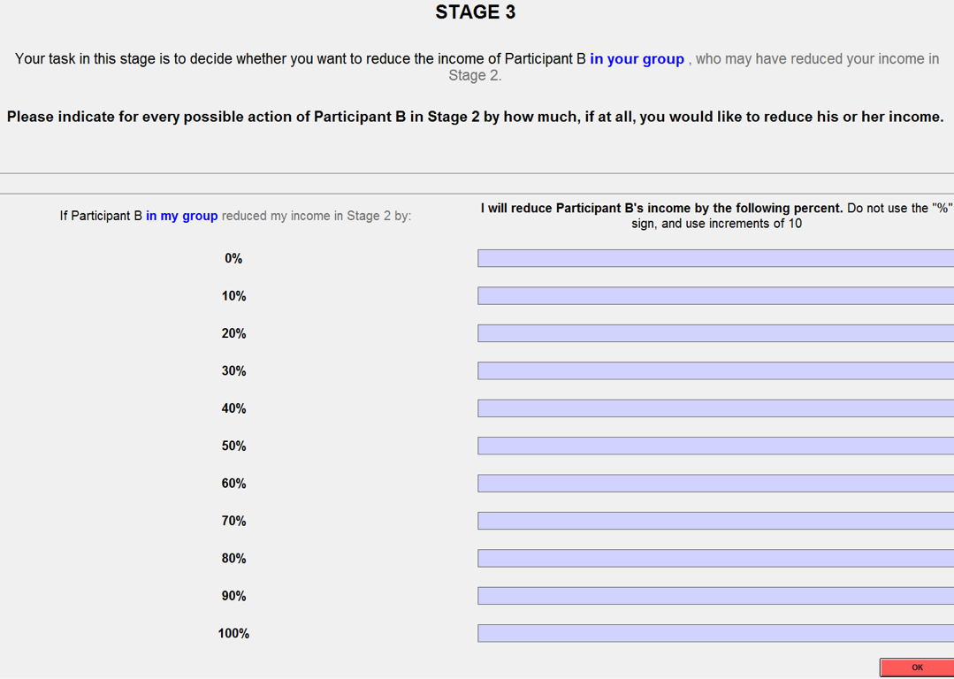

On the screen you must indicate whether and by how much you want to reduce Participant B’s earnings in the case he or she reduced your earnings by 0%, 10%, 20%... 100%.

Given that you will not know which one of the possible actions Participant B has decided on, any of your decisions might be used to determine your final earnings and the earnings of Participant B. Which of your decisions is actually realized depends on the actual decision of Participant B in stage two.

After you have made your decisions, you will be informed of your earnings from the experiment.

Instructions for Participant B

This experiment comprises 2 different types of Participants: Participants A and Participants B. You are a Participant B. At the start of the experiment, the computer will randomly place you into a group with an individual who has been assigned the role of Participant A.

The experiment consists of three stages. In the first stage, those who have been assigned the role of Participant A have to decide whether to take 0, 5 or 10 EMU from the individual with whom they have been paired with. In the second stage, individuals who have been assigned the role of Participant B will have to decide whether they wish to reduce the earnings of Participant A by a certain amount. In the third and final stage of the experiment, those who have been assigned the role of Participant A will be asked whether they wish to reduce the earnings of Participant B.

Neither during nor after the experiment will you be aware of the identities of any of the participants. Equally, other participants will never know with whom they were dealing. All earnings will be paid out anonymously at the experiment. No participant will ever learn how much you earned in the experiment.

Stage One
As mentioned, in stage one, you are grouped together with another participant – Participant A. As a Participant B you get an endowment of 30 EMU at the beginning of stage one. Participant A gets the same endowment of 30 EMU.

Participant A must decide whether or not to take a portion of your income. Participant A can take 0, 5 or 10 EMU from you. If s/he decides to take 0 EMU, your earnings and the earnings of Participant A at the end of the first stage will be the same as the original endowment you received. If s/he takes 5 EMU, your earnings at the end of the first stage will be 25 EMU, while the earnings of Participant A will be 35EMU. If s/he decides to take 10 EMU, your earnings at the end of the first stage will be 20 EMU, while the earnings of Participant A will be 40EMU.

Stage Two
Your task in the second stage will be to decide whether you want to reduce or leave unaffected the earnings of Participant A. You will be awarded an additional 5 EMU, which you can use to reduce Participant’s A earnings by 10%, 20%, 30%... 90%, 100%. The cost of reducing Participant A’s income by a positive amount (i.e, more than 0%) is 5 EMU irrespective of the amount by which you reduce his/her income (i.e., 10%, 20%, ... or 100%). If you do not reduce Participant A’s earnings, then the 5 EMU will be added to your final earnings.

Note that you will have to make your decision about how much you want to decrease Participant A’s earnings before you find out his or her decision in stage one. You will have to state whether and by how much you wish to reduce A’s earnings for each possible decision Participant A may have taken in the first stage. To make your decision you will use a screen as the one shown below.

Given that you will not know which one of the three actions Participant A has decided on, any of the three decisions might be used to determine final earnings of Participant A. Which of your decisions is actually realized depends on the actual decision of Participant A in stage one.

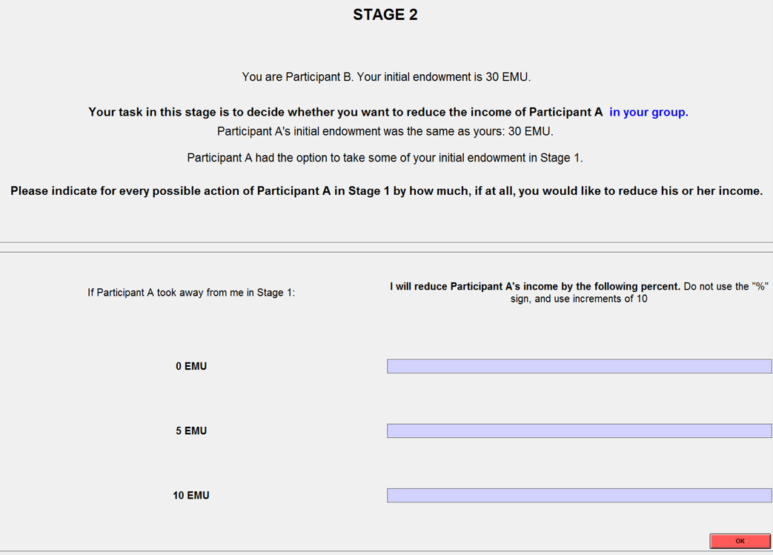

Stage Three
In stage three, Participant A will be asked whether or not s/he wishes to reduce your income. Income reduction in this stage works exactly as in the second stage. S/he will be awarded an additional 5 EMU, which s/he can use to reduce your income by 10%, 20%, 30%... 90%, or 100%. If Participant A decides not to reduce your income, then the 5 EMU are added to his or her final earnings.

After you have made your decisions, you will be informed of your earnings from the experiment.

Control Questions Participant A

Before the experiment can commence, all participants need to answer the following questions correctly. Once you have answered all the questions, please raise your hand to attract the attention of the experimenter. The experiment will begin as soon as all of the participants have answered the questions correctly. As with all examples in the instructions, the numbers should not be taken as a guide for behavior in the experiment.

- You decide to take away 5 EMU from Participant B’s initial endowment. Participant B decides to reduce your income by 40%. What are your final earnings if you do not reduce Participant B’s income in stage three?
_____________________EMU

- You decided to take 5 EMU from Participant B’s initial endowment. What are your earnings at the end of the second stage, if Participant B reduces your income by
- 0%? ___________EMU
- 10%? ___________EMU
- 50%? ___________EMU
- 100%? ___________EMU

- What is the cost for Participant B for reducing your earnings in stage two by
- 0%? ___________EMU
- 10%? ___________EMU
- 50%? ___________EMU
- 100%? ___________EMU

- You decided to take 10 from Participant’s B initial endowment. Participant B then reduced your income by 50%. What are your final earnings if you decide
- Not to reduce B’s earnings: _____________________EMU
- ATo reduce B’s earnings by 10%: _____________________EMU
- To reduce B’s earnings by 100%: _____________________EMU

Control Questions Participant B

Before the experiment can commence, all participants need to answer the following questions correctly. Once you have answered all the questions, please raise your hand to attract the attention of the experimenter. The experiment will begin as soon as all of the participants have answered the questions correctly. As with all examples in the instructions, the numbers should not be taken as a guide for behavior in the experiment.

- Participant A decides to take away 5 EMU from your initial endowment. You decide to reduce Participant A’s income by 40%. Participant A does not reduce your income in stage three. What are your final earnings?
_____________________EMU

- Participant A decides to take 5 EMU from your initial endowment. What are your earnings at the end of the second stage, if you reduce Participant A’s income by
- 0%? ___________EMU
- 10%? ___________EMU
- 50%? ___________EMU
- 100%? ___________EMU

- What is the cost for Participant A for reducing your earnings in stage three by
- 0%? ___________EMU
- 10%? ___________EMU
- 50%? ___________EMU
- 100%? ___________EMU

- Participant A decided to take 10 EMU from your initial endowment. You then reduced Participant A’s income by 50% in stage two. What are your final earnings if Participant A decides:
- Not to reduce your earnings: _____________________EMU
- To reduce your earnings by 10%: _____________________EMU
- To reduce your earnings by 100%: _____________________EMU

Condition 3P

Instructions for Participant A

This experiment comprises different types of Participants: Participant A, Participant B, Participant C, Participant D etc. You are a Participant A. At the start of the experiment, the computer will randomly place you into a group with an individual who has been assigned the role of Participant B. Participant C will be placed into a group with Participant D, Participant E will be placed into a group with Participant F etc.

Neither during nor after the experiment will you be aware of the identities of any of the participants. Equally, other participants will never know with whom they were dealing. All earnings will be paid out anonymously at the end of the experiment. No participant will ever learn how much you earned in the experiment. The experiment consists of three stages, whose procedure is described in detail below.

Stage One
In stage one, you as Participant A will be able to make decisions. As mentioned, in stage one, you are grouped together with another Participant B. As Participant A you get an endowment of 30 EMU at the beginning of stage one. All the other participants get the same endowment of 30 EMU.

You must decide whether or not to take a portion of Participant B’s income. You can take 0, 5 or 10 EMU from Participant B. If you decide to take 0 EMU, your earnings and the earnings of Participant B at the end of the first stage will be the same as the original endowment you received. If you take 5 EMU, your earnings at the end of the first stage will be 35 EMU, while the earnings of Participant B will be 25EMU. If you decide to take 10 EMU, your earnings at the end of the first stage will be 40 EMU, while the earnings of Participant B will be 20 EMU.

You will make your decision as displayed on the screenshot below:

Participant C from another pair also has the option to reduce or leave unaffected the endowment of Participant D by the same amounts – 0, 5 or 10 EMU. Similarly, Participant E has the option to reduce or leave unaffected the endowment of Participant F and so forth.

Stage Two
In stage two, Participant D from another group will be asked whether or not s/he wishes to reduce your income. Participant D will be informed of your decision in stage one. S/he will be awarded an additional 5 EMU, which s/he can use to reduce your income by 10%, 20%, 30%... 90%, or 100%. The cost of reducing your income by a positive amount (i.e, more than 0%) is 5 EMU irrespective of the amount by which Participant D reduces your income (i.e., 10%, 20%, ... or 100%). If Participant D decides not to reduce your income, then the 5 EMU are added to his or her final earnings.

Participant B, from your group, will be asked whether s/he wishes to reduce the earnings of a Participant E in a third group. Participant B cannot reduce your income, but rather the income of Participant E in a third group.

Stage Three
Your task in the third stage will be to decide whether you want to reduce or leave unaffected the earnings of Participant D; that is, the participant from the second pair who was asked in stage two whether or not to reduce your earnings from stage one. Income reduction in this stage works exactly as in the second stage. You will be awarded 5 EMU, which you can use to reduce Participant D’s earnings by 10%, 20%, 30%... 90%, 100%. If you do not reduce Participant D’s earnings, then the 5 EMU will be added to your final earnings.

Note that you will have to make your decision about how much you want to decrease Participant D’s earnings before you find out his or her decision in stage two. You will have to state whether and by how much you wish to reduce D’s earnings for each possible decision Participant D may have taken in the second stage. To make your decision you will use a screen as the one shown below.

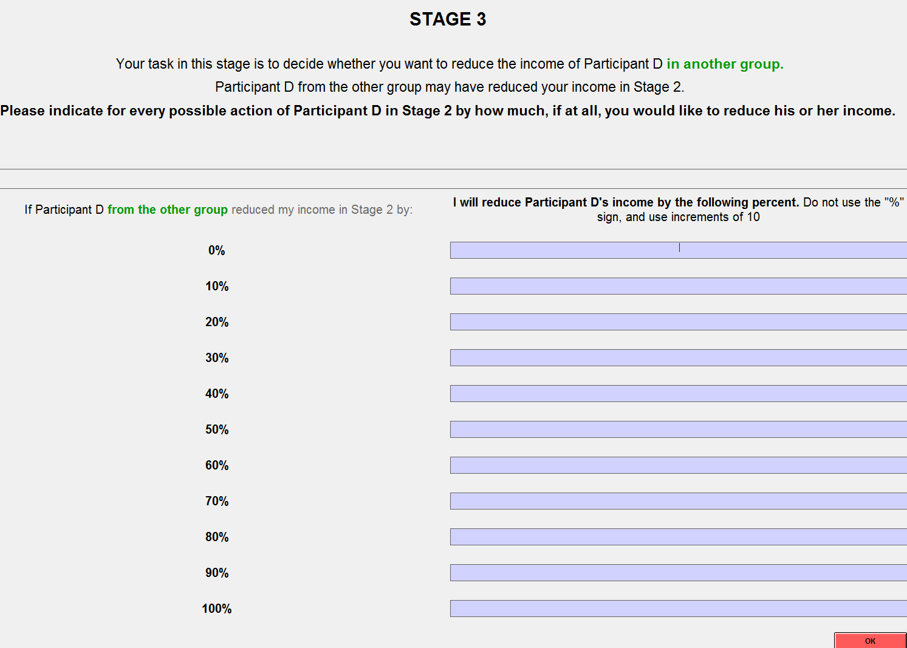

On the screen you must indicate whether and by how much you want to reduce Participant D’s earnings in the case he or she reduced your earnings by 0%, 10%, 20%... 100%.

Given that you will not know which one of the possible actions Participant D has decided on, any of your decisions might be used to determine your final earnings and the earnings of Participant D. Which of your decisions is actually realized depends on the actual decision of Participant D in stage two.

After you have made your decisions, you will be informed of your earnings from the experiment.

Instructions for Participant B

This experiment comprises different types of Participants: Participant A, Participant B, Participant C, Participant D etc. You are a Participant B. At the start of the experiment, the computer will randomly place you into a group with an individual who has been assigned the role of Participant A. Participant C will be placed into a group with Participant D, Participant E will be placed into a group with Participant F etc.

Neither during nor after the experiment will you be aware of the identities of any of the participants. Equally, other participants will never know with whom they were dealing. All earnings will be paid out anonymously at the experiment. No participant will ever learn how much you earned in the experiment. The experiment consists of three stages, whose procedure is described in detail below.

Stage One
In stage individuals assigned the role of Participant A can make decisions. As mentioned, in stage one, you are grouped together with Participant A. As Participant B you get an endowment of 30 EMU at the beginning of stage one. All the other participants get the same endowment of 30 EMU.

Participant A must decide whether or not to take a portion of your income. Participant A can take 0, 5 or 10 EMU from you. If s/he decides to take 0 EMU, your earnings and the earnings of Participant A at the end of the first stage will be the same as the original endowment you received. If s/he takes 5 EMU, your earnings at the end of the first stage will be 25 EMU, while the earnings of Participant A will be 35 EMU. If s/he decides to take 10 EMU, your earnings at the end of the first stage will be 20 EMU, while the earnings of Participant A will be 40 EMU.

Participant C from another pair also has the option to reduce or leave unaffected the endowment of Participant D by the same amounts – 0, 5 or 10 EMU. Similarly, Participant E has the option to reduce or leave unaffected the endowment of Participant F and so forth.

Stage Two
Your task in the second stage will be to decide whether you want to reduce or leave unaffected the earnings of Participant C; that is, the participant from another group who was asked in stage one whether or not to reduce Participant D’s income. You will be awarded an additional 5 EMU, which you can use to reduce Participant C’s earnings by 10%, 20%, 30%... 90%, 100%. The cost of reducing Participant C’s income by a positive amount (i.e, more than 0%) is 5 EMU irrespective of the amount by which you reduce his/her income (i.e., 10%, 20%, ... or 100%). If you do not reduce Participant C’s earnings, then the 5 EMU will be added to your final earnings.

Note that you will have to make your decision about how much you want to decrease Participant C’s earnings before you find out his or her decision in stage one. You will have to state whether and by how much you wish to reduce C’s earnings for each possible decision Participant C may have taken in the first stage. To make your decision you will use a screen as the one shown below.

Given that you will not know which one of the three actions Participant C has decided on, any of the three decisions might be used to determine final earnings of Participant C. Which of your decisions is actually realized depends on the actual decision of Participant C in Stage One.

Stage Three
In stage three, Participant C will be asked whether or not s/he wishes to reduce your income. Income reduction in this stage works exactly as in the second stage. S/he will be awarded an additional 5 EMU, which s/he can use to reduce your income by 10%, 20%, 30%... 90%, or 100%. If Participant C decides not to reduce your income, then the 5 EMU are added to his or her final earnings.

Also, Participant A from your pair can deduct income of a Participant in a third group – F. Participant A cannot deduct your income, but rather an income of another Participant in a third group.

After you have made your decisions, you will be informed of your earnings from the experiment.

Control Questions Participant A

Before the experiment can commence, all participants need to answer the following questions correctly. Once you have answered all the questions, please raise your hand to attract the attention of the experimenter. The experiment will begin as soon as all of the participants have answered the questions correctly. As with all examples in the instructions, the numbers should not be taken as a guide for behavior in the experiment.

- You decide to take away 5 EMU from Participant B’s initial endowment. Participant D decides to reduce your income by 40%. What are your final earnings?
_____________________EMU

- You decided to take 5 EMU from Participant B’s initial endowment. What are your earnings at the end of the second stage, if Participant D reduces your income by
- 0%? ___________EMU
- 10%? ___________EMU
- 50%? ___________EMU
- 100%? ___________EMU
- What is the cost for Participant D for reducing your earnings in stage two by
- 0%? ___________EMU
- 10%? ___________EMU
- 50%? ___________EMU
- 100%? ___________EMU
- You decide to take 10 points from Participant’s B initial endowment. Who will be informed about this decision?
---------------- and ----------------
- Which one of the above in question 4 will have the chance to reduce your earnings in Stage 2?
----------------
- You decided to take 10 EMU from Participant’s B initial endowment. Participant D then reduced your income by 50%. What are your final earnings if you decide
- Not to reduce D’s earnings: _____________________EMU
- To reduce D’s earnings by 10%: _____________________EMU
- To reduce D’s earnings by 100%: _____________________EMU

Control Questions Participant C

Before the experiment can commence, all participants need to answer the following questions correctly. Once you have answered all the questions, please raise your hand to attract the attention of the experimenter. The experiment will begin as soon as all of the participants have answered the questions correctly. As with all examples in the instructions, the numbers should not be taken as a guide for behavior in the experiment.

- Participant C decides to take away 5 EMU from Participant D’s initial endowment. You decide to reduce Participant C income by 40%. Participant C does not reduce your income in Stage three. What are his/her final earnings?
_____________________EMU

- Participant A decides to take 5 EMU from your initial endowment. What are your earnings at the end of the second stage, if you reduce Participant C’s earnings by
- 0%? ___________EMU
- 10%? ___________EMU
- 50%? ___________EMU
- 100%? ___________EMU

- What is the cost for Participant C for reducing your earnings in stage three by
- 0%? _________EMU
- 10%? ___________EMU
- 50%? ___________EMU
- 100%? ___________EMU

- Participant A decided to take 10 EMU from your initial endowment. Participant C decided to take 5 EMU from Participant D’s initial endowment. You then reduced Participant C’s income by 50% in Stage two. What are your final earnings if Participant C decides:
- Not to reduce your earnings: _____________________EMU
- To reduce your earnings by 10%: _____________________EMU
- To reduce your earnings by 100%: _____________________EMU

Post-Experimental Questionnaire

Please take a few minutes to answer the following questions.

What is your gender?
- Male
- Female

What is your intended major?

What is your grade?
- 2015
- 2016
- 2017
- 2018

In a few sentences, please explain how you made your decision in the experiment.

Thank you for your participation. In a moment we will call you to the door to be paid privately.

Note that any discrepancy observed between Figure B3 and the Table C1 arises the Figure is based on the realized earnings while the Table reports answers given by subjects using the strategy method.
There is one participant in 2P who exerted a constant punishment of 30% and there is one participant in 3P who chose positive punishment levels but lower when the amount taken was 10 than 5. Neither of these two participants fit in any of the three main categories, and that is why they are labeled as “other”.

