Supplementary material to the paper "Demographic differences in the effect of price on giving in a diverse population”
by
Luke Lillehaugen, Porter Ludwig, and Robert Mayo

Table of contents.
1 Exploratory experiment | Page
1.1 Instructions…………………………………………………………....................... | 2
1.2 Demographic variables and coding……………………………………………….. | 7
1.3 Follow-up survey
1.3.1 Questions…………………………………………………………………….. | 9
1.3.2 Demographic comparison of subjects completing and not completing follow-up survey…………………………………………………………………... | 11
1.4 Student demographic survey
1.4.1 Instructions…………………………………………………………............... | 12
1.4.5 Demographic comparison of student and MTurk subjects…………………... | 17
1.5 Exploratory experiment demographic responses…………………………………. | 20
1.6 Multicollinearity
1.6.1 Correlation between variables……………………………………………….. | 21
1.6.2 Variance inflation factors……………………………………………………. | 21
1.7 Tobit estimation…………………………………………………………………... | 22
2 Pre-registered experiment
2.1 Instructions………………………………………………………………………... | 23
2.2 Pre-registered experiment demographic responses……………………….............. | 27

Exploratory experiment: Instructions
Page 1

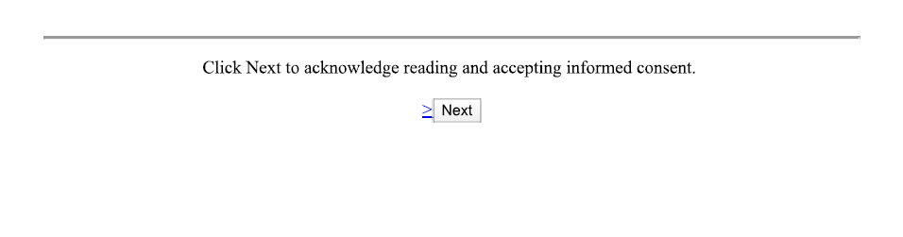
Page 2
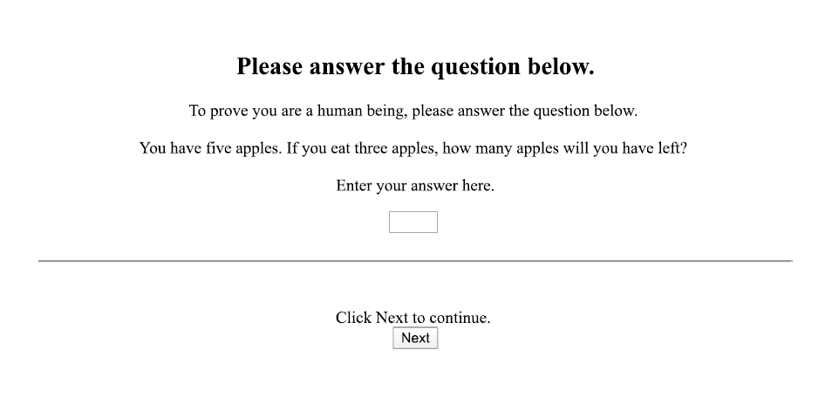

Page 3

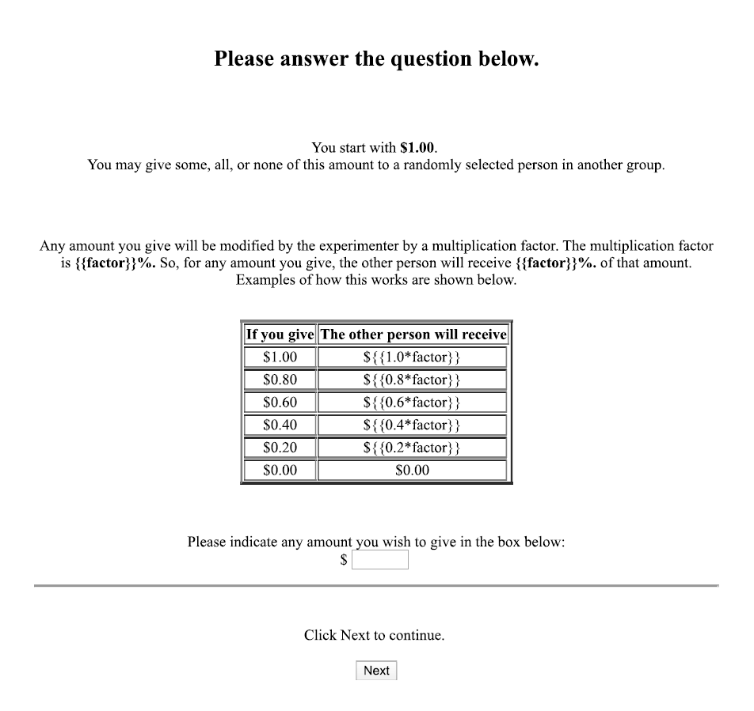

Page 4
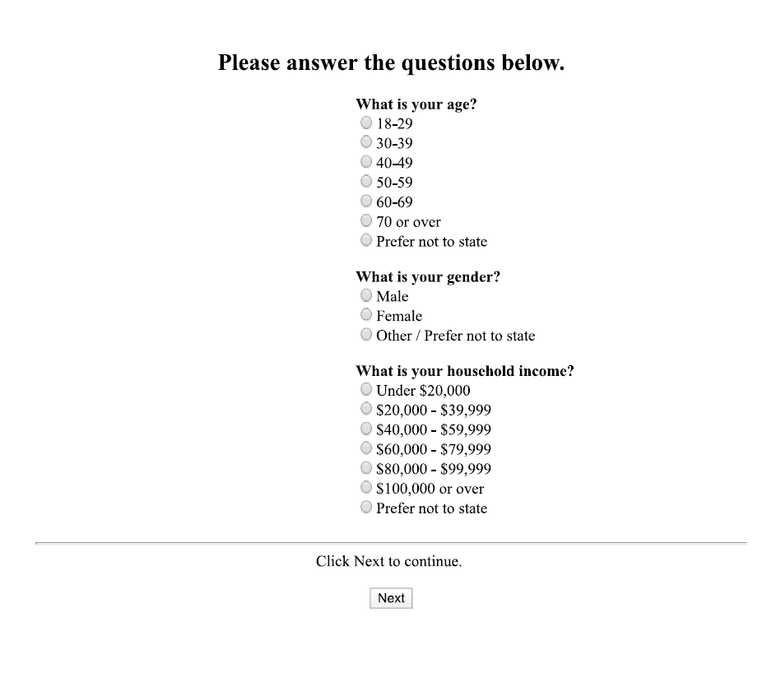

Page 5

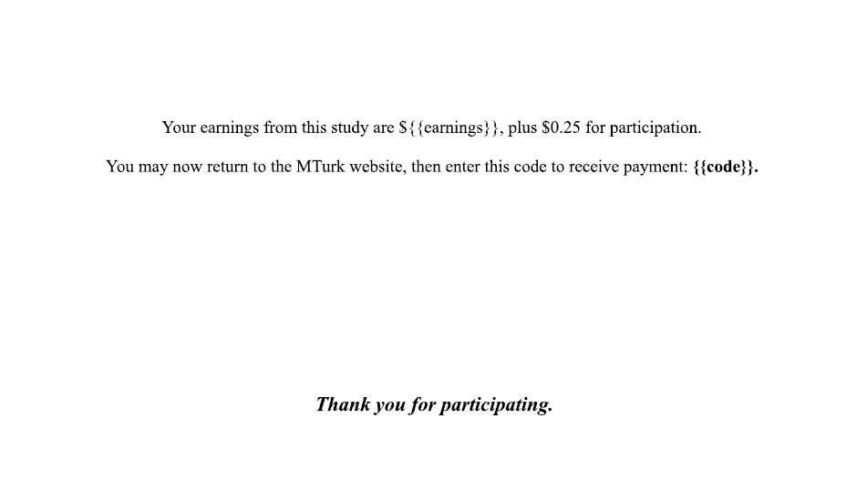

Table A1: Demographic variables and coding
Variable | Question text
Female | “What is your gender?”  “Male”  “Female”  “Other / Prefer not to state”ª
Age | “What is your age?”  "18-29"  "30-39"  "40-49"  "50-59"  "60-69"  "70 or over"^{b}
Income | “What is your income?”  "$0 - $19,999"  "$20,000 - $39,999"  "$40,000 - $59,999"  "$60,000 - $79,999"  "$80,000 - $99,999"  "$100,000 or more"^{c}
Religious | “On a scale of 0 to 100, how would you describe your religious orientation?”  A continuous slider was used with 0 labelled as“Not at all religious” and 100 labelled as“Very religious”. Initially positioned at the mid point of 50.^{d}
Conservative | “On a scale of 0 to 100, how would you describe your political views?”  A continuous slider was used with 0 labelled as“Very conservative” and 100 labelled as “Very liberal”. Initially positioned at the mid point of 50.^{e}
Vote | “Who did you vote for in the 2016 Presidential election?”  “Hillary Clinton”  “Donald Trump”  “Someone else”  “Didn’t vote”^{f}
Party | “Do you consider yourself a”  “Democrat”  “Republican”  “Independent”  “Something else”^{g}
Services | “Aside from weddings and funerals, how often do you attend religious services?”  "Never"  "Seldom"  "A few times a year"  "Once or twice a month"  "Once a week"  "More than once a week"^{h}
ªMale = 0, Female = 1, Other / Prefer not to state = 2.
^{b}Coded as lower category boundry plus 5 years.
^{c}Coded as lower category boundry in thousands plus 10.
^{d}Integers 0 to 100 inclusive.
^{e}Integers 0 to 100 inclusive. In the experiment interface software, more liberal corresponded to a higher number. A new variable, “Conservative” was created and coded as 100 – liberal to make conservative responses appear on the right side of graphs and thus avoid ambiguity when using the term “right”
^{f}Hillary Clinton = 0, Donald Trump = 1, Someone else = 2, Didn’t vote = 3
^{g}Democrat = 0, Republican = 1, Independent = 2, Something else = 3
^{h}Never = 0, Seldom = 1, A few times a year = 2, Once or twice a month = 3, Once a week = 4, More than once a week = 5

Follow-up survey: Questions
Page 1
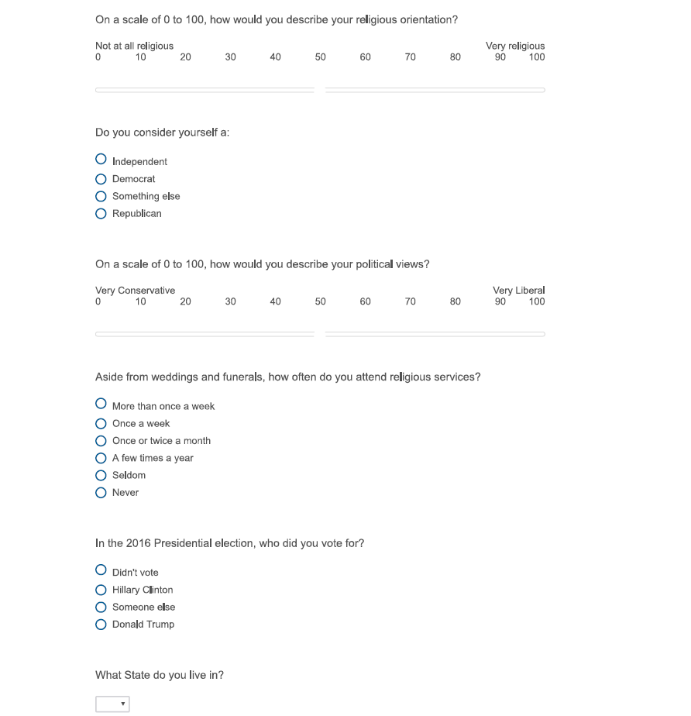

Page 2


Demographic comparison of subjects completing and not completing follow-up survey.

Table A2: Comparison of mean age of subjects completing and not completing follow-up survey:
Completed | N | Mean | Std. Error
No | 271 | 34.480 | 0.711
Yes | 505 | 37.343 | 0.534
Total | 776 | 36.343 | 0.907
$$t\left(774\right)=−3.158,p=0.002$$

Table A3: Comparison of mean income of subjects completing and not completing follow-up survey
Completed | N | Mean | Std. Error
No | 271 | 53.616 | 1.891
Yes | 505 | 56.337 | 1.400
Total | 776 | 55.387 | 1.123
$$t\left(774\right)=−1.155,p=0.249$$

Table A4: Comparison of gender of subjects completing and not completing follow-up survey
Completed | Female | Male | Total
No | 121 | 150 | 271
Yes | 248 | 257 | 505
Total | 412 | 475 | 776
$$χ^{2}\left(1\right)=1.406,p=0.236$$

Student demographic survey: Instructions
Page 1
Page 2
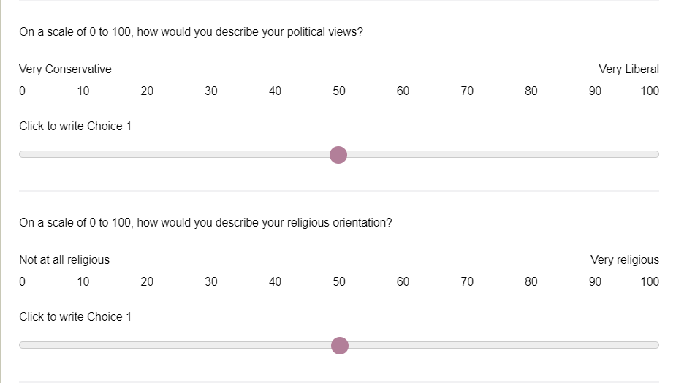


Page 4


Demographic comparison of students and MTurk subjects
To determine whether we were correct in our belief that a sample composed of college students would have been less diverse in age and income than a sample of MTurk workers, we asked the same demographic questions of 101 undergraduate business students at a liberal arts college nominally associated with the Lutheran Church. A significantly larger proportion of subjects reported the lowest age group (18 – 29) in the student sample than in the MTurk sample $\left(98\text{\%}vs.33\text{\%},z=−12.468,p<0.001\right)$and with lower variance $\left(F_{802,100}=58.44,p<0.001\right)$ Similarly, a significantly larger proportion of subjects reported the lowest income group ($0 - $19,999) in the student sample than in the MTurk sample $\left(88\text{\%}vs.13\text{\%},z=−17.360,p<0.001\right)$ again with lower variance $\left(F_{791,100}=2.82,p<0.001\right)$. The student sample was more religious than the MTurk sample $\left(57.3vs.32.8,t\left(598\right)=−6.298,p<0.0001\right).$ Students also reported attending religious services significantly more frequently $\left(χ^{2}\left(5\right)=72.202,p<0.0001\right)$ and were more likely to be Republican than the MTurk sample $\left(χ^{2}\left(3\right)=60.867,p<0.0001\right).$ The proportion of females was lower in the student sample but the difference was only significant at the $α=0.10$ confidence level. A comparison of 2016 Presidential vote was not meaningful since no members of the student sample were of voting age at the time of the election.

Table A5: Comparison of students and MTurk subjects proportion in lowest age category.
Group | Mean | Std. Error
MTurk | 0.332 | 0.017
Students | 0.980 | 0.014
$$z=−12.464,p<0.0001$$

Table A6: Comparison of students and MTurk subjects proportion in lowest income category.
Group | Mean | Std. Error
MTurk | 0.128 | 0.012
Students | 0.881 | 0.032
$$z=−17.360,p<0.0001$$

Table A7: Comparison of gender of students and MTurk subjects.
Group | Female | Male | Total
MTurk | 369 | 407 | 776
Students | 38 | 62 | 100
Total | 407 | 469 | 876
$$χ^{2}\left(1\right)=3.249,p=0.071$$

Table A8: Comparison of students and MTurk subjects religiosity.
Group | N | Mean | Std. Error
MTurk | 505 | 33.768 | 1.601
Students | 95 | 57.263 | 3.328
$$t\left(598\right)=−5.926,p<0.0001$$

Table A9: Comparison of students and MTurk subjects conservatism.
Group | N | Mean | Std. Error
MTurk | 505 | 35.974 | 1.303
Students | 92 | 54.859 | 2.817
$$t\left(595\right)=−5.757,p<0.0001$$

Table A10: Comparison of students and MTurk subjects religious service attendance.
Attend services | MTurk | Student | Total
Never | 233 (46%) | 13 (13%) | 246 (41%)
Seldom | 88 (17%) | 11 (11%) | 99 (16%)
A few times a year | 72 (14%) | 32 (32%) | 104 (17%)
Once or twice a month | 38 (8%) | 28 (28%) | 66 (11%)
Once a week | 61 (12%) | 15 (15%) | 76 (13%)
More than once a week | 13 (3%) | 2 (2%) | 15 (2%)
Total | 505 | 101 | 606
$$χ^{2}\left(5\right)=72.202,p<0.0001$$

Table A11: Comparison of students and MTurk subjects political party.
Party | MTurk | Student | Total
Democrat | 233 (46%) | 17 (17%) | 250 (41%)
Independent | 136 (27%) | 22 (22%) | 158 (26%)
Republican | 126 (25%) | 49 (49%) | 175 (29%)
Something else | 10 (2%) | 13 (13%) | 23 (4%)
Total | 505 | 101 | 606
$$χ^{2}\left(3\right)=60.867,p<0.0001$$

Table A12: Exploratory Experiment demographic responses
Multicolinearity

Table A13: Correlation between variables
 | Age | Income | Female | Vote | Party | Services | Religious | Conservative
Age | 1.000
Income | 0.010 | 1.000
Female | 0.085 | 0.001 | 1.000
Vote | 0.052 | 0.086 | -0.148 | 1.000
Party | 0.077 | 0.142 | -0.034 | 0.837 | 1.000
Services | -0.014 | 0.065 | -0.010 | 0.404 | 0.408 | 1.000
Religious | 0.081 | 0.023 | 0.024 | 0.453 | 0.449 | 0.786 | 1.000
Conservative | 0.101 | 0.076 | -0.037 | 0.658 | 0.757 | 0.306 | 0.325 | 1.000
Bold denotes $ρ>0.5.$
To reduce multicollinearity, the continuous measures of religiosity and political ideology were retained and the categorical variables were dropped resulting in the model shown below.
Variance Inflation Factors were calculated for the model
$$lnY_{i}=α_{0}+α_{1}lnP_{i}+α_{2}female_{i}+α_{3}age_{i}+α_{4}income_{i}+α_{5}conservative+α_{6}religious+ϵ_{i}$$
Where subject index i = 1…,456. $Y_{i}$ is amount sent by subject i plus one cent to avoid taking the log of zero, $P_{i}$ is price for subject i calculated as the inverse of the multiplier thus expressing the cost to the dictator of having $1 be received by the passive player.
Table A14: Variance inflation factors
Variable | VIF | 1/VIF
ln(Price) | 1.02 | 0.984
Female | 1.01 | 0.993
Age | 1.02 | 0.985
Income | 1.01 | 0.993
Conservative | 1.15 | 0.873
Religious | 1.12 | 0.891

Total elasticity estimation using a Tobit model.
As a robustness check, estimation of model 2 in the main text , shown again below, was repeated using Tobit regression, estimates shown below in model 1.
$lnY_{i}=α_{0}+α_{1}lnP_{i}+α_{2}X_{i}+α_{3}lnP_{i}×X_{i}+ϵ_{i}$ (2)
Where subject index i = 1…,505. $Y_{i}$ is amount sent by subject i plus one cent to avoid taking the log of zero, $P_{i}$ is price for subject i. $X_{i}$ is a vector of demographic characteristics of subject i.
Table A15: Results of total elasticity estimation using Tobit model.
Variable | (1)
ln(Price) | -1.085
 | (0.829)
Female | 0.543
 | (0.367)
Age | 0.037
 | (0.015)
Income | -0.003
 | (0.006)
Conservative | -0.006
 | (0.007)
Religious | 0.024***
 | (0.005)
ln(Price) × Female | 0.085
 | (0.417)
ln(Price) × Age | -0.018
 | (0.016)
ln(Price) × Income | 0.002
 | (0.007)
ln(Price) × Conservative | 0.005
 | (0.009)
ln(Price) × Religious | 0.025***
 | (0.006)
Constant | -4.856***
 | (0.719)
R² | 0.040
Observations | 505
Notes: Standard errors in parentheses. *, **, and *** indicate 10, 5, and 1 percent significance levels after Bonferroni correction for multiple comparisons.

Pre-registered experiment : Instructions
Page 1


Page 2

Page 3
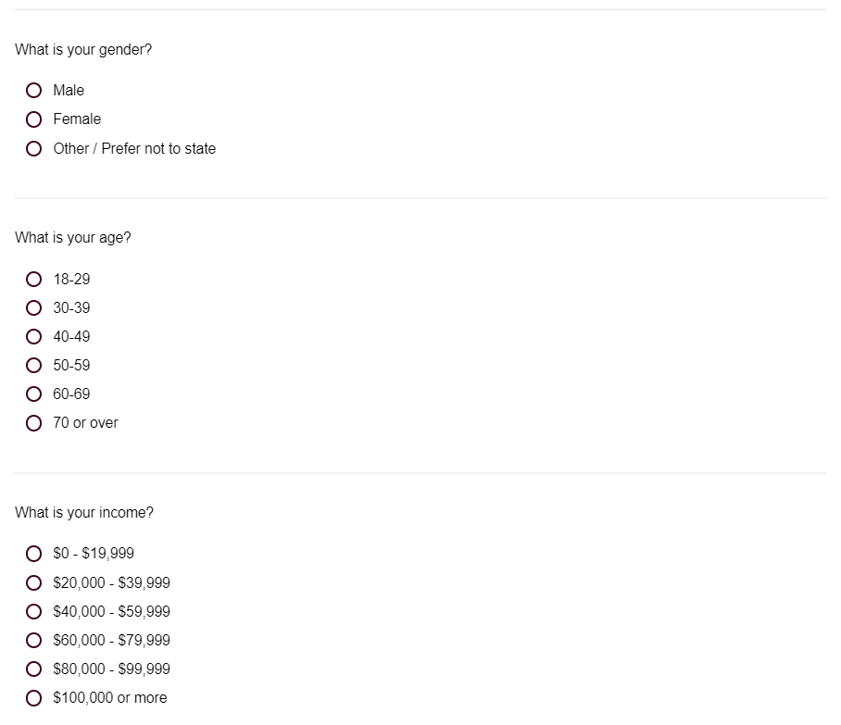
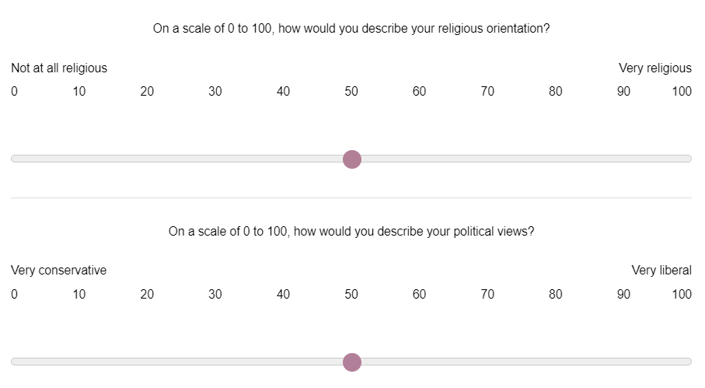
Page 4
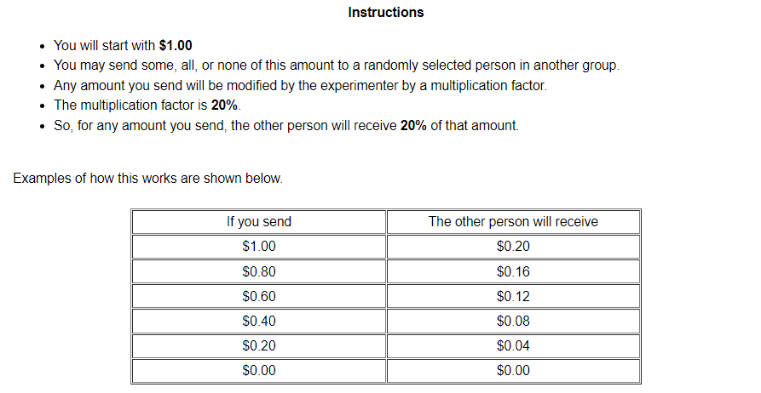
Page 5
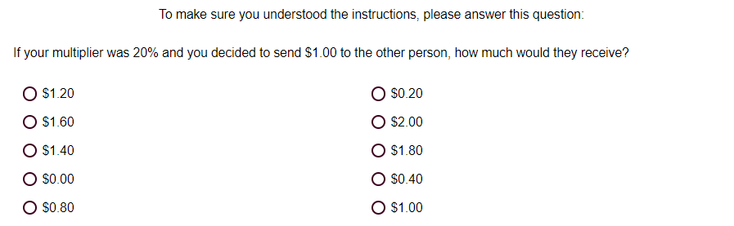
Page 6
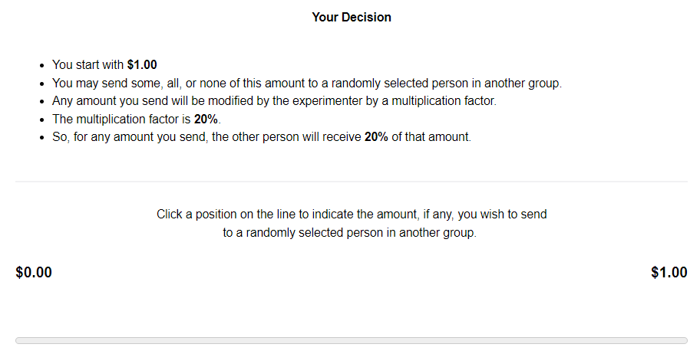
Page 7


Table A15: Pre-registered experiment demographic responses

 | Gender | Age | Income | Conservative | Religious
Female | 439 (46.4%)
Male | 495 (52.3%)
Other / Prefer not to state | 12 (1.3%)
18-29 |  | 178 (18.8%)
30-39 |  | 378 (40.0%)
40-49 |  | 196 (20.7%)
50-59 |  | 126 (13.3%)
60-69 |  | 53 (5.6%)
70 or over |  | 15 (1.6%)
$0-$19,999 |  |  | 179 (18.9%)
$20,000-$39,999 |  |  | 213 (22.5%)
$40,000-$59,999 |  |  | 245 (25.9%)
$60,000-$79,999 |  |  | 129 (13.6%)
$80,000-$99,999 |  |  | 91 (9.6%)
$100,000 or more |  |  | 89 (9.4%)
Mean [SD] |  |  |  | 33.6 [31.9] | 30.5 [45.4]

