Appendix
In this appendix, we redo the article's main results separating the Other experiments category into two subcategories: field experiments and the remaining experiments (i.e., lab-in-the-field, online, and articles using a combination of methods). Field experiments account for 37.0% of all experimental publications, leaving the remaining experiments with 18.1%.
Figure A1 displays the yearly fraction of published articles using Lab, field, and the remaining experiments. The figure shows that the significantly increasing trend reported for Other experiments is present in both subcategories. Figure A2 depicts the average number of 3-year Google Scholar citations. On the whole, we see that Lab experiments tend to be less cited than field experiments or experiments in the remaining subcategory. An OLS regression with 3-year citations as the dependent variable and controls for author characteristics confirms that field experiments are significantly more cited than Lab experiments in AER and the Other Top 5 journals (p<0.003) and weakly significantly more in JEEA+EJ (p=0.062). Experiments in the remaining subcategory are significantly more cited than Lab experiments in JEEA+EJ (p=0.006). They are also more cited in AER and the Other Top 5 journals, but the difference is not statistically significant (p=0.127 and p=0.220). Lastly, Figure A3 shows the fraction of authors of published experiments who are ESA members. We find a larger fraction of ESA members among authors of Lab experiments than field experiments in all journals (p<0.001). The same is true for experiments in the remaining subcategory, but the difference is statistically significant only in AER and the Other Top 5 journals (p<0.001; for JEEA+EJ, p=0.111).

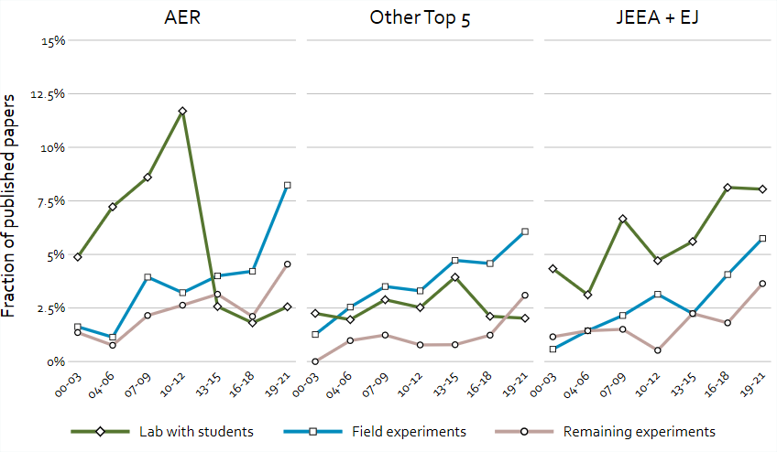
Figure A1 – Fraction published experimental articles per year

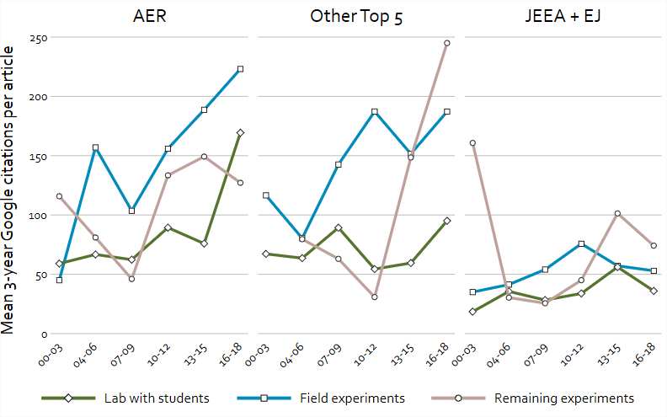
Figure A2 – Average 3-year citations per article

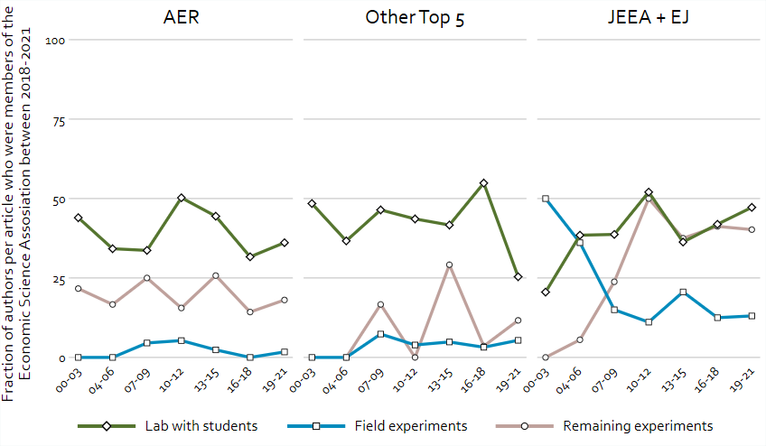
Figure A3 – Fraction of authors who were paying members of the ESA between 2018 and 2021 or had served in the ESA's Executive Committee

