Supplementary Information for

Do Negative Economic Shocks Affect Cognitive Function, Adherence to Social Norms, and Loss Aversion?
Francesco Bogliacino
Corresponding autor
Universidad Nacional de Colombia
Centro de Investigaciones para el Desarrollo (CID)

Felipe Montealegre
Universidad Nacional de Colombia
Centro de Investigaciones para el Desarrollo (CID)
Table of Contents
S1 Experimental Protocol 3
S2 Laboratory 22
S3 Supplementary Statistical Analysis 23
S3.1 Descriptive Statistics 23
S3.2 OLS Regressions with Robust Standard Errors 25
S3.3 OLS Regressions with Robust Standard Errors for Main Effects 30
S3.4 Tests for Cheating 32
S4 Order of Tasks 34
S5 Power analysis and equivalence test for cheating and loss aversion 34

Tables
Table S1: Descriptive Statistics 23
Table S2: T-test of the mean of the control variables by feedback condition. 23
Table S3: Distribution of subjects by condition and by feedback. 24
Table S4: Description of Independent Variables Included in Regression Analyses 25
Table S5: Regressions on Cognitive Performance 26
Table S6: Regressions on cognitive performance, controlling for first round of RET. 27
Table S7: Regressions on Measures of Loss Aversion 28
Table S8: Regression on the Likelihood of Reporting 4 or 5 in the Cheating Game 29
Table S9: Regressions on Cognitive Performance (Main Effects) 30
Table S10: Regressions on Measures of Loss Aversion (Main Effects) 31
Table S11: Regression on the Likelihood of Reporting 4 or 5 in the Cheating Game (Main Effects) 32
Table S12: χ² test of distributions between observed and expected frequencies in the Cheating Game 33
Table S13: χ² Test for Independence between treatments and the Reported Die Roll 33
Table S14: Order of Tasks 34
Table S15: Equivalence test for loss aversion (number of rejected lotteries), Δ=1. 35
Table S16:Equivalence test for cheating (reporting numbers 4 or 5), Δ=1. 35
Figures
Figure S1: Laboratory and participants 22

S1 Experimental Protocol
Note: This is a translation to English from the original protocol in Spanish.
[Before starting the session]
[The information written in square brackets and italics must not be read to participants. These are the procedures to be followed by the experimenter.]
[Turn on computers. Start the session in each of them. Start in kiosk mode. Set up the cardboard divisions for each workstation.]
[Place a blank sheet of paper, a pen, and a die inside a plastic cup, in front of each computer. Open the google chrome shortcut. Check that every computer is connected to the room.]
[Before Starting the session, greet the participants and remind them that for them to participate they must have their ID with them. Align them into a line in order of arrival. Only 18 of them can participate in that session. Others are welcomed to participate in the next session. Give access to the lab by two at a time with the ID card. At the control cabin check if any one of them had participated before.]
[General Instructions]
[When the quota of participants is completed for the session or when it is time to start the session ask participants to log in with their university credentials. After everyone has logged in, start the session.]

[Participants will see the following screen while you read aloud the instructions]

Welcome. We thank you for taking part in this exercise that is part of a study about decision making that we are conducting in Facultad de Ciencias Económicas. It will take approximately 1 hour. From now on it is forbidden to communicate with other participants, for any question raise your hand. The use of electronic devices is expressly forbidden. Please be quiet and turn off your cellphones.
[Give them a moment to turn off their cellphones]
In front of you, there is a blank paper sheet, a pen and a plastic cup with a die inside it. Please do not use them until indicated.
Depending on your decisions, you can win a certain amount of money. Therefore, it is necessary for you to pay attention to these instructions. All information collected for this study is confidential and will be used for academic purposes only. Your name, identification number (ID) or e-mail will not be shown in any document or report about this study.
It is important for you to know that you can walk away; however, only if you complete the exercise and complete the final questionnaire you can receive the amount of money you earned for your decisions. The money used to pay the participants was given by Facultad de Ciencias Económicas and not by the researchers of the study. This is a public entity and, as such, we cannot legalize your payment without collecting a copy of your ID card. We will do this at the end of the session. We apologize if this can be an inconvenience for you.
This exercise comprises two parts. In the first part, you have to solve an addition task. In the second part, you will have to complete four activities, three of which are tasks and one is a decision. That is, this exercise has a total of four tasks and one decision.
Now I will tell you how your earnings are determined. The addition task will always be paid. From the other four remaining activities, only one will be paid. The activity to be paid from the four remaining activities will be drawn by one of you, once all of you will have finished with the activities and after the completion of a very short questionnaire.
In order to do this, each activity has assigned one color: Blue, Green, Yellow, Red. Neither you nor we know which one of the remaining four tasks will be paid until the end of the session when a volunteer will draw one of these colored balls [show the colored balls to everyone] from this black bag [show the black bag to everyone]. It is important for you to think carefully about your decisions because you will only know which of them will be paid once you will have finished everything. To resume, once you will have finished answering all tasks, completed the final questionnaire, and drawn an activity to pay, we will call each one of you, one by one, to give you the earnings from the addition task and the earnings from the task corresponding to the drawn ball.
If you have any questions, please raise your hand and I or any assistant will come by to answer it.
Given this information, we want to confirm that you want to participate in this exercise. If so, click on the “next” button.
[While the participants wait for the other participants to press the button, the following screen appears:]

[When all participants pressed the “next” button the following screen appears with the informed consent:]
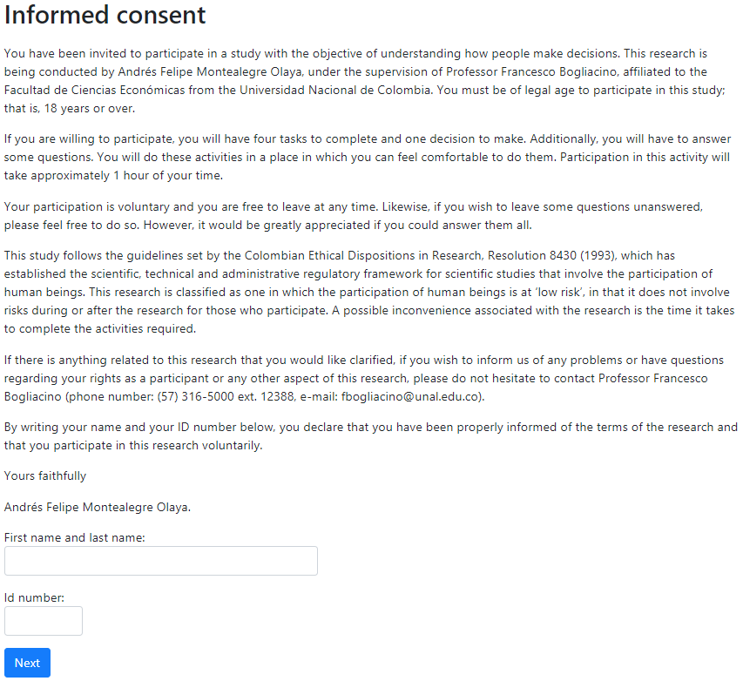
[Read out loud the informed consent]
If you agree to participate in this study, please write your full name and your ID number in the space indicated. Once done, please press the “next” button. After filling out the informed consent please follow the on-screen instructions.
[While participants wait for other participants to fill out the informed consent, they will see the following screen:]
[Instructions. Part 1.]
[Addition task]
[When participants had filled the informed consent and clicked on the “next” button they will see the instructions for the addition task in the screen:]
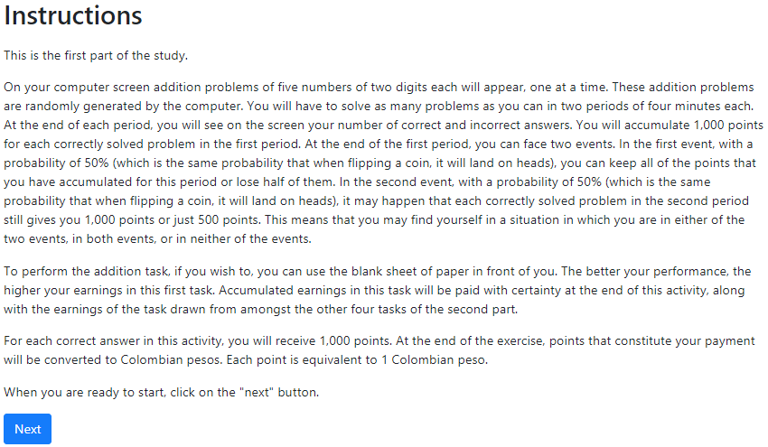
[Participants start the first round of the addition task until the time runs out. They will see the following screen (note that the numbers here are just an example):]
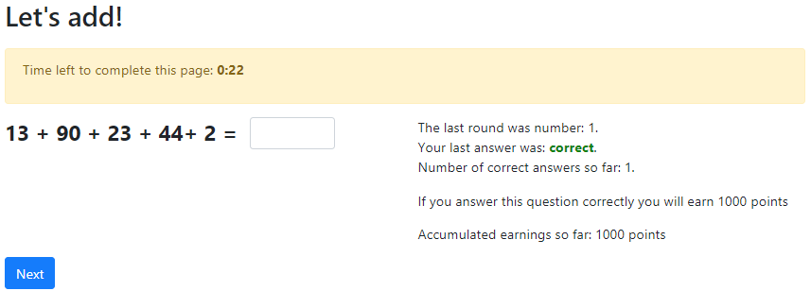
[When the time runs out and depending on the experimental treatment the participant was randomly assigned to, they will see the following screen (in this example the experimental treatment is NIS = 1, NWS = 1):]

[When they click on the “next” button, the second round of the addition task will start. They will see on the screen a similar screen as in the first round:]
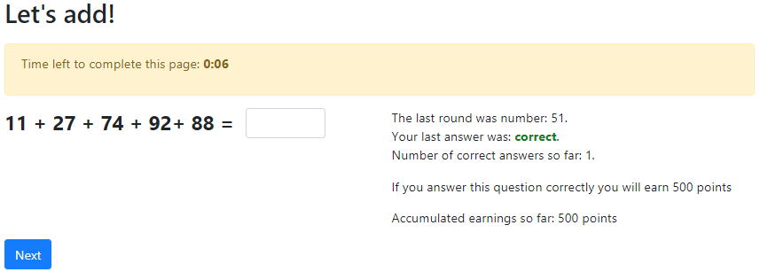
[When the time for the second round of the addition task runs out, they will see a summary of their performance in this task on their screens as in the following screen]
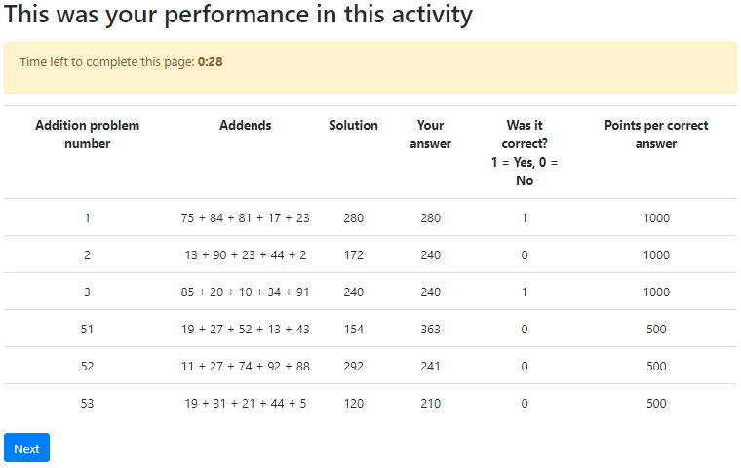
[When they click on the “next” button, the second part of the exercise will start with the instructions of the first task]
[Instructions. Part 2]
[STM task (Blue)]
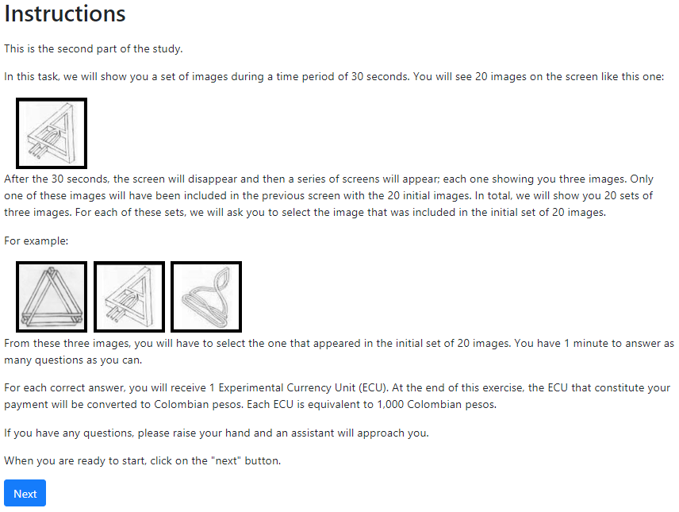 [When they click on the “next” button, the set of 20 images will appear in the following screen:]
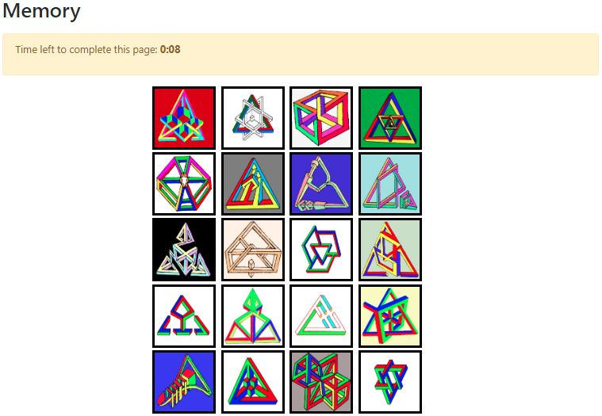
[30 seconds later the last screen will disappear and a succession of 20 pages in which 20 sets of 3 images each is shown to the participant. One set per page. These pages are similar to the next one:]

[After the time is up, they will see the following screen]
----> According to the feedback treatment, participants will see the following: <----
----> No-feedback sessions: <----
----> Feedback sessions :<----

----> End of conditional <----
[When they click on the “next” button, the second task of the second part starts:]
[FI (Red)]
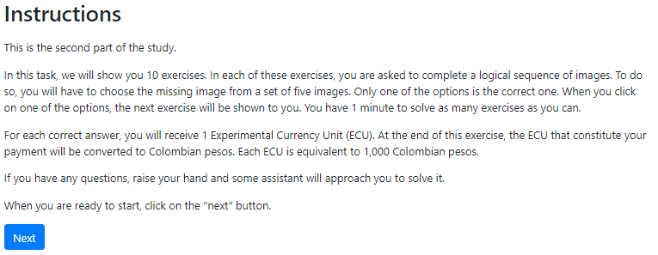 [When they click on the “next” button, participants will see a set of 10 pages. Each page has one problem very similar to the next one:]
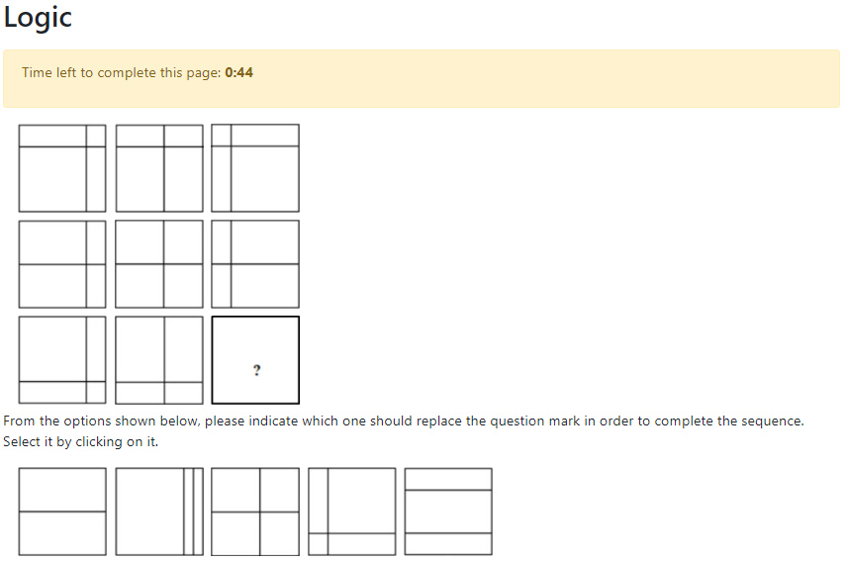
[After time is up, they will see the following screen:]
----> According to the feedback treatment, participants will see the following: <----
----> No-feedback sessions: <----
----> Feedback sessions :<----

----> End of conditional <----
[When they click on the “next” button, the third task of the second part starts:]
[Dice (Green)]
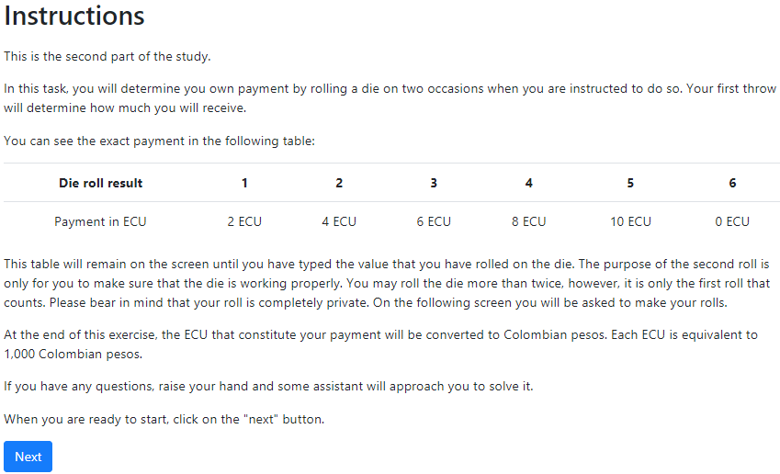 [When they click on the “next” button, the following screen shows up:]
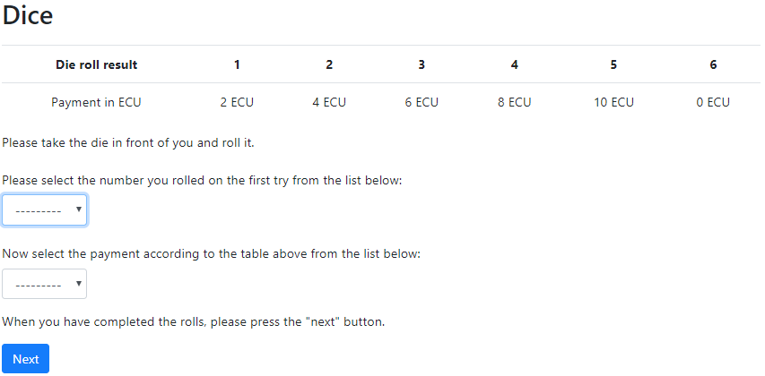 [Only when they have rolled the die, reported the number, and selected the related payoff, they can click on the “next” button. The following screen is displayed:]
----> According to the feedback treatment, participants will see the following: <----
----> No-feedback sessions: <----
----> Feedback sessions :<----

----> End of conditional <----
[When they click on the “next” button, the fourth task of the second part starts:]
[Lottery (Yellow)]
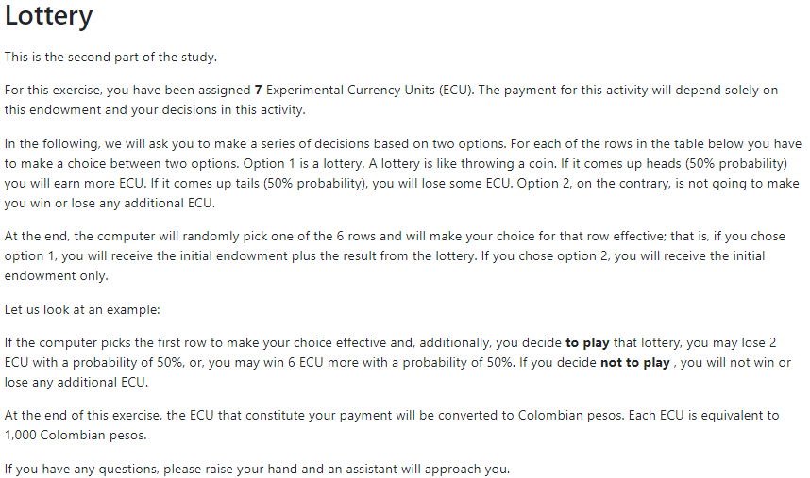
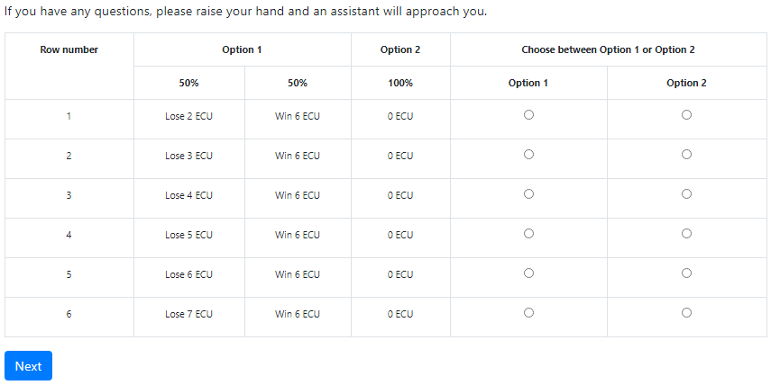
[When they click on the “next” button, a summary of the results in this task is displayed to participants:]

[When they click on the “next” button, a waiting screen will be shown to them where they are informed to wait for the other participants to start the draw of the task to be pay from the tasks in the second part of the experiment:]
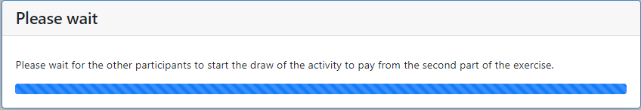
[Draw of the experimental task to pay for the second part]
[When all participants have reached the waiting page, the process of drawing out the task to be paid from the tasks of the second part is started. In this screen, participants are shown how many points they earned in the addition task and how many ECU they earned in each of the other tasks. The following instructions appear onscreen:]
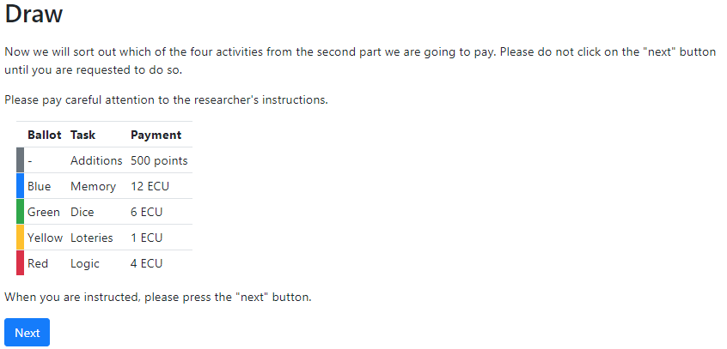
Now we will draw the task to be paid from the four tasks of the second part. Remember that the addition task will always be paid. For this, we will use this black bag [show the black bag to everyone again] and these ballots [show the colored ballots again]. If the blue ball is drawn, then the memory task is the one to be paid. If the green ball is drawn, then the die task will be paid. If the yellow ballot is drawn, then the lottery decision is to be paid. If the red ball is drawn, then the logic task will be paid.
Please one volunteer among you step forward to make the draw. [Inform the volunteer she is not allowed to look into the black bag. The draw is made]
[Say this while showing the ball to everyone] The draw ballot was the [color] one, therefore, the task to be paid is the [task name accordingly].
Now we will calculate your earnings. While we do so please answer the questionnaire that is on the following screen. We will call you one by one to deliver your payment inside an envelope and register your id card. Please click on the “next” button.
[When all participants had clicked on the “next” button, in the following screen appears the questionnaire page]
[Questionnaire]
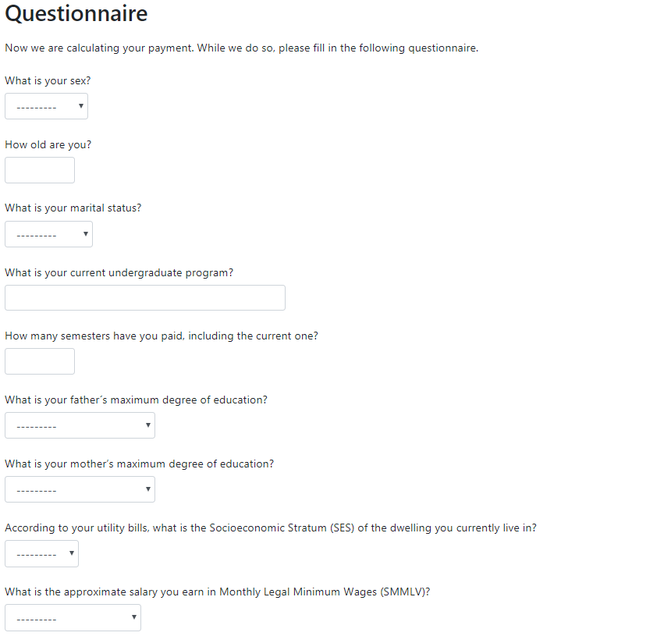
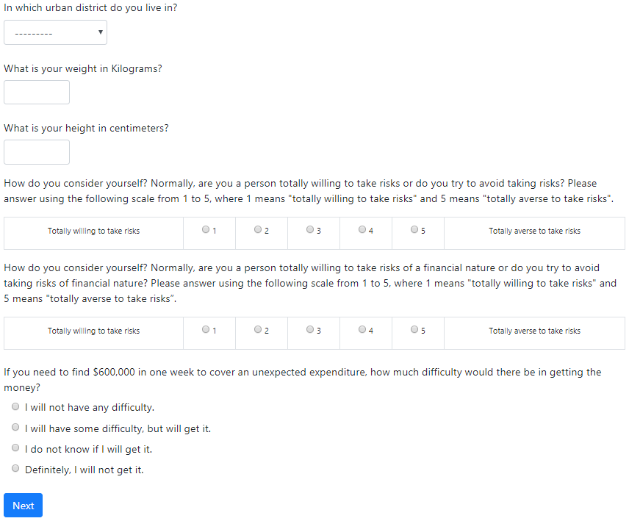
[Payment procedure]
[While participants answer the questionnaire, the session assistant hands out a receipt of payment (compulsory under university regulations) for participants to fill out]
[After completing the questionnaire, participants click on the “next” button and see and instruction to please remain sited until they are asked to come to the front desk as in the following screen:]
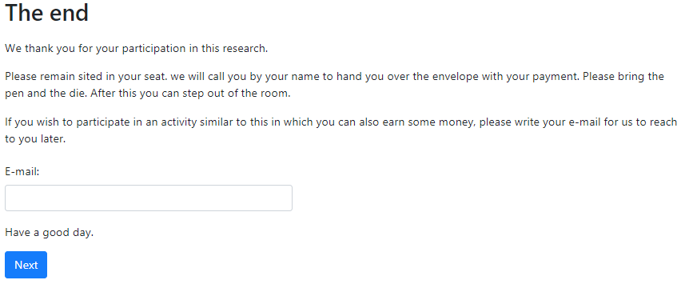
[After delivering the envelopes, check if the form has been filled correctly. Thank the participant and ask her to leave the room.]

S2 Laboratory
Figure S1: Laboratory and participants
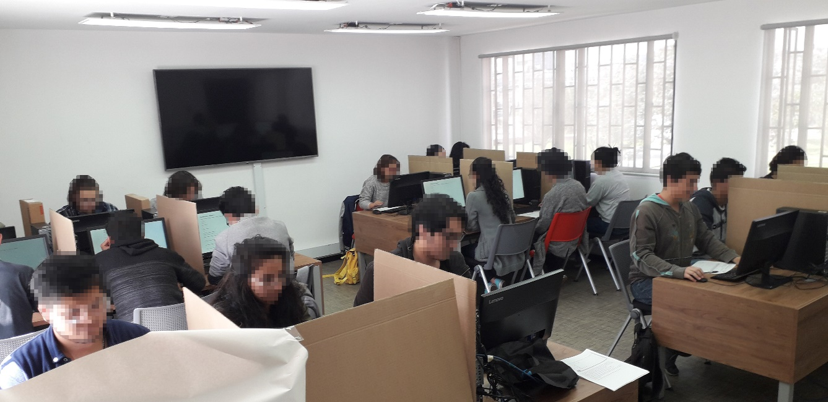
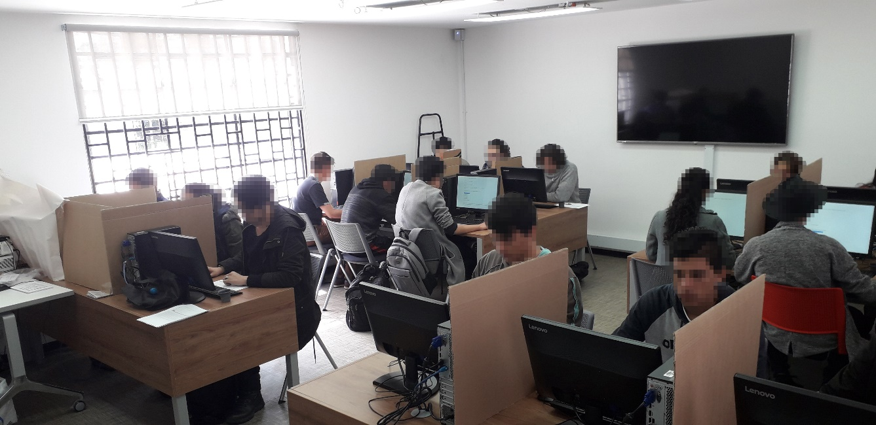

S3 Supplementary Statistical Analysis

S3.1 Descriptive Statistics
Table S1: Descriptive Statistics
Variable | Mean | Mode | % | Second most frequent | % | Minimum | Maximum
Sex | - | Male | (63.93%) | - | - | - | -
Age | 21.69 | 20 y/o | (16.46%) | 18 y/o | (15.71%) | 18 | 42
Civil State | - | Single | (97.14%) | - | - | - | -
Academic Program | - | Graphic Design | (8.21%) | Business Management | (6.79%) | - | -
 |  | - | - | Psychology | (6.79%) | - | -
Math Training | - | Yes | (41.13%) | - | - | - | -
Semesters | 6.08 | 3 | (16.43%) | 6 | (11.79%) | 1 | 15
Mother's Education | - | College | (27.50%) | Undergraduate | (25.00%) | - | -
Father's Education | - | College | (23.21%) | College | (22.14%) | - | -
Municipal District | - | Suba | (16.07%) | Teusaquillo | (14.29%) | - | -
Income (MLMW) | - | < 1 MLMW | (68.10%) | 1-2 MLMW | (19.71%) | < 1 MLMW | > 7 MLMW
SES |  | 3 | (46.43%) | 2 | (29.29%) | 1 | 5
BMI |  | Normal | (74.91%) | Overweight | (13.62%) | Severely Underweight | Morbid Obesity
Risk Propensity |  | 2 | (37.14%) | 3 | (35.36%) | 1 | 5
Financial Risk Propensity |  | 3 | (35.36%) | 4 | (29.29%) | 1 | 5
Emergency |  | 3 | (54.64%) | 2 | (34.29%) | 1 | 4
Losses (share of average experimental earning) | 15.65% | SD(13.50%) | - | - | - | 0% | 100%
MLMW stands for minimum legal monthly wage. In Colombia, by the time of the experiment the MLMW was around 781.242 COP. By the time the experiment was conducted 1 USD was equal to 2958.57 COP. SES stands for Socio-Economical Stratum. SES and Math training is explained in detail in Table S4 below. BMI stands for Body Mass Index. Risk propensity, Financial Risk Propensity, are standard validated scales. Emergency is a question on how easy would be to face an unexpected large expenditure (from 1-4). Losses is calculated as the share of losses in the RET to the average experimental earning. SD stands for standard deviation.
Since we randomize by session the presence of feedback, we report also the t-test for the main control variables by feedback, controlling for unequal variances. Apart for age, there is no significant difference, as it would be expected since we were randomizing.
Table S2: T-test of the mean of the control variables by feedback condition.
Variable | p-value
Order | 0.0687
Female = 1 | 0.1994
Age | 0.0275
Math Training | 0.7386
SES (3-4) | 0.3742
SES (5-6) | 0.1589
Emergency | 0.6648
Joint F test: F(6, 268) = 1.39, p = 0.217
We also report the distribution of the subjects by feedback and by experimental treatments.
Table S3: Distribution of subjects by condition and by feedback.
 | Feedback
Condition | No | Yes | Total
Control | 17 | 58 | 75
NIS Only | 15 | 57 | 72
NWS Only | 20 | 49 | 69
NWS & NIS | 18 | 46 | 64
Total | 70 | 210 | 280
Out of the 282 participants we had to exclude two because they did not complete the questionnaire. One of these was in the control treatment and the other one in the NWS and NIS combined treatment.

S3.2 OLS Regressions with Robust Standard Errors

In all regressions, the estimated model is the following:
$$Y_{i}=β_{0}+β_{1}{T2}_{i}+β_{2}{T3}_{i}+β_{3}{T4}_{i}+γ_{0}{FEED}_{i}+γ_{1}{Order2}_{i}+γ_{2}{Order3}_{i}+γ_{3}{Order4}_{i}$$
$+γ_{4}{Order5}_{i}+γ_{5}{Order6}_{i}+γ_{6}{Age}_{i}+γ_{7}{Female}_{i}+γ_{8}{Math}_{i}+γ_{9}{SES\left(3−4\right)}_{i}$ [S1]
$+γ_{10}{SES\left(5−6\right)}_{i}+γ_{11}{Emergency}_{i}+ε_{i}$
Where Y is the outcome variable, i is the index for subject, and all regressors are included and explained in Table S4 below.
Table S4: Description of Independent Variables Included in Regression Analyses
Variables | Definition
T2 | A dummy variable equal to 1 if the participant was assigned to the second treatment (NIS only) and 0 otherwise.
T3 | A dummy variable equal to 1 if the participant was assigned to the third treatment (NWS only) and 0 otherwise.
T4 | A dummy variable equal to 1 if the participant was assigned to the fourth treatment (Both NIS and NWS) and 0 otherwise.
Feedback | A dummy variable equal to 1 if participants were shown feedback on their performance on the four tasks of the second part (STM, FI, cheating, LA), 0 otherwise.
Order 2 | To control for order effects in the task we randomly assigned participants to one of each of the six possible orders as depicted in Table S14. A dummy variable equal to 1 if participants were shown the tasks in the second order. 0 otherwise.
Order 3 | A dummy variable equal to 1 if participants were shown the tasks in the third order. 0 otherwise.
Order 4 | A dummy variable equal to 1 if participants were shown the tasks in the fourth order. 0 otherwise.
Order 5 | A dummy variable equal to 1 if participants were shown the tasks in the fifth order. 0 otherwise.
Order 6 | A dummy variable equal to 1 if participants were shown the tasks in the sixth order. 0 otherwise.
Age | It depicts the age of the participant.
Female = 1 | A dummy equal to 1 if the participant was a female. 0 otherwise.
Math Training | A dummy variable equal to 1 if the academic program has strong training in mathematics. 0 otherwise. Among all the academic programs participants were enrolled to, those with strong training in mathematics are all the engineering programs, mathematics, physics, economics, statistics, chemistry and biology. Those without strong math training were business management, anthropology, architecture, plastic arts, political science, cinema and television, public accounting, law, graphical design, nursing, literary studies, pharmacy, philology and languages, philosophy, history, linguistics, medicine, veterinary medicine, dentistry, psychology, sociology, social work, and zoology.
SES (3-4) | Socio-economic stratum (SES) is obtained from participant´s self-reported utility-bills dwelling classification. In Colombia, SES is a dwelling classification used to charge for utility bills in a differentiated way (subsidies and contributions). Dwelling classification depends on its physical characteristics, its geographical environment, among other things. SES is divided into 6 tiers. Tier 1 (6) is the lowest (highest) tier. We split participants into three categories depending on their SES. Low SES (SES 1-2), medium SES (SES 3-4), and high SES (SES 5-6). SES (3-4) is a dummy variable equal to 1 if participants reported a SES of 3 or 4 for their dwelling. 0 otherwise.
SES (5-6) | A dummy variable equal to 1 if participants reported a SES of 5 or 6 for their dwelling. 0 otherwise.
Emergency | A standard question used as a proxy of the participants financial situation. “If you need to find 600000 COP in a week, to cover an unexpected expenditure, how difficult would it be to get the money? (a) I will not have any difficulty. (b) I will have some difficulty but will get it. (c) I do not know if I will get it. (d) Definitely, I will not get it.

Table S5: Regressions on Cognitive Performance
 |  | Accuracy |  |  |  |  |  | Response Time
 | RET-STM-FI | STM-FI | F. Component | RET (first round) | RET (second round) | STM | FI | RET-STM-FI
Variables | (1) | (2) | (3) | (4) | (5) | (6) | (7) | (8)
T2 | -0.084 | -0.035 | -1.878 | -0.205 | -0.427 | 0.217 | -0.179 | 0.097
 | (0.094) | (0.114) | (2.755) | (0.391) | (0.389) | (0.478) | (0.196) | (0.090)
T3 | -0.247*** | -0.216* | -6.118** | -0.305 | -0.721* | -0.440 | -0.348* | 0.163*
 | (0.094) | (0.116) | (2.836) | (0.355) | (0.380) | (0.476) | (0.207) | (0.094)
T4 | -0.182* | -0.207* | -4.684* | -0.164 | -0.305 | -1.054** | -0.066 | 0.240**
 | (0.095) | (0.115) | (2.722) | (0.378) | (0.393) | (0.466) | (0.204) | (0.097)
Feedback | 0.180** | 0.280*** | 5.346** | -0.089 | -0.051 | 0.815* | 0.348* | -0.216**
 | (0.082) | (0.104) | (2.477) | (0.306) | (0.310) | (0.430) | (0.181) | (0.087)
Order 2 | 0.116 | 0.092 | 2.670 | 0.309 | 0.381 | 0.559 | -0.010 | -0.061
 | (0.109) | (0.135) | (3.163) | (0.411) | (0.441) | (0.587) | (0.219) | (0.107)
Order 3 | 0.035 | 0.049 | 0.866 | 0.017 | 0.018 | 0.596 | -0.130 | -0.040
 | (0.105) | (0.130) | (3.261) | (0.412) | (0.420) | (0.542) | (0.228) | (0.106)
Order 4 | -0.281** | -0.348** | -7.683* | -0.305 | -0.344 | -0.987 | -0.442 | 0.206
 | (0.137) | (0.169) | (3.978) | (0.479) | (0.564) | (0.719) | (0.294) | (0.141)
Order 5 | 0.122 | 0.161 | 3.454 | 0.488 | 0.099 | 0.314 | 0.266 | -0.021
 | (0.139) | (0.169) | (4.074) | (0.565) | (0.566) | (0.699) | (0.295) | (0.128)
Order 6 | 0.020 | 0.071 | 0.786 | -0.110 | -0.190 | 0.590 | -0.073 | 0.074
 | (0.107) | (0.138) | (3.297) | (0.366) | (0.382) | (0.597) | (0.226) | (0.116)
Female = 1 | -0.142** | -0.224** | -4.306** | -0.011 | 0.054 | -0.464 | -0.358** | 0.175**
 | (0.072) | (0.088) | (2.099) | (0.286) | (0.300) | (0.369) | (0.153) | (0.075)
Age | -0.005 | -0.010 | -0.172 | 0.013 | 0.011 | -0.012 | -0.019 | 0.011
 | (0.012) | (0.014) | (0.391) | (0.046) | (0.048) | (0.056) | (0.028) | (0.011)
Math Training | 0.243*** | 0.142* | 5.502** | 0.873*** | 1.037*** | 0.135 | 0.293* | -0.216***
 | (0.071) | (0.086) | (2.142) | (0.286) | (0.292) | (0.353) | (0.151) | (0.071)
SES (3-4) | 0.150** | 0.174* | 4.065* | 0.026 | 0.236 | 0.308 | 0.300* | -0.142*
 | (0.075) | (0.089) | (2.203) | (0.310) | (0.318) | (0.365) | (0.159) | (0.074)
SES (5-6) | 0.784*** | 0.839*** | 20.444*** | 1.718*** | 1.574** | 2.312*** | 1.096** | -0.512***
 | (0.185) | (0.235) | (4.694) | (0.623) | (0.729) | (0.818) | (0.470) | (0.152)
Emergency | -0.078 | -0.110* | -2.251 | 0.031 | -0.029 | -0.251 | -0.167 | 0.024
 | (0.055) | (0.066) | (1.504) | (0.222) | (0.241) | (0.271) | (0.115) | (0.051)
Constant | 0.111 | 0.258 | 50.574*** | 5.201*** | 5.599*** | 13.691*** | 4.504*** | -0.138
 | (0.315) | (0.389) | (9.979) | (1.187) | (1.231) | (1.572) | (0.709) | (0.314)
Number of observations | 840 | 560 | 280 | 280 | 280 | 280 | 280 | 840
R-squared | 0.071 | 0.090 | 0.156 | 0.073 | 0.084 | 0.101 | 0.118 | 0.057
Table S5 reports the results of regressing different measures of cognitive performance on exposure to shocks and a series of individual control variables (Variables are defined in Table S4). Estimators of standardized measures can be interpreted as percentage of standard deviations. Column (1) shows standardized accuracy grouping together the RET, STM and FI tasks into one single measure. Column (2) repeats the analysis excluding the RET. Column (3) shows accuracy results when we pool data using the first component from a Principal Component Analysis. Columns (4) to (7) show accuracy in the RET, STM and FI tasks individually. Column (8) shows the standardized response time it took participants to answer a question on average, irrespectively if the answer was correct or not. This measure groups together the RET, STM and FI tasks into one single measure. Robust standard Errors in parenthesis; *** p<0.01, ** p<0.05, * p<0.1.
Table S6: Regressions on cognitive performance, controlling for first round of RET.
 |  | Accuracy |  |  |  |  |  | Response Time
 | RET-STM-FI | STM-FI | F. Component | RET (first round) | RET (second round) | STM | FI | RET-STM-FI
Variables | (1) | (2) | (3) | (4) | (5) | (6) | (7) | (8)
T2 | -0.059 | -0.026 | -1.357 | -0.205 | -0.290 | 0.239 | -0.166 | 0.068
 | (0.090) | (0.114) | (2.565) | (0.391) | (0.263) | (0.477) | (0.196) | (0.085)
T3 | -0.209** | -0.203* | -5.341** | -0.305 | -0.516* | -0.407 | -0.329 | 0.120
 | (0.092) | (0.116) | (2.710) | (0.355) | (0.304) | (0.475) | (0.209) | (0.089)
T4 | -0.161* | -0.200* | -4.267 | -0.164 | -0.196 | -1.037** | -0.057 | 0.217**
 | (0.092) | (0.115) | (2.588) | (0.378) | (0.308) | (0.471) | (0.202) | (0.093)
Feedback | 0.191** | 0.284*** | 5.572** | -0.089 | 0.008 | 0.824* | 0.353** | -0.228***
 | (0.079) | (0.103) | (2.327) | (0.306) | (0.257) | (0.428) | (0.179) | (0.084)
Order 2 | 0.077 | 0.078 | 1.883 | 0.309 | 0.174 | 0.526 | -0.029 | -0.018
 | (0.105) | (0.134) | (2.940) | (0.411) | (0.364) | (0.585) | (0.217) | (0.101)
Order 3 | 0.033 | 0.049 | 0.823 | 0.017 | 0.006 | 0.594 | -0.131 | -0.038
 | (0.101) | (0.128) | (3.016) | (0.412) | (0.342) | (0.542) | (0.223) | (0.100)
Order 4 | -0.243* | -0.335* | -6.905* | -0.305 | -0.140 | -0.954 | -0.424 | 0.164
 | (0.136) | (0.171) | (3.965) | (0.479) | (0.455) | (0.729) | (0.296) | (0.136)
Order 5 | 0.061 | 0.140 | 2.211 | 0.488 | -0.227 | 0.261 | 0.236 | 0.048
 | (0.134) | (0.169) | (3.906) | (0.565) | (0.403) | (0.701) | (0.297) | (0.122)
Order 6 | 0.034 | 0.076 | 1.067 | -0.110 | -0.117 | 0.602 | -0.067 | 0.058
 | (0.103) | (0.137) | (3.073) | (0.366) | (0.322) | (0.591) | (0.223) | (0.109)
Female = 1 | -0.141** | -0.224** | -4.277** | -0.011 | 0.061 | -0.463 | -0.358** | 0.174**
 | (0.069) | (0.087) | (1.946) | (0.286) | (0.221) | (0.368) | (0.152) | (0.072)
Age | -0.007 | -0.011 | -0.206 | 0.013 | 0.002 | -0.014 | -0.020 | 0.013
 | (0.011) | (0.014) | (0.356) | (0.046) | (0.034) | (0.056) | (0.027) | (0.010)
Math Training | 0.134** | 0.104 | 3.277 | 0.873*** | 0.453** | 0.042 | 0.240 | -0.093
 | (0.068) | (0.087) | (2.003) | (0.286) | (0.220) | (0.361) | (0.151) | (0.067)
SES (3-4) | 0.147** | 0.173** | 3.999** | 0.026 | 0.219 | 0.305 | 0.298* | -0.139**
 | (0.071) | (0.088) | (2.015) | (0.310) | (0.236) | (0.364) | (0.156) | (0.070)
SES (5-6) | 0.571*** | 0.766*** | 16.068*** | 1.718*** | 0.426 | 2.128*** | 0.991** | -0.271*
 | (0.189) | (0.238) | (4.906) | (0.623) | (0.627) | (0.807) | (0.486) | (0.147)
Emergency | -0.082 | -0.112* | -2.331* | 0.031 | -0.050 | -0.254 | -0.168 | 0.029
 | (0.052) | (0.065) | (1.340) | (0.222) | (0.156) | (0.271) | (0.113) | (0.049)
RET (first round) | 0.124*** | 0.043** | 2.548*** |  | 0.669*** | 0.107 | 0.061* | -0.140***
 | (0.018) | (0.019) | (0.456) |  | (0.061) | (0.075) | (0.035) | (0.017)
Constant | -0.534* | 0.035 | 37.324*** | 5.201*** | 2.120** | 13.134*** | 4.189*** | 0.592*
 | (0.320) | (0.403) | (9.828) | (1.187) | (0.998) | (1.645) | (0.731) | (0.304)
Number of observations | 840 | 560 | 280 | 280 | 280 | 280 | 280 | 840
R-squared | 0.142 | 0.099 | 0.253 | 0.073 | 0.461 | 0.107 | 0.129 | 0.148
Note: Same as Table S5 above but controlling for the performance in the first round of RET, except column (4).

Table S7: Regressions on Measures of Loss Aversion
 | Loss Averse | Switch Point | Rejected Lotteries
Variables | (1) | (2) | (3)
T2 | 0.044 | -0.103 | 0.038
 | (0.058) | (0.246) | (0.210)
T3 | 0.006 | 0.042 | 0.017
 | (0.063) | -0.264 | (0.235)
T4 | -0.024 | -0.153 | 0.124
 | (0.063) | (0.262) | (0.239)
Feedback | 0.033 | -0.250 | 0.227
 | (0.061) | (0.231) | (0.201)
Order 2 | 0.058 | 0.037 | 0.013
 | (0.076) | (0.315) | (0.281)
Order 3 | 0.125* | -0.422 | 0.392
 | (0.071) | (0.306) | (0.269)
Order 4 | 0.127 | -0.364 | 0.399
 | (0.085) | (0.412) | (0.329)
Order 5 | 0.051 | -0.065 | 0.090
 | (0.088) | (0.387) | (0.338)
Order 6 | 0.026 | 0.046 | 0.008
 | (0.083) | (0.336) | (0.299)
Female = 1 | -0.028 | 0.164 | -0.069
 | (0.050) | (0.213) | (0.179)
Age | -0.002 | 0.018 | -0.015
 | (0.008) | (0.032) | (0.029)
Math Training | -0.042 | 0.294 | -0.245
 | (0.048) | (0.201) | (0.177)
SES (3-4) | 0.034 | 0.052 | -0.044
 | (0.049) | (0.213) | (0.186)
SES (5-6) | -0.044 | 0.811 | -0.469
 | (0.140) | (0.557) | (0.463)
Emergency | -0.005 | 0.108 | -0.054
 | (0.034) | (0.141) | (0.117)
Constant | 0.849*** | 2.322*** | 3.401***
 | (0.225) | (0.871) | (0.793)
Number of observations | 241 | 241 | 280
R-squared | 0.038 | 0.050 | 0.038
Table S7 shows the results of regressions on three measures of loss aversion. Independent variables are explained in Table S4. Column (1) shows the likelihood of being loss averse. Column (2) shows the lottery in which participants switched from accepting to rejecting lotteries. Column (3) shows the number of rejected lotteries. The measures of likelihood of being loss averse and the switching point require us to drop participants with multiple switching points. The number of rejected lotteries allows us to measure loss aversion while avoiding dropping multiple switchers. Robust standard Errors in parenthesis; *** p<0.01, ** p<0.05, * p<0.1.
Table S8: Regression on the Likelihood of Reporting 4 or 5 in the Cheating Game
 | Report_45
Variables | (1)
T2 | 0.023
 | (0.081)
T3 | -0.029
 | (0.084)
T4 | 0.045
 | (0.085)
Feedback | 0.096
 | (0.073)
Order 2 | 0.014
 | (0.100)
Order 3 | -0.161*
 | (0.097)
Order 4 | -0.300**
 | (0.120)
Order 5 | -0.141
 | (0.116)
Order 6 | -0.137
 | (0.100)
Female = 1 | -0.035
 | (0.065)
Age | -0.011
 | (0.010)
Math Training | 0.098
 | (0.061)
SES (3-4) | -0.121*
 | (0.064)
SES (5-6) | -0.034
 | (0.168)
Emergency | -0.059
 | (0.046)
Constant | 0.941***
 | (0.268)
Number of observations | 280
R-squared | 0.070
Table S8 shows the result of a regression over the likelihood of reporting numbers 4 or 5 (the highest-paying numbers). Individual controls are explained in Table S4. Robust standard Errors in parenthesis; *** p<0.01, ** p<0.05, * p<0.1.

S3.3 OLS Regressions with Robust Standard Errors for Main Effects
Table S9: Regressions on Cognitive Performance (Main Effects)
 | Accuracy |  |  |  |  |  | Response Time
 | RET-STM-FI | STM-FI | F. Component | RET | STM | FI | RET-STM-FI
Variables | (1) | (2) | (3) | (4) | (5) | (6) | (7)
NIS | -0.015 | -0.015 | -0.333 | -0.034 | -0.171 | 0.036 | 0.087
 | (0.068) | (0.083) | (2.046) | (0.278) | (0.347) | (0.147) | (0.069)
NWS | -0.174*** | -0.195** | -4.492** | -0.307 | -0.848** | -0.122 | 0.153**
 | (0.067) | (0.082) | (2.027) | (0.275) | (0.336) | (0.145) | (0.068)
Feedback | 0.179** | 0.280*** | 5.342** | -0.052 | 0.816* | 0.348* | -0.216**
 | (0.082) | (0.104) | (2.469) | (0.313) | (0.431) | (0.181) | (0.087)
Order 2 | 0.115 | 0.092 | 2.666 | 0.380 | 0.560 | -0.010 | -0.061
 | (0.110) | (0.135) | (3.162) | (0.447) | (0.593) | (0.222) | (0.107)
Order 3 | 0.037 | 0.050 | 0.898 | 0.026 | 0.588 | -0.125 | -0.040
 | (0.106) | (0.130) | (3.263) | (0.428) | (0.545) | (0.229) | (0.106)
Order 4 | -0.282** | -0.348** | -7.695* | -0.347 | -0.984 | -0.444 | 0.207
 | (0.137) | (0.169) | (3.989) | (0.558) | (0.716) | (0.298) | (0.141)
Order 5 | 0.122 | 0.161 | 3.461 | 0.101 | 0.312 | 0.267 | -0.021
 | (0.139) | (0.168) | (4.065) | (0.560) | (0.703) | (0.299) | (0.128)
Order 6 | 0.023 | 0.072 | 0.836 | -0.178 | 0.578 | -0.066 | 0.073
 | (0.108) | (0.138) | (3.306) | (0.389) | (0.599) | (0.228) | (0.116)
Female = 1 | -0.135* | -0.223** | -4.159** | 0.091 | -0.501 | -0.338** | 0.174**
 | (0.072) | (0.087) | (2.077) | (0.299) | (0.366) | (0.152) | (0.075)
Age | -0.005 | -0.010 | -0.160 | 0.014 | -0.015 | -0.018 | 0.011
 | (0.012) | (0.014) | (0.388) | (0.048) | (0.057) | (0.027) | (0.011)
Math Training | 0.244*** | 0.142* | 5.542*** | 1.047*** | 0.125 | 0.299* | -0.216***
 | (0.070) | (0.085) | (2.130) | (0.290) | (0.352) | (0.152) | (0.071)
SES (3-4) | 0.151** | 0.174** | 4.091* | 0.243 | 0.301 | 0.303* | -0.143*
 | (0.075) | (0.089) | (2.204) | (0.320) | (0.364) | (0.158) | (0.074)
SES (5-6) | 0.776*** | 0.837*** | 20.255*** | 1.526** | 2.359*** | 1.069** | -0.511***
 | (0.184) | (0.235) | (4.629) | (0.693) | (0.805) | (0.468) | (0.151)
Emergency | -0.070 | -0.108* | -2.076 | 0.016 | -0.295 | -0.142 | 0.023
 | (0.055) | (0.065) | (1.478) | (0.239) | (0.271) | (0.113) | (0.050)
Constant | 0.040 | 0.237 | 48.994*** | 5.197*** | 14.087*** | 4.284*** | -0.129
 | (0.313) | (0.384) | (9.997) | (1.253) | (1.597) | (0.682) | (0.304)
Number of observations | 840 | 560 | 280 | 280 | 280 | 280 | 840
R-squared | 0.069 | 0.090 | 0.154 | 0.076 | 0.096 | 0.109 | 0.056
Table S9 reports the main effects of exposure to either NS or NWS on different measures of cognitive performance and a series of individual control variables (Variables are defined in Table S4). Estimators of standardized measures can be interpreted as percentage of standard deviations. Column (1) shows standardized accuracy grouping together the RET, STM and FI tasks into one single measure. Column (2) repeats the analysis excluding the RET. Column (3) shows accuracy results when we pool data using the first component from a Principal Component Analysis. Columns (4) to (6) show accuracy in the RET, STM and FI tasks individually. Column (7) shows the standardized response time it took participants to answer a question on average, irrespectively if the answer was correct or not. This measure groups together the RET, STM and FI tasks into one single measure. Robust standard Errors in parenthesis; *** p<0.01, ** p<0.05, * p<0.1.

Table S10: Regressions on Measures of Loss Aversion (Main Effects)
 | Loss Averse | Switch Point | Rejected Lotteries
Variables | (1) | (2) | (3)
NIS | 0.009 | -0.147 | 0.070
 | (0.044) | (0.191) | (0.167)
NWS | -0.030 | -0.003 | 0.051
 | (0.044) | (0.185) | (0.164)
Feedback | 0.032 | -0.251 | 0.227
 | (0.061) | (0.230) | (0.200)
Order 2 | 0.057 | 0.036 | 0.013
 | (0.077) | (0.315) | (0.281)
Order 3 | 0.123* | -0.424 | 0.393
 | (0.071) | (0.305) | (0.269)
Order 4 | 0.126 | -0.366 | 0.399
 | (0.083) | (0.412) | (0.329)
Order 5 | 0.051 | -0.064 | 0.091
 | (0.088) | (0.386) | (0.337)
Order 6 | 0.023 | 0.042 | 0.009
 | (0.083) | (0.334) | (0.299)
Female = 1 | -0.032 | 0.159 | -0.066
 | (0.050) | (0.210) | (0.177)
Age | -0.002 | 0.018 | -0.015
 | (0.008) | (0.032) | (0.029)
Math Training | -0.042 | 0.293 | -0.244
 | (0.048) | (0.201) | (0.176)
SES (3-4) | 0.034 | 0.052 | -0.044
 | (0.049) | (0.213) | (0.186)
SES (5-6) | -0.045 | 0.810 | -0.473
 | (0.143) | (0.558) | (0.459)
Emergency | -0.009 | 0.104 | -0.050
 | (0.032) | (0.139) | (0.115)
Constant | 0.882*** | 2.364*** | 3.368***
 | (0.227) | (0.851) | (0.773)
Number of observations | 241 | 241 | 280
R-squared | 0.035 | 0.050 | 0.038
Table S10 shows the main effect of NIS and NWS on three measures of loss aversion. Independent variables are explained in Table S4. Column (1) shows the likelihood of being loss averse. Column (2) shows the lottery in which participants switched from accepting to rejecting lotteries. Column (3) shows the number of rejected lotteries. The measures of likelihood of being loss averse and the switching point require us to drop participants with multiple switching points. The number of rejected lotteries allows us to measure loss aversion while avoiding dropping multiple switchers. Robust standard Errors in parenthesis; *** p<0.01, ** p<0.05, * p<0.1.

Table S11: Regression on the Likelihood of Reporting 4 or 5 in the Cheating Game (Main Effects)
 | Report_45
Variables | (1)
NIS | 0.047
 | (0.060)
NWS | -0.004
 | (0.060)
Feedback | 0.096
 | (0.073)
Order 2 | 0.014
 | (0.100)
Order 3 | -0.160
 | (0.097)
Order 4 | -0.300**
 | (0.120)
Order 5 | -0.140
 | (0.116)
Order 6 | -0.136
 | (0.100)
Female = 1 | -0.033
 | (0.065)
Age | -0.011
 | (0.010)
Math Training | 0.099
 | (0.061)
SES (3-4) | -0.121*
 | (0.064)
SES (5-6) | -0.037
 | (0.169)
Emergency | -0.056
 | (0.046)
Constant | 0.916***
 | (0.262)
Number of observations | 280
R-squared | 0.069
Table S11 shows the main effects of NIS and NWS on the likelihood of reporting numbers 4 or 5 (the highest-paying numbers). Individual controls are explained in Table S4. Robust standard Errors in parenthesis; *** p<0.01, ** p<0.05, * p<0.1.

S3.4 Tests for Cheating
To test the empirical distribution against a uniform one, which would be the result of correctly reporting in the Cheating Game, we performed two statistical tests: A simulation and a χ² test.
For the simulation, we simulated a random draw of a die from a uniform distribution for 282 simulated participants. We did it 100000 times. While in the real data, 62 participants reported number 4 and 72 participants reported number 5, that is, 134 participants in the experiment reported the highest payoff numbers, none of the 100000 simulated groups had a proportion of participants reporting these numbers greater than in the real one. The probability of seeing a simulated sample reporting 4 or 5 in larger proportion than the original data is less than 0.00001.
For the χ² test we compared observed frequencies vs. expected frequencies in the sample of 280 participants for each of the possible outcomes of rolling a fair six-sided die under the null hypothesis that the distributions of outcomes are the same. We reject the null hypothesis (Pearson’s χ²(5) = 30.7862, p < 0.001). These results are reported in Table S12.
Table S12: χ² test of distributions between observed and expected frequencies in the Cheating Game
Dice draw | Observed number | Expected Number | Observed-Expected | Pearson
1 | 39 | 46.666 | -7.666 | -1.122
2 | 34 | 46.666 | -12.666 | -1.854
3 | 46 | 46.666 | -0.666 | -0.097
4 | 62 | 46.666 | 15.334 | 2.245
5 | 72 | 46.666 | 25.334 | 3.709
6 | 27 | 46.666 | -19.666 | -2.879
 | Pearson chi2 (5) = 30.7234 |  | Pr < = 0.001
 | Likelihood-ratio chi2 (5) = 30.189 |  | Pr < = 0.001

Taken together, these results indicate that participants are indeed overreporting the numbers with the highest payoff.
Now, to see if this cheating behavior is different across experimental treatments, we conducted a χ² test for independence between experimental treatments and the reported die roll. We cannot reject the null hypothesis of independence between these two variables (Pearson χ2 (15) = 10.3095, Pr = 0.800). Results are reported in Table S13.
Table S13: χ² Test for Independence between treatments and the Reported Die Roll
Number reported | Treatment
 | 1 | 2 | 3 | 4 | Total
1 | 13 | 5 | 9 | 12 | 39
2 | 5 | 11 | 10 | 8 | 34
3 | 14 | 11 | 12 | 9 | 46
4 | 17 | 16 | 14 | 15 | 62
5 | 18 | 20 | 17 | 17 | 72
6 | 8 | 9 | 7 | 3 | 27
Total | 75 | 72 | 69 | 64 | 280
Pearson Chi2(15) = 10.3095 |  |  |  | Pr = 0.800
Table S13 reports a χ² test for independence between the reported die roll and experimental treatments in the Cheating Game. We do not have enough evidence to reject the null hypothesis of independence between these two variables.

S4 Order of Tasks
Table S14: Order of Tasks
 | Order 1 | Order 2 | Order 3 | Order 4 | Order 5 | Order 6
Task | RET | RET | RET | RET | RET | RET
Task | STM | STM | FI | FI | CG | CG
Task | FI | CG | STM | CG | STM | FI
Task | CG | FI | CG | STM | FI | STM
Task | LA | LA | LA | LA | LA | LA
Table S14 shows all possible ordering of tasks. To control for order effects, the order of the task was randomly chosen to be implemented by session. RET stands for Real Effort Task. STM stands for Short Term Memory Task. FI stands for Fluid Intelligence Task. CG stands for Cheating Game. LA Stands for Loss Aversion Task. RET and LA tasks were always played first and last respectively because the former was essential to introduce the experimental treatments and the last one introduced an initial endowment.

S5 Power Analysis and Equivalence Test for Cheating and Loss Aversion
Since we did not find an effect on cheating and loss aversion, we need to make sure that lack of effect, and not power is the reason behind these results. We focus on the main effect. By main effect, we mean the average treatment effect on the treated of receiving a negative wealth (income) shock, independently of other shocks. We were expecting 70 observations per treatment, and by virtue of the 2X2 design, 140 were receiving wealth (income) shock, since 70 were receiving both shocks. This means that to calculate power for a wealth (income) shock, we should consider 210 observations, with a ratio of treated to control of two-to-one. To estimate the minimum detectable effect for Loss Aversion (number of rejected lotteries), we define the significance level to be 10% as used in the Tables, the power at 80% as usual, and we used as mean of the control 3.08 and standard deviation 1.345 (these two data are taken from our sample). The estimated minimum detectable effect is 0.491, which is equivalent to a Cohen’s d of 36.5%. For cheating, our outcome variable will be reporting 4 or 5, we define the significance level to be 10% as used in the Tables, the power at 80% as usual, and we used as mean of the control .5 and standard deviation .5 (these two data are taken from our sample). The estimated minimum detectable effect is 0.183, which is equivalent to a Cohen’s d of 36.6%. As a result, we can state that we had the power to detect a small to medium effect.
To perform equivalence test, as explained in the manuscript, we perform two separate one sided tests to reject the null that the coefficient is larger in absolute value than a specified threshold. We define the threshold to be half a standard deviation for both variables. Below, in Table S15 and S16, we report the output using tostregress routine (Dinno, 2017) in Stata®. In the Tables, one can find the coefficient of each variable in the regression, the standard errors and then the two t statistics (columns 3 and 5). The first t statistics is used to test the hypothesis that the coefficient is greater than Δ, and the second t statistics is used to test the hypothesis that minus the coefficient is greater than Δ. The p-value is reported respectively in Column (4) and (6). The relevant row is the one associated with NWS.
Table S15: Equivalence test for loss aversion (number of rejected lotteries), Δ=0.5382.
 | Coef. | Std. Err. | t1 | P(T>t1) | t2 | P(T>t2)
Rejected Lotteries | (1) | (2) | (3) | (4) | (5) | (6)
NIS | 0.070 | 0.167 | 2.800 | 0.003 | 3.640 | 0.000
NWS | 0.051 | 0.164 | 2.970 | 0.002 | 3.590 | 0.000
Feedback | 0.227 | 0.200 | 1.560 | 0.061 | 3.820 | 0.000
Order 2 | 0.013 | 0.281 | 1.870 | 0.031 | 1.960 | 0.025
Order 3 | 0.393 | 0.269 | 0.540 | 0.295 | 3.460 | 0.000
Order 4 | 0.399 | 0.329 | 0.420 | 0.336 | 2.850 | 0.002
Order 5 | 0.091 | 0.337 | 1.330 | 0.093 | 1.870 | 0.032
Order 6 | 0.009 | 0.299 | 1.770 | 0.039 | 1.830 | 0.034
Female = 1 | -0.066 | 0.177 | 3.420 | 0.000 | 2.680 | 0.004
Age | -0.015 | 0.029 | 18.930 | 0.000 | 17.930 | 0.000
Math Training | -0.244 | 0.176 | 4.440 | 0.000 | 1.670 | 0.048
SES (3-4) | -0.044 | 0.186 | 3.130 | 0.001 | 2.660 | 0.004
SES (5-6) | -0.473 | 0.459 | 2.200 | 0.014 | 0.140 | 0.444
Emergency | -0.050 | 0.115 | 5.110 | 0.000 | 4.240 | 0.000
Constant | 3.368 | 0.773 | -3.660 | 1.000 | 5.060 | 0.000

Table S16:Equivalence test for cheating (reporting numbers 4 or 5), Δ=0.2002.
 | Coef. | Std. Err. | t1 | P(T>t1) | t2 | P(T>t2)
Report_45 | (1) | (2) | (3) | (4) | (5) | (6)
NIS | 0.047 | 0.060 | 2.550 | 0.006 | 4.110 | 0.000
NWS | -0.004 | 0.060 | 3.420 | 0.000 | 3.300 | 0.001
Feedback | 0.096 | 0.073 | 1.440 | 0.076 | 4.070 | 0.000
Order 2 | 0.014 | 0.100 | 1.870 | 0.032 | 2.140 | 0.017
Order 3 | -0.160 | 0.097 | 3.700 | 0.000 | 0.410 | 0.341
Order 4 | -0.300 | 0.120 | 4.160 | 0.000 | -0.830 | 0.796
Order 5 | -0.140 | 0.116 | 2.940 | 0.002 | 0.520 | 0.303
Order 6 | -0.136 | 0.100 | 3.360 | 0.000 | 0.640 | 0.260
Female = 1 | -0.033 | 0.065 | 3.590 | 0.000 | 2.570 | 0.005
Age | -0.011 | 0.010 | 21.910 | 0.000 | 19.710 | 0.000
Math Training | 0.099 | 0.061 | 1.660 | 0.049 | 4.900 | 0.000
SES (3-4) | -0.121 | 0.064 | 5.030 | 0.000 | 1.240 | 0.108
SES (5-6) | -0.037 | 0.169 | 1.400 | 0.081 | 0.960 | 0.169
Emergency | -0.056 | 0.046 | 5.600 | 0.000 | 3.150 | 0.001
Constant | 0.916 | 0.262 | -2.740 | 0.997 | 4.270 | 0.000

Hereafter, we report the activity with the color of the ball used to perform the final draw.

