Mental Accounts and the Marginal Willingness to Share
David Clingingsmith* Department of Economics
Case Western Reserve University August 2018

Online Appendix
A1 Mental Accounts and Giving at the Margin
This section builds up intuition about what the shape of g(w, e) can tell us about whether partici- pants treat income sources as fungible or infungible.
In the neoclassical model, fungibility of income means that the decision maker must give the same amount g¯s for any combination of w and e that sum to y¯.

∀(w, e) (w + e = y¯ =⇒ g(w, e) = g¯) (A1)

Fungibility puts several restrictions on the shape of g(w, e). The first is that a marginal increase in either w or e must have the same effect on g.

∂g ∂g
=
∂w ∂e
(A2)

A marginal increase in either windfall income w or earned income e must have the same effect on the sharing choice at all values of (w, e). Equation A2 entails that the equalities

∂²g

∂w2
∂g
=
∂e∂w
∂²g
= ∂e2
(A3)

will also hold when income sources are fungible. I will use econometric estimates of the shape of
g(w, e) to conduct tests of the restrictions given by equations A2 and A3.
The mental accounting approach proposes that decision makers apply different rules to different income sources. This relaxes the requirement of fungibility. Thaler (1999) suggests the particular rules that decision makers give more of a marginal windfall dollar than a marginal earned dollar g_{w} > g_{e}. This is an alternative hypothesis about the shape of g(w, e) to that expressed by equation A2.
*Email: david.clingingsmith@case.edu.

We can distinguish between two types of infungibility: complete infungibility and partial in- fungibility. Complete infungibility requires that the marginal amount given from one source does not depend at all on the level of the other, which means that g_{we} = 0. An example of such a sharing function is g(w, e) = ω(w) + E(e). The decision maker completely ignores the level of e when making decisions about w and vice versa. Incomplete fungibility means that the fraction of a marginal dollar given from one source may depend on the balance in the other source, which implies g_{we} ≶ 0. We might think of complete infungibility as a “strong” mental accounting and
incomplete fungibility as “weak” mental accounting.

A2 Experimental Design

A2.1 Treatments and Random Assignment
Random assignment to treatment takes place in three steps. First, a pair is assigned to the EW, EO, or WO treatment types. EW pairs are then assigned a task duration of 60 to 800 seconds and a windfall level, which is low, medium, or high for most task durations. EO pairs are assigned a task duration of 180 to 1200 seconds. WO pairs are assign a windfall level from low to high. Task durations were chosen based on a pretest of the task to insure expected earnings would scale linearly with the median number of grids completed.
Figure A1 presents a diagram of the experimental design. I have limited the diagram to total token payouts of 50 or less for legibility. The expected windfall and earned tokens from each treatment assignment is shown in orange. Realized token amounts are shown in green. The ovals shown on the diagram illustrate how the expected and realized token combinations are related in EW treatments. The solid oval shows the three expected payouts that correspond to a task duration of 180 seconds. Each of these has expected earnings of 25 tokens. The dashed ovals show the expected and realized payouts for the high, medium, and low windfall levels when the task duration is 180 seconds. Here, the high windfall level has an expected windfall payoff of 25 tokens, the medium 15 tokens, and the low 5 tokens. The realized payouts to the right of the solid oval are reached when an individual performs above the median in the task, while those to the left are reached when performance is below the median. The diagram shows that a person randomized into the 180s task, medium windfall treatment will realize earnings of 20 tokens and windfall of 20 tokens if they perform below the median and earnings of 30 tokens and windfall of 10 tokens if they perform above the median.
The dependence of both windfall and earned realization on performance may seem odd, but this design allows me to evenly span the range of the earned share for each level of total earnings while ensuring exogenous variation in both earned and windfall tokens.1 In this way, marginal changes in either earned or windfall tokens will not be correlated with total income. The exogenous variation enables me to do instrumental variables estimation. While assigning dictators to tasks of different duration creates exogenous variation in expected tokens, realized earnings also depend on participant skill in the task. Below median performers on the task will tend to get a greater share of earnings from windfall while above median performers will get a greater share from earnings.
1A simple random assignment of fixed windfall amounts common to all task durations would have made share of total tokens that come from earnings rise with earnings, making it difficult to achieve the coverage of the positive orthant I desire.
Figure A1: Actual and Expected Token Payouts
20
30
40
50

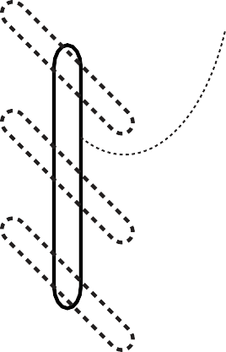
0 10 20 30 40 50
Windfall Tokens
0
10
H
180s Task
M
L
Earned Tokens
Actual Tokens Expected Tokens
Notes: The orange dots represent the expected payouts for different treatments. Green dots represent the realized payouts. The solid oval shows the three expected payouts that correspond to a task duration of 180 seconds. Each of these three has expected earnings of 25 tokens. The dashed ovals show the expected and realized payouts for the high, medium, and low windfall levels when the task duration is 180 seconds. The realized payouts to the right are reached when an individual performs above the median in the task, while those to the left are reached when performance is below the median. The diagram shows that a person randomized into the 180s task, medium windfall treatment will realize earnings of 20 tokens and windfall of 20 tokens if they perform below the median and earnings of 30 tokens and windfall of 10 tokens if they perform above the median.

Similarly, above median performers will get lower realized windfalls on average. Estimating the marginal effects of earnings and windfall on giving therefore presents an identification problem.
Table A1 presents a diagram of the experimental design. Each dictator is assigned to one of the 25 treatments described in the first three columns of the table. There are two sources of random variation in treatments. The first is the duration of the task, which ranges from zero to 1200 seconds (20 minutes) in nine steps. Those in the zero-duration task are in the windfall only (WO) treatment. Dictators in the other task durations may take part in the task only and get earned income (EO) or get both do the task and earn income and get a windfall (EW). Durations were chosen so that expected earnings would scale linearly with the median number of grids completed
in the task. The second source of variation is a random assignment to a windfall category. For durations between 60 and 300 seconds, different windfall levels are associated with each windfall category depending on score. This means that conditional on task duration, the windfall category determines the total payout. For the TW treatment, the mixture between earnings and windfall varies across task duration for each level of total payout.
The windfall levels for each task duration and above/below median performance were chosen to variation between 0 and 1 in the share of total tokens coming from earnings/windfall that is orthogonal to the level of total tokens. This allows me to uncover how the marginal willingness to share an earned or windfall token varies as the composition of income in terms of earnings and windfall varies.

A2.2 Recruitment
I recruited workers on Amazon Mechanical Turk (AMT) who were residents of India to take part in the experiment. AMT is the largest internet platform for distributed outsourcing, also known as “crowd-sourcing.” Employers use these markets to hire workers for tasks that require human intel- ligence, can be broken into discrete chunks, and can be completed using an internet-enabled com- puter. Tasks available to workers include classifying images by content, performing web searches, data entry and validation, taking market research surveys, transcribing audio, translating text, and commenting on blog posts.
A number of studies suggest that AMT workers behave similarly in social science research to the university undergraduates who are frequently used as subjects in the literature on social preferences (Horton et al., 2011; Paolacci et al., 2010; Buhrmester et al., 2011).
AMT allows employers to specify that workers can complete a task only once or multiple times. Workers see a list of tasks they are eligible to work on. The list contains detailed information about the work and the payment offered by the employer. When a worker agrees to perform a task and completes it, employers verify the quality of work, release payment to the worker, and may give a bonus.
The experiment appeared as a task, a Human Intelligence Task or HIT in Amazon parlance, that they could choose to complete. I limited the experiment to workers who had completed at least 500 HITs with a 95% or higher approval rating to filter out cheaters. Workers saw the experiment advertised as with fixed compensation of $0.40 and the headline
Survey with number puzzles and extra compensation. Bonus up to $1.80, with average bonus $0.60. 4-20 minutes. Average completion time 8 minutes.
Those workers who selected the HIT learned more about it. They could then choose whether to accept the HIT or not. The information they saw stated:
This HIT is part of a research project on decision making. In the HIT you will answer a number of questions and make some decisions. The HIT takes between 4 and 25 minutes. You will be paid $0.40 to complete this HIT.
You can get additional money, between $0 and $8.10, depending on decisions made by workers doing the HIT. The average additional amount is $2.10. You will receive any additional amounts as a bonus.
Table A1: Random Assignment and Payoffs

Random Assignment
E(Payoff)
Task Result Actual Payoff

A 10 20 30 0.33
Task  Duration | Treat-  ment | Windfall  Category |  | Earn-  ings | Wind-  fall | Above/Below  Median | Earned | Wind-  fall | Total | Earned  Share
 |  | L | - |  | 30 - - 30 30 0.00
 |  | ML | - |  | 40 - - 40 40 0.00
No Task | WO | M | - |  | 50 - - 50 50 0.00
 |  | MH | - |  | 135 - - 135 135 0.00
 |  | H | - |  | 270 - - 270 270 0.00
 |  | L | 5 |  | 25 B 0 30 30 0.00
60s | EW | M | 5 |  | 35 B 0 40 40 0.00
 |  | H | 5 |  | 45 B 0 50 50 0.00
 |  | L | 15 |  | 15 B 10 20 30 0.33
120s | EW | M | 15 |  | 25 B 10 30 40 0.25
 |  | H | 15 |  | B 10 40 50 0.20
 |  | L | 25 |  | 5 B 20 10 30 0.67
 | EW | M | 25 |  | 15 B 20 20 40 0.50  A 30 10 40 0.75
180s
 |  | H | 25 |  | 25 B 20 30 50 0.40
 | EO |  | 25 |  | - B 20 - 20 1.00
 |  | L | 35 |  | 0 B 30 0 30 1.00
 | EW | M | 35 |  | 5 B 30 10 40 0.75  A 40 0 40 1.00
240s
 |  | H | 35 |  | 15 B 30 20 50 0.60
 | EO |  | 35 |  | - B 30 - 30 1.00
 |  | L | 45 |  | 0 B 40 0 40 1.00
300s |  | H | 45 |  | 5 B 40 10 50 0.80
 | EO |  | 45 |  | - B 40 - 40 1.00
400s | EW | MH | 67.5 |  | 135 B 45 90 135 0.33
800s | EW | MMH | 135 |  | 67.5 B 90 45 135 0.67
1200s | EO | - | 202.5 |  | - B 135 0 135 1.00  A 270 0 270 1.00

A 10 30 40 0.25
A 10 40 50 0.20
A 20 10 30 0.67
A 20 20 40 0.50
35 A 20 30 50 0.40
A 30 0 30 1.00
A 30 20 50 0.60
A 30 - 30 1.00
A 40 0 30 1.00
A 40 10 50 0.80
A 40 - 40 1.00
A 50 0 50 1.00
A 50 0 50 1.00
A 50 - 50 1.00
A 90 180 270 0.33
A 180 90 270 0.67

If you accept this HIT, a link to our website will appear here.
If you completed one of our HITs since June 2012, you are NOT ELIGIBLE to partic- ipate in this one and cannot get paid. This helps us maintain the validity of our results. If you are unsure, accept the HIT and our website will check your ID. You can return the HIT if you are not eligible.
When you have completed the task, you will be provided a completion code. Please paste the code in the box below before submitting the HIT.
We welcome your comments and feedback! Please enter them in the box below.
When a worker accepted the HIT, they linked to the experiment, which was conducted using Qualtrics survey software.

A2.3 Manipulation Check
I wanted to insure that participants in the experiment made their choices carefully and fully un- derstood the instructions. While nearly all tasks on AMT are in English, it is possible that the English ability of some workers is low. AMT workers are also not subject to the implicit monitor- ing encountered in in-person experiments. I embedded the following question near the end of the experiment.
Research in the economics of decision making shows that people, when making de- cisions and answering questions, prefer not to pay attention and minimize their effort as much as possible. Some studies show that over 50% of people don’t carefully read questions. If you are reading this question and have read all the other questions, please select the box marked “other” and type “decision making” in the space provided. Do not select “your choices about dividing money.” Thank you for participating and tak- ing the time to read through the questions carefully!
What was this study about?
- Your choices about dividing money
- Matching numbers
- Political beliefs
- Other

Participants who both checked the ‘other’ box and entered ‘decision making’ passed the test. One quarter of the participants failed the test.

A2.4 Participant characteristics and task performance
Table A2 shows some characteristics of the participants. They averaged 20.4 years old. Most had completed college and 28% had a postgraduate degree. The postgraduate completion rate in India for this cohort is about 6%, so the participants are much better educated than average. Females made up 39% of the total. Most participants work full time and spend the majority of their work hours on distributed outsourcing tasks, either using AMT or another online labor market. At the
end of the experiment, 91% of participants judged the English used easy or very easy to understand.

Table A2: Participant Characteristics, N=1,418

Standard
 | Mean Deviation
Age | 20.4 8.5
Female | 0.388
Less than College | 0.149
College Graduate | 0.567
Postgraduate Degree | 0.284
Total Weekly Work Hours | 40.2 23.4
Share of Work Hours on Distributed Outsourcing | 0.605
Found English in Experiment Easy or Very Easy | 0.907
Notes: Includes participants in the main (N=1,022) and two-lottery (N=396) experiments. Average characteristics do not differ substantively across experiments.

On average, the 507 dictators in the main experiment accumulated $2.09 (about 70 tokens), and spent 13m47s completing the entire experiment. This works out to an hourly rate of $10.67 when we include the $0.40 participation fee. While this is a typical rate for workers on AMT, it is quite high compared to average wages in India. A full-time job paying $10 per hour is well into the top decile of earnings in India (Dubey and Vanneman, 2011).
Figure A2 shows the distribution of matrices solved per minute relative to the median rate for the task duration. Recall that above-median performance paid more. The distribution is smooth around the median, suggesting that workers did not decrease effort if they passed it. There was sub- stantial variation in the number of matrices solved. The 75th percentile worker was twice as fast as the 25th percentile worker. The timer ran only while the matrices were displayed, so the dispersion does not reflect network latency. Solving an extra grid per minute translated to approximately 10 additional tokens.

A2.5 Marginal source changes and total income
In order for us to conclude that the income sources are infungible, it is important to know that total income is unaffected by marginal changes in the sources. If an increase in earned income relative to windfall were to be correlated with increasing total income, for example, the marginal willingness to share from each source would be confounded with the marginal willingness to share overall.
The experimental design randomizes participants to levels of expected earnings and windfall so that total income should not vary with the fraction that is earned or from windfall. I use a local-
Figure A2: Matrices Solved Per Minute Relative to Median
.15
.2
.25

-4 -2 0 2 4 6
Density
0
.05
.1
Matrices Solved Per Minute Relative to Median

Notes: The figure shows a kernel density estimate of the num- ber of matrices solved per minute. The estimation used an Epanechnikov kernel with a bandwidth of 0.7.

linear regression to show how total income varies with the share earned (Cameron and Trivedi, 2005). The expected earned share serves as an instrument for the actual earned share and the bandwidth used is 0.2. Figure A3 plots the estimated conditional mean of total income against the share of income that is earned. The figure also shows the 24 different realized combinations of total income and the share earned. The two are clearly uncorrelated on average, and only weakly correlated local to any particular level of the earned share.

A2.6 Screen Shots
I provide a set of 19 screen shots that show the progress through the experiment for a dictator, beginning with the landing screen that appears when they have accepted the HIT through the final screen.
The task duration for this run was 180 seconds and the windfall category was M (see Table A1). Task performance was below median, which resulted in earned income of 20 tokens and windfall income of 20 tokens.
Screens 1 through 5 introduce the experiment, reveal that the participant will play Role B (the dictator), and describe the number matching task.
The number matching task and its results are shown in screens 6 and 7.
The windfall is revealed in screens 8 through 10. While the screen design makes it appear that the participant’s choice of boxes determines the amount of the windfall in tokens, in fact the windfall level M determines a windfall of 20 tokens given the below-median task performance.
Screens 11 through 14 present the sharing choice. Screen 13 is shown after an amount has
Figure A3: Total Income and Share Earned
200
250
300

0 .2 .4 .6 .8 1
Total Earnings
0
50
100
150
Fraction of Tokens from Earnings

Notes: The blue line shows how the conditional mean of total income varies with the share earned based on a non-parametric regression. Confidence in- tervals computed using bootstrap. Blue dots show the realized combinations of total income and share earned. Bandwith is 0.2.

been selected—when this screen initially appears both bars are at the zero position. The total of the amount shared and the amount kept must equal the dictator’s total earnings before they can continue.
Screens 15 through 19 present the manipulation check, demographic questions, and payment screen.

Screen 1
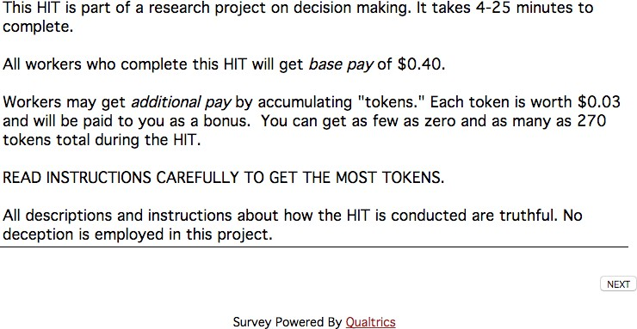

Screen 2
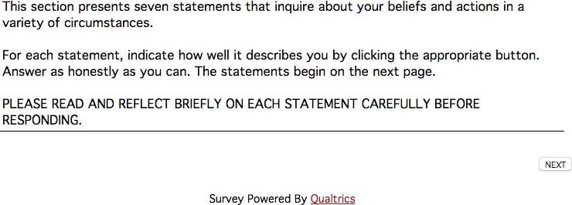

Screen 3
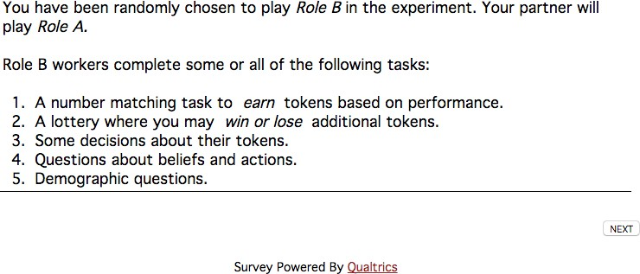

Screen 4
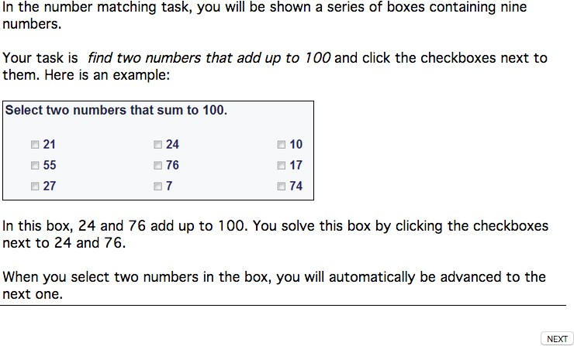

Screen 5
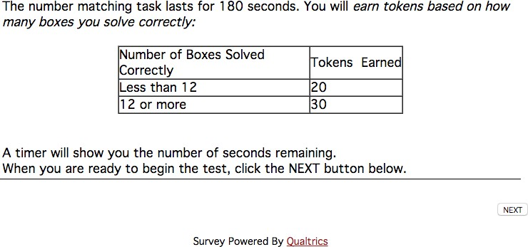

Screen 6
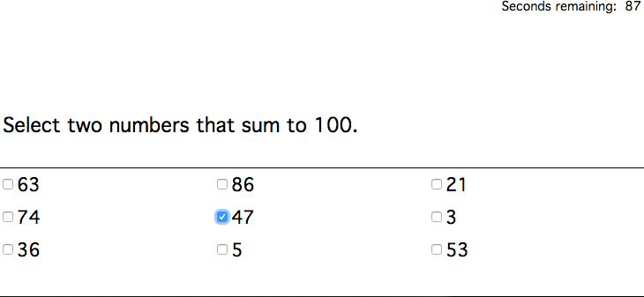

Screen 7
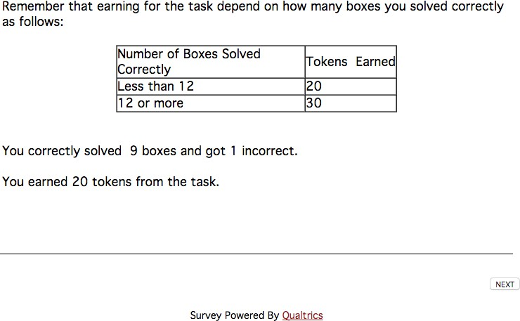

Screen 8
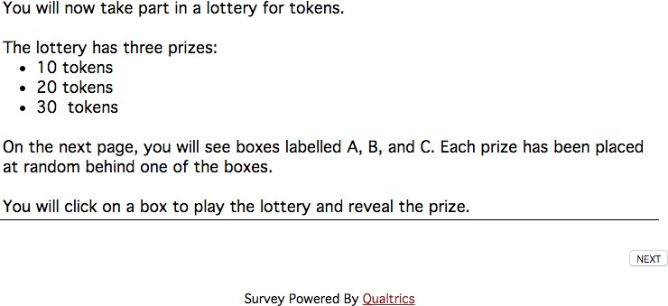

Screen 9
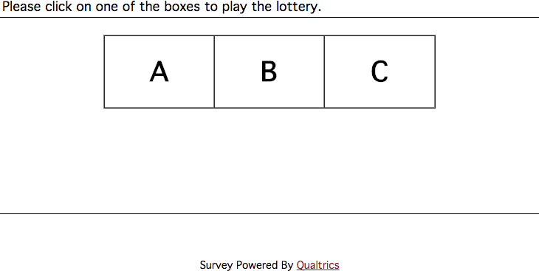

Screen 10
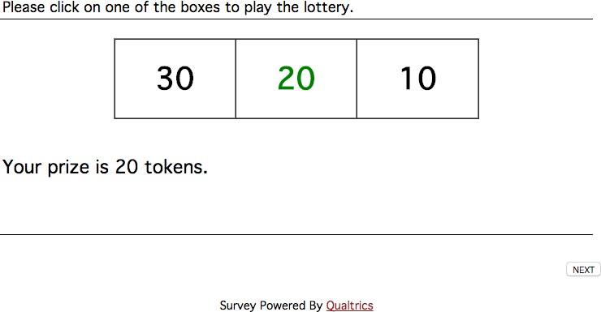

Screen 11
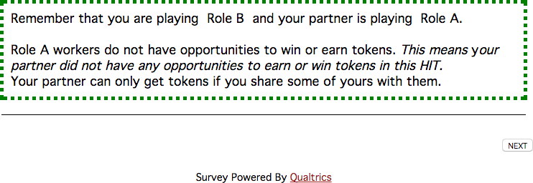

Screen 12


Screen 13
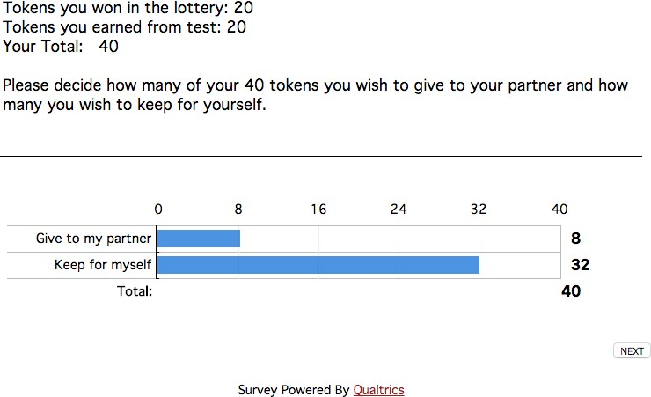

Screen 14
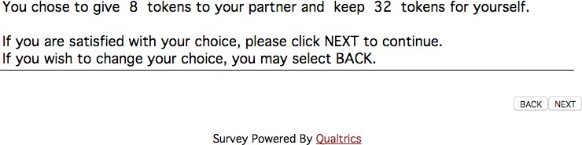

Screen 15


Screen 16
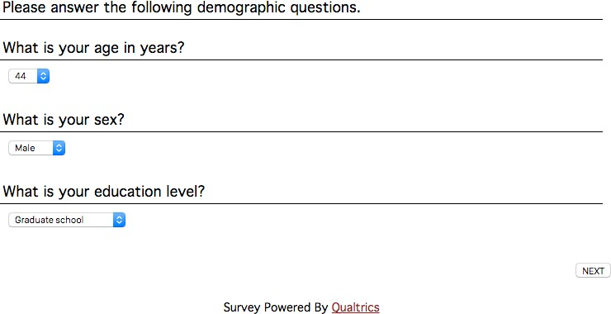

Screen 17
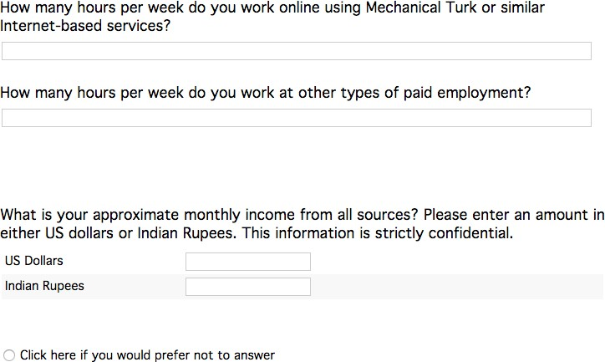

Screen 18
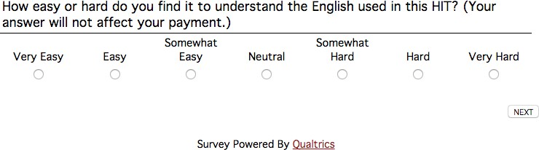

Screen 19
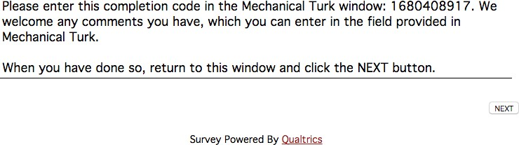

References
Buhrmester, M., Kwang, T., and Gosling, S. D. (2011). Amazon’s Mechanical Turk A New Source of Inexpensive, Yet High-Quality, Data? Perspectives on Psychological Science, 6(1):3–5.
Cameron, A. C. and Trivedi, P. (2005). Microeconometrics: Methods and Applications. Cambridge University Press.
Dubey, A. and Vanneman, R. (2011). Horizontal and Vertical Inequalities in India. India Human Development Survey Working Paper.
Horton, J., Rand, D., and Zeckhauser, R. (2011). The online laboratory: Conducting experiments in a real labor market. Experimental Economics, 14:399–425.
Paolacci, G., Chandler, J., and Ipeirotis, P. (2010). Running experiments on Amazon Mechanical Turk. Judgement and Decision Making, 5(5):411–419.
Thaler, R. H. (1999). Mental Accounting Matters. Journal of Behavioral Decision Making, 206(September 1998):183–206.

