The following is a translation of the original instructions (in Italian). Original instructions are available upon request.

Instructions Phase 1
Dear student, you are about to participate in an experiment on interactive decision making. Your privacy is guaranteed; results will be used and published anonymously. Your choices during the experiment will determine your earnings, which you will receive at the end of the data collection, via bank transfer. In this phase, you can earn between 1€ and 9€. Your earnings will depend on both your choices and the choices of another participant that will play the same games as you. This participant will receive the same instructions as you, and her/his earnings will depend, as in your case, on the combination between your choices and hers/his.

General structure of the game
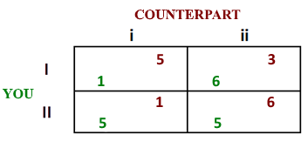
This part of the experiment consists of 48 rounds. In each round, you will face an interactive decision-making situation. The structure of each interactive decision problem, which we will call “game” henceforth, will be represented by a matrix like the one shown below. Each number in the matrix indicates an amount in euros. Throughout the experiment, you will always play as the row player and you will have to choose either row I or row II, while the other participant (counterpart) will always play as the column player and it will choose either column i or column ii.

From each combination of choices of the ROW PLAYER and COLUMN PLAYER (i.e., for each combination of rows and columns), one cell of the matrix will be selected. Each cell contains two numerical values (one in green and one in red). These values correspond to a score for each player. In each cell, the number at the bottom and in green represents the score for the ROW PLAYER (yours), while the number on top and in red represents the score for the COLUMN PLAYER (the one of the counterpart).

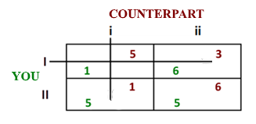
For example, in the matrix below, if YOU choose row I, and your counterpart chooses column i, your respective scores will be located in the cell at the intersection between the selected row and column. In this example, the score is 1 for you and 5 for the other player.

Keep in mind that you cannot directly choose the cell of the matrix, but only one of the rows (the counterpart with whom you will be matched will choose one column). Only the combination of both choices will select one and only one cell, corresponding to your earnings and to those of the counterpart.
The choices that you and the other participant will make, and the corresponding results, will not be communicated to you or her/him after each game.
In each of the 48 rounds, the screen will show the decisional matrix for that round, and you will be asked to make a decision. To select your choice, you will have to press key 1 for row I (the row on the top of the matrix) and key 2 for row II (the row on the bottom of the matrix).
You will face 48 decisional matrices, corresponding to 48 different interactive situations. There is no relation between your choices in the different games, each game is independent from the others. You have not time limit in your response.

Payment
Your earnings in this phase will be determined at the end of the entire experiment, after two additional phases. We will use the following procedure. Each matrix is identified by a code. Some tags will be placed in a box, each showing the code of one of the matrices. The experimenter will ask you to pick one of these tags from the box. You will be paid according to the earnings obtained in the matrix corresponding to the extracted code. Specifically, your earnings will be determined by the combination between your choice and the choice of your counterpart, in the game you have drawn. The earning of all other participants will be determined using the same procedure.
Since each of the 48 decisional matrices of the experiment has the same probability of being selected for payment, we ask you to devote the same attention to all of them.
Before the experiment starts, we will ask you to answer a simple questionnaire, in order to test whether instructions have been clearly understood or whether clarifications are needed. If there are incorrect answers, the relevant part of the instructions will be repeated. The experiment will start after the questionnaire phase is completed.
Thank you for your participation!

Questionnaire Phase 1

Dear Participant,
the following questionnaire has the sole purpose of verifying your understanding of the rules of this experiment. We ask you to answer the following questions. If you are uncertain about how to respond, please consult the instructions sheet or the experimenter. Your answers to these questions will not affect your earnings in the experiment.
Thank you for your cooperation!

Considering this game:
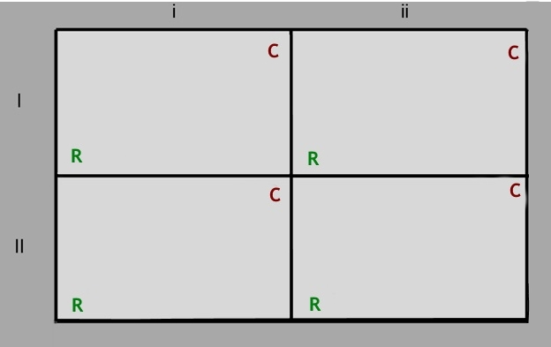
7
2
4
6
1
6
8
2

Suppose you are assigned the role of ROW PLAYER:

- If the COLUMN PLAYER chooses the first column and you choose the first row, how many EUROs will you earn? ........... And how many will the other player earn? ...........
- If you choose the second row, and COLUMN PLAYER chooses the first column, how many EUROs will that person earn? ........... And how many EUROs will you earn? ...........

- If the other player chooses the second column, your earnings will be:
- If you choose the first row: ...........
- If you choose the second row: ...........

- Suppose you are assigned the role of COLUMN PLAYER:
- If the ROW PLAYER chooses the first row and you choose the second column, how many EUROs will you earn? ........... And how many will the other player earn? ...........
- If the other player chooses the second row, your earnings will be:

- If you choose the first column: ...........
- If you choose the second column: ...........
Instructions Phase 2
In this phase of the experiment you will face a computer that will choose its actions following different decision rules. Each of these rules will be described in detail below.
During the experiment, your task will be to adapt your choice according to the rule that from time to time will be used by the computer.

Rule number 1
Your goal: to respond in the best possible way to a computer that chooses randomly.
At each round of this experimental phase, the computer will simulate the behavior of a player who responds randomly. This means that it will choose column i with a 50% probability and column ii with a 50% probability. In this scenario, the best thing you can do to get the highest possible score is to choose the row with the highest average payoff.
In the previous example the action with the highest average payoff is row II. In fact, row II determines an average score of 5 ((5 + 5) / 2), while row I determines an average score of 3.5 ((1 + 6) / 2).

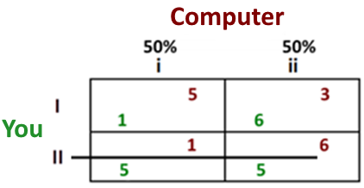

In this part of the experiment you will face 48 rounds of choice. Whenever you choose according to the option that determines the highest average payoff, you will receive 7 cents, if you provide a wrong answer, your earnings (for that round) will be 0 cents.
In this experimental phase, your earnings will vary from a minimum of 0 cents up to a maximum of 3.36 euros, depending on the number of times you choose the row with the highest average score.

Rule number 2
Your goal: to respond in the best possible way to a computer that chooses the column with the highest average payoff. At each round of this experimental phase, the computer will simulate the behavior of a player who chooses the column with the highest average payoff.
In this scenario, the best thing you can do is to choose the option (row I or row II) that allows you to get the highest score based on the column selected by the computer. In the previous example the computer will choose column ii because it offers the highest average payoff (column ii: (3 + 6) / 2 = 4.5; column i: (5 + 1) / 2 = 3). To answer correctly, you will have to choose the option I, which will get you a score of 6, higher than 5 that you would get by choosing the option II.
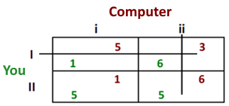

In this part of the experiment you will face 48 rounds of choice. Whenever you choose according to the option that allows you to get the highest payoff (knowing that the computer will choose the column with the highest average payoff) you will receive 7 cents, if you provide a wrong answer, your earnings (for that round) will be 0 cents.
In this experimental phase, your earnings will vary from a minimum of 0 cents up to a maximum of 3.36 euros, depending on the number of times you choose the row with the highest average score.

Rule number 3
Your goal: coordinate your choice with that of the counterpart on the outcome that maximizes the joint payoff.
At each round of this experimental phase the computer will simulate the behavior of a player who will try to coordinate with you on the outcome that maximize the joint payoff of the two players. The computer will choose the column in which the cell with the highest joint score is located. Your goal will be to do the same: to choose the row containing the cell that maximizes the joint payoff of the two players.
In the previous example, the outcome with the highest joint payoff is the lower right cell of the matrix (6 + 5 = 11). For this reason, the computer will choose the option ii. To answer correctly, you have to choose the option II.
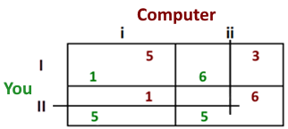

In this part of the experiment you will face 48 rounds of choice. Whenever you choose the row that contains the cell with the highest joint score, you will receive 7 cents, if you provide a wrong answer, your earnings (for that round) will be 0 cents.
In this experimental phase, your earnings will vary from a minimum of 0 cents up to a maximum of 3.36 euros, depending on the number of times you choose the row with the highest average score.

Questionnaire Phase 2
Dear participant,
The following questionnaire has the sole purpose of verifying your understanding of the instructions. Your answers will not affect your future earnings.
To answer the questions you can consult the instructions. If you have any doubts, you can ask the investigator for clarification.
Thanks for your cooperation.

- During the experiment you will play the role of:
Row player Column player

- In each round, ho have to choose:
a Row a Column a matric cell

- Your earnings will be determined based on :
your total points number of corrrect responses

- In the following game, which is the correct response according to:

 | i |  | ii
I |  | 4 |  | 6
 | 3 |  | 1
II |  | 2 |  | 7
 | 2 |  | 4

- the rule number 1:
I II

- the rule number 2:
I II

- the rule number 3:
I II

Instructions Phase 3
Instructions
In this phase, you will play with another participant who play the same games in another experimental session. This participant did not undertake Session 1 and 2. Moreover, he/she doesn’t know that you have played Session 1 and 2 before this session.
From this point, the instructions and payment procedure that you will receive will be identical to the one she/he receive.

General structure of the game
This phase consists of 48 rounds. The structure of each interactive decision problem, which we will call “game” henceforth, will be represented by a matrix like the one shown below. The matrix will always have two rows (I, II), and two columns (i, ii).
You will always play as the row player and you will have to choose either row I or row II, while the other participant (counterpart) will always play as the column player and it will choose either column i or column ii.

From each combination of choices of the ROW PLAYER and COLUMN PLAYER (i.e., for each combination of rows and columns), one cell of the matrix will be selected. Each cell contains two numerical values (one in green and one in red). These values correspond to a score for each player. In each cell, the number at the bottom and in green represents always the score for the ROW PLAYER (yours), while the number on top and in red represents always the score for the COLUMN PLAYER (the one of the counterpart).

For example, in the matrix below, if YOU choose row I, and the counterpart chooses column i, your respective scores will be located in the cell at the intersection between the selected row and column. In this example, the score is 1 for you and 5 for the other player.

Keep in mind that you cannot directly choose the cell of the matrix, but only one of the rows (the counterpart with whom you will be matched will choose one column). Only the combination of both choices will select one and only one cell, corresponding to your earnings and to those of the counterpart.

The choices that you and the other participant will make, and the corresponding results, will not be communicated to you or her/him after each game.
In each of the 48 rounds, the screen will show the decisional matrix for that round, and you will be asked to make a decision. To select your choice, you will have to press key 1 for row I (the row on the top of the matrix) and key 2 for row II (the row on the bottom of the matrix).
You will face 48 decisional matrices, corresponding to 48 different interactive situations. There is no relation between your choices in the different games, each game is independent from the others. You have not time limit in your response.

Payment
Your earnings in this phase will be determined following the same procedure of the first phase. We will use the following procedure. Each matrix is identified by a code. Some tags will be placed in a box, each showing the code of one of the matrices. The experimenter will ask you to pick one of these tags from the box. You will be paid according to the earnings obtained in the matrix corresponding to the extracted code. Specifically, your earnings will be determined by your choice and the choice of your counterpart, in the game you have drawn. The earning of all other participants will be determined using the same procedure.
Since each of the 48 decisional matrices of the experiment has the same probability of being selected for payment, we ask you to devote the same attention to all of them. You can earn between 1€ and 9€ in this phase.
Thank you for your participation!

