Appendix to When is Punishment Harmful to Cooperation?
by Tingting Fu and Louis Putterman

Part 1. Robustness of Herrmann et al.’s (2008) cross-society pattern to substitution of the perverse/normal distinction

While the focus of our paper is on whether a perverse vs. normal classification of punishment better explains subjects’ reactions to being punished than does the antisocial vs. prosocial classification used by Herrmann et al. (2008), it is interesting to consider briefly whether use of a perverse/normal distinction would have substantively altered the conclusions on which Herrmann et al.’s (2008) own analysis focuses. The main theme of their important discussion is that subjects drawn from culturally different populations differ in the way they use punishment in a cooperation-and-punishment experiment: those in countries scoring well on indices of “norms of civic cooperation” and “rule of law” display a much stronger bias towards prosocial punishment than those with lower values of those indices. Would a similar conclusion have been drawn if instead of the prosocial/antisocial distinction the authors had used the normal/perverse one? Figure A.1 suggests a potentially affirmative answer, although also perhaps hinting at why the first approach was preferred. Panel (a) resembles Figure 2.B of Herrmann et al. (2008), plotting average contribution in the punishment condition, by subject pool, against the share of punishment that is antisocial. In panel (b), we instead plot contribution against the share of punishment that is perverse. The two patterns look similar, with most although not all sites occupying similar spatial positions, although the fit is somewhat better in panel (a) (with p-value an order of magnitude smaller). The correlation coefficient between the share of antisocial punishment and the share of perverse punishment, across the 16 sites, is 0.9265 (p < 0.0001, Spearman's rank correlation coefficients). We also plot average contribution against the share of punishment events that are antisocial/perverse in panel (a) and (b) of Figure A.2 as a robustness check. The patterns in Figure A.2 look similar to those in Figure A.1. Overall, then, it seems likely that the general message of Herrmann et al. (2008) would hold also were the alternative parsing of data to have been followed. The broader dispersion of points in panel (a) than panel (b), and the lower p-value for the best linear fit in both Figure A.1 and Figure A.2, might make the prosocial/antisocial categorization more attractive from an expository standpoint.
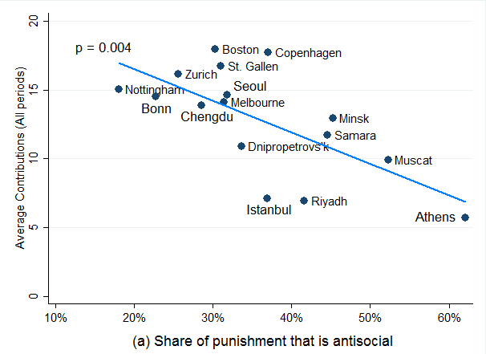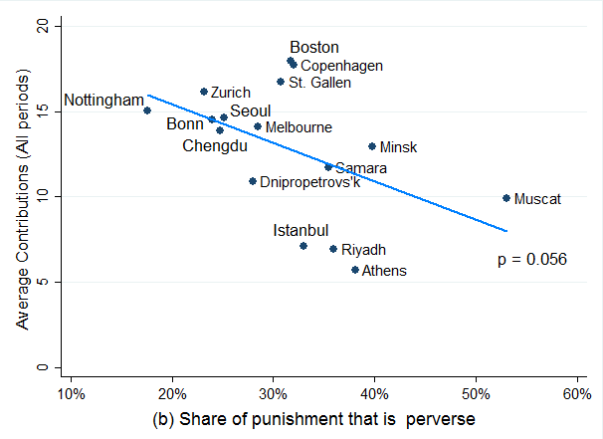
Fig. A.1. Plots of contribution against punishment shares using (a). the antisocial/prosocial distinction, and (b). the perverse/normal distinction.

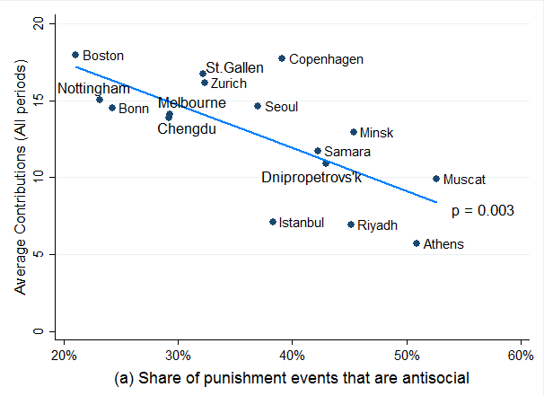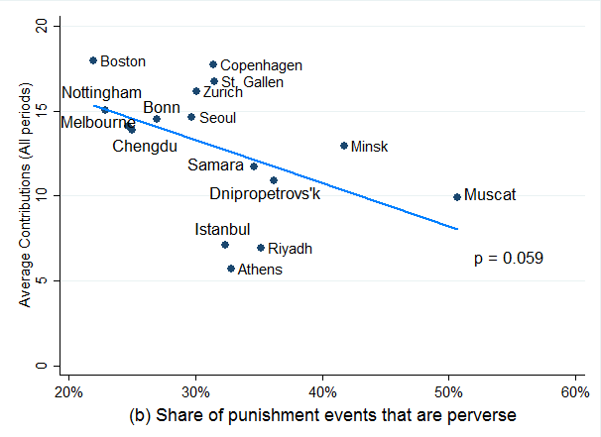
Fig. A.2. Plots of contribution against punishment events shares using (a) the antisocial/prosocial distinction, and (b) the perverse/normal distinction.

Part 2. Between-pool differences in the degree to which perverse and antisocial (normal and prosocial) overlap

Although there is little evidence of systematic difference among countries with respect to the proportion of antisocial punishment that is also perverse, there is evidence of a pattern with respect to the proportion of punishment given to low contributors (normal punishment) that is given by higher ones (prosocially). In high contributing subject pools from countries with evidence of stronger prosocial norms, a higher proportion of normal punishment is also prosocial. Figure A.3 (a) displays this pattern. At sites where high cooperation was attained, a low-contributing subject receiving punishment could have correctly guessed with about 90% accuracy that her punisher was a more cooperative group member than herself, while the proportion is smaller (75%) in less cooperating subject pools. A linear regression predicting contributions as a function of the share of normal punishment events that are prosocial—see the best fit lines of Figure A.3—has p < 0.001 for the partial correlation. Perhaps subjects in the more normatively-inclined societies were more reluctant than those at the more antisocial sites to punish a low contributor unless they themselves had contributed more, even though the contribution level of the punisher would not be known. That is, subjects in the former sites may have felt more concern regarding whether punishing was justified.
However, differences in the opportunity sets created by observed configurations of contributions also contribute to explaining the different shares of antisocial punishment in the universe of normal punishment cases and outlays. Figure A.3(b) indicates that opportunities to punish normally fell more often in the normal and prosocial category in the less antisocial subject pools. The third and fourth rows of each panel of Table 2 provide further information on overall opportunities to engage in each category of punishment. From columns (1) and (2) of the third rows of the relevant panels, we see that the share of opportunities to punish that fell in the normal but antisocial category was about twice as large (11.8% vs. 5.8%) in the more antisocial subject pools and statistically significantly different (two-tailed Pearson’s chi-squared test, chi² = 370.94, p < 0.001). Nonetheless, the proportion of all normal punishment opportunities that fall in the normal but antisocial category does not differ very much (23% vs. 27%), and members of the more antisocial subject pools used a statistically significantly larger share of their opportunities to normally but antisocially punish (28.5% vs. 16.5%, two-tailed Pearson’s chi-squared test, chi² = 50.55, p < 0.001), supporting the interpretation that they were more prone to engage in such punishment after controlling for the number of opportunities.
Fig. A.3. (a) Plot of average contribution against the share of normal punishment events that are prosocial. (b) Plot of average contribution against share of normal punishment opportunities that are prosocial.
Notes: The p-value for the best linear fit is shown in each figure. The parallel figures plot average earning against the share of normal punishment events/opportunities that are prosocial can be found in Fig. A.4. The parallel figures using the share of normal punishment amount (rather than share of events) that is prosocial can be found in Fig. A.5.

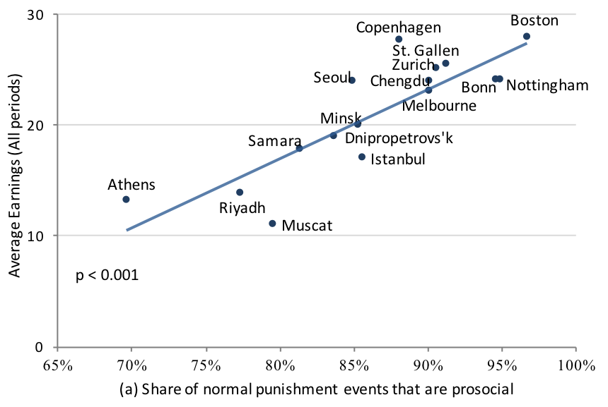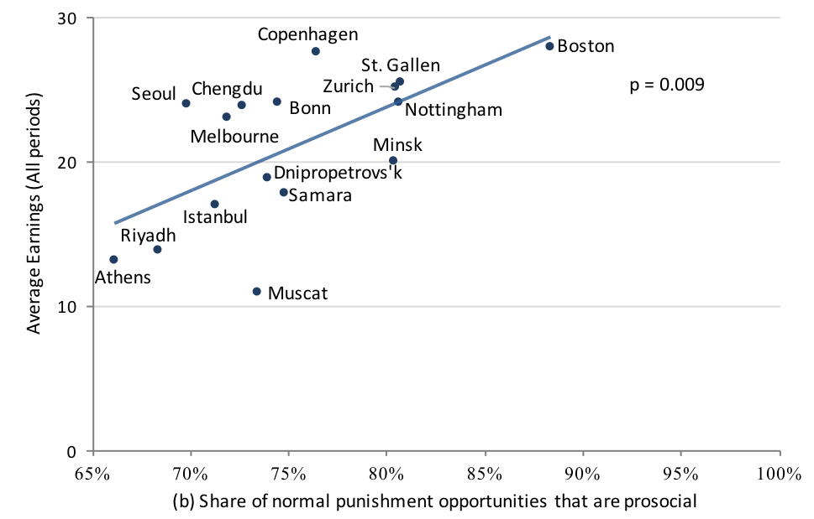
Fig. A.4. (a) Plot of average earning against the share of normal punishment events that are prosocial. (b) Plot of average earning against share of normal punishment opportunities that are prosocial. The p-value for the best linear fit is shown in each figure.
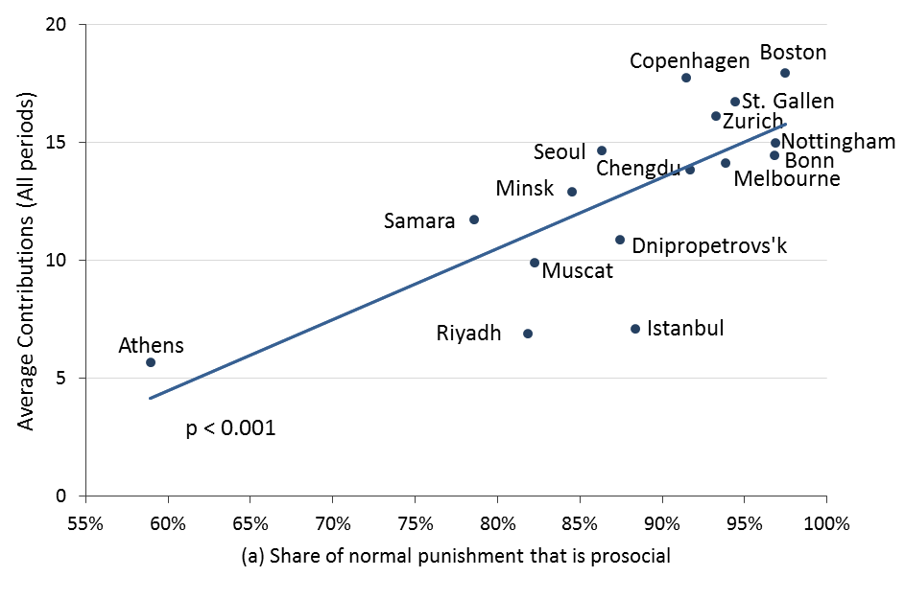
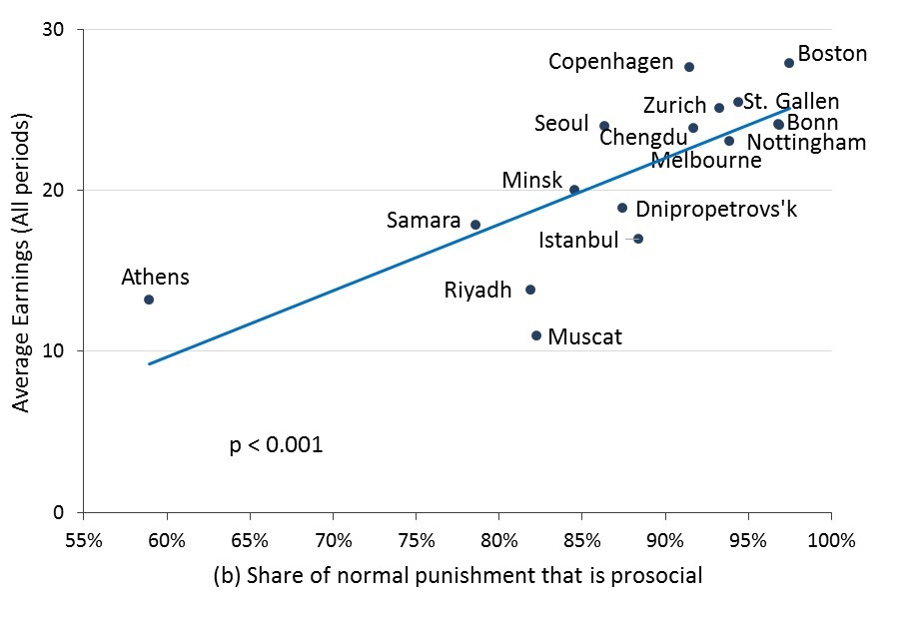
Fig. A.5. Plots of (a) average contribution and (b) average earnings against the share of normal punishment that is prosocial. This figure replicates Figure A.3 except that it uses the share of normal punishment amount that is prosocial rather than share of normal punishment events that are prosocial. The p-value for the best linear fit is shown in each figure.

Part 3. Regressions Estimates

Table A.1. Individual fixed effect linear regression estimates of effects of punishment on contribution, with two-way categorizations (Prosocial/ Antisocial), by subject pool.
 | Samara |  | Athens |  | Dnipropetrovs’k |  |  | Istanbul |  | Minsk | Muscat | Riyadh | Seoul
(i)Received Prosocial Punishment |  | 0.961*** |  | 0.528*** |  | 0.749*** | 0.666*** |  | 0.706*** |  | 0.365** | 0.495*** | 0.867***
 |  | (0.135) |  | (0.074) |  | (0.214) | (0.109) |  | (0.131) |  | (0.129) | (0.151) | (0.072)
(ii)Received Antisocial Punishment |  | -0.293 |  | -0.095 |  | -0.934*** | -0.207** |  | -0.541*** |  | -0.439** | -0.353* | -0.174
 |  | (0.186) |  | (0.110) |  | (0.237) | (0.077) |  | (0.139) |  | (0.178) | (0.178) | (0.137)
(iii)period |  | -0.063 |  | 0.110* |  | -0.167* | 0.053 |  | -0.265*** |  | -0.117 | -0.079 | -0.093***
 |  | (0.061) |  | (0.050) |  | (0.090) | (0.063) |  | (0.090) |  | (0.068) | (0.125) | (0.025)
Constant |  | -0.610 |  | -0.950** |  | 0.421 | -0.838** |  | 0.997* |  | 0.754 | 0.045 | 0.646***
 |  | (0.463) |  | (0.356) |  | (0.500) | (0.371) |  | (0.518) |  | (0.591) | (0.732) | (0.184)
Observations |  | 1,368 |  | 396 |  | 396 | 576 |  | 612 |  | 468 | 432 | 756
R-squared |  | 0.0986 |  | 0.0765 |  | 0.0569 | 0.1422 |  | 0.0869 |  | 0.0509 | 0.0357 | 0.2282
F |  | 17.88 |  | 25.49 |  | 8.99 | 17.54 |  | 30.85 |  | 4.85 | 7.53 | 63.32
Prob > F |  | 0.0000 |  | 0.0001 |  | 0.0035 | 0.0000 |  | 0.0000 |  | 0.0195 | 0.0052 | 0.0000
p-value of F test on (i)=(ii) |  | 0.000*** |  | 0.004*** |  | 0.001*** | 0.000*** |  | 0.000*** |  | 0.003*** | 0.003*** | 0.000***
(a) Eight most antisocial subject pools
 |  | Boston | Nottingham |  |  | Melbourne |  | St. Gallen |  | Bonn | Copenhagen |  |  | Chengdu |  | Zurich
(i)Received Prosocial Punish. | 1.636*** |  |  | 1.469*** | 0.964*** |  | 1.249*** |  | 1.329*** |  |  | 1.199*** | 1.180*** |  | 1.328***
(i)Received Prosocial Punish. | (0.192) |  |  | (0.212) | (0.166) |  | (0.231) |  | (0.100) |  |  | (0.153) | (0.108) |  | (0.187)
(ii)Received Antisocial Punish. | 0.068 |  |  | 0.272 | -0.028 |  | 0.286 |  | -0.889*** |  |  | -0.483 | -0.198 |  | 0.131
(ii)Received Antisocial Punish. | (0.042) |  |  | (0.158) | (0.070) |  | (0.274) |  | (0.089) |  |  | (0.437) | (0.125) |  | (0.195)
(iii)period | -0.113 |  |  | -0.059 | -0.157* |  | -0.160** |  | -0.055 |  |  | -0.140 | -0.162** |  | -0.092**
 | (0.090) |  |  | (0.073) | (0.083) |  | (0.058) |  | (0.071) |  |  | (0.089) | (0.070) |  | (0.041)
Constant | -0.149 |  |  | -0.869* | 0.799* |  | -0.211 |  | -0.314 |  |  | 0.428 | 0.455 |  | -0.279
 | (0.407) |  |  | (0.421) | (0.428) |  | (0.360) |  | (0.353) |  |  | (0.459) | (0.316) |  | (0.302)
Observations | 504 |  |  | 504 | 360 |  | 864 |  | 540 |  |  | 612 | 864 |  | 828
R-squared | 0.3449 |  |  | 0.1958 | 0.2985 |  | 0.1797 |  | 0.2943 |  |  | 0.2919 | 0.1477 |  | 0.2131
F | 36.56 |  |  | 19.18 | 24.42 |  | 12.05 |  | 153.49 |  |  | 24.49 | 40.91 |  | 37.86
Prob > F | 0.0000 |  |  | 0.0000 | 0.0001 |  | 0.0001 |  | 0.0000 |  |  | 0.0000 | 0.0000 |  | 0.0000
p-value of F test on (i)=(ii) | 0.000*** |  |  | 0.001*** | 0.000*** |  | 0.001*** |  | 0.000*** |  |  | 0.003*** | 0.000*** |  | 0.000***
(b) Eight least antisocial subject pools
Notes: The dependent variable is the change in the contribution between period t and period t+1 (∆C_{j} = C_{j(t+1)} – C_{jt}). “Received Punishment” in two-way categorizations is the sum of the tokens received from the other three group members in period t. We separately control for the punishment that subject i gives to subject j in Stage 2 of period t, when subject j’s contribution C_{jt} is less than subject i’s contribution C_{it} in period t(i.e. prosocial punishment), and when subject j’s contribution is more than or equal to subject i’s contribution in period t(i.e. antisocial punishment).“Period” is the period number t. The regressions parallel those of the main text’s Table 3 panel (a). Robust standard errors clustered by group are in parentheses. * p < 0.1, ** p < 0.05, *** p < 0.01.
Table A.2. Individual fixed effect linear regression estimates of effects of punishment on contribution, with two-way categorizations (Normal/ Perverse), by subject pool.
 | Samara | Athens | Dnipropetrovs’k |  |  | Istanbul |  | Minsk |  | Muscat | Riyadh |  | Seoul
(i)Received Normal Punishment | 0.837*** | 0.318*** |  | 0.762*** | 0.629*** |  | 0.715*** |  | 0.495*** |  |  | 0.449*** | 0.875***
(i)Received Normal Punishment | (0.121) | (0.094) |  | (0.218) | (0.102) |  | (0.114) |  | (0.120) |  |  | (0.122) | (0.081)
(ii)Received Perverse Punishment | -0.462*** | -0.092 |  | -1.002** | -0.188** |  | -0.620*** |  | -0.587*** |  |  | -0.432** | -0.573***
(ii)Received Perverse Punishment | (0.170) | (0.185) |  | (0.340) | (0.078) |  | (0.117) |  | (0.157) |  |  | (0.183) | (0.170)
(iii)period | -0.055 | 0.123** |  | -0.161* | 0.063 |  | -0.243** |  | -0.126 |  |  | -0.054 | -0.095***
 | (0.055) | (0.048) |  | (0.088) | (0.061) |  | (0.090) |  | (0.074) |  |  | (0.111) | (0.026)
Constant | -0.596* | -1.099** |  | 0.293 | -0.913** |  | 0.902* |  | 0.890 |  |  | -0.046 | 0.666***
 | (0.345) | (0.369) |  | (0.507) | (0.379) |  | (0.507) |  | (0.656) |  |  | (0.647) | (0.159)
Observations | 1,368 | 396 |  | 396 | 576 |  | 612 |  | 468 |  |  | 432 | 756
R-squared | 0.1351 | 0.0509 |  | 0.0585 | 0.1543 |  | 0.1138 |  | 0.0779 |  |  | 0.0516 | 0.2669
F | 17.19 | 5.41 |  | 6.84 | 17.41 |  | 35.38 |  | 17.77 |  |  | 14.96 | 60.67
Prob > F | 0.0000 | 0.0180 |  | 0.0087 | 0.0000 |  | 0.0000 |  | 0.0001 |  |  | 0.0003 | 0.0000
p-value of F test on (i)=(ii) | 0.000*** | 0.108 |  | 0.002*** | 0.000*** |  | 0.000*** |  | 0.000*** |  |  | 0.000*** | 0.000***
(a) Eight most antisocial subject pools
 | Boston | Nottingham |  | Melbourne |  | St. Gallen | Bonn | Copenhagen |  | Chengdu | Zurich
(i)Received Normal Punish. | 1.674*** |  | 1.444*** | 0.932*** | 1.276*** |  | 1.310*** |  | 1.229*** | 1.158*** | 1.285***
(i)Received Normal Punish. | (0.196) |  | (0.212) | (0.168) | (0.228) |  | (0.088) |  | (0.156) | (0.111) | (0.179)
(ii)Received Perverse Punish. | 0.034 |  | 0.400** | 0.002 | 0.129 |  | -0.825*** |  | -0.603 | -0.482 | -0.036
(ii)Received Perverse Punish. | (0.035) |  | (0.178) | (0.081) | (0.231) |  | (0.125) |  | (0.406) | (0.356) | (0.196)
(iii)period | -0.132 |  | -0.056 | -0.163* | -0.175*** |  | -0.081 |  | -0.131 | -0.169** | -0.095**
 | (0.086) |  | (0.073) | (0.084) | (0.060) |  | (0.066) |  | (0.090) | (0.064) | (0.040)
Constant | -0.040 |  | -0.898* | 0.807* | -0.110 |  | -0.159 |  | 0.321 | 0.516* | -0.233
 | (0.387) |  | (0.426) | (0.427) | (0.368) |  | (0.314) |  | (0.466) | (0.300) | (0.303)
Observations | 504 |  | 504 | 360 | 864 |  | 540 |  | 612 | 864 | 828
R-squared | 0.3518 |  | 0.1950 | 0.2839 | 0.1877 |  | 0.2897 |  | 0.3127 | 0.1709 | 0.2218
F | 35.50 |  | 16.03 | 16.42 | 12.73 |  | 210.11 |  | 24.29 | 42.05 | 37.97
Prob > F | 0.0000 |  | 0.0001 | 0.0005 | 0.0000 |  | 0.0000 |  | 0.0000 | 0.0000 | 0.0000
p-value of F test on (i)=(ii) | 0.000*** |  | 0.001*** | 0.000*** | 0.000*** |  | 0.000*** |  | 0.001*** | 0.000*** | 0.000***
(b) Eight least antisocial subject pools
Notes: The dependent variable is the change in the contribution between period t and period t+1 (∆C_{j} = C_{j(t+1)} – C_{jt}). “Received Punishment” in two-way categorizations is the sum of the tokens received from the other three group members in period t. We control separately the received punishment when the subject’s contribution C_{jt} is less than the average contribution $\overline{C}$_{t} in the group in period t(i.e. normal punishment), and when the subject’s contribution is more than or equal to the average contribution in the group in period t(i.e. perverse punishment). “Period” is the period number t. The regressions parallel those of the main text’s Table 3 panel (b). Robust standard errors clustered by group are in parentheses. * p < 0.1, ** p < 0.05, *** p < 0.01.
Table A.3. Individual Random-effects Tobit regression estimates of effects of punishments on contribution, with left-censored at -20 and right-censored at 20.
 |  | (a) |  |  |  |  | (b)
 |  | (1) |  | (2) | (3) | (4) |  | (5) |  | (6)
 | 8 least antisocial subject pools |  | 8 most antisocial subject pools |  | 16 sites pooled | 8 least antisocial subject pools |  |  | 8 most antisocial subject pools |  | 16 sites pooled
(i)Received Prosocial Punishment |  | 0.925*** |  | 0.440*** | 0.604***
 |  | (0.034) |  | (0.024) | (0.018)
(ii)Received Antisocial Punishment |  | -0.183*** |  | -0.235*** | -0.237***
 |  | (0.059) |  | (0.030) | (0.025)
(iii)Received Normal Punishment |  |  |  |  |  | 0.929*** |  | 0.409*** |  | 0.564***
 |  |  |  |  |  | (0.034) |  | (0.022) |  | (0.017)
(iv)Received Perverse Punishment |  |  |  |  |  | -0.256*** |  | -0.342*** |  | -0.326***
 |  |  |  |  |  | (0.059) |  | (0.031) |  | (0.025)
(v)period |  | -0.164*** |  | -0.096*** | -0.144*** | -0.169*** |  | -0.088*** |  | -0.143***
 |  | (0.022) |  | (0.027) | (0.017) | (0.021) |  | (0.027) |  | (0.017)
Constant |  | 0.482*** |  | 0.324** | 0.494*** | 0.500*** |  | 0.309* |  | 0.503***
 |  | (0.129) |  | (0.162) | (0.103) | (0.129) |  | (0.160) |  | (0.102)
Observations |  | 5,076 |  | 5,004 | 10,080 | 5,076 |  | 5,004 |  | 10,080
Left-censored observations |  | 61 |  | 33 | 94 | 61 |  | 33 |  | 94
Right-censored observations |  | 38 |  | 24 | 62 | 38 |  | 24 |  | 62
Log likelihood |  | -14027.6 |  | -14964.5 | -29210.0 | -14003.0 |  | -14904.0 |  | -29138.9
Wald chi2 |  | 913.12 |  | 440.43 | 1420.26 | 969.46 |  | 573.69 |  | 1584.17
Prob > chi2 |  | 0.0000 |  | 0.0000 | 0.0000 | 0.0000 |  | 0.0000 |  | 0.0000
AIC |  |  |  |  | 58432 |  |  |  |  | 58290
Notes: The dependent variable is the change in the contribution between period t and period t+1 (∆C_{j} = C_{j(t+1)} – C_{jt}). Received punishment in a given category is defined for purposes of these regressions as the sum of the (un-tripled) tokens received from the other three group members in period t. Standard errors are in parentheses. * p < 0.1, ** p < 0.05, *** p < 0.01.

Table A.4. Individual fixed effects linear regression estimates of effects of punishments on contribution in alternative two-way categorizations, with positional dummy terms.
 | (a) |  |  |  | (b)
 | (1) | (2) | (3) | (5) |  | (6) | (7)
 | 8 least antisocial subject | 8 most antisocial subject | 16 sites pooled | 8 least antisocial subject |  | 8 most antisocial subject | 16 sites pooled
(i)Received prosocial punishment amount | 0.921*** | 0.334*** | 0.530***
(i)Received prosocial punishment amount | (0.065) | (0.048) | (0.046)
(ii)Received antisocial punishment amount | -0.080 | -0.165*** | -0.148***
(ii)Received antisocial punishment amount | (0.118) | (0.063) | (0.056)
(iii)Received normal punishment amount |  |  |  | 0.932*** |  | 0.334*** | 0.519***
(iii)Received normal punishment amount |  |  |  | (0.063) |  | (0.045) | (0.044)
(iv)Received perverse punishment amount |  |  |  | -0.121 |  | -0.241*** | -0.200***
(iv)Received perverse punishment amount |  |  |  | (0.124) |  | (0.073) | (0.068)
(v) h | -1.447*** | -3.010*** | -2.362*** | -1.745*** |  | -3.355*** | -2.746***
 | (0.291) | (0.274) | (0.206) | (0.287) |  | (0.272) | (0.204)
(vi) 3rd | 1.782*** | 2.049*** | 1.989*** | 1.124*** |  | 1.165*** | 1.142***
 | (0.335) | (0.290) | (0.225) | (0.337) |  | (0.308) | (0.235)
(vii) l | 2.394*** | 3.683*** | 3.288*** | 1.944*** |  | 3.011*** | 2.711***
 | (0.448) | (0.388) | (0.305) | (0.442) |  | (0.388) | (0.304)
(viii) period | -0.059** | -0.017 | -0.037** | -0.065*** |  | -0.012 | -0.036**
(viii) period | (0.025) | (0.027) | (0.018) | (0.025) |  | (0.025) | (0.018)
Constant | 0.262 | -0.196 | 0.186 | 0.605** |  | 0.230 | 0.595***
Constant | (0.261) | (0.269) | (0.190) | (0.260) |  | (0.264) | (0.190)
Observations | 5040 | 4980 | 10020 | 5040 |  | 4980 | 10020
R-squared | 0.2362 | 0.1575 | 0.1708 | 0.2384 |  | 0.1631 | 0.1732
F | 76.29 | 86.86 | 153.11 | 79.54 |  | 83.57 | 153.16
Prob > F | 0.0000 | 0.0000 | 0.0000 | 0.0000 |  | 0.0000 | 0.0000
p-value of F test on (i)=(ii) | 0.000*** | 0.000*** | 0.000***
p-value of F test on (iii)=(iv) |  |  |  | 0.000*** |  | 0.000*** | 0.000***
Notes: The dependent variable is the change in the contribution between period t and period t+1 (∆C_{j} = C_{j(t+1)} – C_{jt}). Received punishment in corresponding categorization is the sum of the (un-tripled) tokens received from the other three group members in period t. The dummy variable h equals 1 if subject j is the highest contributor or tied for highest in period t, 0 otherwise; dummy variable l equals 1 if subject j is the lowest contributor or tied for lowest in period t, 0 otherwise; dummy variable 3rd equals 1 if subject j is third highest contributor in period t, 0 otherwise. (Further details are provided in the paper, and follow those in Page et al. (2013).) It is a variant of main text’s Table 3 that adds dummy variables h, 3rd and l. Robust standard errors clustered by group are in parentheses. * p < 0.1, ** p < 0.05, *** p < 0.01.
Table A.5. Individual Random-effects Tobit regression estimates of effects of punishment on contribution, with left-censored at -20 and right-censored at 20.
 | (1) | (2) | (3)
 | 8 least antisocial subject pools | 8 most antisocial subject pools | 16 Herrmann et al. sites pooled
(i)Received Punishment if C_{jt}<$\overline{C}$_{t} & C_{it}>C_{jt},  (normal and prosocial punishment amounts) | 0.935*** | 0.449*** | 0.616***
 | (0.034) | (0.025) | (0.018)
(ii)Received Punishment if C_{jt} <$\overline{C}$_{t} & C_{it}≤C_{jt}  (normal but antisocial punishment amounts) | 0.925*** | 0.225*** | 0.230***
 | (0.171) | (0.055) | (0.048)
(iii)Received Punishment if C_{jt}≥$\overline{C}$_{t} & C_{it}≤C_{jt}  (perverse and antisocial punishment amounts) | -0.310*** | -0.379*** | -0.366***
 | (0.062) | (0.033) | (0.027)
(iv)Received Punishment if C_{jt}≥$\overline{C}$_{t} & C_{it} > C_{jt}  (perverse but prosocial punishment amounts) | 0.304 | -0.109 | -0.064
 | (0.204) | (0.087) | (0.075)
(v)period | -0.166*** | -0.091*** | -0.143***
 | (0.021) | (0.026) | (0.017)
Constant | 0.472*** | 0.330** | 0.510***
 | (0.129) | (0.160) | (0.102)
Observations | 5,076 | 5,004 | 10,080
Left-censored observations | 61 | 33 | 94
Right-censored observations | 38 | 24 | 62
Log likelihood | -13999 | -14893 | -29105
Wald chi2 | 977.10 | 597.93 | 1662.8
Prob > chi2 | 0.0000 | 0.0000 | 0.0000
Notes: The dependent variable is the change in the contribution between period t and period t+1 (∆C_{j} = C_{j(t+1)} – C_{jt}). Received punishment in corresponding categorization is the sum of the (un-tripled) tokens received from as many of the other three group members as applicable, in period t. Robust standard errors are in parentheses. * p < 0.1, ** p < 0.05, *** p < 0.01.

Table A.6. Individual fixed effects linear regression estimates of effects of punishment on contribution in alternative two-way categorizations, with positional dummy terms and interaction terms.
 | (a) |  |  |  | (b)
 | (1) | (2) | (3) | (5) |  | (6) | (7)
 | 8 least antisocial subject | 8 most antisocial subject | 16 sites pooled | 8 least antisocial subject |  | 8 most antisocial subject | 16 sites pooled
(i)Received prosocial punishment amount | 0.379* | -0.238* | -0.126
(i)Received prosocial punishment amount | (0.214) | (0.138) | (0.129)
(ii)Received antisocial punishment amount | 0.421** | -0.042 | 0.031
(ii)Received antisocial punishment amount | (0.171) | (0.086) | (0.079)
(iii)Received normal punishment amount |  |  |  | 1.873** |  | 0.601 | 0.818**
(iii)Received normal punishment amount |  |  |  | (0.758) |  | (0.411) | (0.375)
(iv)Received perverse punishment amount |  |  |  | 0.185 |  | -0.205*** | -0.108
(iv)Received perverse punishment amount |  |  |  | (0.147) |  | (0.076) | (0.074)
(v) h | -1.386*** | -3.110*** | -2.453*** | -1.486*** |  | -3.214*** | -2.530***
 | (0.301) | (0.301) | (0.217) | (0.301) |  | (0.285) | (0.210)
(vi) 3rd | 1.685*** | 1.739*** | 1.773*** | 1.563*** |  | 1.596*** | 1.684***
 | (0.343) | (0.320) | (0.242) | (0.368) |  | (0.321) | (0.247)
(vii) l | 2.266*** | 3.074*** | 2.768*** | 2.111*** |  | 2.979*** | 2.717***
 | (0.466) | (0.383) | (0.300) | (0.447) |  | (0.375) | (0.301)
(viii)Received prosocial punishment amount * 3rd | 0.444 | 0.489*** | 0.526***
(viii)Received prosocial punishment amount * 3rd | (0.279) | (0.133) | (0.128)
(ix)Received prosocial punishment amount * l | 0.571*** | 0.652*** | 0.729***
(ix)Received prosocial punishment amount * l | (0.217) | (0.153) | (0.138)
(x)Received antisocial punishment amount * h | -0.605*** | -0.245* | -0.314***
(x)Received antisocial punishment amount * h | (0.224) | (0.129) | (0.114)
(xi)Received normal punishment amount * 3rd |  |  |  | -1.105 |  | -0.425 | -0.508
(xi)Received normal punishment amount * 3rd |  |  |  | (0.748) |  | (0.409) | (0.370)
(xii)Received normal punishment amount * l |  |  |  | -0.921 |  | -0.234 | -0.258
(xii)Received normal punishment amount * l |  |  |  | (0.756) |  | (0.415) | (0.377)
(xiii)Received perverse punishment amount * h |  |  |  | -0.365* |  | -0.069 | -0.155*
(xiii)Received perverse punishment amount * h |  |  |  | (0.187) |  | (0.103) | (0.091)
Period | -0.062** | -0.021 | -0.041** | -0.064** |  | -0.013 | -0.037**
Period | (0.025) | (0.026) | (0.018) | (0.025) |  | (0.026) | (0.018)
Constant | 0.251 | 0.101 | 0.407** | 0.360 |  | 0.140 | 0.437**
Constant | (0.273) | (0.257) | (0.186) | (0.273) |  | (0.238) | (0.180)
Observations | 5040 | 4980 | 10020 | 5040 |  | 4980 | 10020
R-squared | 0.354 | 0.289 | 0.307 | 0.355 |  | 0.290 | 0.305
Notes: The dependent variable is the change in the contribution between period t and period t+1 (∆C_{j} = C_{j(t+1)} – C_{jt}). Received punishment in corresponding categorization is the sum of the (un-tripled) tokens received from the other three group members in period t. The dummy variable h,3rd and l measure whether subject j is the highest, third highest or lowest contributor in period t. The interactions are between position dummies and the punishment amount by category variables (i) – (iv). It is a variant of the main text’s Table 3 that adds dummy variables and dummy interaction terms. Robust standard errors clustered by group in parentheses. * p < 0.1, ** p < 0.05, *** p < 0.01.
We also added to regressions specified like those of Table 3 and Table A.4 interactions between position dummies and the punishment amount by category variables ((i) – (iv) of Table 3), to investigate the possibility that punishments fitting those broad categories might have different effects depending on the contribution position of the targeted individual. Thus, for columns (1) and (2), we added the interactions Received Prosocial Punishment*l, Received Prosocial Punishment*3rd and Received Antisocial Punishment*h, and corresponding interactions with normal and perverse punishment for columns (3) and (4). In the resulting estimates, shown in Table A.6, the coefficients on the stand-alone h, 3rd and l dummies remain qualitatively the same and highly significant, but coefficients on variables (i) – (iv) are in some cases substantially changed, and there are significant coefficients on some interaction terms. As a general characterization, the exercise might suggest that the perverse and normal classifications are more robustly predictive of responsiveness to punishment than the antisocial and prosocial ones, in the sense that more of the coefficients on the uninteracted versions of the former remain significant, whereas far more of the interacted versions of the latter pick up highly significant coefficients. The coefficient on normal but not that on prosocial punishment is significant at the 5% level in the least antisocial populations and in the pooled data. However, the coefficient on antisocial punishment is significant at the 5% level for the least antisocial pools, that for perverse punishment is significant at the 1% level for the most antisocial pools, and neither is significant for the fully pooled data. Since conclusions are difficult to draw from the significance or otherwise of the interaction terms, we refrain from drawing strong conclusions from this exercise.,
Table A.7. Individual fixed effect linear regression estimates of determinants of change in contribution.
 | (1) | (2) | (3)
 | 8 least antisocial subject pools | 8 most antisocial subject pools | 16 sites pooled
(i) h | -1.474*** | -3.200*** | -2.524***
 | (0.309) | (0.301) | (0.220)
(ii) 3rd | 1.541*** | 1.646*** | 1.712***
 | (0.393) | (0.336) | (0.257)
(iii) l | 2.121*** | 3.021*** | 2.750***
 | (0.453) | (0.399) | (0.315)
(iv) h * Total punishment received | -0.179 | -0.252** | -0.240***
(iv) h * Total punishment received | (0.139) | (0.103) | (0.091)
(v) 2nd * Total punishment received | 0.287* | -0.148 | -0.046
(v) 2nd * Total punishment received | (0.163) | (0.090) | (0.086)
(vi) 3rd * Total punishment received | 0.747*** | 0.137** | 0.274***
(vi) 3rd * Total punishment received | (0.153) | (0.061) | (0.060)
(vii) l * Total punishment received | 0.952*** | 0.346*** | 0.543***
(vii) l * Total punishment received | (0.064) | (0.055) | (0.050)
(viii) period | -0.064** | -0.018 | -0.041**
 | (0.025) | (0.026) | (0.018)
Constant | 0.347 | 0.129 | 0.431**
 | (0.278) | (0.253) | (0.190)
Observations | 5040 | 4980 | 10020
R-squared | 0.2385 | 0.1603 | 0.1714
F | 59.39 | 56.24 | 107.90
Prob > F | 0.0000 | 0.0000 | 0.0000
Notes: The dependent variable is the change in contribution between period t and period t+1 (∆C_{j} = C_{j(t+1)} – C_{jt}). The variables (i) to (iii) are dummy variables. The dummy variable h equals 1 if subject j is the highest contributor or tied by highest in period t, 0 otherwise; dummy variable l equals 1 if subject j is the lowest contributor or tied for lowest in period t, 0 otherwise; dummy variable 3rd equals 1 if subject j is third highest contributor in period t, 0 otherwise. The variables (iv) to (vii) are interactions between position dummies and total punishment amount j received in period t. “Period” is the period number t. The specification follows that of Page et al. (2013), Table 4, except that we do not use a Tobit model, for consistency with other estimates in the current paper, which eschew Tobit due to rarity of maximal and minimal changes. Robust standard errors clustered by group are in parentheses. * p < 0.1, ** p < 0.05, *** p < 0.01.

Table A.8. Individual fixed effect linear regression estimates of effects of punishment on contribution, with four-way categorizations, by subject pool.
 | Samara |  | Athens |  | Dnipropetrovs’k |  |  | Istanbul |  | Minsk |  | Muscat |  | Riyadh |  | Seoul
(i)Received punishment if C_{jt}<$\overline{C}$_{t} & C_{it}>C_{jt},  (normal and prosocial) |  | 0.954*** |  | 0.521*** |  | 0.776*** | 0.639*** |  | 0.715*** |  | 0.520*** |  | 0.521** |  | 0.918***
 |  | (0.137) |  | (0.069) |  | (0.223) | (0.108) |  | (0.124) |  | (0.132) |  | (0.177) |  | (0.095)
(ii)Received punishment if C_{jt} <$\overline{C}$_{t} & C_{it}≤C_{jt}  (normal but antisocial) |  | 0.424* |  | 0.040 |  | 0.499 | 0.597*** |  | 0.737* |  | 0.345 |  | 0.150 |  | 0.301
 |  | (0.210) |  | (0.103) |  | (0.405) | (0.189) |  | (0.393) |  | (0.296) |  | (0.312) |  | (0.190)
(iii)Received punishment if C_{jt}≥$\overline{C}$_{t} & C_{it}≤C_{jt}  (perverse and antisocial) |  | -0.639*** |  | -0.187 |  | -1.224*** | -0.318** |  | -0.661*** |  | -0.622** |  | -0.507** |  | -0.452***
 |  | (0.187) |  | (0.163) |  | (0.349) | (0.111) |  | (0.092) |  | (0.231) |  | (0.202) |  | (0.137)
(iv)Received punishment if C_{jt}≥$\overline{C}$_{t} & C_{it} > C_{jt}  (perverse but prosocial) |  | 0.193 |  | 0.416 |  | -0.155 | 0.528*** |  | -0.076 |  | -0.467* |  | -0.126 |  | -0.948**
 |  | (0.183) |  | (0.603) |  | (0.393) | (0.143) |  | (0.550) |  | (0.221) |  | (0.078) |  | (0.351)
(v)period |  | -0.075 |  | 0.127** |  | -0.153 | 0.051 |  | -0.244** |  | -0.124 |  | -0.058 |  | -0.089***
 |  | (0.057) |  | (0.051) |  | (0.088) | (0.058) |  | (0.091) |  | (0.075) |  | (0.121) |  | (0.027)
Constant |  | -0.447 |  | -1.034** |  | 0.310 | -0.848** |  | 0.887* |  | 0.907 |  | -0.028 |  | 0.659***
 |  | (0.377) |  | (0.370) |  | (0.505) | (0.335) |  | (0.507) |  | (0.674) |  | (0.681) |  | (0.192)
Observations |  | 1,368 |  | 396 |  | 396 | 576 |  | 612 |  | 468 |  | 432 |  | 756
R-squared |  | 0.1428 |  | 0.0803 |  | 0.0634 | 0.1657 |  | 0.1152 |  | 0.0785 |  | 0.0514 |  | 0.2821
F |  | 12.73 |  | 15.86 |  | 8.24 | 11.21 |  | 29.61 |  | 20.19 |  | 12.77 |  | 105.47
Prob > F |  | 0.0000 |  | 0.0002 |  | 0.0026 | 0.0001 |  | 0.0000 |  | 0.0000 |  | 0.0003 |  | 0.0000
p-value of F test on (i)=(ii) |  | 0.049** |  | 0.006*** |  | 0.499 | 0.856 |  | 0.959 |  | 0.610 |  | 0.441 |  | 0.018**
p-value of F test on (i)=(iii) |  | 0.000*** |  | 0.006*** |  | 0.001*** | 0.000*** |  | 0.000*** |  | 0.000*** |  | 0.001*** |  | 0.000***
p-value of F test on (i)=(iv) |  | 0.001*** |  | 0.861 |  | 0.092* | 0.357 |  | 0.174 |  | 0.002*** |  | 0.008*** |  | 0.000***
p-value of F test on (ii)=(iii) |  | 0.001*** |  | 0.267 |  | 0.004*** | 0.005*** |  | 0.003*** |  | 0.032** |  | 0.130 |  | 0.000***
p-value of F test on (ii)=(iv) |  | 0.409 |  | 0.536 |  | 0.240 | 0.792 |  | 0.209 |  | 0.061* |  | 0.377 |  | 0.008***
p-value of F test on (iii)=(iv) |  | 0.002*** |  | 0.368 |  | 0.015** | 0.001*** |  | 0.272 |  | 0.708 |  | 0.117 |  | 0.255
(a) Eight most antisocial subject pools
 | Boston |  | Nottingham |  | Melbourne |  |  | St. Gallen |  | Bonn | Copenhagen |  |  | Chengdu |  | Zurich
(i)Received punishment if C_{jt}<$\overline{C}$_{t} & C_{it}>C_{jt},  (normal and prosocial) |  | 1.671*** |  | 1.465*** |  | 0.959*** | 1.248*** |  | 1.332*** |  |  | 1.217*** | 1.166*** |  | 1.304***
 |  | (0.197) |  | (0.214) |  | (0.167) | (0.229) |  | (0.097) |  |  | (0.156) | (0.114) |  | (0.193)
(ii)Received punishment if C_{jt} <$\overline{C}$_{t} & C_{it}≤C_{jt}  (normal but antisocial) |  | 0.760 |  | 1.242** |  | 0.386 | 2.748*** |  | 0.410 |  |  | 2.039** | 1.022*** |  | 0.877**
 |  | (0.565) |  | (0.536) |  | (0.298) | (0.771) |  | (1.639) |  |  | (0.702) | (0.127) |  | (0.361)
(iii)Received punishment if C_{jt}≥$\overline{C}$_{t} & C_{it}≤C_{jt}  (perverse and antisocial) |  | 0.042 |  | 0.149 |  | -0.068 | 0.053 |  | -0.948*** |  |  | -0.571 | -0.696** |  | -0.101
 |  | (0.029) |  | (0.203) |  | (0.050) | (0.260) |  | (0.064) |  |  | (0.408) | (0.333) |  | (0.201)
(iv)Received punishment if C_{jt}≥$\overline{C}$_{t} & C_{it} > C_{jt}  (perverse but prosocial) |  | -0.041 |  | 3.257** |  | 2.288*** | 0.642* |  | 0.752 |  |  | 0.237*** | 0.565 |  | 0.194
 |  | (0.128) |  | (1.226) |  | (0.327) | (0.369) |  | (0.606) |  |  | (0.053) | (0.443) |  | (0.669)
(v)period |  | -0.130 |  | -0.036 |  | -0.150* | -0.172** |  | -0.062 |  |  | -0.126 | -0.173** |  | -0.097**
 |  | (0.084) |  | (0.077) |  | (0.082) | (0.062) |  | (0.070) |  |  | (0.089) | (0.065) |  | (0.038)
Constant |  | -0.037 |  | -1.030** |  | 0.727 | -0.172 |  | -0.283 |  |  | 0.250 | 0.558* |  | -0.205
 |  | (0.380) |  | (0.461) |  | (0.420) | (0.365) |  | (0.375) |  |  | (0.454) | (0.298) |  | (0.271)
Observations |  | 504 |  | 504 |  | 360 | 864 |  | 540 |  |  | 612 | 864 |  | 828
R-squared |  | 0.3582 |  | 0.2019 |  | 0.3024 | 0.1930 |  | 0.2960 |  |  | 0.3135 | 0.1723 |  | 0.2215
F |  | 45.02 |  | 13.21 |  | 15.82 | 7.84 |  | 2585.09 |  |  | - | 29.07 |  | 28.28
Prob > F |  | 0.0000 |  | 0.0001 |  | 0.0003 | 0.0002 |  | 0.0000 |  |  | - | 0.0000 |  | 0.0000
p-value of F test on (i)=(ii) |  | 0.066* |  | 0.677 |  | 0.043** | 0.057* |  | 0.590 |  |  | 0.267 | 0.323 |  | 0.371
p-value of F test on (i)=(iii) |  | 0.000*** |  | 0.001*** |  | 0.000*** | 0.001*** |  | 0.000*** |  |  | 0.002*** | 0.000*** |  | 0.000***
p-value of F test on (i)=(iv) |  | 0.000*** |  | 0.130 |  | 0.001*** | 0.088* |  | 0.338 |  |  | 0.000*** | 0.175 |  | 0.167
p-value of F test on (ii)=(iii) |  | 0.217 |  | 0.083* |  | 0.150 | 0.002*** |  | 0.421 |  |  | 0.001*** | 0.000*** |  | 0.037**
p-value of F test on (ii)=(iv) |  | 0.1370 |  | 0.070* |  | 0.001*** | 0.016** |  | 0.827 |  |  | 0.018** | 0.303 |  | 0.286
p-value of F test on (iii)=(iv) |  | 0.529 |  | 0.025** |  | 0.000*** | 0.173 |  | 0.013** |  |  | 0.040** | 0.038** |  | 0.681
(b) Eight least antisocial subject pools
Notes: The dependent variable is the change in the contribution between period t and period t+1 (∆C_{j} = C_{j(t+1)} – C_{jt}). “Received punishment” in two-way categorizations is the sum of the tokens received, within the relevant category, from the other three group members in period t. “Period” is the period number t. Robust standard errors clustered by group are in parentheses. We separately control for the punishment that subject i gives to subject j in Stage 2 of period t, when subject j’s contribution C_{jt} is less than average contribution $\overline{C}$_{t} and subject i’s contribution C_{it} in period t(i.e. normal and prosocial punishment), and when C_{jt} is less than $\overline{C}$_{t} but more than or equal to C_{it} (i.e. normal but antisocial punishment), when C_{jt} is more than or equal to $\overline{C}$_{t} and C_{it} (i.e. perverse and antisocial punishment), and when C_{jt} is more than or equal to $\overline{C}$_{t} but less than C_{it} (i.e. perverse but prosocial punishment). The regressions parallel those of the main text’s Table 4. * p < 0.1, ** p < 0.05, *** p < 0.01.
Table A.9. Individual fixed effect linear regression estimates of effects of punishment on contribution in four-way categorizations, with positional dummy terms.
 | (1) | (2) | (3)
 | 8 least antisocial subject pools | 8 most antisocial subject pools | 16 sites pooled
(i)Received punishment if C_{jt}<$\overline{C}$_{t} & C_{it}>C_{jt},  (normal and prosocial punishment amounts) | 0.944*** | 0.399*** | 0.585***
 | (0.064) | (0.048) | (0.045)
(ii)Received punishment if C_{jt} <$\overline{C}$_{t} & C_{it}≤C_{jt}  (normal but antisocial punishment amounts) | 0.587*** | 0.061 | 0.121
 | (0.208) | (0.111) | (0.106)
(iii)Received punishment if C_{jt}≥$\overline{C}$_{t} & C_{it}≤C_{jt}  (perverse and antisocial punishment amounts) | -0.163 | -0.262*** | -0.245***
 | (0.134) | (0.075) | (0.066)
(iv)Received punishment if C_{jt}≥$\overline{C}$_{t} & C_{it} > C_{jt}  (perverse but prosocial punishment amounts) | 0.232 | -0.305** | -0.188
 | (0.194) | (0.133) | (0.123)
(v) h | -1.637*** | -3.405*** | -2.723***
 | (0.286) | (0.266) | (0.202)
(vi) 3rd | 1.314*** | 1.272*** | 1.323***
 | (0.351) | (0.303) | (0.234)
(vii) l | 2.032*** | 2.850*** | 2.586***
 | (0.441) | (0.371) | (0.290)
(viii) period | -0.063** | -0.017 | -0.038**
 | (0.025) | (0.026) | (0.018)
Constant | 0.501* | 0.337 | 0.631***
 | (0.260) | (0.242) | (0.178)
Observations | 5040 | 4980 | 10020
R-squared | 0.2393 | 0.1654 | 0.1779
F | 61.47 | 70.51 | 123.67
Prob > F | 0.0000 | 0.0000 | 0.0000
Notes: The dependent variable is the change in the contribution between period t and period t+1 (∆C_{j} = C_{j(t+1)} – C_{jt}). Received punishment in corresponding categorization is the sum of the (un-tripled) tokens of the relevant category of punishment received from the other three group members in period t. The dummy variable h equals 1 if subject j is the highest contributor or tied for highest in period t, 0 otherwise; dummy variable l equals 1 if subject j is the lowest contributor or tied for lowest in period t, 0 otherwise; dummy variable 3rd equals 1 if subject j is third highest contributor in period t, 0 otherwise. It is a variant of main text’s Table 4 that adds dummy variables h, 3rd and l. Robust standard errors clustered by group are in parentheses. * p < 0.1, ** p < 0.05, *** p < 0.01.

Table A.10(a). Individual fixed effect linear regression estimates of effects of punishment on contribution in four-way categorizations, with 3 positional dummy terms and 3 interaction terms.

 | (1) | (2) | (3)
 | 8 least antisocial subject pools | 8 most antisocial subject pools | 16 sites pooled
(i)Received punishment if C_{jt}<$\overline{C}$_{t} & C_{it}>C_{jt},  (normal and prosocial punishment amounts) | 0.955*** | 0.418*** | 0.606***
 | (0.064) | (0.051) | (0.046)
(ii)Received punishment if C_{jt} <$\overline{C}$_{t} & C_{it}≤C_{jt}  (normal but antisocial punishment amounts) | 0.750 | 0.091 | 0.155
 | (0.490) | (0.141) | (0.136)
(iii)Received punishment if C_{jt}≥$\overline{C}$_{t} & C_{it}≤C_{jt}  (perverse and antisocial punishment amounts) | 0.122 | -0.186** | -0.108
 | (0.235) | (0.078) | (0.074)
(iv)Received punishment if C_{jt}≥$\overline{C}$_{t} & C_{it} > C_{jt}  (perverse but prosocial punishment amounts) | 0.214 | -0.318** | -0.209*
 | (0.189) | (0.134) | (0.123)
(v) h | -1.526*** | -3.274*** | -2.573***
 | (0.307) | (0.290) | (0.212)
(vi) 3rd | 1.530*** | 1.527*** | 1.616***
 | (0.376) | (0.318) | (0.244)
(vii) l | 2.077*** | 2.848*** | 2.608***
 | (0.435) | (0.367) | (0.291)
(viii) Received normal and prosocial punishment amounts (variable i)* 3rd | -0.107 | -0.149 | -0.185**
 | (0.196) | (0.093) | (0.089)
(ix) Received normal but antisocial punishment amounts (variable ii)* 3rd | -0.222 | -0.050 | -0.035
 | (0.534) | (0.166) | (0.159)
(x) Received perverse and antisocial punishment amounts (variable iii) * h | -0.308 | -0.107 | -0.181**
 | (0.252) | (0.097) | (0.087)
(xi) period | -0.063** | -0.019 | -0.040**
 | (0.025) | (0.027) | (0.018)
Constant | 0.399 | 0.261 | 0.526***
 | (0.277) | (0.242) | (0.180)
Observations | 5040 | 4980 | 10020
R-squared | 0.355 | 0.293 | 0.309
Notes: The dependent variable is the change in the contribution between period t and period t+1 (∆C_{j} = C_{j(t+1)} – C_{jt}). Received punishment in corresponding categorization is the sum of the (un-tripled) tokens received from the other three group members in period t. The dummy variable h,3rd and l measure whether subject j is the highest, third highest or lowest contributor in period t. The interactions are between position dummies and the punishment amount by category variables (i) – (iv). It is a variant of the main text’s Table 4 that adds dummy variables and dummy interaction terms. Robust standard errors clustered by group are in parentheses. * p < 0.1, ** p < 0.05, *** p < 0.01.

Table A.10(b). Individual fixed effect linear regression estimates of effects of punishment on contribution in four-way categorizations, withe 3 positional dummy terms and 4 interaction terms.

 | (1) | (2) | (3)
 | 8 least antisocial subject pools | 8 most antisocial subject pools | 16 sites pooled
(i)Received punishment if C_{jt}<$\overline{C}$_{t} & C_{it}>C_{jt},  (normal and prosocial punishment amounts) | 0.870*** | 0.308*** | 0.454***
 | (0.198) | (0.078) | (0.082)
(ii)Received punishment if C_{jt} <$\overline{C}$_{t} & C_{it}≤C_{jt}  (normal but antisocial punishment amounts) | 0.750 | 0.091 | 0.155
 | (0.490) | (0.141) | (0.136)
(iii)Received punishment if C_{jt}≥$\overline{C}$_{t} & C_{it}≤C_{jt}  (perverse and antisocial punishment amounts) | 0.124 | -0.187** | -0.109
 | (0.235) | (0.078) | (0.074)
(iv)Received punishment if C_{jt}≥$\overline{C}$_{t} & C_{it} > C_{jt}  (perverse but prosocial punishment amounts) | 0.137 | -0.204 | -0.117
 | (0.407) | (0.159) | (0.152)
(v) h | -1.520*** | -3.289*** | -2.584***
 | (0.315) | (0.292) | (0.215)
(vi) 3rd | 1.518*** | 1.454*** | 1.559***
 | (0.388) | (0.318) | (0.246)
(vii) l | 2.087*** | 2.843*** | 2.603***
 | (0.441) | (0.371) | (0.294)
(viii) Received normal and prosocial punishment amounts (variable i)* l | 0.084 | 0.107 | 0.150*
 | (0.190) | (0.087) | (0.083)
(ix) Received normal but antisocial punishment amounts (variable ii)* 3rd | -0.226 | -0.050 | -0.036
 | (0.536) | (0.166) | (0.159)
(x) Received perverse and antisocial punishment amounts (variable iii) *h | -0.310 | -0.107 | -0.180**
 | (0.252) | (0.097) | (0.087)
(xi) Received perverse but prosocial punishment amounts (variable iv)* 2nd | 0.096 | -0.123 | -0.101
 | (0.425) | (0.201) | (0.189)
(xii) period | -0.063** | -0.019 | -0.040**
 | (0.025) | (0.027) | (0.018)
Constant | 0.393 | 0.275 | 0.537***
 | (0.280) | (0.245) | (0.183)
Observations | 5040 | 4980 | 10020
R-squared | 0.355 | 0.293 | 0.309
Notes: The dependent variable is the change in the contribution between period t and period t+1 (∆C_{j} = C_{j(t+1)} – C_{jt}). Received punishment in corresponding categorization is the sum of the (un-tripled) tokens received from the other three group members in period t. The dummy variable h,3rd and l measure whether subject j is the highest, third highest or lowest contributor in period t. The interactions are between position dummies and the punishment amount by category variables (i) – (iv). It is a variant of the main text’s Table 4 that adds dummy variables and dummy interaction terms. Robust standard errors clustered by group are in parentheses. * p < 0.1, ** p < 0.05, *** p < 0.01.

Table A.10(c). Individual fixed effect linear regression estimates of effects of punishment on contribution in four-way categorizations, with 3 positional dummy terms and 3 interaction terms.

 | (1) | (2) | (3)
 | 8 least antisocial subject pools | 8 most antisocial subject pools | 16 sites pooled
(i)Received punishment if C_{jt}<$\overline{C}$_{t} & C_{it}>C_{jt},  (normal and prosocial punishment amounts) | 0.872*** | 0.305*** | 0.452***
 | (0.198) | (0.079) | (0.082)
(ii)Received punishment if C_{jt} <$\overline{C}$_{t} & C_{it}≤C_{jt}  (normal but antisocial punishment amounts) | 0.750 | 0.091 | 0.155
 | (0.490) | (0.141) | (0.136)
(iii)Received punishment if C_{jt}≥$\overline{C}$_{t} & C_{it}≤C_{jt}  (perverse and antisocial punishment amounts) | 0.122 | -0.187** | -0.109
 | (0.235) | (0.078) | (0.074)
(iv)Received punishment if C_{jt}≥$\overline{C}$_{t} & C_{it} > C_{jt}  (perverse but prosocial punishment amounts) | 0.216 | -0.317** | -0.208*
 | (0.189) | (0.134) | (0.123)
(v) h | -1.527*** | -3.278*** | -2.577***
 | (0.308) | (0.290) | (0.212)
(vi) 3rd | 1.505*** | 1.480*** | 1.576***
 | (0.377) | (0.313) | (0.242)
(vii) l | 2.081*** | 2.855*** | 2.611***
 | (0.436) | (0.368) | (0.292)
(viii) Received normal and prosocial punishment amounts (variable i)* l | 0.082 | 0.110 | 0.152*
 | (0.190) | (0.088) | (0.084)
(ix) Received normal but antisocial punishment amounts (variable ii)* 3rd | -0.224 | -0.053 | -0.038
 | (0.534) | (0.166) | (0.159)
(x) Received perverse and antisocial punishment amounts (variable iii) * h | -0.308 | -0.107 | -0.180**
 | (0.252) | (0.097) | (0.087)
(xi) period | -0.063** | -0.019 | -0.040**
 | (0.025) | (0.027) | (0.018)
Constant | 0.399 | 0.264 | 0.530***
 | (0.278) | (0.242) | (0.181)
Observations | 5040 | 4980 | 10020
R-squared | 0.355 | 0.293 | 0.309
Notes: The dependent variable is the change in the contribution between period t and period t+1 (∆C_{j} = C_{j(t+1)} – C_{jt}). Received punishment in corresponding categorization is the sum of the (un-tripled) tokens received from the other three group members in period t. The dummy variable h,3rd and l measure whether subject j is the highest, third highest or lowest contributor in period t. The interactions are between position dummies and the punishment amount by category variables (i) – (iv). It is a variant of the main text’s Table 4 that adds dummy variables and dummy interaction terms. Robust standard errors clustered by group are in parentheses. * p < 0.1, ** p < 0.05, *** p < 0.01.

Table A.10(d). Individual fixed effect linear regression estimates of effects of punishment on contribution in four-way categorizations, with 3 positional dummy terms and 6 interaction terms.

 | (1) | (2) | (3)
 | 8 least antisocial subject pools | 8 most antisocial subject pools | 16 sites pooled
(i)Received punishment if C_{jt}<$\overline{C}$_{t} & C_{it}>C_{jt},  (normal and prosocial punishment amounts) | 1.567* | 0.877** | 1.013***
 | (0.803) | (0.347) | (0.322)
(ii)Received punishment if C_{jt} <$\overline{C}$_{t} & C_{it}≤C_{jt}  (normal but antisocial punishment amounts) | 0.735 | 0.081 | 0.145
 | (0.490) | (0.144) | (0.138)
(iii)Received punishment if C_{jt}≥$\overline{C}$_{t} & C_{it}≤C_{jt}  (perverse and antisocial punishment amounts) | 0.472 | -0.303*** | -0.221**
 | (0.552) | (0.089) | (0.086)
(iv)Received punishment if C_{jt}≥$\overline{C}$_{t} & C_{it} > C_{jt}  (perverse but prosocial punishment amounts) | 0.088 | -0.186 | -0.102
 | (0.399) | (0.163) | (0.155)
(v) h | -1.517*** | -3.196*** | -2.520***
 | (0.315) | (0.296) | (0.218)
(vi) 3rd | 1.526*** | 1.605*** | 1.669***
 | (0.405) | (0.333) | (0.254)
(vii) l | 2.092*** | 2.964*** | 2.683***
 | (0.443) | (0.389) | (0.305)
(viii) Received normal and prosocial punishment amounts (variable i)* l | -0.613 | -0.465 | -0.410
 | (0.802) | (0.352) | (0.326)
(ix) Received normal and prosocial punishment amounts (variable i)* 3rd | -0.714 | -0.604* | -0.589*
 | (0.800) | (0.354) | (0.327)
(x) Received normal but antisocial punishment amounts (variable ii)* 3rd | -0.206 | -0.041 | -0.027
 | (0.537) | (0.168) | (0.161)
(xi) Received perverse and antisocial punishment amounts (variable iii) * h | -0.658 | 0.008 | -0.069
 | (0.563) | (0.087) | (0.082)
(xii) Received perverse and antisocial punishment amounts (variable iii)* 2nd | -0.378 | 0.180 | 0.169
 | (0.584) | (0.118) | (0.114)
(xiii) Received perverse but prosocial punishment amounts (variable iv)* 2nd | 0.150 | -0.139 | -0.115
 | (0.425) | (0.203) | (0.190)
(xiv) period | -0.063** | -0.018 | -0.040**
 | (0.025) | (0.027) | (0.018)
Constant | 0.388 | 0.176 | 0.471**
 | (0.281) | (0.258) | (0.190)
Observations | 5040 | 4980 | 10020
R-squared | 0.355 | 0.293 | 0.309
Notes: The dependent variable is the change in the contribution between period t and period t+1 (∆C_{j} = C_{j(t+1)} – C_{jt}). Received punishment in corresponding categorization is the sum of the (un-tripled) tokens received from the other three group members in period t. The dummy variable h,3rd and l measure whether subject j is the highest, third highest or lowest contributor in period t. The interactions are between position dummies and the punishment amount by category variables (i) – (iv). It is a variant of the main text’s Table 4 that adds dummy variables and dummy interaction terms. Robust standard errors clustered by group are in parentheses. * p < 0.1, ** p < 0.05, *** p < 0.01.

Table A.11. Individual fixed effect linear regression estimates of effects of punishment on contribution, by identifiable and ambiguous categorizations.
 | (1)  8 least antisocial subject pools |  | (2)  8 most antisocial subject pools |  |  | (3)  16 sites pooled
(i)Amount of identifiably prosocial and normal punishment received |  | 1.259*** |  | 0.772*** | 0.969***
 |  | (0.065) |  | (0.058) | (0.048)
(ii)Amount of normal but ambiguous punishment received |  | 1.451*** |  | 0.492*** | 0.717***
 |  | (0.124) |  | (0.065) | (0.075)
(iii)Amount of identifiably antisocial and perverse punishment received |  | -0.278 |  | -0.636*** | -0.524***
 |  | (0.178) |  | (0.143) | (0.127)
(iv)Amount of perverse but ambiguous punishment received |  | -0.074 |  | -0.333*** | -0.239***
 |  | (0.142) |  | (0.068) | (0.064)
(v) Period |  | -0.120*** |  | -0.080*** | -0.114***
 |  | (0.024) |  | (0.027) | (0.018)
Constant |  | -0.072 |  | 0.024 | 0.033
 |  | (0.134) |  | (0.175) | (0.114)
Observations |  | 5,076 |  | 5,004 | 10,080
R-squared |  | 0.2243 |  | 0.1062 | 0.1376
F |  | 84.43 |  | 43.28 | 92.73
Prob > F |  | 0.0000 |  | 0.0000 | 0.0000
p-value of F test on (i)=(ii) |  | 0.101 |  | 0.001*** | 0.001***
p-value of F test on (i)=(iii) |  | 0.000*** |  | 0.000*** | 0.000***
p-value of F test on (i)=(iv) |  | 0.000*** |  | 0.000*** | 0.000***
p-value of F test on (ii)=(iii) |  | 0.000*** |  | 0.000*** | 0.000***
p-value of F test on (ii)=(iv) |  | 0.000*** |  | 0.000*** | 0.000***
p-value of F test on (iii)=(iv) |  | 0.179 |  | 0.018** | 0.011**
Notes: Robust standard errors clustered by group are in parentheses. The dependent variable is the change in the contribution between period t and period t+1 (∆C_{j} = C_{j(t+1)} – C_{jt}). Robust standard errors clustered by group, in parentheses. * p < 0.1, ** p < 0.05, *** p < 0.01.

Table A.12. Individual fixed effect linear regression estimates of effects of punishment on contribution, with identifiable and ambiguous categorizations and positional dummy terms.
 | (1)  8 least antisocial subject pools |  | (2)  8 most antisocial subject pools |  | (3)  16 sites pooled
(i)Amount of identifiably prosocial and normal punishment received |  | 0.926*** | 0.438*** | 0.601***
 |  | (0.066) | (0.052) | (0.046)
(ii)Amount of normal but ambiguous punishment received |  | 0.976*** | 0.174*** | 0.343***
 |  | (0.138) | (0.054) | (0.062)
(iii)Amount of identifiably antisocial and perverse punishment received |  | -0.163 | -0.354*** | -0.314***
 |  | (0.162) | (0.101) | (0.093)
(iv)Amount of perverse but ambiguous punishment received |  | -0.067 | -0.205*** | -0.161***
 |  | (0.118) | (0.068) | (0.061)
(v) h |  | -1.709*** | -3.209*** | -2.627***
 |  | (0.282) | (0.273) | (0.202)
(vi) 3rd |  | 1.093*** | 1.576*** | 1.524***
 |  | (0.347) | (0.325) | (0.246)
(vii) l |  | 1.969*** | 3.036*** | 2.742***
 |  | (0.434) | (0.391) | (0.302)
(viii) Period |  | -0.064** | -0.022 | -0.041**
 |  | (0.025) | (0.026) | (0.018)
Constant |  | 0.563** | 0.208 | 0.549***
 |  | (0.260) | (0.261) | (0.187)
Observations |  | 5040 | 4980 | 10020
R-squared |  | 0.2387 | 0.1667 | 0.1773
F |  | 61.86 | 68.04 | 123.96
Prob > F |  | 0.0000 | 0.0000 | 0.0000
p-value of F test on (i)=(ii) |  | 0.726 | 0.000*** | 0.000***
p-value of F test on (i)=(iii) |  | 0.000*** | 0.000*** | 0.000***
p-value of F test on (i)=(iv) |  | 0.000*** | 0.000*** | 0.000***
p-value of F test on (ii)=(iii) |  | 0.000*** | 0.000*** | 0.000***
p-value of F test on (ii)=(iv) |  | 0.000*** | 0.000*** | 0.000***
p-value of F test on (iii)=(iv) |  | 0.456 | 0.121** | 0.070**
Notes: The dependent variable is the change in the contribution between period t and period t+1 (∆C_{j} = C_{j(t+1)} – C_{jt}). Received punishment in corresponding categorization is the sum of the (un-tripled) tokens received from the other three group members in period t. The dummy variable h equals 1 if subject j is the highest contributor or tied for highest in period t, 0 otherwise; dummy variable l equals 1 if subject j is the lowest contributor or tied for lowest in period t, 0 otherwise; dummy variable 3rd equals 1 if subject j is third highest contributor in period t, 0 otherwise. Robust standard errors clustered by group are in parentheses. * p < 0.1, ** p < 0.05, *** p < 0.01.

Table A.13. Individual fixed effect linear regression estimates of effects of punishment on contribution, by both identifiable and non-identifiable categorizations (“omniscient” classification).
 | 8 least antisocial subject pools | 8 most antisocial subject pools | 16 sites pooled
(i)Amount of identifiably prosocial and normal punishment received | 1.262*** | 0.779*** | 0.977***
 | (0.066) | (0.058) | (0.048)
(ii)Amount of normal and unidentifiably prosocial punishment received | 1.526*** | 0.635*** | 0.922***
 | (0.136) | (0.078) | (0.088)
(iii)Amount of normal and unidentifiably antisocial punishment received | 1.100*** | 0.299** | 0.374***
 | (0.189) | (0.146) | (0.136)
(iv)Amount of identifiably antisocial and perverse punishment received | -0.288 | -0.652*** | -0.551***
 | (0.182) | (0.133) | (0.114)
(v)Amount of perverse and unidentifiably antisocial punishment received | -0.252 | -0.397*** | -0.330***
 | (0.153) | (0.080) | (0.073)
(vi)Amount of perverse and unidentifiably prosocial punishment received | 0.627*** | -0.150 | 0.001
 | (0.225) | (0.139) | (0.131)
(vii) Period | -0.115*** | -0.081*** | -0.111***
 | (0.025) | (0.028) | (0.018)
Constant | -0.089 | 0.028 | 0.025
 | (0.135) | (0.179) | (0.115)
Observations | 5,076 | 5,004 | 10,080
R-squared | 0.2257 | 0.1071 | 0.1406
F | 60.61 | 39.60 | 73.27
Prob > F | 0.0000 | 0.0000 | 0.0000
p-value of F test on (i)=(ii) | 0.036** | 0.101 | 0.5235
p-value of F test on (i)=(iii) | 0.402 | 0.002*** | 0.000***
p-value of F test on (i)=(iv) | 0.000*** | 0.000*** | 0.000***
p-value of F test on (i)=(v) | 0.000*** | 0.000*** | 0.000***
p-value of F test on (i)=(vi) | 0.006*** | 0.000*** | 0.000***
p-value of F test on (ii)= (iii) | 0.057* | 0.080* | 0.003***
p-value of F test on (ii)=(iv) | 0.000*** | 0.000*** | 0.000***
p-value of F test on (ii)=(v) | 0.000*** | 0.000*** | 0.000***
p-value of F test on (ii)=(vi) | 0.000*** | 0.000*** | 0.000***
p-value of F test on (iii)=(iv) | 0.000*** | 0.000*** | 0.000***
p-value of F test on (iii)=(v) | 0.000*** | 0.000*** | 0.000***
p-value of F test on (iii)=(vi) | 0.078* | 0.034** | 0.058*
p-value of F test on (iv)=(v) | 0.826 | 0.027** | 0.027**
p-value of F test on (iv)=(vi) | 0.002*** | 0.016** | 0.003***
p-value of F test on (v)=(vi) | 0.001*** | 0.144 | 0.037**
Notes: Robust standard errors clustered by group are in parentheses. The dependent variable is the change in the contribution between period t and period t+1 (∆C_{j} = C_{j(t+1)} – C_{jt}). Robust standard errors clustered by group, in parentheses. * p < 0.1, ** p < 0.05, *** p < 0.01.
Table A.14. Individual Random-effects Tobit regression estimates of effects of punishment on contribution, with left-censored at -20 and right-censored at 20, by both identifiable and non-identifiable categorizations (“omniscient” classification).
 | 8 least antisocial subject pools | 8 most antisocial subject pools | 16 sites pooled
(i)Amount of identifiably prosocial and normal punishment received | 0.903*** | 0.465*** | 0.621***
 | (0.035) | (0.027) | (0.019)
(ii)Amount of normal and unidentifiably prosocial punishment received | 1.158*** | 0.385*** | 0.594***
 | (0.072) | (0.051) | (0.040)
(iii)Amount of normal and unidentifiably antisocial punishment received | 0.807*** | 0.245*** | 0.237***
 | (0.175) | (0.056) | (0.049)
(iv)Amount of identifiably antisocial and perverse punishment received | -0.339*** | -0.445*** | -0.425***
 | (0.081) | (0.043) | (0.036)
(v)Amount of perverse and unidentifiably antisocial punishment received | -0.263*** | -0.303*** | -0.295***
 | (0.091) | (0.047) | (0.040)
(vi)Amount of perverse and unidentifiably prosocial punishment received | 0.308 | -0.129 | -0.080
 | (0.204) | (0.087) | (0.075)
(vii) Period | -0.159*** | -0.092*** | -0.143***
 | (0.021) | (0.026) | (0.017)
Constant | 0.424*** | 0.337** | 0.506***
 | (0.130) | (0.160) | (0.102)
Observations | 5,076 | 5,004 | 10,080
Left-censored observations | 61 | 33 | 94
Right-censored observations | 38 | 24 | 62
Log likelihood | -13992 | -14889 | -29101
Wald chi2 | 988.96 | 606.13 | 1670.42
Prob > chi2 | 0.0000 | 0.0000 | 0.0000
p-value of F test on (i)=(ii) | 0.000*** | 0.148 | 0.5336
p-value of F test on (i)=(iii) | 0.586 | 0.000*** | 0.000***
p-value of F test on (i)=(iv) | 0.000*** | 0.000*** | 0.000***
p-value of F test on (i)=(v) | 0.000*** | 0.000*** | 0.000***
p-value of F test on (i)=(vi) | 0.004*** | 0.000*** | 0.000***
p-value of F test on (ii)= (iii) | 0.077* | 0.097* | 0.000***
p-value of F test on (ii)=(iv) | 0.000*** | 0.000*** | 0.000***
p-value of F test on (ii)=(v) | 0.000*** | 0.000*** | 0.000***
p-value of F test on (ii)=(vi) | 0.000*** | 0.000*** | 0.000***
p-value of F test on (iii)=(iv) | 0.000*** | 0.000*** | 0.000***
p-value of F test on (iii)=(v) | 0.000*** | 0.000*** | 0.000***
p-value of F test on (iii)=(vi) | 0.061* | 0.000*** | 0.000***
p-value of F test on (iv)=(v) | 0.528 | 0.022** | 0.0128**
p-value of F test on (iv)=(vi) | 0.003*** | 0.001*** | 0.000***
p-value of F test on (v)=(vi) | 0.012** | 0.089* | 0.015**
Notes: Robust standard errors are in parentheses. The dependent variable is the change in the contribution between period t and period t+1 (∆C_{j} = C_{j(t+1)} – C_{jt}). * p < 0.1, ** p < 0.05, *** p < 0.01.

Table A.15. Individual fixed effect linear regression estimates of effects of punishment on contribution, with non-identifiable categorizations and positional dummy terms.
 | 8 least antisocial subject pools | 8 most antisocial subject pools | 16 sites pooled
(i)Amount of identifiably prosocial and normal punishment received | 0.930*** | 0.442*** | 0.610***
 | (0.066) | (0.052) | (0.046)
(ii)Amount of normal and unidentifiably prosocial punishment received | 1.056*** | 0.241*** | 0.470***
 | (0.150) | (0.067) | (0.082)
(iii)Amount of normal and unidentifiably antisocial punishment received | 0.557*** | 0.088 | 0.142
 | (0.211) | (0.122) | (0.115)
(iv)Amount of identifiably antisocial and perverse punishment received | -0.171 | -0.358*** | -0.330***
 | (0.165) | (0.100) | (0.089)
(v)Amount of perverse and unidentifiably antisocial punishment received | -0.148 | -0.175** | -0.160**
 | (0.129) | (0.078) | (0.068)
(vi)Amount of perverse and unidentifiably prosocial punishment received | 0.248 | -0.325** | -0.208*
 | (0.201) | (0.134) | (0.124)
(vii) h | -1.626*** | -3.282*** | -2.643***
 | (0.284) | (0.272) | (0.203)
(viii) 3rd | 1.222*** | 1.528*** | 1.501***
 | (0.347) | (0.315) | (0.239)
(ix) l | 2.022*** | 2.962*** | 2.667***
 | (0.437) | (0.382) | (0.295)
(x) Period | -0.061** | -0.021 | -0.040**
 | (0.025) | (0.026) | (0.018)
Constant | 0.481* | 0.263 | 0.571***
 | (0.263) | (0.249) | (0.181)
Observations | 5040 | 4980 | 10020
R-squared | 0.2400 | 0.1670 | 0.1788
F | 50.68 | 56.93 | 100.53
Prob > F | 0.0000 | 0.0000 | 0.0000
p-value of F test on (i)=(ii) | 0.404 | 0.009*** | 0.087*
p-value of F test on (i)=(iii) | 0.104 | 0.008*** | 0.000***
p-value of F test on (i)=(iv) | 0.000*** | 0.000*** | 0.000***
p-value of F test on (i)=(v) | 0.000*** | 0.000*** | 0.000***
p-value of F test on (i)=(vi) | 0.001*** | 0.000*** | 0.000***
p-value of F test on (ii)= (iii) | 0.063* | 0.346 | 0.040**
p-value of F test on (ii)=(iv) | 0.000*** | 0.000*** | 0.000***
p-value of F test on (ii)=(v) | 0.000*** | 0.000*** | 0.000***
p-value of F test on (ii)=(vi) | 0.000*** | 0.000*** | 0.000***
p-value of F test on (iii)=(iv) | 0.010*** | 0.009*** | 0.003***
p-value of F test on (iii)=(v) | 0.010** | 0.110 | 0.045**
p-value of F test on (iii)=(vi) | 0.248 | 0.031** | 0.047**
p-value of F test on (iv)=(v) | 0.864 | 0.045** | 0.034**
p-value of F test on (iv)=(vi) | 0.102 | 0.858 | 0.464
p-value of F test on (v)=(vi) | 0.092* | 0.363 | 0.746
Notes: The dependent variable is the change in the contribution between period t and period t+1 (∆C_{j} = C_{j(t+1)} – C_{jt}). Received punishment in corresponding categorization is the sum of the (un-tripled) tokens received from the other three group members in period t. The dummy variable h equals 1 if subject j is the highest contributor or tied for highest in period t, 0 otherwise; dummy variable l equals 1 if subject j is the lowest contributor or tied for lowest in period t, 0 otherwise; dummy variable 3rd equals 1 if subject j is third highest contributor in period t, 0 otherwise. Robust standard errors clustered by group are in parentheses. * p < 0.1, ** p < 0.05, *** p < 0.01.
Table A.16. Individual Random-effects Tobit regression estimates of effects of punishment on contribution, with left-censor/ed at -20 and right-censored at 20, with non-identifiable categorizations and positional dummy terms.
 | 8 least antisocial subject pools | 8 most antisocial subject pools | 16 sites pooled
(i)Amount of identifiably prosocial and normal punishment received | 0.762*** | 0.253*** | 0.426***
 | (0.038) | (0.032) | (0.025)
(ii)Amount of normal and unidentifiably prosocial punishment received | 0.938*** | 0.119** | 0.329***
 | (0.074) | (0.053) | (0.043)
(iii)Amount of normal and unidentifiably antisocial punishment received | 0.448** | 0.060 | 0.045
 | (0.180) | (0.056) | (0.050)
(iv)Amount of identifiably antisocial and perverse punishment received | -0.265*** | -0.296*** | -0.351***
 | (0.081) | (0.044) | (0.036)
(v)Amount of perverse and unidentifiably antisocial punishment received | -0.211** | -0.194*** | -0.235***
 | (0.093) | (0.047) | (0.040)
(vi)Amount of perverse and unidentifiably prosocial punishment received | 0.196 | -0.262*** | -0.207***
 | (0.212) | (0.089) | (0.077)
(vii) h | -0.716*** | -1.961*** | -1.365***
 | (0.219) | (0.233) | (0.160)
(viii) 3rd | 0.852*** | 0.683** | 0.872***
 | (0.299) | (0.275) | (0.201)
(ix) l | 1.362*** | 1.439*** | 1.560***
 | (0.264) | (0.260) | (0.185)
(x) Period | -0.125*** | -0.064** | -0.106***
 | (0.021) | (0.026) | (0.017)
Constant | 0.504** | 0.706*** | 0.773***
 | (0.224) | (0.231) | (0.161)
Observations | 5040 | 4980 | 10020
Left-censored observations | 61 | 33 | 94
Right-censored observations | 38 | 24 | 62
Log likelihood | -13837 | -14651 | -28697
Wald chi2 | 1118.73 | 337.51 | 1085.74
Prob > chi2 | 0.0000 | 0.0000 | 0.0000
p-value of F test on (i)=(ii) | 0.016** | 0.016** | 0.026**
p-value of F test on (i)=(iii) | 0.082* | 0.002*** | 0.000***
p-value of F test on (i)=(iv) | 0.000*** | 0.000*** | 0.000***
p-value of F test on (i)=(v) | 0.000*** | 0.000*** | 0.000***
p-value of F test on (i)=(vi) | 0.008*** | 0.000*** | 0.000***
p-value of F test on (ii)= (iii) | 0.014** | 0.474 | 0.000***
p-value of F test on (ii)=(iv) | 0.000*** | 0.000*** | 0.000***
p-value of F test on (ii)=(v) | 0.000*** | 0.000*** | 0.000***
p-value of F test on (ii)=(vi) | 0.000*** | 0.000*** | 0.000***
p-value of F test on (iii)=(iv) | 0.000*** | 0.000*** | 0.000***
p-value of F test on (iii)=(v) | 0.001*** | 0.000*** | 0.000***
p-value of F test on (iii)=(vi) | 0.360 | 0.002*** | 0.006***
p-value of F test on (iv)=(v) | 0.651 | 0.093* | 0.026**
p-value of F test on (iv)=(vi) | 0.041** | 0.728 | 0.092*
p-value of F test on (v)=(vi) | 0.079* | 0.500 | 0.756
Notes: The dependent variable is the change in the contribution between period t and period t+1 (∆C_{j} = C_{j(t+1)} – C_{jt}). Received punishment in corresponding categorization is the sum of the (un-tripled) tokens received from the other three group members in period t. The dummy variable h equals 1 if subject j is the highest contributor or tied for highest in period t, 0 otherwise; dummy variable l equals 1 if subject j is the lowest contributor or tied for lowest in period t, 0 otherwise; dummy variable 3rd equals 1 if subject j is third highest contributor in period t, 0 otherwise. Robust standard errors are in parentheses. * p < 0.1, ** p < 0.05, *** p < 0.01.

Herrmann et al.’s (2008) Figure 2.B uses the mean antisocial punishment amount rather than the share of punishment that is antisocial. The pattern is qualitatively similar.
One of the reviewers raised an additional issue: might subjects have responded to the information about how many other group members were punishing them that could be inferred from the number of punishment points they received? For example, a punished low contributor might react more to being punished by two others than by one, holding the amount of punishment as given. Since subjects receive no explicit information about the number of others punishing them, they could only make the following inferences, relying on the facts that punishment amounts had to be integers and that any one subject could only give up to 10 points of punishment to any other one: if total punishment given to them = 1, there is only one punisher; if punishment = 2, there can be two but not three punishers; if total punishment > 10, there are at least two punishers; and if total punishment > 20, there must be three punishers. We pursued the issue by estimating regressions in which change in contribution is the dependent variable, and independent variables are total punishment points received, a total punishment = 1 dummy variable, and either a 1 < total punishment ≤ 10 dummy variable, or a total punishment > 10 dummy variable. (Cases with punishment > 20 are exceedingly rare.) Results show the total punishment received and the total punishment = 1 variables obtain significant positive coefficients, the other dummy variable an insignificant coefficient. This suggests that the analysis does not find evidence to reject that one had multiple punishers did not in itself increase response to punishment.
There are many other ways of classifying punishment for related kinds of analysis. One of these is to adopt the approach of Page et al. (2013) in full, that is, drop both the antisocial/prosocial and the perverse/normal categorizations and simply categorize punishment points received according to whether the recipient was in the h, 2nd, 3rd or l position for the group and period. We present such an analysis in Table A.7. These classifications seem to predict very well how subjects change their contributions, especially when all subject pools are combined. Independent of punishment, highest contributors lower their contributions, lowest and next-to-lowest (3rd) contributors raise theirs, all significant at the 1% level and with the expected ordering of l vs. 3rd. More impressively, the amount of punishment received significantly predicts a large contribution decline for highest contributors, a smaller contribution decline for 2nd highest contributors, a large contribution increase for lowest contributors, and a smaller contribution increase for next-to-lowest (3rd) contributors.

