Appendix to:
Gender Differences in Giving in the Dictator Game: The Role of Reluctant Altruism

David Klinowski

This document provides supplementary analysis in support of the results presented in the main text, as well as experiment documentation. It is organized as follows.

- Supplementary analysis
- Instructions for the experiment in Pittsburgh
- Screenshots from the experiment in Pittsburgh
- Instruction for the experiment in Santiago (translated into English)
- Screenshots from the experiment in Santiago

1. SUPPLEMENTARY ANALYSIS
Table A1: Giving in the Dictator Game, No Controls
 | a. Amount transferred |  |  |  | b. Prob. transfer nothing |  |  |  | c. Prob. split evenly
 | Pittsburgh | Santiago | Pooled |  | Pittsburgh | Santiago | Pooled |  | Pittsburgh | Santiago | Pooled
Female | 0.405* | 0.575** | 0.492*** |  | -0.111** | -0.157*** | -0.136*** |  | 0.075 | -0.019 | 0.028
 | (0.240) | (0.224) | (0.168) |  | (0.055) | (0.047) | (0.037) |  | (0.046) | (0.053) | (0.034)
Controls | No | No | No |  | No | No | No |  | No | No | No
R² | 0.009 | 0.020 | 0.081 |  | 0.009 | 0.031 | 0.084 |  | 0.008 | 0.000 | 0.012
N | 308 | 326 | 634 |  | 308 | 326 | 634 |  | 308 | 326 | 634

Notes: Marginal effects on the (a) amount of ECU transferred by dictators, (b) the probability that the dictator transfers nothing to the recipient, and (c) the probability that the dictator splits the endowment evenly with the recipient. Estimates from OLS in (a) and probit regressions in (b) and (c). Pooled regressions include a location fixed effect. Bootstrapped standard errors from 1000 replications in parentheses. *p<0.1, **p<0.05, ***p<0.01.

Table A2: Choice of Retraction Probability, No Controls
 | a. Retraction $P$ |  |  |  | b. Prob. retraction $P>10\text{\%}$
 | Pittsburgh | Santiago | Pooled |  | Pittsburgh | Santiago | Pooled
Female | 8.893*** | 6.763** | 7.798*** |  | 0.170*** | 0.178*** | 0.174***
 | (3.313) | (3.359) | (2.379) |  | (0.056) | (0.051) | (0.037)
Controls | No | No | No |  | No | No | No
R² | 0.0223 | 0.0120 | 0.0500 |  | 0.0221 | 0.0267 | 0.0638
N | 308 | 326 | 634 |  | 308 | 326 | 634

Notes: Marginal effects on the (a) dictator’s selected retraction probability, and (b) the probability that retraction probability is larger than 10 percent. Estimates from OLS in (a) and probit regressions in (b). Pooled regressions include a location fixed effect. Bootstrapped standard errors from 1000 replications in parentheses. *p<0.1, **p<0.05, ***p<0.01.

Table A3: Choice of Retraction Probability, Conditional of Giving 2 or More ECU
 | a. Retraction $P$ |  |  |  | b. Prob. retraction $P>10\text{\%}$
 | Pittsburgh | Santiago | Pooled |  | Pittsburgh | Santiago | Pooled
Female | 7.764 | 3.264 | 4.285 |  | 0.130* | 0.105* | 0.118***
 | (5.735) | (4.044) | (3.114) |  | (0.072) | (0.055) | (0.044)
Controls | Yes | Yes | Yes |  | Yes | Yes | Yes
R² | 0.1005 | 0.0137 | 0.0196 |  | 0.0907 | 0.0358 | 0.0338
N | 131 | 233 | 364 |  | 125 | 233 | 364

Notes: Marginal effects on the (a) dictator’s selected retraction probability, and (b) the probability that retraction probability is larger than 10 percent. Estimates from OLS in (a) and probit regressions in (b), that control for the dictator’s age, and in Pittsburgh in addition for the dictator’s net earnings prior to the Dictator game and for whether the dictator is a native English speaker. Pooled regressions include a location fixed effect. Sample restricted to dictators who transfer at least 2 ECU in the Dictator Game. Bootstrapped standard errors from 1000 replications in parentheses. *p<0.1, **p<0.05, ***p<0.01.

Table A4: Choice of Retraction Probability, Conditional of Giving 1 or 0 ECU
 | a. Retraction $P$ |  |  |  | b. Prob. retraction $P>10\text{\%}$
 | Pittsburgh | Santiago | Pooled |  | Pittsburgh | Santiago | Pooled
Female | 2.567 | -4.524 | 1.299 |  | 0.061 | -0.014 | 0.048
 | (2.781) | (4.616) | (2.344) |  | (0.064) | (0.095) | (0.047)
Controls | Yes | Yes | Yes |  | Yes | Yes | Yes
R² | 0.0377 | 0.0430 | 0.0226 |  | 0.0150 | 0.0266 | 0.0456
N | 177 | 93 | 270 |  | 152 | 88 | 270

Notes: Marginal effects on the (a) dictator’s selected retraction probability, and (b) the probability that retraction probability is larger than 10 percent. Estimates from OLS in (a) and probit regressions in (b), that control for the dictator’s age, and in Pittsburgh in addition for the dictator’s net earnings prior to the Dictator game and for whether the dictator is a native English speaker. Pooled regressions include a location fixed effect. Sample restricted to dictators who transfer 1 or 0 ECU in the Dictator Game. Bootstrapped standard errors from 1000 replications in parentheses. *p<0.1, **p<0.05, ***p<0.01.

Table A5: Amount Transferred Accounting for Retraction, No Controls
 | a. Expected transfer |  |  |  | b. DG transfer – Expected transfer
 | Pittsburgh | Santiago | Pooled |  | Pittsburgh | Santiago | Pooled
Female | 0.075 | 0.159 | 0.118 |  | 0.330** | 0.416** | 0.374***
 | (0.158) | (0.159) | (0.114) |  | (0.155) | (0.166) | (0.112)
Controls | Yes | Yes | Yes |  | Yes | Yes | Yes
R² | 0.0007 | 0.0030 | 0.0358 |  | 0.0144 | 0.0196 | 0.0584
N | 308 | 326 | 634 |  | 308 | 326 | 634

Notes: Marginal effects from OLS regressions on the (a) expected amount of ECU transferred by dictators given the selected retraction probability, and (b) the difference between the amount transferred by the dictator in the Dictator Game and the expected transfer. Pooled regressions include a location fixed effect. Bootstrapped standard errors from 1000 replications in parentheses. *p<0.1, **p<0.05, ***p<0.01.

Table A6: Likelihood of Selecting a Retraction Probability Larger than 10 percent, Controlling for the Amount Transferred in the Dictator Game, Conditional of Transferring 2 or More ECU
 | Prob. retraction $P>10\text{\%}$ (pooled data)
 | (1) | (2) | (3)
Female | - | 0.118*** | 0.114***
 |  | (0.044) | (0.044)
Amount transferred in DG | -0.024 | - | -0.021
 | (0.019) |  | (0.018)
Controls | Yes | Yes | Yes
R² | 0.0182 | 0.0338 | 0.0384
N | 364 | 364 | 364

Notes: Marginal effects on the probability that retraction probability is larger than 10 percent. Estimates from probit regressions that control for the dictator’s age and include a location fixed effect. Sample restricted to dictators who transfer at least 2 ECU in the Dictator Game. Bootstrapped standard errors from 1000 replications in parentheses. *p<0.1, **p<0.05, ***p<0.01.

2. INSTRUCTIONS FOR THE EXPERIMENT IN PITTSBURGH

Instructions [tasks prior to Dictator Game]

Welcome to this experiment on decision making. The other people in this room are also participating in the experiment. Please refrain from talking with them during the session. If you have any questions, please raise your hand and the experimenter will come to where you are to answer it in private.

In this experiment you will be able to earn money by completing two tasks in the computer for five rounds. You will receive the money that you earn in private and in cash at the end of the experiment.

All your actions in this experiment are anonymous, and are made through the computer. No other participant will see your actions.

Task 1
For Task 1 you will have 90 seconds to slide seven scroll bars to their center positions. An example of one scroll bar at two different positions is shown below.

Initial position Center position

The number to the right of the scroll bar indicates the current position of the scroll bar. This number goes from 0 to 100. As you slide the scroll bar this number changes. You have successfully positioned the scroll bar at the center when the number becomes 50.

For Task 1 you have 90 seconds to slide seven scroll bars to their center positions. You earn $1.50 if you successfully slide the seven scroll bars to their center, and $0 otherwise.

After the 90 seconds are up, you will move to Task 2.

Task 2
For Task 2 you will be asked to click a button at a precise second. On the screen you will see a timer displaying the seconds elapsed since the start of Task 2, and next to the timer you will see a button labeled with the number '15.' You must press this button precisely when the timer reads '15'—not before, nor after. You earn $1.50 if you successfully press the button exactly when the timer reads 15, and $0 otherwise.

Rounds
After finishing Task 1 and Task 2, the round ends, and a new round begins. The experiment consists of five identical rounds. For every task that you complete successfully you earn $1.50, so that you can earn up to $3 in a round. Your total earnings are the sum of your earnings from each of the five rounds.

Instructions - Extra round [Dictator Game and Retraction Opportunity]

At the beginning of this round, the computer will randomly assign you either the color BLUE or the color GREEN, and will randomly pair you with a participant in this room of the other color to form a BLUE-GREEN pair.

For this round both you and the participant paired with you will make 2 decisions: Decision 1 and Decision 2. Your payment in this round will depend on the decisions made by you or by the participant paired with you.

Only one decision from only one member of the pair will count for payment. After everyone makes the two decisions, the experimenter will randomly select a color (BLUE or GREEN) and a decision (1 or 2) to be the decision that counts.

Your payment from this round will be added to the money you have already earned from the previous rounds.

Instructions for Decision 1 appear on the next screen. Instructions for Decision 2 will be given once everybody completes Decision 1.

Press OK to move to the instructions for Decision 1.

Decision 1
For this decision you must choose how to allocate $10 between you and the participant paired with you. You may choose any allocation that sums to $10 and that consists of whole numbers. In other words, you may choose any of the following allocations:

You: | $10 | $9 | $8 | $7 | $6 | $5 | $4 | $3 | $2 | $1 | $0
Other participant: | $0 | $1 | $2 | $3 | $4 | $5 | $6 | $7 | $8 | $9 | $10

As you privately make this decision, the participant paired with you will also privately make a decision by choosing from the same set of allocations.

Payment
If Decision 1 is randomly chosen as the decision that counts for payment, and your color is randomly chosen, then the allocation that you select in Decision 1 will be implemented. The money that you allocate to yourself will be paid to you, and the money that you allocate to the participant paired with you will be paid to that participant.

On the other hand, if Decision 1 is randomly chosen as the decision that counts for payment, and your color is not the one randomly chosen, then the allocation that the participant paired with you selects in Decision 1 will be implemented. The money that that participant allocates to you will be paid to you, and the money that that participant allocates to him or herself will be paid to that participant.

Remember that all decisions are private, and will never be linked to your identity.
Press OK to see what color you've been assigned, and then move to Decision 1.

Decision 2
Decision 2 involves two possible allocations of money between you and the participant paired with you. Allocation A is the allocation that you selected in Decision 1. Allocation B is $9 for you and $0 for the participant paired with you. Below you see these two allocations.

 | You | Participant paired with you
A | $9 | $0
B | $$ | $$ | ⬅Your Decision 1

The computer will choose one of these two allocations as your allocation for Decision 2. It will make the choice based partly on chance, and partly on a number that you must indicate. The rule that the computer will use when choosing between A and B can be illustrated as follows.

The computer will place 100 balls in a bag, and will randomly draw one ball from the bag. Balls are labeled either A or B. The letter on the ball drawn by the computer determines whether allocation A or allocation B is chosen.

Your task in Decision 2 is to indicate to the computer how many of the 100 balls in the bag you want to be "B" balls. You can indicate any number between 10 and 90.

Once you indicate the number of B balls you want in the bag, the computer will place the desired number of B balls in the bag, and the remaining as A balls to complete 100 balls. It will then draw one ball, and the letter on the ball drawn will be your allocation for Decision 2.

Of course the computer will not literally use balls and a bag, but the algorithm is the same. The number that you indicate is therefore the probability with which the computer chooses allocation B. 100 minus the number that you indicate is the probability with which the computer chooses allocation A.

Notice that because the number that you indicate must be between 10 and 90, there are always at least 10 balls of each letter in the bag, and therefore there is always some chance that the computer chooses either allocation regardless of what number you indicate.

Payment
After the computer chooses between allocation A and allocation B for Decision 2, you will learn which allocation the computer chose.

If Decision 2 is randomly chosen as the decision that counts for payment, and your color is randomly chosen, then your allocation for Decision 2 will be implemented. The money allocated to yourself will be paid to you, and the money allocated to the participant paired with you will be paid to that person.

On the other hand, if Decision 2 is randomly chosen as the decision that counts, and your color is not the one randomly chosen, then the allocation for Decision 2 of the participant paired with you will be implemented. The money allocated to you will be paid to you, and the money allocated that participant will be paid to that participant.

3. SCREENSHOTS FROM THE EXPERIMENT IN PITTSBURGH
Slider task:

Clicking task:

Donation decision:

Dictator Game:
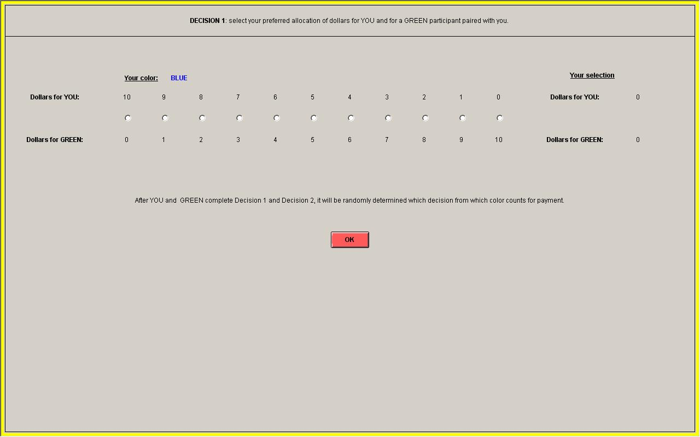

Retraction opportunity:
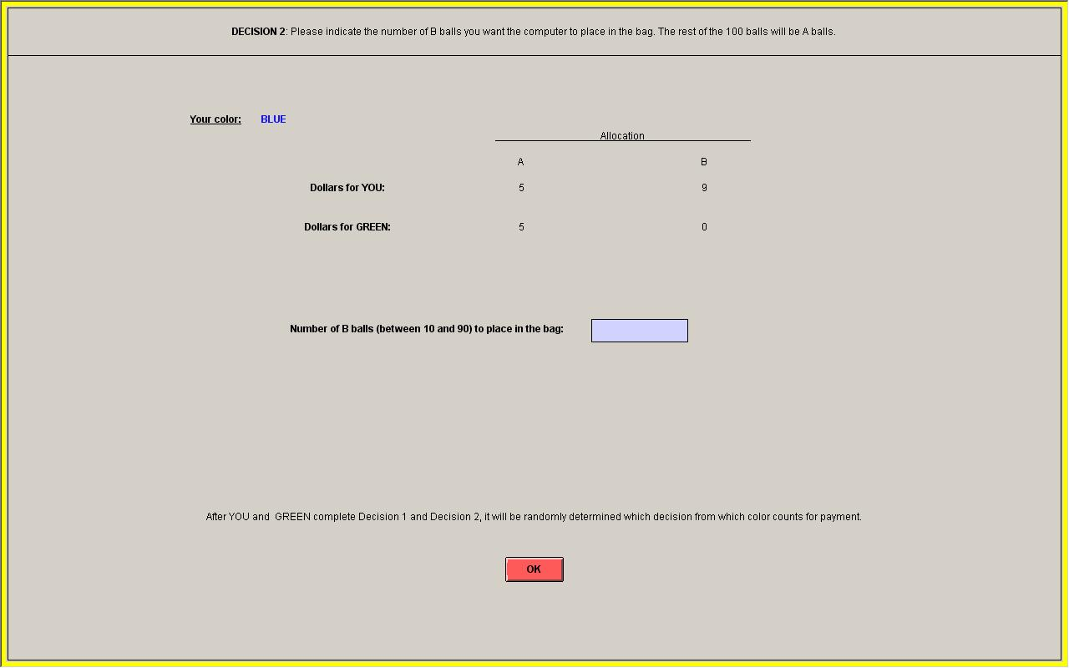

4. INSTRUCTIONS FOR THE EXPERIMENT IN SANTIAGO (TRANSLATED INTO ENGLISH)

Instructions
Welcome to the experiment and thank you for coming.

Voluntary participation. Remember that your participation is voluntary and you are free to leave the lab at any time.

Anonymity and risks. All your decisions in this experiment are anonymous. We will not collect any personal information from you, and no one will be able to link your identity with any decision you make in the experiment. There are no risks to you associated with participating in the experiment.

Rules of the lab. The other people in the room are also participating in the experiment. Please do not talk with them during the session. Please keep your cellphone turned off and away during the experiment. If at any time you have a question, please raise your hand and the experimenter will come to where you are to answer in private.

Payment. You are guaranteed to receive $2000 for your participation. In addition, you can increase your payment significantly depending on the decisions you make in the experiment, according to the instructions that you will receive later.

The experiment consists of 2 parts. Your final payment will be your earnings from each part plus the $2000 for your participation. You will receive the total payment in private and in cash before you leave the lab.

Instructions of the experiment. As we said, the experiment consists of 2 parts. The instructions for each part will be given at the beginning of the corresponding part.

Part 1
In Part 1, you will have 3 minutes to move 15 sliders to their targets.

At the left of each slider will appear the target number. At the right of each slider will appear the actual number where the slider is located. Below you can see two example images.

Figure A:
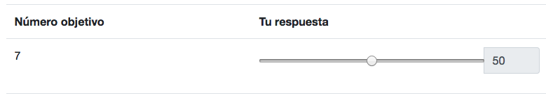

In Figure A, the target number is “7” and the slider is currently at “50”. In this example, the slider has not been successfully moved to its target.

Figure B:
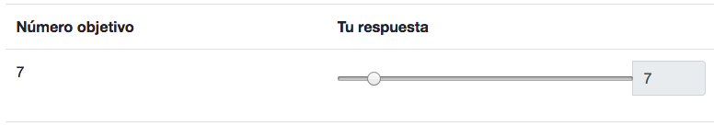

In Figure B, the target number is “7” and the slider is currently at “7”. In this example, the slider has been successfully moved to its target.

In Part 1, you will see 15 siders. You will have 3 minutes to move them to their targets. After the time finishes, your answers will be submitted automatically.

Payment. If you move the 15 sliders to their targets before the time finishes, you will earn $2000. Otherwise, you will earn $0.

Only at the end of the experiment you will receive confirmation of your earnings from this part. In addition to these earnings you will receive $2000 for participating and your earnings from Part 2.

Part 2
In Part 2, the computer will randomly assign you a color (BLUE or GREEN) and will randomly select a participant of the other color to form a BLUE-GREEN pair.

Both you and the participant paired with you will make 2 decisions: Decision 1 and Decision 2. Your payment for this part will depend on your decisions or the decisions of the participant paired with you.

Payment. Only one decision (1 or 2) from only one member of the pair (BLUE or GREEN) will count for payment. After both participants make the two decisions, the experimenter will randomly select one decision (1 or 2) and one color (BLUE or GREEN) as the decision that counts for payment. This payment will be added to the $2000 for your participation and your earnings from Part 1.

The instructions for Decision 1 will appear in the next screen. The instructions for Decision 2 will appear after all participants finish making Decision 1.

Decision 1
For Decision 1, you must choose how to allocate $5000 between yourself and the participant of the other color. You can choose any division in multiples of $500. That is, you can choose any of the following options.

While you make this decision, the participant of the other color will also make a decision in private choosing among the same options.

Payment. Only one decision (1 or 2) from only one member of the pair (BLUE or GREEN) will count for payment. The experiment will randomly select a decision and a color at the end of the experiment.

If Decision 1 is selected and your color is selected, then the option that you choose in this Decision will be implemented. Your will receive the amount that corresponds to you according to your option, and the other participant will receive the amount that corresponds to them according to your option. In this case, you will not receive confirmation of the option selected by the other participant in Decision 1.

On the other hand, if Decision 1 is selected and the other color is selected, then the option that the other participant chooses in this Decision will be implemented. You will receive the amount that corresponds to you according to the other participant’s option, and the other participant will receive the amount that corresponds to them according to their option. In this case, the other participant will not receive confirmation of the option you select in Decision 1.

Decision 2
For Decision 2, that are 2 payment options for you and the other participant.

Option A is the option you selected in Decision 1.

Option B is $4500 for you and $0 for the participant of the other color.

Below you can see these two options.

The computer will choose at random one of these two choices as your Decision 2. However, it will make the choice based partly on chance and partly on a number that you must indicate. The rule that the computer will use to choose between Option A and Option B can be described as follows.

The computer will place 100 balls in a bag and will draw a ball from the bag. Each ball is labeled with the letter “A” or the letter “B”. The letter label in the ball drawn by the computer will be the option that the computer assigns as your Decision 2.

Your task is to indicate to the computer how many of the 100 balls in the bag you want to be “B” balls. You can indicate any number between 10 and 90 (inclusive).

Once you indicate the number of “B” balls you want in the bag, the computer will place that number of “B” balls and will place the rest as “A” balls to make 100 balls. Then, it will draw at random one ball from the bag, and will assign you the option with the letter from the ball drawn as your Decision 2.

Obviously, the computer will not literally use a bag and balls, but the rule that it will use is the same. The number that you indicate will be the probability with which the computer chooses Option B as your Decision 2. And 100 minus the number that you indicate will be the probability with which the computer chooses Option A as your Decision 2.

Given that the number that you indicate must be between 10 and 90, that will always be at least 10 balls of each letter in the bag. Therefore, there will always be at least a 10% probability that the computer chooses Option A or Option B independently of the number you indicate.

Information. After the computer choose between Option A and Option B, you will receive confirmation of the option selected by the computer.

The other participant will never know how many “B” balls you indicate.

Payment. Only one decision (1 or 2) from only one member of the pair (BLUE or GREEN) will count for payment.

If at the end of the experiment Decision 2 is selected for payment, only information corresponding to Decision 2 (and not Decision 1) will be revealed, as follows.

If your color is selected for payment, then your option for Decision 2 will be implemented. Both you and the other participant will see confirmation of the payments corresponding to both according to your option for Decision 2, and will receive the corresponding payments. In this case, you will not receive information about the other participant’s option for Decision 2.

On the other hand, if the color of the other participant is selected for payment, then the other participant’s option for Decision 2 will be implemented. Both you and the other participant will see confirmation of the payments corresponding to both according to the other participant’s option for Decision 2, and will receive the corresponding payments. In this case, the other participant will not receive information about your option for Decision 2.

5. SCREENSHOTS FROM THE EXPERIMENT IN SANTIAGO

Slider task (bottom 8 sliders cropped):
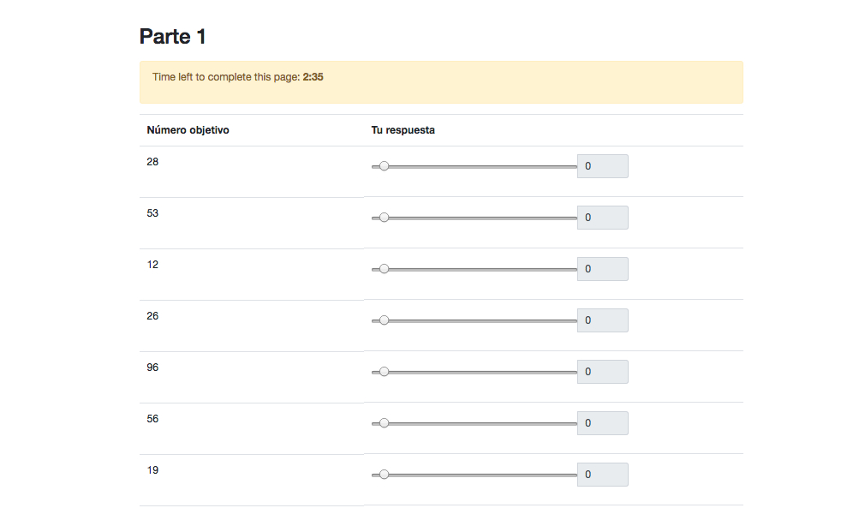

Dictator Game (instructions on top cropped):

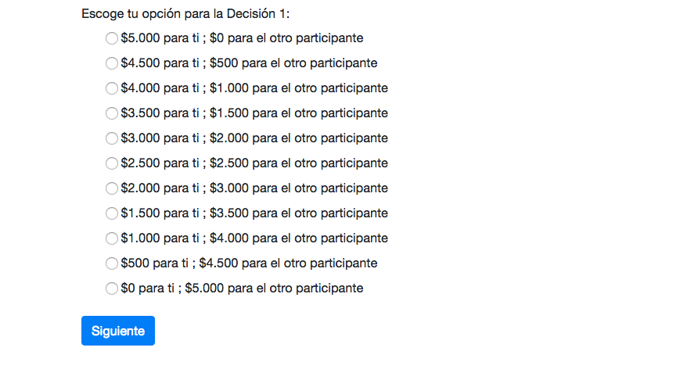

Retraction opportunity (instructions on top cropped)

