Pushing the Bad Away:
Reverse Tullock Contests

Bettina Rockenbach, Sebastian Schneiders and Marcin Waligora

ELECTRONIC SUPPLEMENTARY MATERIAL

APPENDIX A. Additional Tables and Figures, p. 02

APPENDIX B. Additional Theory

B1. Alternative Reference Points, p. 05

B2. Joy of Winning, p. 06

INSTRUCTIONS:

Instructions TC (English), p. 08

Instructions TR (English), p. 12

Instructions TC (German), p. 16

Instructions TR (German), p. 20

Note: English instructions are translated

form the German original.

Appendix A. Additional Tables and Figures

Table 1: Descriptive statistics of behavior in benchmark studies.
Study | (1)  Ind. Obs. | (2)  Mean | (3)  St. Dev. | Coefficient  of variation (3)/(2)
Abbink et al. (2010):  Treatment 1:1 | 14 | 512.96 | 184.94 | 0.3605
Ahn et al. (2011):  Baseline treatment | 16 | 336.93 | 123.21 | 0.3657
Note: Data from Abbink et al.’s study are publicly available under
https://www.aeaweb.org/articles?id=10.1257/aer.100.1.420.
Data from Ahn et al.’s study were kindly provided by Tim C. Salmon.

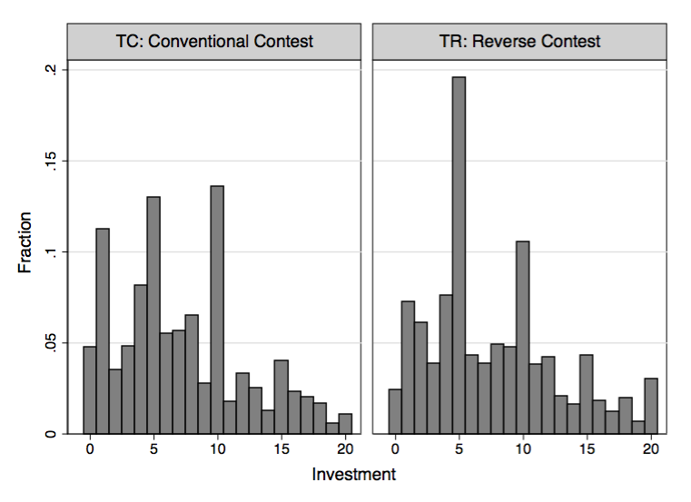
Figure 3: Distribution of individual investments across treatments.

Table 2: Random effects regressions.

DV: Investments | (I) | (II) | (III)
TR | 0.626 | 0.678 | 0.378
 | (1.023) | (1.058) | (0.468)
Period | -0.051 |  | 0.005
 | (0.033) |  | (0.015)
Period X TR | -0.015 |  | -0.007
 | (0.055) |  | (0.021)
Total profit lag |  | -0.001*
 |  | (0.001)
Total profit lag X TR |  | -0.002
 |  | (0.002)
Winner lag |  |  | -0.267
 |  |  | (0.291)
Winner lag X TR |  |  | 0.089
 |  |  | (0.389)
Own investment lag |  |  | 0.509***
 |  |  | (0.042)
Own investment lag X TR |  |  | -0.024
 |  |  | (0.060)
Other investment lag |  |  | 0.257***
 |  |  | (0.050)
Other investment lag X TR |  |  | 0.053
 |  |  | (0.067)
Female |  |  | 0.756*
 |  |  | (0.400)
Female X TR |  |  | -0.459
 |  |  | (0.520)
Constant | 7.729*** | 7.723*** | 6.986***
 | (0.761) | (0.787) | (0.363)
No. of Observations | 2359 | 2241 | 2241
No. of Clusters | 59 | 59 | 59
Overall R-squared | 0.007 | 0.039 | 0.466

Notes: Panel regressions with random effects at the subject level. Robust standard errors clustered at the partner matching level in parentheses. As the correlation between a simple period variable and (lagged) accumulated wealth over time is naturally very high (r=0.83 in the full sample), we always include only one of them to avoid problems of multicollinearity. Lagged investment and lagged competitor investment are mean centered. In TR, one subject did not enter a decision within the prescribed time frame of three minutes in the first round. This single observation of one subject in one round is dropped for all analyses. Including this observation does not change any result. Significance levels: *** p<0.01, ** p<0.05, * p<0.1

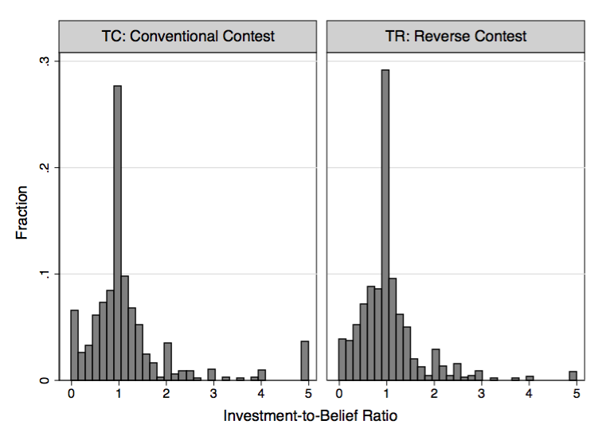
Figure 4. Distribution of individual investment-to-belief ratios across treatments;
investment-to-belief ratios for beliefs different from zero and censored at five.

Appendix B. Additional Theory

B1. Alternative Reference Points
The reference point against which subjects evaluate outcomes as gains and losses might be different from the endowment as we assumed in section 2. Rather, subjects may perceive the utility they can ensure without taking any action as reference point against which outcomes are then evaluated. In the conventional contest, this reference point is the endowment $E$ as before, as this is what subjects receive when they do not invest. Thus, the expected utility remains as before in equation (5):
$$E_{C,λ,\text{E}}\left[u | | i\right]=E+p_{i}\left(V−x_{i}\right)+\left(1−p_{i}\right)λ\left(−x_{i}\right)$$ | (B1)
Equilibrium predictions do not change and individual equilibrium investment remains $x_{C,λ,\text{ E }}^{}=\frac{V}{λ+3}$ in the conventional Tullock contest under loss aversion.
In the reverse contest, subjects receive the bad for sure when they do not invest and the alternative reference point would therefore be $E−V$. With respect to this reference point, winning the lottery and thus keeping $V−x_{i}$ is perceived as a gain and only losing the investment $x_{i}$ when the lottery is lost is perceived as a loss. In this case, the expected utility in the reverse contest is:
$$E_{R,λ,\text{E-V}}\left[u | | i\right]=E−V+p_{i}\left(V−x_{i}\right)+\left(1−p_{i}\right)λ\left(−x_{i}\right)$$ | (B2)
By comparing (B1) and (B2), it is straightforward that the derivatives with respect to $x_{i}$ and thus the best response functions as well as equilibrium predictions are the same in the conventional and the reverse contest. Individual equilibrium investments in both versions of the contest are $x_{C,λ,\text{ E }}^{}=x_{R,λ,\text{ E -V}}^{}=\frac{V}{λ+3}$, i.e. investments are similarly decreasing in loss aversion in both treatments. Hence, with these reference points, including loss aversion into the utility function does not predict differences in behavior between conventional and reverse contests.
Note that in Chowdhury et al.’s (2017) design, in which zero investments of both players lead to a 50 percent probability to win the prize or not to lose the prize, it can be shown that assuming the respective alternative references points of the secure utility level from inaction also leads to the prediction that there are not treatment differences, similar to our setting.
B2. Joy of Winning
Sheremeta (2013) notes that “in addition to monetary utility, some subjects seem to derive non-monetary utility of winning and such a utility can partially explain overbidding.” Following his modelling approach, we include a linear additive term into the utility functions with loss aversion of section 2 to account for this additional motive. In the conventional contest player i now additionally obtains a non-monetary utility from winning $W$ with probability $p_{i}$. Updating equation (5), her expected utility including joy of winning is:
$$E_{C,λ,W}\left[u | | i\right]=E+p_{i}\left(V−x_{i}\right)+\left(1−p_{i}\right)λ\left(−x_{i}\right)+p_{i}W$$ | (B3)
Differentiating (B3) with respect to $x_{i}$ yields the following best response function:
$$x_{i}\left(x_{j}\right)=\sqrt{x_{j}\left(V+W\right)−\left(λ−1\right)x_{j}^{2}}−x_{j}$$ | (B4)
Solving (B4) for the symmetric Nash equilibrium under loss aversion and joy of winning yields individual equilibrium investments of $x_{C,λ,W}^{}=\frac{V+W}{λ+3}$ in the conventional contest.
In the reverse contest, player i now additionally experiences a gain in utility from winning the lottery $W$ with probability $p_{i}$. Thus, updating equation (7), her expected utility in the reverse contest including joy of winning is:
$$E_{R,λ,W}\left[u | | i\right]=E−λ\left(x | | i+\left(1−p_{i}\right)V\right)+p_{i}W$$ | (B5)
Differentiating (B5) with respect to $x_{i}$ yields the following best response function:
$$x_{i}\left(x_{j}\right)={\left(\sqrt{{λx}_{j}\left(λV+W\right)}−{λx}_{j}\right)}/λ.$$ | (B6)
The individual investments in the symmetric equilibrium of the reverse Tullock contest under loss aversion and joy of winning then are $x_{R,λ,W}^{}=\frac{V+\left(W/λ\right)}{4}$.
Figure 5 plots predicted equilibrium investments in conventional and reverse contests for different levels of relative importance of joy of winning for a fixed level of loss aversion $λ=2.25$ and a prize of $V=20$ as discussed in section 2. Investments in the conventional contest react stronger to relative increases in joy of winning, which can also formally be shown by differentiating the individual equilibrium investments with respect to $W$. The intuition for this result is that in the conventional contest, joy of winning is a gain in utility and simply adds to the utility from the monetary prize in the gain domain. In the reverse contest, however, where all monetary outcomes are perceived as losses, joy of winning as a utility gain is relatively less important compared to monetary utility losses and is therefore “discounted”. Consequently, the influence of joy of winning is less important in the reverse contest and predicted treatment differences become smaller the larger relative joy of winning is. For instance, it can be shown that given a level of loss aversion of $λ=2.25$ the predicted treatment difference is smaller than 25 percent as soon as the relative importance of joy of winning to monetary outcomes is roughly 10 percent or larger.
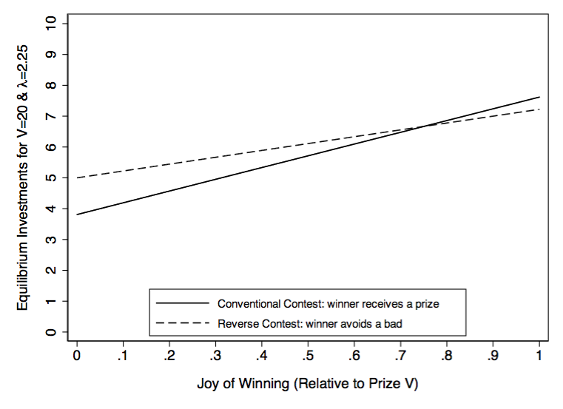

Figure 5: Equilibrium investments predicted for different degrees of joy of winning for $λ=2.25$.

Note that when applied to Chowdhury et al.’s (2017) treatments, this model of loss aversion and joy of winning generates exactly the same best response functions (B4) and (B6) and thus the same equilibrium predictions as in our design.

General Information

Welcome to this experiment! It is very important that you carefully read and understand the following instructions. If you have a question, please raise your hand. We will then come to you and answer your question. Communication with other participants before and during the experiment is not allowed. If you violate this rule, you will have to leave the experiment and will not receive any payment.

You can earn money in this experiment. You will receive 4 EUR for your participation. You can earn additional money during the experiment. The amount of money that you earn depends on your decisions and on those of other participants in the experiment. Your earnings in the experiment are denoted in points. These will be converted into EUR and paid out in cash at the end of the experiment. The exchange rate is:

45 Points = 1 EUR.

The experiment consists of several rounds. Points that you earn in each round are added to your points account. Your payoff is the sum of points that you have earned in all rounds of the experiment. No participant will receive information about the other participants’ identity or their payoff during or after the experiment.

Course of the Experiment

In today’s experiment, you will interact with another participant. You will shortly be randomly matched with an opponent. In every pair, there will be a player A (marked blue) and a player B (marked red). The roles are also randomly assigned. The pairings as well as the roles remain unchanged for the entire experiment. Information about whether you are player A or player B will be displayed on the screen before the first round begins.

The experiment consists of 20 rounds. All rounds proceed in the same way. In each round, you and your opponent will compete in a lottery.

At the beginning of each round, you receive an endowment of 40 points from us. Then, you can decide how many points you want to spend on lottery tickets. For one point, you can purchase one ticket (1 point = 1 ticket). You can purchase as many tickets as you want but you can spend a maximum of 20 points in a single round. Points that you do not spend on lottery tickets are added to your account.

The lottery decides who in a given round is awarded additional 20 points. If one of your tickets is drawn, you receive the additional points.

Your chance of receiving additional points depends solely on how many tickets you have bought and how many your opponent has bought. The more tickets you have bought, the more likely it is that you will receive the additional points. The more tickets your opponent has bought, the less likely it is that you will receive the additional points. The probability with which you receive the additional points is equal to the number of your tickets divided by the number of all tickets bought. This means, it is computed according to the following rule:

$\text{Probability to receive add. points = }\frac{Numberofyourtickets}{Numberofyourtickets+Numberof{opponent}^{'}stickets}.$
Your earnings in a single round are computed as follows:

Your earnings if you win the lottery= 40 – your investment in the tickets + 20
Your earnings if you lose the lottery = 40 – your investment in the tickets

If only one player buys tickets, she/he wins the lottery with certainty and receives 20 additional points. If neither you nor your opponent buy any tickets, the lottery does not take place and no player receives additional points.

Each round consists of three steps:

Step 1
In the first step, you decide how many tickets you would like to purchase. At the same time, your opponent makes the same decision.

While you make your decision, you can use a what-if calculator (see Figure 1). You can insert a hypothetical investment by your opponent and the calculator computes the probabilities of receiving or not receiving the additional points and corresponding payoffs, subject to your investment. The expected payoff is also computed.

The expected payoff is computed in the following way:
Probability of not receiving additional points
Expected payoff
Payoff with additional points
Probability of receiving additional points
Payoff without additional points
=
+
X
X

You can use the calculator as often as you want. Please simply insert a value in the field of the opponent’s investment and click on “Compute” (see red field (1) in Figure 1).

The example in Figure 1 shows the what-if-calculator for the opponent’s hypothetical investment of 10. For instance, you can see in the table that if you invest 2 points, your probability of receiving the additional points is 16.67%, whereby your payoff will amount to 58 points then. You will lose the lottery and do not receive the additional points with a probability of 83.33%. In such a case, your payoff will be 38 points. Your expected payoff is 41.33 points.

If you invest 19 points for example, you will win the lottery and achieve a payoff of 41 points with a probability of 65.52%, while you will lose and achieve a payoff of 21 points with a probability of 34.48%. Your expected payoff will be 34.10 points.

In every round, you should insert within the given time your final decision in the fields on the right-hand side of the screen and confirm with the “OK” button (see red field (2) in Figure 1). You are not only asked about your investment, but also what investment you expect from your opponent. For this you can earn a bonus of maximal 4 points. The amount of the bonus depends on how good your prediction was. The smaller the mistake in your prediction, the higher your bonus. The bonus is computed in the following way:

$$Bonus=4−0.4∗{Mistake}^{2}$$

The mistake is the difference between your prediction and actual opponent’s investment:

$$Mistake=Yourprediction−Actual{opponent}^{'}sinvestment∨$$

It is not important that you understand the bonus formula well. In general, it is true that the better you guess you opponent’s behavior the higher is you bonus. If the mistake is larger than 3, the bonus is 0. This means that there is no negative bonus; you cannot lose any points for your prediction.

The time for your decision in every round is limited. In the first ten rounds, you have 3 minutes time, in the next 10 rounds 2 minutes. If you do not insert any values within the given time, your investment in the round will be zero and you will not receive any bonus for your prediction.

Step 2
In the second step, you receive feedback on the opponent’s decision: how many tickets she/he has bought. Your and your opponent’s probabilities of winning are also computed and displayed. All tickets bought are numbered. On your screen, you receive information on which numbers correspond to your tickets and which to those of your opponent. In order to make it clearer, this is also displayed graphically.

Each ticket is equally likely to be drawn.

You also receive feedback concerning how good your prediction about your opponent’s investment was and how large your bonus is.

Step 3
In the last step, the lottery takes place. The computer draws one of the bought tickets. The number of the winning ticket and the information about who is awarded the additional points are displayed on the screen, as are your earnings in the current round.

Figure 1

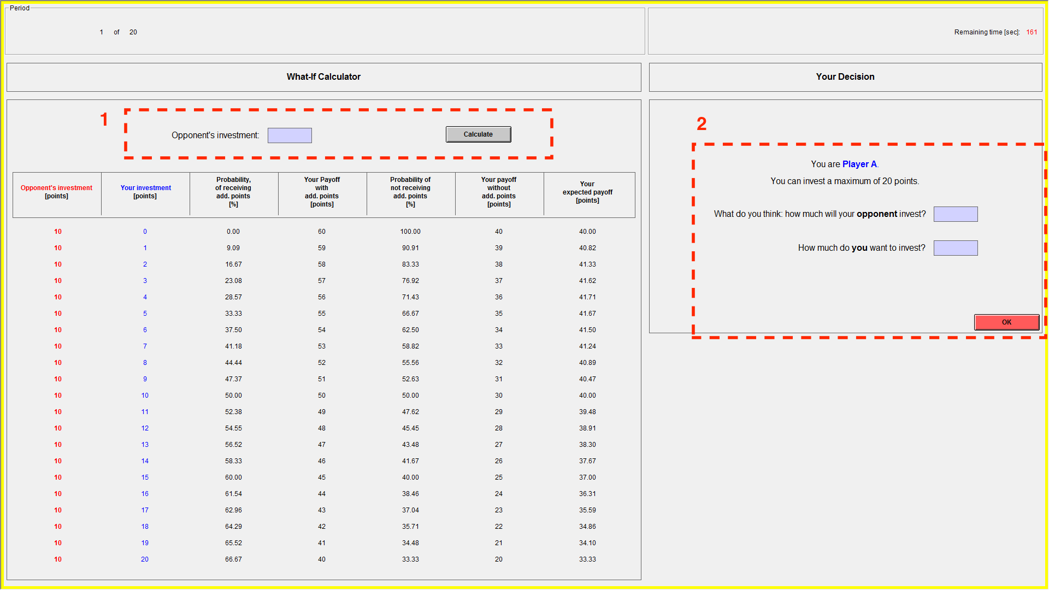
General Information

Welcome to this experiment! It is very important that you carefully read and understand the following instructions. If you have a question, please raise your hand. We will then come to you and answer your question. Communication with other participants before and during the experiment is not allowed. If you violate this rule, you will have to leave the experiment and will not receive any payment.

You can earn money in this experiment. You will receive 4 EUR for your participation. You can earn additional money during the experiment. The amount of money that you earn depends on your decisions and on those of other participants in the experiment. Your earnings in the experiment are denoted in points. These will be converted into EUR and paid out in cash at the end of the experiment. The exchange rate is:

45 Points = 1 EUR.

The experiment consists of several rounds. Points that you earn in each round are added to your points account. Your payoff is the sum of points that you have earned in all rounds of the experiment. No participant will receive information about the other participants’ identity or their payoff during or after the experiment.

Course of the Experiment

In today’s experiment, you will interact with another participant. You will shortly be randomly matched with an opponent. In every pair, there will be a player A (marked blue) and a player B (marked red). The roles are also randomly assigned. The pairings as well as the roles remain unchanged for the entire experiment. Information about whether you are player A or player B will be displayed on the screen before the first round begins.

The experiment consists of 20 rounds. All rounds proceed in the same way. In each round, you and your opponent will compete in a lottery.

At the beginning of each round, you receive an endowment of 40 points from us. Then, you can decide how many points you want to spend on lottery tickets. For one point, you can purchase one ticket (1 point = 1 ticket). You can purchase as many tickets as you want but you can spend a maximum of 20 points in a single round. Points that you do not spend on lottery tickets are added to your account.

The lottery decides who in a given round receives a deduction of 20 points from the endowment. If one of your tickets is drawn, you avoid the deduction.

Your chance of not being deducted points depends solely on how many tickets you have bought and how many your opponent has bought. The more tickets you have bought, the more likely it is that you will avoid the deduction. The more tickets your opponent has bought, the less likely it is that you will avoid the deduction. The probability with which you avoid the deduction of points is equal to the number of your tickets divided by the number of all tickets bought. This means, it is computed according to the following rule:

$\text{Probability to avoid deduction of points = }\frac{Numberofyourtickets}{Numberofyourtickets+Numberof{opponent}^{'}stickets}.$
Your earnings in a single round are computed as follows:

Your earnings if you win the lottery= 40 – your investment in the tickets
Your earnings if you lose the lottery = 40 – your investment in the tickets – 20

If only one player buys tickets, she/he wins the lottery with certainty and the opponent receives the deduction of 20 points. If neither you nor your opponent buy any tickets, the lottery does not take place and both players receive a deduction of 20 points.

Each round consists of three steps:

Step 1
In the first step, you decide how many tickets you would like to purchase. At the same time, your opponent makes the same decision.

While you make your decision, you can use a what-if calculator (see Figure 1). You can insert a hypothetical investment by your opponent and the calculator computes the probabilities of receiving or not receiving the deduction of points and corresponding payoffs, subject to your investment. The expected payoff is also computed.

The expected payoff is computed in the following way:
Probability of receiving deduction of points
Payoff after the deduction
Expected payoff
Payoff without deduction
Probability of avoiding deduction of points
=
+
X
X

You can use the calculator as often as you want. Please simply insert a value in the field of the opponent’s investment and click on “Compute” (see red field (1) in Figure 1).

The example in Figure 1 shows the what-if-calculator for the opponent’s hypothetical investment of 10. For instance, you can see in the table that if you invest 2 points, your probability of avoiding the deduction of points is 16.67%, whereby your payoff will amount to 38 points then. You will lose the lottery and receive the deduction of points with a probability of 83.33%. In such a case, your payoff will be 18 points. Your expected payoff is 21.33 points.

If you invest 19 points for example, you will win the lottery and achieve a payoff of 21 points with a probability of 65.52%, while you will lose and achieve a payoff of 1 point with a probability of 34.48%. Your expected payoff will be 14.10 points.

In every round, you should insert within the given time your final decision in the fields on the right-hand side of the screen and confirm with the “OK” button (see red field (2) in Figure 1). You are not only asked about your investment, but also what investment you expect from your opponent. For this you can earn a bonus of maximal 4 points. The amount of the bonus depends on how good your prediction was. The smaller the mistake in your prediction, the higher your bonus. The bonus is computed in the following way:

$$Bonus=4−0.4∗{Mistake}^{2}$$

The mistake is the difference between your prediction and actual opponent’s investment:

$$Mistake=Yourprediction−Actual{opponent}^{'}sinvestment∨$$

It is not important that you understand the bonus formula well. In general, it is true that the better you guess you opponent’s behavior the higher is you bonus. If the mistake is larger than 3, the bonus is 0. This means that there is no negative bonus; you cannot lose any points for your prediction.

The time for your decision in every round is limited. In the first ten rounds, you have 3 minutes time, in the next 10 rounds 2 minutes. If you do not insert any values within the given time, your investment in the round will be zero and you will not receive any bonus for your prediction.

Step 2
In the second step, you receive feedback on the opponent’s decision: how many tickets she/he has bought. Your and your opponent’s probabilities of winning are also computed and displayed. All tickets bought are numbered. On your screen, you receive information on which numbers correspond to your tickets and which to those of your opponent. In order to make it clearer, this is also displayed graphically.

Each ticket is equally likely to be drawn.

You also receive feedback concerning how good your prediction about your opponent’s investment was and how large your bonus is.

Step 3
In the last step, the lottery takes place. The computer draws one of the bought tickets. The number of the winning ticket and the information about who receives the deduction of points are displayed on the screen, as are your earnings in the current round.
Figure 1

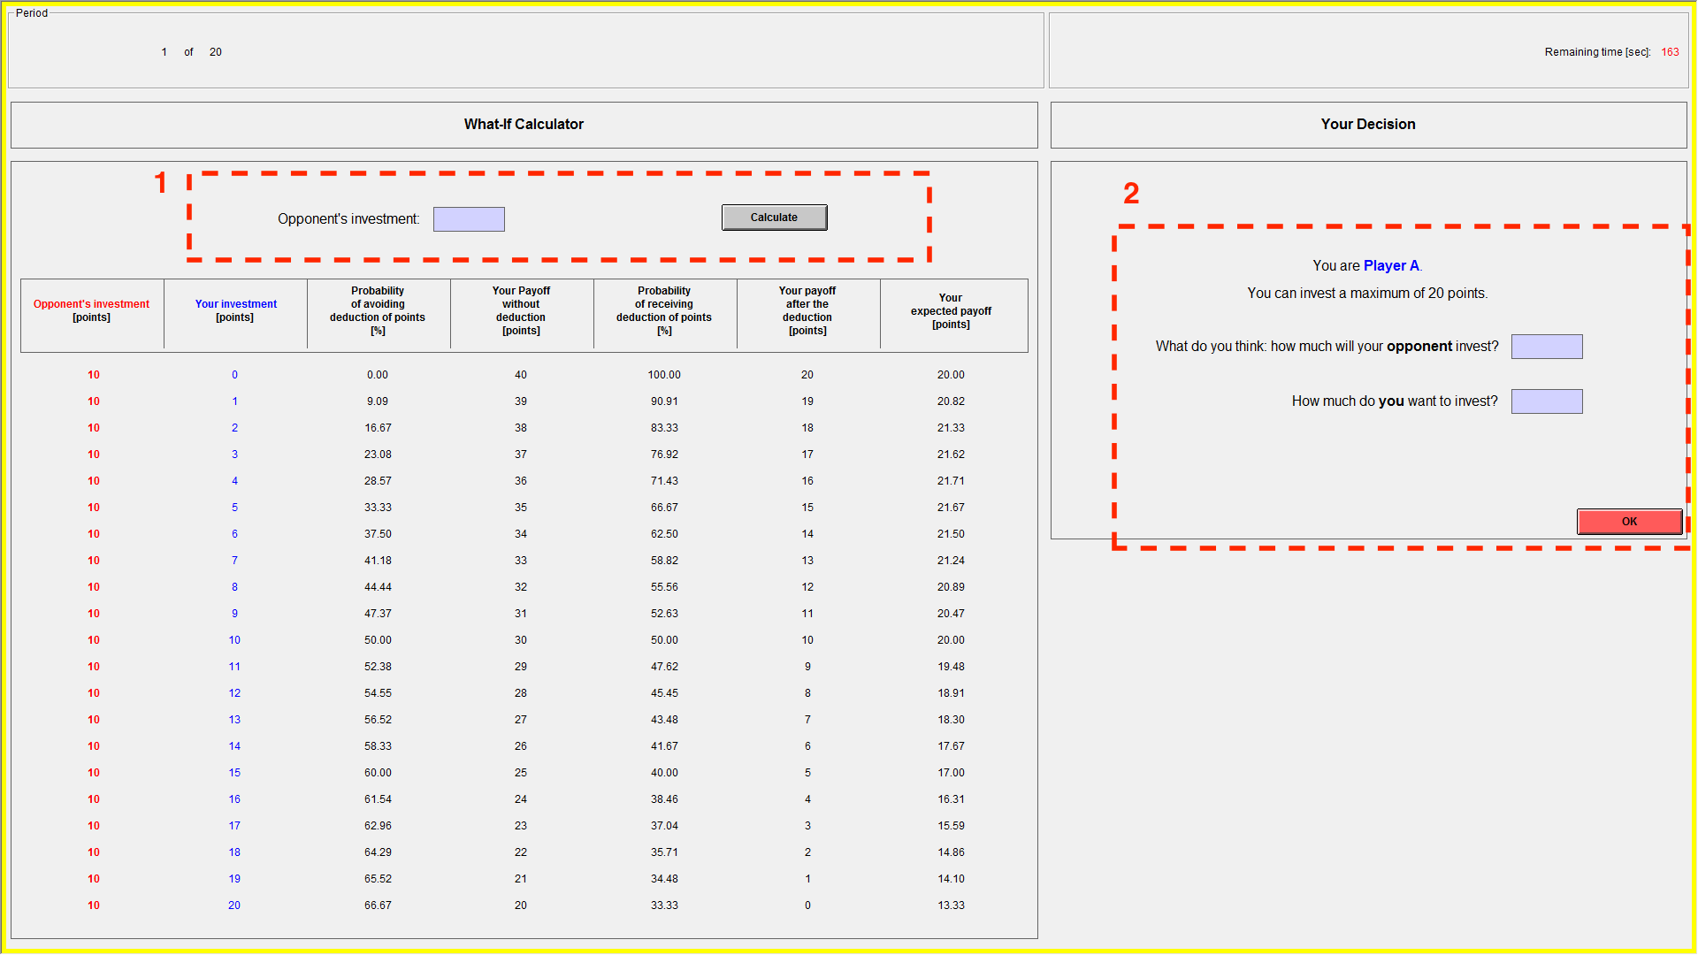
Allgemeine Informationen

Willkommen bei diesem Experiment! Es ist sehr wichtig, dass Sie die folgenden Erklärungen genau durchlesen und verstehen. Wenn Sie Fragen haben, heben Sie bitte Ihre Hand. Wir werden dann zu Ihnen kommen und Ihre Fragen beantworten. Die Kommunikation mit anderen Teilnehmern vor und während des Experiments ist nicht erlaubt. Wenn Sie gegen diese Regel verstoßen, müssen Sie das Experiment verlassen und sind von allen Auszahlungen ausgeschlossen.

In diesem Experiment können Sie Geld verdienen. Sie bekommen 4 EUR für die Teilnahme. Sie können während des Experiments zusätzliches Geld verdienen. Der Geldbetrag, den Sie erzielen, hängt von den Entscheidungen ab, die Sie und andere Teilnehmer treffen. Ihre Gewinne während des Experiments werden in Punkten angegeben. Diese werden am Ende des Experiments in EUR umgerechnet und in bar ausgezahlt. Der Wechselkurs beträgt:

45 Punkte = 1 EUR.

Das Experiment besteht aus mehreren Runden. Punkte, die Sie in jeder Runde verdienen, werden Ihrer Punktebilanz gutgeschrieben. Ihre Auszahlung wird anhand der Summe der verdienten Punkte aus allen Runden des Experiments berechnet. Keiner der Teilnehmer wird während oder nach dem Experiment Informationen über die Identität der anderen Teilnehmer oder über deren Auszahlung erhalten.

Ablauf des Experiments

Im heutigen Experiment werden Sie mit einem anderen Teilnehmer interagieren. Gleich wird Ihnen zufällig ein Gegenspieler zugeteilt. In jedem Paar wird es einen Spieler A (blau markiert) und einen Spieler B (rot markiert) geben. Diese Rollen werden ebenfalls zufällig zugeteilt. Die Paarungen der Spieler sowie die zugeteilten Rollen bleiben für das ganze Experiment unverändert. Die Information, ob Sie Spieler A oder B sind, erscheint auf dem Bildschirm bevor die erste Runde beginnt.

Das Experiment besteht aus 20 Runden. Alle Runden laufen gleich ab. Sie und Ihr Gegenspieler werden in jeder Runde in einer Lotterie konkurrieren.

Am Anfang jeder Runde bekommen Sie von uns eine Anfangsausstattung von 40 Punkten. Dann können Sie entscheiden, wie viele Punkte Sie für Lotterielose ausgeben möchten. Für jeden Punkt können Sie ein Los erwerben (1 Punkt = 1 Los). Sie können eine beliebige ganze Zahl an Losen kaufen, dürfen aber in jeder Runde maximal 20 Punkte für die Lose ausgeben. Punkte, die Sie nicht in Lose investiert haben, werden Ihrer persönlichen Punktebilanz gutgeschrieben.

Die Lotterie entscheidet, wer in der jeweiligen Runde 20 Punkte zusätzlich bekommt. Wenn eins Ihrer Lose gezogen wird, erhalten Sie die Punktgutschrift.

Ihre Chance die Punktgutschrift zu bekommen hängt nur davon ab, wie viele Lotterielose Sie gekauft haben und wie viele Ihr Gegenspieler gekauft hat. Je mehr Lose Sie gekauft haben, desto wahrscheinlicher ist es, dass Sie die Punktgutschrift bekommen. Umgekehrt, je mehr Lose Ihr Gegenspieler gekauft hat, desto weniger wahrscheinlich ist es, dass Sie die Punktgutschrift bekommen. Die Wahrscheinlichkeit, mit der Sie die Punktgutschrift bekommen, ist gleich der Anzahl Ihrer Lose dividiert durch die Anzahl aller gekauften Lose. Das heißt, sie wird gemäß der folgenden Regel berechnet:

$\text{W'keit Punktgutschrift zu bekommen = }\frac{AnzahlIhrerLose}{AnzahlIhrerLose+AnzahlderLosedesGegenspielers}.$

Ihre Auszahlung in der jeweiligen Runde wird folgendermaßen berechnet:

Ihre Auszahlung falls Sie gewinnen = 40 – Ihre Investition in Lose + 20
Ihre Auszahlung falls Sie verlieren = 40 – Ihre Investition in Lose

Wenn nur ein Spieler Lose kauft, gewinnt er/sie die Lotterie mit Sicherheit und erhält die Punktgutschrift von 20 Punkten. Sollten sowohl Sie als auch Ihr Gegenspieler keine Lose gekauft haben, findet die Verlosung in der jeweiligen Runde nicht statt und niemand erhält die Punktgutschrift.

Jede Runde besteht aus drei Schritten:

Schritt 1
Im ersten Schritt entscheiden Sie, wie viele Lose Sie kaufen möchten. Gleichzeitig trifft Ihr Gegenspieler dieselbe Entscheidung.

Während Sie die Entscheidung treffen, steht Ihnen ein „Szenario-Rechner“ zur Verfügung (s. Abbildung 1). Sie können eine hypothetische Investition des Gegenspielers eingeben und der Rechner berechnet die Wahrscheinlichkeit die Punktgutschrift zu bekommen oder nicht zu bekommen, sowie entsprechende Auszahlungen in Abhängigkeit von Ihrer Investition. Angegeben werden auch erwartete Auszahlungen.
Die erwartete Auszahlung wird folgendermaßen berechnet:
W’keit, Punktgut-schrift nicht zu bekommen
Erwartete Auszahlung
Auszahlung mit Punkt-gutschrift
W’keit, Punktgut-schrift zu bekommen
Auszahlung ohne Punktgut-schrift
=
+
X
X

Sie dürfen den Rechner beliebig oft verwenden. Geben Sie einfach in das Feld die Investition des Gegenspielers ein und drücken Sie auf „Berechnen“ (s. rotes Feld (1) in Abbildung 1).

Das Beispiel in Abbildung 1 zeigt den „Szenario-Rechner“ für die hypothetische Investition des Gegenspielers von 10 Punkten. Der Tabelle können Sie beispielweise folgendes entnehmen. Wenn Sie 2 Punkte investieren, gewinnen Sie die Lotterie und bekommen die Punktgutschrift mit einer Wahrscheinlichkeit von 16.67%, Ihre Auszahlung beträgt damit 58 Punkte. Anderenfalls verlieren Sie die Lotterie und bekommen keine Punktgutschrift mit einer Wahrscheinlichkeit von 83.33%. In so einem Fall beträgt Ihre Auszahlung 38 Punkte. Ihre erwartete Auszahlung beträgt 41.33 Punkte.
Wenn Sie beispielweise 19 Punkte investieren, gewinnen Sie die Lotterie und erzielen eine Auszahlung von 41 Punkten mit der Wahrscheinlichkeit von 65.52%; Sie verlieren und erzielen eine Auszahlung von 21 Punkten mit der Wahrscheinlichkeit von 34.48%. Insgesamt beträgt die erwartete Auszahlung 34.10 Punkte.

In jeder Runde sollen Sie innerhalb der gegebenen Zeit Ihre endgültige Entscheidung im Fenster auf der rechten Seite des Bildschirms eingeben und mit dem Knopf „OK“ bestätigen (siehe rotes Feld (2) in Abbildung 1). Dabei werden Sie nicht nur nach Ihrer Investition gefragt, sondern auch welche Investition Sie vom Gegenspieler erwarten. Dafür können Sie einen Bonus von maximal 4 Punkten verdienen. Die Höhe des Bonus hängt von der Güte Ihrer Schätzung ab. Je kleiner die Abweichung Ihrer Schätzung von der tatsächlichen Investition, desto höher ist der Bonus.
Der Bonus wird folgendermaßen berechnet:

$$Bonus=4−0.4∗{Abweichung}^{2}$$

Die Abweichung ist der Unterschied zwischen Ihrer Schätzung und der tatsächlichen Investition des Gegenspielers:

$$Abweichung=IhreSchätzung−TatsächlicheInvestitiondesGegenspielers∨$$

Es ist nicht wichtig, dass Sie die Formel für den Bonus gut verstehen. Im Allgemeinen gilt es, je besser Sie das Verhalten des Gegenspielers erraten haben, desto höher ist Ihr Bonus. Wenn die Abweichung größer als 3 ist, beträgt der Bonus 0. Das heißt, es gibt keinen negativen Bonus; Sie können für Ihre Schätzung keine Punkte verlieren.

Die Zeit für Ihre Entscheidung in jeder Runde ist begrenzt. In den ersten zehn Runden haben Sie 3 Minuten Zeit, in den weiteren zehn Runden 2 Minuten Zeit. Wenn Sie innerhalb der gegebenen Zeit keine Eingaben tätigen, beträgt Ihre Investition in der Runde Null und Sie bekommen keinen Bonus.

Schritt 2
Im zweiten Schritt bekommen Sie ein Feedback über die Entscheidung des Gegenspielers: wie viele Lose er/sie gekauft hat. Dabei werden auch die Gewinnwahrscheinlichkeiten für Sie und Ihren Gegenspieler ausgerechnet und angezeigt.
Alle gekauften Lose werden nummeriert. Sie erhalten auf dem Bildschirm die Information darüber, welche Nummern Ihren Losen entsprechen und welche denen des Gegenspielers. Um es deutlicher darzustellen, wird dies auch graphisch angezeigt.

Jedes Los hat dieselbe Wahrscheinlichkeit gezogen zu werden.

Sie bekommen auch Information darüber, ob Ihre Schätzung über die Investition des Gegenspielers richtig war und wie hoch Ihr Bonus ist.

Schritt 3
Im letzten Schritt erfolgt die Verlosung. Der Computer wird eins von den gekauften Losen ziehen. Die Nummer des gezogenen Loses und die Information, wer die Punktgutschrift bekommt, werden auf dem Bildschirm angezeigt. Ihre Auszahlung in der Runde wird ebenso angezeigt.
Abbildung 1

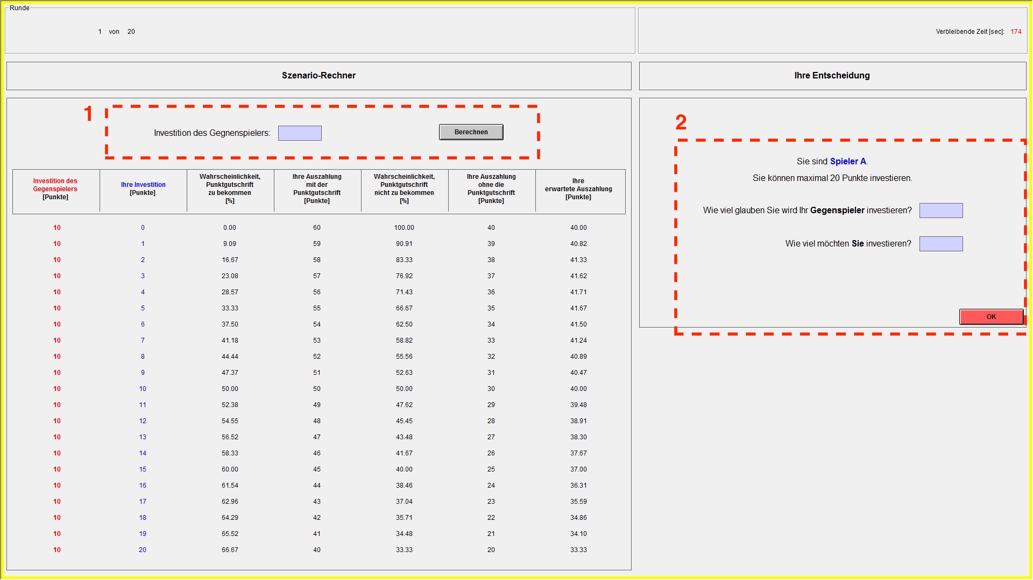
Allgemeine Informationen

Willkommen bei diesem Experiment! Es ist sehr wichtig, dass Sie die folgenden Erklärungen genau durchlesen und verstehen. Wenn Sie Fragen haben, heben Sie bitte Ihre Hand. Wir werden dann zu Ihnen kommen und Ihre Fragen beantworten. Die Kommunikation mit anderen Teilnehmern vor und während des Experiments ist nicht erlaubt. Wenn Sie gegen diese Regel verstoßen, müssen Sie das Experiment verlassen und sind von allen Auszahlungen ausgeschlossen.

In diesem Experiment können Sie Geld verdienen. Sie bekommen 4 EUR für die Teilnahme. Sie können während des Experiments zusätzliches Geld verdienen. Der Geldbetrag, den Sie erzielen, hängt von den Entscheidungen ab, die Sie und andere Teilnehmer treffen. Ihre Gewinne während des Experiments werden in Punkten angegeben. Diese werden am Ende des Experiments in EUR umgerechnet und in bar ausgezahlt. Der Wechselkurs beträgt:

45 Punkte = 1 EUR.

Das Experiment besteht aus mehreren Runden. Punkte, die Sie in jeder Runde verdienen, werden Ihrer Punktebilanz gutgeschrieben. Ihre Auszahlung wird anhand der Summe der verdienten Punkte aus allen Runden des Experiments berechnet. Keiner der Teilnehmer wird während oder nach dem Experiment Informationen über die Identität der anderen Teilnehmer oder über deren Auszahlung erhalten.

Ablauf des Experiments

Im heutigen Experiment werden Sie mit einem anderen Teilnehmer interagieren. Gleich wird Ihnen zufällig ein Gegenspieler zugeteilt. In jedem Paar wird es einen Spieler A (blau markiert) und einen Spieler B (rot markiert) geben. Diese Rollen werden ebenfalls zufällig zugeteilt. Die Paarungen der Spieler sowie die zugeteilten Rollen bleiben für das ganze Experiment unverändert. Die Information, ob Sie Spieler A oder B sind, erscheint auf dem Bildschirm bevor die erste Runde beginnt.

Das Experiment besteht aus 20 Runden. Alle Runden laufen gleich ab. Sie und Ihr Gegenspieler werden in jeder Runde in einer Lotterie konkurrieren.

Am Anfang jeder Runde bekommen Sie von uns eine Anfangsausstattung von 40 Punkten. Dann können Sie entscheiden, wie viele Punkte Sie für Lotterielose ausgeben möchten. Für jeden Punkt können Sie ein Los erwerben (1 Punkt = 1 Los). Sie können eine beliebige ganze Zahl an Losen kaufen, dürfen aber in jeder Runde maximal 20 Punkte für die Lose ausgeben. Punkte, die Sie nicht in Lose investiert haben, werden Ihrer persönlichen Punktebilanz gutgeschrieben.

Die Lotterie entscheidet, wem 20 Punkte von der Anfangsausstattung in der jeweiligen Runde abgezogen werden. Wenn eins Ihrer Lose gezogen wird, vermeiden sie den Punktabzug.

Ihre Chance keine Punkte abgezogen zu bekommen hängt nur davon ab, wie viele Lotterielose Sie gekauft haben und wie viele Ihr Gegenspieler gekauft hat. Je mehr Lose Sie gekauft haben, desto wahrscheinlicher ist es, dass Sie den Punktabzug vermeiden. Umgekehrt, je mehr Lose Ihr Gegenspieler gekauft hat, desto weniger wahrscheinlich ist es, dass Sie den Punktabzug vermeiden. Die Wahrscheinlichkeit, mit der Sie den Punktabzug vermeiden, ist gleich der Anzahl Ihrer Lose dividiert durch die Anzahl aller gekauften Lose. Das heißt, sie wird gemäß der folgenden Regel berechnet:

$\text{W'keit den Punktabzug zu vermeiden = }\frac{AnzahlIhrerLose}{AnzahlIhrerLose+AnzahlderLosedesGegenspielers}.$

Ihre Auszahlung in der jeweiligen Runde wird folgendermaßen berechnet:

Ihre Auszahlung falls Sie die Lotterie gewinnen = 40 – Ihre Investition in Lose
Ihre Auszahlung falls Sie die Lotterie verlieren = 40 – Ihre Investition in Lose - 20

Wenn nur ein Spieler Lose kauft, gewinnt er/sie die Lotterie mit Sicherheit und sein Gegenspieler bekommt 20 Punkte abgezogen. Sollten sowohl Sie als auch Ihr Gegenspieler keine Lose gekauft haben, findet die Verlosung in der jeweiligen Runde nicht statt und beiden Spielern werden 20 Punkte abgezogen.

Jede Runde besteht aus drei Schritten:

Schritt 1
Im ersten Schritt entscheiden Sie, wie viele Lose Sie kaufen möchten. Gleichzeitig trifft Ihr Gegenspieler dieselbe Entscheidung.

Während Sie die Entscheidung treffen, steht Ihnen ein „Szenario-Rechner“ zur Verfügung (s. Abbildung 1). Sie können eine hypothetische Investition des Gegenspielers eingeben und der Rechner berechnet die Wahrscheinlichkeit den Punktabzug zu vermeiden oder zu bekommen, sowie entsprechende Auszahlungen in Abhängigkeit von Ihrer Investition. Angegeben werden auch erwartete Auszahlungen.
Die erwartete Auszahlung wird folgendermaßen berechnet:
W’keit, Punktabzug zu bekommen
Erwartete Auszahlung
Auszahlung ohne den Punktabzug
W’keit, Punktabzug zu vermeiden
Auszahlung nach dem Punktabzug
=
+
X
X

Sie dürfen den Rechner beliebig oft verwenden. Geben Sie einfach in das Feld die Investition des Gegenspielers ein und drücken Sie auf „Berechnen“ (s. rotes Feld (1) in Abbildung 1).

Das Beispiel in Abbildung 1 zeigt den „Szenario-Rechner“ für die hypothetische Investition des Gegenspielers von 10 Punkten. Der Tabelle können Sie beispielweise folgendes entnehmen. Wenn Sie 2 Punkte investieren, gewinnen Sie die Lotterie und vermeiden den Punktabzug mit einer Wahrscheinlichkeit von 16.67%, Ihre Auszahlung beträgt damit 38 Punkte. Anderenfalls verlieren Sie die Lotterie und bekommen den Punktabzug mit einer Wahrscheinlichkeit von 83.33%. In so einem Fall beträgt Ihre Auszahlung 18 Punkte. Ihre erwartete Auszahlung beträgt 21.33 Punkte.
Wenn Sie beispielweise 19 Punkte investieren, gewinnen Sie die Lotterie und erzielen eine Auszahlung von 21 Punkten mit der Wahrscheinlichkeit von 65.52%; Sie verlieren und erzielen eine Auszahlung von 1 Punkt mit der Wahrscheinlichkeit von 34.48%. Insgesamt beträgt die erwartete Auszahlung 14.10 Punkte.

In jeder Runde sollen Sie innerhalb der gegebenen Zeit Ihre endgültige Entscheidung im Fenster auf der rechten Seite des Bildschirms eingeben und mit dem Knopf „OK“ bestätigen (siehe rotes Feld (2) in Abbildung 1). Dabei werden Sie nicht nur nach Ihrer Investition gefragt, sondern auch welche Investition Sie vom Gegenspieler erwarten. Dafür können Sie einen Bonus von maximal 4 Punkten verdienen. Die Höhe des Bonus hängt von der Güte Ihrer Schätzung ab. Je kleiner die Abweichung Ihrer Schätzung von der tatsächlichen Investition, desto höher ist der Bonus.
Der Bonus wird folgendermaßen berechnet:

$$Bonus=4−0.4∗{Abweichung}^{2}$$

Die Abweichung ist der Unterschied zwischen Ihrer Schätzung und der tatsächlichen Investition des Gegenspielers:

$$Abweichung=IhreSchätzung−TatsächlicheInvestitiondesGegenspielers∨$$

Es ist nicht wichtig, dass Sie die Formel für den Bonus gut verstehen. Im Allgemeinen gilt es, je besser Sie das Verhalten des Gegenspielers erraten haben, desto höher ist Ihr Bonus. Wenn die Abweichung größer als 3 ist, beträgt der Bonus 0. Das heißt, es gibt keinen negativen Bonus; Sie können für Ihre Schätzung keine Punkte verlieren.

Die Zeit für Ihre Entscheidung in jeder Runde ist begrenzt. In den ersten zehn Runden haben Sie 3 Minuten Zeit, in den weiteren zehn Runden 2 Minuten Zeit. Wenn Sie innerhalb der gegebenen Zeit keine Eingaben tätigen, beträgt Ihre Investition in der Runde Null und Sie bekommen keinen Bonus.

Schritt 2
Im zweiten Schritt bekommen Sie ein Feedback über die Entscheidung des Gegenspielers: wie viele Lose er/sie gekauft hat. Dabei werden auch die Gewinnwahrscheinlichkeiten für Sie und Ihren Gegenspieler ausgerechnet und angezeigt.
Alle gekauften Lose werden nummeriert. Sie erhalten auf dem Bildschirm die Information darüber, welche Nummern Ihren Losen entsprechen und welche denen des Gegenspielers. Um es deutlicher darzustellen, wird dies auch graphisch angezeigt.

Jedes Los hat dieselbe Wahrscheinlichkeit gezogen zu werden.

Sie bekommen auch Information darüber, ob Ihre Schätzung über die Investition des Gegenspielers richtig war und wie hoch Ihr Bonus ist.

Schritt 3
Im letzten Schritt erfolgt die Verlosung. Der Computer wird eins von den gekauften Losen ziehen. Die Nummer des gezogenen Loses und die Information, wer den Punktabzug bekommt werden auf dem Bildschirm angezeigt. Ihre Auszahlung in der Runde wird ebenso angezeigt.
Abbildung 1

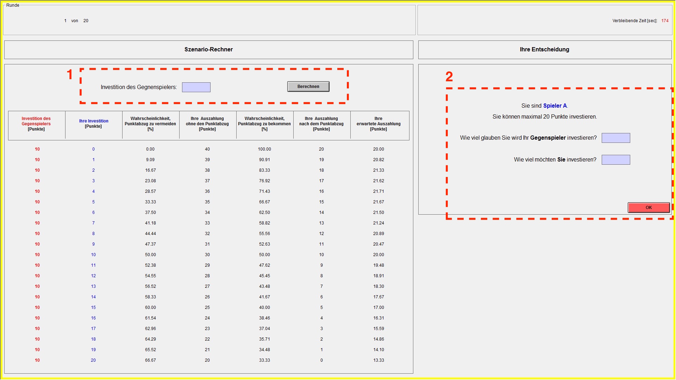

Formally, this is done by substituting $W=ωV$ into $\frac{V+\left(W/λ\right)}{4}≤\frac{1.25∗V+W}{λ+3}$. Given $λ=2.25$and $V=20$, solving this expression for the relative importance of joy of winning yields $ω≥0.094$.

