Online Appendix (Translated Instructions from German)

General Information

Welcome to this economic experiment.
Your decisions and possibly the decisions of other participants will affect your payoff in this experiment. Therefore, it is very important to read these instructions carefully. For the entire duration of the experiment, it is not allowed to communicate with other participants. We therefore ask you not to talk to each other. Besides, please turn off your mobile phones and tablets. If you do not understand something, please look into the experimental instructions again. If you still have some questions, please give us a hand sign. We will come to you and answer your questions personally.
Today’s experiment consists of two experiments, but these two experiments are independent. In the first experiment, there are 15 decision situations, and one of them will be randomly selected and paid. In the second experiment, there are 20 periods, and one of these periods will be randomly selected and paid.
During the experiment we do not talk about Euro but points. The income is calculated in points. The total number of points you get during the experiment is converted into Euro at the end with the exchange rate which is specified in each experiment. In addition to the points that you earn in the experiment, you will also receive 3 Euro for showing up. The exact course of the experiment is explained in detail on the following pages.
First you will get the instructions for the first experiment. When all participants have completed the first experiment, you will get the instructions for the second experiment.

Experiment A

In this experiment, all participants in the lab are randomly divided into groups of two. That is, you are assigned to a group with another participant. Nobody will find out neither during or after the experiment with whom he or she is paired.
This experiment consists of 15 decision situations. In each situation, there are nine options which determine how to distribute points between yourself and the other participant in your group. You can choose one of nine options respectively. At the end of today’s experiment, one of the situations will be randomly selected to be paid out according to your decision or the decision of the other participant in your group, which is randomly determined as well. The points in this experiment will be converted into Euro as follows:
1 Point = 0.05 Euro.
Decision on the Screen
The decision situation is displayed as shown in the following screenshot. You can see a possible option in each grey box: the upper number indicates how many points you receive, and the lower number indicates how many points the other participant in your group receives. For example, in the fourth distribution you get 73 points and the other participant in your group gets 65 points. You make your decision by clicking the left mouse button on one of the nine grey areas. After each decision, an intermediate screen appears. By clicking the “Next” button you will leave the screen and continue to the next decision situation.
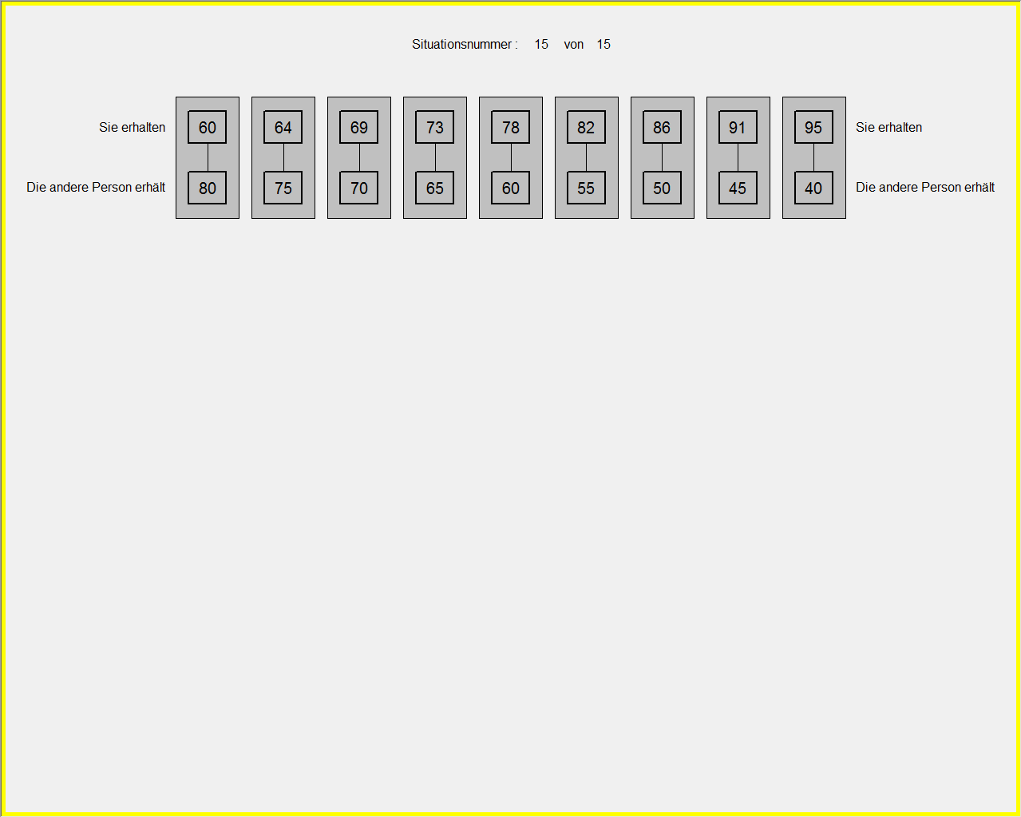
Please answer the comprehension questions on the screen. Your answers will not affect your payment. If you have any questions, please raise your hand.

Experiment B

Overview
This experiment is repeated for 20 periods. One of the 20 periods will be randomly selected at the end and you will get the points in the corresponding period. The points you earn in this experiment will be converted into Euro as follows:
1 Point = 0.30 Euro.
In each period, all participants in the lab are randomly assigned to groups of four persons. And the group is randomly reassembled at the beginning of each period. Therefore, your group will consist of different participants in different periods. You will not know who is in your group and the other members in your group will not know you are in the group either.
Each period of this experiment consists of two stages. At the first stage you decide how many points you would like to contribute to a project. At the second stage you are informed about the contributions of the other group members, and you can assign deduction points to them.
The following pages describe the course of the experiment in detail.
Stage I
At the beginning of each period, each participant receives 20 points as an endowment. You decide how many of the 20 points you would like to contribute to a project. All the points that are contributed to the project by the members of your group are multiplied by 1.6 and divided among the four group members. Therefore, your income consists of two parts:
- The points you keep for yourself. This income is
20 – Your contribution to the project.
- The income from the project. This income is
1.6 * Sum of the contributions in your group / 4.
Therefore, your total income at the first stage is
(20 – Your contribution to the project) + (1.6 * Sum of the contributions in your group / 4).
The income of each group member is calculated in the same way. This means that the income from the project is equal for everyone in the group. For example, assume that you have contributed 12 points, and the other group members have contributed 16, 18 and 14 points. Thus, a total of 60 (=12+16+18+14) points have been contributed to the project. Then all the group members get 24 (=1.6*60/4) points from the project. Because you have contributed 12 points, you will also receive 8 (=20-12) retained points. Your total income is 32 (=8+24) points. The person who has contributed 16 points has 4 retained points and a total income of 28 (=4+24) points.
Basically, the more people contribute to the project, the higher income of the group, since the contributions are multiplied by 1.6 before being distributed. However, one may receive less than his/her own contribution because he/she can only get 0.4 times of the amount of the project.
Input on the Computer
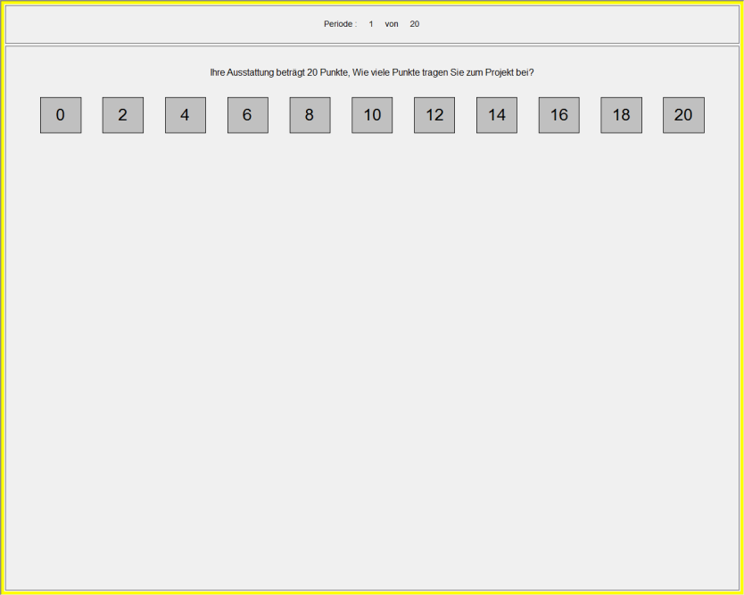
You can contribute multiples of 2 points to the project, i.e., 0, 2, 4 to 20. These options are displayed in small grey boxes. You make your decisions by clicking the left mouse button on the corresponding boxes.
After all participants have made their decisions, you will be informed about the outcome of the period. As you can see in the following screenshot: your own contribution, the sum of all contributions, the income from the retained points, the income from the project and the total income are reported.
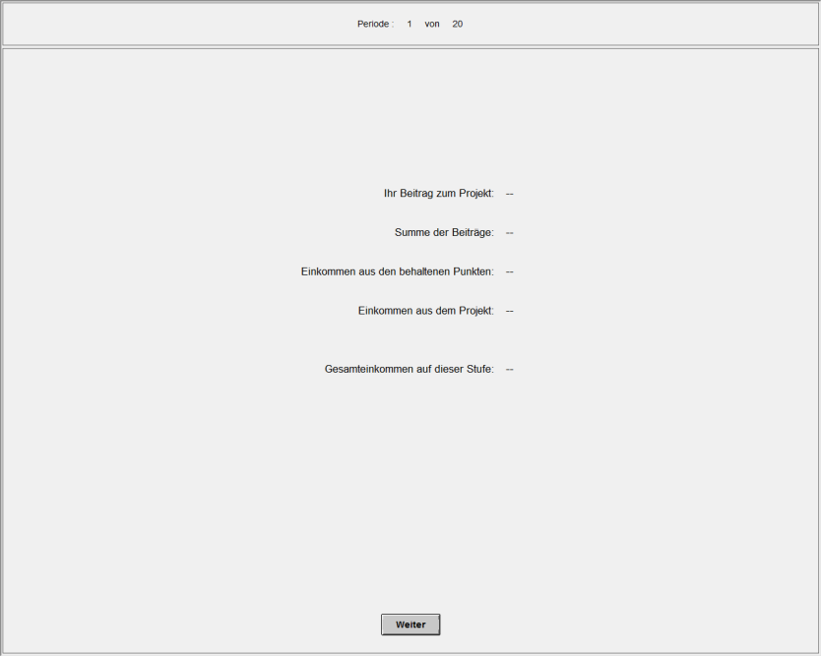
Stage II
At the second stage, you will learn how many points each of your group members has contributed and then decide whether to assign deduction points to them or not. If you assign deduction points, maybe it is costly for you. How many deduction points you can assign and what costs are associated with deduction is determined by chance. The following four possibilities occur with equal probabilities:
- 0:2 = You have a cost of 0 and the other group member is deducted by 2 points.
- 0:8 = You have a cost of 0 and the other group member is deducted by 8 points.
- 2:2 = You have a cost of 2 and the other group member is deducted by 2 points.
- 2:8 = You have a cost of 2 and the other group member is deducted by 8 points.
You have 120 seconds to decide for each of the three persons. If you do not decide within this time, 3 points will be deducted.
Conversely, the other group members can also assign deduction points to you.
Your income is thus composed of the following parts:
- The income from the first stage.
- The total cost of your decisions.
- The total deduction points that the others have assigned to you.
- Deduction of 3 points for every late decision.
Theoretically it would be possible that the income is negative. But in this case you will receive an income of 0.
Display on the Screen
You make your decision successively on the other three group members. The order of the other three members is random.
Each decision is made on a screen similar to the following screenshot. On this screen you have the following information: your own contribution, the contribution of other group member, your cost when you assign the deduction and the number of points that are deducted from the group member. The decision is made similar to the contribution decisions. You click on the grey rectangle "Deduction" or "No Deduction" with the left mouse button to make decisions.
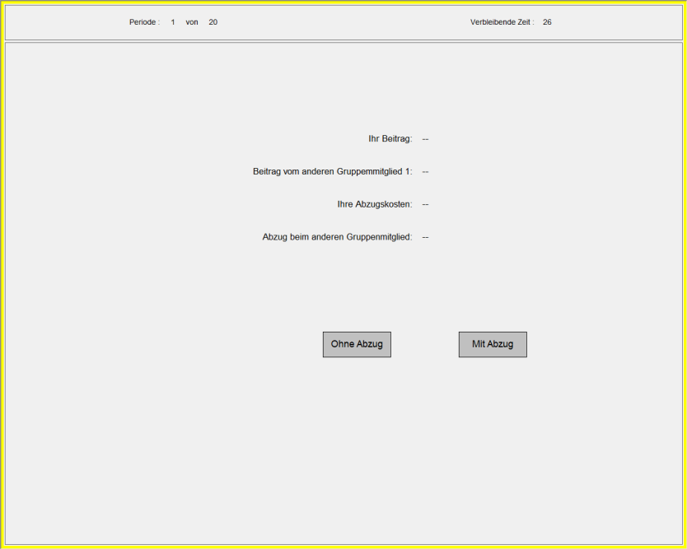
If all participants have made decisions on whether to assign deduction or not, you get the information listed on the following screen.
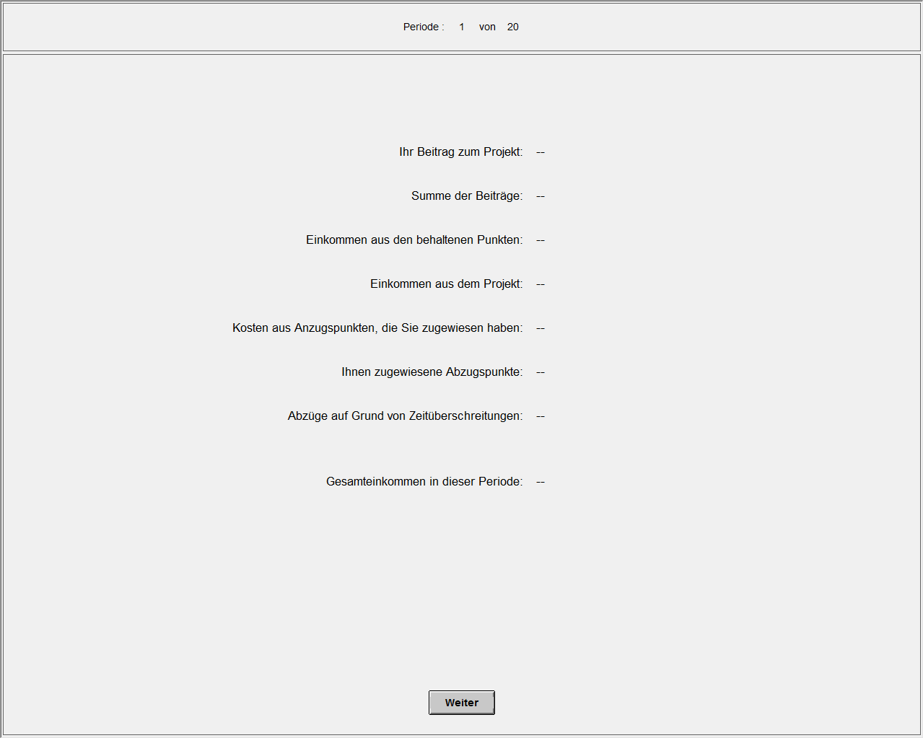
The experiment is repeated for 20 periods. After each period, all participants are assigned to a new groups randomly.
Payment
At the end of the experiment, the following information will be randomly determined:
In the first experiment:
- Which situation is paid.
- Which of the two participants’ decision determines the payment in the corresponding situation.
In the second experiment:
- Which period is paid.
Now please solve the comprehensive questions on the screen. Your answers will not affect your payment.
On the bottom right of the screen, there is a button with which you can get the calculator of the computer.
If you have any questions, please contact us by raising hands.

