Online Appendix A: Additional Statistical Analyses

Table A1: Principals’ switching behavior

Panel A: Grouped by whether agents stick to their messages
 | Proposal > Message | Proposal = Message | Proposal < Message
Switch | 39 | 143 | 9
Not switch | 12 | 123 | 4
Last round | 6 | 24 | 0
Percentage Switch | 76.5% | 53.8% | 69.2%
Chi Square, compared to Proposal = message | χ₍₁₎ = 9.03*** |  | χ₍₁₎ = 1.20

Panel B: Grouped by whether the proposal was rejected
 | Proposal rejected | Proposal not rejected
Switch | 40 | 151
Not switch | 17 | 122
Last round | 3 | 27
Percentage Switch | 70.2% | 55.3%
Chi Square, compared to Proposal not rejected | χ₍₁₎ = 4.27*

Table A2: Delegation over time in UGAC

 | (1)
VARIABLES | UseAgent
Round | -0.101***
 | (0.030)
Constant | 0.156
 | (0.264)
Observations | 360
Robust standard errors in parentheses
*** p<0.01, ** p<0.05, * p<0.1

Note: Logit with likelihood of using an agent as dependent variable and standard errors clustered by principal. Round is used as a discrete variable to capture changes in delegation over time.

Figure A1: Percentage of agent use over time, UGAC
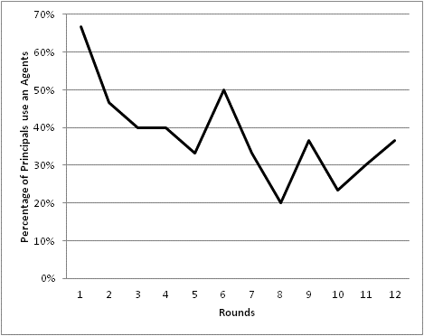

Figure A2: Average Proposals over time
