Appendix I: Experiment Instructions
Experiment Instructions -
Overview

In this experiment, you will be placed in a group of 10 participants (including you). You will remain in the same group for the entire experiment. The experiment will consist of 3 consecutive parts of 12 trading periods each. Each part may have different rules, and assets and shares do not carry over from one part to the next part (e.g., your money and asset stores “start over” at the beginning of each part). You will learn the rules of each part immediately before each part starts. However, you will remain in the same group of 10 participants for all 3 parts of the experiment.

Part 1
(Note to readers: This small section highlighted here in italics was included in the observational learning treatments. Other relatively minor edits were made to remove the second-person nature of the instructions and refer to the decisions of “your match.”)
You and everyone else in the room will be observers for this part – this means you will not be making any decisions of your own. Other students like you participated in the experiment previously, and you will randomly be matched with one of them. This means the following:
- you will observe the past decisions of your match, the outcomes of the decisions, and the decisions of the others in the group of your match
- your group members will each be matched with 1 person from the group of your match, but also will not make decisions of their own
- your profits in this part will be exactly equal to the profits your match received based on his/her decisions
- thus, you should think of any money or shares owned by your match as “your” shares

In each period, there will be a market open, in which you may buy or sell shares of a good called X. These shares of X can be considered an asset with a life of 12 periods, and your inventory of X shares carries over from one trading period to the next (but will never carry over to the next part of the experiment). Each share of X in your inventory at the end of each trading period pays a dividend to you.

At the end of each trading period, the computer will randomly determine the dividend paid for that period. Each share of X held by you at the end of each period pays a dividend of 0, 8, 28 or 60 experimental dollars. These four outcomes are equally likely, so that on average, you can expect to earn 24 experimental dollars from each share in one period (24 = (0+8+28+60)/4). As explained below, you can calculate the average value of each share in each period by multiplying the number of periods remaining by the expected dividend value.

Participants will have a different number of shares of X and of cash at the beginning of period 1 of the experiment. The number of shares of X and of cash assigned to you will be revealed on your screen when we begin, and is known only to you but not to the other participants in your group. You will have the opportunity to buy and sell X shares in the market.

Your cash on hand and your inventory of X shares will carry over from period to period beginning in period 1. That means that your cash and your inventory of X at the beginning of period 2 will remain the same as it was at the end of period 1, etc.

Your profits in this part are the total of the dividends that you receive on shares of X in your inventory at the end of each market period plus your initial cash balance and changes in your cash holdings due to trades you make. Experimental dollars will be converted to U.S. dollars at the rate of $1 = 150 Experimental Dollars.

Average Holding Value Table
You can use your AVERAGE HOLDING VALUE TABLE to help you make decisions. There are 5 columns in the table. The first column, labeled Ending Period, indicates the last trading period of this part of the experiment. The second column, labeled Current Period, indicates the period during which the average holding value is being calculated. The third column gives the number of holding periods from the period in the second column until the end of this part of the experiment. The fourth column, labeled Average Dividend Per Period, gives the average amount that the dividend will be in each period for each unit held in your inventory. The fifth column, labeled Average Holding Value Per Unit of Inventory, gives the expected total dividend for the remainder of this part for each unit held in your inventory. That is, for each unit you hold in your inventory for the remainder of this part, you receive on average the amount listed in column 5. The number in column 5 is calculated by multiplying the numbers in columns 3 and 4.

AVERAGE HOLDING VALUE TABLE

(1)  ENDING PERIOD | (2)  CURRENT PERIOD | (3)  HOLDING PERIODS REMAINING | (4)  AVERAGE DIVIDEND PER PERIOD | (5)  AVERAGE HOLDING VALUE PER UNIT OF INVENTORY
12 | 1 | 12 | 24 | 288
12 | 2 | 11 | 24 | 264
12 | 3 | 10 | 24 | 240
12 | 4 | 9 | 24 | 216
12 | 5 | 8 | 24 | 192
12 | 6 | 7 | 24 | 168
12 | 7 | 6 | 24 | 144
12 | 8 | 5 | 24 | 120
12 | 9 | 4 | 24 | 96
12 | 10 | 3 | 24 | 72
12 | 11 | 2 | 24 | 48
12 | 12 | 1 | 24 | 24

Trading Stage: How to Buy and Sell Shares of X
During the trading stage, shares of X can be purchased from and sold to other participants in your group. At any time during the trading stage, everyone is free to make an offer to buy a share of X at a price they choose; likewise, everyone is free to make an offer to sell a share of X at a price they choose. Also at any time during the period, everyone is free to buy at the best offer price specified by someone wishing to sell, and everyone is free to sell at the best offer price specified by someone wishing to buy. Of course, there are some limits: to sell a share or make a sales offer, you need to have a share to sell. And to buy a share or make a buy offer, you need to have enough cash to pay.
You will enter offer prices and accept prices to execute transactions using your computer. Figure 1 shows the market trading screen for one of the trading period. You will have 2 minutes to buy and/or sell shares of X in each trading period. The time left in the period is shown on the upper right of the trading screen. The current period is shown on the upper left, and the number of remaining periods is shown on the right in the “Account Summary” box. The “Account Summary” box will also show you the number of shares that you currently hold and your current cash balance.

Figure 1:
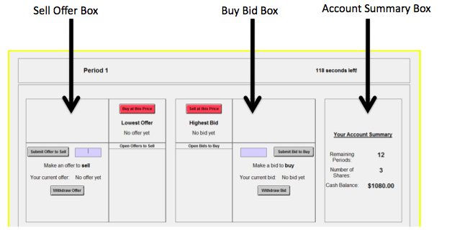
Selling shares of X
Participants interested in selling can submit offer prices by entering a price and clicking the “Submit Offer to Sell” button on the left side of the screen. This offer price is immediately displayed on all traders’ computers on the left part of the screen, labeled “Open Offers to Sell.” Once this offer price has been submitted, it is binding in the sense that anyone wishing to buy can accept this price offer. Such an acceptance results in an immediate trade at that price. Your current sell offer price will be listed on the left side of the screen - if you need to withdraw your offer to sell, click on the “Withdraw Offer” button directly below your listed current offer.
Another way to sell shares of X is with the red “Sell at this Price” button in the middle of the screen. Anyone wishing to sell can accept the best (that is, highest bid price) by simply clicking the “Sell at this Price” button on the top of their computer screen. This results in an immediate trade at that price.
Regardless of how you sell shares of X, your share and cash totals will be updated at the time of sale in the box on the far right. You will also see a notice alerting you of the sale. Note that if you attempt to submit a sell offer that is lower than a current standing bid to buy, you will get an error message alerting you to use the “Sell at this Price” button in the middle instead. This gives you a higher sales price and therefore greater trading profits.

Buying shares of X
Similarly, participants interested in buying can submit bid prices by entering a price and clicking the “Submit Bid to Buy” button in the middle of the screen. This bid price is displayed on traders’ computers, labeled “Open Bids to Buy.” Once this bid price has been submitted it is binding, and if it is accepted this results in an immediate trade at that price. If you need to withdraw your bid to buy, click on the “Withdraw Bid” button directly below your listed current bid amount.
Another way to buy shares of X is with the red “Buy at this Price” button. Anyone wishing to buy can accept the best (that is, lowest offer price) by simply clicking this button. This results in an immediate trade at that price.
Regardless of how you buy shares of X, your share and cash totals will be updated at the time of sale in the box on the far right. You will also see a notice alerting you of the purchase. Note that if you attempt to submit a buy bid that is higher than a current standing offer to sell, you will get an error message alerting you to use the “Buy at this Price” button on the left instead. This gives you a lower purchase price and therefore greater trading profits.

Graphical Representation (Note to readers: This section was used for Visualized Market Treatment)
To assist you in making your decisions, we have provided you with a graphical representation of trades that will be visible on the screen at all times (see Figure 2). The graphical representation will display the trade price and progression of all completed trades (both buys and sells) in the market to all participants in your group.

Figure 2: Graphical Representation
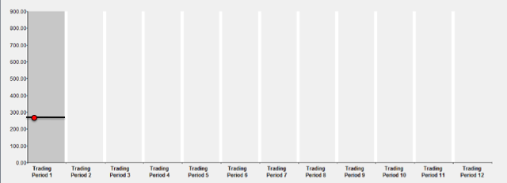

In the graphical representation, each trading period is represented on the horizontal axis, and the trading price is on the vertical axis. The current trading period is highlighted in gray. As soon as a trade occurs, a red dot will appear on the screen at the relevant price – for example, in Figure 2, the red dot represents an initial trade at a price of $288 early in the period. The horizontal black line represents the average price of trades in that period, and adjusts immediately as trades occur. Therefore, looking at the graphical representation can give you an idea about trade prices occurring in your group. After each period is completed, the past trades from earlier periods are converted to black dots.

Past Prices List (Note to readers: This section was used for Text Market Treatment)
To assist you in making your decisions, we have provided you with a list of past trade prices that will be visible on the screen at all times (see Figure 2). The table will display the trade price and progression of all completed trades (both buys and sells) in the market to all participants in your group.

Figure 2: Past Prices
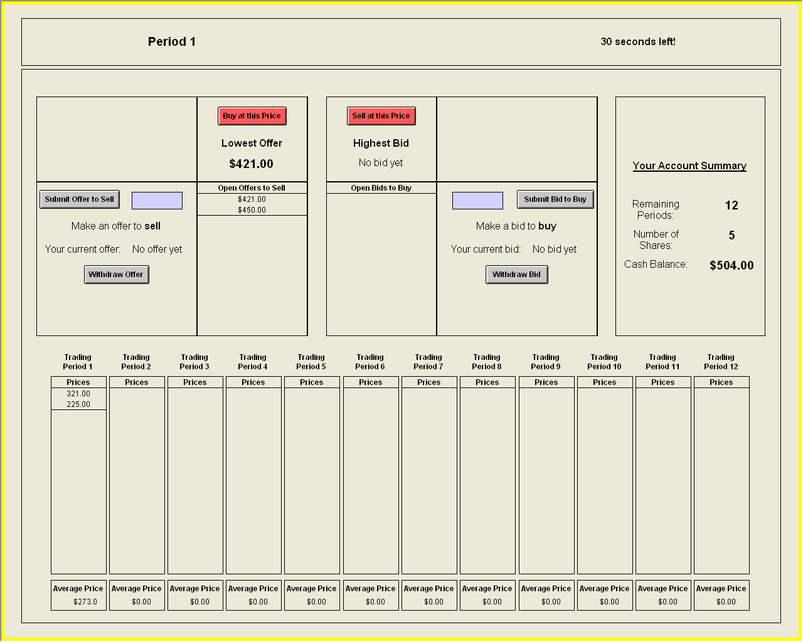

In this table, each column represents a trading period. As soon as a trade occurs, the trade price will appear on the screen at the top of the price list – for example, in Figure 2, the lower number represents an initial trade at a price of $225 followed by a price of $321 shown in the higher number. The average price of trades in that period is shown at the bottom and adjusts immediately as trades occur. Looking at these numbers can give you an idea about trade prices occurring in your group.

Outcome Screen & Record Sheet
At the end of the period, you will click to continue on to the outcome screen. The sample outcome screen is displayed in Figure 3. On the right, you will still see your account summary as before.
On the left, you will see the dividend outcome – this is the experimental dollars paid in this period for each dividend you hold. This dividend outcome is randomly determined by the computer and is the same for all participants in the group.
You will also see your status – the total dividend payment you received in this period (this is calculated as the number of dividends you currently hold * dividend outcome). Finally, you will see your current cash balance (calculated as the cash balance from the previous round plus the total dividend payment).

Figure 3: Outcome Screen
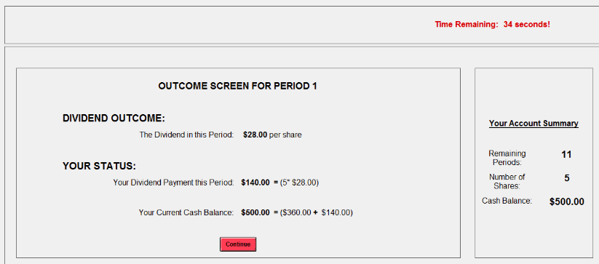

Please record the dividend per share, current number of shares held, and total dividend payment, as well as your total cash balance on your record sheet before you click “Continue.”
Your total earnings for Part 1 are the total of your dividend earnings for periods 1-12 plus your initial cash balance, as recorded in the amount of cash you hold at the end of Period 12. Your shares of X cannot be traded anymore after Period 12 ends; therefore, after the last dividend payment in Period 12, shares of X are worth $0 experimental dollars. Remember that shares do not carry over from Part 1 to the next Part 2.

Part 2
Part 2 of the experiment will proceed exactly like part 1. There will be 12 trading periods as before. You will continue to interact in the market with the same 9 other participants.
Note that you will receive a new initial cash endowment and new shares of X at the beginning of period 1, and these will carry over from period to period during Part 2. Remember that shares do not carry over from Part 2 to the next Part 3.
At the end of Part 2, your total experimental dollar earnings will be converted to US dollars at the rate of $1 = 150 Experimental Dollars and will be added to your earnings in Part 1.

Part 3
Part 3 of the experiment will proceed exactly like part 1 and part 2. There will be 12 trading periods as before. You will continue to interact in the market with the same 9 other participants.
Note that you will receive a new initial cash endowment and new shares of X at the beginning of period 1, and these will carry over from period to period during Part 3.
At the end of Part 3, your total experimental dollar earnings will be converted to US dollars at the rate of $1 = 150 Experimental Dollars and will be added to your earnings in Parts 1 and 2.

Note to readers: For the observational learning treatments, the Part 2 instructions began with the following section, and then included a review (identical to the Part 1 instructions shown above) about how to make trades.

Part 2 (Observational Learning Only)
The market trading rules in Part 2 of the experiment are exactly the same as the rules in Part 1 – with one major difference – now you and everyone in your group will be making your own decisions. This means that:
- you will make your own decisions and you will observe the decisions that members of your group make on their own
- your profits will depend only on your decisions and the decisions of your group members
There will be 12 trading periods as before. You will be matched with the same 9 participants as before, only this time you will all be making your own decisions. Let’s review how you can make decisions:

Sample Record Sheet used by Active and Passive Participants

Station ID number: ___________
PERIOD EARNINGS SHEET – PART 1
(1)  PERIOD | (2)  DIVIDEND PER SHARE OF X | (3)  NUMBER OF SHARES OF X IN ACCOUNT | (4)  DIVIDEND PAYMENT THIS PERIOD | (5)  END OF PERIOD CASH BALANCE
1 | ______ | * ______ | = ______ | ______
2 | ______ | * ______ | = ______ | ______
3 | ______ | * ______ | = ______ | ______
4 | ______ | * ______ | = ______ | ______
5 | ______ | * ______ | = ______ | ______
6 | ______ | * ______ | = ______ | ______
7 | ______ | * ______ | = ______ | ______
8 | ______ | * ______ | = ______ | ______
9 | ______ | * ______ | = ______ | ______
10 | ______ | * ______ | = ______ | ______
11 | ______ | * ______ | = ______ | ______
12 | ______ | * ______ | = ______ | ______

Experimental dollar earnings for this part.
Appendix II: Additional Figures
Text Market Display
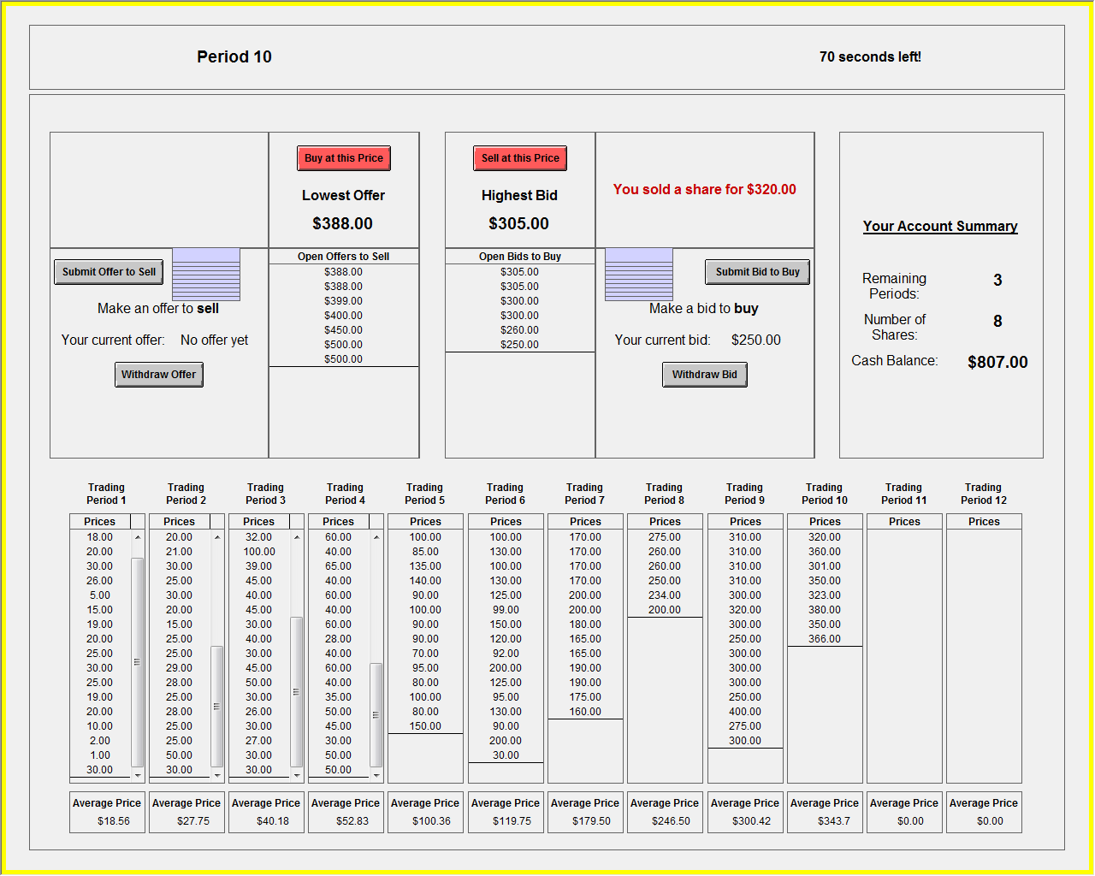
Visualized Market Display
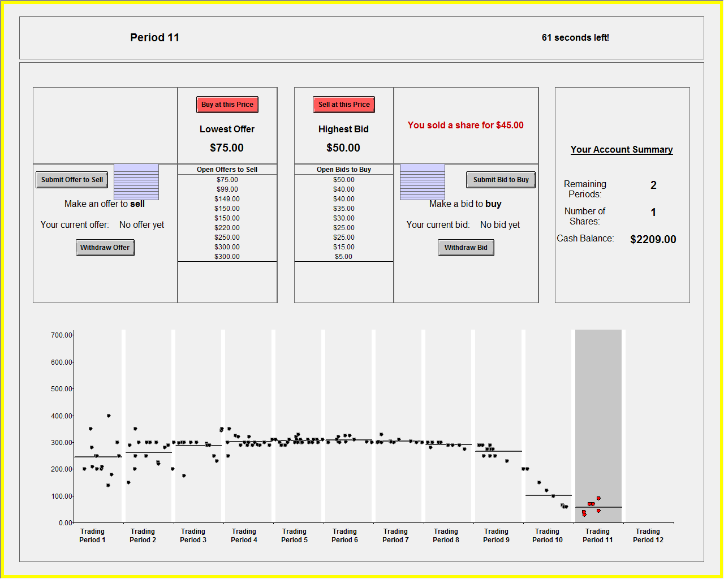
Appendix III: Additional Bubble Measures, by Treatment and Market Number
We also conducted additional tests as are standard in the literature:
- $$Amplitude=max\left\{\frac{\left|P_{t}−f_{t}\right|}{E}:t=1,…,12\right\}−min\left\{\frac{\left|P_{t}−f_{t}\right|}{E}:t=1,…,12\right\}$$
- $$Duration=max\left\{m:P_{t}−f_{t}<P_{t+1}−f_{t+1}<…<P_{t+m}−f_{t+m}\right\}$$
- $$Turnover=\sum_{t}{\frac{V_{t}}{S}}$$
- Relative Deviation (RD) – $RD=\left(1/N\right)\sum_{p=1}^{N}{{\left({\overline{P}}_{p}−{FV}_{P}\right)}/{}\overline{FV}∨}$
- Payoff variance – using each trader’s mean earnings (payoff variance variable)
The table below provides a summary of averages for each of the measures in each market and treatment. Numbers in parentheses represent standard deviation. Using Amplitude as a measure of bubble magnitude, we observe similar results as reported in the paper for RAD. However, treatment does not affect pricing along the other dimensions, including duration, turnover, RD or payoff variance.
 | Amplitude
 | Market 1 | Market 2 | Market 3
1. Text Treatment | 0.97 (0.34) N=6 | 0.49 (0.22) N=6 | 0.46 (0.25) N=6
2. Visualized Treatment | 0.50 (0.12) N=6 | 0.25 (0.14) N=6 | 0.34 (0.11) N=6
3. Pre-Text Treatment |  | 0.57 (0.19) N=6 | 0.31 (0.21) N=6
4. Pre-Visualized Treatment |  | 0.38 (0.18) N=6 | 0.37 (0.08) N=6
 | Duration
 | Market 1 | Market 2 | Market 3
1. Text Treatment | 7.50 (3.20) N=6 | 5.17 (3.54) N=6 | 6.83 (3.37) N=6
2. Visualized Treatment | 6.33 (3.08) N=6 | 5.00 (2.61) N=6 | 5.67 (2.34) N=6
3. Pre-Text Treatment |  | 5.83 (2.79) N=6 | 5.67 (1.97) N=6
4. Pre-Visualized Treatment |  | 5.17 (3.54) N=6 | 5.33 (2.73) N=6
 | Turnover
 | Market 1 | Market 2 | Market 3
1. Text Treatment | 3.93 (1.79) N=6 | 3.80 (3.98) N=6 | 2.73 (1.93) N=6
2. Visualized Treatment | 3.43 (1.08) N=6 | 2.50 (1.29) N=6 | 2.21 (0.99) N=6
3. Pre-Text Treatment |  | 2.66 (0.96) N=6 | 2.57 (0.88) N=6
4. Pre-Visualized Treatment |  | 3.25 (1.95) N=6 | 2.67 (1.97) N=6
 | RD
 | Market 1 | Market 2 | Market 3
1. Text Treatment | 0.30 (0.27) N=6 | -0.09 (0.39) N=6 | -0.24 (0.35) N=6
2. Visualized Treatment | 0.22 (0.67) N=6 | -0.13 (0.09) N=6 | -0.28 (0.14) N=6
3. Pre-Text Treatment |  | 0.27 (0.35) N=6 | 0.14 (0.12) N=6
4. Pre-Visualized Treatment |  | -0.00 (0.16) N=6 | -0.16 (0.22) N=6
 | Payoff Variance
 | Market 1 | Market 2 | Market 3
1. Text Treatment | 0.64 (0.21) N=6 | 0.44 (0.11) N=6 | 0.37 (0.07) N=6
2. Visualized Treatment | 0.53 (0.06) N=6 | 0.37 (0.06) N=6 | 0.34 (0.08) N=6
3. Pre-Text Treatment |  | 0.52 (0.13) N=6 | 0.39 (0.07) N=6
4. Pre-Visualized Treatment |  | 0.41 (0.10) N=6 | 0.39 (0.06) N=6
Standard Deviation in Parentheses.

