Online Appendix

Table A1
Ordered probit regression checking for order effects in the TIE task
Explanatory variables | # of tokens invested (TIE)
Age (in years) | 0.233***
 | (0.039)
Female (=1) | -0.044
 | (0.088)
Number of siblings | -0.045
 | (0.038)
Both tasks (=1)§ | 0.078
 | (0.205)
cut1
Constant | 1.634***
 | (0.426)
cut2
Constant | 2.211***
 | (0.436)
cut3
Constant | 2.771***
 | (0.434)
cut4
Constant | 3.224***
 | (0.431)
cut5
Constant | 3.445***
 | (0.430)
Observations | 596
Pseudo R² | 0.0223
Notes. ***, **, * denote significance at the 1%, 5%, 10% level, robust standard errors in parentheses. Clustered on class level.
§ The variable “Both tasks” indicates whether someone participated in both experiments (=1; N=561) or only in the TIE task (=0; N=35).

Table A2
Probit regression for explaining inconsistent choice patterns in the CL task
Explanatory variables | [1] | [2]
 | Inconsistent choice pattern  (CL task) | Inconsistent choice pattern  (CL task)
Age (in years) | 0.028 | 0.019
 | (0.044) | (0.042)
Female (=1) | 0.116 | 0.103
 | (0.092) | (0.099)
Risk-taking propensity† |  | -0.008
 |  | (0.044)
Relative IQ$ |  | 0.038
 |  | (0.243)
Constant | -1.039*** | -0.969**
 | (0.376) | (0.458)
Observations | 561 | 550
Pseudo R² | 0.0022 | 0.0017
Notes. ***, **, * denote significance at the 1%, 5%, 10% level, robust standard errors in parentheses. Clustered on class level.
Dependent variable: dummy coded 1 if choice pattern in the CL-task was inconsistent, 0 else.
† Number of tokens invested in a risk experiment (min=0; max = 5). The risk taking experiment was run between the two experiments on time preferences. The child had to decide how many of five tokens to invest in a lottery that doubled the number of invested tokens with a 50% probability, while with 50% probability the child lost the invested tokens (Charness and Gneezy, 2010). Non-invested tokens were safe earnings for the child.
$ The IQ was measured relative to the respective grade (values above 1 indicate above average IQ in the respective grade; values below 1 indicate below average IQ)

Table A3
OLS# Regressions of patience with different measures as dependent variable
 | [1] | [2]
Explanatory variables | Patience | Patience
 | (CL-Task) | (TIE)
Age (in years) | 0.1932*** | 0.2306***
 | (0.0342) | (0.0421)
Female (=1) | -0.2563** | -0.1756*
 | (0.1005) | (0.1038)
Risk-taking propensity† | 0.1394*** | 0.1265***
 | (0.0442) | (0.0454)
Relative IQ$ | 0.8877*** | 0.7688***
 | (0.2597) | (0.1997)
Incons (=1)§ | 3.0783*** | 1.7223**
 | (0.5196) | (0.6790)
Age*Incons | -0.1724*** | -0.1511**
 | (0.0482) | (0.0642)
Female*Incons | 0.3426** | 0.4615**
 | (0.1436) | (0.2122)
Risk*Incons | -0.1736*** | -0.1605*
 | (0.0472) | (0.0871)
IQ*Incons | -0.9255** | -0.2354
 | (0.4262) | (0.4440)
Constant | -1.8149*** | -2.050***
 | (0.3776) | (0.4186)
Observations | 550 | 550
R² | 0.1707 | 0.127
Wald Tests
H0: no age effect for inconsistent subjects
(β_{age}+β_{age*Incons}=0) | 0.537 | 0.165
H0: no gender effect for inconsistent subjects
(β_{female}+β_{female*Incons}=0) | 0.403 | 0.108
H0: no effect of risk tolerance for inconsistent subjects
(β_{risk}+β_{risk*Incons}=0) | 0.309 | 0.629
H0: no effect of IQ for inconsistent subjects
(β_{IQ}+β_{IQ*Incons}=0) | 0.883 | 0.168
H0: no difference between consistent and inconsistent girls with average risk tolerance and average IQ in each age group …
(β_{Incons}+β_{age*Incons}*7.5+β_{female*Incons}+β_{risk*Incons}*$\overline{risk}$+β_{IQ*Incons}*$\overline{IQ}$=0) | 0.000 | 0.002
(β_{Incons}+β_{age*Incons}*8.5+β_{female*Incons}+β_{risk*Incons}*$\overline{risk}$+β_{IQ*Incons}*$\overline{IQ}$=0) | 0.000 | 0.038
(β_{Incons}+β_{age*Incons}*9.5+β_{female*Incons}+β_{risk*Incons}*$\overline{risk}$+β_{IQ*Incons}*$\overline{IQ}$=0) | 0.000 | 0.479
(β_{Incons}+β_{age*Incons}*10.5+β_{female*Incons}+β_{risk*Incons}*$\overline{risk}$+β_{IQ*Incons}*$\overline{IQ}$=0) | 0.021 | 0.996
H0: no difference between consistent and inconsistent boys with average risk tolerance and average IQ in each age group …
(β_{Incons}+β_{age*Incons}*7.5+β_{risk*Incons}*$\overline{risk}$+β_{IQ*Incons}*$\overline{IQ}$=0) | 0.000 | 0.676
(β_{Incons}+β_{age*Incons}*8.5+β_{risk*Incons}*$\overline{risk}$+β_{IQ*Incons}*$\overline{IQ}$=0) | 0.020 | 0.112
(β_{Incons}+β_{age*Incons}*9.5+β_{risk*Incons}*$\overline{risk}$+β_{IQ*Incons}*$\overline{IQ}$=0) | 0.189 | 0.042
(β_{Incons}+β_{age*Incons}*10.5+β_{risk*Incons}*$\overline{risk}$+β_{IQ*Incons}*$\overline{IQ}$=0) | 0.524 | 0.003
Notes.
***, **, * denote significance at the 1%, 5%, 10% level, robust standard errors in parentheses. Clustered on the level of individual subjects.
# We employ OLS rather than Ordered Probit because of the problems associated with Logit and Probit models when incorporating interaction terms (Ai and Norton, 2003).
Dependent variables: patience in CL and TIE normalized by dividing the number of patient choices in CL, respectively the number of invested tokens in TIE through the average patience level of CL and TIE, respectively. Through the normalization the values of the two measures are adjusted to a common scale and range between 0 and 3.04 for TIE, respectively 3.07 for CL.
† Number of tokens invested in a risk experiment (min=0; max = 5). The risk taking experiment was run between the two experiments on time preferences. The child had to decide how many of five tokens to invest in a lottery that doubled the number of invested tokens with a 50% probability, while with 50% probability the child lost the invested tokens (Charness and Gneezy, 2010). Non-invested tokens were safe earnings for the child.
$ The IQ was measured relative to the respective grade (values above 1 indicate above average IQ in the respective grade; values below 1 indicate below average IQ).
§ Indicates if a subject chose inconsistently in the CL-task (=1) or not (=0).

Table A4
OLS# Regressions of patience in each of the two methods
 | [1] | [2] | [3]
Explanatory variables | Patience | Patience | Patience
 | (All subjects) | (Consistent) | (Inconsistent)
Age (in years) | 0.1664*** | 0.1932*** | 0.0207
 | (0.0304) | (0.0368) | (0.0341)
Female (=1) | -0.1813** | -0.2563*** | 0.0864
 | (0.0788) | (0.0957) | (0.0877)
Risk-taking propensity† | 0.1091*** | 0.1394*** | -0.0342
 | (0.0345) | (0.0412) | (0.0374)
Relative IQ$ | 0.7808*** | 0.8877*** | -0.0377
 | (0.2171) | (0.2522) | (0.2379)
TIE (=1) | -0.1066 | 0.1816 | -1.4625**
 | (0.4405) | (0.5161) | (0.7282)
Age*TIE | 0.0153 | 0.0100 | 0.0516
 | (0.0398) | (0.0472) | (0.0670)
Female*TIE | 0.0963 | 0.0774 | 0.2053
 | (0.0991) | (0.1181) | (0.1647)
Risk*TIE | -0.0108 | -0.0098 | -0.0016
 | (0.0459) | (0.0543) | (0.0691)
IQ*TIE | -0.0404 | -0.1647 | 0.5528
 | (0.2655) | (0.3080) | (0.4592)
Constant | -1.3403*** | -1.8149*** | 1.2634***
 | (0.3593) | (0.4260) | (0.4141)
Observations | 1,100 | 848 | 252
R² | 0.1063 | 0.1443 | 0.1169
Wald Tests
H0: no age effect for TIE
(β_{age}+β_{age*TIE}=0) | 0.000 | 0.000 | 0.248
H0: no gender effect for TIE
(β_{female}+β_{female*TIE}=0) | 0.281 | 0.050 | 0.064
H0: no effect of risk tolerance for TIE
(β_{risk}+β_{risk*TIE}=0) | 0.008 | 0.003 | 0.575
H0: no effect of IQ for TIE
(β_{IQ}+β_{IQ*TIE}=0) | 0.000 | 0.001 | 0.218
H0: no difference between CL and TIE for girls with average risk tolerance and average IQ in each age group …
(β_{TIE}+β_{age*TIE}*7.5+β_{female*TIE}+β_{risk*TIE}*$\overline{risk}$+β_{IQ*TIE}*$\overline{IQ}$=0) | 0.580 | 0.069 | 0.009
(β_{TIE}+β_{age*TIE}*8.5+β_{female*TIE}+β_{risk*TIE}*$\overline{risk}$+β_{IQ*TIE}*$\overline{IQ}$=0) | 0.440 | 0.053 | 0.017
(β_{TIE}+β_{age*TIE}*9.5+β_{female*TIE}+β_{risk*TIE}*$\overline{risk}$+β_{IQ*TIE}*$\overline{IQ}$=0) | 0.426 | 0.111 | 0.075
(β_{TIE}+β_{age*TIE}*10.5+β_{female*TIE}+β_{risk*TIE}*$\overline{risk}$+β_{IQ*TIE}*$\overline{IQ}$=0) | 0.440 | 0.189 | 0.329
H0: no difference between CL and TIE for boys with average risk tolerance and average IQ in each age group …
(β_{TIE}+β_{age*TIE}*7.5+β_{risk*TIE}*$\overline{risk}$+β_{IQ*TIE}*$\overline{IQ}$=0) | 0.476 | 0.513 | 0.000
(β_{TIE}+β_{age*TIE}*8.5+β_{risk*TIE}*$\overline{risk}$+β_{IQ*TIE}*$\overline{IQ}$=0) | 0.541 | 0.379 | 0.000
(β_{TIE}+β_{age*TIE}*9.5+β_{risk*TIE}*$\overline{risk}$+β_{IQ*TIE}*$\overline{IQ}$=0) | 0.764 | 0.298 | 0.004
(β_{TIE}+β_{age*TIE}*10.5+β_{risk*TIE}*$\overline{risk}$+β_{IQ*TIE}*$\overline{IQ}$=0) | 0.896 | 0.414 | 0.057
Notes.
***, **, * denote significance at the 1%, 5%, 10% level, robust standard errors in parentheses. Clustered on the level of individual subjects.
# We employ OLS rather than Ordered Probit because of the varying number of categories between the two methods (4 categories in CL and 6 in TIE) and because of the problems associated with Logit and Probit models when incorporating interaction terms (Ai and Norton, 2003).
Dependent variable: patience in CL and TIE (two observations per subject) normalized by dividing the number of patient choices in CL, respectively the number of invested tokens in TIE through the average patience level of CL and TIE, respectively. Through the normalization the values of the two measures are adjusted to a common scale and range between 0 and 3.04 for TIE, respectively 3.07 for CL.
† Number of tokens invested in a risk experiment (min=0; max = 5). The risk taking experiment was run between the two experiments on time preferences. The child had to decide how many of five tokens to invest in a lottery that doubled the number of invested tokens with a 50% probability, while with 50% probability the child lost the invested tokens (Charness and Gneezy, 2010). Non-invested tokens were safe earnings for the child.
$ The IQ was measured relative to the respective grade (values above 1 indicate above average IQ in the respective grade; values below 1 indicate below average IQ)

Fig. A1: Frequency of patience in both experiments, subjects with consistent choice patterns (N = 434 overall)

Fig. A2: Frequency of patience in both experiments, subjects with inconsistent choice patterns (N = 127 overall)

Experimental instructions (translated from Italian)
Note: Italic font is used for the instructions to the experimenter.

Experimental instructions “Time preferences – choice list task”
Register the order of explanation (blue first or green first) in the computer.
Good morning. My name is … Today I have prepared a game for you. In this game you can earn tokens. With these tokens you can buy some presents in our shop. Each present costs 1 token. You can choose your favorite present in our shop and you will get equally many pieces of this present as many tokens as you have earned in this game. The game consists of 3 parts. The blue part, the yellow part and the green part (when mentioning the parts please point at the respective decision sheets).
The game works as follows:
In the blue part you have to decide whether you prefer receiving 2 tokens (please point at the tokens on the decision sheet) immediately, in this case please tick THIS box (point at the respective box), or whether you prefer receiving 3 tokens in 4 weeks, in that case please tick THAT box (point at the respective box). If you want to receive 2 pieces of your favorite present, you will get the presents immediately after the game. If you rather want to wait, you will get three pieces of your favorite presents in 4 weeks. This is the blue part. Could you please repeat the rules of the game? (If the child is unable to repeat, please explain the game again; the child has to be able to repeat the correct meaning of the game autonomously.)
The yellow part is very similar to the blue part. Here you see the decision sheet for the yellow part. Again, there are 2 tokens on the left-hand side, but on the right-hand side there are 4 tokens now. What do you think will happen if you tick THIS box? (please point at the box with the immediate reward) What do you think will happen if you tick THAT box? (please point at the box with the delayed reward of four tokens; the child has to answer the questions correctly, otherwise the experimenter has to repeat the explanation).
The green part is very similar to the blue and yellow part. Here you see the decision sheet for the yellow part. Again, there are 2 tokens on the left-hand side, but on the right-hand side there are 5 tokens now. What do you think will happen if you tick THIS box? (please point at the box with the immediate reward) What do you think will happen if you tick THAT box? (please point at the box with the delayed reward of five tokens; the child has to answer the questions correctly, otherwise the experimenter has to repeat the explanation).
It is important to note that at the end only one of the three parts counts. That means that you will receive the tokens for one of the three parts only. After your decisions I will mingle the three decision sheets under the table (please demonstrate; Attention: you have to handle the sheets such that the child is not able to see the color of the respective sheet! You need to cover the three parts with an additional large-format sheet when placing the sheets on the table for drawing) and then you can draw one of the three parts. (In what follows, adapt the explanation to the order in which you draw the sheets:) If you draw the blue part (demonstrate the drawing of the first sheet), only the blue part counts and you will receive the tokens for this part only. The other two parts do not count in this case. If you, for example, ticked THIS box (please point at the box with the immediate reward), what happens? If you, for example, ticked THAT box (please point at the box with the delayed reward), what happens (child must answer both questions correctly; IMPORTANT: give both examples!)? If you however draw the yellow part (demonstrate the drawing of the second sheet), only the yellow part counts and you will receive the tokens for the yellow part only. The other two parts do not count in this case. If you draw the green part (demonstrate the drawing of the third sheet), only the green part counts and you will receive the tokens for the green part only. The other two parts do not count in this case. However, you need to make a decision for each of the three parts because you don’t know yet which part will be drawn at the end of the game. Could you please repeat the last part? Will you receive the tokens for all three parts? Do you need to make a decision for each of the three parts? (If the child answers incorrectly the experimenter has to repeat the explanation of this part.)
Please take your decision for each of the three parts now (place the decision sheets side by side on the table; the child should fill out the decision sheets from left to right). Start with this part (point at the first decision sheet (blue or green, depending on the order of explanation)) and continue with this part (point at the second decision sheet) and finally make your decision in this part (point at the third decision sheet). Take as much time as you need. In the meantime I will turn around so that I don’t disturb you. Just call me when you are done.

Fig. A3: Decision sheets for the choice list tasks (translated from Italian)
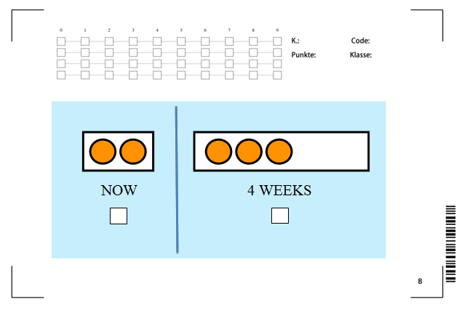

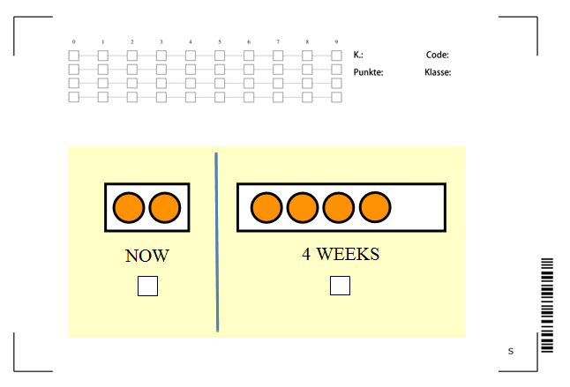

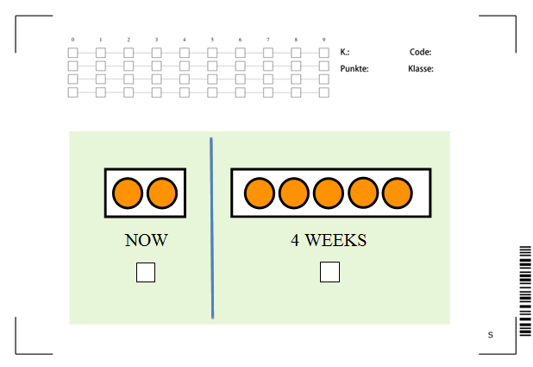

Experimental Instructions for the time-investment-exercise (TIE)

Good morning. My name is … Today’s game works as follows:
At the beginning you will receive 5 tokens (please place the 5 tokens in front of the child). You have to decide how many of these 5 tokens you want to put in the box labeled NOW (point at the left box) and how many tokens you want to put in the box labeled “4 WEEKS” (point at the right box). You will receive the tokens that you put in the box “NOW” immediately after the game and you can use these tokens for buying presents in our present shop. You can take these presents home today. Each token that you put in the box “4 WEEKS” will be doubled and you will receive the presents that you choose with these tokens in 4 weeks only.
Let’s consider an example: If you, for instance, want to receive two tokens today, what do you have to do? (Answer of the child: “I have to put 2 tokens in the left box) And what happens with the other 3 tokens? (Answer: I have to put these tokens in the right box”; please let the child demonstrate this) How many tokens will be added to this box? (point at the right box; answer of the child: “3”; please demonstrate!) How many tokens are in the box in total? (Answer: 6). When will you receive the presents which you can choose with these 6 tokens? (Answer: in 4 weeks). And what happens if you put 5 tokens in that box? (point at the left box; Answer: then I will receive 5 tokens immediately after the game and I can choose presents with these 5 tokens which I can take home today). And what happens if you put all 5 tokens in that box? (point at the right box; Answer: then these tokens will be doubled and I can choose presents with the 10 tokens which I will receive only in 4 weeks.) Could you please repeat the rules of the game? (If the child is unable to repeat, please explain the game again; the child has to be able to repeat the correct meaning of the game autonomously.)
Please take your decision now. You have to put the tokens which you want to receive today in this box (point at the left box) and the tokens with which you can buy presents which you will receive in 4 weeks in that box (point at the right box). Take as much time as you need for your decision. In the meantime I will turn around so I don’t disturb you. Just call me when you are done.

Fig. A4: Decision sheet for the time-investment-exercise (TIE, translated form Italian)

