**Table 1**. Information on focus groups and interviewees

| **Name** | **Institutional or professional role** | **Date** | **Acronym in the article** |
| --- | --- | --- | --- |
| **Participants** | | | |
| A (FOCUS GROUP 1) | Representative from the Federation of Catalan Social Action Entities. | 22/02/2023 | A1 |
| B (FOCUS GROUP 1) | Representative from the Third Sector Platform of Catalonia. | 22/02/2023 | A2 |
| C (FOCUS GROUP 1) | Representative from the Social Services in the local administration. | 22/02/2023 | A3 |
| D (FOCUS GROUP 1) | Representative from XARSE (Socioeconomic Response Network) from the Barcelona City Council. | 22/02/2023 | A4 |
| E (FOCUS GROUP 1) | Representative from Barcelona Activa (‘Let’s Connect’ Project) - Barcelona City Council. | 22/02/2023 | A5 |
| F (FOCUS GROUP 2) | Third sector worker for the Basic Needs Program at Cáritas Diocesana de Barcelona. | 05/05/2023 | A6 |
| G (FOCUS GROUP 2) | Third sector worker, technical Reference for the Social Inclusion Area at the ‘Creu Roja’. | 05/05/2023 | A7 |
| H (FOCUS GROUP 2) | Vice President of the Third Social Sector Board and Coordinator of the Inclusion and Poverty Working Group. | 05/05/2023 | A8 |
| I (FOCUS GROUP 2) | Social Intervention Project Technician from the Third Sector (Creu Roja) | 05/05/2023 | A9 |
| J (FOCUS GROUP 2) | Head of Social Policies at the Third Social Sector Board. | 05/05/2023 | A10 |
| **Expert interviews** | | | |
| K | General Secretary of Inclusion and Social Welfare (Ministry of Inclusion Social Security, and Migration) | 24/05/2022 | A11 |
| L | Political Advocacy and Legal Analysis Coordinator of Cáritas (main responsible for the IMV negotiations) | 24/05/2022 | A12 |
| M | Regional Minister, responsible for the compatibility between the IMV and the regional scheme | 31/10/2024 | A13 |
| N | Coordinator for the draft bill establishing the IMV | 16/05/2022 | A14 |

*Source***:** Own elaboration

**Figure 1.** Analytical model: a two-step sequence to assess social policy implementation

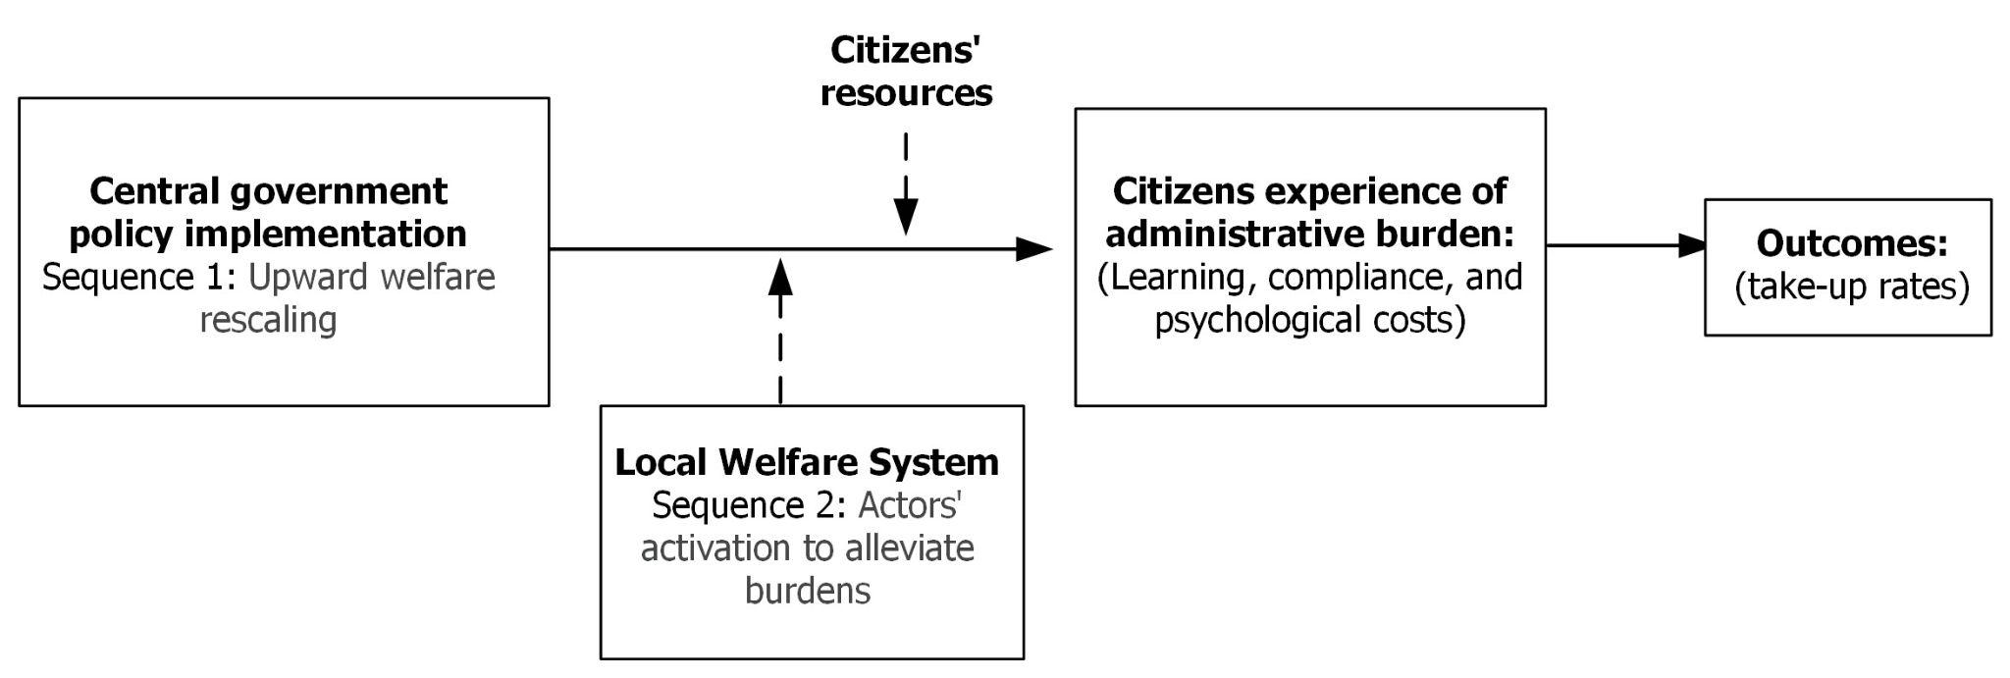

*Source:* Own elaboration

*Note*: In our article, the dependent variable analyzed is the administrative burden experienced by citizens within this sequence. While outcomes may result from this, we do not establish a causal relationship between our model and non-take-up rates – a connection that future research could explore.

**Figure 2**. Policy-sequence vignette used for interactive focus groups

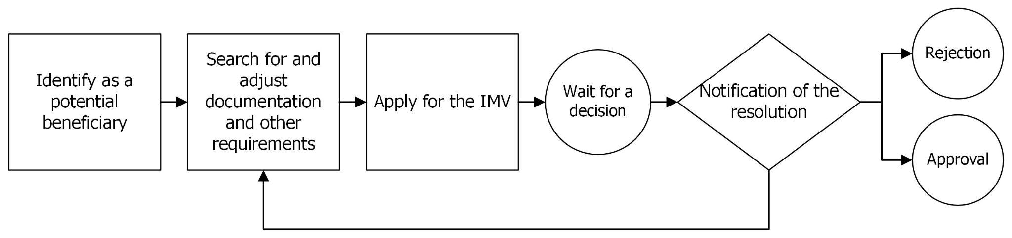

*Source*: Own elaboration, inspired in Madsen et al. (2012).