Supplement
This supplement provides additional, non-essential analysis. First, it presents descriptive statistics, followed by randomization checks confirming that demographics have no relationship with conditions. This supplement then provides additional details about our conjoint experiment, then about our vignette experiment. It concludes with the complete survey instrument.

Descriptive statistics
Descriptive statistics for respondent demographics appear in Table S1. Education, age, partisanship (with leaners coded as partisans), income, and ideology are measured categorically; sex, race, and voter turnout are measured dichotomously. Possible values appear in parentheses after each variable name. Question wording and response options appear in the questionnaire included later in this supplement. Ideology and partisanship correlate moderately (r=0.55, p<0.01), as do income and education (r=0.42, p<0.01) and our two indicators of race, non-Hispanic white and non-Hispanic Black (r=−0.55, p<0.01). Other correlations are modest.
Table S1: Respondent demographics
Variable | N | Mean | Std Dev
Education (1-5) | 1,977 | 3.02 | 1.07
Age category (1-6) | 1,976 | 3.57 | 1.65
Party ID (1-3) | 1,914 | 1.84 | 0.89
Female (0-1) | 1,977 | 0.52 | 0.50
Non-Hispanic white (0-1) | 1,976 | 0.71 | 0.45
Non-Hispanic Black (0-1) | 1,976 | 0.11 | 0.31
Income (1-12) | 1,976 | 5.64 | 3.31
Voted in 2020 (0-1) | 1,942 | 0.75 | 0.43
Ideology (1-7) | 1,956 | 4.14 | 1.75
Table S2 provides descriptive statistics for questions about the US Constitution and the US Supreme Court’s interpretation of it. The first two items indicate support for an originalist or living interpretation of the US Constitution; “Net: Living − Originalism” is the difference, from −6 to +6, with higher scores indicating a greater preference for a living interpretation. “SCOTUS invalidation” summarizes support for the US Supreme Court invalidating state actions under US Constitutional authority. The next 4 items are evaluations of the US Constitution, as shown in the questionnaire. The final row shows the 1st dimension from principal components factor analysis of the four items assessing the US Constitution, ranging from −2.10 to +2.17.
Table S2: Interpretation and evaluation of the US Constitution
Variable | N | Mean | Std Dev
SCOTUS originalism (1-7) | 1,975 | 4.28 | 1.84
SCOTUS living (1-7) | 1,975 | 4.74 | 1.78
Net: Living – Originalism | 1,975 | 0.46 | 3.00
SCOTUS invalidation (1-5) | 1,975 | 3.09 | 1.14
US Const: Selfish (1-5) | 1,977 | 2.82 | 1.29
US Const: Amend more (1-5) | 1,977 | 3.24 | 1.23
US Const: Outdated (1-5) | 1,976 | 3.07 | 1.37
US Const: Visionary (1-5) | 1,977 | 3.81 | 1.06
US Const 1st factor | 1,973 | -0.07 | 1.04
Table S3 summarizes responses to the four iterations of our conjoint experiment. These are panel data—1,978 respondents over 4 iterations, totaling 7,903 observations per variable—so we report “between” (cross-sectional) and “within” (longitudinal) standard deviations in addition to the overall standard deviation. Each row corresponds to those in the preceding table, but about hypothetical state constitutions. Here, the factor in the final row ranges from −2.86 to +2.69.
Table S3: Interpretation and evaluation of hypothetical state constitutions
Variable | Mean | Std Dev | SD btw | SD within
Originalism (1-7) | 4.39 | 1.58 | 1.31 | 0.88
Living (1-7) | 4.57 | 1.60 | 1.36 | 0.85
Net: Living – Originalism | 0.17 | 2.33 | 2.01 | 1.19
Invalidation (1-5) | 3.14 | 1.05 | 0.88 | 0.57
Const: Selfish (1-5) | 3.08 | 1.11 | 0.94 | 0.58
Const: Amend more (1-5) | 3.11 | 1.12 | 0.97 | 0.57
Const: Outdated (1-5) | 3.02 | 1.18 | 0.98 | 0.65
Const: Visionary (1-5) | 3.40 | 0.99 | 0.82 | 0.56
Const 1st factor | 0.02 | 1.00 | 0.89 | 0.45
Table S4 summarizes responses to the 7 policy questions at the beginning of our survey. Wording appears in the questionnaire below. Responses are scored from 1 to 6, with higher scores indicating greater support for a particular proposal.
Table S4: Interpretation and evaluation of the US Constitution
Variable | N | Mean | Std Dev
Parental consent for abortion | 1,974 | 3.54 | 1.89
Businesses may not ban guns | 1,976 | 3.16 | 1.80
Restrict CRT in schools | 1,973 | 3.71 | 1.90
Medicaid more difficult | 1,977 | 2.55 | 1.61
Trans non-discrimination | 1,974 | 3.67 | 1.93
School gun-free zones | 1,977 | 4.52 | 1.73
Racial diversity in higher ed | 1,976 | 3.98 | 1.67
Table S5 summarizes responses to our vignette experiment. The first three rows summarize variables manipulated in the vignette. The vignette piped in one of the policies asked about earlier (and shown in Table S4); “policy agreement” indicates whether the respondent had previously indicated agreement with the piped-in policy, on the same 1-6 scale used in Table S4. “Divided legislature” indicates dichotomously whether the vignette characterized the policy as passing easily out of the state legislature (0) or narrowly (1). “Old provision” indicates whether the state supreme court invalidated the legislature’s law on the basis of a recently-adopted provision (0) or an older one (1). Finally, “support for invalidation” summarizes the respondent’s support for the state supreme court’s invalidation.
Table S5: Interpretation and evaluation of the US Constitution
Variable | N | Mean | Std Dev
Policy agreement (1-6) | 1,975 | 3.70 | 1.88
Divided legislature (0-1) | 1,976 | 0.50 | 0.50
Old provision (0-1) | 1,977 | 0.50 | 0.50
Support for invalidation (1-4) | 1,977 | 2.70 | 1.02

Randomization checks
We checked whether randomized assignment correlates with respondent demographics. For the vignette experiment, we used multinomial probit to regress the respondent’s assigned policy on respondent education, age, partisanship, sex, race (white and Black dummies), income, and 2020 turnout. The resulting model estimated 63 coefficients, so we would expect around 3-4 to attain a p-value below 0.05 by mere chance; none did.
For the conjoint experiment, we used 6 separate multinomial probit models to regress the respondent’s various assigned conditions on the same demographic variables, clustered by respondent. Collectively, these models estimate 171 coefficients. By chance, we would expect 17 of them to attain a p-value below 0.10; we observe 18. We would also expect around 9 to attain a p-value below 0.05; we observe 13, which is slightly higher than expected but not alarming. Careful scrutiny of coefficients with p-values below 0.05 does not suggest any particular pattern, leading us to conclude that randomization succeeded. Complete results of this analysis available by request from the authors.

Full pre-registered analysis of conjoint experiment
Our pre-registration called for assessing the results of our conjoint experiment using ordinary least squares regression, ordered probit, and average marginal component effects. Using OLS, Table S6 regresses results from our conjoint experiment on each state constitutional attribute we varied: Its age (as of 2022), the age of its most recent amendment (also as of 2022), its cumulative number of amendments, its total page length, its focus (structuring government vs making policy), and the state’s partisan lean (coded here as 1 if the state leans away from the respondent’s preferred party, 2 if the state is competitive or the respondent is independent, and 3 if the state leans toward the respondent’s preferred party). Since each respondent answered four iterations of the conjoint experiment, standard errors are clustered by respondent; thus, though models include almost 8,000 observations each, the true statistical power is determined by the number of distinct respondents (1,976). Dependent variables are the respondent’s support for an originalist interpretation of this constitution (model a), a living interpretation (model b), the net difference between these outcomes (i.e., living – original, model c), and respondent support for judicial invalidation based on this constitution.
Table S6: OLS analysis of conjoint experiment
 | (a) Original | (b) Living | (c) Net | (d) Invalidation
Constitution age | -0.0008** | 0.0005 | 0.0013*** | -0.0002
 | (0.0003) | (0.0003) | (0.0004) | (0.0002)
Amendment age | 0.0029 | 0.0003 | -0.0026 | -0.0006
 | (0.0026) | (0.0027) | (0.0038) | (0.0018)
Amendments | -0.0002 | 0.0004 | 0.0005 | -0.0006*
 | (0.0004) | (0.0004) | (0.0006) | (0.0003)
Constitution length | 0.0003 | 0.0001 | -0.0002 | 0.0004
 | (0.0004) | (0.0004) | (0.0006) | (0.0003)
Constitution focus | -0.0274 | -0.0214 | 0.0059 | -0.0016
 | (0.0364) | (0.0365) | (0.0543) | (0.0240)
Partisan match | 0.0897*** | 0.1474*** | 0.0577 | 0.0945***
 | (0.0257) | (0.0260) | (0.0365) | (0.0178)
Constant | 4.2958*** | 4.1848*** | -0.1112 | 3.0040***
 | (0.0862) | (0.0876) | (0.1233) | (0.0592)
N | 7,637 | 7,636 | 7,636 | 7,638
R² | 0.003 | 0.005 | 0.002 | 0.006
*p≤0.05, **p≤0.01, ***p≤0.001 (two-tailed). OLS coefficients with cluster-corrected standard errors in parentheses.
To benchmark our R² values, we ran similar models but using no right-hand variables except dummies for Strong Republicans, Republicans, Republican leaners, true independents, and so on, obtaining R² values of 0.030, 0.095, 0.093, and 0.007 respectively. As shown empirically in the main manuscript, Democratics favor a living interpretation by a wide margin (with Republicans doing the opposite), consistent with common wisdom and cited literature. Despite strong theoretical priors and a large substantive effect, we nevertheless obtain low values of R² in these benchmark models. The small R² values reported in Table S6 are therefore unsurprising; we would not expect our manipulations to fit the dependent variable as well as partisanship.
The dependent variables in Table S6 are categorical. Table S7 therefore replicates the preceding table using ordered probit. Results are similar.
Table S7: Ordered probit analysis of conjoint experiment
 | (a) Original | (b) Living | (c) Net | (d) Invalidation
Constitution age | -0.0005** | 0.0003 | 0.0005*** | -0.0002
 | (0.0002) | (0.0002) | (0.0002) | (0.0002)
Amendment age | 0.0020 | 0.0001 | -0.0007 | -0.0005
 | (0.0017) | (0.0017) | (0.0017) | (0.0018)
Amendments | -0.0002 | 0.0002 | 0.0002 | -0.0006*
 | (0.0003) | (0.0003) | (0.0003) | (0.0003)
Constitution length | 0.0002 | 0.0001 | 0.0000 | 0.0004
 | (0.0003) | (0.0003) | (0.0003) | (0.0003)
Constitution focus | -0.0175 | -0.0117 | 0.0111 | -0.0021
 | (0.0237) | (0.0233) | (0.0238) | (0.0240)
Partisan match | 0.0568*** | 0.0953*** | 0.0250 | 0.0932*
 | (0.0168) | (0.0168) | (0.0159) | (0.0178)
N | 7,637 | 7,636 | 7,636 | 7,638
*p≤0.05, **p≤0.01, ***p≤0.001 (two-tailed). Probit coefficients with cluster-corrected standard errors in parentheses.
These specifications assume that variables like a constitution’s age will have the same marginal effect across the range of possible values. Best practices advise breaking out each variable to estimate average marginal component effects (Hainmueller, Hopkins, and Yamamoto 2014). Figures S1, S2, S3, and S4 below depict marginal means from this sort of analysis, corresponding with models a, b, c, and d respectively. (Here, we replace constitution and amendment age with constitution and amendment year.) Figures S1a, S2a, S3a, and S4a display pooled results; Figures S1b, S2b, S3b, and S4b display results separately for Democratic (dark) and Republican (light) respondents. When it comes to variables flagged as statistically significant in the preceding two tables, these figures suggest that constitution age has a more linear effect in model (c) than (a); the cumulative number of amendments has a roughly linear effect in model (d), and partisan match has a linear effect in models (b) and (d) but not (a).
Figure S1a: Respondent support for originalist interpretation (marginal means)
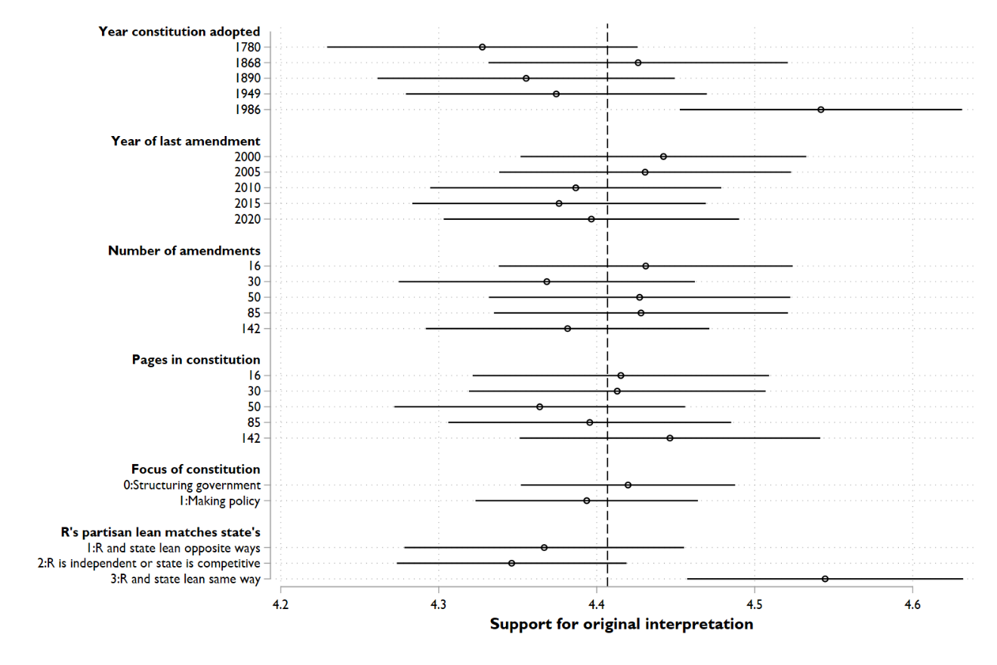
Figure S1b: Respondent support for originalist interpretation, by respondent party
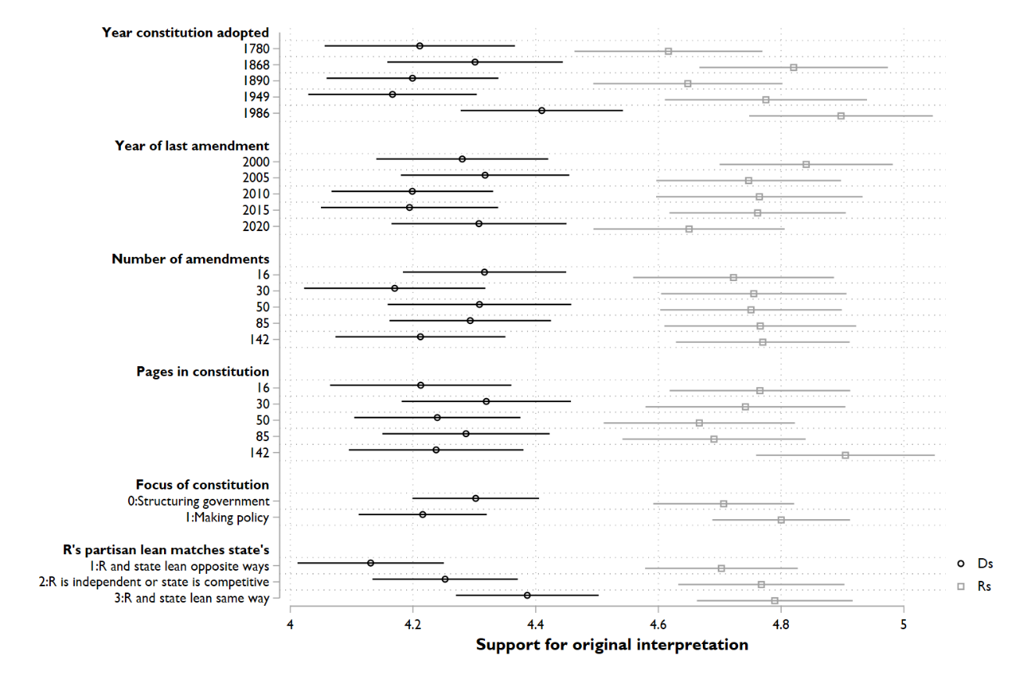
Figure S2a: Respondent support for living interpretation (marginal means)
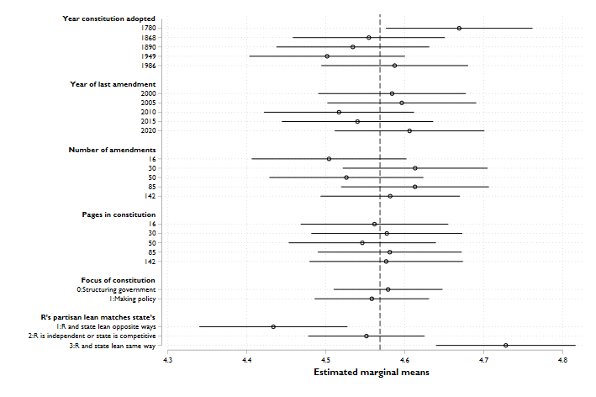
Figure S2b: Respondent support for living interpretation, by respondent party
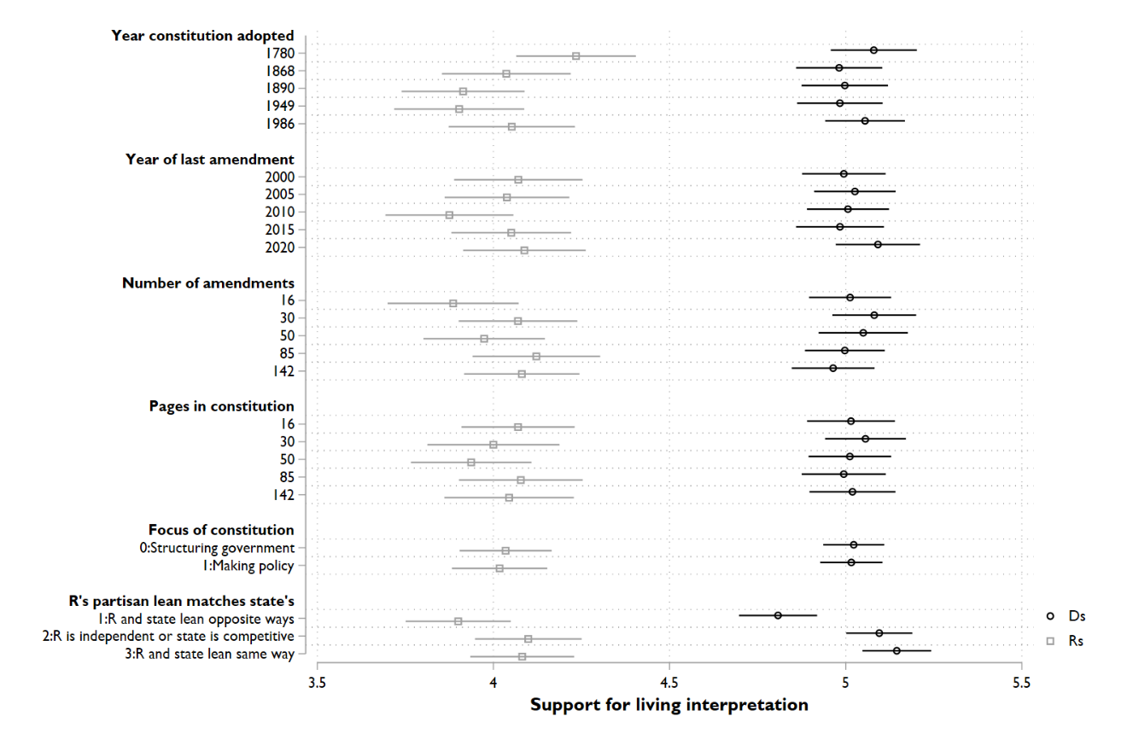
Figure S3a: Net support for living – originalist interpretation (marginal means)
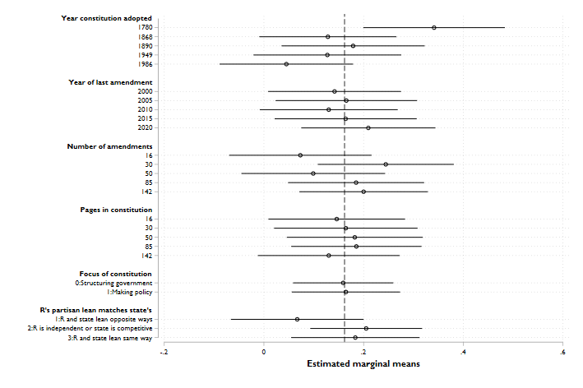
Figure S3b: Net support for living – originalist interpretation, by respondent party
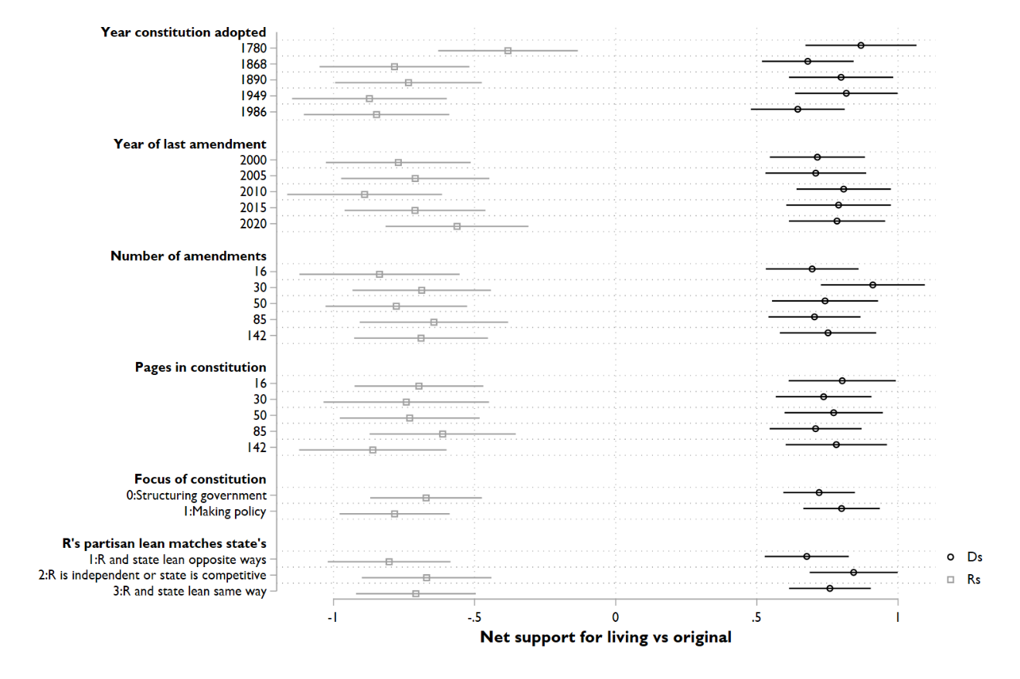
Figure S4a: Respondent support for judicial invalidation (marginal means)
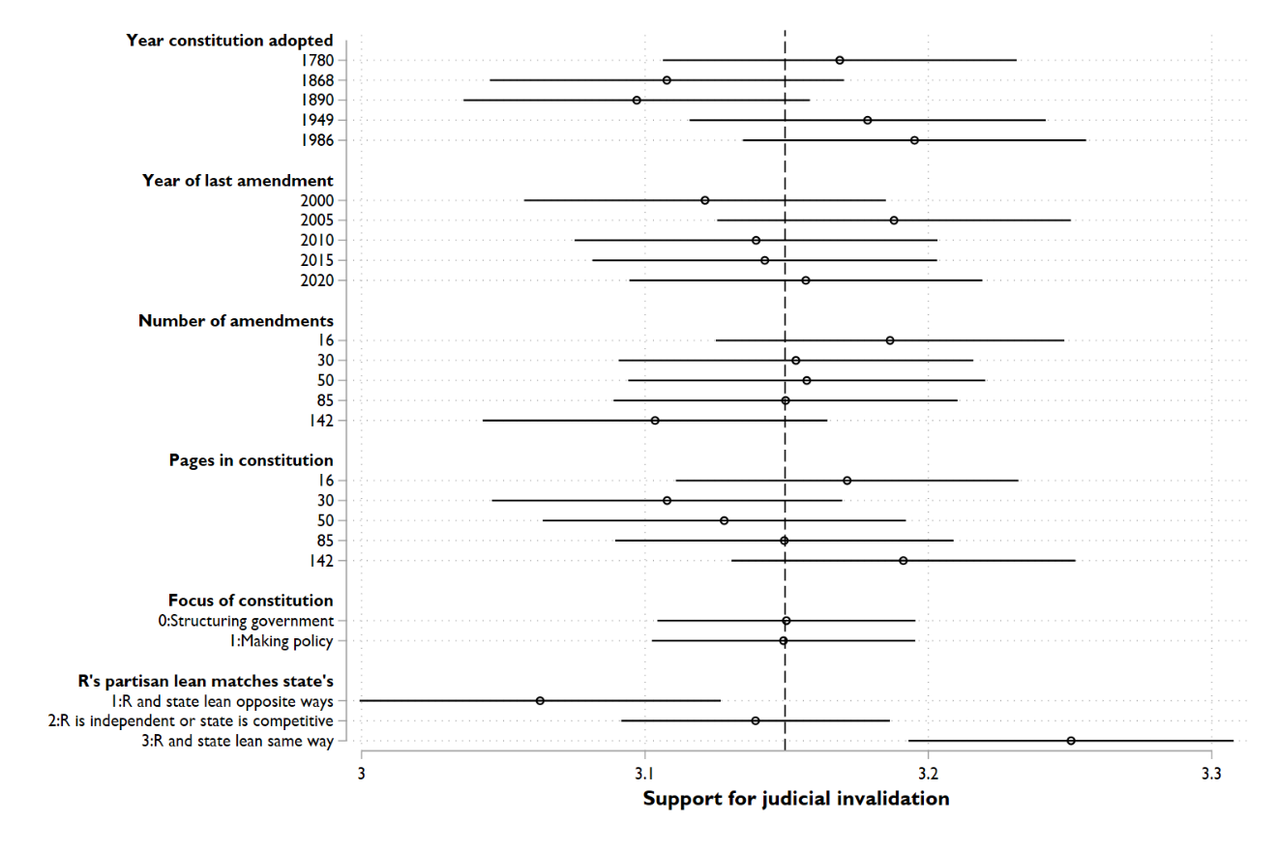
Figure S4b: Respondent support for judicial invalidation, by respondent party
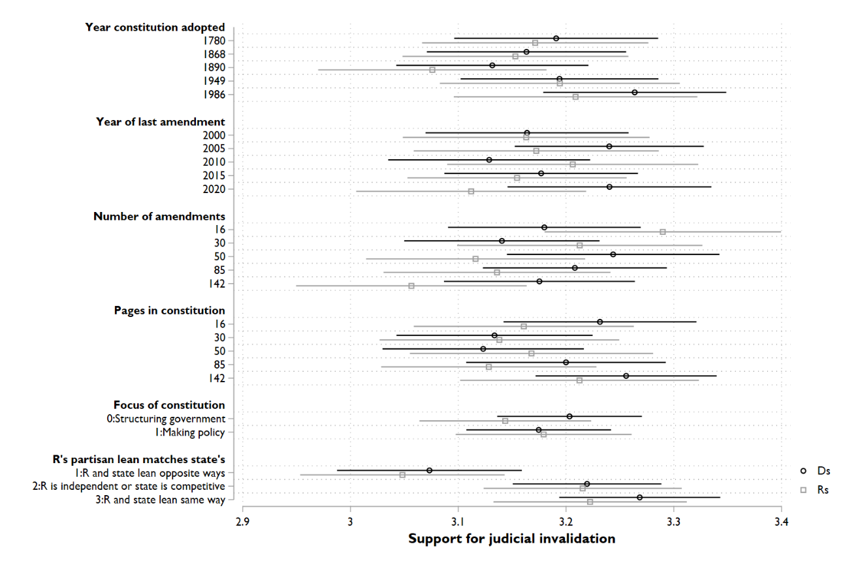

In each iteration, we also asked respondents to evaluate each constitution using a battery derived from Brown and Pope’s (2018) study of constitutional veneration. Table S8 regresses each item on the components of the conjoint experiment. In model (a), respondents were more likely to agree that a particular constitution was “outdated” if it was adopted or amended longer ago, or if the state’s partisan lean conflicted with the respondent’s partisan preference. Similarly, in model (b), respondents were more likely to agree that a particular constitution “should be amended more often” if it had a lower amendment rate, or if it had been a longer time since its last amendment. Together, these two items serve as something of a manipulation check, showing that respondents internalized the conjoint experiment’s language about each hypothetical constitution’s age, amendment rate, and amendment recency.
Table S8: Evaluations of hypothetical state constitutions
 | (a) Outdated | (b) Amend more | (c) Selfish | (d) Visionary
Constitution age | 0.0008*** | 0.0003 | -0.0001 | 0.0004*
 | (0.0002) | (0.0002) | (0.0002) | (0.0002)
Amendment age | 0.0096*** | 0.0053** | 0.0017 | -0.0014
 | (0.0020) | (0.0019) | (0.0018) | (0.0016)
Amendments | -0.0004 | -0.0009** | 0.0003 | -0.0001
 | (0.0003) | (0.0003) | (0.0003) | (0.0003)
Constitution length | -0.0002 | -0.0001 | 0.0005 | -0.0003
 | (0.0003) | (0.0003) | (0.0003) | (0.0003)
Constitution focus | 0.0198 | -0.0027 | 0.0202 | -0.0514*
 | (0.0264) | (0.0261) | (0.0261) | (0.0221)
Partisan match | -0.0714*** | -0.0117 | -0.1079*** | 0.1242***
 | (0.0187) | (0.0184) | (0.0184) | (0.0169)
Constant | 2.9674*** | 3.0919*** | 3.2196*** | 3.1779***
 | (0.0638) | (0.0619) | (0.0594) | (0.0549)
N | 7,636 | 7,636 | 7,637 | 7,639
*p≤0.05, **p≤0.01, ***p≤0.001 (two-tailed). OLS coefficients with cluster-corrected standard errors in parentheses.
In model (c), respondents were more likely to say that a constitution’s creators “were looking out for themselves” to the extent the state’s partisan lean conflicts with the respondent’s partisan preference. Perhaps most interesting, in model (d), respondents were more likely to say a hypothetical constitution “was written by visionary people” if the constitution was older and more focused on structuring government than on enacting policy. Meanwhile, in the vignette experiments, respondents were less supportive of judicial invalidation based on an older constitutional provision—even though respondents would presumably say that older provision “was written by visionary people.” This tension suggests that respondents can distinguish between a visionary constitutional provision and a democratic one—and its democratic nature, or recent adoption, is what lends a provision legitimacy when it comes to invalidation.
We then derived a unidimensional factor from this battery using principal components analysis. This factor has a higher value to the extent respondents felt a particular state constitution’s authors were “visionary”; it has a lower value to the extent they felt a particular constitution was outdated, in need of more frequent amendments, or written by people who were looking out for themselves. This factor correlates with respondents’ net preference for a living rather than original interpretation modestly (r=−0.24, p<0.01). Put differently, respondents show a greater preference for originalism to the extent they evaluate a constitution favorably, and they show a greater preference for a living approach to the extent they evaluate it otherwise. Figure S5a presents results from a conjoint analysis using this factor as the dependent variable; Figure S5b separates respondents by party. Respondents, especially Democrats, show a clear preference for state constitutions adopted or amended more recently.
Figure S5a: Factor reflecting respondent evaluations of state constitution (marginal means)
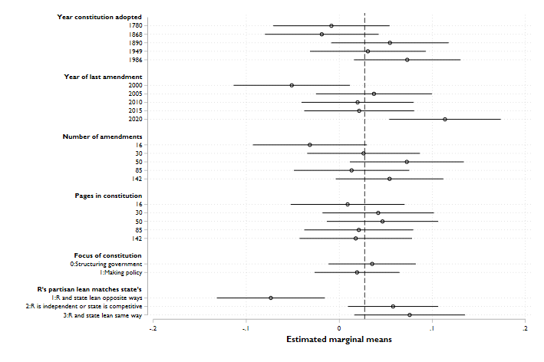
Figure S5b: Factor reflecting respondent evaluations of state constitution, by respondent party
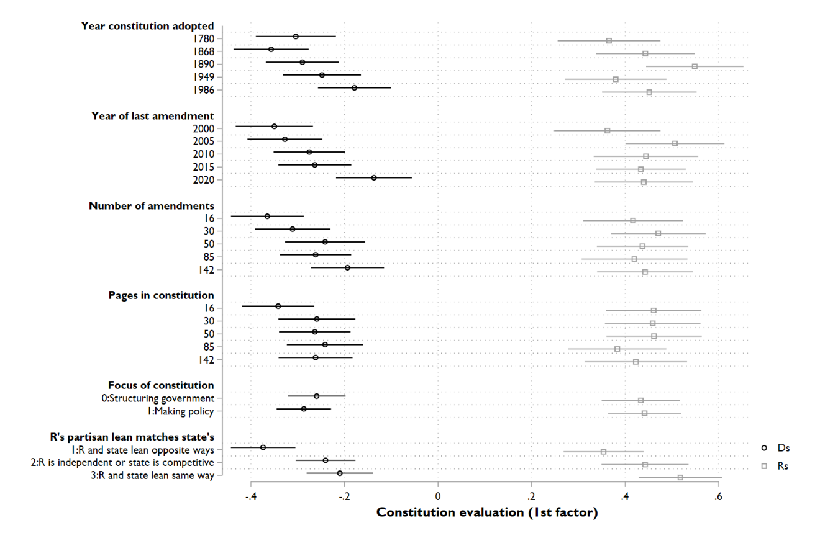

Full pre-registered analysis of vignette experiment
Table S9 reports full results of our vignette experiment. The dependent variable is the respondent’s assessment of the “appropriateness” of the state supreme court’s invalidation of a specific policy recently passed by the state legislature, measured 1 through 4 with higher values indicating greater support. As called for in our pre-registration, we provide both ordinary least squares and ordered probit results for this ordinal indicator. Both approaches yield essentially the same results. Independent variables are measured as described previously.
Table S9: Results of vignette experiment
 | OLS | Ordered probit
Policy agreement | −0.117***  (0.012) | −0.130***  (0.013)
Divisive in legislature | −0.021  (0.045) | −0.027  (0.048)
Old provision | −0.148***  (0.045) | −0.163***  (0.048)
Constant | 3.22***  (0.059) | Cut 1: −1.63  Cut 2: −0.83  Cut 3: −0.09
N | 1,975 | 1,975
R² | 0.06
*p≤0.05, **p≤0.01, ***p≤0.001 (two-tailed). Standard errors in parentheses.

Questionnaire
[Informed consent language available by request.]
We would like to ask about some policies that various states have considered in recent years. Please indicate whether you support or oppose each one.
[Each of the following policies was evaluated on a 7-point scale from “strongly oppose” to “strongly support”:] Prohibit businesses from denying service to transgender individuals; Make it more difficult for people to quality for state-subsidized health care (Medicaid); Prohibit teen girls from receiving an abortion without parental consent; Prohibit businesses from banning firearms on their premises; Adopt measures to increase the racial diversity among students at state universities; Keep critical race theory out of public high schools; Expand gun-free zones around public schools.
[Next screen.] Please tell us a little about yourself before we proceed.
What is the highest level of school you have completed? [Less than high school degree; High school; Associates degree or certificate; Bachelor’s or other 4-year degree; Post-graduate degree]
What is your age? [Under 18; 18-24; 25-34; 35-44; 45-54; 55-64; 65+]
When it comes to politics, how would you describe yourself? [Strong Democrat; Democrat; Independent who leans Democratic; Independent; Independent who leans Republican; Republican; Strong Republican; Something else (with text entry)]
What is your sex? [Male; Female; Something else (with text entry); Prefer not to say]
What is your current income? [12 categories, from “Less than $10,000” to “$150,000 or more”]
Did you vote in the 2020 presidential election? [No; Yes; Don’t recall]
Here is a 7-point scale on which the political views that people hold are arranged from extremely liberal (left) to extremely conservative (right). Where would you place yourself on this scale? [Slider labeled “Liberal” and “Conservative” on the ends.]
[Next screen.] We are interested in understanding your views about how judges make rulings. Judges are often called upon to interpret constitutions. Consider carefully the United States Constitution below.
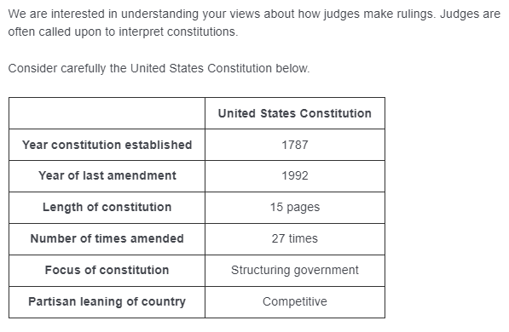
Some say that judges should apply constitutional provisions consistent with modern views and sensibilities. Others say that judges should apply constitutional provisions as they were understood by those who initially wrote them. Please indicate your level of agreement with each of the approaches to interpreting the United States Constitution.
Judges should interpret the United States Constitution as generally understood at the time the constitutional provisions were written. [7 point scale, strongly disagree to strongly agree]
Judges should interpret the United States Constitution as generally understood according to current views and sensibilities. [7 point scale, strongly disagree to strongly agree]
How much would you approve of judges using the United States Constitution to strike down state laws? [5 point scale, strongly disapprove to strongly approve]
How strongly do you agree with each of the following statements about the United States Constitution? [Each on a 5 point scale, strongly disagree to strongly agree]
The creators of the United States Constitution were looking out for themselves.
The United States Constitution should be amended more often.
The United States Constitution is outdated.
The United States Constitution was written by visionary people.
[Next screen.] As you may know, every state has its own constitution. Some states have replaced their constitution from time to time, while others have kept a single constitution since statehood. State constitutions vary in their length and their amendment rate. They also vary in whether they focus on erecting government structures rather than establishing specific laws and policies. On the next few screens, we will briefly describe a few hypothetical state constitutions and ask for your reaction. You will consider 4 different state constitutions.
[Next screen.] State Constitution [NUMBER] of 4
Below we present you with details regarding State Constitution [NUMBER]. We also provide related information about the US Constitution in gray for your convenience. Please carefully review the details of State Constitution [NUMBER], then answer the questions.
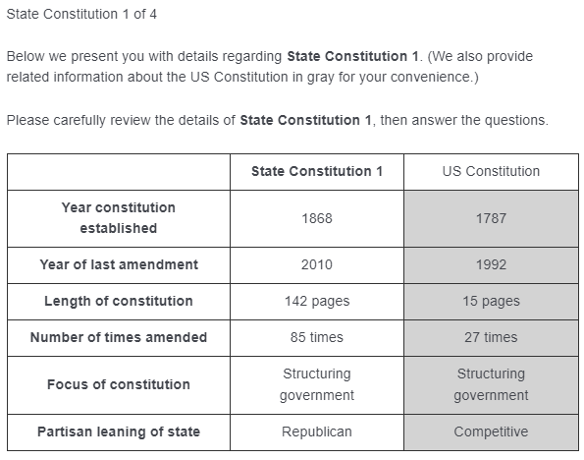
Attribute levels for state constitution drawn from these values using uniform randomization:
Year constitution established: 1780, 1868, 1890, 1949, 1986
Year of last amendment: 2000, 2005, 2010, 2015, 2020
Length: 16 pages, 30 pages, 50 pages, 85 pages, 142 pages
Frequency of amendment: 16 times, 30 times, 50 times, 85 times, 142 times
Focus of constitution: Structuring government, Making policy
Partisan leaning of state: Republican, Democratic, Competitive
Judges are often called upon to interpret state constitutions. How would you prefer that judges apply the provisions of State Constitution [NUMBER] above?
The judge should interpret State Constitution [NUMBER] as generally understood at the time its constitutional provisions were written. [7 point scale, strongly disagree to strongly agree]
The judge should interpret State Constitution [NUMBER] as generally understood according to current state residents’ views and sensibilities. [7 point scale, strongly disagree to strongly agree]
How much would you approve of judges using State Constitution [NUMBER] to strike down state laws? [5 point scale, strongly disapprove to strongly approve]
How strongly do you agree with each of the following statements about State Constitution [NUMBER]? [Each on a 5 point scale, strongly disagree to strongly agree]
The creators of this constitution were looking out for themselves.
This constitution should be amended more often.
This constitution is outdated.
This constitution was written by visionary people.
[AFTER ITERATION 3 ONLY, AN ATTENTION CHECK] Which constitution did you evaluate in the question above? [The US Constitution; State Constitution 3; A typical state constitution]
[Next screen, after iterating the preceding conjoint experiment 4 times.] For the following (and final!) question of the survey, we present you with a hypothetical scenario. Our purpose is to understand whether you think it is appropriate for a judge to strike down a law in the particular circumstance posed in the question.
[Next screen.] We would like to ask you about a recent controversy in an American state. Last year, this state enacted a law [PIPE IN A POLICY FROM BELOW]. This law passed [easily, with over 70% of state lawmakers voting in favor OR narrowly, with barely 50% of state lawmakers voting in favor]. A few months ago, this state’s highest court struck down this law, saying that it violates a provision of the state constitution that was ratified in [1896 OR 2016].
In general, it is appropriate for a court to strike down a law in this sort of situation? [Very appropriate; Somewhat appropriate; Somewhat inappropriate; Very inappropriate]
Policy descriptions to pipe into vignette experiment:
- designed to keep critical race theory out of public high schools
- making it more difficult for people to qualify for state-subsidized health care (Medicaid)
- prohibiting businesses from denying service to transgender individuals
- expanding gun-free zones around public schools
- designed to increase the racial diversity among students at state universities
- making it easier for people to qualify for state-subsidized health care (Medicaid)
- prohibiting teen girls from receiving an abortion without parental consent
- prohibiting businesses from banning firearms on their premises
- designed to keep critical race theory out of public high schools
[End of survey]

