Appendix materials for

Diffuse support, partisanship, and the electoral relevance of the Supreme Court

Table of contents

Table A1. Descriptive sample demographics for Wave 4 Supreme Court and Democracy panelists 1
Figure A1. Subject issue priorities for vote choice 2
Table A2. Correlations among perceived ideology and candidate attractiveness 3
Table A3. Factor analysis of diffuse support for the Supreme Court (legitimacy) 4
Table A4. Factor analysis of judicial cynicism 5
Table A5. Model estimates for producing Figure 6 in main text 6
Survey experiment text and outcomes 7

Table A1. Descriptive sample demographics for Wave 4 Supreme Court and Democracy panelists
Variable | Category | Proportion
Race | Black | 13%
 | White | 65%
 | Hispanic | 13%
 | Other | 9%
Gender | Male | 48%
 | Female | 52%
Education | No HS | 4%
 | HS school graduate | 37%
 | Some college | 18%
 | 2-year | 11%
 | 4-year | 18%
 | Post-grad | 12%
Partisanship | Democrat | 45%
 | Independent (pure) | 22%
 | Republican | 33%
Ideology | Not sure | 7%
 | Very liberal | 13%
 | Liberal | 17%
 | Moderate | 31%
 | Conservative | 20%
 | Very conservative | 12%
Notes: Cell entries are un-weighted percentages associated with categories of variables for all subjects who participated in wave 4 survey. Percentages within a category may not sum to 100% due to rounding. Mean age is 52 among panelists.

Figure A1. Subject issue priorities for vote choice
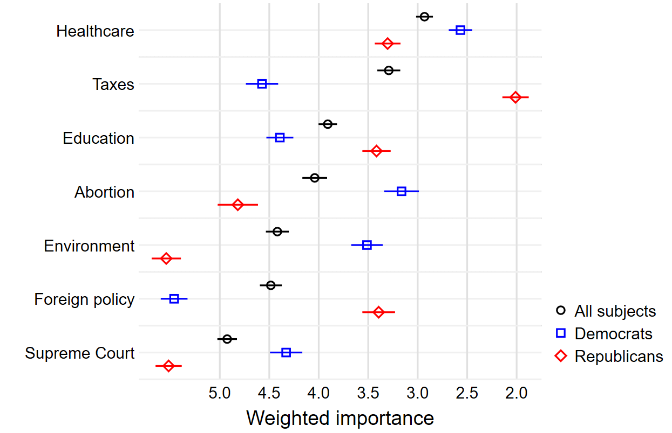
Notes: Subjects were asked to rank the issues above in terms of their importance to their vote choice. Point estimates reflect the cumulative importance of each issue; values were rescaled to range from one to seven. Lower (higher) values convey that those subjects viewed the respective issue to be more (less) important.

Table A2. Correlations among perceived ideology and candidate attractiveness
 |  | Candidate ideology | Candidate strength
Full sample | Candidate strength | 0.09
 | Candidate thermometer | 0.02 | 0.63
Democrats | Candidate strength | -0.31
 | Candidate thermometer | -0.44 | 0.57
Republicans | Candidate strength | 0.57
 | Candidate thermometer | 0.57 | 0.69
Independent (Democrat) | Candidate strength | 0.18
 | Candidate thermometer | 0.16 | 0.60
Independent (Republican) | Candidate strength | -0.03
 | Candidate thermometer | 0.02 | 0.56
Notes: Cell entries are Pearson’s product-moment correlations.

Table A3. Factor analysis of diffuse support for the Supreme Court (legitimacy)
 | Loading
- If the Supreme Court started making a lot of decisions that most people disagree with, it might be better to do away with the court altogether. | 0.79
- The right of the Supreme Court to decide certain types of controversial issues should be reduced. | 0.84
- The U.S. Supreme Court gets too mixed up in politics | 0.66
- Judges on the Supreme Court who consistently make decisions at odds with what a majority of the people want should be removed from their position as judge | 0.87
- The U.S. Supreme Court ought to be made less independent so that it listens a lot more to what the people want. | 0.85
- It is inevitable that the U.S. Supreme Court gets mixed up in politics; thus, we ought to have stronger means of controlling the Court’s actions. | 0.84
Notes: One factor retained with Eigenvalue of 3.96 Cronbach’s alpha = 0.92.

Table A4. Factor analysis of judicial cynicism
 | Loading
- Judges’ values and political views have little to do with how they decide cases before the Supreme Court. | -0.70
- Judges’ party affiliations have little to do with how they decide cases before the Supreme Court. | -0.72
- Judges always say their decisions are based on the law and the Constitution, but in many cases, judges are really basing their decisions on their own personal beliefs. | 0.75
- Since the Constitution must be updated to reflect society’s values as they exist today, Supreme Court judges have a great deal of leeway in their decisions, even when they claim to be “interpreting” the Constitution. | 0.50
- Please rate your agreement with the following statement: Supreme Court judges are little more than politicians in robes. | 0.71
Notes: One factor retained with Eigenvalue of 2.3. Cronbach’s alpha = 0.81.

Table A5. Model estimates for producing Figure 6 in main text
 | b | se
Republican dummy | 0.380* | (0.19)
Pro-Reform | 0.451** | (0.15)
Anti-Reform | -0.266 | (0.15)
Diffuse support | 0.577* | (0.27)
Diffuse support x Pro-Reform | -0.790* | (0.34)
Diffuse support x Anti-Reform | 0.371 | (0.38)
Pro-Reform x Republican | -0.590* | (0.28)
Anti-Reform x Republican | -0.365 | (0.26)
Republican x Diffuse support | -0.691* | (0.33)
Pro-reform x Republican x Diffuse support | 0.405 | (0.46)
Anti-reform x Republican x Diffuse support | 0.605 | (0.48)
Supreme Court rank | -0.016 | (0.01)
White | 0.101 | (0.05)
Female | 0.039 | (0.05)
Age | 0.001 | (0.00)
Lib-con placement | 0.022 | (0.02)
News interest | -0.048* | (0.02)
Family income | -0.001 | (0.00)
Intercept | 2.730*** | (0.18)
r2 | 0.112
N | 1070
Notes: *p<0.05, **p<0.01, ***p<0.001

Survey experiment text and outcomes

Next, we’d like you to read a brief biography about a candidate running for office during the 2022 midterms.
{Democrat, Republican} Sam Smith is a veteran running for a legislative seat in the House of Representatives during the 2022 midterm elections. Sam is a small business owner who supports various charitable causes with his wife of 20 years, Vicky Smith. He wants to protect prescription drug benefits for the elderly and believes that the economy would be stronger if Americans produced and bought more of this country’s own goods. He is a strong supporter of improving early childhood educational opportunities. {(1) No further text, proceed to post-treatment questions; (2) Sam also supports Supreme Court reform and has indicated he is open to term limits for sitting justices.; (3) Sam also opposes Supreme Court reform and has indicated he is against term limits for sitting justices.}
Now, we’d like to learn a bit about what you think of {Democrat, Republican} Sam Smith.
- How liberal or conservative do you think Sam Smith is?
7-point scale: Very Liberal, Somewhat Liberal, Slightly Liberal, Neither Liberal nor Conservative, Slightly Conservative, Somewhat Conservative, Very Conservative
- If asked by Sam’s campaign to donate money, how likely would you be willing to donate?

Likert scale, 7 points, from very unlikely to very likely

- How much money would you be willing to donate to Sam Smith’s campaign?

Response text
Slider from 0 to 2900

- How strong of a {Democratic, Republican} candidate do you think Sam Smith is?
Response text
Not at all strong, Not very strong, Somewhat strong, Very strong

- On a scale from 0-100, with 0 being very cold and unfavorable and 100 being very warm and favorable, how do you feel about Sam Smith?

Slider from 0 to 100

