Online Appendix A:
The 2021 Insurrection and Impeachment Survey

The data reported in this paper are taken from the second wave of a two-wave panel study of African Americans. Here, I describe each of the two surveys, although all analysis in this paper is limited to the t₂ survey.

The t₁ Survey
The fieldwork for the 2021 Insurrection and Impeachment Survey (IIS) was conducted by NORC. Funded and operated by NORC at the University of Chicago, AmeriSpeak® is a probability-based panel designed to be representative of the U.S. household population. Randomly selected U.S. households are sampled using area probability and address-based sampling, with a known, non-zero probability of selection from the NORC National Sample Frame. These sampled households are then contacted by U.S. mail, telephone, and field interviewers (face to face). The panel provides sample coverage of approximately 97% of the U.S. household population. Those excluded from the sample include people with P.O. Box only addresses, some addresses not listed in the USPS Delivery Sequence File, and some newly constructed dwellings. While most AmeriSpeak households participate in surveys by web, non-internet households can participate in AmeriSpeak surveys by telephone. Households without conventional internet access but having web access via smartphones are allowed to participate in AmeriSpeak surveys by web. AmeriSpeak panelists participate in NORC studies or studies conducted by NORC on behalf of governmental agencies, academic researchers, and media and commercial organizations. For more information, visit AmeriSpeak.norc.org.
A general population sample of U.S. adults age 18 and older was selected from NORC’s AmeriSpeak Panel for this study. Included as well were oversamples of African Americans, resulting in 680 completed interviews, and active college students, resulting in 316 completed interviews. This survey was offered only in English and was administered on the web. Invitations to participate in the survey were initiated on February 18, 2021, and the last interviews were completed on March 10, 2021. In total, NORC collected 2,027 interviews.
To encourage study cooperation, NORC sent three email reminders to sampled web-mode respondents. Panelists were offered the cash equivalent of $5 for completing the study. Interviewed respondents took 20 minutes (median) to complete the survey. NORC applied cleaning rules to the survey data for quality control by removing responses in the main study from non-eligible respondents. These respondents provided responses indicative of speeding through the survey and skipping survey questions; they were not included in the final dataset.
The data are weighted, with various factors going into the construction of the final study weight. These include: (1) panel base sampling weights, (2) final panel weights, (3) study-specific base sampling weights, and (4) nonresponse adjusted survey weights. The weighted AAPOR Response Rate #3 recruitment rate was 19.5%, with a weighted household retention rate of 75.0% and a survey completion rate of 20.1%. A weighted AAPOR Response Rate #3 cumulative response rate of 2.9% was achieved. The survey has a margin of error of 3.77%, and an average design effect of 2.99.
This research was approved by the [REDACTED] Institutional Review Board (IRB). That IRB judged this project to be in the “exempt” category owing to the fact that participation in the survey was voluntary, no harm was afflicted on the respondents, and no identifiers were connected to the database generated, among other factors.

The t₂ Survey
An attempt was made to reinterview all African American respondents in the t₁ survey. With fieldwork commencing on 6/2/2021 and concluding on 6/24/2021, 579 interviews were completed, for a response rate of 85.3%. The median length of interview was 21 minutes.
This survey was approved by the [REDACTED] Institutional Review Board (IRB). That IRB judged this project to be in the “exempt” category owing to the fact that participation in the survey was voluntary, no harm was afflicted on the respondents, and no identifiers were connected to the database generated, among other factors.

Panel Attrition
Not all the Black respondents in the February/March 2021 (t₁) AmeriSpeak survey were re-interviewed in the June 2021 panel survey (t₂). Instead, 85.3% were re-interviewed. As a consequence, the possibility exists that those re-interviewed differ systematically from those we were unable to re-interview.
To assess panel attrition bias, I have investigated whether those t₁ respondents who completed the t₂ interview differ systematically from those who did not. For this analysis, I considered the following variables: gender, age, income, level of education, household internet access, metropolitan area residence, home ownership, whether the respondent is “born again,” party identification, ideological identification, and level of diffuse support for the U.S. Supreme Court. In a multivariate logit equation, only a single variable achieved statistical significance: the respondent’s age. The effects of none of the other predictors, including diffuse support, even approaches statistical significance.
The effect of the respondent’s age on participating in the t₂ survey is exactly as predicted. Figure A.1 reports the bivariate relationship. Younger people were considerably more likely not to be re-interviewed; those 65 years old and older were considerably more likely to participate in the June survey. These and other incidental imbalances are corrected via t₂ sample weights.

Figure A.1. Age and Attrition Between Waves 1 and 2 of the Panel Survey, African Americans

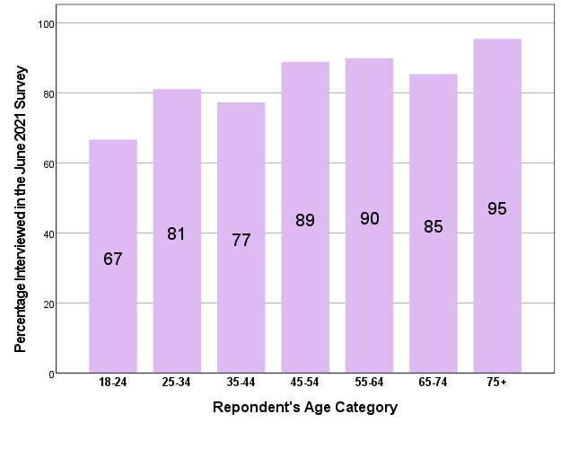

The Representativeness of the Sample
The data in Table A.1 show that the 2021 NORC sample is in many if not most respects similar to the population of African Americans in 2021. Exceptions exist, however. For instance, very high-income Black people are under-represented in the NORC sample, while middle-aged Black people (ages 45-64) are over-represented. Generally, however, large deviations between the sample and the population on these attributes are not great.

Table A.1. Sample and Population Attributes, African Americans

Attribute |  | Census/ACS | 2021 NORC Survey
Gender
 | Female | 52 | 58
 | Male | 48 | 42
Age Categories
 | 20-29 | 21 | 16
 | 30-44 | 38 | 30
 | 45-64 | 24 | 35
 | 65+ | 17 | 19
Home Ownership
 | Own | 44 | 43
 | Rent | 56 | 57
Level of Education (Among those 25+ years old)
 | Less than High School | 12 | 9
 | High School Graduate | 30 | 37
 | Some College | 32 | 23
 | College Graduate | 16 | 20
 | Advanced Degree | 10 | 11
Region of Residence
 | Northeast | 17 | 16
 | Midwest | 17 | 17
 | South | 56 | 57
 | West | 10 | 10
Employment Status
 | Employed | 56 | 53
 | Unemployed | 7 | 13
 | Not in Labor Force | 37 | 35
Household Income
 | Less than $25,000 | 29 | 35
 | $25,000 — $49,999 | 24 | 28
 | $50,000 — $74,999 | 17 | 17
 | $75,000 — $99,999 | 11 | 11
 | $100,000 and Higher | 20 | 10
Notes: The population data were taken from the Pew Research Center https://www.pewresearch.org/social-trends/fact-sheet/facts-about-the-us-black-population/
Pew analyzed the microdata from the Census Bureau’s 2021 American Community Survey (ACS). In some instance, the Census categories do not match perfectly the categories in the survey. Every effort has been made provide data from the two sources that are as comparable as possible. The 2021 NORC data are from the June 2021 AmeriSpeak® Panel survey, which is a sample of 579 African American respondents.

Online Appendix B:
Question Wording

Willingness to Extend Legitimacy to the Police
Scholars interested in public attitudes toward the police have focused on a wide variety of aspects of police views, often without much clear or explicit conceptualization. For example, the attitudes examined range from generalized approval of the police, job approval, affect toward the police, trust in the police, policy attitudes, support for police reform, support for accountability, perceptions of the behavior of the police, responses to police killings of African Americans, support for the use of deadly force by the police, support for police militarization, etc. Unfortunately, it is difficult to know if and how these various attitudes and indicators relate to one another because no previous research has investigated the theoretical and psychometric properties of the various conceptualizations, approaches, and indicators. Moreover, the bulk of the literature on public attitudes toward the police focuses on the views of White Americans (e.g., Crabtree and Yadon 2022; Davis and Wilson 2022)
In this research, I rely upon the earlier research on police legitimacy of Reynolds, Estrada-Reynolds, and Nunez (2018), employing a subset of their measures:
Make fair decisions: Police officers usually make fair decisions when enforcing laws.
Have reasons for arrests: Police officers usually have a reason when they stop or arrest people.
Treat people with respect: Police officers treat people with respect.
Not afraid to call police: I’m not afraid to call the police when I need to.
Police listen to me: I feel that police officers are willing to listen to me when I come into contact with them.
Relieved to see police: I feel relieved to see police officers when I am out in the community.
Police share my values: Most police officers define right and wrong the same way that I do.
I hypothesize that these items represent a unidimensional latent construct, willingness to extend legitimacy to the police.
The psychometric analyses of validity and reliability support my hypothesized measurement model. As to reliability, Cronbach’s alpha is .87 (with a mean inter-item correlation of .50). From a Common Factor Analysis (CFA), I confirm that the item-set is strongly unidimensional (eigenvalue₂ = .81), and that all 7 items load significantly on the first factor extracted. The strongest observed loading is for the “respect” item (.79); the weakest (.60) is associated with the “not afraid to call” statement. I created an index of police legitimacy as the average response to these items; that index is correlated with a factor score from the CFA at .99. This index serves as the dependent variable for the analysis reported in this paper.

Ingroup Attachments
Following Gibson and Nelson (2018) and the recommendations of McClain et al. (2009), identities were measured along two dimensions. The first is ingroup attachments, indicated by the responses to the following items.

Now, on a different subject, how important is it to think of yourself as African American or Black? Would you say it is very important, somewhat important, not very important, or not important at all?
Very important
Somewhat important
Not very important
Not important at all

Even though I might sometimes disagree with the standpoint/viewpoint taken by other Black people, it is extremely important to support the Black point-of-view.
Agree strongly
Agree
Uncertain
Disagree
Disagree strongly

When it comes to politics, it is important for all Blacks to stand together.
Agree strongly
Agree
Uncertain
Disagree
Disagree strongly

Owing to the skewed measure of ingroup attachment (70.8% say it is very important to think of themselves as Black; only 2.7% say Black identity is not important at all; skewness = 1.8), the correlations with the other two indicators are depressed somewhat. Nevertheless, Cronbach’s alpha for the three-item set is still .59 (based on an average inter-item correlation of .31). An attempted Common Factor Analysis (CFA) of this item set resulted in the commonality of an item exceeding 1.0. However, a maximum likelihood Factor Analysis succeeded and identified only a single significant factor, but the loading of the identity importance indicator was only .33. Clearly, the skewness of the identity importance measure is unsettling these psychometric results (even if skewness in a similar psychometric analysis conducted on 2014 data did not affect the results (Gibson and Nelson 2018)).

“Linked fate” is a concept widely used in research on ingroup attachments (e.g., Gay, Hochschild, and White 2016; Bunyasi and Smith 2019). The measure read:

Do you think what happens generally to Black people in this country has something to do with what happens in your life? Would you say…
What happens to Black people in this country has nothing to do with what happens in my life.
What happens to Black people in this country affects what happens in my life very little.
What happens to Black people in this country affects what happens in my life some.
What happens to Black people in this country affects what happens in my life a lot.

The data indicate that a strong sense of linked fate is considerably less common than robust African American group identities. For example, while 70.8% of the Black respondents regard it as very important to think of themselves as Black, only 37.8% think their fates are tied at least “a lot” to the fate of Black people as a group. And, indeed, the correlation between the linked fate response and the index of group identities is a paltry -.02. Clearly, having a strong sense of group identity does not necessarily translate into thinking that one’s fate is tied to the fate of one’s group, at least for African Americans. For example, of those saying that it is very important to think of themselves as Black, 29.5% also say that the fate of Black people affects them not at all or very little. I therefore include in the analyses both the simple measure of linked fate and the index measuring ingroup identification.

Personal and Vicarious Experiences with the Police
Following Peffley and Hurwitz (2010) and Gibson and Nelson (2018), I measured both personal experiences with unfair treatment by the police and perceptions that Black people as a group have been treated unfairly by the criminal justice system.

Was there any time in the last five years or so when you felt you were treated unfairly in dealing with the police – such as being stopped or followed while driving – just because you were African American? If so, did this happen once, twice, or three times, or more?
No, haven’t been treated unfairly in dealing with the police
Have been treated unfairly once in dealing with the police
Have been treated unfairly twice in dealing with the police
Have been treated unfairly three times in dealing with the police
Have been treated unfairly more than three times in dealing with the police

The following are some statements that some people make about problems with the justice system in their community. Please rate how serious it is in your community on a seven-point scale, where 1 means it is not a problem and 7 means it is a serious problem.

Police stop and question Blacks far more often than they stop Whites.
1 - Not a Problem
2
3
4
5
6
7 - A Serious Problem

Courts that give harsher sentences to African Americans than to Whites.
1 - Not a Problem
2
3
4
5
6
7 - A Serious Problem

Personal and vicarious experiences with discrimination are far from redundant: r = .14. This weak relationship is perhaps foretold by the frequencies: Most African Americans have not personally experienced unfair treatment, while at the same time large majorities of African Americans perceive that Black people as a group are unfairly treated. Indeed, perceptions of discrimination against African Americans vary little depending upon one’s own experiences with discrimination. For example, the mean discrimination score for those without any unfair police experiences is about the same as that for those with one or two unfair experiences. Likewise, the average score for African Americans without any unfair experiences is only slightly smaller than the score for those with more than three such experiences. Perhaps the most important conclusion from this analysis is that one need not experience personal discrimination in order to perceive that Black people in general suffer from discrimination by the legal system. Personal and vicarious experiences with unfair treatment are, simply put, different phenomena.

Systemic Racism
Bartels (2020) and others have focused on general racial attitudes as predictors of a variety of aspects of contemporary American politics (including support for political violence). In this research, I used two statements as indicators of Black attitudes toward systemic or institutional racism in America.

Discrimination against Whites is as big a problem today as discrimination against Blacks and other minorities.
White people benefit from advantages in society that Black people do not have.

Nearly one in five (19.7%) of the Black respondents agreed with this statement and another 10.7% is uncertain as to their views. Only 4.5 % percent of African Americans disagreed with this statement, along with another 7.8% who were uncertain of their views. The responses to these two propositions are correlated at .40. I created an index of belief in systemic racism in the U.S. as the mean of the responses to these items.

Black Lives Matter
Because Pew has reported on a number of surveys it has conducted on attitudes toward Black Lives Matter (see Horowitz and Livingston 2016, Horowitz 2021, and Parker, Horowitz, and Anderson 2020, and Thomas and Horowitz 2020), I use their question-wording for these items.

In the last year or so, how much attention have you paid to the Black Lives Matter movement?
Paid a great deal of attention
Paid some attention
Didn’t pay much attention
Paid no attention at all

From what you’ve read and heard, how do you feel about the Black Lives Matter movement?
Strongly support
Somewhat support
Somewhat oppose
Strongly oppose

Below is a list of institutions in this country. As far as the people running these institutions are concerned, would you say you have a great deal of confidence, only some confidence, or hardly any confidence at all in them?
Black Lives Matter leaders

Religiosity
Religiosity was measured by three items used fairly widely in previous research (e.g., Gibson 2010; Nunn, Crockett, and Williams 1978):

We are also interested in what people like you think about some religious matters. Please select the statement that comes closest to your own personal opinion.
I know God really exists and I have no doubts about it
While I have doubts, I feel that I do believe in God
I find myself believing in God some of the time, but not at all other times
I don’t believe in a personal god, but I do believe in a higher power of some kind
I don’t know whether there is a god, and I don’t believe there is any way to find out
I don’t believe in God

Next, please select which statement comes closest to what you believe about the Devil. I think it is completely true that the Devil exists
I think it is probably true that the Devil exists
I think it is probably not true that the Devil exists
I think it is definitely not true that the Devil exists

Most of the problems of this world result from the fact that more and more people are moving away from God.
Agree strongly
Agree
Neither agree nor disagree
Disagree
Disagree strongly

Responses to these three questions represent a latent construct of religiosity. The measures are quite reliable (Cronbach’s alpha = .76) and strongly unidimensional (eigenvalue₂ = .62). These respondents on average score high in religiosity.

Online Appendix C:
Variable Attributes

Table C.1: The Distributions of the Variables Used in this Analysis

Variable | Mean | S.D. | N
Police Legitimacy | .48 | .22 | 543
Personal Experience with Unfair Treatment | .24 | .34 | 543
Vicarious Experience with Unfair Treatment | .86 | .21 | 543
Group Consciousness | .74 | .21 | 543
Linked Fate | .65 | .35 | 543
Knowledge of Black Lives Matter | .78 | .25 | 543
Support Black Lives Matter | .79 | .24 | 543
Confidence in Black Lives Matter Leaders | .64 | .34 | 543
Perceived Systemic Racism | .78 | .24 | 543
Party Identification (Whether Strong Republican) | .20 | .25 | 543
Ideological Identification (Whether Extreme Conservative) | .41 | .22 | 543
Gender (Whether male) | .42 | .49 | 543
Age | .48 | .27 | 543
Level of Education | .47 | .29 | 543
Household Income | .42 | .30 | 543
Live in the South | .57 | .50 | 543
Live in a Metropolitan Area | .90 | .31 | 543
Internet Access | .83 | .37 | 543
Home Ownership | .42 | .50 | 543
Church Attendance | .42 | .34 | 543
Whether Born Again | .45 | .50 | 543
Religiosity | .79 | .22 | 543
Whether Opinion Leader | .28 | .45 | 543
Notes:
All variables are scored to range between 0 and 1.

Online Appendix D:
Partisanship, Ideological Identities and Police Legitimacy

It is perhaps a little surprising that, in a fairly comprehensive equation, ideological self-identifications are associated with willingness to extend legitimacy to the police—and that partisan self-identifications are not. Figure D.1 shows the contrast between the relationship of police legitimacy and ideological and partisan self-identifications. First, readers should note the numbers of respondents within each of the categories of the identity variables. Second, as Table 2 reports, the correlation of police legitimacy with respondent ideology is .22; with party identification, r = -.00. Third, these are bivariate correlations, so the relationships are not interacting with and/or detracting from each other.
The figure shows that Black liberals are considerably less likely to extend legitimacy to the police, although I also note that the average legitimacy scores from those who identify as “Extremely Liberal” through “Moderate” are nearly identical—on average, extreme liberals and moderates have the same views of the police. The driver of the correlation is a simple split between liberals/moderates and those who identify as to any degree conservative, with the latter endorsing almost twice as many police legitimacy statements. I do not want to over-emphasize the strength of this relationship—the bivariate correlation is only .22—but there is certainly a highly significant inter-connection here.
The data on party identification are strikingly different—although the warning about noting the Ns on which the means are based is particularly apposite. The data seem to suggest that if there were more Black Republicans the relationship would be stronger, but that is not all there is to the story. Varying degree of Democratic identification make no difference for police legitimacy attitudes, and those who are independents, who do not lean to a party, or who have no party identification are actually the least likely subgroup to extend legitimacy to the police.
In general, the story here is that ideological identifications are connected to police attitudes, but partisanship is not. And, it should be added, this conclusion derives from both the bivariate and multivariate findings; obviously, the connection of legitimacy and ideology is independent of experiences, identities, racial attitudes, etc.

Figure D.1. Ideological and Partisan Self-Identifications and Willingness to Extend Legitimacy to the Police

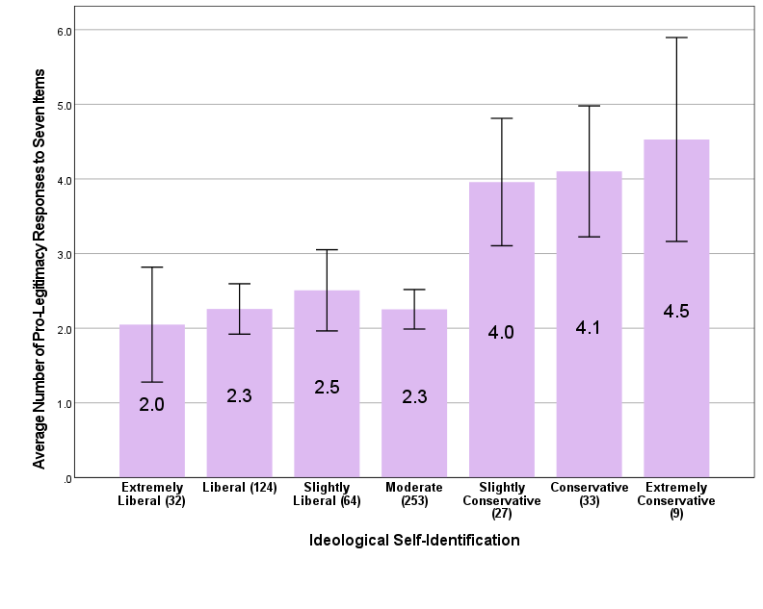
Notes:
N = 543
Difference of means: p < .001
r = .22 (average response index)
The numbers in parentheses are the numbers of cases on which the means are based.
95% confidence intervals around each mean are shown.

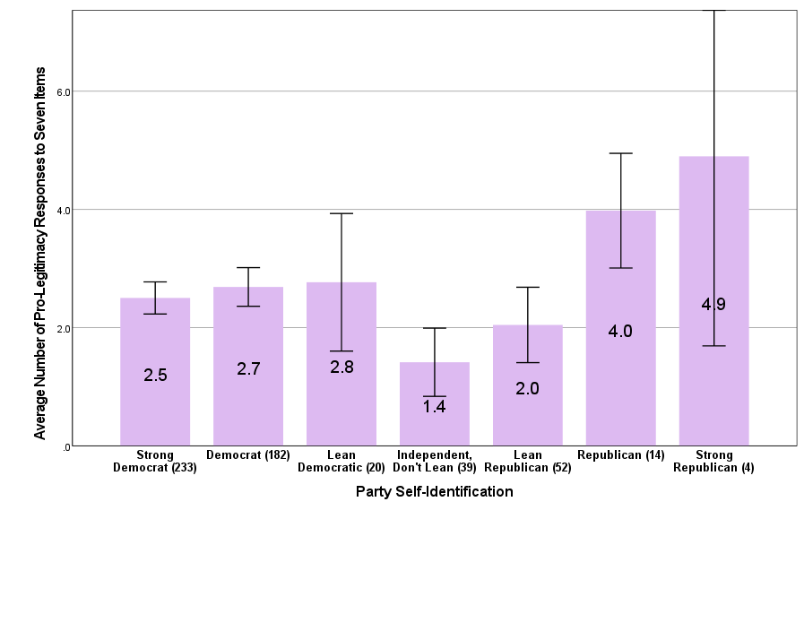
Notes:
N = 543
Difference of means: p = .003
r = -.00 (average response index)
The numbers in parentheses are the numbers of cases on which the means are based.
95% confidence intervals around each mean are shown.

ReferenceS

Bartels, Larry M. 2020. “Ethnic Antagonism Erodes Republicans’ Commitment to Democracy.” PNAS 117 (#37): 22752-22759.
Boudreau, Cheryl, Scott A. MacKenzie, and Daniel J. Simmons. 2022. “Police Violence and Public Opinion After George Floyd: How the Black Lives Matter Movement and Endorsements Affect Support for Reforms.” Political Research Quarterly 75 (#2):497–511.
Bunyasi, Tehama Lopez, and Candis Watts Smith. 2019. “Do All Black Lives Matter Equally to Black People? Respectability Politics and the Limitations of Linked Fate.” The Journal of Race, Ethnicity, and Politics 4: 180-215.
Crabtree, Kiela, and Nicole Yadon. 2022. “Remaining Neutral: White Americans’ Reactions to Police Violence and Policing.” Political Behavior forthcoming.
Davis, Darren W., and David C. Wilson. 2022. Racial Resentment in the Political Mind. Chicago: The University of Chicago Press.
Gay, Claudine, Jennifer L. Hochschild, and Ariel White. 2016. “Americans’ Belief in Linked Fate: Does the Measure Capture the Concept?” Journal of Race, Ethnicity, and Politics 1 (#1, March): 117-144.
Gibson, James L. 2010. “The Political Consequences of Religiosity: Does Religion Always Cause Political Intolerance?” In Religion and Democracy in America: Danger or Opportunity? Edited by Alan Wolfe and Ira Katznelson. New York and Princeton, NJ: Russell Sage Foundation and Princeton University Press. Pp. 147-175.
Gibson, James L., and Michael J. Nelson. 2018. Black and Blue: How and Why African Americans Judge the American Legal System. Oxford: Oxford University Press.
Horowitz, Juliana Menasce. 2021. “Support for Black Lives Matter Declined After George Floyd Protests, but has Remained Unchanged Since.” Pew Research Center, September 27. https://www.pewresearch.org/fact-tank/2021/09/27/support-for-black-lives-matter-declined-after-george-floyd-protests-but-has-remained-unchanged-since/.
Horowitz, Juliana Menasce, and Gretchen Livingston. 2016. “How Americans View the Black Lives Matter Movement.” Pew Research Center, July 8. https://www.pewresearch.org/fact-tank/2016/07/08/how-americans-view-the-black-lives-matter-movement/.
Horowitz, Juliana Menasce, Anna Brown, and Kiana Cox. 2019. "Race in America 2019." Pew Research Center, April 9. https://www.pewresearch.org/social-trends/2019/04/09/race-in-america-2019/.
Jefferson, Hakeem. forthcoming. “The Curious Case of Black Conservatives: Assessing the Validity of the Liberal-Conservative Scale among Black Americans.” Public Opinion Quarterly forthcoming.
McClain, Paula D., Jessica D. Johnson Carew, Eugene Walton, Jr., and Candis S. Watts. 2009. “Group Membership, Group Identity, and Group Consciousness: Measures of Racial Identity in American Politics?” Annual Review of Political Science 12: 471-485.
Nunn, Clyde Z., Harry J. Crockett, and J. Allen Williams. 1978. Tolerance for Non-Conformity. San Francisco: Jossey-Bass.
Parker, Kim, Juliana Menasce Horowitz, and Monica Anderson. 2020. “Amid Protests, Majorities Across Racial and Ethnic Groups Express Support for the Black Lives Matter Movement.” Pew Research Center, June 12. https://www.pewresearch.org/social-trends/2020/06/12/amid-protests-majorities-across-racial-and-ethnic-groups-express-support-for-the-black-lives-matter-movement/.
Peffley, Mark, and Jon Hurwitz. 2010. Justice in America: The Separate Realities of Blacks and Whites. Cambridge, NY: Cambridge University Press.
Pew Research Center. 2019. Why Americans Don’t Fully Trust Many Who Hold Positions of Power and Responsibility. Technical Report. https://www.pewresearch.org/politics/2019/09/19/whyamericans-dont-fully-trust-many-who-hold-positions-of-powerand-responsibility/.
Reynolds, Joshua J., Victoria Estrada-Reynolds, and Narina Nunez. 2018. “Development and Validation of the Attitudes Towards Police Legitimacy Scale.” Law and Human Behavior 42 (#2):119-134.
Sanchez, Gabriel R., and Edward D. Vargas. 2016. “Taking a Closer Look at Group Identity: The Link Between Theory and Measurement of Group Consciousness and Linked Fate.” Political Research Quarterly 69 (1):160-174.
Thomas, Deja, and Juliana Menasce Horowitz. 2020. “Support for Black Lives Matter Has Decreased Since June but Remains Strong Among Black Americans.” Pew Research Center, September 16. https://www.pewresearch.org/fact-tank/2020/09/16/support-for-black-lives-matter-has-decreased-since-june-but-remains-strong-among-black-americans/.

Excludes Census categories of 16-19 years old.
Their paper is an exceptionally clear and thorough explication of the “police legitimacy” concept, and their analysis very strongly supports the validity and reliability of their purposed measures (including predictive validity).
I should note that these findings differ rather dramatically from those reported by Gibson and Nelson (2018), with every indicator of ingroup attachments registering much larger percentages in the 2021 survey. My findings also differ dramatically from those of Sanchez and Vargas (2016), which were based on a 2004 national survey of Black people. They concluded: “Substantively, what these findings suggest is that for blacks: collective action, commonality, perceived discrimination, and linked fate are all tapping into the same general construct (i.e., group identity). . . . the three dimensions of group consciousness typically used by researchers using a multidimensional approach with measurement load onto one factor for both Latinos and African Americans. This implies that creating a single measure based on these dimensions to capture group consciousness is justifiable for these two groups, less so for Asian Americans or whites.” (Sanchez and Vargas 2016, 171). My findings obviously disagree. Throughout this paper, I develop a theory that posits that linked fate is more determined by external environmental forces than by internal individual psychology and is therefore more malleable than some researchers seem to assume.
This item is not too dissimilar to a measure of racial resentment put forth by Davis and Wilson (2022, 292): “Whites are generally treated better than other groups in American society today.” See also the items listed on pages 300-301.
Note that the two forms of identification are only correlated at .29. For an analysis that questions whether ideological self-identifications are validly measured among African Americans see Jefferson forthcoming.
To aid in making these relationships understandable, I report in Figure D.1 an index of the number of pro-legitimacy responses given to the 7 indicators. For all analytical (as opposed to illustrative) purposes (e.g., Table 2), I use the average response to the items, using the entire response set for each answer.
Boudreau, MacKenzie, and Simmons report an interesting study of support for police reform in California. I resist making comparisons to their analysis because they employ a quite different dependent variable (support for four specific police reforms) and analyze attitudes of (mainly White) Californians. I do note, however, that they find that support for police reforms “appears to be both bipartisan and multi-racial” (2022, 504).

