High-quality delivery of high-power picosecond laser in single-ring anti-resonant hollow-core fiber for micromachining
Xinshuo Chang^{1,2,3,4,5,†}, Qinan Jiang^{1,†}, Zhiyuan Huang^{1,2,5,*}, Jinyu Pan², Donghan Liu^{1,2,5}, Qingwei Zhang^{6,7}, Nan Li⁶, Zhuozhao Luo^{1,5}, Ruochen Yin^{1,3,5}, Wenbin He^{1,5}, Jiapeng Huang^{1,5}, Yuxin Leng^{2,4}, Xin Jiang^{1,5}, Shanglu Yang⁶, and Meng Pang^{1,4,5,8}
¹ Russell Centre for Advanced Lightwave Science, Shanghai Institute of Optics and Fine Mechanics (SIOM) and Hangzhou Institute of Optics and Fine Mechanics (HIOM), Hangzhou 311400, China
² State Key Laboratory of Ultra-intense Laser Science and Technology, Shanghai Institute of Optics and Fine Mechanics (SIOM), Chinese Academy of Sciences (CAS), Shanghai 201800, China
³ Center of Materials Science and Optoelectronics Engineering, University of Chinese Academy of Sciences (UCAS), Beijing 100049, China
⁴ Hangzhou Institute for Advanced Study, University of Chinese Academy of Sciences (UCAS), Hangzhou 310024, China
⁵ Zhejiang Key Laboratory of Microstructured Specialty Optical Fiber, Hangzhou Institute of Optics and Fine Mechanics (HIOM), Hangzhou 311400, China
⁶ Center for Laser-Aided Manufacturing and Processing, Shanghai Institute of Optics and Fine Mechanics (SIOM), Chinese Academy of Sciences (CAS), Shanghai 201800, China
⁷ e-mail: zhangqingwei@siom.ac.cn
⁸ e-mail: pangmeng@siom.ac.cn
*Corresponding author: huangzhiyuan@siom.ac.cn
†These authors contributed equally to this work

High-quality delivery of high-power picosecond laser in single-ring anti-resonant hollow-core fiber for micromachining
- The measured loss of the anti-resonant hollow-core fiber (AR-HCF)
The measured loss of the AR-HCF was obtained using the cut-back method, and the measurement results were plotted in Fig. S1. Figures S1(a) and S1(b) correspond to the fiber losses of AR-HCF1 and AR-HCF2, respectively. The dashed black lines in Figs. S1(a) and S1(b) indicate the pump wavelength of 1064 nm, at which the fiber losses of AR-HCF1 and AR-HCF2 were measured to be 0.12 dB/m and 0.10 dB/m, respectively.
Figure. S1. Measured loss of the AR-HCF, (a) and (b) correspond to AR-HCF1 and AR-HCF2, respectively. The dashed black lines in panels (a) and (b) represent the pump wavelength of 1064 nm, at which the fiber losses of AR-HCF1 and AR-HCF2 were measured to be 0.12 dB/m and 0.10 dB/m, respectively.
- Evolution of beam profiles at output ports of three laser delivery systems in static and oscillating states
Figures S2(a) and S2(b) present the evolution of beam profiles measured at 20-second intervals from the output ports of three laser delivery systems (including free space, 3-m-long AR-HCF1, and 3-m-long AR-HCF2) under static and oscillating fiber conditions, respectively. When the AR-HCF is in a static state, it can be observed that for the laser delivery systems: 3-m-long AR-HCF1 and 3-m-long AR-HCF2, the beam profiles at the output ports during in-line processing are as stable as the beam profiles in free space, as shown in Fig. S2(a). However, when the AR-HCF is in an oscillating state, we can observe the beam-profile instability at the output port of the AR-HCF1, which is caused by certain energy coupling from fundamental optical mode to some high-order modes of the fiber (see Fig. S2(b)). Therefore, the in-line processing results using AR-HCF1 exhibit obvious displacements from the perfectly-straight line due to the instability of the output beam from the fiber, see Fig. 5(b) of the main text. While for AR-HCF2, this beam-profile instability can be efficiently eliminated, so that highly-pure fundamental optical mode with a Gaussian-like shape can always be obtained at the fiber output port without being affected by external perturbations, see Fig. S2(b). It can be found that the manufacturing quality of the AR-HCF2 delivery system is almost the same with that of the free-space delivery system, see Figs. 5(a) and 5(c) of the main text.
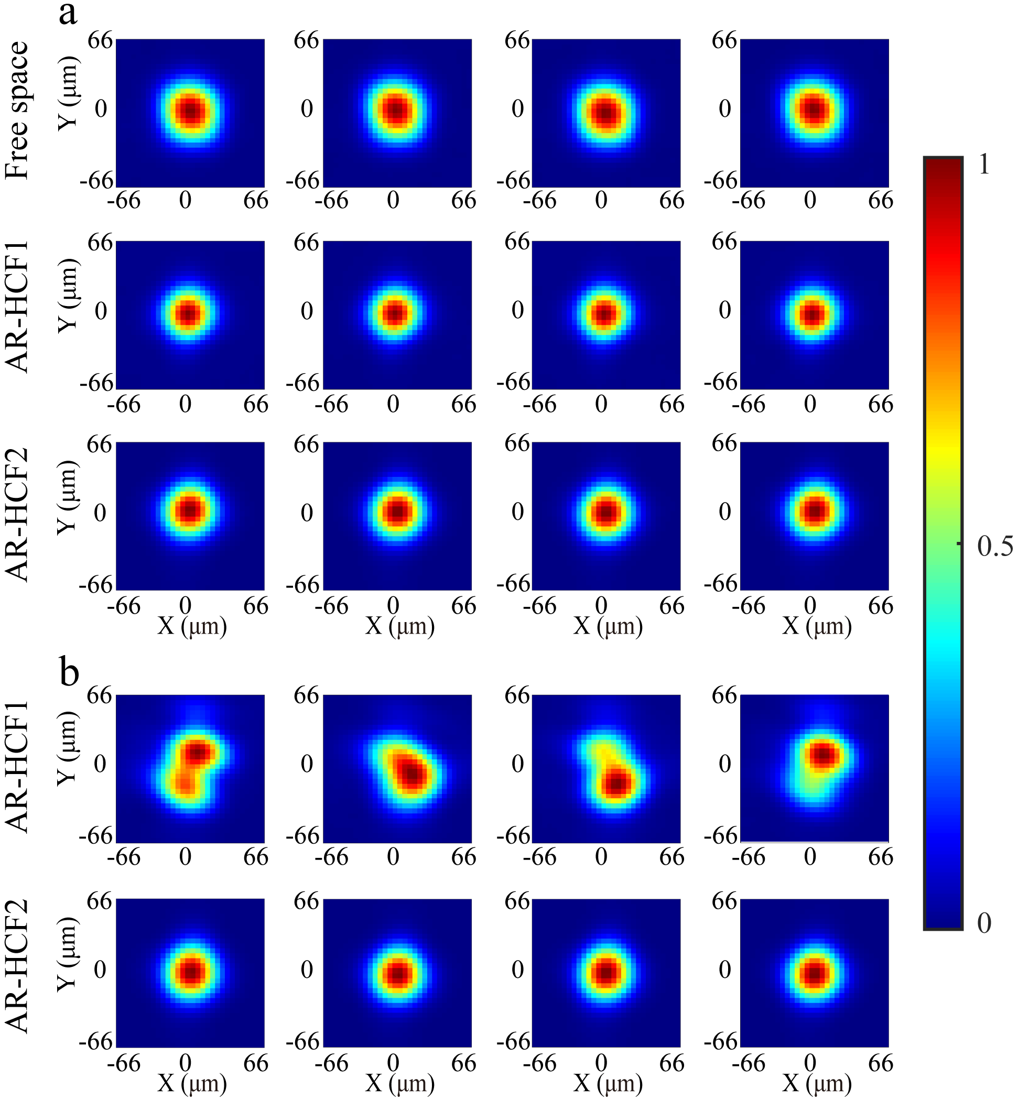
Figure. S2. During in-line processing, beam profiles were measured at 20-second intervals from the output ports of three laser delivery systems: free space, 3-m-long AR-HCF1, and 3-m-long AR-HCF2, under static (a) and oscillating (b) fiber conditions. The measured beam profiles in (b) correspond to the in-line processing results in Figs. 5(b) and 5(c) of the main text.
- Estimation of displacement degree
In order to quantitatively evaluate the quality of the in-line processing, we estimated the displacement degree of these in-line processing results. Figure S3 exhibits the in-line processing result on the surfaces of aluminum sheet using ~20 W picosecond laser beams delivered over 3-m-long AR-HCF2. We first select two points at the beginning and end of this processing trace and connect them into a line, using this line as the reference line (solid red line in Fig. S3). Then, 52 points are uniformly selected along the center of this processing trace, and the vertical distances from these points to the reference line are obtained (the vertical distances of 8 sampling points are shown in Figs. S3). The displacement degree of this processing result is defined as the ratio of the standard deviation of these 52 values to their mean, and the calculated value is 2.38%. Using the same estimation method, we can obtain the displacement degrees are 2.12% and 5.66% for the laser delivery systems over free space and 3-m-long AR-HCF1, respectively.
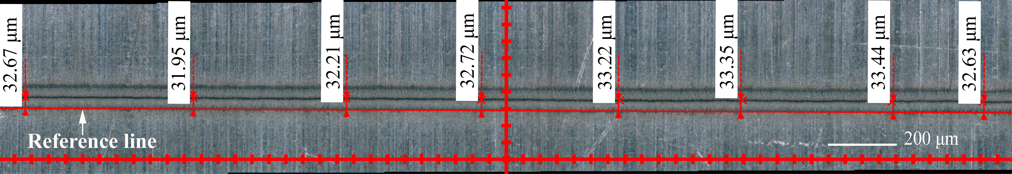
Figure. S3. Schematic diagram of point-based estimation of displacement degree. This in-line processing result on the surfaces of aluminum sheet using ~20 W picosecond laser beams delivered over 3-m-long AR-HCF2.
- Simulation of pulse temporal width and spectral profile
The pulse temporal width and spectral profile at the output port of the 3-m-long AR-HCF were not directly measured through experiments, but obtained through numerical simulations based on the generalized nonlinear Schrödinger equation. Figure S4 exhibits the simulation results of the pulse temporal width and spectral profile at the input and output ports of the 3-m-long AR-HCFs when the input pulse energy is 14.9 µJ (corresponding to the output average power of 20 W at 1.5 MHz). As shown in Fig. S4, there is no significant change in the pulse temporal and spectral FWHM (full width at half maximum) widths of both AR-HCF1 and AR-HCF2 outputs, except for a slight broadening of the spectral edges. This spectral broadening is attributed to the low nonlinearity in air-filled AR-HCFs, but its broadening degree is less than 0.2 nm. It should be noted that in the single-shot processing experiment, when the input pulse energy was increased to 89.5 µJ (corresponding to the output pulse energy of 80 µJ), the pulse spectrum still showed a certain degree of broadening. However, due to the low dispersion value of the fiber (group delay dispersion values are -3426 fs² (AR-HCF1) and -4212 fs² (AR-HCF2) for 3-m-long fiber at 1 bar air), the pulse temporal width remained at 15 ps, consistent with the input pulse width.
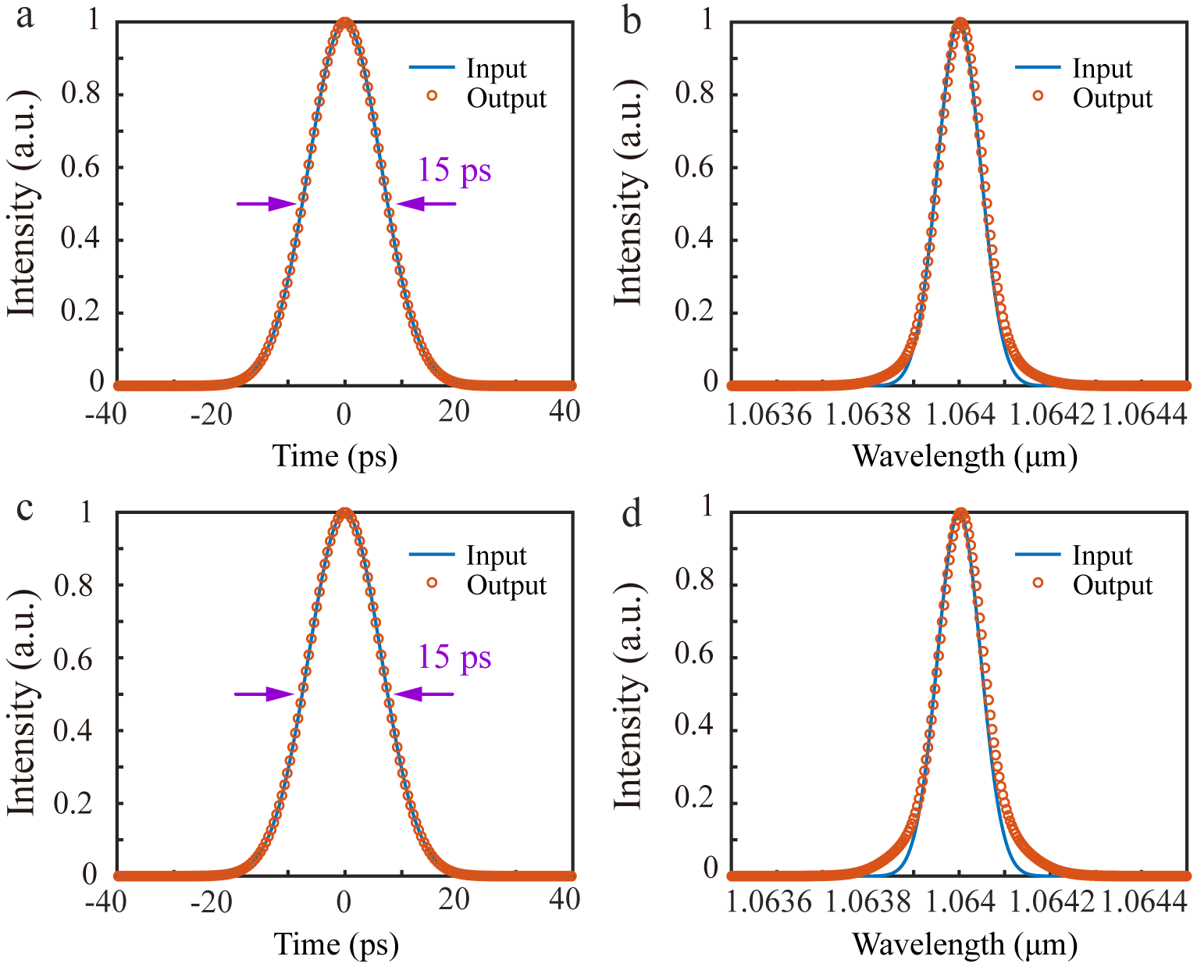
Figure. S4. Simulation results of pulse temporal width and spectral profile at the input and output ports of the 3-m-long AR-HCFs. (a), (b) Results of the 3-m-long AR-HCF1 laser delivery system. (c), (d) Results of the 3-m-long AR-HCF2 laser delivery system.
- Measurement of quality factors (M²) of delivered laser beams
We measured experimentally the quality factors (M²) of delivered laser beams at different experimental conditions, using the M²-measuremnet equipment (Ophir, BeamSquared), and the results are illustrated in the Fig. S5. The corresponding beam astigmatism and asymmetry are also summarized in Table S1. These results exhibit clearly that the advantage of the AR-HCF2 delivery system, the M² factors for this case are always <1.2. In contrast, the measured M² factors for the AR-HCF1 case, varied from ~1.2 to 2.2, due to the fiber micro-bending. Interestingly, the measured M² factors for the free-space case were also stable with, however, a bit larger values than the AR-HCF2 case, highlighting the advantage of fiber-based delivery system.

Table S1. Beam astigmatism and asymmetry at different positions.
Laser delivery systems | P1 |  |  | P2 |  |  | P3
Laser delivery systems | astigmatism | asymmetry |  | astigmatism | asymmetry |  | astigmatism | asymmetry
Free space | 0.35 | 1.23 |  | 0.30 | 1.24 |  | 0.29 | 1.26
AR-HCF1 | 0.95 | 1.03 |  | 0.33 | 1.17 |  | 0.10 | 1.14
AR-HCF2 | 0.11 | 1.02 |  | 0.06 | 1.01 |  | 0.07 | 1.01
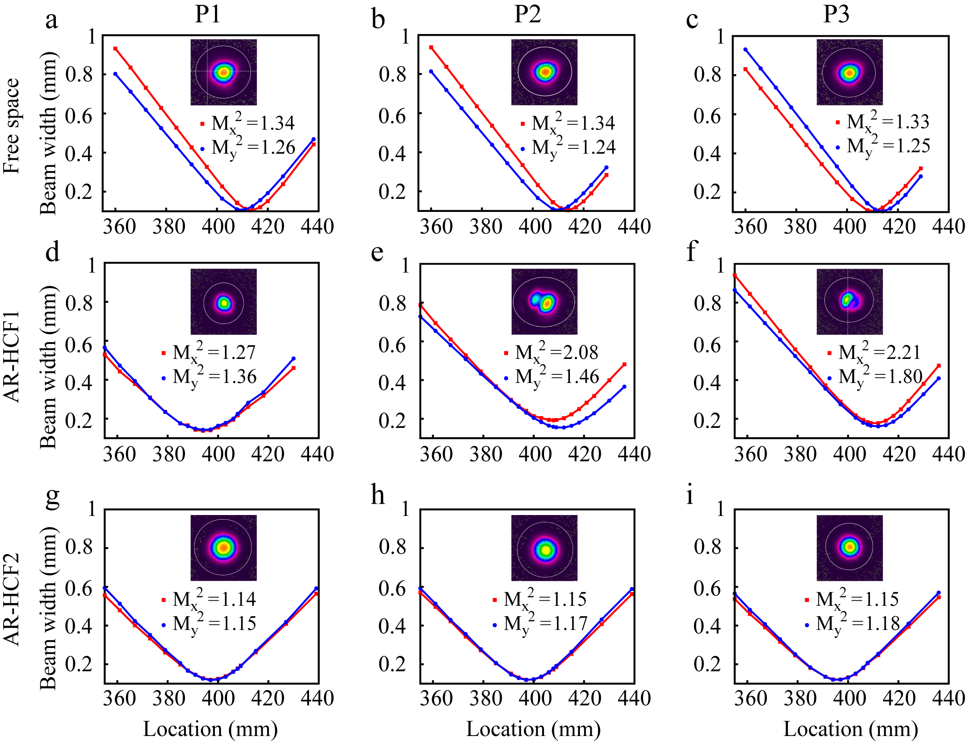
Figure. S5. Measurement of beam quality factors (M²) at the output ports of three laser delivery systems: free space (a-c), 3-m-long AR-HCF1 (d-f), and 3-m-long AR-HCF2 (g-i).
- Measurement of power and pointing stabilities of AR-HCF laser delivery systems in oscillating state
In the experiment, we measured the power and pointing stabilities of the AR-HCF laser delivery systems when oscillating the fiber samples. The measured results are illustrated in Fig. S6. During oscillating, as observed in Figs. S6(a) and S6(c), for the 3-m-long AR-HCF1 laser delivery system, the RMS value of power fluctuation was measured to be ~0.37%, exhibiting obviously a worse value than that at the stable state (~0.24%, see Fig. 2(c) in the main text). In contrast, for the 3-m-long AR-HCF2 laser delivery system, the RMS value of power fluctuations is ~0.23%, close to the value at the stable state (~0.2%, see Fig. 2(e) in the main text). Similarly, as seen in Figs. S6(b) and S6(d), when the AR-HCF was at oscillating state, the pointing stability of AR-HCF1 (θ_{x} = 72.1 µrad and θ_{y} = 138.6 µrad) degraded significantly, while the pointing stability of AR-HCF2 exhibit much better performance during oscillating (θ_{x} = 10.5 µrad and θ_{y} = 17.4 µrad).
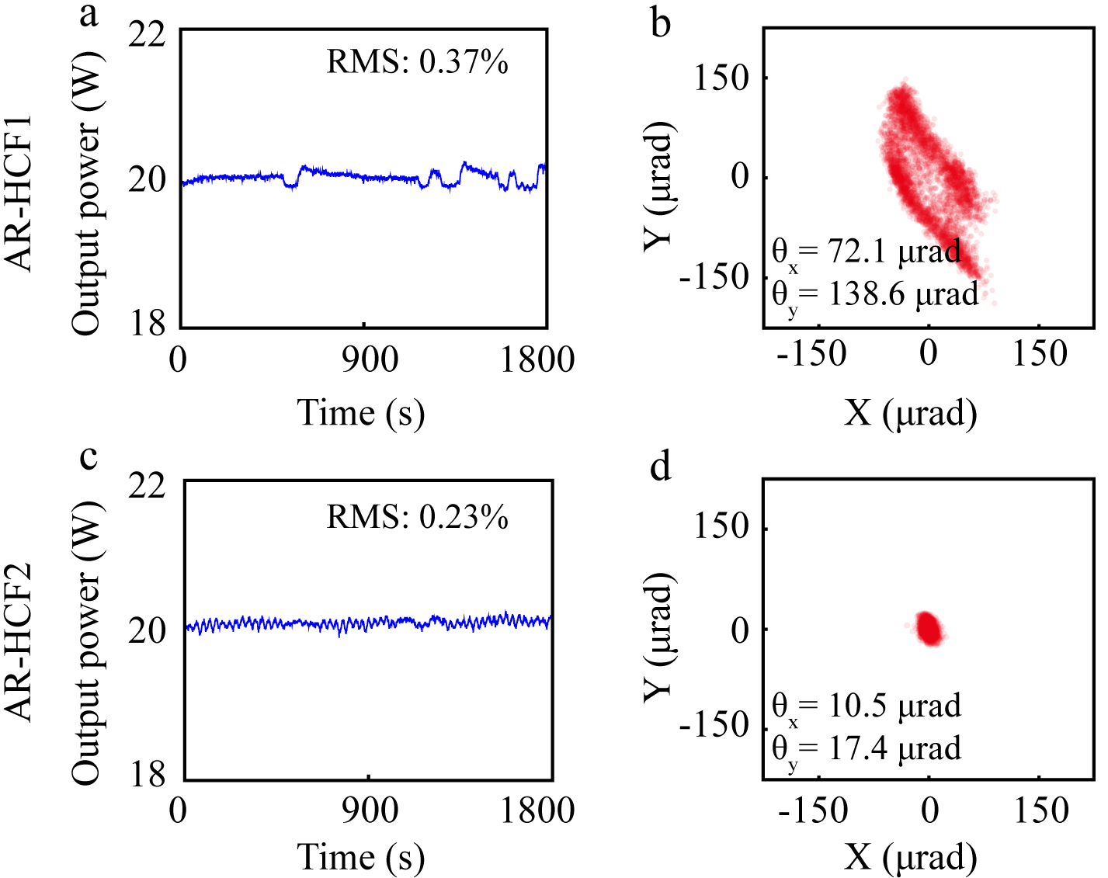
Figure. S6. The power stability and pointing stability of AR-HCF laser delivery systems in oscillating state. (a), (b) Results of the 3-m-long AR-HCF1 laser delivery system. (c), (d) Results of the 3-m-long AR-HCF2 laser delivery system.
- Characterization of AR-HCF mode purity
We performed the AR-HCF mode purity characterization using the spectral method. In the experimental measurement, a supercontinuum source was initially coupled into the two AR-HCFs, with the corresponding transmission spectra shown in Figs. S7(a) and S7(b). We can observe distinct interference fringes in AR-HCF1 (see Fig. S7(a)), whereas AR-HCF2 exhibits a smooth transmission spectrum (see Fig. S7(b)). This spectral comparison indicates significant higher-order mode components in AR-HCF1, while AR-HCF2 demonstrates superior modal purity. Quantitatively, we introduced the fringe amplitude as a figure of merit (FOM) for modal quality assessment. The measured fringe amplitudes were 0.696 dB (AR-HCF1) and 0.03 dB (AR-HCF2), corresponding to the FOM value of 23.2. These results confirm the excellent single-mode characteristics of AR-HCF2.
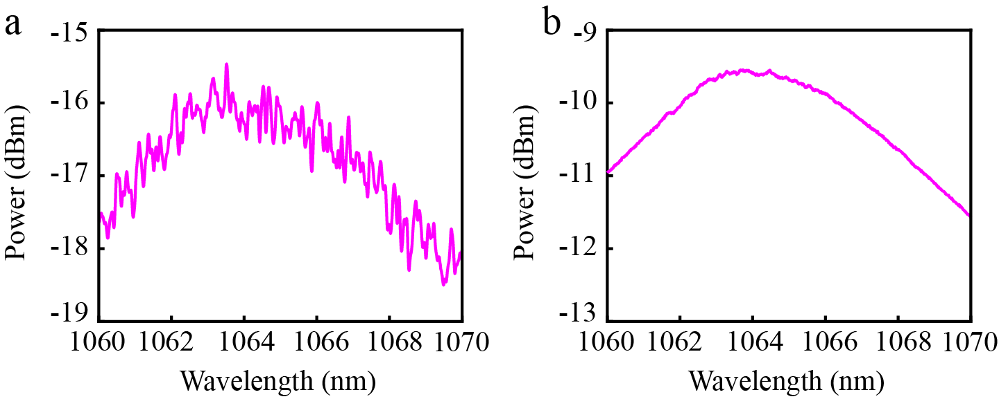
Figure. S7. The transmission spectra measured at the output ports of AR-HCFs. (a) Results of the 20-m-long AR-HCF1. (b) Results of the 6.5-m-long AR-HCF2.

