Supplementary material
Digital generation of super-Gaussian perfect vortex beams via wavefront shaping with globally adaptive feedback
Rui Ma^{1, 2,‡}, Ke Hai Luo^{1,‡}, Jing Song He^{2, 5}, Wei Li Zhang³, Dian Yuan Fan¹, Anderson S. L. Gomes⁴, and Jun Liu^{1, *}
¹ International Collaborative Laboratory of 2D Materials for Optoelectronics Science and Technology of Ministry of Education, Institute of Microscale Optoelectronics, Shenzhen University, Shenzhen 518060, China
² Institute for Advanced Study, Shenzhen University, Shenzhen 518060, China
³ Fiber Optics Research Centre, School of Information and Communication Engineering, University of Electronic Science & Technology of China, Chengdu 611731, China
⁴ Departamento de Física, Universidade Federal de Pernambuco, 50670-901 Recife-PE, Brazil
⁵ hejingsong@szu.edu.cn
* liuj1987@szu.edu.cn
‡ These authors contributed equally to this work.

Supplementary Note 1：Characteristics of the random lasing light source
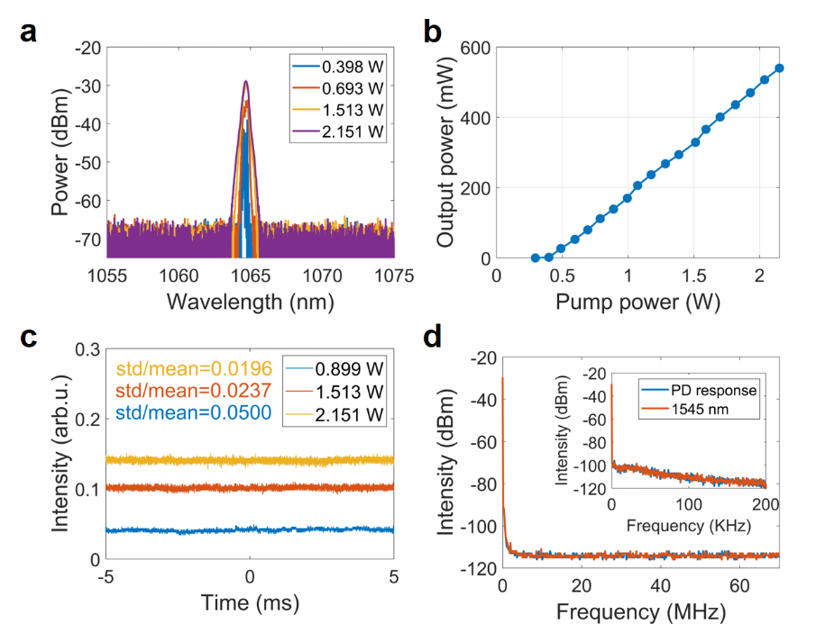
Figure S1. Characteristics of the low coherence random lasing light source. (a) Optical spectra at different pump powers. (b) Output power versus pump power. (c) Short-time temporal domain traces at different pump powers. (d) Radio frequency spectra.
Random fiber lasing is a low coherence laser featured by its non-resonated open cavity structure in contrast to conventional fiber lasers. When the pump power is increased to the lasing threshold, narrow linewidth spikes appear randomly in the reflection band of the HR-FBG as shown in Fig. S1(a), which is excited by stimulated Brillouin scattering (SBS) and the cascaded Stokes lines. The spectrum undergoes a broadening effect with the boost of pump power beyond the lasing threshold. Once the spectrum broadens exceeding the Brillouin gain bandwidth (typically ~20 MHz in SMF), the SBS process would be strongly suppressed and the random spectral spikes would be merged into a smooth, stable, and relatively broad (3 dB bandwidth 0.35 nm) curve, as indicated in Fig. S1(a). The output power versus the launched pump power is given in Fig. S1(b). It can be seen that the lasing threshold is 0.400 W with a slope efficiency of 30.52%. It is worth noting that both the maximum output power and the optical-to-optical efficiency could be further optimized for conventional random lasing. The most appealing point to employ a random lasing as the light source is the stable output resulting from the open cavity structure, which can be found in the strongly suppressed temporal dynamics (i.e., typical quasi-CW with standard deviation divided by the mean value as low as 0.0196) as shown in Fig. S1(c) and the non-resonated oscillation in the whole radio frequency range (both the 14 MHz range and the 200 kHz range) as shown in Fig. S1(d).
Supplementary Note 2：Characteristics of the generated PVBs
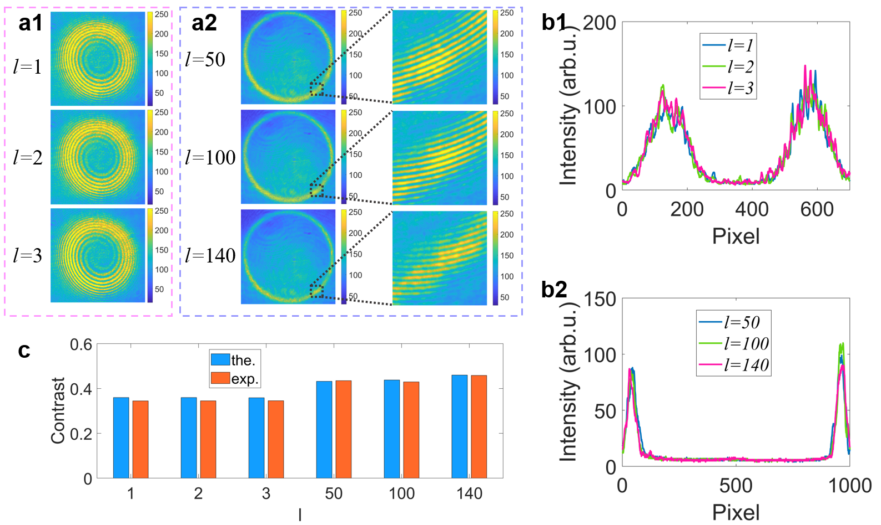
Figure S2. Characteristics of the generated PVBs. (a) Interference patterns. (b) The central cross-section curves corresponding to the PVB intensity profiles in Fig. 2(f). (c) Theoretical calculated and experimentally measured speckle contrast.
To verify the helical phase front of the generated PVBs, a reference beam splitting from the unmodulated incident light is introduced in the Mach-Zehnder interferometer. The interference patterns for the two PVB groups are given in Fig. S2(a). It is clear that spiral stripes corresponding to the topological charge extend outward from the central phase singularity for the lower topological charge group, while for the higher topological charge group, the spiral stripes are only observed in the overlapped area with the intensity annulus due to the large hollow core. Therefore, the vortex beam obtained even with a super high topological charge, i.e., 140, can still be verified through the interference pattern. The topological charge of 140 is also the highest order PVB that is experimentally realized using the super-pixel wavefront shaping to the best of our knowledge.
To characterize the flatness of the PVBs, the central cross-section curves corresponding to the PVB intensity profiles in Fig. 2(f) of the main manuscript are first investigated, as depicted in Fig. S2(b). All the intensity curves of the two topological charge groups show a Gaussian-like profile which is in agreement with the target intensity profile defined in Eq. 2. It is obvious that the intensity profile is not spatially uniform. As a golden standard, speckle contrast C defined by (where denotes the standard deviation of the intensity and is the average intensity) is generally used to quantitatively evaluate the flatness of a considered optical field. Here, the beam speckle contrast is also used to analyze the spatial uniformity for the experimentally obtained PVBs in Fig. 2(f) and the theoretically calculated PVBs in Fig. 2(d), as shown in Fig. S2(c). The beam speckle contrasts of the experimentally obtained PVBs in the lower topological charge group (i.e., 0.3446, 0.3450, 0.3452 for l = 1, 2, 3) is much smaller than that in the higher topological charge group (i.e., 0.4348, 0.4291, 0.4582 for l =50, 100, 140), while all the experimental values coincide well with the theoretical ones. However, the speckle contrast value for a spatially uniform beam, i.e., a typical flat-top beam, is generally ~0.1. This means the Gaussian model defined PVB generation is not suitable to realize a high-quality flat-top PVB.
Supplementary Note 3：Degeneration of the intensity modulation due to non-uniform illumination
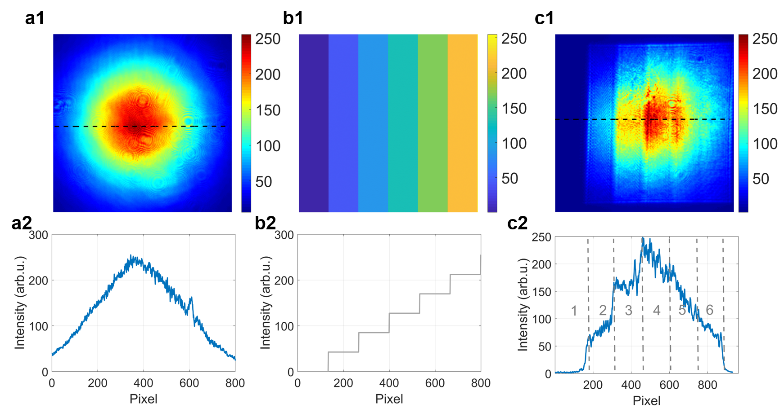
Figure S3. Degeneration of the intensity modulation due to non-uniform illumination. The output single transverse mode profile from the fiber distal end (a1) and its central cross-section curve (a2) correspond to the dashed lines in (a1). A stair-wise increased intensity target (b1) and the curve in the central cross-section (b2). The measured intensity profile (c1) and its sectional curve (c2) correspond to the dashed lines in (c1).
In the super-pixel wavefront-shaping, the unmodulated incident beam is supposed to be an ideal plane wave that is uniformly distributed. However, in a practical experiment scenario, the non-flat-top PVB may result in the non-uniform incident illumination, i.e., a Gaussian shaped profile for a fiber laser, as the transverse mode field shown in Fig. S3(a). The intensity of the central region is much stronger than the outer region as depicted in the curve of the central cross-section in Fig. S3(a2). To further verify the capability of the intensity modulation under Gaussian shaped illumination, a stair-wise increased intensity profile (Fig. S3(b)) is used as the target. After loading the corresponding binary DMD pattern, the measured intensity profile shown in Fig. S3(c) is obtained. The region marked from 1 to 6 correspond to the target intensity from 0 to 212 stepped by ~42. It is observed that only regions 1, 2, and 3 show a clear stair-wise increased intensity, while from region 4 the measured intensity does not obey this rule.

