Extremely powerful and frequency-tunable terahertz pulses from a table-top laser-plasma wiggler

1 Influence of laser intensity and density
To further explore the impact of laser intensity and plasma density on terahertz radiation, we conducted additional parameter scans. Fig. S1 (a) illustrates the influence of laser intensity on both efficiency and frequency. As depicted, with increasing light intensity, the frequency experiences fluctuations until it eventually stabilizes. On the other hand, Fig. S1 (b) demonstrates the effect of plasma density on efficiency and frequency. Here, we observe that as the plasma density rises, the energy conversion efficiency diminishes, while the frequency remains constant.
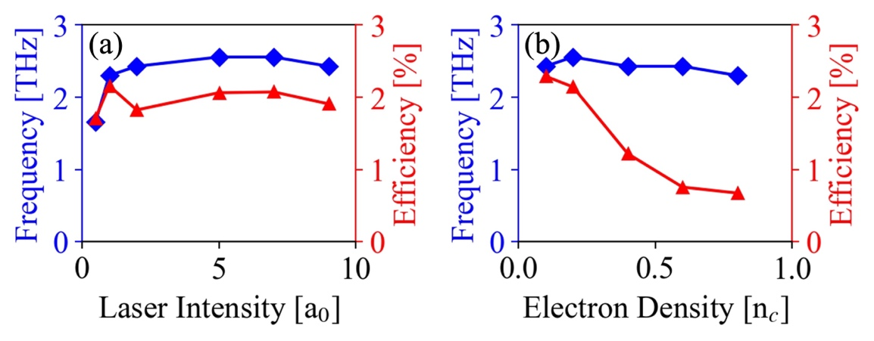
Fig. S1. Energy conversion efficiency and center frequency as a function of (a) laser intensity and (b) plasma density at a length of 750 microns and thickness of 30 microns.
2 Velocity density distribution of B-type electrons
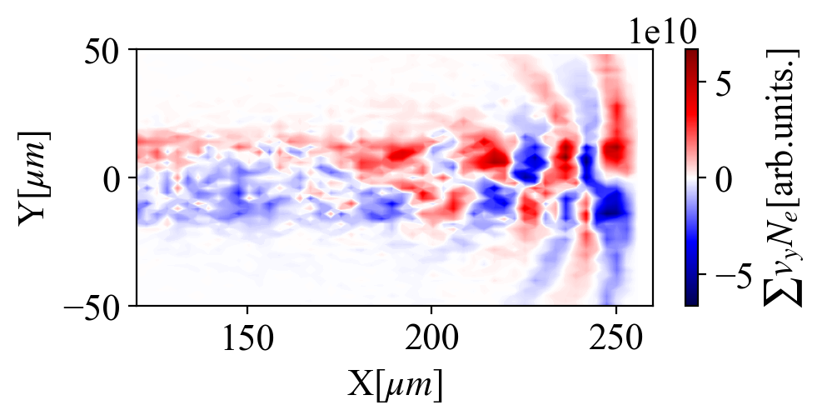
Fig. S2. Type-B electron velocity density distribution at 900 fs.
In PIC simulations, it is not possible to directly obtain the current of type-b electrons. Therefore, particle tracing is utilized to derive their current. The current is proportional to the product of velocity and density. In Fig. (Please provide the correct figure number), the velocity density distribution of type-b electrons, as described by Fig. S2, can be interpreted as the current resulting from the lateral motion of type-b electrons.
The figure demonstrates that the periodic motion of electrons generates periodic currents, leading to radiation emission. As the simulation progresses, the period of the current density at the back-end gradually lengthens, which corresponds to a slight decrease in frequency observed during the parameter sweep. This behavior is consistent with the results obtained when increasing the length of the target in the parameter analysis.
3 The 3D simulation results
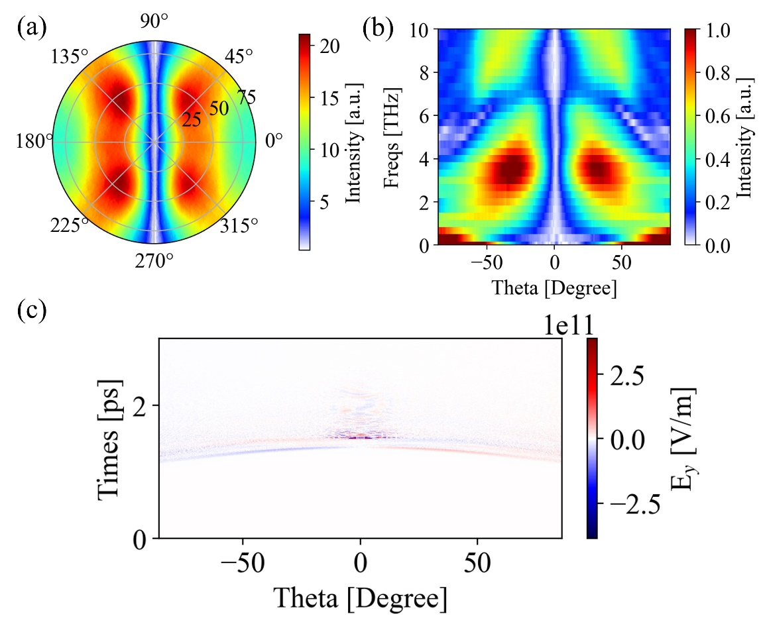
Fig. S3. The 3D reconstruction of terahertz field. (a) Angular radiation distribution of terahertz on the sampling screen. (b) Terahertz spectrogram at 0 degrees. (c) Time-angle electric field distribution at 0 degrees.
To explore the results in three-dimensional scenarios, we conducted 3D PIC simulations. Due to limitations in computing resources, lower resolutions were employed, and a sampling radius of 79 microns was used. This sampling radius is relatively small compared to the target's size, leading to challenges in accurately capturing the far-field radiation detection signal.
A 3D reconstruction technique was utilized in a Cartesian coordinate system to get the 3D terahertz information. Through this approach, we successfully obtained the angular distribution of radiation energy, as well as the spectrum and field strength of the radiation. Remarkably, the characteristics of the radiation observed in Fig. S3 closely resembled those obtained in the 2D simulations. This significant similarity between the two sets of results verifies the physical feasibility of the findings from the 2D simulations.
4 Description of the charge separation field
The surface charge separation field in the vicinity of the type-b electrons is denoted as Es. Fig. S4 (a) illustrates the spatial distribution of the electric field at the moment of 586 femtoseconds. It is evident that both the front-end and the backend exhibit strong charge separation fields. To further analyze this, we conducted field averaging around 100-140 microns and 155 microns, resulting in two cross-sectional charge separation fields.
In Fig. S4 (b), the red curve represents the electric field Es in the vicinity of type-b electrons. By integrating this electric field, we obtain the barrier. For the integral over the black area, we determine the front-end barrier, as shown in Fig. S4 (c).
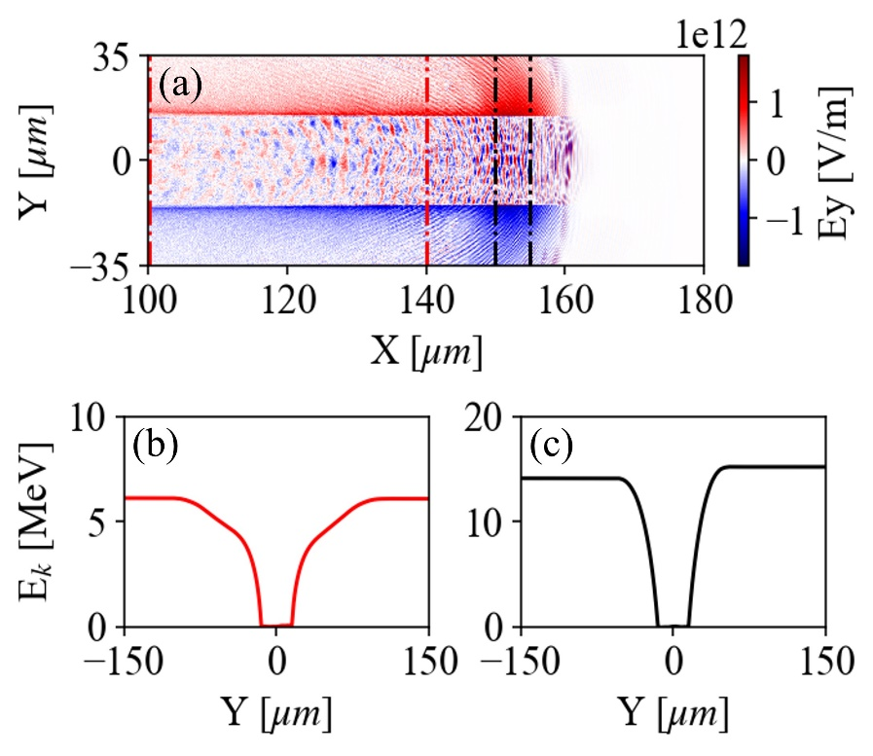
Fig. S4. Charge separation field information. (a) Spatial distribution of the charge separation field at 586 fs. (b) The red line denotes the barrier of the type-B electron. (c) The barrier is situated between the two black curves.

