Supplemental Table One: Interaction of Race and Ethnicity and HOUSES Index Quartile
 |  | Odds ratio | 95% CI | P Value
Non-Hispanic White | Houses Q2 | 1.095 | 1.015-1.183 | 0.02
 | Houses Q3 | 1.253 | 1.168-1.345 | <0.001
 | Houses Q4 | 1.236 | 1.157-1.321 | <0.001
Other Race and Ethnicity | Houses Q2 | 1.369 | 1.109-1.691 | 0.004
 | Houses Q3 | 1.528 | 1.256-1.860 | <0.001
 | Houses Q4 | 1.733 | 1.448-2.975 | <0.001

Supplemental Figure One Consent Rate: (percentage) by HOUSES within race and ethnicity

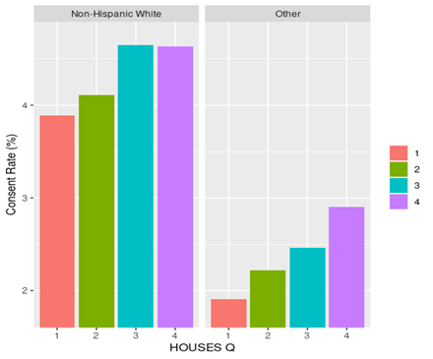
Legend: Houses Quartile from 1 to 4 with 1 having the lowest socioeconomic status and 4th quartile having the highest socioeconomic status.
Supplemental Figure 2: Consent Recruitment Charts for Midwest, Florida and Arizona

