Supplemental Tables and Figures

Supplemental Table A: Social Needs Screening Questions
Social Need Screening Question | Variable name
Are you worried that the place you are living now is making you sick? (Has mold, bugs/rodents, water leaks, not enough heat) | Housing Quality
Are you worried that in the next 2 months, you may not have a safe or stable place to live? (Eviction, being kicked out, homelessness) | Housing Instability
In the last 12 months, did you worry that your food could run out before you got money to buy more? | Food Insecurity
In the last 12 months, has lack of transportation kept you from medical appointments or getting your medications? | Health-related Transportation
In the last 12 months, did you have to skip buying medications or going to doctor’s appointments to save money? | Healthcare Costs
In the last 12 months, has the electric, gas, oil, or water company threatened to shut off services to your home? | Utility Costs
Are you finding it hard to get along with a partner, spouse, or family members? | Domestic Disputes
Do you need help getting childcare or care for an elderly or sick adult? | Child or Adult Care
Do you need legal help? (child/family services, immigration, housing discrimination, domestic issues, etc)? | Legal Help
Does anyone in your life hurt you, threaten you, frighten you or make you feel unsafe? | Interpersonal Violence

Supplemental Table B: Comparison of Area-level Social Determinants of Health Metrics
Domain | Item | ADI | SDI | SVI
Income | Below Poverty Level | X | X | X
 | Below 150% of Poverty Level | X
 | Income Disparity | X
 | Median Family Income | X
 | Per Capita Income |  |  | X
Employment | Unemployment | X | X | X
 | White Collar Occupation | X
Education | High School Diploma or Higher | X
 | < High School Diploma |  | X | X
 | <9 years Education | X
Housing | Owner-occupied Housing | X
 | Rented Housing Unit |  | X
 | Median Monthly Mortgage | X
 | Median Gross Rent | X
 | Median Home Value | X
Household | Single-parent Households | X | X | X
Characteristics | Age 65+ Years |  |  | X
 | Age < 17 Years |  |  | X
 | Persons with Disability |  |  | X
 | Households Without a Telephone | X
 | Households Without a Motor Vehicle | X | X | X
 | Housing Without Complete Plumbing | X
Housing Type | Multi-unit (10+) Structures |  |  | X
 | Crowding (>1 person/room) | X | X | X
 | Mobile Homes |  |  | X
 | Persons in Group Quarters |  |  | X
Minority Status and Language | Non-hispanic White |  |  | X
 | Speak English ‘Less Than Well’ |  |  | X

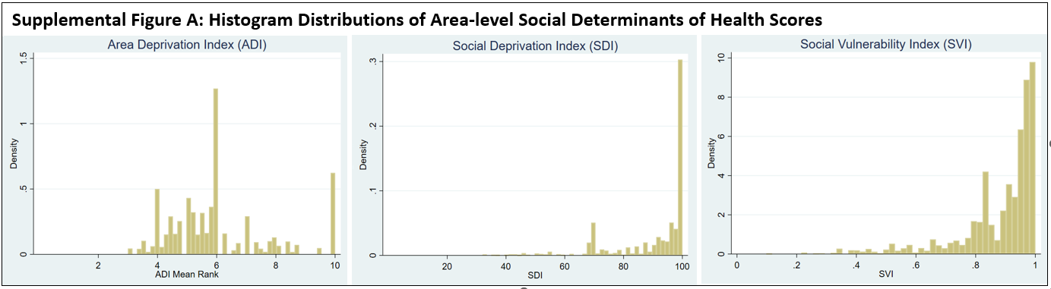

Supplemental Table C: Distribution of Reported HRSNs , N (%)*
Housing Quality | 2,662 (5.9)
Money for Food | 2,611 (5.8)
Healthcare Transportation | 2,087 (4.6)
Housing Situation | 2,029 (4.5)
Healthcare Cost | 1,752 (3.9)
Domestic Disputes | 1,516 (3.4)
Utility Shutoff Threat | 1,372 (3.0)
Legal Help | 1,262 (2.8)
Child or Adult Care | 1,329 (2.9)
Interpersonal Violence | 548 (1.2)
*total N=8,396

Supplemental Table D: Count of Census Tracts Within Each Category of Area and Individual-level Risk
 | Low Area SDoH Score and Low Individual Need (Gray census tracts, N) | High Area SDoH Score and Low  Individual Need (Pink Census Tracts, N) | Low Area SDoH Score and High Individual Need (Light Blue Census Tracts, N) | High Area SDoH Score and High Individual Need (Dark Blue Census Tracts, N)
Map with Area Deprivation Index (ADI) | 124 | 31 | 140 | 32
Map with Social Vulnerability Index (SDI) | 129 | 26 | 80 | 92
Map with Social Vulnerability Index (SVI) | 128 | 27 | 80 | 92

Supplemental Table E: Comparison of Patients Screened for HRSN and General Medical Center Population
 | Total Screened, N (%) | General Population (N, %*)
Total | 45,279 | 308,687
Age (median [IQR]) | 33.5 [11.4-58.8] | 39 [16-60]
Sex  Female  Male  Transgender Non-Conforming | 27,018 (59.7)  18,261 (40.3) | 190,225 (61.6)  118,213 (38.3)  249 (0.0008)
Race and ethnicity  Non-Hispanic Black  Non-Hispanic White  Hispanic  Other  Missing | 12,737 (28.1)  1,518 (3.4)  17,866 (39.5)  1,005 (2.2)  12,153 (26.8) | 89,052 (28.8)  18,047 (5.8)  110,243 (35.7)  26,720 (8.7)  64,625 (20.9)
Preferred Language  English  Spanish  Other  Missing | 35,995 (79.5)  7,157 (15.8)  1,139 (2.5)  989 (2.2) | 250,384 (81.1)  46,486 (15.1)  8,863 (2.9)  2,955 (1.0)
Payer  Commercial  Medicaid  Medicare  Uninsured | 14,110 (31.2)  20,438 (45.1)  8,357 (18.5)  2,374 (5.2) | 105,035 (34.0)  138,698 (44.9)  61,069 (19.8)  3,885 (1.3)
* unpublished health system data from 2021

